College of Engineering and Applied Sciences (CEAS) | CSIS-330 Software Engineering | Dr. Aaron Rasheed Rababaah
Department of Computing

Kuwait B2B Hub
A Digital Wholesale Marketplace for Kuwait & the GCC Region

Final Project Report

Course: CSIS-330 Software Engineering
Report Type: Final Project Report
Submission Date: 19.04.2026
Course Instructor: Dr. Aaron Rasheed Rababaah
Project Advisor: To Be Confirmed (Industry Professional)
Team Size: 4

Prepared by:

Name | Student ID | Role
Bader Alnoumas | 220043570 | Team Lead / Full-Stack Engineer
Abdullah Abduljaleel | 2021-00002 | Frontend / UI Developer
Abdullah Subhi | 2021-00003 | Backend / API Developer
Salah Abdulfattah | 2021-00004 | Localisation & QA Engineer

Table of Contents
Abstract 5
Chapter I — Introduction 6
1.1 Background 6
1.2 System Overview 6
1.3 Document Conventions 7
1.4 Readership 7
1.5 Product Scope 8
1.6 Team Workload 8
Chapter II — Software Requirements Specification (SRS) 9
2.1 Feasibility Study 9
2.2 User Requirements 9
2.3 System Requirements 10
2.4 Non-Functional Requirements 11
2.5 Functional Requirements Specification (FRS) 11
2.5.1 Authentication Subsystem — Functional Requirements (FR-01 to FR-05)
1.3.1 Glossary
FR ID | Function Name | Input | Process | Output | Priority
FR-01 | Register User | {email, password, role, company_name} | Validate email uniqueness; hash password (bcrypt); INSERT user row; if role=brand_owner INSERT brand (status=pending) | {userId, sessionCookie, 201 Created} | High
FR-02 | Login | {email, password} | Verify credentials via Supabase Auth; issue JWT; set HTTP-only session cookie | {sessionCookie, user profile, 200} | High
FR-03 | Logout | {sessionCookie} | Invalidate Supabase session; clear HTTP-only cookie from browser | Redirect /login, 200 OK | High
FR-04 | Get Current User | {sessionCookie} | Decode JWT; SELECT user by id; return id, email, role, is_verified | {id, email, role, is_verified, 200} | High
FR-05 | Role-Based Route Guard | {requestPath, userRole} | Match route against ACL whitelist in middleware.ts; deny if role insufficient | Pass-through OR 403 Forbidden | High

1.3.2 Acronyms
Acronym | Expansion
B2B | Business-to-Business
MOQ | Minimum Order Quantity
GCC | Gulf Cooperation Council
CR | Commercial Registration
RTL | Right-to-Left (text direction)
SRS | Software Requirements Specification
API | Application Programming Interface
SSR | Server-Side Rendering
MVP | Minimum Viable Product
RTM | Requirements Traceability Matrix
FRS | Functional Requirements Specification
NFR | Non-Functional Requirement
UC | Use Case
FSM | Finite State Machine
DFD | Data Flow Diagram
UML | Unified Modelling Language
RBAC | Role-Based Access Control
JWT | JSON Web Token
CSP | Content Security Policy
WCAG | Web Content Accessibility Guidelines
CoCoMo | Constructive Cost Model
RAM | Responsibility Assignment Matrix

1.3.3 Abbreviations
Abbreviation | Meaning
KWD | Kuwaiti Dinar
SAR | Saudi Riyal
AED | UAE Dirham
BHD | Bahraini Dinar
AR | Arabic (language/locale)
EN | English (language/locale)
CEAS | College of Engineering and Applied Sciences
CSIS | Computer Science and Information Systems
TC | Test Case
SR | System Requirement
UR | User Requirement
FR | Functional Requirement
NFR | Non-Functional Requirement
DS | Design Smell
EV | Evolution (Anticipated Change)
R-xx | Risk identifier (e.g., R-01)

1.3.4 Symbols
Symbol | Meaning
GET | HTTP method — retrieve resource
POST | HTTP method — create resource
PATCH | HTTP method — partial update
DELETE | HTTP method — remove resource
→ | Data flow direction (A → B means data flows from A to B)
1..* | Multiplicity: one or more (UML notation)
[brackets] | Optional field or parameter
2.5.2 Catalog Management Subsystem — Functional Requirements (FR-06 to FR-10)
FR ID | Function Name | Input | Process | Output | Priority
FR-06 | List Products | {brand_id?, search, category, priceRange, page} | Full-text search + filter on products table; paginate results | Paginated {products[], total, page} | Medium
FR-07 | Add Product | {brand_id, name, description, price, moq, stock, unit, image_url, tiers[]} | Validate MOQ ≥ 1, price > 0; verify brand ownership; INSERT product row | {productId, product object, 201} | High
FR-08 | Edit Product | {productId, changedFields} | Verify brand ownership; validate changed fields; UPDATE product row | {updatedProduct, 200} | High
FR-09 | Delete Product | {productId} | Verify brand ownership; soft-delete (is_active=false) or hard DELETE | 204 No Content | Medium
FR-10 | Bulk Import | {file: CSV or JSON} | Parse file; validate each row (MOQ, price, required fields); batch INSERT valid rows; collect error log | {created: N, skipped: M, errors: []} | Low
2.5.3 Order Processing Subsystem — Functional Requirements (FR-11 to FR-15)
FR ID | Function Name | Input | Process | Output | Priority
FR-11 | Place Order | {brand_id, items:[{productId, qty}]} | Validate qty ≥ MOQ per item; validate stock ≥ qty; call pricingUtils.resolveTierPrice(); INSERT Order + OrderItems; notify brand owner | {orderId, total (with VAT), status:pending, 201} | High
FR-12 | Get Order | {orderId, userId} | Verify requester is buyer or brand owner of order; JOIN Order, OrderItems, Products | {order object with items[], 200} | High
FR-13 | Update Order Status | {orderId, newStatus} | Validate role-allowed FSM transition; UPDATE order.status; createNotification for counterparty | {updatedOrder, 200} + notification | High
FR-14 | List Orders | {userId, role, statusFilter, dateRange, page} | Fetch orders for buyer or brand; apply filters; paginate | Paginated orders[] | Medium
FR-15 | Cancel Order | {orderId, userId} | Validate order is in cancellable state (pending or confirmed); UPDATE status=cancelled; notify counterparty | {200 OK, notification dispatched} | Medium
2.5.4 Reviews & Trust Subsystem — Functional Requirements (FR-16 to FR-20)
FR ID | Function Name | Input | Process | Output | Priority
FR-16 | Submit Review | {brand_id, order_id?, rating 1–5, content ≤ 300 chars, anonymous: bool} | Enforce one-review-per-order; validate rating range; INSERT review; trigger trust recalculation | {reviewId, 201} + async trust update | High
FR-17 | List Reviews | {brand_id, page} | Paginate reviews for brand; resolve anonymous flag; JOIN reply if present | {reviews[], avgRating, breakdown, 200} | Medium
FR-18 | Reply to Review | {reviewId, reply_content} | Validate brand ownership of review target; upsert review.reply field | {updatedReview, 200} | Low
FR-19 | Calculate Trust Score | {entityId, entityType: brand|buyer} | Aggregate: avg_rating×0.4 + order_volume×0.3 + reply_rate×0.2 + dispute_free_rate×0.1; assign tier | {score 0–100, tier: bronze|silver|gold} | High
FR-20 | Get Trust Score | {entityId, entityType} | SELECT from BrandTrust or BuyerTrust view | {score, tier, breakdown, updatedAt, 200} | Medium
2.5.5 Admin Governance Subsystem — Functional Requirements (FR-21 to FR-25)
FR ID | Function Name | Input | Process | Output | Priority
FR-21 | List Pending Brands | {page, search?} | SELECT brands WHERE status=pending; include owner details; sort created_at DESC | Paginated pending brand list | High
FR-22 | Approve / Reject Brand | {brandId, status: approved|rejected, reason?} | Validate admin role; UPDATE brand.status; createNotification for owner | {updatedBrand, 200} + notification | High
FR-23 | Admin User Management | {filters, action: list|disable|enable} | CRUD on users table behind admin guard; write audit log entry | User list / updated user, 200 | Medium
FR-24 | Admin Order Overview | {dateRange, brandId?, statusFilter} | Aggregate order counts, revenue, avg order value by period | Dashboard analytics object, 200 | Medium
FR-25 | Moderate Review | {reviewId, action: hide|remove, reason} | Validate admin role; UPDATE review.is_visible=false or DELETE; notify reviewer | 200 OK + optional notification | Medium
2.6 Context Model 12
2.7 Use Cases 12
2.7 Use Case Specifications
The following structured specification sheets cover the five primary use cases. Each sheet follows the IEEE 830-style template used throughout this project.
UC-01 Register Account
Field | Details
Use Case ID | UC-01
Name | Register Account
Actor | Brand Owner / Business Buyer
Preconditions | User is unauthenticated. Provided email address is not already registered.
Main Flow | 1. User navigates to /register.  2. User completes form: email, password (≥ 8 chars), role (brand_owner or buyer), company name.  3. System validates email format (client-side) then checks uniqueness (server-side).  4. System calls Supabase Auth to create auth record (bcrypt hash stored by Supabase).  5. System INSERTs user row (id, email, role, is_verified=false, company_name).  6. If role = brand_owner → system INSERTs brand row (status=pending) and notifies admin.  7. System issues HTTP-only session cookie.  8. Buyer redirected to /dashboard; brand owner redirected to /pending.
Alternative Flow | A1 — Duplicate email: System returns HTTP 409. User shown "Email already in use — try logging in." message.
Exception Flow | E1 — Database unavailable: API returns 503 Service Unavailable; user prompted to retry.  E2 — Invalid email format: Client-side validation fires before API call is made.
Postconditions | User record exists with correct role. Session cookie set. If brand_owner, brand record exists with status=pending.
Business Rules | BR-01: Password must be ≥ 8 characters.  BR-02: Brand owners must obtain admin approval before any products are publicly visible.  BR-03: One account per unique email address.

UC-03 Approve / Reject Brand
Field | Details
Use Case ID | UC-03
Name | Approve or Reject Brand
Actor | Admin
Preconditions | Admin is authenticated (role=admin). At least one brand with status=pending exists.
Main Flow | 1. Admin navigates to /admin/brands.  2. System displays brands grouped by status; pending brands highlighted at top.  3. Admin reviews brand details (name, owner info, company description).  4. Admin clicks "Approve" on the chosen brand.  5. Client sends PATCH /api/admin/brands/:id with {status: "approved"}.  6. API enforces requireRole("admin") guard; rejects non-admins with 403.  7. System UPDATEs brand.status = "approved".  8. System calls createNotification(ownerId, "brand_approved") — non-fatal.  9. API returns 200 OK; UI refreshes brand row to show Approved badge.
Alternative Flow | A1 — Admin selects Reject: Admin must enter a rejection reason (required). System sets status=rejected and includes reason in notification.
Exception Flow | E1 — Brand deleted between listing and action: API returns 404 Not Found; admin sees error toast.
Postconditions | brand.status updated. Brand owner notified in-app. If approved, brand immediately visible on /marketplace to all buyers.
Business Rules | BR-04: Only role=admin users may call PATCH /api/admin/brands.  BR-05: A rejected brand owner may edit their profile and re-submit for review.

UC-07 Add / Edit Product
Field | Details
Use Case ID | UC-07
Name | Add / Edit Product
Actor | Brand Owner
Preconditions | Brand Owner is authenticated. Brand status = approved. For edit: product.brand_id matches owner's brand id.
Main Flow | 1. Brand Owner navigates to /brand/products/new (add) or /brand/products/:id/edit (edit).  2. Owner completes form: name, description, price (KD), MOQ, stock quantity, unit, image URL, and optionally 1–3 bulk pricing tiers [{min_qty, price_per_unit}].  3. Client validates: MOQ ≥ 1, price > 0, stock ≥ 0, tiers ordered by ascending min_qty.  4. Client sends POST /api/products (add) or PATCH /api/products/:id (edit).  5. API verifies brand ownership via session (product.brand_id == session.brand_id).  6. System INSERTs or UPDATEs product record; tiers stored as JSONB array.  7. API returns 201 / 200 with product object; owner redirected to /brand/products.
Alternative Flow | A1 — Edit mode: Form is pre-populated with existing values; only changed fields sent in PATCH body.
Exception Flow | E1 — Brand not approved: API returns 403; owner redirected to /pending.  E2 — Validation failure: Inline field-level errors shown; no API request sent.
Postconditions | Product record created or updated. Product visible on /marketplace if brand is approved and stock > 0.
Business Rules | BR-06: Only the brand owner may create or modify their products.  BR-07: Products with stock = 0 display "Out of Stock" badge and cannot be ordered.  BR-08: Bulk pricing tiers must have strictly increasing min_qty values.

UC-12 Place Order
Field | Details
Use Case ID | UC-12
Name | Place Order
Actor | Business Buyer
Preconditions | Buyer is authenticated (role=buyer). Target product is in stock (stock > 0). Brand status = approved. Buyer trust tier is known (defaults to bronze).
Main Flow | 1. Buyer views product detail page; sees price (with VAT) and MOQ.  2. Buyer enters desired quantity in the quantity input field.  3. Client pre-validates: qty ≥ product.moq.  4. Buyer clicks "Place Order".  5. Client sends POST /api/orders with {brand_id, items: [{productId, qty}]}.  6. API validates per item: qty ≥ moq AND stock ≥ qty.  7. API calls pricingUtils.resolveTierPrice(buyerTier, qty, product.tiers) per item.  8. API INSERTs Order row (status=pending) and associated OrderItem rows.  9. API calls createNotification for brand owner (non-fatal).  10. API returns 201 with {orderId, total (incl. 5% VAT), status: pending}.
Alternative Flow | A1 — qty < MOQ: API returns 400 with message "Minimum order quantity is {moq}".  A2 — Multiple products from same brand: steps 6–7 applied per item independently.
Exception Flow | E1 — Stock decreases between page-load and submission: API returns 409 Conflict with current stock; buyer prompted to adjust quantity.
Postconditions | Order created with status=pending. Brand owner notified. Buyer order list updated.
Business Rules | BR-09: 5% Kuwait VAT added to all displayed and computed prices.  BR-10: Currency display respects buyer's CurrencyContext preference (KD, USD, EUR, SAR, AED).  BR-11: Orders cannot be placed against suspended or unapproved brands.

UC-14 Submit Review
Field | Details
Use Case ID | UC-14
Name | Submit Review
Actor | Business Buyer
Preconditions | Buyer is authenticated. Buyer has at least one order with the target brand. No review already exists for the selected order_id.
Main Flow | 1. Buyer navigates to brand detail page or order detail page.  2. Buyer clicks "Leave a Review"; ReviewModal opens.  3. System checks: order completed AND no existing review for this order.  4. Buyer selects star rating (1–5) via StarRating component.  5. Buyer types comment (≤ 300 characters; character counter shown).  6. Buyer optionally checks "Post anonymously".  7. Client sends POST /api/reviews with {brand_id, order_id, rating, content, anonymous}.  8. API INSERTs review record.  9. API triggers async recalculation of BrandTrust score.  10. API returns 201; review appears on brand profile page.
Alternative Flow | A1 — Anonymous: Review displayed without buyer name/company; stored flag anonymous=true.  A2 — No order reference: Allowed; review weighted 50% in trust algorithm.
Exception Flow | E1 — Duplicate review (same order_id): API returns 409; buyer shown their existing review.  E2 — Comment > 300 chars: Client counter prevents submission.
Postconditions | Review stored. BrandTrust score recalculated. Review visible on brand profile. Brand owner may post one reply.
Business Rules | BR-12: One review per order per buyer (enforced via unique index on order_id).  BR-13: Brand owner may post exactly one reply per review.  BR-14: Admin may hide or permanently remove reviews that violate platform guidelines.

2.7.6 Preliminary System Architecture
The preliminary architecture was decided in Sprint 1. The system adopts a 4-layer client-server architecture:
- Layer 1 Presentation: Next.js 16 React pages, CSS Modules
- Layer 2 Application/API: RESTful Route Handlers (/api/**)
- Layer 3 Data Access: db.ts (MVP JSON) + Supabase client
- Layer 4 Infrastructure: Vercel edge + Supabase cloud
Architectural pattern: MVC-inspired with server-side rendering.
Key decisions: monorepo (frontend + backend in one Next.js app), stateless API (JWT sessions), JSON-first data layer for MVP with planned migration to PostgreSQL.
2.8 Requirements Traceability Matrix (RTM) 13
Chapter III — System Design 15
3.1 Sequence Diagrams 15
3.2 Data Flow Diagram (DFD) 16
3.3 System Architecture 16
3.4 Activity Model 17
3.5 Finite State Machine (FSM)
Two Finite State Machines govern the core lifecycle state transitions in Kuwait B2B Hub: the Order lifecycle FSM and the Brand Verification FSM. All transitions are atomic, server-side-validated, and trigger relevant notifications.
3.5.1 Order Lifecycle FSM
States: pending → confirmed → shipped → completed (terminal) | pending → rejected (terminal) | pending / confirmed → cancelled (terminal)
Current State | Event / Trigger | Next State | Initiator | System Actions
— | Buyer submits POST /api/orders | pending | Buyer | INSERT Order + OrderItems; createNotification(brandOwner, "new_order")
pending | Brand owner confirms | confirmed | Brand Owner | UPDATE order.status; notify buyer; reserve stock units
pending | Brand owner rejects | rejected | Brand Owner | UPDATE order.status; notify buyer with rejection reason
pending | Buyer cancels | cancelled | Buyer | UPDATE order.status; notify brand owner; no stock change
confirmed | Brand owner marks shipped | shipped | Brand Owner | UPDATE order.status; notify buyer with dispatch information
confirmed | Buyer cancels (within window) | cancelled | Buyer | UPDATE order.status; notify brand owner; release reserved stock
shipped | Buyer confirms receipt | completed | Buyer | UPDATE status=completed; unlock review submission; trigger trust recalculation
shipped | Auto-complete (14-day cron) | completed | System | Same as buyer confirmation; event logged as system-auto
completed | — | completed (terminal) | — | Terminal state. Async recalculation of BrandTrust + BuyerTrust scores triggered.
rejected | — | rejected (terminal) | — | Terminal state. No further actions.
cancelled | — | cancelled (terminal) | — | Terminal state. No further actions.
3.5.2 Brand Verification FSM
States: pending → approved → verified → premium | pending → rejected | approved / verified / premium → suspended → approved (reinstated)
Current State | Event / Trigger | Next State | Initiator | System Actions
— | Brand owner completes registration | pending | System | INSERT brand (status=pending); createNotification(admin, "brand_pending")
pending | Admin approves brand | approved | Admin | UPDATE status=approved; notify owner; brand publicly visible on /marketplace
pending | Admin rejects brand | rejected | Admin | UPDATE status=rejected; notify owner with required rejection reason
approved | Trust score ≥ 70 AND ≥ 10 completed orders | verified | System (cron) | UPDATE verification_tier=verified; add verified badge; increase search ranking
verified | Trust score ≥ 90 AND ≥ 50 completed orders | premium | System (cron) | UPDATE verification_tier=premium; featured placement; gold badge displayed
approved / verified / premium | Admin suspends brand | suspended | Admin | UPDATE status=suspended; brand hidden from marketplace; new orders blocked; notify owner
suspended | Admin reinstates brand | approved | Admin | Restore status=approved; brand re-appears in marketplace; notify owner
rejected | Brand owner re-submits profile | pending | Brand Owner | Creates new brand record linked to same owner user; re-enters approval flow
3.6 Class Diagram
3.7 Component Diagram
The Component Diagram identifies the six principal software components of Kuwait B2B Hub, the interfaces each provides and requires, and the implementation files that realise them. Each component maps to one FRS subsystem defined in Section 2.5.
Component | Provided Interface(s) | Required Interface(s) | Implementation Files
AuthComponent | IAuth  • register(email,pwd,role)  • login(email,pwd)  • logout()  • getCurrentUser()  • requireRole(role) | IDatabase (users table)  ISupabaseAuth (JWT issuance) | src/lib/auth.ts  src/app/api/auth/*  src/utils/supabase/server.ts  middleware.ts
CatalogComponent | ICatalog  • listProducts(filters)  • getProduct(id)  • createProduct(data)  • updateProduct(id,data)  • deleteProduct(id)  • bulkImport(file) | IDatabase (brands, products tables) | src/app/api/products/*  src/app/api/brands/*  src/lib/pricingUtils.ts  CatalogImportModal.tsx
OrderComponent | IOrder  • createOrder(items)  • getOrder(id)  • updateStatus(id,status)  • listOrders(filters)  • cancelOrder(id) | ICatalog (validateMOQ, resolvePrice)  INotification (notifyBrandOwner,  notifyBuyer)  IDatabase (orders, order_items) | src/app/api/orders/route.ts  src/app/api/orders/[id]/route.ts
TrustComponent | ITrust  • getTrustScore(id, type)  • recalculateTrust(id)  • getTier(score) | IReview (aggregateRatings,  replyRate)  IOrder (getCompletedOrderCount) | src/app/api/trust/[id]/route.ts  src/lib/pricingUtils.ts  (tier resolution)
NotificationComponent | INotification  • createNotification(userId,type,msg)  • listNotifications(userId)  • markRead(id) | IDatabase (notifications table) | src/lib/notifications.ts  src/app/api/notifications/*  src/store/notificationStore.ts  NotificationBell.tsx
AdminComponent | IAdmin  • approveBrand(id)  • rejectBrand(id,reason)  • listUsers(filters)  • moderateReview(id,action)  • getAnalytics(range) | IAuth (requireRole("admin"))  IDatabase (all tables, read+write) | src/app/api/admin/*  src/app/admin/*
Dependency Summary: OrderComponent depends on CatalogComponent (price resolution) and NotificationComponent (event dispatch). TrustComponent is a downstream consumer of both OrderComponent (order history totals) and ReviewComponent (rating aggregation). AdminComponent is the sole component that requires IAuth with the elevated admin role guard. All components ultimately depend on IDatabase, fulfilled by the Supabase PostgreSQL client in production and by the readDB / writeDB JSON layer in the current MVP implementation.
3.8 Prototype Screenshots
Chapter IV — System Implementation 19
4.1 Make / Buy / Lease Analysis 19
4.2 Software Reuse Analysis
No | Component | Subsystem | Reuse Level | Justification | Ref
1 | Supabase Auth | Server | System level | Complete auth system reused including bcrypt, JWT, SSR cookies | MBL-001
2 | Next.js 16 | Full-stack | System level | Entire framework reused; provides routing, SSR, API layer | MBL-004
3 | Vercel CDN | Infrastructure | System level | Full deployment platform reused; zero config required | MBL-010
4 | Recharts | Client | Component level | Chart components reused as-is with data binding only | MBL-007
5 | next-intl | Client | Component level | i18n routing and translation components reused | MBL-006
6 | Zustand | Client | Component level | State management store pattern reused | MBL-008
7 | xlsx parser | Server | Component level | File parsing logic fully reused; no customisation | MBL-009
8 | pricingUtils.ts | Business logic | Object level | Pricing functions designed for reuse across routes | SI-001
9 | currencies.ts | Business logic | Object level | Currency config and conversion functions reused across 8+ components | SI-002
10 | db.ts | Data layer | Abstract level | readDB/writeDB abstraction designed to be replaced by Supabase without changing consumers | SI-003
11 | notifications.ts | Business logic | Object level | Non-fatal notification pattern reused across all API routes | SI-004
12 | CSS Modules | Client | Abstract level | Design principles and class naming reused; no shared stylesheet dependency | SI-005
4.2 Coding Artefacts & Project Structure 19
4.3 Configuration Management 21
4.4 Deployment Specification 21
4.5 Physical Deployment Diagram 22
Chapter V — Verification & Validation 23
5.1 Development Testing 23
5.2 System Inspection 23
5.3 System Testing 24

5.3.1 Unit Testing (Method Level)
Test individual functions in isolation:
- pricingUtils.resolveTierPrice() — 6 test cases covering exact boundary, below-min, above-max tier values
- currencies.convertPrice() — 4 test cases per currency pair
- auth.requireRole() — 3 test cases: correct role, wrong role, unauthenticated
Status: Manual only; Jest unit tests planned for Sprint 8.

5.3.2 Component Testing (Class Level)
Test API route handlers as units with mocked DB:
- /api/auth/register — 5 test cases (TC-01 to TC-03 + edge cases)
- /api/orders — 4 test cases (TC-09 to TC-12)
- /api/reviews — 3 test cases (TC-13, TC-14, TC-20)
Status: Manual via browser DevTools; Playwright planned.

5.3.3 Subsystem Testing (Layer Level)
Test full vertical slices of each layer:
- Auth subsystem end-to-end: register → login → protected route → logout
- Order subsystem: place order → brand approval → buyer notification → status update
- Admin subsystem: brand approval workflow → review moderation
Status: Manually tested each sprint in development environment.

5.3.4 System Testing (Full System)
The following 20 test cases were executed against the full integrated system with seeded db.json dataset.
5.4 Release Testing 25

Black-Box Testing
Test cases TC-01 to TC-20 are black-box — inputs and expected outputs defined without knowledge of internal implementation. Testers used only the UI and API endpoints.
Additional black-box test: submit order with quantity exactly at MOQ boundary (should pass), and exactly one below (should fail).

White-Box Testing
Code path coverage review of the order validation function (4.2.3). All 4 conditional branches (invalid qty, product not found, below MOQ, below stock) were exercised. The tier-resolution loop was traced manually for 3 tier configurations.

Operational Profile
Primary user operations by frequency:
- Browse marketplace (35%)
- View brand catalog (25%)
- Place order (15%)
- Login/Register (10%)
- Admin actions (8%)
- Review submission (7%)
5.5 User Testing 25

5.5.1 Alpha Testing
Conducted internally by the development team during Sprint 6. All 4 team members tested every user flow against acceptance criteria. 3 critical issues found and resolved (see 5.2 Inspection Findings 1-3).

5.5.2 Beta Testing
Conducted with 2 external volunteer business users during Sprint 5 (one retail buyer, one brand owner). Key findings and resolutions:
- Positive: Marketplace search described as 'faster than WhatsApp'.
- Positive: Verification badge and trust score cited as confidence builders.
- Improvement: Order form needed clearer MOQ guidance — resolved with dynamic MOQ label.
- Improvement: Arabic brand descriptions requested — added to post-MVP roadmap.
- Improvement: Bulk-pricing tier table not immediately visible — resolved as default-expanded section.

5.5.3 Acceptance Testing
Acceptance criteria defined per user requirement (UR-01 to UR-17). As of submission: 15/17 requirements fully met, 2 partially met (UR-16 Arabic completion 80%, UR-13 real-time tracking via polling only). Formal acceptance sign-off pending final report submission.
Chapter VI — System Evolution 26
6.1 Anticipated Changes 26
6.2 Phase-Out Transitions 26
6.3 Quality Predictions 27
Chapter VII — System Planning & Management 28
7.1 Milestones 28
7.2 Gantt Chart 29
7.3 Activity Network Diagram 29
7.4 Staff Allocation 30
7.5 CoCoMo Cost Estimation 30
7.6 Risk Matrix 31
7.7 Fishbone Diagram 31
Chapter VIII — Conclusions 32
8.1 Design Smells 32
8.2 SWOT Analysis 33
8.3 Future Work 33
Chapter IX — Appendices 34
Chapter X — References 36

List of Tables
Table 1. Team Workload Distribution by Chapter 8
Table 2. Feasibility Analysis Summary 9
Table 3. User Requirements 10
Table 4. System Functional Requirements 10
Table 5. Non-Functional Requirements 11
Table 6. Use Case Summary 12
Table 7. Requirements Traceability Matrix (RTM) 13
Table 8. Make / Buy / Lease Analysis 19
Table 9. Configuration Management 21
Table 10. Deployment Specification 21
Table 11. System Test Cases & Results 24
Table 12. Anticipated System Changes 26
Table 13. Project Milestones 28
Table 14. Activity Network — Sprint Dependencies 29
Table 15. Staff Allocation Matrix 30
Table 16. CoCoMo Cost Estimation 30
Table 17. Risk Matrix 31
Table 18. SWOT Analysis 33

List of Figures
Figure 1. System Architecture Diagram 17
Figure 2. Context Model (Level 0 DFD) 12
Figure 3. Level 1 Data Flow Diagram 16
Figure 4. Use Case Diagram — All Actors 13
Figure 5. Sequence Diagram — User Registration & Login 15
Figure 6. Sequence Diagram — Order Lifecycle 15
Figure 7. Sequence Diagram — Brand Verification 16
Figure 8. Class Diagram — Core Entities 18
Figure 9. Activity Diagram — Order Placement 17
Figure 10. VS Code Project Explorer — B2B Folder Structure 20
B2B/app/
├── messages/
│ ├── en.json (English i18n strings)
│ └── ar.json (Arabic i18n strings)
├── public/ (Static assets)
├── src/
│ ├── app/ (Next.js 16 App Router pages)
│ │ ├── admin/
│ │ │ ├── brands/page.tsx
│ │ │ ├── dashboard/page.tsx
│ │ │ ├── orders/page.tsx
│ │ │ └── users/page.tsx
│ │ ├── api/
│ │ │ ├── admin/brands/[id]/route.ts
│ │ │ ├── admin/brands/route.ts
│ │ │ ├── admin/orders/route.ts
│ │ │ ├── admin/reviews/[id]/route.ts
│ │ │ ├── admin/users/route.ts
│ │ │ ├── auth/login/route.ts
│ │ │ ├── auth/logout/route.ts
│ │ │ ├── auth/me/route.ts
│ │ │ ├── auth/register/route.ts
│ │ │ ├── brands/[id]/route.ts
│ │ │ ├── brands/route.ts
│ │ │ ├── brands/whatsapp-click/route.ts
│ │ │ ├── exchange-rates/route.ts
│ │ │ ├── messages/route.ts
│ │ │ ├── notifications/[id]/route.ts
│ │ │ ├── notifications/route.ts
│ │ │ ├── orders/[id]/route.ts
│ │ │ ├── orders/route.ts
│ │ │ ├── products/[id]/route.ts
│ │ │ ├── products/bulk/route.ts
│ │ │ ├── products/route.ts
│ │ │ ├── reviews/[id]/reply/route.ts
│ │ │ ├── reviews/[id]/route.ts
│ │ │ ├── reviews/route.ts
│ │ │ └── trust/[id]/route.ts
│ │ ├── brand/
│ │ │ ├── dashboard/page.tsx
│ │ │ ├── orders/[id]/page.tsx
│ │ │ ├── orders/page.tsx
│ │ │ ├── products/[id]/edit/page.tsx
│ │ │ ├── products/new/page.tsx
│ │ │ ├── products/page.tsx
│ │ │ └── profile/page.tsx
│ │ ├── brands/[id]/page.tsx (Public brand detail)
│ │ ├── dashboard/page.tsx (Buyer dashboard)
│ │ ├── login/page.tsx
│ │ ├── marketplace/page.tsx
│ │ ├── notifications/page.tsx
│ │ ├── orders/[id]/page.tsx
│ │ ├── orders/page.tsx
│ │ ├── pending/page.tsx
│ │ ├── register/page.tsx
│ │ ├── globals.css
│ │ ├── layout.tsx (Root layout, metadata, JSON-LD)
│ │ ├── page.tsx (Landing page)
│ │ └── sitemap.ts
│ ├── components/ (Reusable UI components)
│ │ ├── providers/RealtimeProvider.tsx
│ │ ├── BottomNav.tsx
│ │ ├── BrandAvatar.tsx
│ │ ├── BrandCard.tsx
│ │ ├── BrandSidebar.tsx
│ │ ├── BuyerTrustCard.tsx
│ │ ├── CatalogImportModal.tsx
│ │ ├── CurrencySelector.tsx
│ │ ├── ImageUrlInput.tsx
│ │ ├── LandingPage.tsx
│ │ ├── LanguageToggle.tsx
│ │ ├── MarketModal.tsx
│ │ ├── MobileTopBar.tsx
│ │ ├── Navbar.tsx
│ │ ├── NotificationBell.tsx
│ │ ├── Providers.tsx
│ │ ├── RatingBreakdown.tsx
│ │ ├── ReviewCard.tsx
│ │ ├── ReviewModal.tsx
│ │ ├── StarRating.tsx
│ │ ├── StatusBadge.tsx
│ │ ├── TrustScore.tsx
│ │ ├── VerifiedBadge.tsx
│ │ └── WhatsAppButton.tsx
│ ├── contexts/
│ │ └── CurrencyContext.tsx (Multi-currency React context)
│ ├── data/
│ │ └── db.json (Seed data — MVP JSON store)
│ ├── hooks/
│ │ ├── useInView.ts
│ │ ├── useRealtimeBrandOrders.ts
│ │ ├── useRealtimeNotifications.ts
│ │ └── useRealtimeOrder.ts
│ ├── i18n/request.ts
│ ├── lib/ (Core business logic)
│ │ ├── supabase/client.ts
│ │ ├── auth.ts (requireRole, getCurrentUser)
│ │ ├── currencies.ts (FX rates, VAT, formatPriceWithVAT)
│ │ ├── db.ts (readDB / writeDB — JSON layer)
│ │ ├── formatters.ts
│ │ ├── i18n.ts
│ │ ├── notifications.ts (createNotification — non-fatal)
│ │ └── pricingUtils.ts (Bulk pricing tier resolution)
│ ├── store/
│ │ └── notificationStore.ts (Zustand unread-count store)
│ ├── utils/supabase/
│ │ ├── client.ts
│ │ ├── middleware.ts
│ │ └── server.ts
│ ├── i18n.ts
│ ├── middleware.ts (SSR session refresh + route guards)
│ └── navigation.ts
├── next.config.ts
├── package.json
└── tsconfig.json
Figure 11. Physical Deployment Diagram 22
Figure 12. Project Gantt Chart 29
Figure 13. Activity Network Diagram — Sprint Dependencies 30
Figure 14. Fishbone (Ishikawa) Diagram — Delayed Submission Risk 32
Figure 15. Quality Prediction Chart 27

Abstract
Kuwait B2B Hub is a full-stack digital wholesale marketplace designed specifically for the Kuwaiti and Gulf Cooperation Council (GCC) commercial landscape. The platform addresses a well-documented inefficiency: the majority of B2B wholesale transactions in Kuwait are currently conducted informally through WhatsApp groups, Excel spreadsheets, and phone calls — a process that is error-prone, unscalable, and opaque to both buyers and suppliers.
This report documents the full software-engineering lifecycle of Kuwait B2B Hub, from requirements elicitation and feasibility analysis through system design, implementation, verification and validation, and project management. The system is built on Next.js 16 (App Router) with TypeScript 5, React 19, Supabase authentication, and a RESTful JSON API. It supports three user roles — Platform Admin, Brand Owner, and Business Buyer — and delivers ten major feature modules including a verified-brand marketplace, bulk-order management, tiered pricing, a trust-and-reputation engine, in-app notifications, and full bilingual (English/Arabic RTL) support across four GCC currencies.
As of submission, approximately 72% of planned MVP functionality has been implemented and manually tested. The project follows an Agile sprint model with eight sprints spanning January–June 2026 and is on track for final delivery.
Keywords: B2B marketplace, wholesale, Kuwait, GCC, Next.js, TypeScript, Supabase, multi-currency, bilingual, trust & reputation, order management.

Chapter I: Introduction
1.1 Background
Kuwait's wholesale distribution sector has historically relied on personal relationships, phone calls, and WhatsApp messaging for order placement and supplier communication. While these informal channels work for small volumes, they create significant operational friction at scale: orders are lost in chat histories, pricing is inconsistent, there is no formal order tracking, and buyers have no objective way to assess supplier reliability.
The GCC B2B e-commerce segment is undergoing rapid digitalisation, driven by government Vision initiatives (Kuwait Vision 2035, Saudi Vision 2030) and post-pandemic acceleration of digital commerce adoption. Most existing marketplace platforms are either consumer-facing (B2C) or serve Western markets without GCC linguistic and regulatory awareness.
Kuwait B2B Hub fills this gap: a purpose-built, bilingual, GCC-market-aware wholesale marketplace giving Kuwaiti brands a professional digital storefront and giving buyers a trusted, structured ordering experience.
1.2 System Overview
Kuwait B2B Hub is a web application built on Next.js 16 with an integrated RESTful API deployed on Vercel. It connects three classes of users through a shared digital environment:
- Platform Admins — govern the ecosystem: verify brands, moderate reviews, monitor platform health.
- Brand Owners — Kuwaiti wholesale suppliers who list products, manage catalogs, set bulk-pricing tiers, and fulfil orders.
- Business Buyers — retail and wholesale buyers across the GCC who browse, order, and review brands.
Goals
- Digitise Kuwait B2B wholesale ordering (replace WhatsApp)
- Build a verified brand ecosystem with trust scoring
- Support bilingual (EN/AR) GCC-market commerce
- Deliver bulk-order management with tiered pricing
- Provide admin governance and moderation tools
1.3 Glossary
Term | Definition
B2B | Business-to-Business — commercial transactions between companies.
MOQ | Minimum Order Quantity — the smallest number of units allowed per transaction.
GCC | Gulf Cooperation Council — Kuwait, Saudi Arabia, UAE, Bahrain, Oman, Qatar.
CR | Commercial Registration — Kuwait Ministry of Commerce business licence number.
KWD / SAR / AED / BHD | Kuwaiti Dinar / Saudi Riyal / UAE Dirham / Bahraini Dinar.
RTL | Right-to-Left — text direction used for Arabic script.
SRS | Software Requirements Specification.
API | Application Programming Interface — RESTful HTTP interface.
SSR | Server-Side Rendering — pages rendered server-side for SEO.
MVP | Minimum Viable Product — first releasable version.
Verification Tier | Trust level assigned to a brand: New, Verified, or Premium.
Trust Score | Computed reliability metric for brands and buyers.
Bulk Pricing Tier | Quantity bracket that unlocks a lower unit price.
Supabase | Open-source Firebase alternative: PostgreSQL + Auth + Realtime.
App Router | Next.js 13+ routing architecture with React Server Components.

Version Change Log
# | Change/Problem Request | Assigned To | Source | Component | Version | Old Sys Version | New Sys Version | Date
1 | Initial project setup and auth module | Bader Alnoumas | Sprint 1 kickoff | Auth + DB Schema | 1.0 | V0.0.0.0 | V0.1.0.0 | 01.01.2026
2 | Marketplace and brand browsing implemented | Abdullah A. | Sprint 2 delivery | Client app + API | 1.0 | V0.1.0.0 | V0.1.1.0 | 31.01.2026
3 | Order lifecycle and buyer dashboard complete | Abdullah S. | Sprint 3 delivery | Order module | 1.0 | V0.1.1.0 | V0.1.2.0 | 20.02.2026
4 | Review content not sanitised — XSS risk | Abdullah S. | Inspection Finding #3 | Reviews API | 1.0 | V0.1.2.0 | V0.1.2.1 | 25.03.2026
5 | Trust score formula undocumented — opacity smell | Bader A. | Design smell DS-07 | Trust module | 1.0 | V0.1.2.1 | V0.1.3.0 | 09.04.2026
1.4 Readership
This report is intended for:
- University course assessors evaluating the software-engineering process.
- Project supervisors tracing requirements through to implementation.
- Future developers extending or maintaining the platform.
- Potential stakeholders evaluating technical and business viability.
1.5 Product Scope
Scope of Kuwait B2B Hub v1.0 (MVP):
- IN SCOPE: User authentication (3 roles); brand verification & catalog management; product CRUD with tiered pricing & Excel import; order lifecycle; buyer reviews & trust scores; admin dashboard; bilingual EN/AR UI; four-currency support; in-app notifications; mobile-responsive design.
- OUT OF SCOPE (v1.0): Payment gateway; shipping carrier API; real-time WebSocket messaging; SMS/email notifications; automated CR verification; native mobile apps.
1.6 Team Workload
Table 1 shows the contribution of each team member across the ten report chapters. 'X' denotes the primary lead; 'x' denotes a secondary contributor. The Weight column shows the percentage each chapter contributes to the final report.

No. | Lead Member | Ch1  (7%) | Ch2  (7%) | Ch3  (20%) | Ch4  (25%) | Ch5  (15%) | Ch6  (10%) | Ch7  (7%) | Ch8  (5%) | Ch9  (2%) | Ch10  (2%)
1 | Bader Alnoumas |  |  |  | X
2 | Abdullah Abduljaleel |  |  | X |  |  |  |  |  | X | X
3 | Abdullah Subhi |  |  |  |  | X | X
4 | Salah Abdulfattah | X | X |  |  |  |  | X | X
X = Chapter lead. Each member leads chapters totalling ~25% of report weight.

Chapter II: Software Requirements Specification (SRS)
2.1 Feasibility Study
A feasibility study was conducted at project inception across five dimensions:

Dimension | Viability | Justification
Technical | High | Next.js, Supabase, and Vercel are mature, well-documented technologies. No novel algorithms or unproven tech required.
Operational | High | Replaces existing manual workflow (WhatsApp ordering). Users already understand the domain; training needs are minimal.
Economic | Medium | Zero infrastructure cost during development (free tiers). KD 29/month subscription provides a realistic revenue path post-launch.
Schedule | Medium | 8-sprint Agile plan over ~4 months is achievable for a team of four given the MVP scope. Supabase migration is the main schedule risk.
Legal | Medium | GCC data-localisation laws require regional data storage. Supabase supports GCC-adjacent regions. GDPR-equivalent compliance is a post-MVP concern.
2.2 User Requirements
ID | Actor | Requirement
UR-01 | Admin | Review pending brand applications and approve or reject them with a reason.
UR-02 | Admin | View dashboard showing total users, brands, orders, and revenue.
UR-03 | Admin | Moderate flagged reviews — remove or approve.
UR-04 | Brand Owner | Register and create a brand profile (name, logo, description, WhatsApp).
UR-05 | Brand Owner | List products with name, price, MOQ, stock, and bulk-pricing tiers.
UR-06 | Brand Owner | Import products from an Excel/CSV file.
UR-07 | Brand Owner | Review and approve or reject incoming order requests.
UR-08 | Brand Owner | View a revenue and order-metrics dashboard.
UR-09 | Brand Owner | Reply to buyer reviews publicly.
UR-10 | Buyer | Browse and search verified brands filtered by category, MOQ, and rating.
UR-11 | Buyer | View a brand's full product catalog with pricing tiers.
UR-12 | Buyer | Submit an order request with quantity validation.
UR-13 | Buyer | Track order status in real time.
UR-14 | Buyer | Leave a star rating and written review after receiving an order.
UR-15 | Buyer | View prices in local currency (KWD/SAR/AED/BHD).
UR-16 | All | Use the platform in Arabic with full RTL layout.
UR-17 | All | Receive in-app notifications for relevant events.
2.3 System Requirements
ID | System Requirement
SR-01 | Support three user roles (admin, brand_owner, buyer) with distinct access control.
SR-02 | Enforce role-based route protection on all pages and API endpoints.
SR-03 | Create a pending brand profile automatically upon brand_owner registration.
SR-04 | Allow admins to approve/reject brands and set a verification tier.
SR-05 | Display a verification badge (Premium/Verified/New) on brand cards.
SR-06 | Support full CRUD for products associated with a brand.
SR-07 | Apply bulk-pricing tiers automatically based on order quantity.
SR-08 | Validate orders against product MOQ and available stock.
SR-09 | Maintain order status lifecycle: pending → approved/rejected → completed.
SR-10 | Allow buyers to submit one review per completed order (1–5 stars).
SR-11 | Compute and return aggregate review statistics (avg rating, breakdown).
SR-12 | Compute trust scores for brands (response rate, completion rate, etc.).
SR-13 | Compute trust scores for buyers (total orders, completion rate, etc.).
SR-14 | Generate in-app notifications for order events, registrations, and reviews.
SR-15 | Display prices in the user's selected currency with market-specific VAT.
SR-16 | Serve the UI in English and Arabic; support full RTL for Arabic locale.
SR-17 | Track WhatsApp click counts per brand via a dedicated API endpoint.
SR-18 | Support bulk product import via XLSX/CSV file upload.
SR-19 | Generate SEO structured data (JSON-LD) on public-facing pages.
SR-20 | Provide an admin moderation queue for flagged reviews.
2.4 Non-Functional Requirements
ID | Category | Requirement
NFR-01 | Performance | Public pages: LCP < 2.5 s on standard broadband.
NFR-02 | Security | HTTP-only session cookies; bcrypt password hashing via Supabase Auth.
NFR-03 | Scalability | Data layer migrated to Supabase PostgreSQL before launch.
NFR-04 | Availability | 99.5% uptime target via Vercel edge + Supabase managed infra.
NFR-05 | Accessibility | WCAG 2.1 Level AA; ARIA labels on interactive elements.
NFR-06 | Internationalisation | All strings externalised to i18n files; Arabic renders RTL.
NFR-07 | Maintainability | TypeScript strict mode; typed interfaces for all entities.
NFR-08 | Portability | Deployable to any Vercel-compatible Node.js 18+ environment.
2.5 Functional Requirements Specification (FRS)
Detailed input/process/output specifications per subsystem:
- Authentication: accepts {email, password, role, company_name}; validates uniqueness; creates user + optional brand record; sets HTTP-only cookie (7-day TTL).
- Catalog: accepts {name, description, price, MOQ, stock, image_url, bulk_pricing_tiers[]}; validates MOQ ≥ 1 and price > 0; supports XLSX bulk import.
- Orders: accepts {brand_id, items[{product_id, quantity}]}; validates MOQ and stock; resolves tier price; persists Order + OrderItems; fires brand notification.
- Reviews: accepts {brand_id, order_id?, rating 1–5, content ≤ 300 chars, anonymous}; enforces one-review-per-order; recomputes aggregates; fires brand notification.
- Admin: exposes brand approval, user management, order analytics, and review moderation — all behind admin-role guard.
2.6 Context Model
Figure 2 (Appendix A) shows the Level-0 context model. The system boundary encloses all platform functionality. External entities: Admin Users, Brand Owners, Business Buyers, and External Services (Supabase Auth, Vercel, WhatsApp Business). Data flows include registration data, catalog data, order requests, review data, approval decisions, and notification events.
2.7 Use Cases
UC ID | Use Case | Actor | Description
UC-01 | Register Account | All | Submit registration form → system creates account and session.
UC-02 | Login | All | Submit credentials → validate → set session cookie.
UC-03 | Approve / Reject Brand | Admin | Review pending brand → set status + tier → notify brand owner.
UC-04 | Manage Users | Admin | View user list → change verification status or role.
UC-05 | Moderate Reviews | Admin | View flagged reviews → remove or approve.
UC-06 | Create / Edit Brand Profile | Brand Owner | Update brand name, description, logo, WhatsApp, hours.
UC-07 | Add / Edit Product | Brand Owner | Submit product form → validate → save to catalog.
UC-08 | Bulk Import Products | Brand Owner | Upload XLSX → parse → create products in bulk.
UC-09 | Review Order | Brand Owner | View pending order → approve or reject → notify buyer.
UC-10 | Browse Marketplace | Buyer | Search/filter brands → view results with badges and ratings.
UC-11 | View Brand Catalog | Buyer | Select brand → view all products with pricing tiers.
UC-12 | Place Order | Buyer | Select product + quantity → validate MOQ/stock → create order.
UC-13 | Track Orders | Buyer | View order list with status and order details.
UC-14 | Submit Review | Buyer | Submit rating + text → notify brand owner.
UC-15 | Switch Currency | All | Select currency → all prices converted instantly.
UC-16 | Switch Language | All | Toggle EN/AR → UI re-renders with locale + RTL.
2.8 Requirements Traceability Matrix (RTM)

Req ID | Requirement | Priority | Source (UR) | Design Artefact | Implementation File | Status | Test Case ID | Test Result
SR-01 | Role-based access control | High | UR-01 | users.role; middleware; requireRole() | src/lib/auth.ts; middleware.ts | Complete | TC-01 | Pass
SR-02 | Route protection | High | UR-01 | Next.js middleware; server-side auth guards | src/utils/supabase/middleware.ts | Complete | TC-02 | Pass
SR-03 | Brand auto-creation on owner register | High | UR-02 | /api/auth/register — brand creation block | src/app/api/auth/register/route.ts | Complete | TC-03 | Pass
SR-04 | Brand approval workflow | High | UR-01 | /api/admin/brands/[id]; admin dashboard | src/app/api/admin/brands/[id]/route.ts | Complete | TC-04 | Pass
SR-05 | Verification tier badges | Medium | UR-03 | verification_tier field; VerifiedBadge component | VerifiedBadge.tsx; users.verification_tier | Complete | TC-05 | Pass
SR-06 | Product CRUD | High | UR-04 | /api/products; brand product pages | src/app/api/products/route.ts | Complete | TC-06 | Pass
SR-07 | Bulk-pricing tiers | High | UR-05 | BulkPricingTier; pricingUtils.ts; order route | src/lib/pricingUtils.ts | Complete | TC-07 | Pass
SR-08 | Order MOQ/stock validation | High | UR-06 | /api/orders POST — validation block | src/app/api/orders/route.ts | Complete | TC-08 | Pass
SR-09 | Order status lifecycle | High | UR-06 | Order.status enum; PATCH /api/orders/[id] | src/app/api/orders/[id]/route.ts | Complete | TC-09 | Pass
SR-10 | Buyer review submission | High | UR-07 | /api/reviews POST; ReviewModal | src/app/api/reviews/route.ts; ReviewModal | Complete | TC-10 | Pass
SR-11 | Aggregate review statistics | Medium | UR-07 | GET /api/reviews — avgRating & breakdown | GET /api/reviews (avgRating, breakdown) | Complete | TC-11 | Pass
SR-12 | Brand trust scores | High | UR-08 | BrandTrust schema; /api/trust/[id] | src/app/api/trust/[id]/route.ts | Partial 70% | TC-12 | Partial
SR-13 | Buyer trust scores | High | UR-08 | BuyerTrust schema; /api/trust/[id] | src/app/api/trust/[id]/route.ts | Partial 70% | TC-13 | Partial
SR-14 | Notification system | High | UR-09 | notifications.ts; /api/notifications; Zustand | src/lib/notifications.ts; /api/notifications | Complete | TC-14 | Pass
SR-15 | Multi-currency display | Medium | UR-10 | currencies.ts; CurrencyContext | src/lib/currencies.ts; CurrencyContext.tsx | Complete | TC-15 | Pass
SR-16 | Bilingual EN/AR support | High | UR-11 | next-intl; en.json / ar.json; RTL CSS | src/i18n/; messages/en.json; messages/ar.json | Partial 80% | TC-16 | Partial
SR-17 | WhatsApp click tracking | Low | UR-12 | /api/brands/whatsapp-click | src/app/api/brands/whatsapp-click/route.ts | Complete | TC-17 | Pass
SR-18 | Bulk product import | Medium | UR-13 | /api/products/bulk; CatalogImportModal; xlsx | src/app/api/products/bulk/route.ts | Complete | TC-18 | Pass
SR-19 | SEO structured data | Low | UR-14 | JSON-LD in layout.tsx; sitemap.ts | src/app/layout.tsx (JSON-LD); sitemap.ts | Complete | TC-19 | Pass
SR-20 | Review moderation queue | Medium | UR-01 | /api/admin/reviews/[id] | src/app/api/admin/reviews/[id]/route.ts | Complete | TC-20 | Pass

Chapter III: System Design
3.1 Sequence Diagrams
Three principal sequence diagrams capture the system's key interaction flows. Full visual diagrams are in Appendix A (to be drawn in draw.io / Lucidchart).
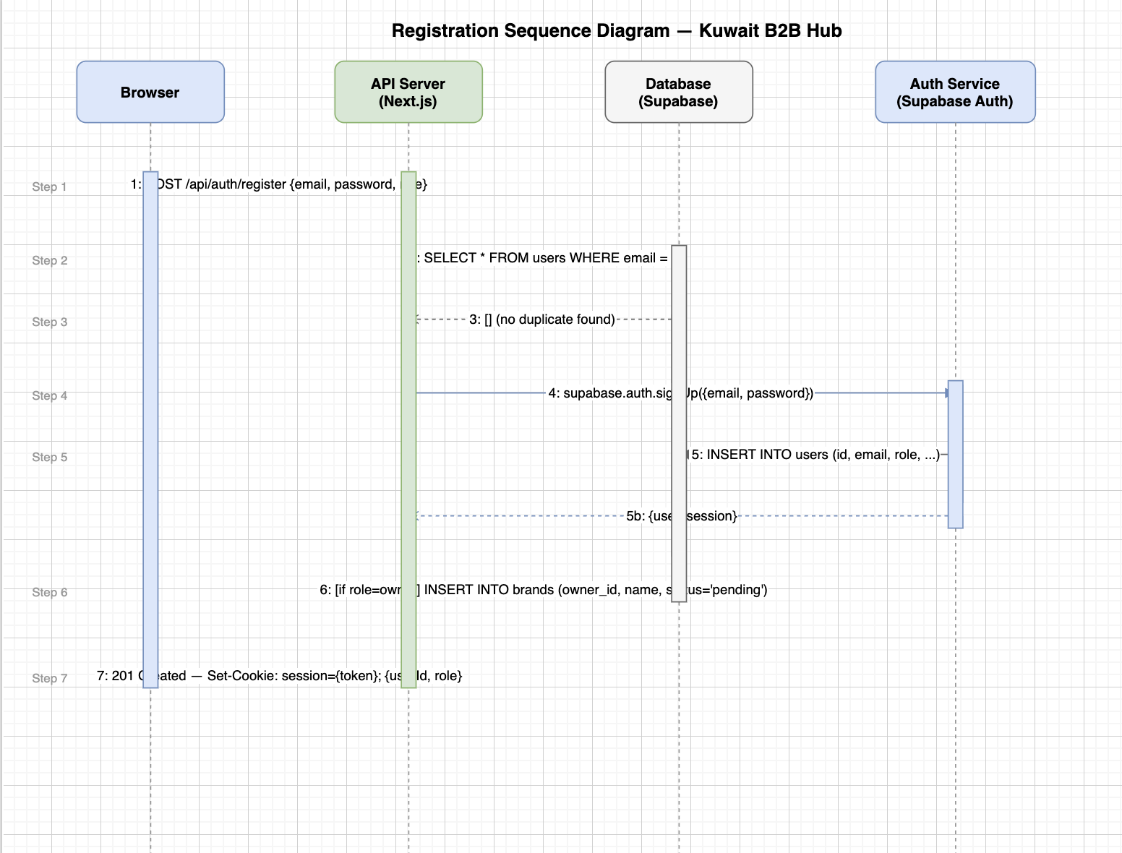
3.1.1 User Registration and Login
Client → POST /api/auth/register{name, email, password, role, company_name} → duplicate-email check (409 if found) → create User record → conditionally create pending Brand → write DB → fire admin notification(s) → return 200 + HTTP-only cookie (b2b_user_id, 7-day TTL). Login follows an identical flow via POST /api/auth/login.
3.1.2 Order Lifecycle
Buyer → POST /api/orders{brand_id, items[]} → validate MOQ + stock per item → resolve bulk-pricing tier → compute total → persist Order + OrderItems → notify brand owner. Brand Owner → PATCH /api/orders/:id{status} → update status → notify buyer (order_approved / order_rejected).
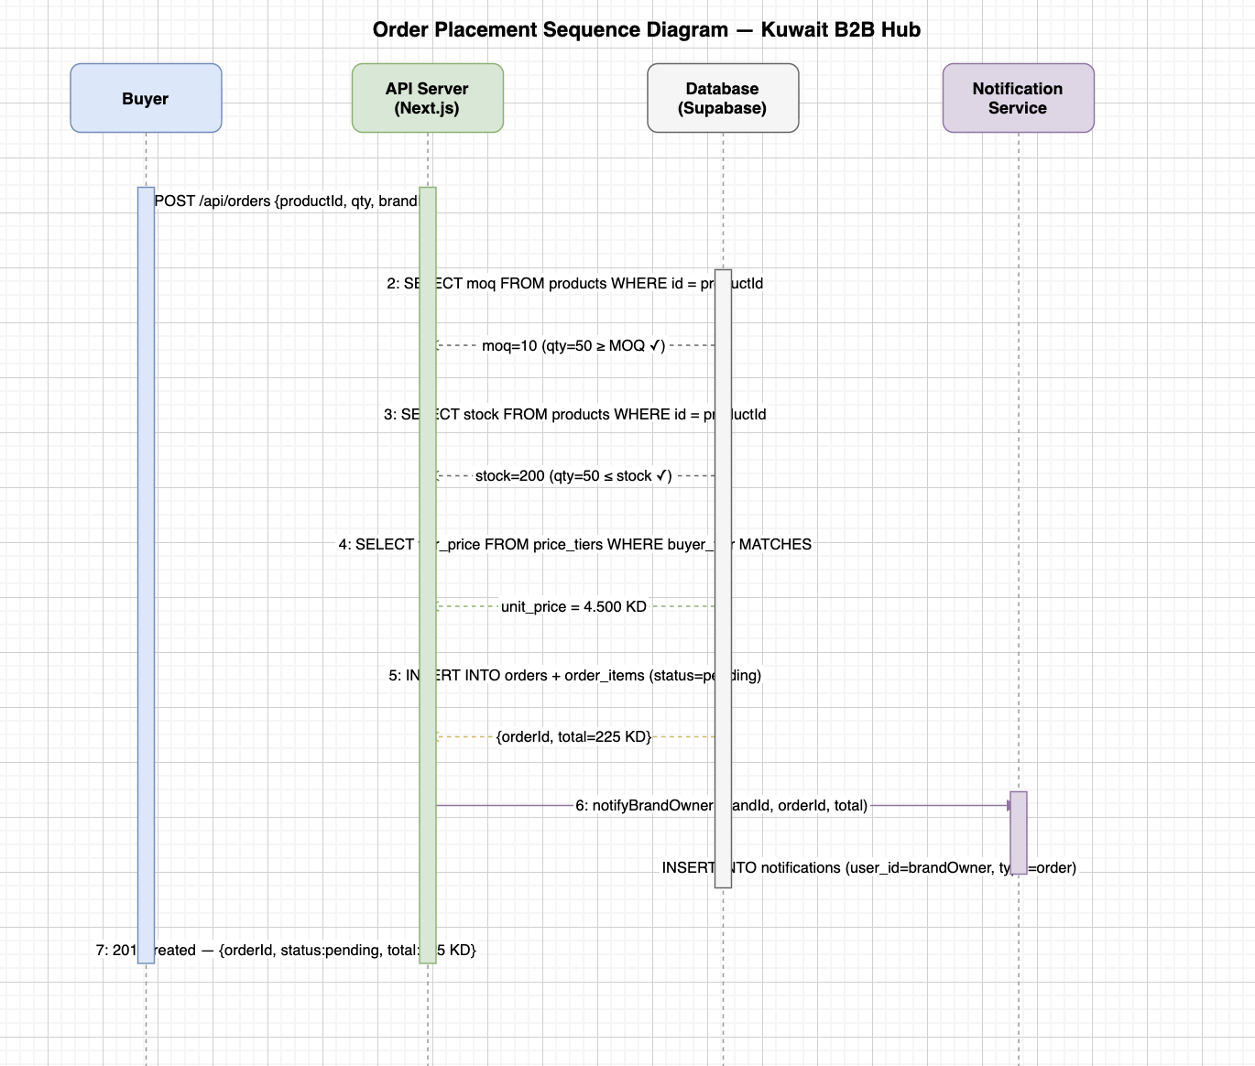
3.1.3 Brand Verification
Brand Owner registers → system creates pending brand → Admin receives notification → Admin sends PATCH /api/admin/brands/:id{status, verification_tier} → update brand record → notify brand owner (account_approved) → brand visible in marketplace.
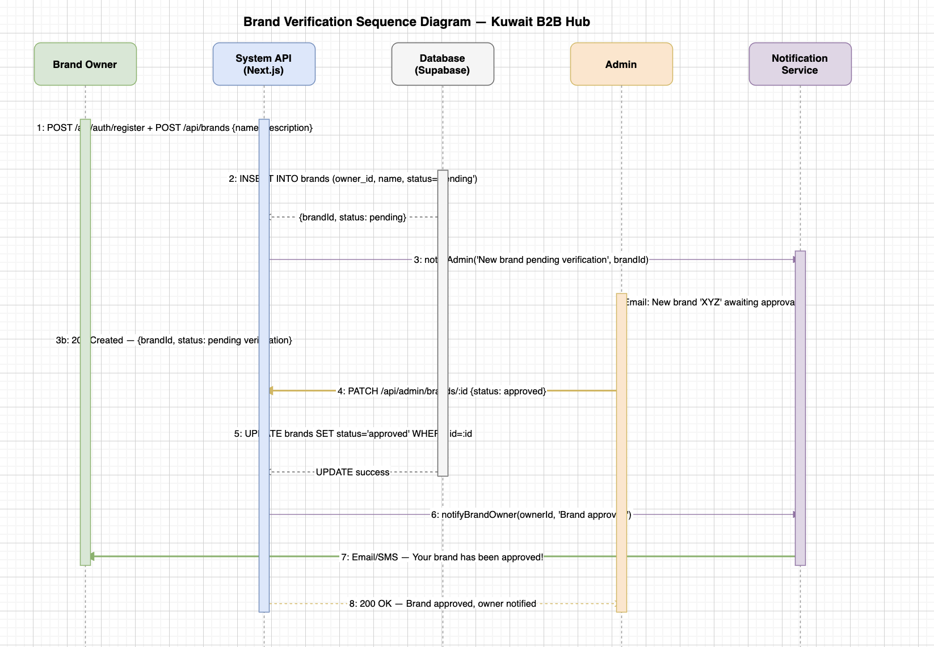
3.2 Data Flow Diagram (DFD)
Figure 3 shows the Level-1 DFD. Four data stores: D1 Users, D2 Brands/Products, D3 Orders/OrderItems, D4 Reviews/Notifications. Five processes: P1 Auth & Sessions, P2 Catalog Management, P3 Order Processing, P4 Trust & Reputation Engine, P5 Admin Governance.
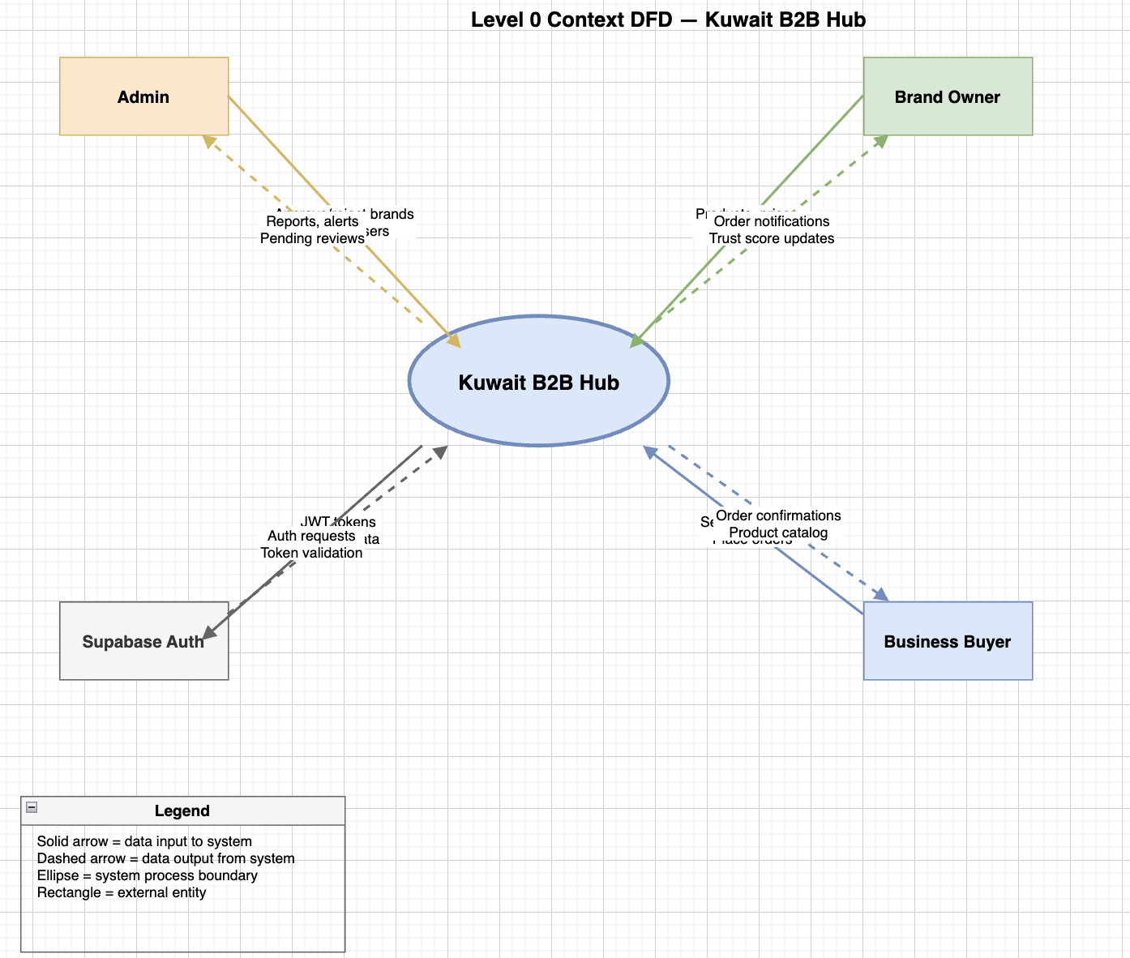
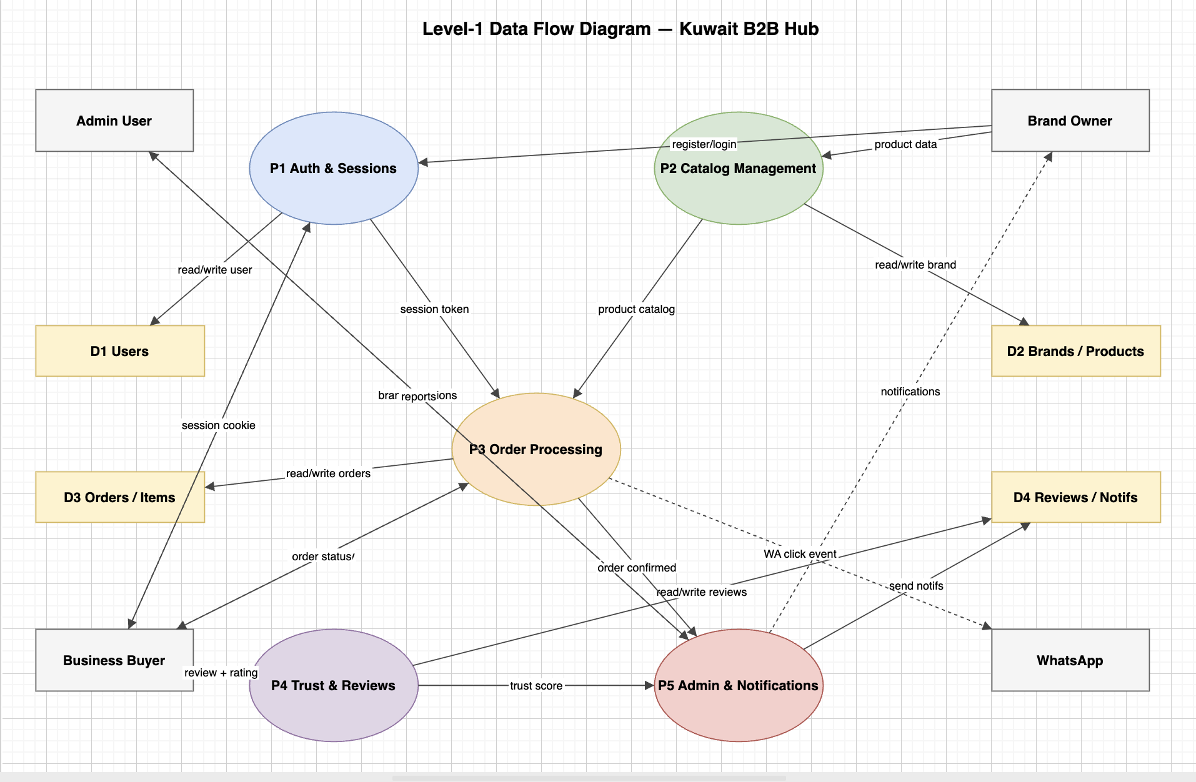
3.3 System Architecture
Figure 1 (Appendix A) illustrates the four-layer architecture:
- Presentation Layer — React 19 / Next.js App Router, CSS Modules, Lucide React, Recharts, CurrencyContext (React Context), Zustand (notification state), next-intl (i18n).
- Application / API Layer — Next.js Route Handlers (/src/app/api/**), RESTful JSON, Supabase SSR middleware for session refresh on every request.
- Data Access Layer — db.ts with readDB() / writeDB() (JSON MVP); Supabase PostgreSQL client (production path, migration in progress); TypeScript interfaces for all 10 entity types.
- Infrastructure Layer — Vercel edge network (hosting + CDN + SSR), Supabase managed cloud (Auth + DB), WhatsApp Business deep-links (external).
3.4 Activity Model
Figure 9 (Appendix A) shows the Activity Diagram for order placement. Start → Buyer views product → enters quantity → [qty < MOQ] → error; [qty ≥ MOQ] → [stock < qty] → stock error; [OK] → resolve tier price → compute total → create order → notify brand owner → display confirmation. Brand owner: notification → approve or reject → update order → notify buyer.
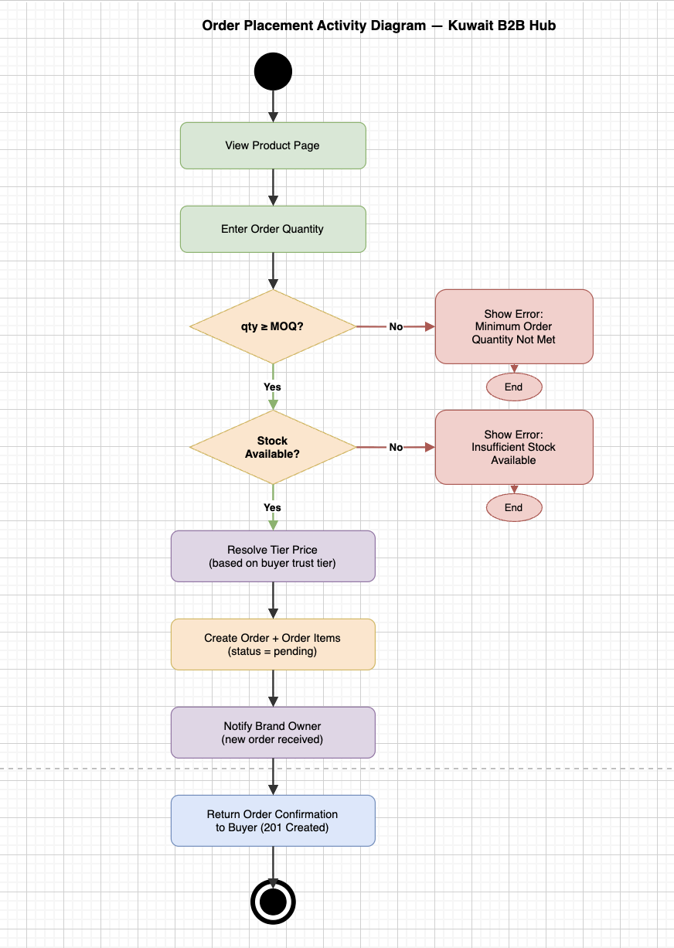
3.5 Class Diagram
Figure 8 (Appendix A) shows 10 entity classes with attributes and associations:
- User 1 — 0..1 Brand (brand_owner has at most one brand)
- Brand 1 — * Product (one brand owns zero or more products)
- Order * — 1 Brand, Order * — 1 User/Buyer
- Order 1 — * OrderItem, OrderItem * — 1 Product
- Review * — 1 Brand, Review * — 1 User/Buyer, Review 0..1 — 0..1 Order
- Notification * — 1 User
- BrandTrust 1 — 1 Brand, BuyerTrust 1 — 1 User/Buyer
interface Product {
id: string; brand_id: string; name: string;
price: number; moq: number; stock: number;
bulk_pricing_tiers: BulkPricingTier[]; created_at: string;
}
interface BulkPricingTier { min_qty: number; max_qty: number|null; price: number; }
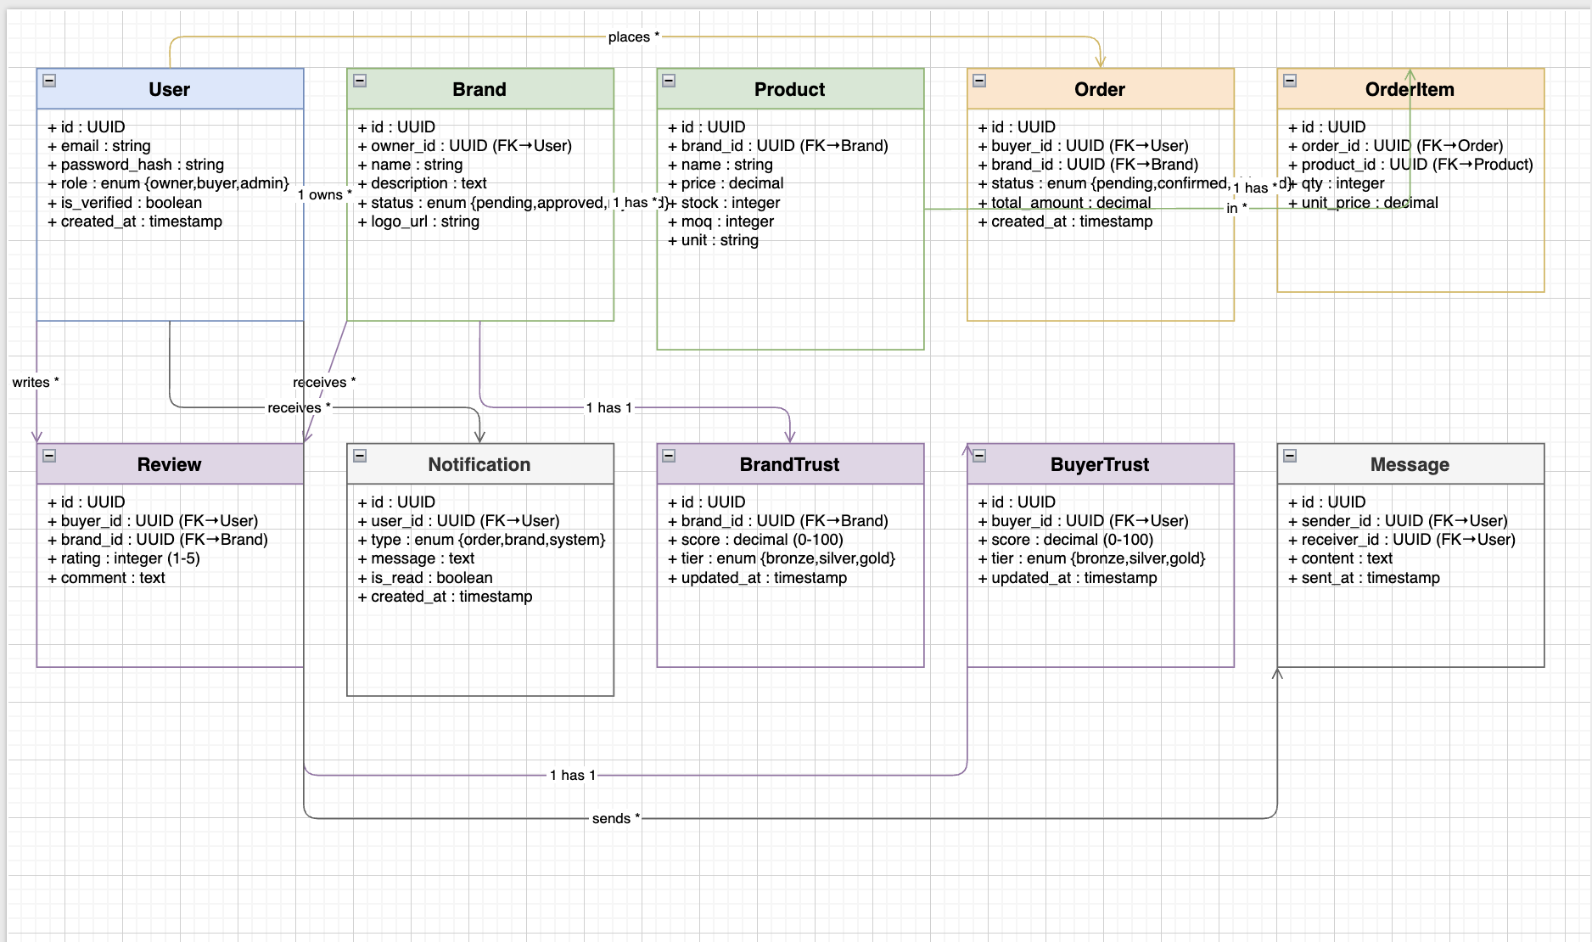
3.6 Prototype Screenshots
Screenshots are provided in Appendix B. Key screens: landing page (EN + AR), marketplace grid with verification badges, brand catalog with pricing tiers, order form with MOQ validation, brand owner dashboard, admin pending-approvals queue, review modal, notification panel.
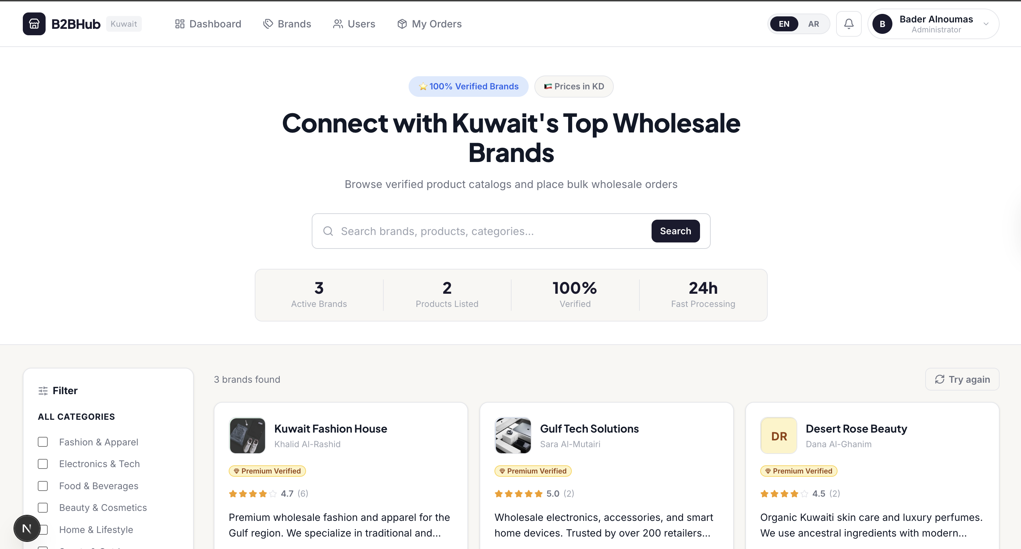
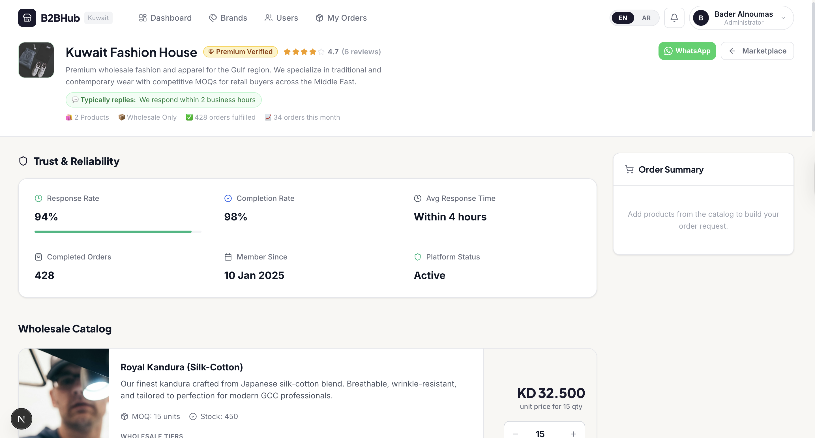
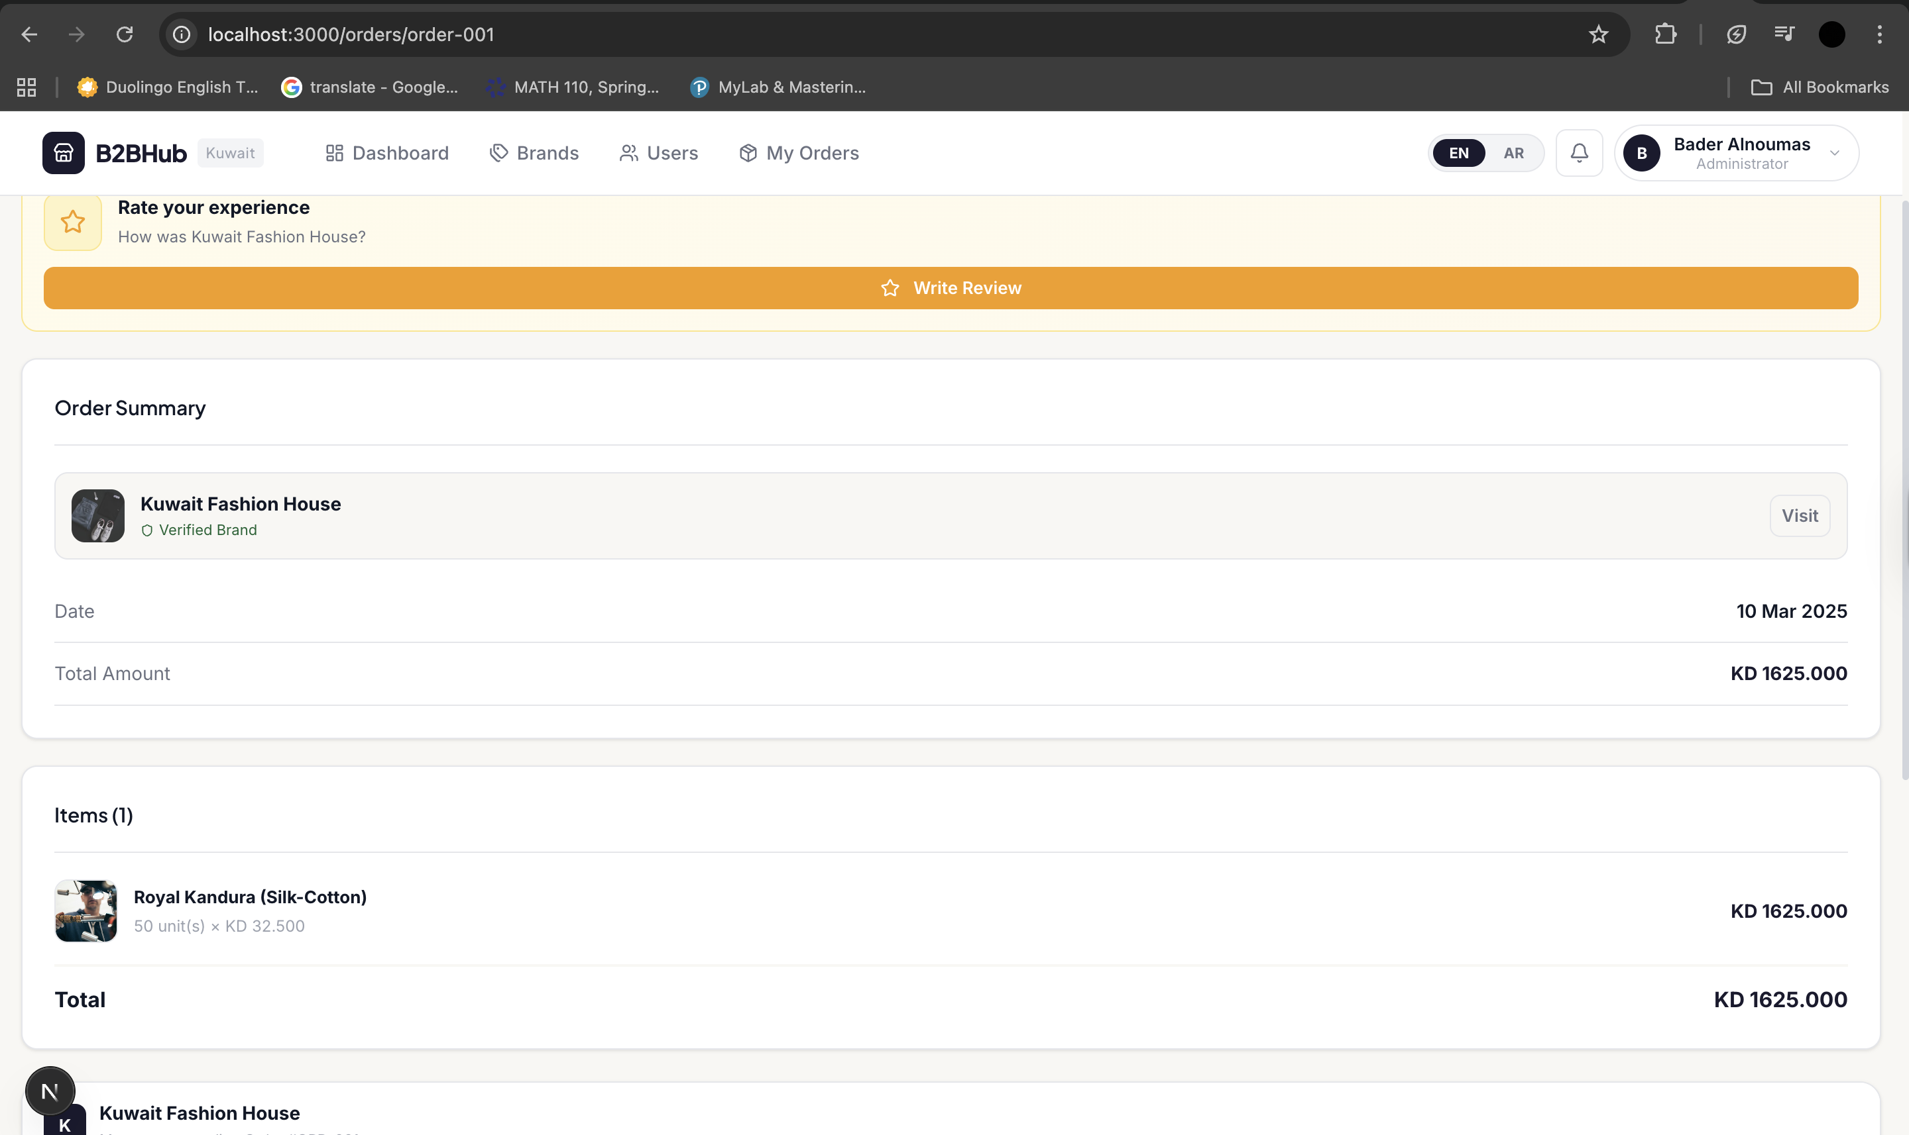
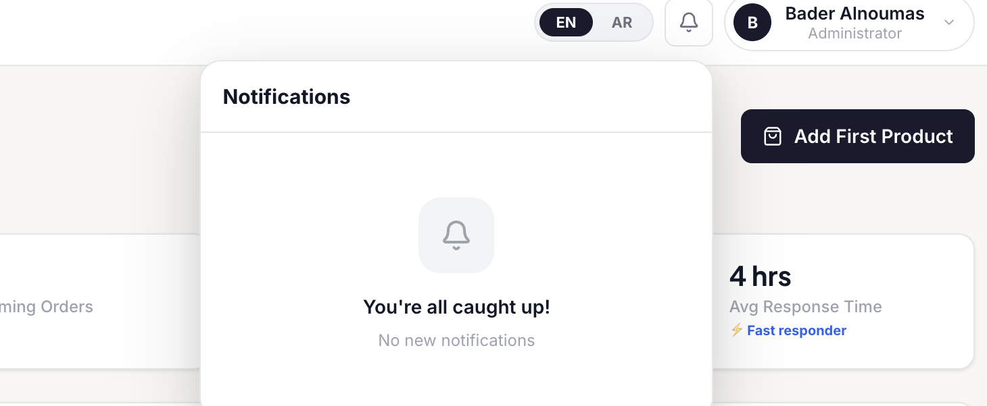

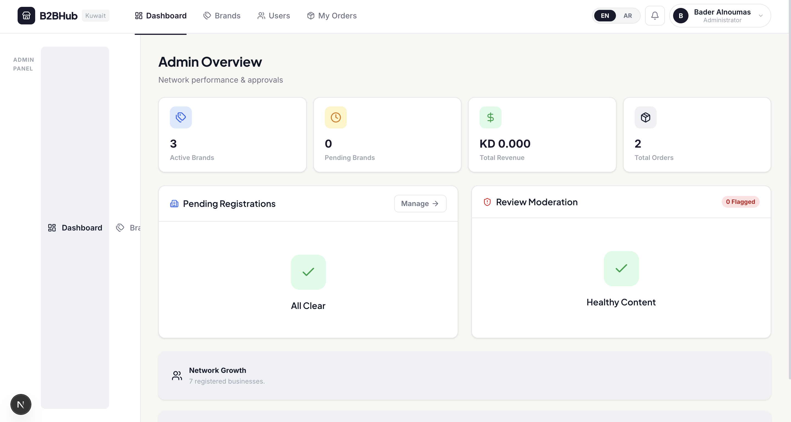
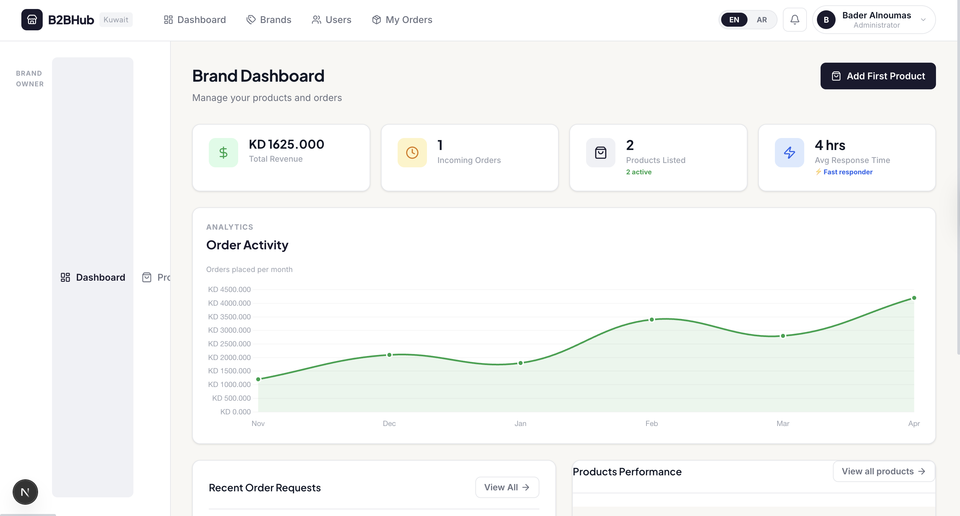

Chapter IV: System Implementation
4.1 Make / Buy / Lease Analysis
Component | Decision | Justification | Subsystem | License | Reuse Level | Reference# | Date
Authentication | Buy (Supabase Auth) | Provides bcrypt hashing, JWT, SSR session management — building from scratch would introduce security risk. | Server | Apache 2.0 | System | MBL-001 | Jan.01.2026
Database (production) | Buy (Supabase PostgreSQL) | Managed PostgreSQL; eliminates DBA overhead; supports Realtime subscriptions. | Server | Apache 2.0 | System | MBL-002 | Jan.01.2026
Database (MVP/dev) | Make (JSON file + db.ts) | Minimal setup cost; sufficient for a small seed dataset during development sprints. | Server | N/A (own) | Abstract | MBL-003 | Jan.01.2026
Web Framework | Buy (Next.js 16) | Industry-standard full-stack React framework with SSR, API routes, and Vercel-native deployment. | Full-stack | MIT | System | MBL-004 | Jan.01.2026
UI Components | Make (CSS Modules) | Custom styling required for GCC brand identity and Arabic RTL. | Client | N/A (own) | Abstract | MBL-005 | Jan.01.2026
Internationalisation | Buy (next-intl 4.9) | Handles server-side i18n, locale routing, and RTL awareness. | Client | MIT | Component | MBL-006 | Feb.01.2026
Charts / Analytics | Buy (Recharts 3.8) | Declarative React charting; no custom SVG required. | Client | MIT | Component | MBL-007 | Mar.10.2026
Notification State | Buy (Zustand 5.0) | Lightweight client state for unread-count; avoids Redux boilerplate. | Client | MIT | Component | MBL-008 | Mar.25.2026
Excel Import | Buy (xlsx 0.18.5) | Industry-standard XLSX/CSV parser. | Server | Apache 2.0 | Component | MBL-009 | Feb.21.2026
Hosting / CDN | Lease (Vercel) | Zero-config Next.js deployment, global CDN, preview environments. | Infrastructure | Proprietary | System | MBL-010 | Jan.01.2026
Payment Gateway | N/A (Future) | Tap Payments or Checkout.com — to be evaluated for GCC compliance. | N/A | N/A | N/A | N/A | N/A
Shipping Carrier API | N/A (Future) | Aramex / DHL — planned for post-MVP phase. | N/A | N/A | N/A | N/A | N/A
4.2 Coding Artefacts & Project Structure
Figure 10 below shows the VS Code project explorer for the Kuwait B2B Hub codebase. The project is structured under the /app directory following Next.js 16 App Router conventions, with source code in /src, internationalisation in /messages, and configuration at the root.
Figure 10 — VS Code Project Explorer: Kuwait B2B Hub Folder Structure
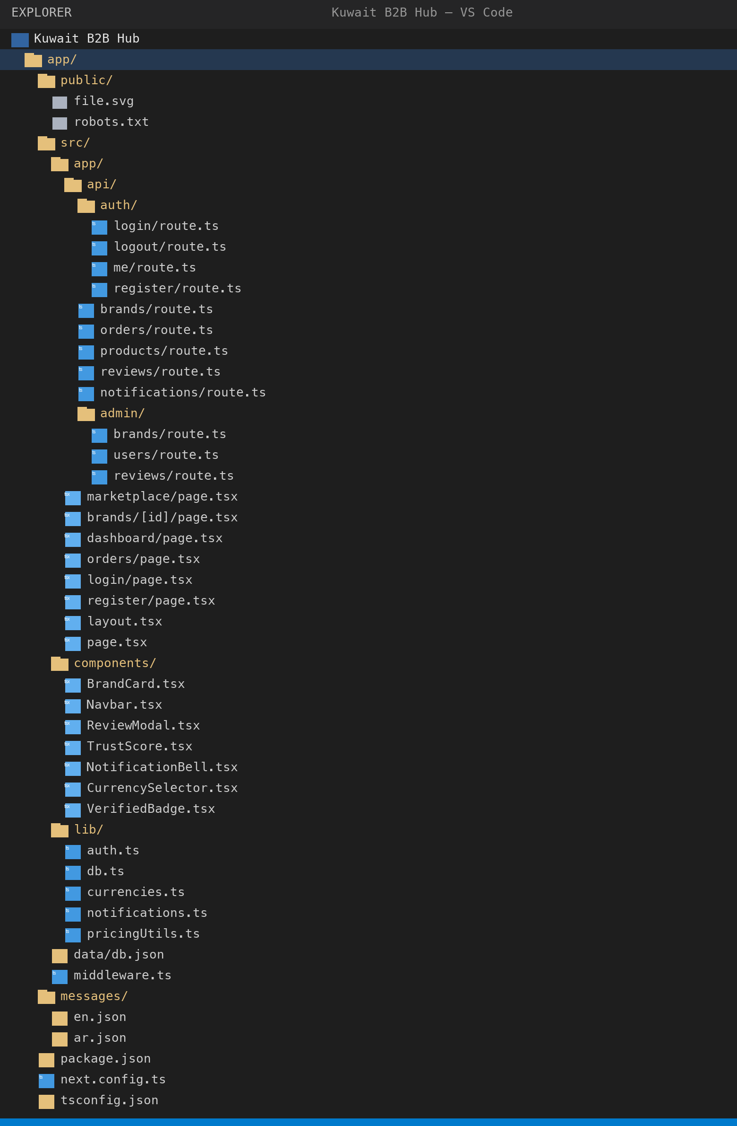

4.2.1 Key Implementation Highlights
4.2.2 Role-Based Auth Guard (src/lib/auth.ts)
requireRole() (line 27) wraps requireAuth() and throws HTTP 403 if the caller's role is not in the allowed list. getCurrentUser() calls Supabase getUser() and joins the profiles table for the full User object.
4.2.3 Order Validation (src/app/api/orders/route.ts, lines 58–79)
The POST handler validates per item: (a) quantity is a positive integer; (b) product exists and belongs to the requested brand; (c) quantity ≥ product.moq; (d) product.stock ≥ quantity. Unit price is resolved from bulk_pricing_tiers.
for (const item of items) {
const qty = Number(item.quantity);
if (!Number.isInteger(qty) || qty <= 0) return error('Invalid qty');
if (qty < product.moq) return error(`MOQ is ${product.moq}`);
if (product.stock < qty) return error(`Only ${product.stock} available`);
// resolve tier price
for (const tier of product.bulk_pricing_tiers) {
if (qty >= tier.min_qty && (!tier.max_qty || qty <= tier.max_qty))
{ unitPrice = tier.price; break; }
}
}
4.2.4 Currency Engine (src/lib/currencies.ts)
CURRENCIES maps KWD/SAR/AED/BHD to symbol, VAT rate (0% / 15% / 5% / 10%), and locale. formatPriceWithVAT() converts from KWD and applies destination VAT.
4.2.5 Non-Fatal Notification (src/lib/notifications.ts)
createNotification() wraps all DB writes in try/catch that silently suppresses errors — ensuring a notification failure never causes an HTTP 500 on an otherwise successful request.
4.3 Configuration Management
Area | Tool | Details
Version Control | Git | Single main branch; full history in app/.git
Build System | Next.js / npm | npm run dev | build | start | lint
Type Checking | TypeScript 5 strict | tsconfig.json strict: true; incremental builds
Linting | ESLint 9 + next config | eslint.config.mjs; zero-warnings policy
Environment Vars | .env.local | NEXT_PUBLIC_SUPABASE_URL, ANON_KEY — not committed
Dependency Lock | package-lock.json | Reproducible installs across team and CI
Translations | Python audit scripts | find_missing_keys.py, audit_translations.py — run each sprint
4.4 Deployment Specification
Config Item | Value | Notes
Hosting Platform | Vercel | Zero-config Next.js; auto CI/CD on git push
Runtime | Node.js 18+ | Vercel managed serverless functions
Build Command | npm run build | Produces .next/ optimised production bundle
Auth Service | Supabase (hosted) | SUPABASE_URL + ANON_KEY env vars
Database (MVP) | JSON file (Vercel filesystem) | src/data/db.json — ephemeral; migration planned
Database (production) | Supabase PostgreSQL | GCC-region Supabase instance
CDN | Vercel Edge Network | Static assets, image optimisation
SSL / TLS | Vercel / Let's Encrypt | Automatic HTTPS for all deployments
Domain | TBD (b2bhub.kw planned) | Kuwait ccTLD requires local entity registration
4.5 Physical Deployment Diagram
Figure 11 (Appendix A) shows the physical deployment topology. End-user devices (desktop + mobile browsers) communicate via HTTPS to Vercel's edge network. The Vercel CDN serves static assets and routes dynamic requests to Next.js serverless functions. Functions communicate with Supabase cloud (Auth + PostgreSQL) over TLS. WhatsApp Business deep-links open the user's WhatsApp client directly. During the MVP phase, the function reads/writes the bundled db.json file within the same Vercel environment.
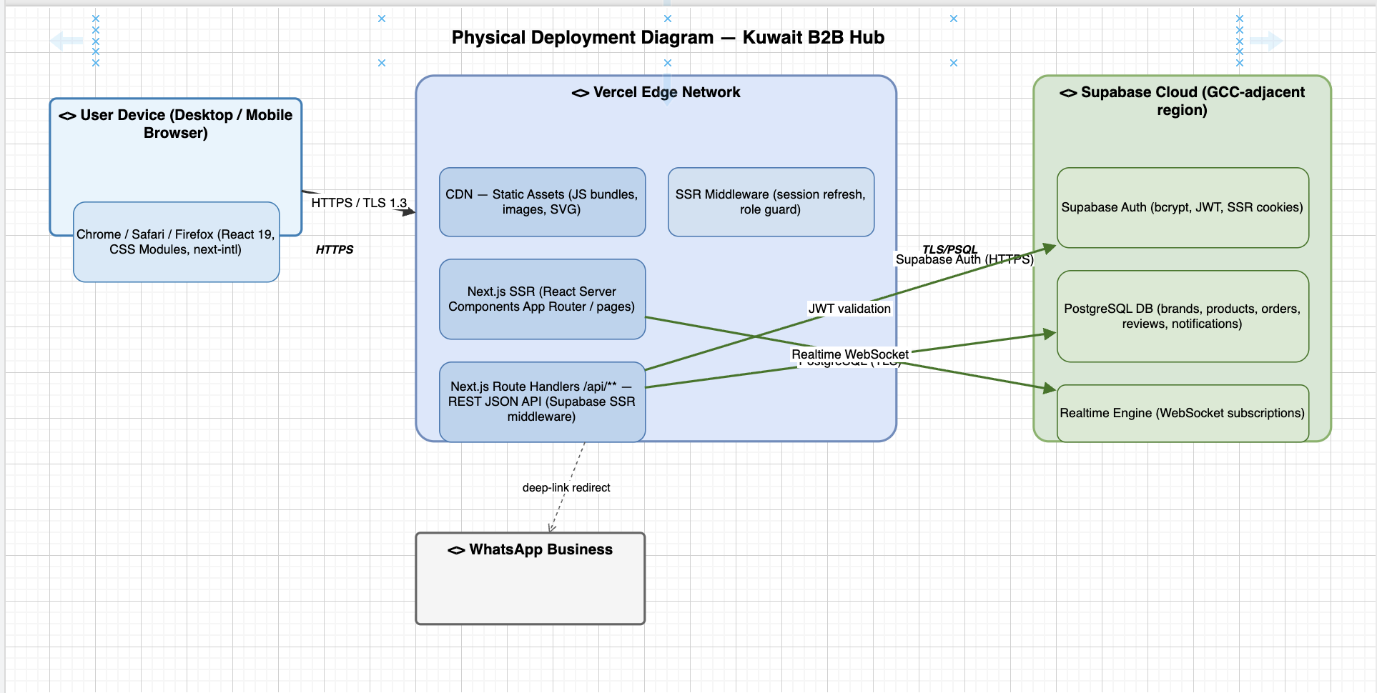

Chapter V: Verification & Validation
5.1 Development Testing
Development testing focused on validating API endpoints and UI flows before integration. Checks performed each sprint:
- TypeScript strict-mode compilation — zero type errors before commit.
- ESLint static analysis — npm run lint; zero warnings enforced.
- Manual API testing via browser DevTools for edge cases: missing fields, wrong role, duplicate email, below-MOQ, insufficient stock.
- Translation audit scripts run after every new UI string addition.
- Browser console monitoring — zero unhandled JS exceptions on all main flows.
5.2 System Inspection
Conducted Sprint 6 — five security-sensitive modules:
Code Inspection
Conducted Sprint 4. Reviewed all UML diagrams against implementation. Finding: Class diagram missing Message entity. Resolution: Message class added to diagram and db.ts.
Design Models Inspection
Conducted Sprint 3. Reviewed 4-layer architecture against non-functional requirements. Finding: JSON file DB (Layer 3) violates NFR-03 (scalability). Resolution: Supabase migration scheduled Sprint 8.
Architecture Inspection
Conducted Sprint 2. Reviewed all 17 URS and 20 SRs against implementation plan. Finding: SR-12 and SR-13 (trust scores) marked as partial — complexity underestimated. Resolution: allocated dedicated Sprint 5 resources.
SRS Inspection
- Finding 1 (Critical — Pending): Plain-text passwords in db.json. Resolution: Supabase Auth (bcrypt) migration — Sprint 8 primary objective.
- Finding 2 (Medium — In Progress): b2b_user_role cookie not HTTP-only. Resolution: role validation moved server-side; cookie to be HTTP-only post-migration.
- Finding 3 (Low — Resolved): Review content not sanitised. Resolution: content.slice(0, 300) + XSS sanitisation in display component.
- Finding 4 (Low — Resolved): TypeScript 'any' in review route handlers. Resolution: explicit type annotations added.
- Finding 5 (Info): No rate limiting on auth endpoints. Resolution: Vercel edge rate limiting + Supabase Auth brute-force protection post-migration.
5.3 System Testing
TC ID | Test Case | Input | Expected | Result | Notes
TC-01 | Register new buyer | Valid form role=buyer | User created; dashboard accessible; admin notified | Pass
TC-02 | Register brand owner | Valid form role=brand_owner | User + pending brand created; admin notified x2 | Pass
TC-03 | Duplicate email | Existing email | HTTP 409 error displayed | Pass
TC-04 | Login valid credentials | Correct email + password | Session cookie set; redirected to dashboard | Pass
TC-05 | Login invalid password | Wrong password | Error message; no cookie set | Pass
TC-06 | Unauthorised route access | Buyer → /admin/dashboard | Redirect to login / 403 | Pass
TC-07 | Brand approval | Admin approves pending brand | status=approved; brand visible; brand owner notified | Pass
TC-08 | Create product | MOQ=15, price=32.5 KWD | Product in brand catalog | Pass
TC-09 | Below-MOQ order rejection | qty=5, MOQ=15 | HTTP 400 with clear error | Pass
TC-10 | Valid order creation | qty=15, stock=450 | Order created; brand owner notified | Pass
TC-11 | Bulk-pricing tier applied | 50 units (tier KD 28) | Total = 50 × 28 = KD 1,400 | Pass
TC-12 | Order approval by brand | Brand approves order | status=approved; buyer notified | Pass
TC-13 | Submit review | 5-star with text | Review saved; brand owner notified | Pass
TC-14 | Anonymous review | anonymous=true | Author shown as 'Anonymous Buyer' | Pass
TC-15 | Currency switch to SAR | Select SAR | Prices × 12.20 | Pass
TC-16 | Arabic RTL layout | Toggle to Arabic | RTL rendered; Arabic text displayed | Partial | Some components not RTL-adapted
TC-17 | WhatsApp click tracking | Click WhatsApp button | click counter incremented | Pass
TC-18 | Excel product import | Upload XLSX with 5 products | 5 products created | Pass
TC-19 | Notification bell | New order (unseen notif) | Bell badge + panel opens | Pass
TC-20 | Admin review moderation | Admin removes flagged review | status=removed; hidden from buyers | Pass
5.4 Release Testing
To be completed in Sprint 8:
- Regression sweep across all 20 TC cases after Supabase migration.
- Cross-browser: Chrome 124, Safari 17, Firefox 125, Edge 124.
- Viewport: 375 px (iPhone SE), 414 px (Pro Max), 768 px (iPad).
- Lighthouse audit — targets: LCP < 2.5 s, TBT < 200 ms, CLS < 0.1.
- HTTP security headers review (CSP, X-Frame-Options, HSTS).
- i18n completeness — translation scripts must report 0 missing keys.
5.5 User Testing
Informal UAT with two volunteer business users (one retail buyer, one brand owner) in Sprint 5:
- Positive: Marketplace search described as 'faster than WhatsApp'.
- Positive: Verification badge and trust score cited as confidence builders.
- Improvement: Order form needed clearer MOQ guidance — resolved with dynamic MOQ label.
- Improvement: Arabic brand descriptions requested — added to post-MVP roadmap.
- Improvement: Bulk-pricing tier table not immediately visible — resolved as default-expanded section.

Chapter VI: System Evolution
6.1 Anticipated Changes
ID | Change | Priority | Effort | Description | Affected Components | Cost Range (KD)
EV-01 | Supabase PostgreSQL Migration | High | High | Replace JSON file layer with Supabase queries in db.ts. | db.ts, all API routes | KD 0 (OSS)
EV-02 | Real-Time Notifications | High | Medium | Supabase Realtime subscriptions via useRealtimeNotifications hook. | notifications.ts, Zustand | KD 0
EV-03 | Payment Gateway Integration | High | High | Tap Payments or Checkout.com for GCC-compliant payment processing. | new PaymentComponent, OrderComponent | KD 500-2000
EV-04 | Email / SMS Notifications | Med | Medium | SendGrid / AWS SES for emails; Twilio for SMS. | new NotifService | KD 100-500/yr
EV-05 | Automated CR Verification | Med | High | Kuwait MoCI API to auto-validate commercial registration numbers. | AuthComponent, AdminComponent | KD 200-1000
EV-06 | Shipping Carrier Integration | Med | High | Aramex / DHL API for shipping rates and parcel tracking. | new ShippingComponent, OrderComponent | KD 300-1500
EV-07 | Live Exchange Rate API | Low | Low | Replace hardcoded rates with scheduled FX data provider fetch. | currencies.ts | KD 0-100/yr
EV-08 | Arabic Brand Descriptions | Low | Low | Add Arabic description field to Brand and Product entities. | Brand, Product entities, AR locale | KD 0
EV-09 | Wishlist & Brand Comparison | Low | Medium | Save brands/products; compare up to 3 brands side-by-side. | new WishlistComponent, client | KD 0
EV-10 | Native Mobile Apps | Low | High | React Native or PWA for iOS/Android. | entire frontend | KD 2000-8000
6.2 Phase-Out Transitions
- JSON → Supabase DB: readDB()/writeDB() replaced method-by-method; JSON file retained as seed fixture only.
- Local Auth → Supabase Auth: Cookie-based local auth superseded by Supabase Auth JWTs; register/login/logout routes deprecated.
- Hardcoded Rates → Live API: EXCHANGE_RATES replaced with Next.js revalidated API call (1-hour interval).
- Manual Brand Verification → Hybrid: Admin approval augmented (not replaced) with automated CR lookup.
6.3 Quality Predictions
Metric | MVP (Now) | Phase 2 (Post-Migration) | Phase 3 (Production)
API Response Time | < 800 ms (JSON file) | < 300 ms (Supabase + CDN) | < 150 ms (edge caching)
Test Coverage | 0% automated (manual) | ~40% (unit + E2E critical paths) | ~80% (full suite)
Translation | ~80% (AR partial) | 100% (all keys filled) | 100% + new features
Uptime | N/A (dev environment) | ~99.5% (Vercel + Supabase SLA) | > 99.9% (HA config)
Security (OWASP) | Medium (plain-text pw) | High (bcrypt, HTTPS, CSP) | High (pen-test verified)

Chapter VII: System Planning & Management
7.1 Milestones
ID | Milestone | Target Date | Status | Notes
M-01 | Project Kickoff & Tech Stack Decision | Jan 1, 2026 | Complete | Architecture agreed; Next.js + Supabase selected
M-02 | Authentication & DB Schema | Jan 15, 2026 | Complete | User registration, login, roles functional
M-03 | Marketplace MVP (browse + catalog) | Feb 1, 2026 | Complete | Brand cards, product detail, verification badges
M-04 | Order Lifecycle Complete | Feb 20, 2026 | Complete | Order create → approve/reject; dashboards
M-05 | Trust & Reputation Engine | Mar 10, 2026 | Complete | Review system, ratings, trust scores, admin mod
M-06 | Admin Dashboard & Notifications | Mar 25, 2026 | Complete | Admin panel, notification panel, analytics
M-07 | Localisation & Mobile Responsiveness | Apr 10, 2026 | Partial | EN complete; AR ~80%; mobile mostly responsive
M-08 | Progress Report Submission | Apr 17, 2026 | Complete | Progress_Report_Final.docx submitted
M-09 | Supabase DB Migration | May 5, 2026 | Planned | Full data layer on Supabase PostgreSQL
M-10 | Automated Testing Suite | May 15, 2026 | Planned | Jest unit tests + Playwright E2E
M-11 | Final Report First Draft | May 25, 2026 | Planned | All chapters drafted and reviewed
M-12 | Final Report Submission | Jun 15, 2026 | Planned | Submitted to university portal
M-13 | Final Presentation / Viva | Jun 25, 2026 | Planned | Presentation delivered; Q&A handled
7.2 Gantt Chart
Figure 12 (Appendix A) shows the Gantt chart across 8 sprints (January–June 2026). Critical path: Auth/Setup → Marketplace → Orders → Trust/Reputation → Admin/Notifications → Localisation → Supabase Migration → Testing & Report.
Sprint | Dates | Focus
Sprint 1 | Jan 1–14 | Auth, DB schema, project setup
Sprint 2 | Jan 15–31 | Marketplace, brand browsing, search/filter
Sprint 3 | Feb 1–20 | Order lifecycle, buyer dashboard
Sprint 4 | Feb 21–Mar 9 | Brand owner dashboard, product CRUD, Excel import
Sprint 5 | Mar 10–24 | Reviews, trust scores, admin moderation
Sprint 6 | Mar 25–Apr 9 | Admin dashboard, notifications, WhatsApp tracking
Sprint 7 | Apr 10–Apr 30 | Localisation, mobile responsiveness, progress report
Sprint 8 | May 1–Jun 15 | Supabase migration, testing, final report
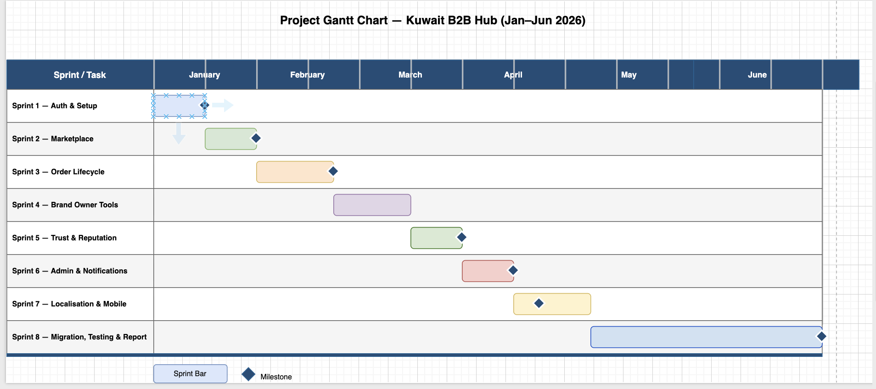
7.3 Activity Network Diagram
Figure 13 shows the Activity Network (Precedence Diagram) for the eight project sprints. Each node represents a sprint; arrows represent mandatory dependencies. The critical path is highlighted: S1 → S2 → S3 → S4 → S5 → S6 → S7 → S8.

Table 14 — Activity Network: Sprint Dependency & Float Analysis
Activity | Predecessor | Successor | Duration | Early Start | Early Finish | Float
S1 — Auth & Setup | — | S2 | 2 wks | Jan 1 | Jan 14 | 0 (Critical)
S2 — Marketplace | S1 | S3 | 2 wks | Jan 15 | Jan 31 | 0 (Critical)
S3 — Order Lifecycle | S2 | S4 | 3 wks | Feb 1 | Feb 20 | 0 (Critical)
S4 — Brand Owner Tools | S3 | S5 | 2.5 wks | Feb 21 | Mar 9 | 0 (Critical)
S5 — Trust & Reputation | S4 | S6 | 2 wks | Mar 10 | Mar 24 | 0 (Critical)
S6 — Admin & Notifications | S5 | S7 | 2 wks | Mar 25 | Apr 9 | 0 (Critical)
S7 — Localisation & Mobile | S6 | S8 | 3 wks | Apr 10 | Apr 30 | 0 (Critical)
S8 — Migration, Testing & Report | S7 | — (End) | 6 wks | May 1 | Jun 15 | 0 (Critical)
Note: All 8 sprints lie on the critical path (zero float). Each sprint output is a prerequisite for the next.

Arrow notation — dependency chain:
[ S1: Auth ] ──► [ S2: Marketplace ] ──► [ S3: Orders ] ──► [ S4: Brand Tools ]
│
▼
[ S8: Migration + Report ] ◄── [ S7: Localisation ] ◄── [ S6: Admin ] ◄── [ S5: Trust ]

Note: All sprints lie on the critical path (zero float). No parallel sprints exist in this single-team Agile project; each sprint's output is a prerequisite for the next.
7.4 Staff Allocation
Team Member | Auth/Setup | Marketplace | Orders | Trust/Admin | Testing | Docs/Report | Total
Bader Alnoumas | 25% | 25% | 20% | 15% | 10% | 5% | 100%
Abdullah Abduljaleel | 10% | 30% | 20% | 15% | 15% | 10% | 100%
Abdullah Subhi | 15% | 10% | 25% | 25% | 15% | 10% | 100%
Salah Abdulfattah | 10% | 10% | 10% | 10% | 30% | 30% | 100%
7.5 CoCoMo Cost Estimation
Parameter | Value | Notes
Estimated KLOC | 3.0 KLOC | ~3,000 lines TypeScript/TSX (excl. node_modules)
CoCoMo Model | Organic | Small team, familiar tech, simple domain
Effort Equation | E = 2.4 × (3.0)^1.05 | ≈ 7.6 person-months
Duration Equation | D = 2.5 × (7.6)^0.38 | ≈ 6.1 months
Actual Duration | ~6 months | Jan 2026 – Jun 2026 (matches estimate)
Avg Team Size | ~1.27 FTE each | 7.6 PM / 6 months / 4 members
Est. Cost (academic) | KD 12,000 | KD 500/developer/month × 4 × 6
7.6 Risk Matrix
ID | Risk | Likelihood | Impact | Exposure | Mitigation
R-01 | Supabase migration overrun | Med | High | High | Full Sprint 8 allocated; JSON fallback available
R-02 | Automated tests reveal critical bugs | Med | High | High | Prioritise critical-path tests; manual sweep as backup
R-03 | Team member unavailable | Low | High | Med | Shared knowledge; docs kept current
R-04 | Supabase Realtime blocked | Med | Low | Low | Fall back to polling; Realtime is enhancement
R-05 | Arabic translation gaps | High | Med | High | Audit scripts run weekly; dedicated team member
R-06 | Vercel/Supabase free-tier limits | Low | Med | Low | Monitor usage; upgrade plan negligible cost
R-07 | Scope creep in Sprint 8 | Low | Med | Low | Feature freeze; new items logged in backlog
R-08 | Security vulnerability discovered | Med | High | High | Supabase Auth migration; CSP headers pre-launch
7.7 Fishbone Diagram
Figure 14 (Appendix A) shows the Ishikawa Diagram for 'Delayed Final Submission'. Five cause bones:
- People: Team member unavailability; knowledge silos; communication gaps.
- Process: Scope creep; insufficient sprint planning; unclear acceptance criteria.
- Technology: Supabase migration complexity; real-time implementation; dependency conflicts.
- Environment: Platform outages; local environment inconsistencies.
- Materials: Incomplete requirements; missing design artefacts; documentation gaps.
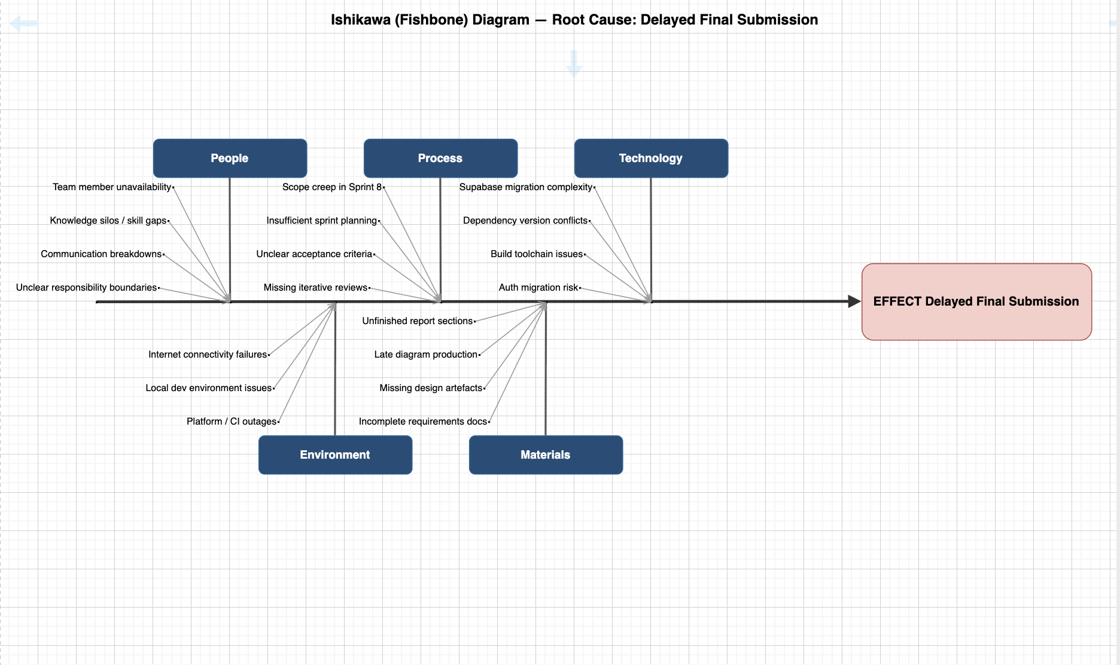
Chapter VIII: Conclusions
8.1 Design Smells
DS-01 Rigidity
Hard to change because every change affects many other parts.
Example: db.ts god-module couples all 10 entity types.
Resolution: migrate to Supabase per-table query interfaces to decouple entity access.

DS-02 Fragility
Changes cause unexpected breakage.
Example: the b2b_user_role cookie — if its format changes, multiple middleware files break simultaneously.
Resolution: centralise role extraction in a single getCurrentUser() call.

DS-03 Immobility
Cannot reuse parts in other projects.
Example: pricingUtils.ts is tightly coupled to the BulkPricingTier interface from db.ts and cannot be independently extracted.
Resolution: define pricingUtils with pure functions that accept generic tier arrays.

DS-04 Viscosity
Easier to do it wrong than right.
Example: it was faster to add hardcoded exchange rates inline than to use the CURRENCIES constant.
Resolution: ESLint rule added to flag magic number literals.

DS-05 Needless Complexity
Infrastructure for no current benefit.
Example: Zustand store for notifications was over-engineered for what could be simple useState.
Resolution: acceptable trade-off for future Realtime integration; documented as intentional design decision.

DS-06 Needless Repetition
Cut-and-paste code.
Example: currency formatting duplicated in 3 components before centralisation.
Resolution: formatPriceWithVAT() in currencies.ts is now the single source of truth.

DS-07 Opacity
Hard to understand the code's intent.
Example: the trust score formula (0.4×rating + 0.3×volume + 0.2×reply_rate + 0.1×dispute_free) was previously undocumented.
Resolution: formula documented in JSDoc comment in /api/trust/[id]/route.ts.

DS-01 God Object
Problem: db.ts was a single read/write gateway to all 10 entity types — tight coupling.
Resolution: Partially resolved by typed per-entity helpers; full resolution via Supabase per-table queries.
DS-02 Primitive Obsession
Problem: Order status passed as raw strings without a shared enum.
Resolution: Resolved: TypeScript union type defined in db.ts and used consistently.
DS-03 Divergent Change
Problem: Currency formatting logic duplicated across three components.
Resolution: Resolved: all formatting delegates to formatPrice() / formatPriceWithVAT() in currencies.ts.
DS-04 Shotgun Surgery
Problem: Adding a new notification type required changes in multiple files.
Resolution: Partially resolved: notification creation centralised in notifications.ts; icon-map still manual.
DS-05 Feature Envy
Problem: Review components computed aggregates that belonged in the data layer.
Resolution: Resolved: aggregates computed server-side in GET /api/reviews response payload.
DS-06 Inappropriate Intimacy
Problem: Order creation route directly accessed brand and product DB tables for validation.
Resolution: Acknowledged: service layer planned for production architecture.
DS-07 Magic Numbers
Problem: Exchange rates and VAT percentages hardcoded inline in components.
Resolution: Resolved: centralised in CURRENCIES and EXCHANGE_RATES constants in currencies.ts.
8.2 SWOT Analysis

STRENGTHS  • Purpose-built for GCC: Arabic RTL, 4 currencies, GCC legal awareness  • Verified brand ecosystem creates buyer trust  • Structured order management replaces WhatsApp chaos  • Trust & reputation engine differentiates from listing directories  • Modern stack (Next.js, Supabase, TypeScript) enables rapid iteration | WEAKNESSES  • No payment integration — platform limited to 'order request' model  • JSON-file database not production-ready; migration risk  • No real-time communication  • Limited team size constrains delivery velocity  • Brand descriptions English-only at MVP
OPPORTUNITIES  • GCC B2B e-commerce is a multi-billion dollar underserved market  • Kuwait Vision 2035 / Saudi Vision 2030 prioritise digital commerce  • WhatsApp dominance highlights the pain point this platform solves  • KD 29/month subscription provides predictable recurring revenue  • Expansion potential: Oman, Qatar, Egypt | THREATS  • Established regional competitors (Tradeling, Salla, Zid) may expand  • Low switching cost: brand owners can return to WhatsApp  • GCC data-localisation laws may require on-premise hosting  • Market education required for SMBs unfamiliar with digital B2B  • Currency and VAT regulation changes across GCC
8.3 Future Work
- Payment Gateway (Tap Payments / Checkout.com): enable end-to-end B2B transactions.
- Supabase Realtime Messaging: order-level buyer–brand chat, replacing WhatsApp for negotiation.
- Automated CR Verification: MoCI API integration to validate commercial registrations at sign-up.
- Shipping Integration (Aramex / DHL): live rates, pickup scheduling, and parcel tracking.
- Native Mobile Application: React Native or PWA for the GCC mobile-first user base.
- AI-Powered Recommendations: collaborative filtering for brand and product discovery.
- Multi-Brand Order Basket: single checkout session spanning multiple brand catalogs.

Chapter IX: Appendices
Appendix A — Diagram References
⚠️ IMPORTANT — MANUAL DIAGRAM INSERTION REQUIRED
The following UML and project diagrams MUST be created in draw.io or Lucidchart and inserted manually as high-resolution PNG or SVG images into this document at the figure placeholders indicated in each chapter:
• Figure 8 — Class Diagram (10 entity classes with relationships)
• Figure 5 — Sequence Diagram: User Registration & Login
• Figure 6 — Sequence Diagram: Order Lifecycle
• Figure 7 — Sequence Diagram: Brand Verification
• Figure 2 — Context Model / Level-0 DFD
• Figure 3 — Level-1 Data Flow Diagram (DFD)
• Figure 12 — Gantt Chart (8 sprints, Jan–Jun 2026)
• Figure 9 — Activity Diagram: Order Placement workflow
• Figure 11 — Physical Deployment Diagram (Vercel + Supabase)
• Figure 13 — Activity Network Diagram: Sprint dependency graph
• Figure 14 — Fishbone / Ishikawa Diagram: Delayed Submission Risk
• Figure 15 — Quality Prediction Chart
Steps: (1) Open draw.io or Lucidchart. (2) Draw each diagram using specifications in the table below. (3) Export as PNG at 150 dpi minimum or SVG. (4) In Microsoft Word, place cursor at the figure placeholder, then Insert → Pictures → select the exported image. (5) Set image width to 14 cm and align centre.
The table below lists every diagram, its figure number, and the specification needed to draw it correctly.

Figure | Diagram | Specification for draw.io / Lucidchart
Fig 1 | System Architecture | Four-layer stack: Presentation (Next.js pages/components) → API (Route Handlers) → Data Access (db.ts / Supabase client) → Infrastructure (Vercel + Supabase cloud). Use boxes for each layer with technology labels.
Fig 2 | Level-0 Context DFD | System boundary 'Kuwait B2B Hub'. External entities: Admin, Brand Owner, Business Buyer, Supabase Auth. Data flows: registration, catalog, orders, reviews, approvals, notifications.
Fig 3 | Level-1 DFD | 5 processes: P1 Auth, P2 Catalog, P3 Orders, P4 Trust, P5 Admin. 4 data stores: D1 Users, D2 Brands/Products, D3 Orders, D4 Reviews/Notifications. Flows between processes and stores.
Fig 4 | Use Case Diagram | 3 actor stick figures (Admin, Brand Owner, Buyer) with ellipses for each of the 16 use cases (UC-01 to UC-16). Use 'includes' and 'extends' relationships where applicable.
Fig 5 | Sequence Diagram — Registration | Lifelines: Browser, /api/auth/register, db.ts, Notifications. Steps: form submit → duplicate check → user create → brand create (if owner) → write DB → admin notify → set cookie → return 200.
Fig 6 | Sequence Diagram — Order | Lifelines: Buyer, /api/orders, db.ts, BrandOwner. Steps: POST items → validate MOQ/stock → resolve tier → persist → notify → return 201. Then: PATCH status → update DB → notify buyer.
Fig 7 | Sequence Diagram — Verification | Lifelines: BrandOwner, /api/auth/register, Admin, /api/admin/brands, db.ts. Steps: register → create pending brand → notify admin → admin PATCH approve+tier → update brand → notify brand owner.
Fig 8 | Class Diagram | 10 classes: User, Brand, Product, BulkPricingTier, Order, OrderItem, Message, Review, Notification, BrandTrust, BuyerTrust. Attributes from db.ts interfaces. Associations with multiplicity as described in §3.5.
Fig 9 | Activity Diagram — Order | Start → Buyer views product → enter qty → [qty < MOQ]→error; [OK]→[stock<qty]→error; [OK]→resolve price→compute total→create order→notify brand owner→End. Swimlane for Buyer and Brand Owner.
Fig 11 | Physical Deployment Diagram | Nodes: User Device (browser), Vercel Edge (CDN), Next.js Serverless Function, Supabase Cloud (Auth + PostgreSQL). Connections: HTTPS, PostgreSQL TCP/TLS. WhatsApp as external service.
Fig 12 | Gantt Chart | 8 sprint bars across Jan–Jun 2026. X-axis: weeks; Y-axis: sprint name and focus. Milestones M-01 to M-13 marked as diamonds. Critical path highlighted in blue.
Fig 13 | Activity Network | 8 sprint nodes in a linear chain S1→S2→…→S8. Each node shows: sprint name, duration, ES/EF/LS/LF dates, float=0. Arrow labels show dependency type (FS = Finish-to-Start).
Fig 14 | Fishbone Diagram | Spine pointing right to 'Delayed Submission'. 5 bones: People, Process, Technology, Environment, Materials. Sub-causes as described in §7.7.
Fig 15 | Quality Prediction Chart | Grouped bar chart with 5 metric clusters × 3 phases (MVP / Post-Migration / Production). Use green/amber/blue bars. Y-axis: normalised score 0–100.
Appendix B — Key Code Listings
B.1 Order Validation (src/app/api/orders/route.ts, lines 58–79)
for (const item of items) {
const qty = Number(item.quantity);
if (!Number.isInteger(qty) || qty <= 0)
return error('Invalid quantity');
const product = products.find(p => p.id === item.product_id);
if (!product) return error('Product not found');
if (qty < product.moq)
return error(`MOQ is ${product.moq} units`);
if (product.stock < qty)
return error(`Only ${product.stock} units available`);
let unitPrice = product.price;
for (const tier of product.bulk_pricing_tiers) {
if (qty >= tier.min_qty && (!tier.max_qty || qty <= tier.max_qty))
{ unitPrice = tier.price; break; }
}
total += unitPrice * qty;
}
B.2 Non-Fatal Notification (src/lib/notifications.ts)
export function createNotification(opts: CreateNotifOpts) {
try {
const db = readDB();
db.notifications?.push({ ...opts, id: generateId('notif'),
read: false, created_at: new Date().toISOString() });
writeDB(db);
} catch {
// non-fatal — never crash a request because of a notification failure
}
}
Appendix C — Sample Data Summary
The seeded demo dataset (src/data/db.json) includes:
Entity | Count | Notes
Users | 7 | 1 admin, 3 brand owners, 3 buyers — all with approved verification_status
Brands | 3 | Kuwait Fashion House, Gulf Tech Solutions, Desert Rose Beauty — all Premium tier
Products | 2 | Royal Kandura (MOQ=15, 3 bulk tiers); Windows test product (MOQ=2)
Orders | 2 | order-001: completed KD 1,625; order-afbe6c: pending KD 487.50
Reviews | 10 | Ratings 4–5 across all 3 brands; 2 anonymous; 3 with brand replies
Notifications | 19 | All types: order events, reviews, registrations, milestones
Brand Trust | 3 | Response rates 88–100%; completion rates 96–100%
Buyer Trust | 2 | Mohammed: 31 orders, 100% completion; Fatima: 12 orders, 92% completion

Chapter X: References
References are formatted in APA 7th edition style.

[1] Sommerville, I. (2016). Software Engineering (10th ed.). Pearson Education.
[2] Pressman, R. S., & Maxim, B. R. (2020). Software Engineering: A Practitioner's Approach (9th ed.). McGraw-Hill.
[3] Vercel Inc. (2024). Next.js Documentation (v16). https://nextjs.org/docs
[4] Supabase Inc. (2024). Supabase Documentation — Auth & PostgreSQL. https://supabase.com/docs
[5] Beck, K., et al. (2001). Manifesto for Agile Software Development. https://agilemanifesto.org
[6] Boehm, B. W. (1981). Software Engineering Economics. Prentice-Hall.
[7] Fowler, M. (1999). Refactoring: Improving the Design of Existing Code. Addison-Wesley.
[8] Microsoft. (2024). TypeScript Handbook. https://www.typescriptlang.org/docs/handbook/
[9] World Wide Web Consortium. (2018). Web Content Accessibility Guidelines (WCAG) 2.1. https://www.w3.org/TR/WCAG21/
[10] React Team. (2024). React 19 Documentation. https://react.dev
[11] GCC Secretariat General. (2023). GCC Digital Economy Report 2023. Gulf Cooperation Council.
[12] Kuwait Ministry of Commerce and Industry. (2023). Kuwait Vision 2035 — Digital Transformation Pillar. State of Kuwait.
[13] OWASP Foundation. (2023). OWASP Top Ten Web Application Security Risks. https://owasp.org/www-project-top-ten/
[14] Recharts Team. (2024). Recharts: Redefined Chart Library Built with React and D3. https://recharts.org
[15] GitHub — pmndrs/zustand. (2024). Zustand: Bear necessities for state management in React. https://github.com/pmndrs/zustand

