Niche breadth as a driver of SDM performance: a comparison of MaxEnt, GLM and BRT using virtual species
Do MaxEnt, GLM and BRT differ systematically in their predictive performance when modelling virtual species with narrow, intermediate and broad ecological niches, and which algorithm performs best for which niche breadth?
Introduction
The ecological niche concept is central to our understanding of species distributions, and species distribution models (SDMs) have become the primary tool for translating niche theory into spatial predictions of species occurrence (Elith & Leathwick 2009).
A species’ ecological niche can be divided into the fundamental niche and the realised niche (Ainsworth & Drake 2020, p. 2). The fundamental niche encompasses the full range of environmental conditions and resources under which a species can survive, whereas the realised niche takes into account the influence of other biotic mechanisms, which generally reduce the size of the niche, but sometimes also expand it (Ainsworth & Drake 2020, p. 2). Species can be classified as habitat generalists or specialists depending on their ability to adapt to environmental variables (Ainsworth & Drake 2020, p. 2f.; Connor et al. 2018, p. 1271).
Since existing studies report contradictory findings on the relationship between niche breadth and SDM performance (Connor et al. 2018; Tessarolo et al. 2021, p. 2), a controlled comparison using virtual species is needed to disentangle the effect of niche breadth from confounding factors inherent to real occurrence data. In order to investigate the influence of niche width as a determinant of model performance, we will use virtual species in this study, as these are species whose entire niche and range are known (Saupe et al. 2012, p. 12). We will use three different algorithms (GLM, MaxEnt, BRT) to model the distribution of these species in Germany.
Data and Methods
Three virtual species with contrasting niche breadths were generated based on bioclimatic variables from the WorldClim 2.1 dataset (Fick & Hijmans 2017), available at a spatial resolution of 30 arc-seconds (~1 km) for Germany. Annual mean temperature, altitude, seasonal precipitation and annual mean evapotranspiration are the environmental variables who have a direct influence on the ecology niche from species (Soultan & Safi 2017, p. 3). A Principal Component Analysis (PCA) (Leroy et al., p. 600) was conducted on four bioclimatic variables (BIO1: Annual Mean Temperature; BIO4: Temperature Seasonality; BIO12: Annual Precipitation; BIO15: Precipitation Seasonality). The first two principal components (PC1: 41.8 %, PC2: 40.2 %) together explained 82 % of the total environmental variance across Germany and were used to define the ecological niche of each virtual species. With this variables the virtual species are generated using the R package virtualspecies (Leroy et al. 2016). The Niche breadth is controlled by the mean standard deviation (σ) of a Gaussian response function along both PC axes, representing the proportion of the total environmental range covered by each species: broad-niche species (generalist) σ = 0.8 (80 %), intermediate-niche species σ = 0.5 (50 %), and narrow-niche species (specialist) σ = 0.2 (20 %) (cf. Soultan & Safi 2017, p. 3). To ensure comparability of model performance across niche breadths, an equal number of presence points (n = 100) was sampled for each virtual species, as sample size is known to strongly influence SDM performance independently of niche characteristics (Hernandez et al. 2006). Pseudo-absence selection was tailored to each algorithm: GLM used 1,000 randomly selected pseudo-absences with equal weighting, while BRT used pseudo-absences equal in number to the available presences (n = 100), averaged across 10 runs (Barbet-Massin et al. 2012). MaxEnt does not require pseudo-absences as it is a presence-only method (Phillips et al. 2006).

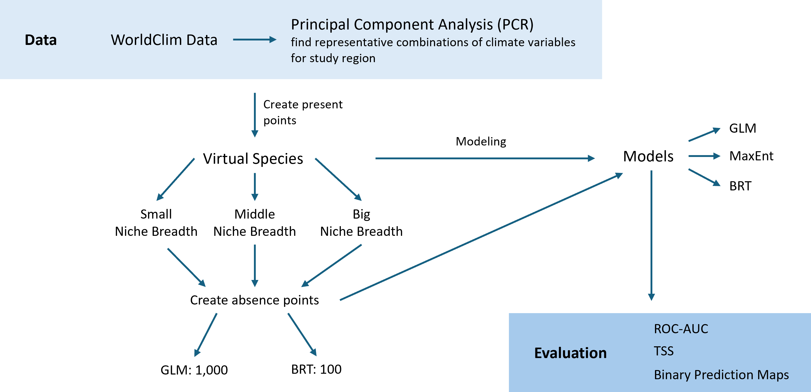

The models will be evaluated using threshold-dependent and threshold-independent metrics, to offer a range of ... TSS is threshold-dependent and measures the model performance. It is based on the sensitivity and specificity, with a great advantage of it not being dependent of prevalence (Allouche et al. 2006, 1224f.; Connor et al. 2018, 1271). The area under the ROC curve (AUC) also measures the performance, but different to TSS is threshold-independent (Allouche et al. 2006, 1224). This metric assesses whether presence locations receive higher predicted probability values than absence locations (McPherson & Jetz 2007, 142).

Discussion
The niche breadth is expected to have a strongly influence on the performance of the different model. Other studies have discovered a correlation between specialized species and a higher accuracy, with descending performances the larger the niche (Connor et al., 2018, p. 1275; Hernandez et al., 2006, p. 774), that we also expect in our analysis. Additionally, we put forward the following hypotheses:
H1: Specialist species with narrow niches are modelled more accurately than generalists across all three algorithms (Connor et al. 2018; Hernandez et al., 2006; Tessarolo et al. 2021).
H2: MaxEnt and BRT outperform GLM across all niche breadths, but may differ from each other in their sensitivity to niche breadth (Elith et al. 2008; Valavi et al. 2022).
One limiting factor is the small number of species and algorithms as well as the few evaluation metrics used, leading to restricted results with limited informative value. Another factor that could be implemented in future research is the number of sample sizes of the different species. As Hernandez et al. (2006) have discussed, this also has an important influence on the performance of the models and should therefore be considered. Furthermore, the virtual species were simulated based on a static climatic time stamp, including seasonality variables (BIO4, BIO15) that describe spatial climatic patterns rather than temporal dynamics in this case. Because of that, the transferability of results to real species responding to actual seasonal variation may be limited.

Timetable
17.06.2026 | Project outline
30.06.2026 | Write code
12.07.2026 | Data analysis + Discussion
31.07.2026 | Final writing —> finished report
20.08.2026 | Buffer time

References
Ainsworth, A. & Drake, D. R. (2020). Classifying Hawaiian plant species along a habitat generalist-specialist continuum: Implications for species conservation under climate change. PLoS ONE, 15(2), e0228573. 10.1371/journal.pone.0228573
Barbet-Massin, M., Jiguet, F., Albert, C. & Thuiller, W. (2012). Selecting Pseudo-Absences for Species Distribution Models: How, Where and How Many?. Methods in Ecology and Evolution. 3. 327–338. 10.1111/j.2041-210X.2011.00172.x.
Connor, T., Hull, V., Vina, A., Shortridge, A., Tang, Y., Zhang, J., Wang, F. & Liu, J. (2017). Effects of grain size and niche breadth on species distribution modeling. Ecography, 41(8), 1270-1282. 10.1111/ecog.03416
Elith, J. & Leathwick, J. R. (2009). Species Distribution Models: Ecological Explanation and Prediction Across Space and Time. Annual Review Ecology, Evolution, and Systematics, 40, 677-697. 10.1146/annurev.ecolsys.110308.120159
Fick, S.E. & R.J. Hijmans (2017). WorldClim 2: new 1km spatial resolution climate surfaces for global land areas. Version 2.1 2020. International Journal of Climatology, 37(12), 4302-4315. 10.1002/joc.5086

Hernandez, P.A., Graham, C.H., Master, L.L. & Albert, D.L. (2006). The effect of sample size and species characteristics on performance of different species distribution modeling methods. Ecography, 29(5), 773-785. 10.1111/j.0906-7590.2006.04700.x
Leroy, B., Meynard, C.N., Bellard, C. & Courchamp, F. (2016). virtualspecies, an R package to generate virtual species distributions. Ecography, 39(6), 599-607. 10.1111/ecog.01388
McPherson, J. M. & Jetz, W. (2007). Effects of species’ ecology on the accuracy of distribution models. – Ecography, 30(1), 135–151. 10.1111/j.0906-7590.2007.04823.x
Phillips, S. J., Anderson, R. P. & Schapire, R. E. (2006). Maximum entropy modeling of species geographic distributions. Ecological Modelling, 190(3–4), 231-259. 10.1016/j.ecolmodel.2005.03.026
Saupe, E., Barve, V., Myers, C., Soberón, J., Barve, N. & Hensz, C., Peterson, A., Owens, H. & Lira-Noriega, A. (2012). Variation in niche and distribution model performance: The need for a priori assessment of key causal factors. Ecological Modelling. 237–238. 11-22. 10.1016/j.ecolmodel.2012.04.001
Soultan, A. & Safi, K. (2017). The interplay of various sources of noise on reliability of species distribution models hinges on ecological specialisation. PLoS ONE, 12(11), e0187906. 10.1371/journal.pone.0187906
Tessarolo, G., Lobo, J., Rangel, T. & Hortal, J. (2021). High uncertainty in the effects of data characteristics on the performance of species distribution models. Ecological Indicators. 121. 107147. 10.1016/j.ecolind.2020.107147
Valavi, R., Guillera-Arroita, G., Lahoz-Monfort, J. J. & Elith, J. (2022). Predictive performance of presence-only species distribution models: a benchmark study with reproducible code. Ecological Monographs, 92(1), e01486. 10.1002/ecm.1486

