

King Abdul-Aziz University

Faculty of Engineering

Industrial Engineering Department

IE-351

Fall (2018/2019)

Final Report

Souq.com

**CA**

**TEAM 1**

|  |  |
| --- | --- |
| Student Name | Student ID |
| Abdullah Waleed Hawarnah | 1635455 |
| Abdullah Ali Alothman | 1635304 |
| Bader Omar Balamash | 1635669 |
| Mohammed Salem Mahfooz | 1636565 |
| Mautaz Ali Aljayzani | 1640593 |
| Mohammed Thamer Alganawi | 1642658 |

Instructor: Dr. Basil Al-Sasi

**Table of Content**

* Introduction …………………………………………..….………………….3
* Methodology…………………………………….…………………………..3
* Background information ……………………………..…………………….4
* Company strategy……………….……………………..…...……………….6
* Competitive advantage ………………….………………….………….7
* The challenges …………………………………………..…........……..7
* Industry-Level strategy ………………………………...……………....8
* Managing operation ……………………………...……………………..….11
* Shopping & Ordering ………………….………..………….………....11
* Online Payments ………………………………………...….....…..….12
* Delivery ………………………………………………...………….....13
* After Sale Services………………………………………...….....…....14
* Creating & Managing Traffic ….…………………...…………..….....15
* Inventory……………………………………………………………...……16
* Amazon acquisition ……………………………...………………….…….16
* Why souq? ………………….……………..……..………….…….….16
* Market share……………………………………………….……....…17
* Amazon strategy ……………………………………………………...18
* What has changed………………………………………...….....…….18
* Future plans and position………………………………………………….19
* Conclusion ……………………………………………………………...…21
* References ………………………………………………………………...22

**Table of Figures**

1. MENA Online Shopping Statistic …………………...….…………...…….4
2. One of Souq Approaches ………………...…………….….……………….5
3. The locations of Souq Fulfillment Centers ………..…........………...…….7
4. Delivery Car …………………………………...……….……………..……8
5. PayFort logo …………………………………………….…..…….…..……8
6. Wing logo ………………………………………….…...…..……...……….8
7. Porter's Five Forces Model …...………………………….….…...………....8
8. The logo of Affiliates.Souq ……………………………….….…...…….….9
9. Souq Coupon ………………………………………….…...………...….…10
10. RadioShack store ……………………………………….….…….…..….....10
11. Jarir bookstore logo ………………………………………...……....……...11
12. Noon logo ……………………………………………………………....….11
13. extra stores logo ………………………………………….…..….….……...11
14. Souq Home Page …………………………………….….………..………...12
15. Sadad Logo ………………………………………….….….……….....…...13
16. PayFort Logo ……………………………………….….……………….….13
17. Qitaf Logo ………………………………………….….………….….....….13
18. Fulfilled by Souq label ………………………………….….…………...….14
19. Same Day Delivery label ……………………………….….………..….….14
20. Helpbit Logo ………………………………………….….…………..…….14
21. Example of tracking shipment service ………………….….……..………..14
22. Whit Friday Sale Logo ………………………………….….………..……..15
23. Deal of The Day Logo ………………………………….….……..………..15
24. Every Thing For You Sale Logo ………………………….….…..………..15
25. Market share of different companies in Egypt, UAE and KSA ………..….18

**Introduction**

Nowadays, electronic commerce is a highly demanded property that most people prefer to use when it comes to shopping and buying their needs, especially with the revolutionary development of smart phones technologies and applications.

Souq.com is a well-known, Arabic-English language, and huge electronic commerce platform that sells a variety of products through the World Wide Web. It is considered the largest electronic commerce platform in the Middle East and all Arab regions! On March-2017, Amazon, Incorporation has decided and confirmed that it will be acquiring and buying Souq.com with around $580 million.

This huge, Dubai-based company was founded by Ronaldo [Mouchawar](https://en.wikipedia.org/wiki/Ronaldo_Mouchawar), and Samih Toukan in 2005. Souq.com has passed through several stages before Amazon, Inc. acquisition. First, Souq.com starts as an auction site which was-at that time- linked to and internet portal “Maktoob” (an online services company founded in Amman, Jordan). After that “Maktoob” was acquired by “Yahoo”, then Souq.com at that time was acquired by “Jabbar Company”. Souq.com then changed its layout from an auction site linked to an e-commerce company to an online shopping website very similar to Amazon but in the Middle East.

**Methodology**

In this report, a full scale analysis was conducted on souq.com which includes: background information, company strategy on the multinational level, operation managing which includes: starting from the order of the customer to the delivery of goods, online payments, after sale services, and creating & managing traffic. Amazon acquisition also will be discussed in detail in this report such as, why souq.com, what strategy has Amazon followed in this acquisition? What has changed? Last but not least, souq.com position, future plans, quality, productivity, and inventory will be discussed in this report.

**Background Information**

Souq.com has been founded in 2005. At that time, the middle region was an ambiguous place for e-commerce start-up. Taking the decision to be an e-commerce start-up company at that time absolutely was not an easy decision to make. In the other hand, the middle east region had tremendous potential that cannot be ignored in any case, such as a total population of nearly more than 350 million people especially if we know that half of them were younger than 25 years old, high purchasing power especially in Arab Gulf region. (Mouchawar, 2018).  Picture 1 shows a statistic for the middle east and north Africa online shopping among 18-24 year-olds. We can see that percentages of both "shops online monthly" and "shops less frequently" is high compared to those who "have never shopped online" especially in Arab Gulf countries. We can realize that the market share of online shopping (included Souq) will be growing in a tremendous way next few years. On the opposite side, the middle east region was a highly fragmented area that consists of twenty-two countries (many of them with relatively small populations), each country has its own laws and regulations, logistics systems, and payment infrastructure. Personal computer and broadband penetration rates were low. (Mouchawar, 2018). According to Souq.com Traffic Statistics made by Alexa, Souq is the 7th website of most websites have been searched for in Saudi Arabia by a percent of visitors 35.2% in that area and it has near ranks to Saudi Arabia ranks in other Arab Countries, like 5th place at United Emirates. (Alexa, 2018)

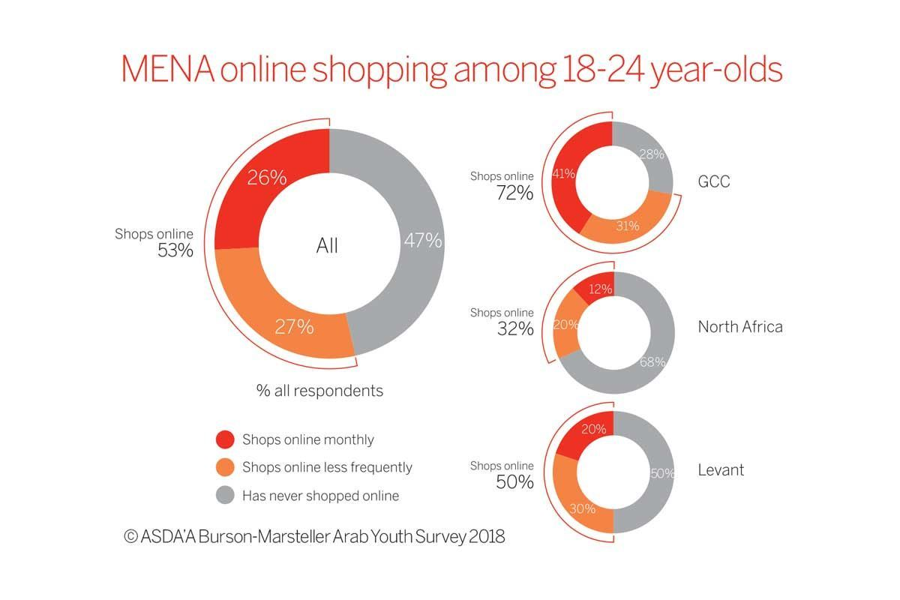

*Figure (1):shows MENA Online Shopping Statistic*

Source: Hamdan, L. (2018). MENA Online Shopping Statistic. [image] Available at: https://www.arabianbusiness.com/retail/396973-platform-for-success-souqcoms-ronaldo-mouchawar-on-his-winning-formula [Accessed 4 Dec. 2018].

After Souq has been launched, it has become the largest e-commerce provider in the middle east region and one of the fastest growing companies in the middle east. On average, Souq monthly 35 million visitors browse its catalog that has 500,000 unique products categorized into 20 different categories. The goals of Souq is first to encourage awareness and increase consideration of campaign and offers.

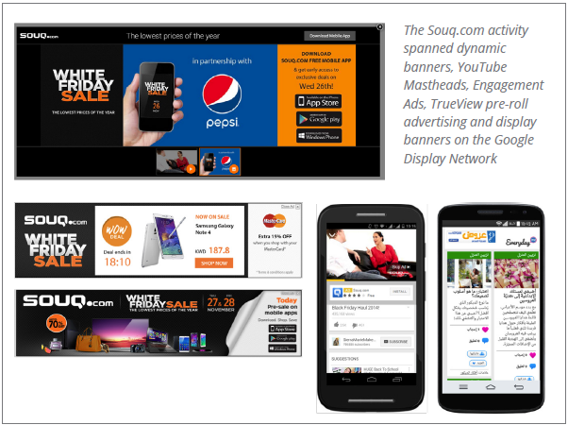

*Figure (2):Shows One of Souq Approaches*

**Source:** Google (2018). *One of Souq Approaches*. [image] Available at: https://hbr.org/2017/09/souq-coms-ceo-on-building-an-e-commerce-powerhouse-in-the-middle-east [Accessed 5 Dec. 2018].

Second, is to the be the cost leaders of product sales. To apply these goals, Souq has used multiple approaches. First, making a long-week campaign, so each new week they had a new campaign in order to combine branding with performance. As shown in figure 2, using the dynamic banner to make friendly and fast so the customer can be satisfied. Fourth, using incorporated YouTube mastheads, engagement ads on the Google Display Network. As result, the number of banner designs required has decreased by 898% this could be as a saving in many aspects like services has to be done, a number of IT employees required and decrease the waiting cost which considered as a cost. Also, by using these approaches the online purchases in Souq increased by 190%. (Think with Google, 2018).

While the ecosystem improves nowadays, the work is no easier than before. As a result, the market is getting more competitive as new companies join the market. In Souq case, many companies join the e-commerce and become competitors for Souq, such as Noon, otlobmall, etc. so the intensity of rivalry has been tremendously increased by new entrants especially noon and namshi. [4] Souq sees Namshi as not a threat to Souq, as Ayman Haddad who is Souq's product manager says "I think there is a lot of room for many players. I don't think they are obsessed about competitors at this point and I don't think they should be" then he added and said, " they need to be obsessed about the customer". (Montini, 2018).

The value proposition of Souq is based on four key offerings. Firstly, it offers an easy and accessible for thousands of SME (small and medium enterprises) to sell their issues online using Souq platform easily with no website developing cost for them as SME. As a result, SME does not have to build technical issues or even marketing skills. Merchants find it simple and easy to list their products in Souq 's offerings of 500,000 SKUs (store Keeping unit which is a unique number assigned to a product by the retailer through it the price, the product options and manufacturer can be known so we can track inventory where is it) (HUDSON, 2018).  consequently, the customer will the biggest winner by having a huge variety of choice. Differentiation point from other e-commerce sites is three things: payment options, risk management, and brand status. (Oakley, 2018).

Souq makes revenues using four ways. the direct buying where costumers buy items on the platform pay nothing directly. Where merchants who used the platform pay fees that support the marketplace for consumers. Souq charges merchants a commission on their sales and fees for the transaction of each sale. This represents the biggest part of Souq revenues. In addition, the merchants can make advertising for their products on the site. Finally, the prepaid cards such as visa, master card, and PayPal charge a small commission that is not announced by Souq. (Oakley, 2018).

**Company strategy**

A company strategy means a set of decisions a company take to achieve long-term goals. We are going to analysis Competitive Advantages for Souq and the challenges they faced and how they overcame them, and finally e-commerce market analysis in the region by using Porter's Five Forces Model.

**Competitive advantage**

Competitive advantage gives a company an advantage over its competitors by offering customers greater value. One of the competitive advantages is that Souq has fulfillment centers in Saudi Arabia, UAE, and Egypt to serve customers which helps to reduce any delivery delays and this lead to Customer satisfaction. And finally, technology is a critical strength and competitive advantage in e-commerce that has helped Souq manages customer convenience. Souq has companies in technology in order to improve customer experience. For example, PayFort, owned by Amazon through Amazon’s acquisition of the Souq, is the payment gateway for large e-Commerce websites such as BEIN SPORTS and Talabat. (Payfort, 2018)

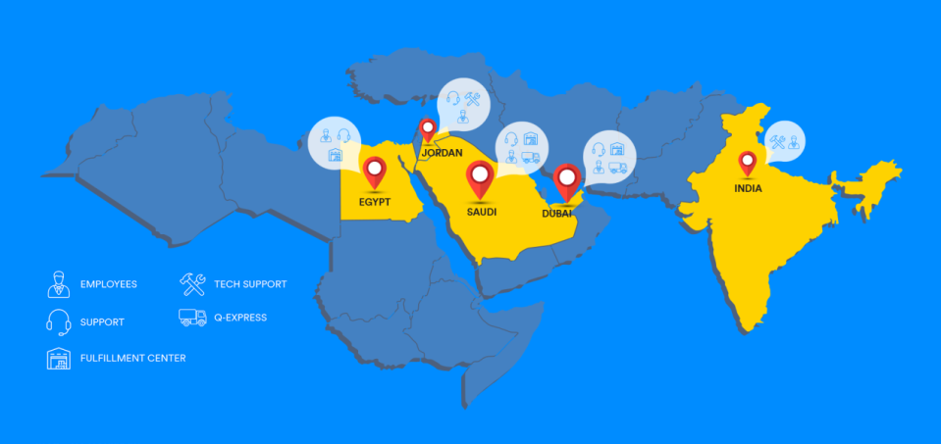

*Figure (3): shows the locations of Souq Fulfillment Centers*

**The challenges**

Nowadays, companies always face a range of challenges that influence the company's performance and customer satisfaction. There are many problems in technology, logistics, finance and laws. In technology, **t**he customer always prefers secure and convenient payment options and the challenge is customer protection from cybercrimes in order to keep their trust in the company and ensuring their return. Souq tried to solve this problem, wherefore it established PayFort to solve the payment problem in the region. PayFort is the payment gateway which helps to simplify payments for the customers and protect them from **cybercrimes. (**Payforted, 2018) In logistics, companies often face challenges in delivering productsto their customers. Souq faces problems in delivering products on time, wherefore it established its own fleet to solve the problem, and also it purchased Wing.ae company which helps to delivery products in the same or next day and this will lead to Customer satisfaction. (Forbes, 2018)

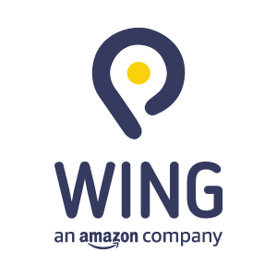

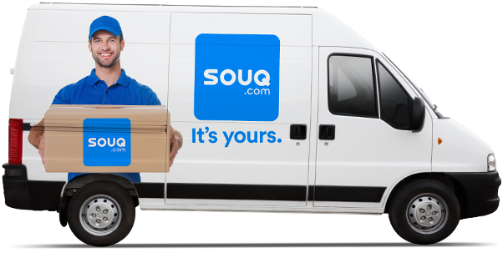

*Figure (5): shows Wing logo*

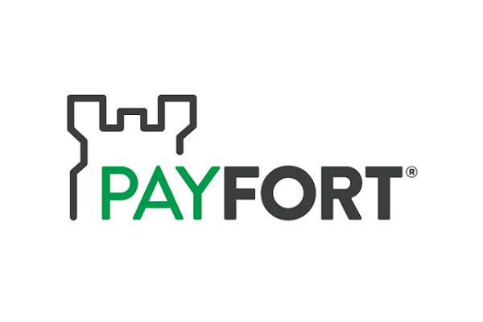

*Figure (4): shows Delivery Car*

*Figure (6): shows PayFort logo*

**Industry-level strategy**

Industry-level strategy helps in knowing how a company will compete in this industry.We are going to analysisthe e-commerce market in the region by using Porter's Five Forces Model

**Porter's Five Forces Model**

The five forces model helps companies assess the factors that effect on competitiveness in the market. (Porter, 2008) The five forces are:

1. Threat of new entry.
2. Power of Buyers.
3. Power of suppliers.
4. Threat of substitution.
5. Rivalry in the industry.

These forces are a part of any market and, this analysis helps Souq develop their competitive strengths and reduce weaknesses.

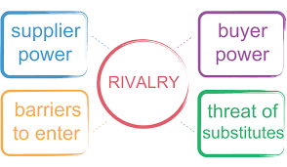

*Figure (7): shows Porter's Five Forces Model*

**Threat of new entrants** measures how easy it is for any company to enter the industry. The barriers are low to entry any competitor in the same industries in which Souq competes. Now it is easier for any company to build a business model with the available resources, resulting in the appearance of brands that are competing with Souq. From Noon to Jollychic. There are several reasons for the ease of entry into these industries such as the relatively low capital investment costs and the switching costs are very low and it is easy for any company can partner with courier services such as FedEx, Aramex, DHL in delivery services, and also new entrants may depend on innovation and creativity to give them a competitive advantage that would help them to win customers and grow the business. Nevertheless, it is difficult for any company to be like Souq or any large company because of the power of branding and economies of scale (Economies of scale occur when a company’s long-run average cost per unit decreases as its production increases) (Dictionary, 2018) which are some of Souq´s main differentials and weakens the influence of new companies. For example, in the United States, Amazon spent $10.06 billion on marketing in 2017 up from $7.2 billion in the previous year so that driving customers to its websites, (Statista, 2018) and Amazon spent more on marketing in 2016 than Wal-Mart, Target and Best Buy combined. (Neiger,2017) There are many methods are used in E-Marketing, and one of them is called affiliate marketing which helps anyone earn money by creating the link and referring users to the site. Souq gives 10% for every time a user clicks on the link and buys any product on the site (Affiliates.souq.com, 2018)

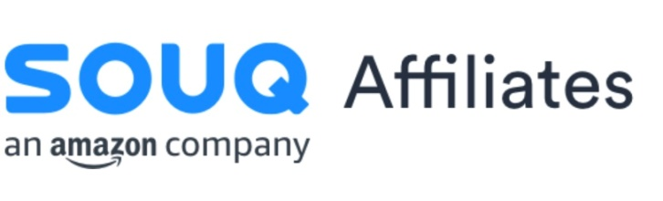

*Figure (8): shows The logo of Affiliates.Souq*

**Power of Buyers** at the e-commerce market is high. Customers want to purchase the best offerings with the minimum price as possible, and the internet has allowed customers to find alternatives to Suoq because there are several small and big brands, and instead of purchasing on Souq website, a customer can go to Noon. Moreover, When the power of buyers is high, the companies can give big discounts to buyers in order to attract them. For example, Coupon Code, the customers can get up to 10% Discount On their Shopping by Souq Coupon. (Saudi.souq.com, 2018)

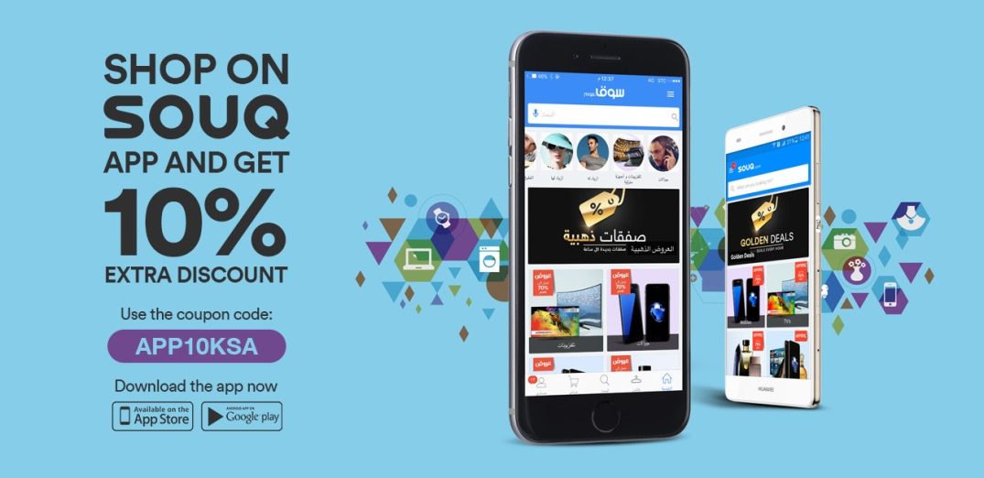

*Figure (9): shows Souq Coupon*

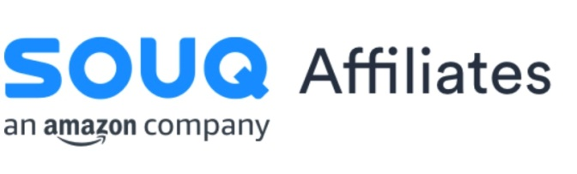

**Power of suppliers**, measures how much control a company’s supplier has over raised the prices. In e-commerce market, the power of the suppliers can vary with the size of the suppliers and the company. Souq has more than 45 million visits per month (ArabianBusiness.com, 2018) and serves more than 75,000 sellers in the region, (Chauhan, 2018) and the suppliers are bound by the rules that the company have set because of its size, and there are a few large companies in the e-commerce market, wherefore the suppliers do not have too many options and therefore, in e-commerce market, the power of the suppliers is low to moderate.

**Threat of substitution** measures the availability of other products that a customer can buy from outside, and companies try to earn a competitive advantage through low prices and quality of products in order to maintain customer loyalty. There two main threats for any company in the e-commerce market. The first is from direct competitors with the company and the second is the physical retailers. One of the reasons that make many companies go out of business in the United States is online stores affect. Physical retailers closed more than 8,000 stores in the United States in 2017. (Business Insider, 2018) the growth of e-commerce in the region could lead to the closure of many physical retailers. UAE and Saudi Arabia e-commerce market will be worth $49 billion by 2020. (ArabianBusiness, 2018)

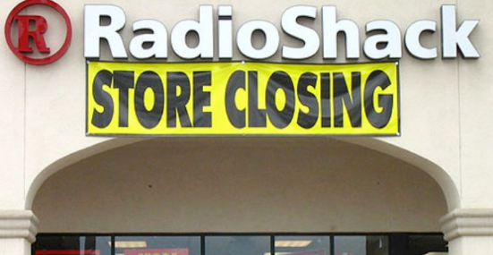

*Figure (10): shows RadioShack store*

**Rivalry in the industry** measures of the extent of competition between existing companies. The number of e-Commerce stores and Physical Retailers who changed their strategy by adding e-Commerce into their business model such as (Jarir bookstore and extra stores) has grown and this has led to higher competition. The competitive in the region is expected to increase with the arrival of Amazon (Souq) and Noon. In general, the competition in the e-commerce market is high. There needs to be a focus on the environment and competitive moves as well as product development and innovation.



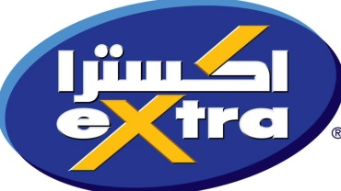

*Figure (13): shows extra stores logo*

*Figure (12): shows Noon logo*

*Figure (11): shows Jarir bookstore logo*

**Managing Operation**

Souq.com is the biggest E-market in the Arabian world, with over 400000 products from different categories which include electronics, fashion, home product, watches, scents, and others. Souq.com operate in Egypt, Saudi Arabia, Emirates, and Kuwait. It has over that 45 million visitors every month (Souq.com,2018), you can imagine the numbers of orders per day that Souq has to process every day from customers entering the website to order creating traffic, choosing their items then putting them on a packet to complete the purchase, setting the location, choosing the payment method than buying, finally tracking their orders until they receive it. Souq.com is a service company and we are going to address the process of daily operations from Shopping & Ordering, Online Payments, Delivery (Logistics), After Sale Services

**Shopping & Ordering:** The first thing that a customer will see when he enters Souq.com [1] is the home page from there he can start browsing through hundreds and hundreds of thousands of products that are displayed for sale from Souq authorized sellers. There is an option for search if he is looking for something specific, or he can browse a specific category, for example, sports gear or headphones and many other categories. Now all of that is made possible because of Souq operation management they manage all of this service from the website server and database that store all of these items and transactions. Also, the operation team have developed the interface to show you the popular items that most people buy or come looking for it, not only that but they have special algorithms that are programmed to study your behavior by seeing things like your browser history, entering from a desktop or by your phone, your purchase history and more. To show you things that you like and have a bigger probability that you will buy. This will make customers have to spend less time searching for their needs and increase sales for Souq. This will result in a satisfied customer and more profit.

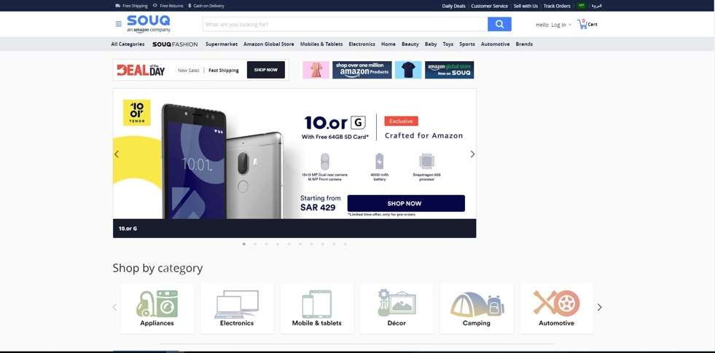

*Figure (14): shows Souq Home Page*

**Online Payments:**

After a customer chooses his items and adds them to his shopping cart it is time to check out. When he presses on payment method it will give him for ways to conduct the payment there are

* Credit Card or Mada Debit Card
* Cash on Delivery
* Sadad
* Qitaf

Let's break it down the first one Credit Card or Mada Debit Card, in the Arabian Gulf the payments providers are poor, there are limited options and to a recent time, there are no FinTech companies to provide payments methods, even Mada did not start their project to make customers able to shop online and buy there gate. For that Souq has started their own company called PayFort [2] wish is an online payment gate provider and the most trusted in the middle east (PayFort,2018). Now Souq can process credit cards throw PayFort. Second is Cash on Delivery, according to the E-COMMERCE KSA is the most popular payment method is Saudi Arabia for many reasons like the level of trust in the E-market and easier (Ecomsociety,2018). Third, is Sadad [3] wish is a Payment System first served as the national Electronic Bill Presentment and Payment (EBPP) service provider for the Kingdom of Saudi Arabia (Sadad,2018). Last is Qitaf [4] wish is a royalty system that belongs to STC that enable STC users to cash in their point in Souq.com (Qitaf,2018). All of these services that Souq operation team provide and operate is to give customers a lot of options to choose which platform they are more comfortable with to achieve a higher customer satisfaction.

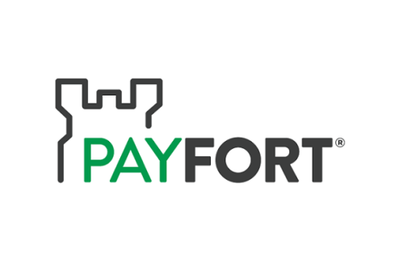

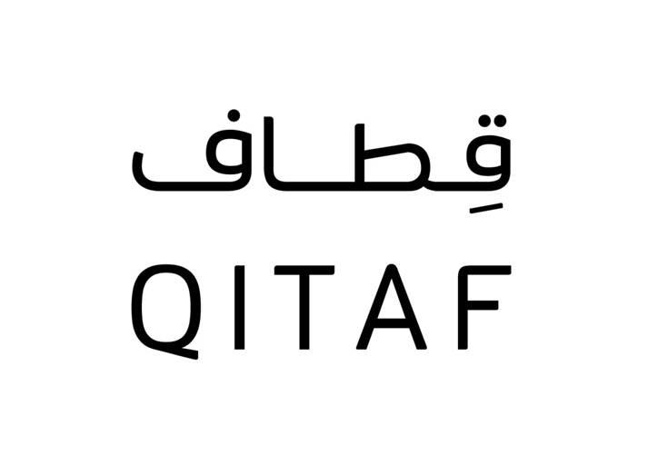

*Figure (16): shows PayFort Logo*

*Figure (17): shows* Qitaf Logo

*Figure (15): shows Sadad Logo*

**Delivery (Logistics)**

One major part of the operations in Souq is delivery of goods to customers on time. At the begging Souq has tried to outsource logistics companies to help with delivery of goods but in The Arabian, Golf the market was poor when it came for professional E-market logistic companies (Ecomsociety,2017), most companies were not even familiar with the term E-commerce even Post Offices often avoided doing business deals with them. Because of that Souq has started his delivery fleet to deliver goods for customers and build fulfillment center and warehouses in Riyadh, Dubai and many other cities. After a while, the business started to get bigger, so they needed a professional logistic handling for product delivery, so they started the *Fulfilled by Souq* project. This project basically is instead of you doing the bagging and delivery of goods you hand it to the professionals at Souq fulfillment centers in exchange for commissions. This is perfect for beginners they do not need to worry about bagging and delivery on time, not only that but having your items and product labeled as *Fulfilled by Souq* [5]customers tend to trust in your product, Souq will handle returns plus customer service for your items, your products get promoted higher in search plus have special filter and sellers get to participate at Souq promotions like White Friday (Souq.com,2018). Logistics and delivery of goods are a big deal of any e-commerce and it is the responsibility for the operation team to manage and develop their logistics services. For example, Souq recently has introduced a new future which is you can track your shipments from Souq website or by using Souq app on your smartphone to find out exactly where your shipment is and how many days is left for your shipment to an arrive. Another service that has been introduced lately is *Same Day Delivery* [6] service wish is a big leap forward for Souq that indicates the level of confidence that Souq operation team have in their logistic abilities. Right now, it only available in Dubai but there are planning to expand it for other cities in the region of MENA(Pr.Souq.com,2016).

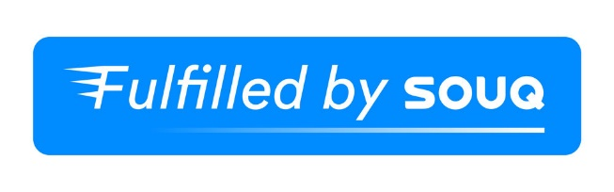

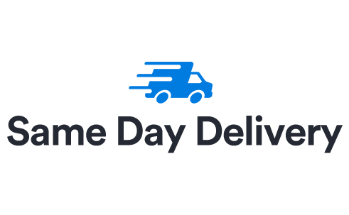

*Figure (18): shows Fulfilled by Souq label*

*Figure (19): shows Same Day Delivery label*

**After Sale Services**

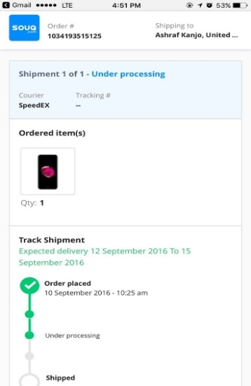Souq.com take a lot of pride in their after-sale services and according to their CEO it what make Souq.com special (almentor.net,2018). They have the typical after sale services like customer call center, support emails and frequently asked questions, but Souq went a little further with their tracking shipment services [8] where you can know where your shipment is and how long has it been traveling or setting in one location. Another service is Helpbit [7] which is a service provider that Souq.com contracted with to provide services to Souq customer. They preform services in a lot of areas like electronics, home, laundry, satellite, car, and hourly cleaning services. For example, the services they provide in the area of electronics are laptop repair, mobile repair, CCTV installation, game console repair, windows and mac support, and others. They also have an app that enables you to order their services and see their offers (Pr.Souq.com,2016). As you know the after-sale services are one of the duties of operations team in their responsibility to follow up on customer compliance and feedback. In a case where a customer is dissatisfied with the services that were delivered to him, it is a responsibility on the customer service team to perform *service recovery* to try restoring trust and comfort to the customer, as a result, we may win the customer back as a more loyal and loving customer than before to Souq.com.

*Figure (21): shows Example of tracking shipment service*

*Figure (20): Helpbit Logo*

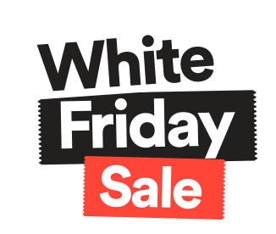**Creating & Managing Traffic**

An important factor in the success of any E-commerce is to create and manage traffic. Souq.com has his own ways of creating traffic, there are especially good at promotion campaigns and sales events, like White Friday [9], Deal of The Day [10], Everything That You Wish For [11] and other campaigns. Some of the thesis campaigns had such a big success like White Friday, in 2015 whit Friday Souq had 13 million visitors and 600,000 items sold during November 25-28 across the UAE, Saudi Arabia, Kuwait and Egypt (ArabianBusiness,2015). Now Souq arranges his campaigns by time, for example, White Friday is a yearly event, and Deal of The Day is a daily sale event. By mixing his sale events and campaigns every time in the year there is something happing inside this giant e-market this will make customers always coming back and checking if there anything happing. Of course, this is a big task to manage and handle this enormous number of visitors and orders, it will take a will organize team and a calculated system to make sure everything is running smoothly.

*Figure (22): shows Whit Friday Sale Logo Every Year Sale Event*

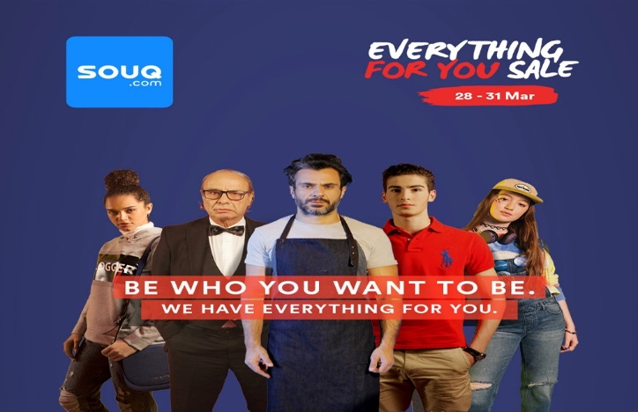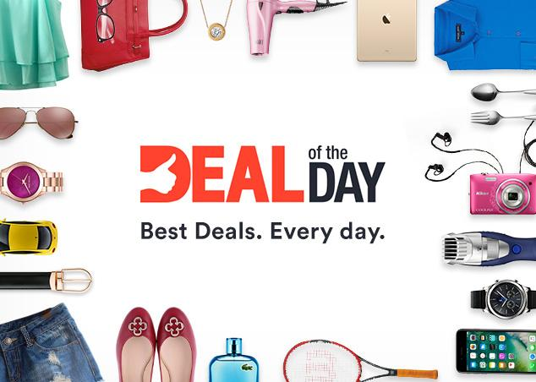

*Figure (24):Every Thing For You Sale Logo*

*Figure (23*): Deal of The Day Logo Every Day Sale Event

As you saw those were the main tasks that the operation team of Souq is responsible for the operations cycle from Ordering & Shopping to Creating & Managing traffic. As thing stand out Souq has been going to will and their strategies and decisions have

fruited. For instance, Souq now is considered as a Unicorn (the company is valid over 1 billion dollars) according to Forbes (Forbes,2016), not only that but according to CEO and Co-Founder of Souq.com Ronaldo Mouchawar in an interview with Arabian Business “We witnessed six times more, new buyers, every day, clearly indicating that Souq.com is building awareness of online shopping and leading the e-commerce growth in the region.” (Arabian Business,2015). More on the subject Souq.com features over 400,000 products and attracts 23 million visits per month that have made the biggest e-commerce in the world attention Amazon. Right now, Amazon owns Souq.com seeing it as their opportunity to make a move to the middle east market. All of these information and evidence prove that Souq.com knows their way around the business and they understand the importance of operations management especially for a service company like Souq.

**Inventory**

Souq.com also uses the inventory system, most of the electronic commerce platforms depend mainly on their inventory systems. In souq.com they always try to maximize storage capacity by storing different types of product in the same place, such as tooth brush, a book, and a phone in the same place. Doing so, will increase and allows full utilization of the storage space. This will also decrease the operational cost while maximizing speed. This will also allow the management to have larger control on their inventory and storage and logically will increase the speed of delivering the products to customers. (Logistics Middle East, 2018)

**Amazon acquisition**

**Why Souq**

We must look from different perspectives to see why Amazon choose Souq and take a risky move which is unexpected from Amazon. To understand that we will first take a market share for the companies in the region. Then we will talk about why Amazon didn’t build its own infrastructure.

**Market share**

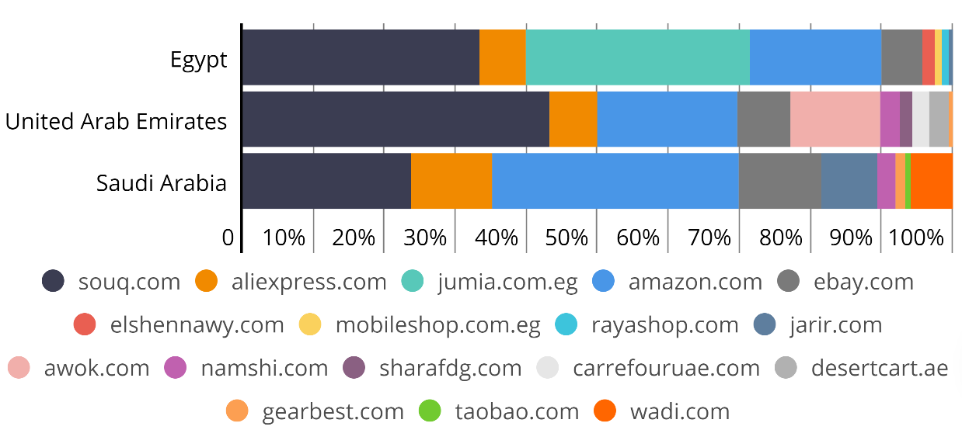

*Figure (25): shows market share of different companies in Egypt, UAE and KSA*

The above figure showed the market share of e-commerce companies in medal east and South Africa. It shows how much Souq.com holds market share and the percent increase from year to year. Also, the percent of Amazon also increased that give us an overall thought that Amazon wants to increase its market share in this region. (Bobrov and Perspective, 2018)

Amazon wants to be on the ground of this region so acquiring customers takes time, effort, risk, and incremental mindset to adapt strategies. Considering these problems Amazon want to avoid the risk and take an easy secure way. Like the acquisition of LinkedIn by Microsoft it takes the costumes, good minds in the company and full infrastructure that needed if you want to build up a similar project. Souq realizes the market share is moving to Amazon slowly in Saudi Arabia and to Jumia.com in Egypt. know that this is one of the reasons Souq accept the offer of Amazon.

With the acquisition, Amazon earns the logistics and the operation without falling in error by starting a new one. full infrastructure will increase the market share and let Amazon give its product faster. Also, it will access the information that Souq had about the customers in this region to help them in acting with people with different culture and lifestyle. Through the acquisition, Amazon enters and extend in the Gulf and North Africa.

**Amazon strategy**

All companies want to increase their market share, and this led to increases in profit most of the time. In this case, Amazon is looking to buy its way in a new region rather than expanding in the same region. Amazon acquires company shares the same type of e-commerce that’s named Related diversification under the Portfolio strategy which minimizes risk by diversifying investments. (Carla Sertin, 2018)

After Souq acquired by Amazon the company will stay with the same staff and techniques that used by Souq until they predict what competitor in the region will do. after that, they will stay with the same type of operation or they change it to another type. Doing this and compare it with the Reference Point to see whether the company stay at the same level or they should change the way of acting.

Amazon wants to use the new portal to sell its product not by using the same distributor but with the information that comes from Souq. Take a picture of how people think in this new area will be valuable to the company. (Khalid, 2018)

**What has to change**

For Souq, the change can be positive and can be negative to the decision making, operation and investing in new methods. we will take these perspectives to make an image of what will Souq do after the acquisition and how the company will act to the changes. While Souq growth is decreasing put the market share is the same it becomes a Cash Cow to Amazon after it was a star.

First in the decision making it seems that the Souq will have the same authority and it will take the decisions fast. But this will not happen and if it happens it will not continue. Acquisition with hostile or with an over it means that the charge with the other company. So Souq now needs the approval from Amazon to make the big decisions pass. This step will take a long time and reduce the speed of taking decisions and may lose a good opportunity in the market. We can consider it a negative change from this side.

Second, the operation infrastructure will improve by adding the knowledge and the experience of a worldwide company. A small step can make a huge improve the company now start putting a new product and features to the platform. Souq has the ads more than the direct impact opposite is for Amazon.

The last thing is the investment to improve the company’s work by adding or improving the current equipment or system. Investment come with risk and a profit in long term. Amazon with 580 Million acquisitions will continue to improve the company by investing in its current infrastructure. Now Amazon will use the will improve the delivery time of its own product by investing in Souq delivery system. This will improve the service of providing the products in a short time. Also, Amazon will use the 45 million visits to Souq site to see what customers want and try to invest in change the way of presenting the products to a more preferred to the customers. (keyes, 2018) (Arab News, 2018)

**Position and Future plans**

As mentioned previously in this report, souq.com is considered the largest electronic commerce platform in the Middle East and all Arab regions. In 2006, since the beginning of the company, souq.com had a belief that they can build a giant electronic commerce platform that can help producers (sellers) benefit from the advantages and the power internet in our world today, and how people can make great organizations with high potential! It is basically a connection point between producers and their customers regardless the long distances between them. since the Arab regions’ population is over 350 million, with same traditions and culture, and communicating with the same language, it was very challenging for Ronaldo (the founder and CEO of Souq.com) and his team to overcome this obstacle, it creates a lot of difficulties and hardships. Souq.com planned to cover, at that time, around 22 countries, souq.com faced a lot of difficulties regarding logistics and technology. The main objective and goal of souq.com at that time was trying to reach to this huge number of customers and producers. One of the biggest problem that souq.com faced in 2006 was the number of customers who use the internet were very low, so it was also very challenging for souq.com team on how to convince the producers to believe in the power of internet and how it can turn their small businesses into huge organizations. At that time, the payment methods for electronic shopping was not safe from the customer’s point of view so the purchasing power was low. How to convince customers about the electronic shopping and the safety behind payment methods was one the biggest challenges. The revolutionary development of smart phones helped souq.com to reach to maximum number of customers in the Arab region especially in the Gulf countries. (Gulf Business, 2018)

The future plans at that time for souq.com was trying to establish new small companies that can solve the company’s problems and difficulties. One example of these companies was “Payfor”. The aim and goal of establishing this company was to increase the customer’s confidence regarding the payment method via internet, the main problem that souq.com established this company for was trying to solve the payment and logistics problems. Another problem souq.com faced at that time was the weak transportation, and “pay at delivery” methods, so they also established a company to solve this issue in minimizing the time to deliver the product to the customer and also customer experience when buying from the internet, and also the operational cost at its lowest rate. (ArabianBusiness.com, 2018)

Souq.com was trying to minimize the time to deliver the product to the customer. To do so, they improved the company’s logistics and transportation methods; as a result, if you are living in the United Arab Emirates, then you can order from souq.com and get your product at the same day in a new service from souq.com called “same day delivery” this service was established in 2016. Souq.com also used operation management in order to increase the efficiency of product delivery, which means they purchased devices built in china to optimize the order procedure, in other words, if customer “X” ordered from souq.com and he wants the delivery to be after two days for example, and customer “Y” ordered the same product, but he wants the delivery to be at the same day of ordering, the new system of souq.com will optimize the delivery procedure which means they will deliver the product to customer “Y” first!. (ArabianBusiness.com, 2018)

Another goal for souq.com as future plans is the acquisition of small and moderate companies which can in a way help souq.com increase their efficiency, product quality, and most importantly, customer satisfaction. One example of the companies that souq.com acquiesced was “wing.ae”, they also invested in “InstaShop” and “helpbit.com”. also as a future plan souq.com definitely envision a future where they will have drones delivering orders to houses, but from the practical point of view, it is not in the near-term future plan. (Gulf Business, 2018) (Souq.com newsroom, 2018)

**Conclusion**

As a conclusion, the electronic commerce market in the Arab region is rapidly developing. Souq.com faced a lot of difficulties and hardships and they as a team tried successfully to overcome these difficulties by either acquiring or establishing new companies that help them to develop their services. On the other hand, souq.com also tried to improve their inventory system because they believe that in order to be successful in this particular market, they should develop and optimize their inventory system. Souq.com should be aware of their competitors (new entrants to the marker) such as “Noon”, “JollyChick”, “Wadi”, etc…

**Reference**

Affiliates.souq.com. (2018). Souq.com | Affiliates Hub. [online] Available at: https://affiliates.souq.com/home [Accessed 4 Dec. 2018].

Alexa.com. (2018). Souq.com Traffic, Demographics and Competitors - Alexa. [online] Available at: https://www.alexa.com/siteinfo/souq.com [Accessed 1 Dec. 2018].

ArabianBusiness.com. (2018). Platform for success: Souq.com's Ronaldo Mouchawar on his winning formula. [online] Available at: https://www.arabianbusiness.com/retail/396973-platform-for-success-souqcoms-ronaldo-mouchawar-on-his-winning-formula [Accessed 4 Dec. 2018].

ArabianBusiness.com. (2018). Revealed: how much you spent in Souq.com's White Friday sale. [online] Available at: https://www.arabianbusiness.com/industries/retail/384633-revealed-how-much-you-spent-in-souqcoms-white-friday-sale?utm_source=Jarvis&utm_medium=arabianbusiness.com&utm_campaign=recommended [Accessed 5 Dec. 2018].

ArabianBusiness.com. (2018). It's back: Souq.com reveals plan for White Friday sale. [online] Available at: https://www.arabianbusiness.com/industries/retail/383494-its-back-souqcom-reveals-plan-for-white-friday-sale [Accessed 5 Dec. 2018].

ArabianBusiness.com. (2018). Middle East e-commerce market to double to $69bn by 2020. [online] Available at: https://www.arabianbusiness.com/industries/retail/379450-middle-east-e-commerce-market-to-double-to-69bn-by-2020 [Accessed 4 Dec. 2018].

ArabianBusiness.com. (2018). Souq.com sales ‘double during White Friday’. [online] Available at: https://www.arabianbusiness.com/souq-com-sales-double-during-white-friday--614475.html?utm_source=Jarvis&utm_medium=arabianbusiness.com&utm_campaign=you-may-also-like [Accessed 5 Dec. 2018].

Arab News, 2017. Souq.com and Amazon complete $650m acquisition deal. Arab News. Available at: http://www.arabnews.com/node/1123616/business-economy [Accessed December 5, 2018].

Bobrov, L. and Perspective, A. (2018). Amazon's Acquisition of Souq.com: a Digital Marketing Perspective. [online] Similarweb Blog. Available at: https://www.similarweb.com/blog/amazon-acquisition-of-souq-com-digital-strategy [Accessed 3 Dec. 2018].

Business Insider. (2018). More than 8,000 store closures were announced in 2017 — here's the full list. [online] Available at: https://www.businessinsider.com/stores-closures-announced-in-2017-2017-12 [Accessed 4 Dec. 2018].

Chauhan, H. (2018). Amazon Makes a Big Bet on This $20 Billion Opportunity -- The Motley Fool. [online] The Motley Fool. Available at: https://www.fool.com/investing/2017/04/11/amazon-makes-a-big-bet-on-this-20-billion-opportun.aspx [Accessed 4 Dec. 2018].

Dictionary, E. (2018). ECONOMIES OF SCALE | meaning in the Cambridge English Dictionary. [online] Dictionary.cambridge.org. Available at: https://dictionary.cambridge.org/dictionary/english/economies-of-scale [Accessed 4 Dec. 2018].

Ecomsociety.org. (2018). *مجتمع التجارة الإلكترونية في السعودية*. [online] Available at: http://www.ecomsociety.org/ [Accessed 5 Dec. 2018].

Forbes.com. (2018). *The Middle East's First Unicorn: Souq.com's CEO On Leadership, Timing And Coping With Rejection*. [online] Available at: https://www.forbes.com/sites/elizabethmacbride/2016/03/25/e-commerce-gold-in-the-middle-east-behind-souqs-success-story/#5b97fb131ee0 [Accessed 5 Dec. 2018].

Forbes (2017). Souq.com Reaches Agreement To Acquire Wing.ae. Forbes Middle East. Available at: https://archives.forbesmiddleeast.com/en/souq-com-reaches-agreement-to-acquire-wing-ae/ [Accessed December 5, 2018]

Harvard Business Review. (2018). *How Souq.com’s CEO Built an E-Commerce Powerhouse in a Region Where Cash Still Rules*. [online] Available at: https://hbr.org/2017/09/souq-coms-ceo-on-building-an-e-commerce-powerhouse-in-the-middle-east [Accessed 5 Dec. 2018].

HUDSON, M. (2018). What is an SKU in Retail?. [online] The Balance Small Business. Available at: https://www.thebalancesmb.com/what-is-a-sku-in-retail-terms-2890158 [Accessed 3 Dec. 2018].

Keyes, D., 2017. Amazon's Souq acquires delivery startup. Business Insider. Available at: https://www.businessinsider.com/amazons-souq-acquires-delivery-startup-2017-9 [Accessed December 5, 2018].

Khalid, U., 2017. Why Amazon Acquired Souq.com. CMSWire.com. Available at: https://www.cmswire.com/digital-experience/why-amazon-acquired-souqcom/ [Accessed December 5, 2018].

Montini, L. (2018). Meet Souq, the Amazon of the Middle East. [online] Inc.com. Available at: https://www.inc.com/laura-montini/meet-souq-the-e-commerce-giant-of-the-middle-east.html [Accessed 2 Dec. 2018].

Mouchawar, R. (2018). How Souq.com’s CEO Built an E-Commerce Powerhouse in a Region Where Cash Still Rules. [online] Harvard Business Review. Available at: https://hbr.org/2017/09/souq-coms-ceo-on-building-an-e-commerce-powerhouse-in-the-middle-east [Accessed 3 Dec. 2018].

Neiger, C. (2017). 5 Things Investors Need to Know About Amazon's Advertising Business -- The Motley Fool. [online] The Motley Fool. Available at: https://www.fool.com/investing/2018/12/03/5-things-investors-need-to-know-about-amazons-adve.aspx [Accessed 4 Dec. 2018].

Oakley, D. (2018). Souq Business Model Canvas | Denis Oakley. [online] Denis Oakley. Available at: https://www.denis-oakley.com/souq-business-model-canvas/ [Accessed 5 Dec. 2018].

Payfort.com. (2018). PAYFORT introduces card-on-delivery service in the region. [online] Available at: https://www.payfort.com/press/payfort-introduces-card-on-delivery-service-in-the-region/ [Accessed 4 Dec. 2018].

PAYFORT. (2018). PAYFORT. [online] Available at: https://www.payfort.com/ar/ [Accessed 5 Dec. 2018].

Porter (2008). The Five Competitive Forces That Shape Strategy. [online] Cemi.com.au. Available at: https://cemi.com.au/sites/all/publications/Porter%202008.pdf [Accessed 4 Dec. 2018].

Sadad.com. (2018). Overview. [online] Available at: https://www.sadad.com/en/Pages/Overview.aspx [Accessed 5 Dec. 2018].

Saudi.souq.com. (2018). Shop on SOUQ apps and get extra discounts. [online] Available at: https://saudi.souq.com/sa-en/sa-apps-coupon/c/ [Accessed 4 Dec. 2018].

Saudi.souq.com. (2018). عن موقع سوق.كوم. [online] Available at: https://saudi.souq.com/sa-ar/about-us/c/ [Accessed 5 Dec. 2018].

Saudi.souq.com. (2018). Fulfilled by Souq. [online] Available at: https://saudi.souq.com/sa-en/fulfilled-by-souq/c/ [Accessed 5 Dec. 2018].

Sertin, C. & Forbes, 2017. Amazon Completes Acquisition Of Souq.com. Forbes Middle East. Available at: https://archives.forbesmiddleeast.com/en/amazon-completes-acquisition-of-souq-com/ [Accessed December 5, 2018].

Statista (2018). Amazon marketing spending worldwide 2017 | Statistic. [online] Statista. Available at: https://www.statista.com/statistics/506535/amazon-marketing-spending/ [Accessed 4 Dec. 2018].

SME Advisor. (2018). Souq.com – The story that teaches you to dream big. [online] Available at: https://smeadvisor.com/industry-watch/souq-com-story-teaches-dream-big/ [Accessed 5 Dec. 2018].

Souq.com newsroom. (2018). SOUQ.com introduces Same Day Delivery Service. [online] Available at: http://pr.souq.com/139204-souq-com-introduces-same-day-delivery-service [Accessed 5 Dec. 2018].

Souq.com newsroom. (2018). SOUQ.com launches E-commerce Fulfilment Services for Local and International Sellers via “Fulfilled by SOUQ”. [online] Available at: http://pr.souq.com/138026-souq-com-launches-e-commerce-fulfilment-services-for-local-and-international-sellers-via-fulfilled-by-souq [Accessed 5 Dec. 2018].

Souq.com newsroom. (2018). SOUQ.com Launches Helpbit.com to Boost After-Sales Services at Consumers’ Doorstep. [online] Available at: http://pr.souq.com/137995-souq-com-launches-helpbit-com-to-boost-after-sales-services-at-consumers-doorstep [Accessed 5 Dec. 2018].

Souq.com غرفة الأخبار. (2018). سوق.كوم يعيد فعالية أكبر تخفيضات الموسم مع "تخفيضات كل ما تتمناه". [online] Available at: http://pr.souq.com/147418- [Accessed 5 Dec. 2018].

Stc.com.sa. (2018). STC - Qitaf-Tamayouz Loyalty Program. [online] Available at: https://www.stc.com.sa/wps/wcm/connect/english/loyaltyPrograms/qitaf-programs [Accessed 5 Dec. 2018].

Think with Google. (2018). Souq.com records a 190% increase in online purchases and a 10-to-1 ROI. [online] Available at: https://www.thinkwithgoogle.com/intl/en-145/success-stories/global-case-studies/souqcom-records-190-increase-online-purchases-and-10-1-roi/ [Accessed 5 Dec. 2018].