**Task 5.II:**

* North Lanes KDE:

Figure : detailed profile for north lanes

* NB_MID KDE: A graph of a distribution of gap

  Description automatically generated

Figure : KDE For NB_MID (ALL THE TIMELINE)

Figure : detailed profile for NB_MID

* NB_MID 7AM-19PM KDE Parts:

Figure : detailed profile for 7AM-10AM

Figure : detailed profile for 16PM-19PM

Figure : detailed profile for 10AM-13PM

Figure : detailed profile for 13PM-16PM

Figure : 4 Parts of hours for NB_MID

Comparison between Mean and Median to prove Median is a better suitable candidate:

Figure : Before inserting Mean in missing Values

Figure : After inserting Mean in missing values

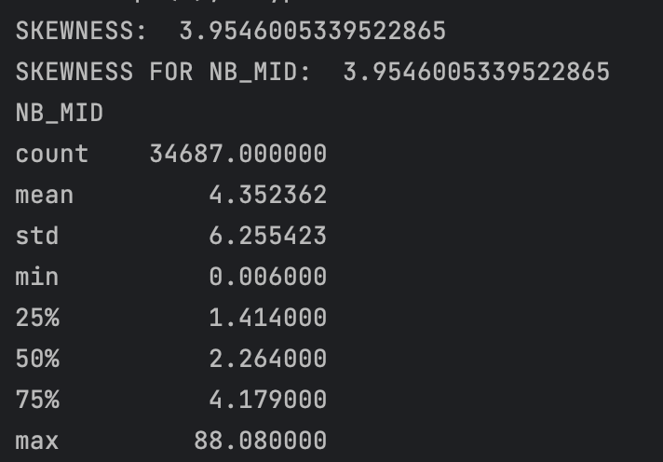

Figure : Before inserting Median in missing values

Figure : After inserting Median in missing values

Figure : Comparison between Median and Mean graphs

Figure 16: After inserting Mode in missing values

Figure 15: Before inserting Mode in missing Values

Figure 17: Journey Time in MinutesA screen shot of a computer

Description automatically generated

Figure 18: Column Completeness