Camunda 8.9 SaaS
Advanced Process Orchestration — Implementation Assessment
Five enterprise use cases on the base microservice framework
Target audience | Camunda developers / solution engineers on the team
Platform | Camunda 8.9 SaaS (Web Modeler, Zeebe, Tasklist, Operate, Connectors)
Backend | Spring Boot 4.x job workers built on the provided base microservice framework
Human tasks | Completed exclusively through Camunda Tasklist
Assessment mode | One use case per participant (assigned); timeboxed implementation + walkthrough

1. About This Assessment
Purpose
This assessment verifies that each team member can independently design and deliver a production-grade process orchestration solution on Camunda 8.9 SaaS using our base microservice framework. Each use case is deliberately constructed so it cannot be completed without exercising the full Camunda 8.9 toolset: BPMN processes and sub-processes, DMN decision tables, AI connectors, ad-hoc sub-processes, Tasklist human tasks, and Spring Boot 4.x job workers.
Ground Rules
- Use the provided base framework for all backend services — do not scaffold a new project from scratch. Follow its hexagonal layering, error-handling and observability conventions.
- All human tasks must be performed through Camunda Tasklist with proper forms and candidate groups; do not simulate task completion through the API in your demo.
- All service tasks must be implemented as Spring Boot 4.x job workers; connectors may be used only where the use case explicitly calls for them (AI steps, notifications).
- DMN tables must be deployed and invoked from the process — hardcoded rule logic in workers will be marked down.
- The conceptual diagrams in this document are intentionally not BPMN. Translating them into a correct, well-structured BPMN design is part of what is being assessed.
- Where a flow says “selects only the tasks needed”, an ad-hoc sub-process is expected — not a chain of exclusive gateways.
What You Will Be Assessed On
Modeling quality, decision design, AI integration, worker engineering on the framework, resilience, and your ability to explain trade-offs. The full rubric is in Section 9.

2. How to Read the Conceptual Diagrams
Every use case includes a conceptual flow diagram. It shows what happens, in what order, and who acts — it deliberately avoids BPMN notation so that the BPMN design remains your work. Interpret the shapes as follows:
- Rounded blue boxes are automated steps you will implement as Spring Boot 4.x job workers on the base framework.
- Rounded green boxes are human tasks completed in Camunda Tasklist by the persona named in the personas table.
- Rounded purple boxes are AI steps you will implement with Camunda AI connectors.
- Orange diamonds are business rule decisions you will implement as DMN decision tables (never as code or gateways alone).
- Dashed containers group steps that belong to one sub-process (embedded or call activity — your choice, justify it).
- Dotted pink containers are ad-hoc sub-processes: the named persona activates only the tasks needed at runtime. Dashed arrows leaving them show where control returns.
Camunda 8.9 Capability Coverage by Use Case
Each use case emphasizes a different part of the platform. The assigned use case determines which capabilities you must demonstrate in depth (“core” marks the use case that stresses that capability hardest).
Camunda 8.9 Capability | UC1 Loan | UC2 Health | UC3 Supply | UC4 Cyber | UC5 Claims
DMN decision tables | 2 | 2 | 2 | 2 | 3
Embedded / call-activity sub-processes | ✓ | ✓ | ✓ | ✓ | ✓
Ad-hoc sub-process | ✓ | ✓ | ✓ | ✓ | ✓
AI Connector steps | 1 | 2 | 2 | 2 | 2–3
Parallel execution | ✓ | ✓ (multi-instance) | – | ✓ | ✓
Message / event-driven | – | ✓ (vitals) | ✓ (core) | – | –
Timers & escalation | – | – | – | ✓ (core) | –
Compensation / rollback | ✓ | – | – | – | ✓
Tasklist human tasks | ✓ | ✓ | ✓ | ✓ | ✓
Spring Boot 4.x job workers | ✓ | ✓ | ✓ | ✓ | ✓

4. Use Case 1: Intelligent Commercial Loan Origination
Business Background
A commercial bank receives loan applications from small and medium enterprises for working capital and asset financing. Today the journey is fragmented: documents are reviewed manually, due diligence teams work in silos over email, and the credit committee frequently sends applications back because information is incomplete. Turnaround time averages 18 days and the bank wants it under 5.
The bank wants a single orchestrated journey where document review is AI-assisted, eligibility and risk decisions are externalized as business rules, due diligence runs in parallel across four teams, and the credit committee can dynamically request only the extra checks a specific application needs.
Objective
Design and implement the end-to-end commercial loan origination process on the base microservice framework, demonstrating parallel due diligence, rule-driven eligibility and risk grading, AI-assisted document review, and a dynamic (ad-hoc) information-gathering stage controlled by the credit committee.
Personas
Persona | Role in the Process | Tasklist Involvement
Customer (SME) | Submits the loan application with financial documents; responds to additional information requests. | External start (form / API); responds via requested-document tasks.
Relationship Manager | Owns the customer relationship; validates and enriches the application before due diligence. | Completes data-validation exceptions and customer follow-ups.
Credit Analyst | Performs credit appraisal on bureau data and financials. | Completes the credit appraisal task.
Compliance Officer | Reviews KYC/AML screening hits and clears or escalates them. | Completes the compliance review task.
Field Valuer | Visits the business premises and values the offered collateral. | Completes the collateral valuation task with the field report.
Credit Committee (Manager) | Takes the final approve / reject / needs-more-info decision; selects ad-hoc investigation tasks. | Completes the committee decision task; launches ad-hoc tasks.

Business Flow
- The customer submits a loan application with financial statements, bank statements, and KYC documents.
- The system validates and enriches the application data (registry lookups, deduplication); exceptions route to the Relationship Manager.
- An AI step reviews the uploaded documents: it extracts key figures, checks completeness, and flags inconsistencies.
- A DMN decision table screens eligibility (segment, requested amount, vintage, document completeness). Ineligible applications receive an automated rejection notice and the process ends.
- Eligible applications fan out into four parallel due diligence streams: Credit Appraisal (sub-process: bureau pull, then analyst appraisal), Compliance & KYC (sub-process: automated screening, then officer review), automated financial statement analysis, and field collateral valuation.
- When all streams complete, a DMN decision grades the risk and derives pricing (rate, tenor caps, covenants).
- The Credit Committee reviews the consolidated file in Tasklist and decides: approve, reject, or needs more information.
- If more information is needed, the committee activates an ad-hoc sub-process and selects only the tasks required for this application (request additional documents, business site visit, guarantor interview). On completion, the file returns to the committee.
- On approval, a disbursement sub-process generates the sanction letter and disburses funds; if disbursement fails after the sanction letter is issued, compensation must reverse the sanction.
- On rejection at any point, the customer receives a rejection notice with reasons.
Conceptual Flow Diagram
Read this diagram using the legend in Section 2. It describes what must happen and who acts — the BPMN design that realizes it is part of your assessment.
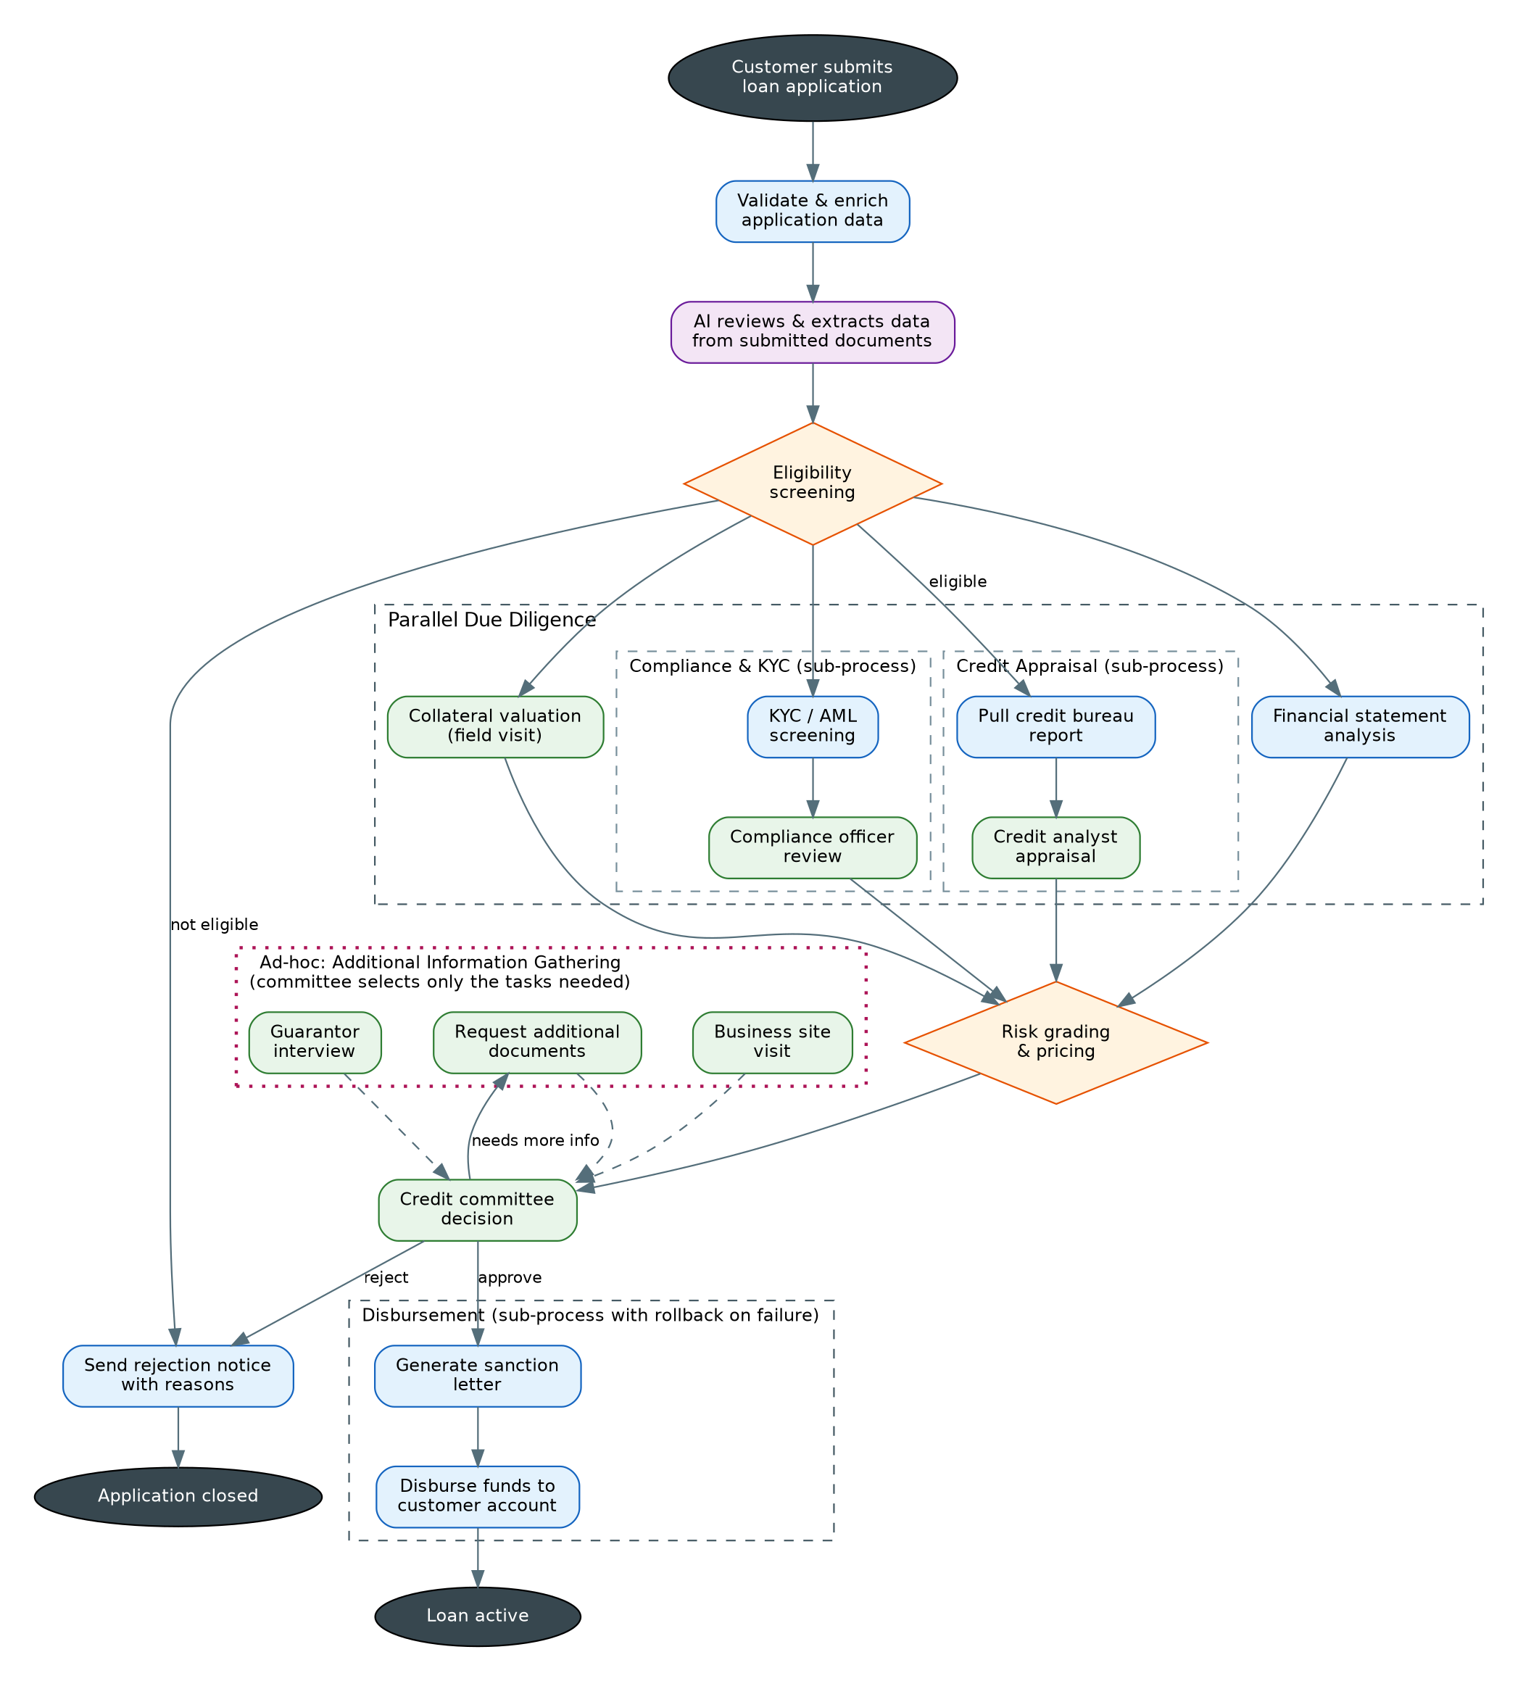
Camunda 8.9 Implementation Expectations
- Processes & sub-processes: one parent process with at least two embedded or call-activity sub-processes (Credit Appraisal, Compliance & KYC) and a Disbursement sub-process with compensation handlers.
- Parallelism: a parallel gateway (or equivalent) fanning out the four due diligence streams and joining before risk grading.
- DMN: two decision tables minimum — Eligibility Screening and Risk Grading & Pricing — with hit policies chosen deliberately and justified.
- AI Connector: document review step using an AI connector; the AI output (extracted figures, completeness flags) must feed the eligibility DMN inputs.
- Ad-hoc sub-process: the additional-information stage must be a true ad-hoc sub-process where the committee activates only the tasks it needs at runtime.
- Tasklist: human tasks for analyst, compliance officer, valuer, and committee, each with a proper form and candidate group.
- Spring Boot 4.x workers: validation/enrichment, bureau pull, KYC screening, financial analysis, sanction letter, and disbursement as job workers on the base framework.
- Error handling: BPMN error for bureau unavailability with retry/backoff on the worker, and compensation on the disbursement sub-process.
Expected Deliverables
- BPMN 2.0 model(s) deployed to Camunda 8.9 SaaS, including all sub-processes and the ad-hoc sub-process.
- DMN 1.3 decision tables (deployed and invoked from the process via business rule tasks).
- AI Connector configuration for every AI step, with prompt design and output variable mapping documented.
- Tasklist forms for every human task, assigned to the correct persona (candidate groups / assignees).
- Spring Boot 4.x job workers built on the base framework for every service task, following the framework's hexagonal layering.
- Error handling: BPMN error events, retry configuration on workers, and compensation/rollback where the flow indicates it.
- Testing evidence: at least one end-to-end happy path execution in Operate, plus one exception path (screenshots or recording).

5. Use Case 2: Healthcare Treatment Journey
Business Background
A multi-specialty hospital wants to orchestrate the inpatient journey from admission to discharge. Clinicians currently reconcile paper history, diagnostic results arrive at different times from different departments, and specialist consultations are coordinated over phone calls — causing missed consults and delayed discharges.
The target journey uses AI to summarize a patient's prior records at admission, runs ordered diagnostics in parallel, lets the attending physician dynamically pull in exactly the specialist consults a patient needs, and gates discharge on an objective readiness decision.
Objective
Design and implement the treatment journey on the base framework, demonstrating a multi-instance parallel diagnostics stage, an ad-hoc specialist consultation stage driven by the physician, DMN-based triage and discharge-readiness decisions, and AI-generated clinical summaries.
Personas
Persona | Role in the Process | Tasklist Involvement
Patient | Admitted through ER or referral; the subject of the journey. | None directly (represented by process data).
Registration Desk Officer | Registers the patient, captures demographics and consent. | Completes the registration & consent task.
Attending Physician | Reviews diagnostics, defines the treatment plan, selects specialist consults, signs off discharge. | Treatment plan, consult selection (ad-hoc), discharge sign-off.
Diagnostics Technician | Performs the cardiology workup and uploads results. | Completes the cardiology workup task.
Specialist (Neuro / Endo / Physio) | Provides consultation notes when the physician requests a consult. | Completes the assigned consult task.
Nurse | Administers treatment per the plan and records observations. | Completes treatment administration tasks.

Business Flow
- A patient is admitted via ER or referral and the process starts with the admission event.
- The registration desk completes registration and consent capture in Tasklist.
- An AI step summarizes the patient's medical history from prior records and attaches the summary to the case.
- A DMN decision performs triage and selects the care pathway, including which diagnostic tests to order.
- The ordered tests execute as a parallel multi-instance sub-process — one instance per test — covering lab tests, imaging, and a cardiology workup (human task).
- The attending physician reviews all results in Tasklist and defines the treatment plan.
- If consults are needed, the physician activates an ad-hoc sub-process and selects only the required consultations (neurology, endocrinology, physiotherapy). Each consult is a human task for that specialist.
- The treatment execution sub-process runs: the nurse administers treatment while automated vitals monitoring raises alerts on threshold breaches.
- A DMN decision evaluates discharge readiness from vitals trends, completed treatment steps, and consult outcomes. If not ready, the flow loops back to the physician to revise the plan.
- When ready, an AI step drafts the discharge summary and home-care instructions; the physician reviews, signs off, and the patient is discharged.
Conceptual Flow Diagram
Read this diagram using the legend in Section 2. It describes what must happen and who acts — the BPMN design that realizes it is part of your assessment.
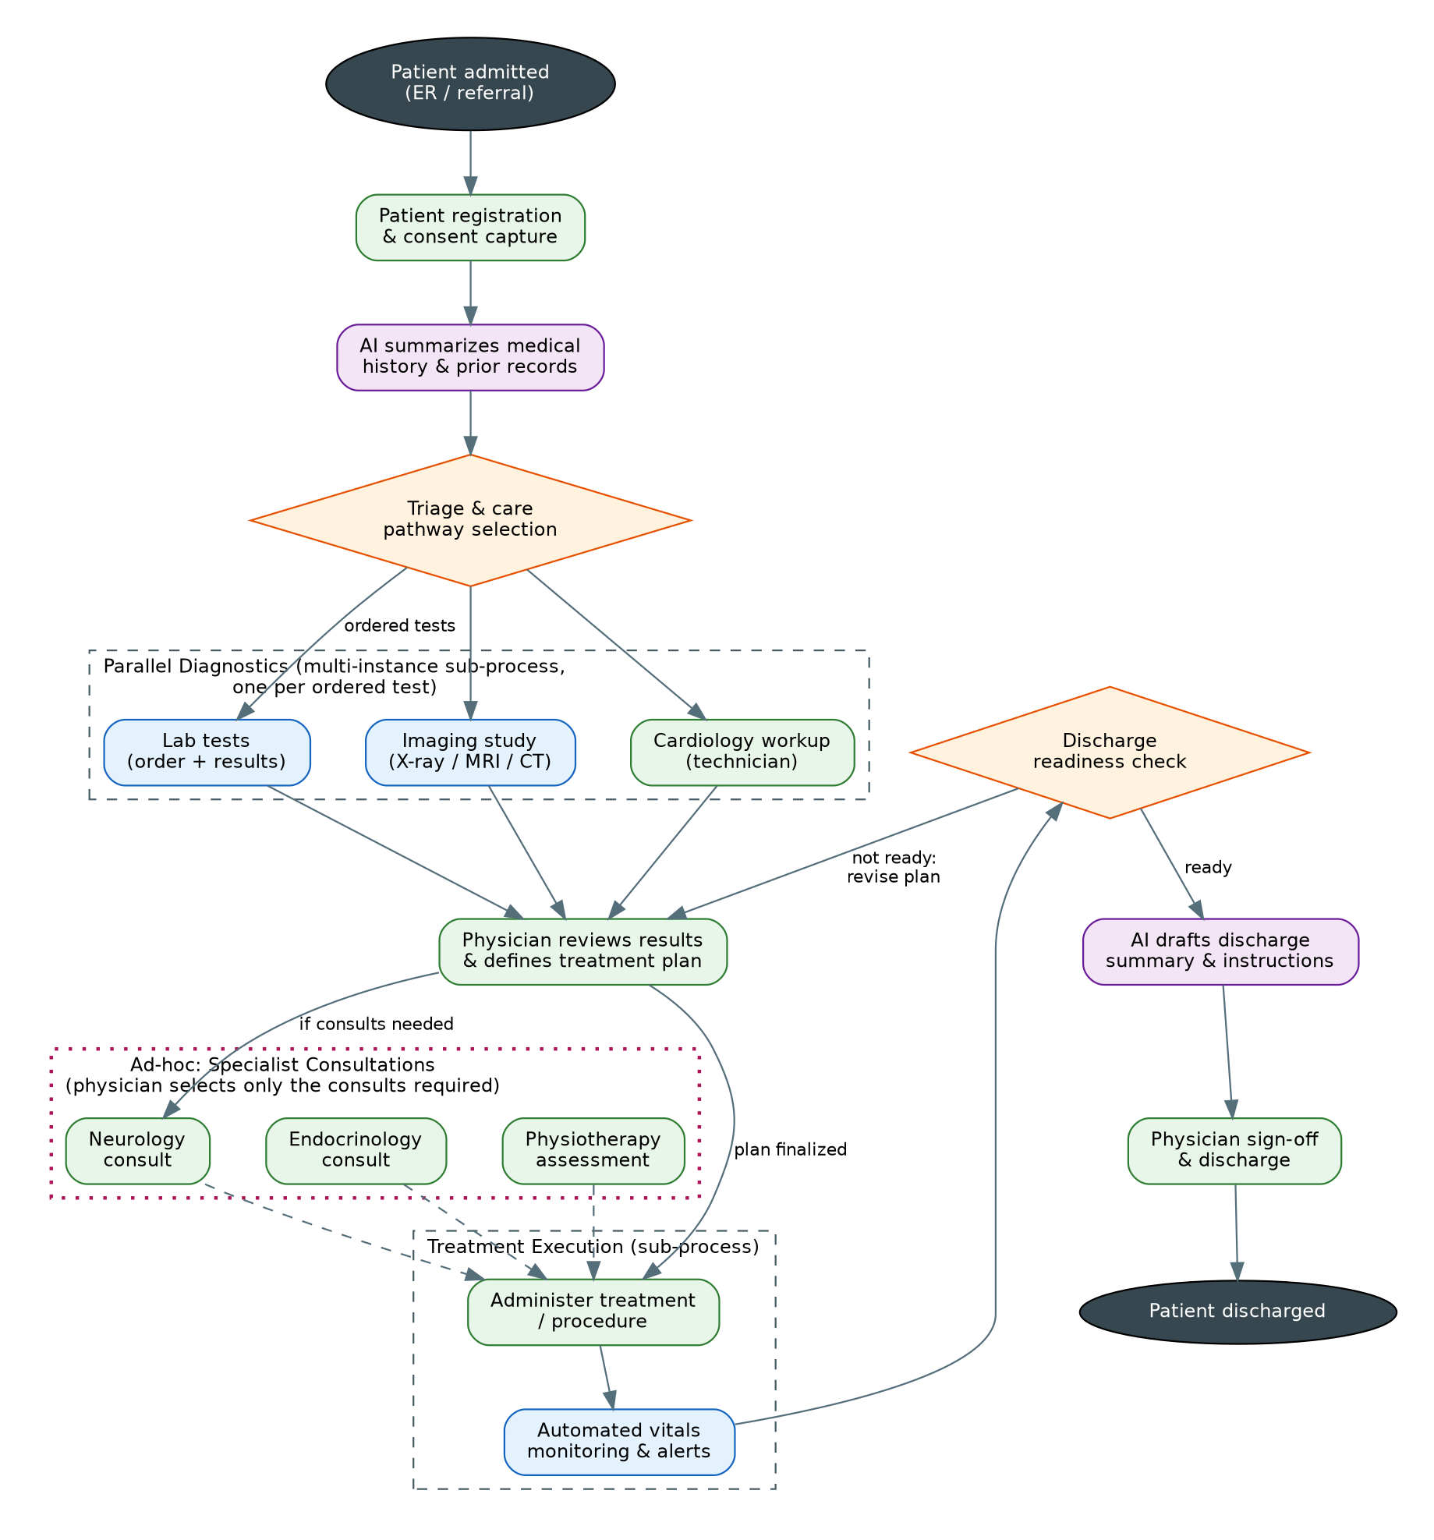
Camunda 8.9 Implementation Expectations
- Processes & sub-processes: parent journey with a multi-instance parallel diagnostics sub-process (dynamic cardinality from the triage DMN output) and a treatment execution sub-process.
- DMN: two decision tables minimum — Triage & Care Pathway (which also outputs the list of tests) and Discharge Readiness.
- AI Connector: two AI steps — history summarization at admission and discharge summary drafting — with prompts that use process variables.
- Ad-hoc sub-process: specialist consultations as an ad-hoc sub-process; the physician activates individual consult tasks at runtime.
- Looping: the not-ready path from discharge readiness back to plan revision must be modeled safely (no infinite-loop risk; consider an attempt counter or escalation).
- Tasklist: registration, cardiology workup, treatment plan, each consult, treatment administration, and discharge sign-off as forms with correct candidate groups.
- Spring Boot 4.x workers: lab/imaging ordering and result ingestion, vitals monitoring/alerting, and record archiving as job workers; the vitals worker should demonstrate message correlation back into the process.
- Error handling: handle a diagnostic system timeout with a BPMN error and an escalation to the physician.
Expected Deliverables
- BPMN 2.0 model(s) deployed to Camunda 8.9 SaaS, including all sub-processes and the ad-hoc sub-process.
- DMN 1.3 decision tables (deployed and invoked from the process via business rule tasks).
- AI Connector configuration for every AI step, with prompt design and output variable mapping documented.
- Tasklist forms for every human task, assigned to the correct persona (candidate groups / assignees).
- Spring Boot 4.x job workers built on the base framework for every service task, following the framework's hexagonal layering.
- Error handling: BPMN error events, retry configuration on workers, and compensation/rollback where the flow indicates it.
- Testing evidence: at least one end-to-end happy path execution in Operate, plus one exception path (screenshots or recording).

6. Use Case 3: Global Supply Chain Disruption Management
Business Background
A manufacturer ships finished goods to distributors across three continents. Disruptions — port closures, carrier delays, customs holds, cargo damage — are detected late and handled in spreadsheets. By the time a recovery plan is agreed, options such as re-routing or expediting production have often expired.
The company wants an event-driven orchestration: shipments are tracked continuously, a detected disruption triggers AI impact analysis, and a supply planner assembles a recovery plan from a menu of options, validated by business rules and approved by the operations head before execution.
Objective
Design and implement disruption management on the base framework, demonstrating event-driven detection (message events), AI impact analysis, severity and feasibility DMN decisions, an ad-hoc recovery-options stage, and orchestrated recovery execution with customer communication.
Personas
Persona | Role in the Process | Tasklist Involvement
Customer (Distributor) | Placed the order; receives delay notifications and revised ETAs. | None directly (notified via system).
Supply Planner | Assembles the recovery plan by selecting recovery options for the specific disruption. | Activates and completes ad-hoc recovery option tasks.
Procurement Manager | Sources and contracts an alternate supplier when that option is selected. | Completes the alternate-supplier task.
Logistics Coordinator | Confirms bookings, re-routes, and execution of the agreed plan. | Completes the execution confirmation task.
Operations Head (Manager) | Approves or rejects the consolidated recovery plan. | Completes the approval task.

Business Flow
- A customer order is created and the shipment is booked with a carrier.
- A tracking worker listens for carrier events; the process waits on shipment milestones (message events).
- A disruption event arrives (port closure, major delay, or cargo damage) and interrupts the normal wait.
- An AI step analyzes impact: affected orders, probable root cause, and estimated delay.
- A DMN decision rates disruption severity. Low severity triggers an automated minor-delay notification and the process resumes normal tracking.
- For medium/high severity, the supply planner opens an ad-hoc recovery-options stage and selects any combination of: re-route via an alternate lane, source from an alternate supplier (procurement task), or expedite production at the plant.
- A DMN decision checks cost and feasibility of the selected combination against thresholds (cost ceiling, SLA impact, capacity). Infeasible combinations send the planner back to rework the options.
- The operations head reviews and approves the recovery plan in Tasklist.
- The execution sub-process updates orders, bookings and inventory allocations, and the logistics coordinator confirms completion.
- An AI step drafts the customer communication; the system sends it and publishes the revised ETA, and the order completes.
Conceptual Flow Diagram
Read this diagram using the legend in Section 2. It describes what must happen and who acts — the BPMN design that realizes it is part of your assessment.
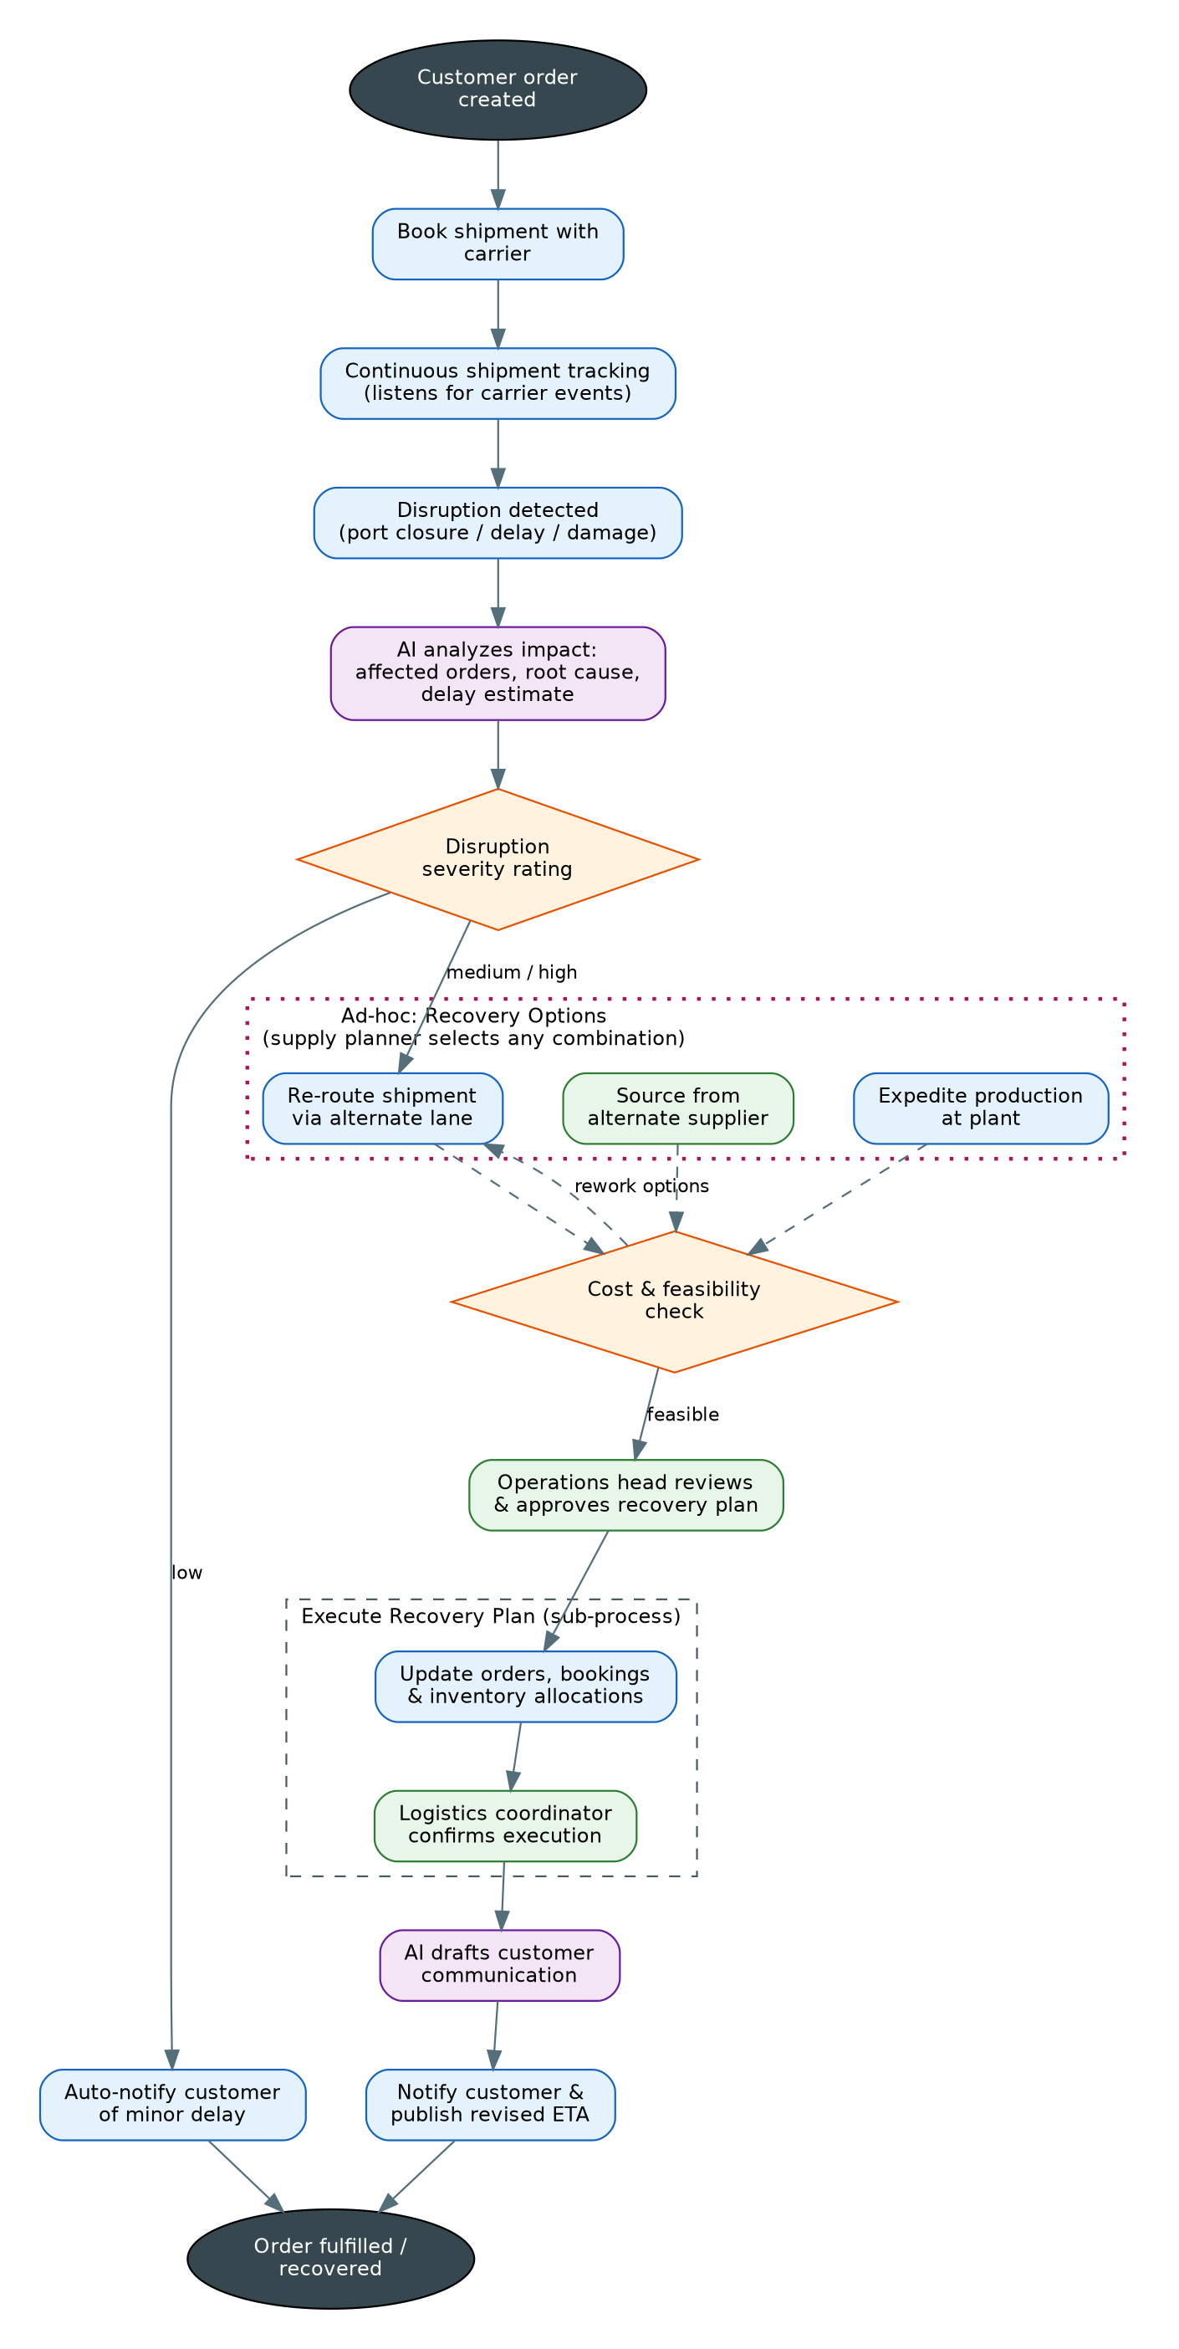
Camunda 8.9 Implementation Expectations
- Event-driven design: shipment milestones and the disruption as message events with correct correlation keys; the disruption should interrupt the tracking wait (event sub-process or boundary event — justify the choice).
- DMN: two decision tables minimum — Disruption Severity and Cost & Feasibility — the second taking the planner's selected option set as input.
- AI Connector: impact analysis after detection and customer-communication drafting before notification.
- Ad-hoc sub-process: recovery options as an ad-hoc sub-process; the planner may activate one, two, or all three options, and completion of the stage is planner-controlled.
- Rework loop: the infeasible path from the cost check back into the ad-hoc stage must preserve already-completed option outputs.
- Tasklist: alternate-supplier sourcing, plan approval, and execution confirmation as forms for the right personas.
- Spring Boot 4.x workers: carrier booking, tracking/event ingestion (publishing messages to Zeebe), order/inventory updates, and notification dispatch on the base framework.
- Error handling: carrier API failure with retries and an escalation path to the logistics coordinator after retry exhaustion.
Expected Deliverables
- BPMN 2.0 model(s) deployed to Camunda 8.9 SaaS, including all sub-processes and the ad-hoc sub-process.
- DMN 1.3 decision tables (deployed and invoked from the process via business rule tasks).
- AI Connector configuration for every AI step, with prompt design and output variable mapping documented.
- Tasklist forms for every human task, assigned to the correct persona (candidate groups / assignees).
- Spring Boot 4.x job workers built on the base framework for every service task, following the framework's hexagonal layering.
- Error handling: BPMN error events, retry configuration on workers, and compensation/rollback where the flow indicates it.
- Testing evidence: at least one end-to-end happy path execution in Operate, plus one exception path (screenshots or recording).

7. Use Case 4: Cyber Security Incident Response
Business Background
An enterprise SOC receives thousands of alerts daily. Genuine incidents demand a coordinated response across containment, forensics and communications, yet today runbooks live in wikis, response actions are executed manually, and regulatory notification deadlines (72 hours in several jurisdictions) are tracked in email.
The target design triages alerts with AI, classifies severity through business rules, runs containment and forensics in parallel, lets the incident commander invoke response actions dynamically as the investigation unfolds, and enforces the regulatory notification decision before closure.
Objective
Design and implement incident response on the base framework, demonstrating AI-assisted triage, DMN-based classification and regulatory decisions, parallel containment/forensics sub-processes, an ad-hoc response-actions stage for the incident commander, and time-bound escalation.
Personas
Persona | Role in the Process | Tasklist Involvement
SOC Analyst | Front-line responder; verifies containment of affected systems. | Completes the containment verification task.
Incident Commander | Owns the incident; selects response actions dynamically and formally closes the incident. | Activates ad-hoc response actions; completes closure.
Forensics Lead | Analyzes collected evidence and establishes scope and root cause. | Completes the forensic analysis task.
CISO (Manager) | Reviews the incident, accepts residual risk, authorizes recovery. | Completes the CISO review task.
Legal / Compliance Officer | Files regulatory and customer notifications when required. | Completes the regulatory notification task.

Business Flow
- A security alert is raised by the SIEM and starts the process.
- An AI step triages the threat: enrichment, IOC lookups, and attack-pattern matching, producing a structured triage report.
- A DMN decision classifies the incident P1–P4 from the triage output. P4/false positives are logged and auto-closed.
- For P1–P3, three streams run in parallel: a Containment sub-process (automated isolation, then SOC analyst verification), a Forensics sub-process (evidence collection, then forensics lead analysis), and automated stakeholder notification.
- Throughout the response, the incident commander uses an ad-hoc sub-process to invoke response actions as findings emerge: block malicious IPs/domains, revoke compromised credentials, deploy an emergency patch.
- The CISO reviews the consolidated incident file, accepts residual risk, and authorizes recovery.
- The Recovery sub-process restores services from a clean state and a human task verifies system integrity.
- A DMN decision determines whether regulatory notification is required (data categories affected, record counts, jurisdictions). If yes, Legal files the notices — this path must respect the 72-hour deadline with a timer-based escalation.
- An AI step generates the post-incident report and lessons learned.
- The incident commander reviews the report and closes the incident.
Conceptual Flow Diagram
Read this diagram using the legend in Section 2. It describes what must happen and who acts — the BPMN design that realizes it is part of your assessment.
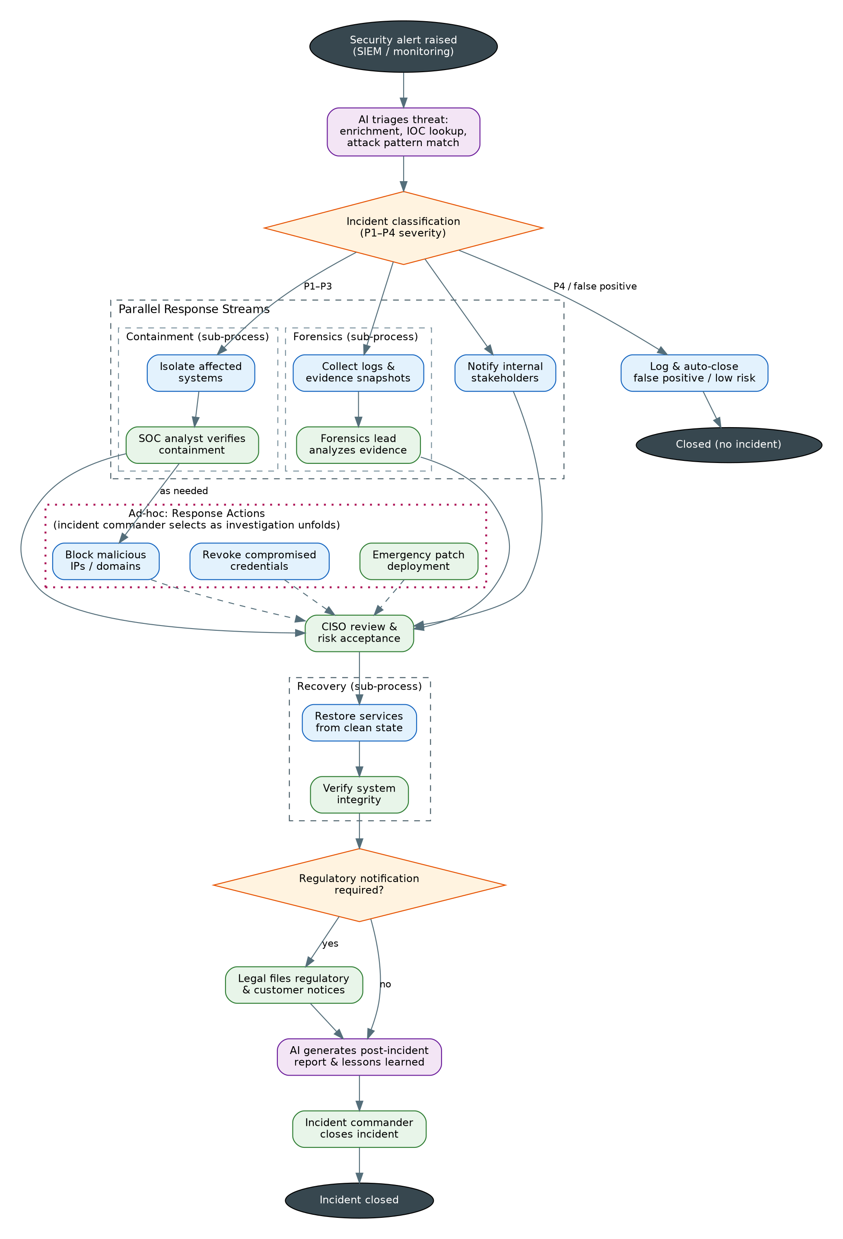
Camunda 8.9 Implementation Expectations
- Processes & sub-processes: Containment, Forensics and Recovery as sub-processes; a parallel split for the P1–P3 response streams.
- DMN: two decision tables minimum — Incident Classification (P1–P4) and Regulatory Notification Required — with the classification driving downstream SLAs.
- AI Connector: threat triage at intake and post-incident report generation at the end.
- Ad-hoc sub-process: response actions as an ad-hoc sub-process available for the duration of the response; actions may be invoked multiple times where meaningful.
- Timers & escalation: a timer enforcing the 72-hour regulatory deadline with escalation to the CISO, and severity-based SLA timers on key human tasks.
- Tasklist: containment verification, forensic analysis, CISO review, regulatory notification, integrity verification, and closure as forms with the right candidate groups.
- Spring Boot 4.x workers: SIEM ingestion, isolation actions, evidence collection, IP blocking, credential revocation, restore automation — idempotent workers on the base framework (re-delivery must be safe).
- Error handling: failed isolation raises a BPMN error that escalates to the incident commander rather than silently retrying forever.
Expected Deliverables
- BPMN 2.0 model(s) deployed to Camunda 8.9 SaaS, including all sub-processes and the ad-hoc sub-process.
- DMN 1.3 decision tables (deployed and invoked from the process via business rule tasks).
- AI Connector configuration for every AI step, with prompt design and output variable mapping documented.
- Tasklist forms for every human task, assigned to the correct persona (candidate groups / assignees).
- Spring Boot 4.x job workers built on the base framework for every service task, following the framework's hexagonal layering.
- Error handling: BPMN error events, retry configuration on workers, and compensation/rollback where the flow indicates it.
- Testing evidence: at least one end-to-end happy path execution in Operate, plus one exception path (screenshots or recording).

8. Use Case 5: Catastrophe Insurance Claims Processing
Business Background
After a major weather event, a general insurer receives a surge of property claims — often 50× normal volume within days. Manual damage assessment and sequential fraud checks create backlogs of weeks, while regulators and customers expect fast, fair settlement.
The insurer wants a surge-ready claims journey: AI assesses damage from submitted photos at intake, policy and coverage checks are rule-driven, field inspection and fraud screening run in parallel, and a fraud investigator can order exactly the extended checks a suspicious claim warrants.
Objective
Design and implement catastrophe claims processing on the base framework, demonstrating AI-based damage assessment and fraud scoring, coverage and settlement DMN decisions, parallel inspection and fraud streams, an ad-hoc extended-investigation stage, and a payment sub-process with compensation.
Personas
Persona | Role in the Process | Tasklist Involvement
Policyholder (Customer) | Submits the claim (FNOL) with photos and documents; receives settlement or denial. | External start; responds to document-request tasks.
Claims Intake Officer | Handles intake exceptions and incomplete submissions. | Completes intake exception tasks.
Field Adjuster | Inspects the property and submits the inspection report. | Completes the field inspection task.
Fraud Investigator | Investigates flagged claims; selects the extended checks required. | Activates and completes ad-hoc investigation tasks.
Claims Manager | Takes the final settle/deny decision within their authority limit. | Completes the final decision task.

Business Flow
- The policyholder submits a first notice of loss (FNOL) with photos and supporting documents.
- An AI step assesses damage from the photos and produces a structured loss estimate with confidence scores.
- The system validates policy status and premium standing.
- A DMN decision determines coverage and deductible. Non-covered claims receive a denial letter with an explanation and the process ends.
- Covered claims fan out in parallel: a Field Inspection sub-process (schedule the adjuster, then on-site inspection and report) and a Fraud Screening sub-process (AI fraud scoring on patterns and anomalies, then a DMN threshold decision).
- A DMN decision computes the settlement amount and the approval authority level, reconciling the AI estimate with the adjuster's report.
- If fraud screening flagged the claim, the fraud investigator opens an ad-hoc extended-investigation stage and selects only the checks needed: second site visit, additional document request, claimant interview.
- The claims manager takes the final decision in Tasklist: approve settlement or deny.
- On approval, the Payment sub-process disburses the settlement and an AI step drafts the settlement letter; a payment failure after partial disbursement must trigger compensation.
- The claim is closed and records are archived; denials at any point produce a reasoned denial letter.
Conceptual Flow Diagram
Read this diagram using the legend in Section 2. It describes what must happen and who acts — the BPMN design that realizes it is part of your assessment.
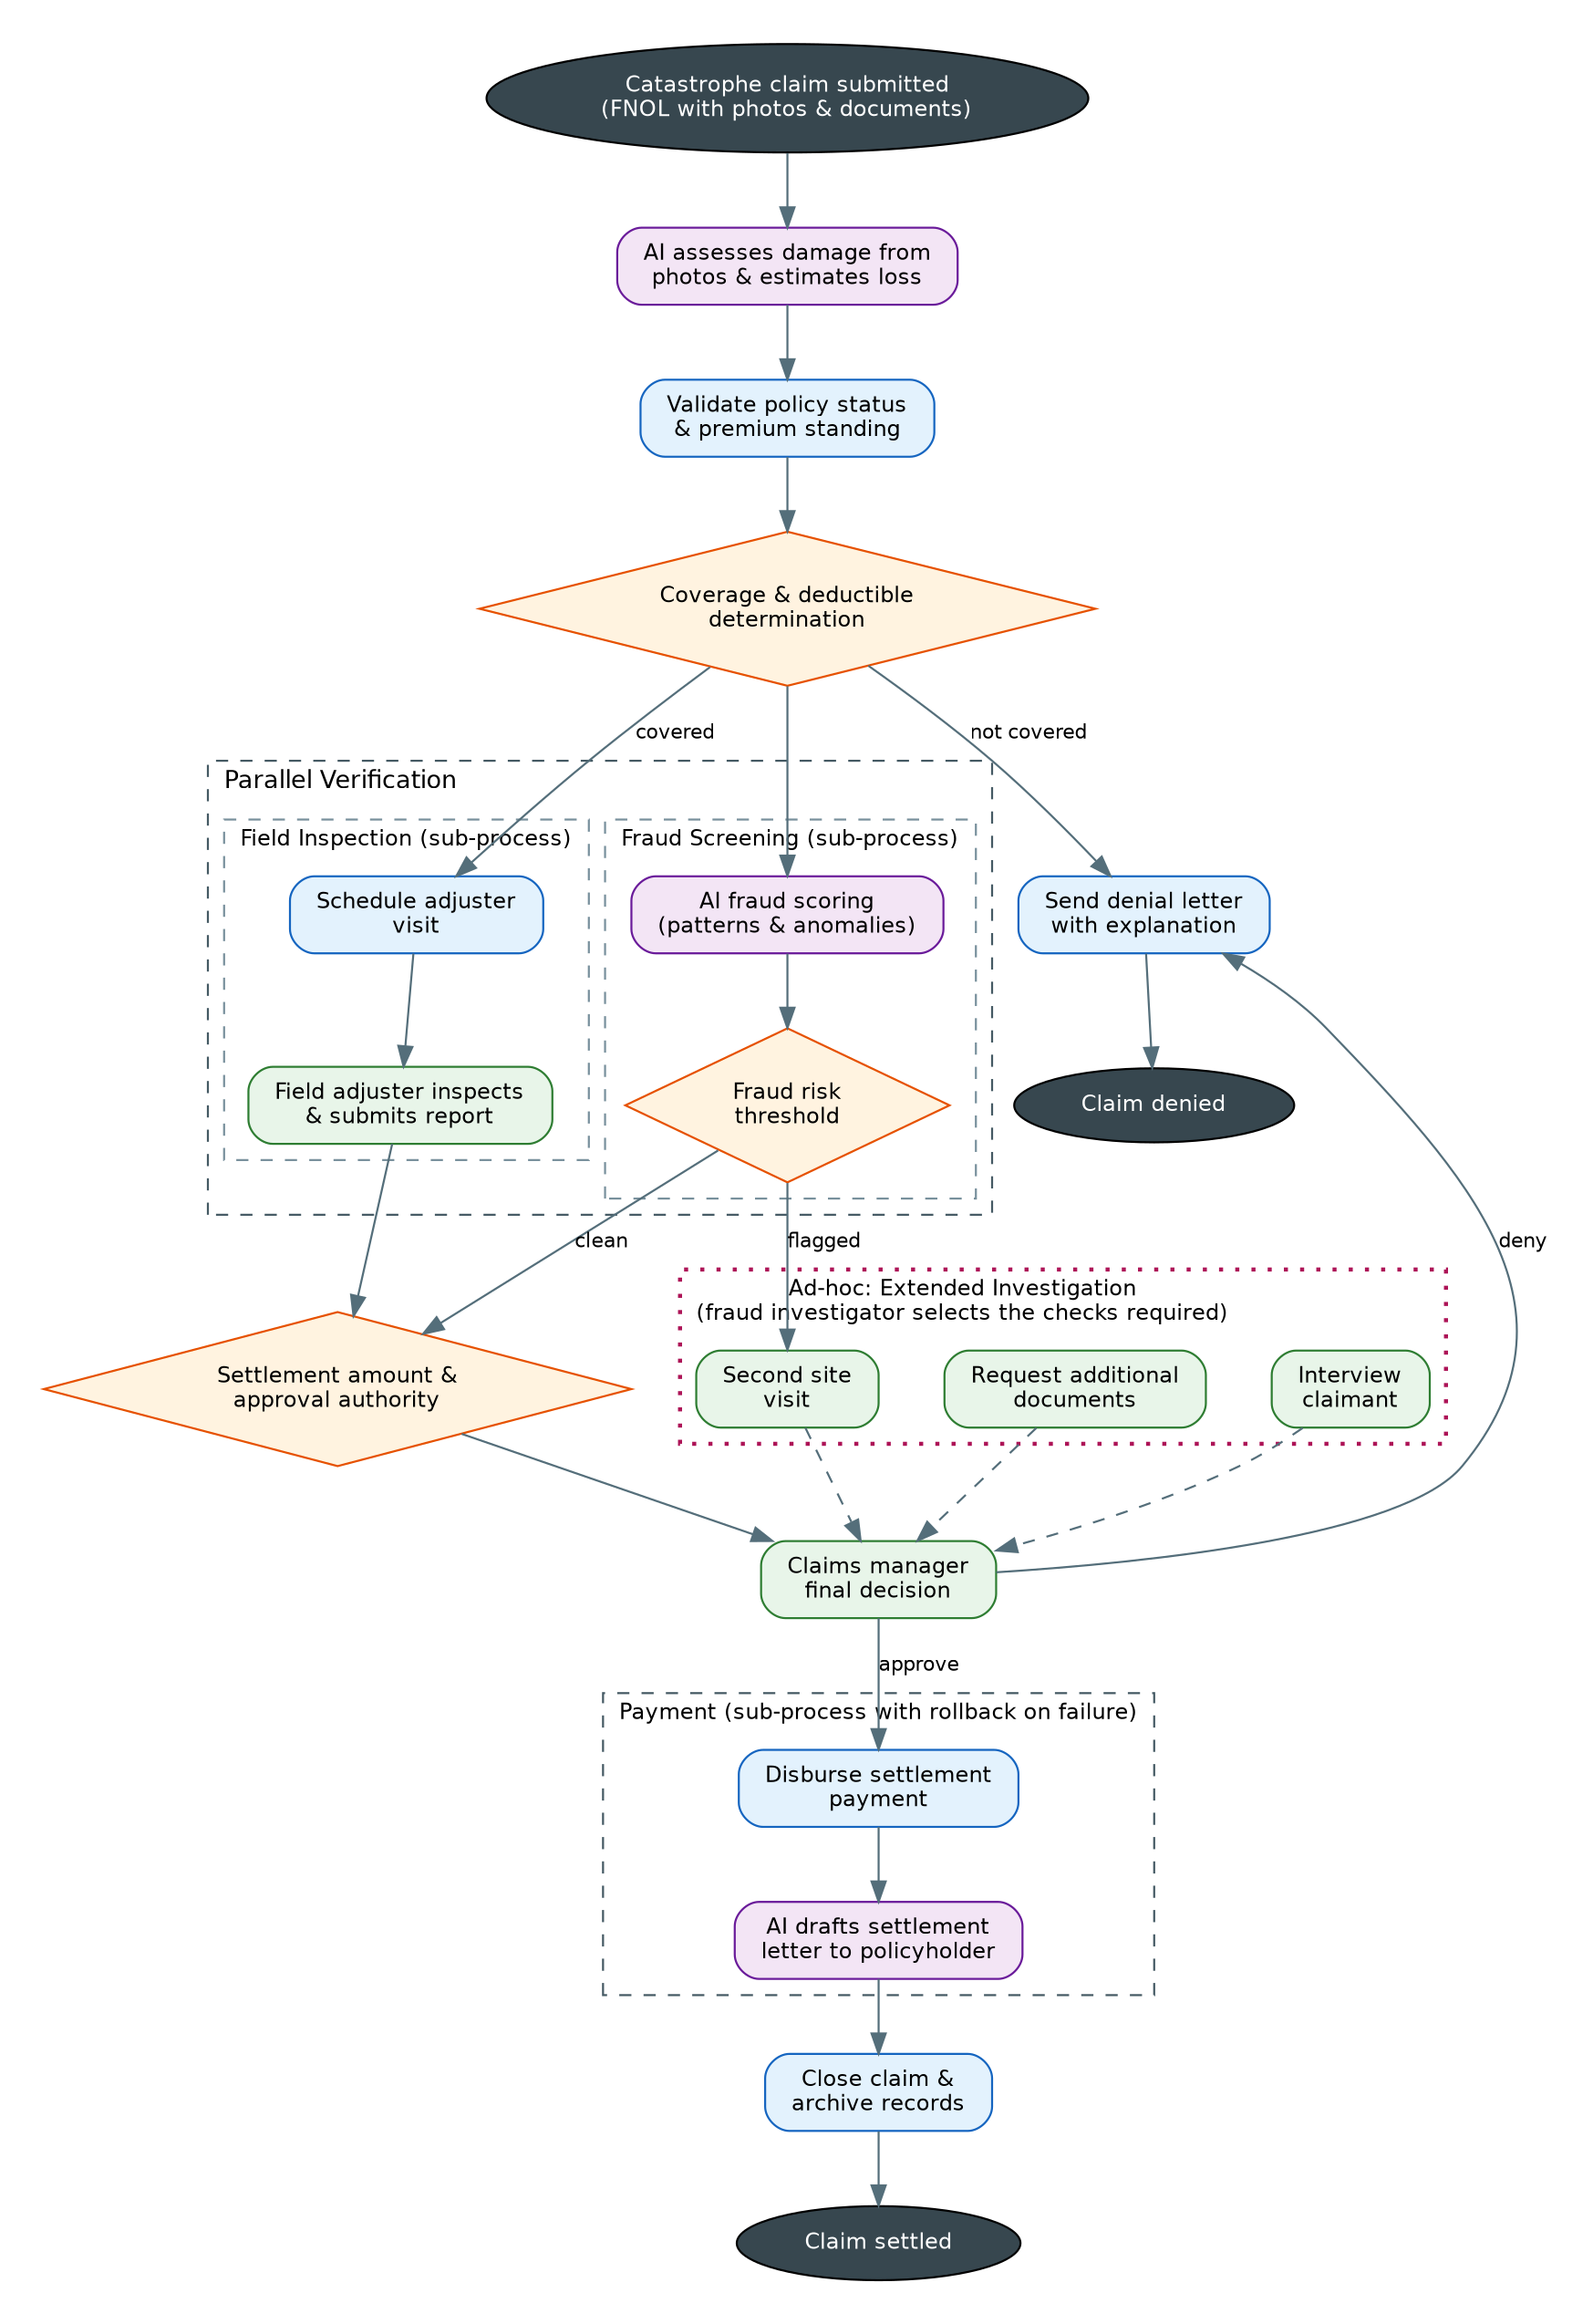
Camunda 8.9 Implementation Expectations
- Processes & sub-processes: Field Inspection, Fraud Screening and Payment as sub-processes; Payment with compensation handlers.
- DMN: three decision tables — Coverage & Deductible, Fraud Risk Threshold, and Settlement Amount & Authority — with the authority output routing to the correct approver level.
- AI Connector: damage assessment from photos at intake, fraud scoring in screening, and settlement-letter drafting at payout (minimum two of the three implemented, all three designed).
- Ad-hoc sub-process: extended investigation as an ad-hoc sub-process; the investigator activates only what the claim warrants and can add a repeat check.
- Surge readiness: explain (in the design note) how the model and workers behave under 50× volume — idempotency, worker scaling, and multi-instance considerations.
- Tasklist: intake exceptions, field inspection, investigation tasks, and the manager decision as forms with candidate groups per persona.
- Spring Boot 4.x workers: policy validation, scheduling, payment disbursement, letter dispatch, and archiving as job workers on the base framework.
- Error handling: payment gateway failure with bounded retries, then a BPMN error into the compensation path; duplicate FNOL submissions must be handled idempotently.
Expected Deliverables
- BPMN 2.0 model(s) deployed to Camunda 8.9 SaaS, including all sub-processes and the ad-hoc sub-process.
- DMN 1.3 decision tables (deployed and invoked from the process via business rule tasks).
- AI Connector configuration for every AI step, with prompt design and output variable mapping documented.
- Tasklist forms for every human task, assigned to the correct persona (candidate groups / assignees).
- Spring Boot 4.x job workers built on the base framework for every service task, following the framework's hexagonal layering.
- Error handling: BPMN error events, retry configuration on workers, and compensation/rollback where the flow indicates it.
- Testing evidence: at least one end-to-end happy path execution in Operate, plus one exception path (screenshots or recording).

9. Evaluation Rubric
Criterion | Weight | What a strong submission looks like
Process modeling quality | 20% | Clean BPMN aligned to the conceptual flow; correct gateway and sub-process choices; readable model with meaningful element names.
DMN design | 15% | Correct hit policies with justification; inputs sourced from process/AI variables; tables versioned and unit-testable.
AI Connector usage | 15% | Well-designed prompts using process variables; structured outputs mapped to variables; failure/timeout handling on AI steps.
Ad-hoc sub-process | 10% | True runtime task selection by the designated persona; correct completion condition; state handled cleanly.
Spring Boot 4.x workers | 20% | Workers follow the base framework's layering and patterns; idempotent handlers; correct job activation, timeouts and retries; no business logic in the model that belongs in workers (and vice versa).
Error handling & resilience | 10% | BPMN errors vs. incidents used deliberately; compensation where the flow demands it; bounded retries with escalation.
Tasklist & personas | 5% | Forms are usable; candidate groups match personas; task variables scoped correctly.
Testing evidence & documentation | 5% | Happy path plus at least one exception path evidenced in Operate; concise design note explaining key decisions.
10. Submission Guidelines
- Export your BPMN and DMN files from Web Modeler and commit them, together with your Spring Boot worker code, to the assessment repository under your name.
- Include a short design note (1–2 pages): sub-process choices (embedded vs. call activity), DMN hit policies, AI prompt design, and error-handling strategy.
- Provide testing evidence from Operate: one full happy-path instance and one exception-path instance (screenshots or a short recording).
- Be prepared for a 30-minute walkthrough: you will demo the flow end-to-end through Tasklist and answer design-trade-off questions.
- Timebox: 5 working days from assignment. Ask clarifying questions early — requirement interpretation is part of the assessment, but blocked time is not.

