*North South University*



Assignment - 1

**Name-** Mohammad Mahabub A Mostafa Badhan

**ID -** 1731082642

**Section -** 10

**Course –** CSE311L

**Due Date - 18 July 2020**

**Lab Manual 03**

**LECTURE1**

Activity1:

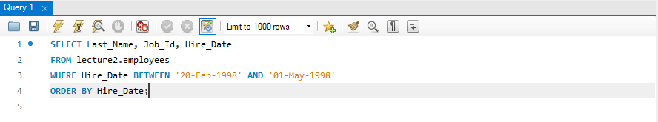

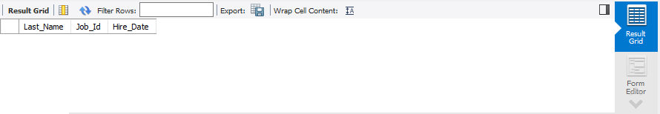

Activity2:

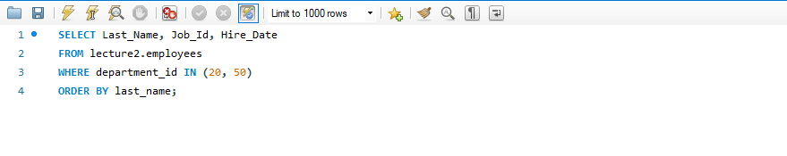

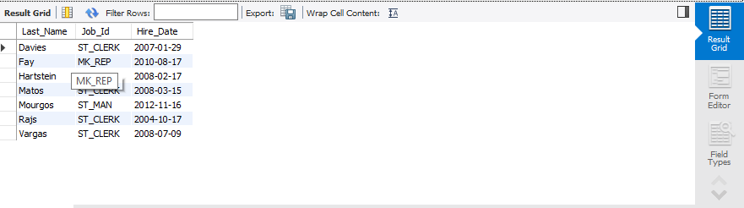

**LECTURE 2**

Activity1:

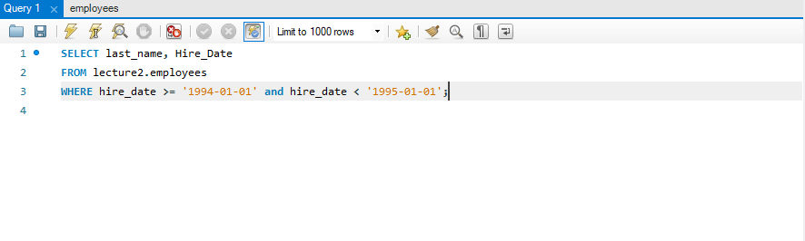

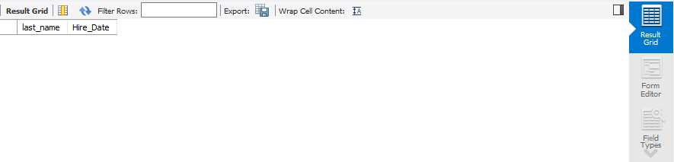

Activity2:

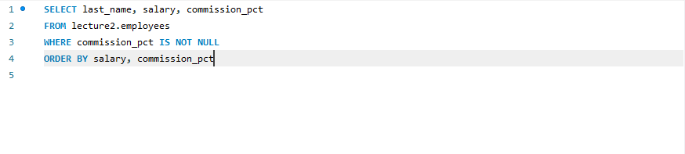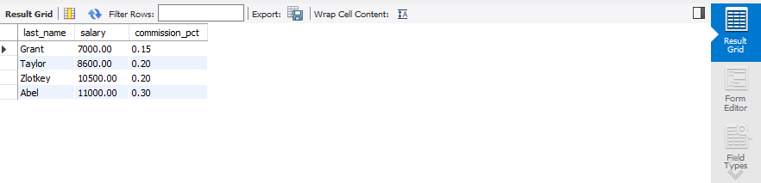

Activity3: