SE - 801 – Software Project Lab III
Midterm Technical Report

CodePulse
Intelligent Multi-Platform Coding Performance Analyzer

Submitted by:
Abdus Salam Islam Badhon
ID: BSSE-1401
Institute of Information Technology
University of Dhaka
Supervised by:
Mohd. Zulfiquar Hafiz
Professor, Department of IIT
Institute of Information Technology
University of Dhaka
Date: June 2, 2026



Table of Contents

1. Project Overview 3
1.1 Project Title 3
1.2 Problem Statement 3
1.3 Objectives 4
1.4 Scope 4
1.5 Deliverables 5
2. Requirements Analysis 6
2.1 Functional Requirements 6
2.1.1 Authentication & User Management 6
2.1.2 Data Synchronisation 6
2.1.3 Analytics 6
2.1.4 Recommendations 7
2.1.5 AI Coach 7
2.2 Non-Functional Requirements 7
2.3 Stakeholders 8
3. System Modeling 8
3.1 Use Case Modeling & Descriptions 8
3.1.1 System Use Case Diagram 8
Figure 1 : Level-0 Use Case Diagram 10
3.1.2.1 UC-1 Use Case Diagram: Authentication & Profile Handle Configuration 11
Figure 2 : Use Case Diagram — User Authentication & Profile Configuration Pipeline 12
3.1.2.2 UC-2 Use Case Diagram: Multi-Platform Data Sync & Pruning 12
Figure 3 : Use Case Diagram — Multi-Platform Data Sync & Pruning 13
3.1.2.3 UC-3 Use Case Diagram: Analytics Computation & Hidden Insights Engine 13
Figure 4 : Use Case Diagram — Analytics Computation & Hidden Insights Engine 14
3.1.2.4 UC-4 Use Case Diagram: Algorithmic Recommendation Generation & Feedback 15
Figure 5 : Use Case Diagram — Algorithmic Recommendation Generation & Feedback 16
3.1.2.5 UC-5 Use Case Diagram: AI Coach Consultation & Session Persistence 16
Figure 6 : Use Case Diagram — AI Coach Consultation & Session Persistence 17
3.3 Activity Diagram 17
3.2.1 AD-1: User Authentication & Profile Configuration Pipeline 18
Figure 10 : Activity Diagram —Algorithmic Recommendation & Feedback Pipeline 22
Figure 11 : Activity Diagram —AI Coach Prompt-to-Recommendation Pipeline 23
4.1 Database Schema 24
4.2 ER Diagram 25
Figure 12 : ER Diagram 26
5. Software Design 26
5.1 Component Diagram 26
Figure 13 : Component Diagram 27
5.2 Key Design Decisions 28
5.2.1 Direct HTTP vs Spring AI SDK for Mistral 28
5.2.2 CodePulse Rating Algorithm 28
5.2.3 Submission Pruning 28
5.2.4 Hidden Insights Engine 28
6. AI Engineering Design 29
6.1 AI Pipeline 29
6.2 Model Selection 31
6.3 Prompt Design 31
7. Preliminary Test Plan 31
7.1 Testing Objectives 31
7.2 Features to Be Tested 31
7.3 Test Cases 32
8. Timeline 34
8.1 Development Phases 34
8.2 Gantt Chart 35
Figure 15 : Gantt Chart (Weeks 1–16) 35
9. Appendix 34
9.A API Endpoint Reference 34
9.B Project Source Code Link 35

1. Project Overview

1.1 Project Title
CodePulse — Intelligent Multi-Platform Coding Performance Analyzer

1.2 Problem Statement
Competitive programmers and software engineering students practise across multiple platforms — Codeforces, LeetCode, AtCoder, and CodeChef. Each platform operates in isolation, presenting only its own statistics and offering no consolidated view of a user's overall performance. As a result, learners face several concrete challenges:
- No single place to see combined solved problems, acceptance rates, or activity trends across all four platforms.
- No automated mechanism to detect topic weaknesses that span platforms (e.g., failing Dynamic Programming on both CF and LC).
- Problem selection for future practice is ad-hoc — users cannot state their goals in natural language and receive personalised recommendations.
- There is no unified rating that reflects competency across all four platforms simultaneously.
- Behavioural patterns such as declining activity, comfort-zone stagnation, or streak loss are invisible without manual log-keeping.

CodePulse solves all of these by acting as an analytical intelligence layer above the four platforms.

1.3 Objectives
- Build a full-stack web application that aggregates competitive programming data from Codeforces, LeetCode, AtCoder, and CodeChef into a single dashboard.
- Compute a unified CodePulse Rating from cross-platform activity using a weighted Elo-like algorithm.
- Implement automated topic-level weakness detection and a curated problem recommendation engine.
- Integrate Mistral AI (LLM) to accept free-text coaching prompts from users and return personalised problem recommendations grounded in the user's actual performance history.
- Generate hidden analytical insights — automatically detected patterns the user would not otherwise notice.
- Implement scheduled and on-demand synchronisation with all four platform APIs, with a configurable submission ceiling (default: 300 per user) to keep the system performant.

1.4 Scope
In scope:
- Authentication, user profile management with 4 platform handles.
- Data synchronisation with Codeforces REST API, LeetCode GraphQL API, AtCoder kenkoooo.com community API, and CodeChef community wrapper API.
- Combined analytics: CodePulse Rating, streak tracking, difficulty distribution, topic coverage, weakness radar, activity heatmap, per-platform breakdown, hidden insights engine.
- Curated (algorithmic) recommendations across all four platforms.
- AI Coach: Mistral-powered prompt-to-recommendation with full context injection and DB-persisted sessions.
- Automatic 6-hour sync schedule and manual sync option.
- Submission pruning to keep the latest 300 per user.

Out of scope: contest scheduling, real-time editorial fetching, social/collaborative features, mobile native app.

1.5 Deliverables
- Full-stack application: Spring Boot 3 backend + Next.js 14 frontend.
- PostgreSQL schema with 7 tables (users, problems, topics, submissions, recommendations, ai_sessions, ai_items).
- REST API with 20+ documented endpoints.
- Technical report (this document).

2. Requirements Analysis

2.1 Functional Requirements

2.1.1 Authentication & User Management
- FR-1: Users can register with username, email, and password. Passwords are BCrypt-hashed.
- FR-2: Users can log in and receive a JWT access token (24-hour expiry).
- FR-3: Users can store and update their Codeforces, LeetCode, AtCoder, and CodeChef handles via their profile.
- FR-4: Platform handles are always fetched fresh from the database on profile and dashboard load.

2.1.2 Data Synchronisation
- FR-5: The system fetches up to 200 recent submissions per sync from Codeforces (/user.status), LeetCode (GraphQL), AtCoder (kenkoooo API), and CodeChef (community API).
- FR-6: Submissions are deduplicated by platformSubmissionId before storage.
- FR-7: If a user's total submission count exceeds 300, the oldest submissions are automatically pruned, keeping only the most recent 300.
- FR-8: Synchronisation runs automatically every 6 hours via a scheduled cron job and can also be triggered manually by the user.

2.1.3 Analytics
- FR-9: The system computes a combined CodePulse Rating from all connected platforms using a weighted average algorithm.
- FR-10: Current streak, longest streak, and total active days are calculated across all platforms combined.
- FR-11: Topic-level weakness scores (failure rate per topic) are computed from all submissions.
- FR-12: The system generates 6–10 hidden insights automatically from the user's data (weakness detection, comfort-zone analysis, streak pattern, activity trend, platform imbalance, etc.).
- FR-13: Per-platform breakdown stats (solved count, acceptance rate, verdict distribution, topic coverage) are returned alongside combined stats.

2.1.4 Recommendations
- FR-14: The algorithmic recommendation engine selects up to 10 unsolved problems from the user's weakest topics within their estimated difficulty range.
- FR-15: Generating new recommendations replaces all previous ones for that user.
- FR-16: Users can mark recommendations as solved (feedback loop) or dismiss them.

2.1.5 AI Coach
- FR-17: Users can submit a free-text prompt describing their practice goal.
- FR-18: The system builds a rich context payload (rating, weakness scores, per-platform stats, recently solved problems, recent WA/TLE topics) and sends it to Mistral AI alongside the user's prompt.
- FR-19: Mistral returns a structured JSON response with problem recommendations, a coach insight paragraph, and focus areas.
- FR-20: AI recommendation sessions are persisted to the database; the latest session is shown to the user on page load without requiring regeneration.
- FR-21: Regenerating AI recommendations deactivates the previous session and creates a new one.
- FR-22: Users can mark AI-recommended items as solved or dismiss them.

2.2 Non-Functional Requirements
- NFR-1 Performance: API responses for analytics must be returned within 2 seconds for a user with up to 300 submissions.
- NFR-2 Security: All endpoints except /api/auth/** are protected by JWT. Passwords are never stored in plaintext.
- NFR-3 Reliability: The background sync service catches and logs failures per-platform without crashing the overall job.
- NFR-4 Scalability: Submission pruning ensures database growth is bounded per user. Async @Scheduled syncs prevent blocking the request thread.
- NFR-5 Usability: The frontend provides real-time loading skeletons, toast notifications, and empty states with action prompts.
- NFR-6 Maintainability: Each platform sync is an independent service class; adding a new platform requires adding only one new service and registering its handle in the User entity.
- NFR-7 AI Correctness: The LLM prompt is structured to produce only valid JSON. Responses are parsed via JsonNode (not class mapping) to tolerate future API schema additions without code changes.

2.3 Stakeholders
Stakeholder | Role | Interest in CodePulse
Competitive Programmer | Primary user | Improve problem-solving skills efficiently
CS Student | Primary user | Prepare for coding interviews and contests
Supervisor / Evaluator | Academic oversight | Assess technical depth and research contribution
Developer / Maintainer | Builder | Clean architecture, extensible platform

3. System Modeling
System modeling provides both structural and behavioral representations of CodePulse. This section details the system's operational scope using Use Case modeling alongside fine-grained Activity Diagrams that detail execution logic across the Spring Boot backend, PostgreSQL persistence layer, and external integrations.

3.1 Use Case Modeling & Descriptions

3.1.1 System Use Case Diagram
The Level-0 System Use Case Diagram illustrates the interactions between primary human actors, automated system schedulers, internal system boundaries, and external third-party API services.

Primary use cases:
- Register / Login — Create account and authenticate with JWT.
- Manage Profile — Add or update platform handles; view connection status.
- Sync Data — Trigger cross-platform submission fetch (manual or automated).
- View Dashboard — See CodePulse Rating, streak, platform connections, recent submissions.
- View Analytics — Access deep performance charts, platform breakdown, and hidden insights.
- Get Curated Recommendations — Browse algorithmically selected problems; mark solved or dismiss them.
- Ask AI Coach — Enter a free-text prompt; receive AI-generated problem recommendations grounded in personal history.

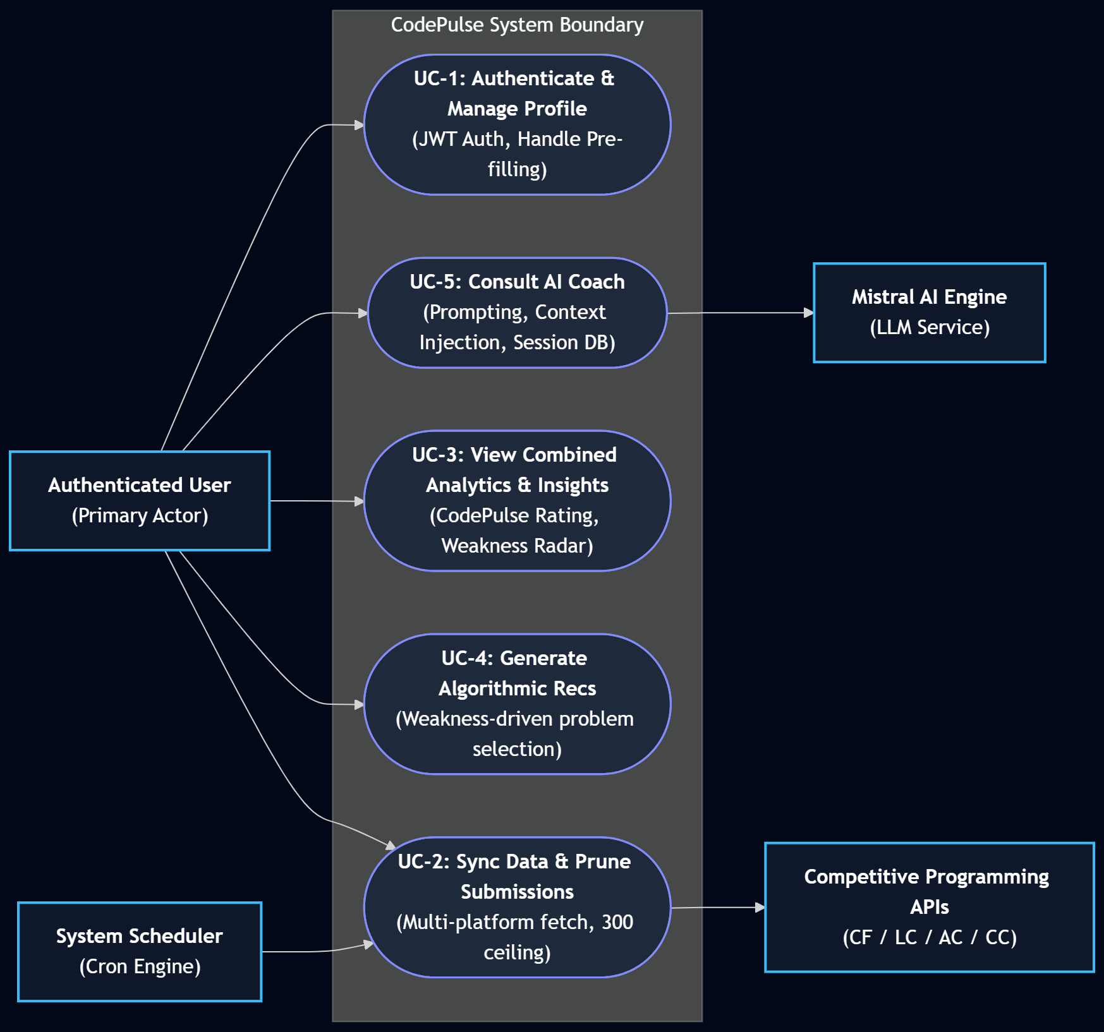

Figure 1 : Level-0 Use Case Diagram

3.1.2 Detailed Use Case Descriptions

3.1.2.1 UC-1 Use Case Diagram: Authentication & Profile Handle Configuration

Field | Description
Actor | Authenticated User
Trigger | User navigates to Register/Login page or updates profile settings (/profile).
Preconditions | System backend is operational; PostgreSQL database connection is active.
Main Flow | 1. User registers with email, username, and password, or logs in with credentials.2. Backend authenticates user via BCrypt verification and issues a 24-hour signed JWT access token.3. User enters or updates platform handles (Codeforces, LeetCode, AtCoder, CodeChef) in Profile.4. Backend pre-fills and persists handles in the users table.5. System triggers an initial asynchronous sync for new handles.
Post-conditions | JWT stored in client state; platform handles saved and ready for cross-platform data fetching.
Exceptions | Invalid credentials → Return 401 Unauthorized.Duplicate email/username → Return 409 Conflict.
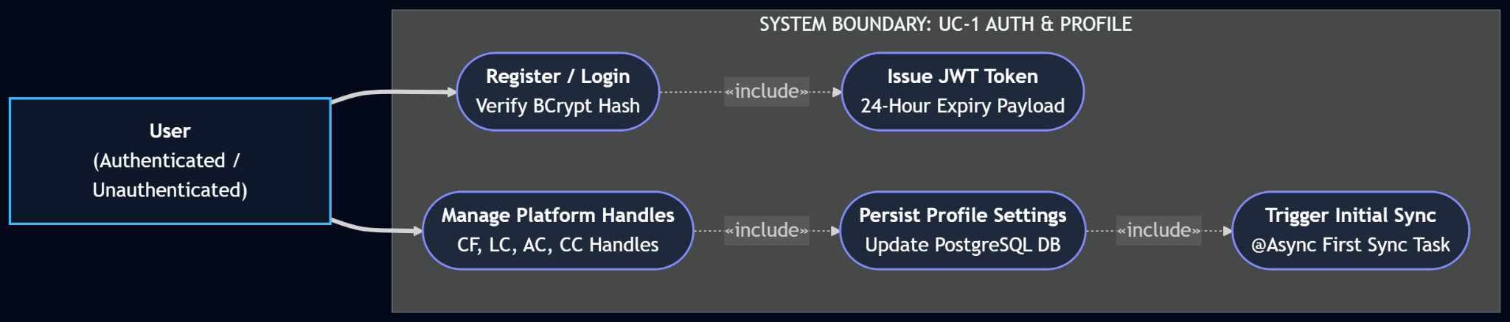

Figure 2 : Use Case Diagram — User Authentication & Profile Configuration Pipeline

3.1.2.2 UC-2 Use Case Diagram: Multi-Platform Data Sync & Pruning

Field | Description
Actor | Authenticated User / Background Cron Scheduler (ScheduledSyncService)
Trigger | User clicks "Sync All Platforms" (POST /api/analytics/sync) or automated 6-hour cron fires.
Preconditions | User profile contains at least one connected competitive programming handle.
Main Flow | 1. System initiates parallel @Async requests to connected platform APIs (Codeforces REST, LeetCode GraphQL, AtCoder Kenkoooo, CodeChef API).2. System fetches up to 200 recent submissions per platform.3. Incoming submissions are deduplicated using platformSubmissionId.4. New Problem and Topic records are generated and saved if non-existent.5. SubmissionPruningService checks user total submission count; if count $> 300$, the oldest submissions are deleted to maintain a 300 ceiling.6. lastSyncedAt timestamp is updated in the users table.
Post-conditions | Database contains up to 300 recent submissions per user; analytics are recalculated on demand.
Exceptions | Individual platform API timeout/rate limit → Log error for failing platform, continue syncing remaining platforms.

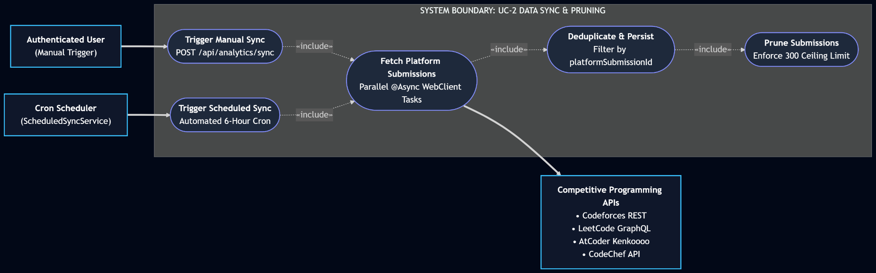

Figure 3 : Use Case Diagram — Multi-Platform Data Sync & Pruning

3.1.2.3 UC-3 Use Case Diagram: Analytics Computation & Hidden Insights Engine

Field | Description
Actor | Authenticated User
Trigger | User views Dashboard or Analytics page (GET /api/analytics/me).
Preconditions | User is authenticated with a valid JWT token; user has synced submission data.
Main Flow | 1. AnalyticsServiceImpl fetches user submissions and connects to CombinedRatingCalculator.2. System calculates individual platform ratings and computes weighted Elo CodePulse Rating.3. System calculates active streak, longest streak, and combined active days.4. System evaluates topic failure rates to map strength/weakness distributions.5. Hidden Insights Engine analyzes data array to generate 6–10 automated findings (e.g., comfort-zone stagnation, platform imbalance).6. Return combined PerformanceAnalyticsResponse DTO to Next.js frontend.
Post-conditions | Analytics charts, CodePulse Rating, streak stats, and hidden insights rendered on UI.
Exceptions | No submission history available → Return zeroed stats DTO with empty state UI flags.

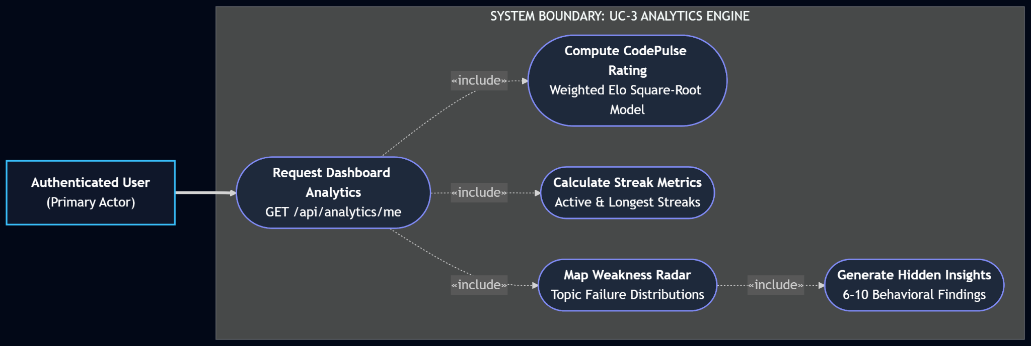Figure 4 : Use Case Diagram — Analytics Computation & Hidden Insights Engine

3.1.2.4 UC-4 Use Case Diagram: Algorithmic Recommendation Generation & Feedback

Field | Description
Actor | Authenticated User
Trigger | User requests curated recommendations (POST /api/recommendations/generate).
Preconditions | User has weakness scores calculated from synced submission history.
Main Flow | 1. RecommendationServiceImpl identifies user's top weakness topics from problem submission failure rates.2. Engine determines user's difficulty rating bracket based on CodePulse Rating.3. Engine queries problems database for unsolved problems in those weakness topics within rating bounds.4. System selects up to 10 curated problems across all 4 platforms.5. System deletes previous recommendations for user and persists new items in recommendations table.6. User interacts with recommendations by marking them as solved (PATCH /{id}/solved) or dismissing them (PATCH /{id}/dismiss).
Post-conditions | Curated recommendation list updated; solved/dismissed flags persisted in database.
Exceptions | Insufficient database problem catalog → Fall back to standard difficulty-matched platform problems.

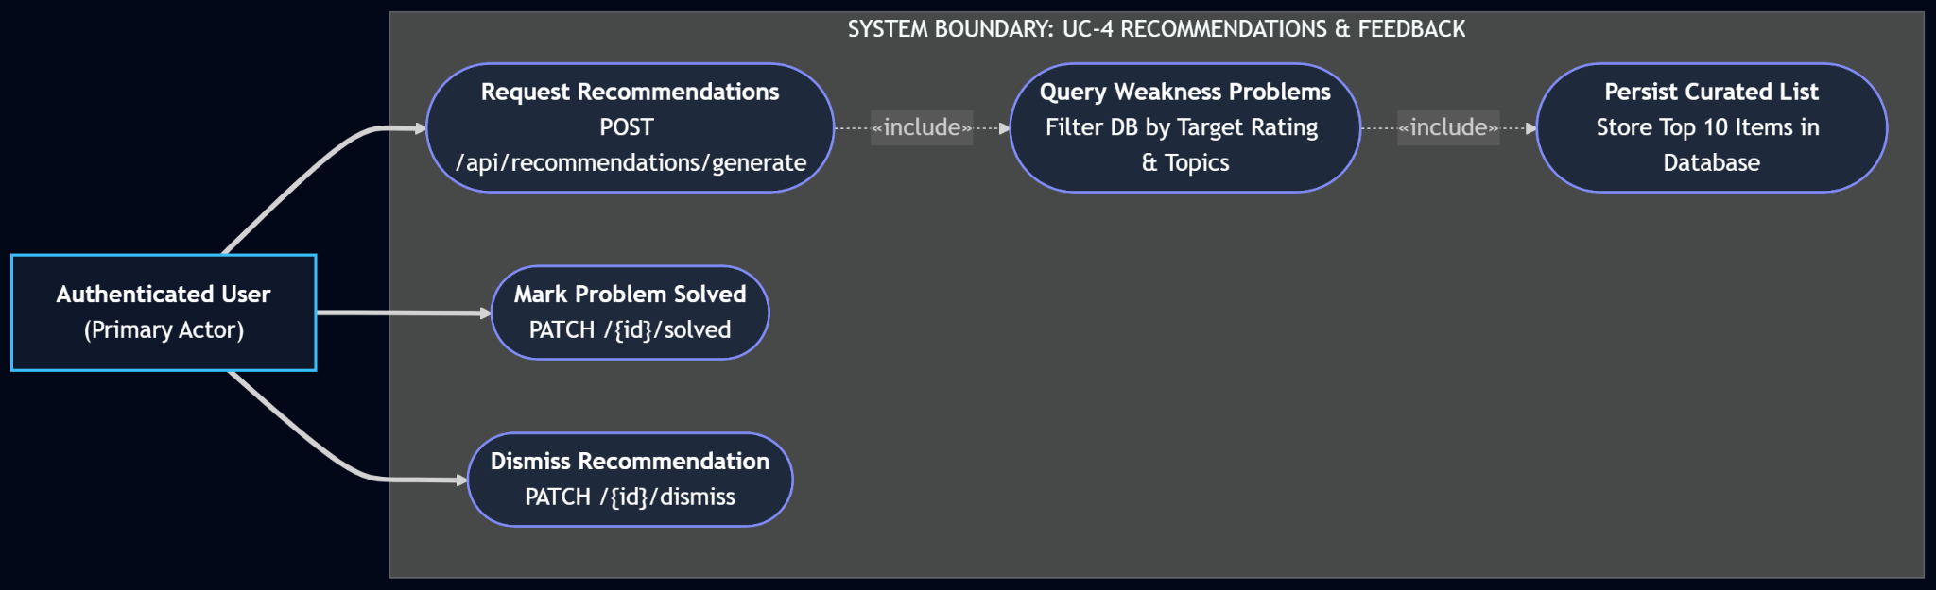

Figure 5 : Use Case Diagram — Algorithmic Recommendation Generation & Feedback

3.1.2.5 UC-5 Use Case Diagram: AI Coach Consultation & Session Persistence

Field | Description
Actor | Authenticated User
Trigger | User submits free-text practice prompt (POST /api/ai/recommend).
Preconditions | Mistral AI API key configured (spring.ai.mistralai.api-key); user is logged in.
Main Flow | 1. System triggers context assembly: pulls CodePulse Rating, per-platform stats, top 8 weak topics, top 5 strong topics, and recent WA/TLE struggle topics.2. Prompt Assembler merges user prompt with context payload and strict system JSON schema.3. Backend executes POST request to Mistral AI endpoint (mistral-large-latest).4. JsonNode parser validates structural integrity of response.5. Active status of previous session in ai_recommendation_sessions is set to false.6. System saves new session and items to ai_recommendation_sessions and ai_recommendation_items.7. Return structured AI Coach recommendations, coach insight, and focus areas to frontend.
Post-conditions | DB stores session history; latest AI Coach session auto-loads on page render.
Exceptions | Malformed JSON response or Mistral API error → Catch exception, log error, execute buildError() fallback, retain previous session.
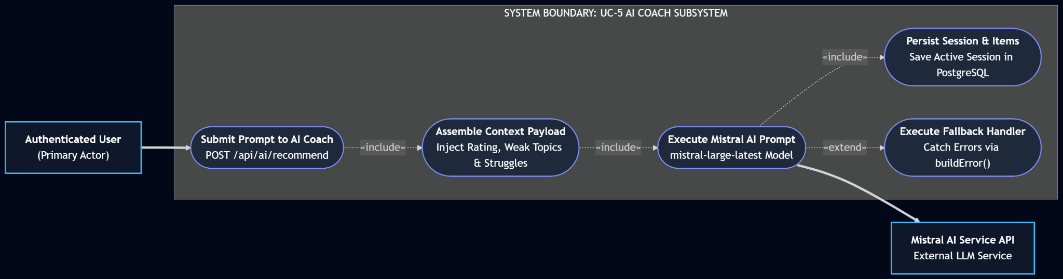

Figure 6 : Use Case Diagram — AI Coach Consultation & Session Persistence

3.3 Activity Diagram
Activity diagrams model the detailed operational flows, branching decisions, and state transitions for CodePulse's core execution pipelines.

3.2.1 AD-1: User Authentication & Profile Configuration Pipeline
This flow captures initial user registration, BCrypt password hashing, JWT token issuance, and profile handle persistence.
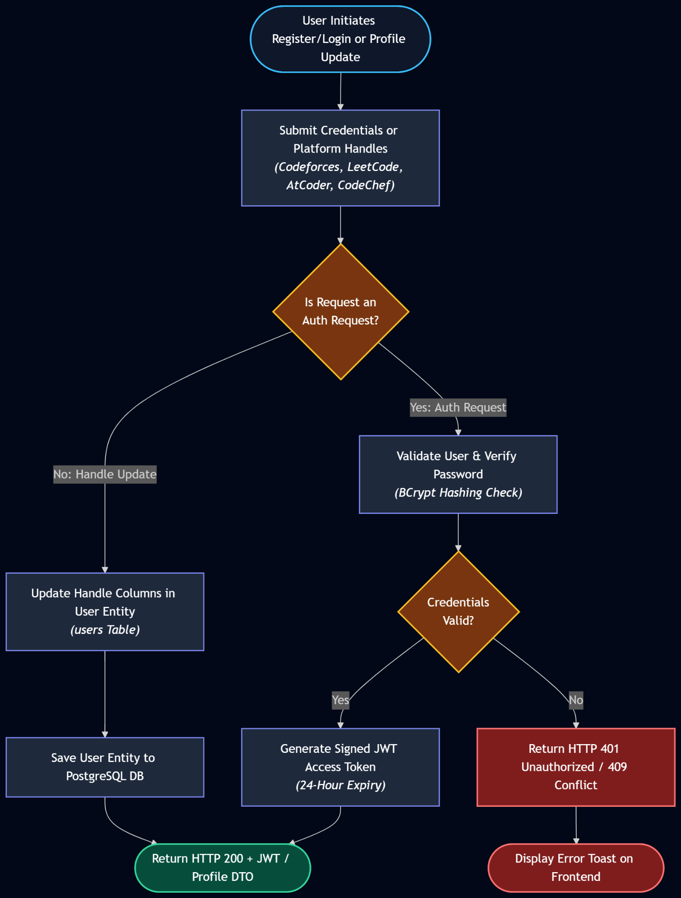Figure 7 : Activity Diagram — User Authentication & Profile Configuration Pipeline
3.2.2 AD-2: Multi-Platform Async Synchronisation & Pruning Pipeline
This flow captures asynchronous multi-platform data fetching, submission deduplication, database storage, and the 300-submission ceiling pruning algorithm.
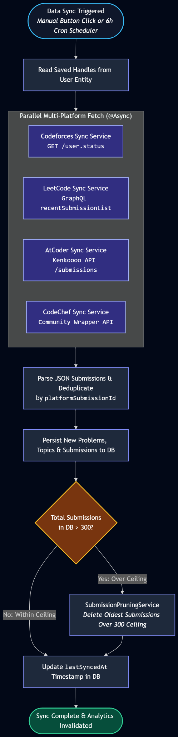
Figure 8 : Activity Diagram —Multi-Platform Async Synchronisation & Pruning Pipeline

3.2.3 AD-3: Analytics Engine & CodePulse Rating Pipeline
This flow details how analytics requests aggregate cross-platform data, compute weighted Elo ratings, calculate active streaks, and trigger the Hidden Insights Engine.
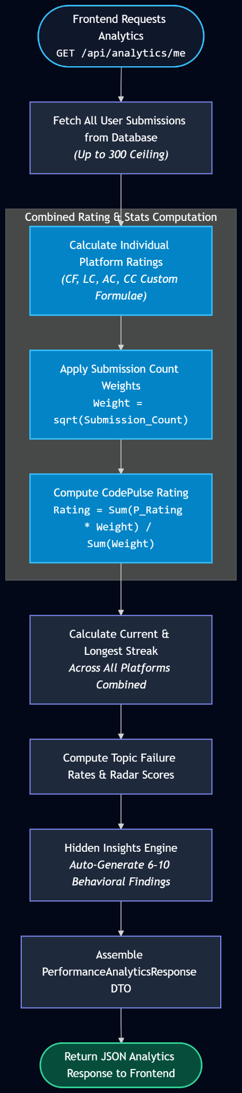
Figure 9 : Activity Diagram —Analytics Engine & CodePulse Rating Pipeline
3.2.4 AD-4: Algorithmic Recommendation & Feedback Pipeline
This flow illustrates weak-topic detection, rating-bracket problem querying, recommendation invalidation, and user feedback tracking (solving/dismissing). 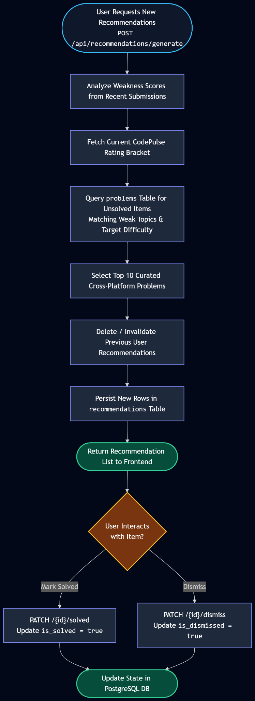

Figure 10 : Activity Diagram —Algorithmic Recommendation & Feedback Pipeline

3.2.5 AD-5: AI Coach Prompt-to-Recommendation Pipeline
This flow captures the full vertical pipeline for context construction, prompt assembly, Mistral AI API execution, JsonNode parsing, session persistence, and error handling.

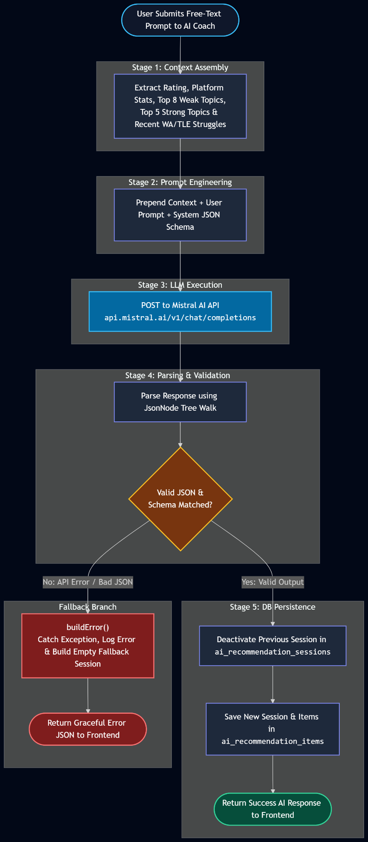 Figure 11 : Activity Diagram —AI Coach Prompt-to-Recommendation Pipeline

4. Data & Information Modeling

4.1 Database Schema
CodePulse uses a PostgreSQL relational database with 7 core tables. All tables use auto-generated bigint primary keys and appropriate foreign key constraints. The schema is managed by Hibernate with ddl-auto=update.

Table | Key Columns | Purpose
users | id, username, email, password_hash, codeforces_handle, leetcode_handle, atcoder_handle, codechef_handle, role, last_synced_at | Platform handles + auth
problems | id, platform_id, platform, title, difficulty_rating, difficulty_label, problem_url | Cross-platform problem catalogue
topics | id, name, slug | Algorithm topic tags
problem_topics | problem_id (FK), topic_id (FK) | Many-to-many join
submissions | id, user_id (FK), problem_id (FK), platform_submission_id, verdict, language, submitted_at | All synced submissions
recommendations | id, user_id (FK), problem_id (FK), reason, score, is_solved, is_dismissed | Algorithmic recs
ai_recommendation_sessions | id, user_id (FK), prompt, coach_insight, focus_areas_json, model_used, active | AI Coach sessions
ai_recommendation_items | id, session_id (FK), title, platform, url, difficulty, topics_json, reason, is_solved, is_dismissed | Items within a session

4.2 ER Diagram
The entity-relationship diagram below illustrates the primary associations. Key cardinalities:
- User 1 — N Submissions
- Problem N — M Topics (via problem_topics)
- Submission N — 1 Problem
- User 1 — N Recommendations, each referencing 1 Problem
- User 1 — N AiRecommendationSessions
- AiRecommendationSession 1 — N AiRecommendationItems

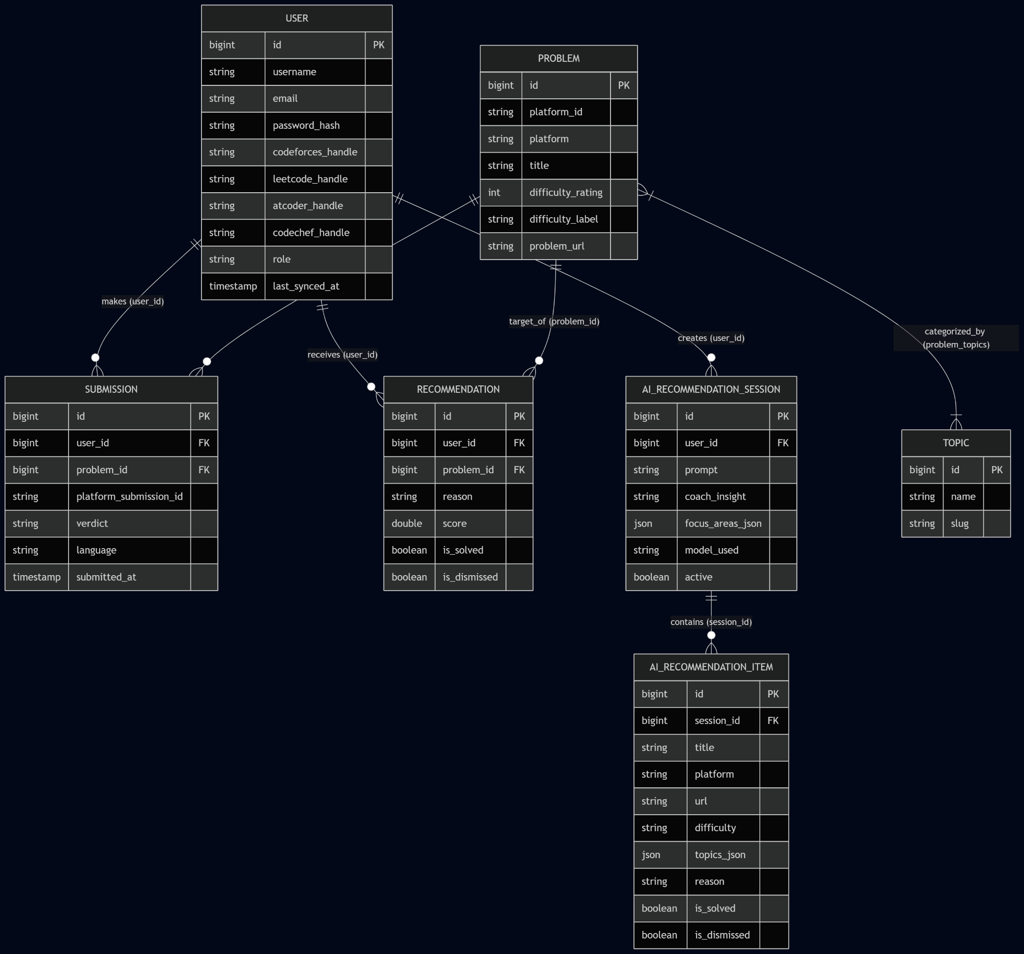
Figure 12 : ER Diagram

5. Software Design

5.1 Component Diagram
The system follows a clean 3-tier architecture with an additional AI integration layer.
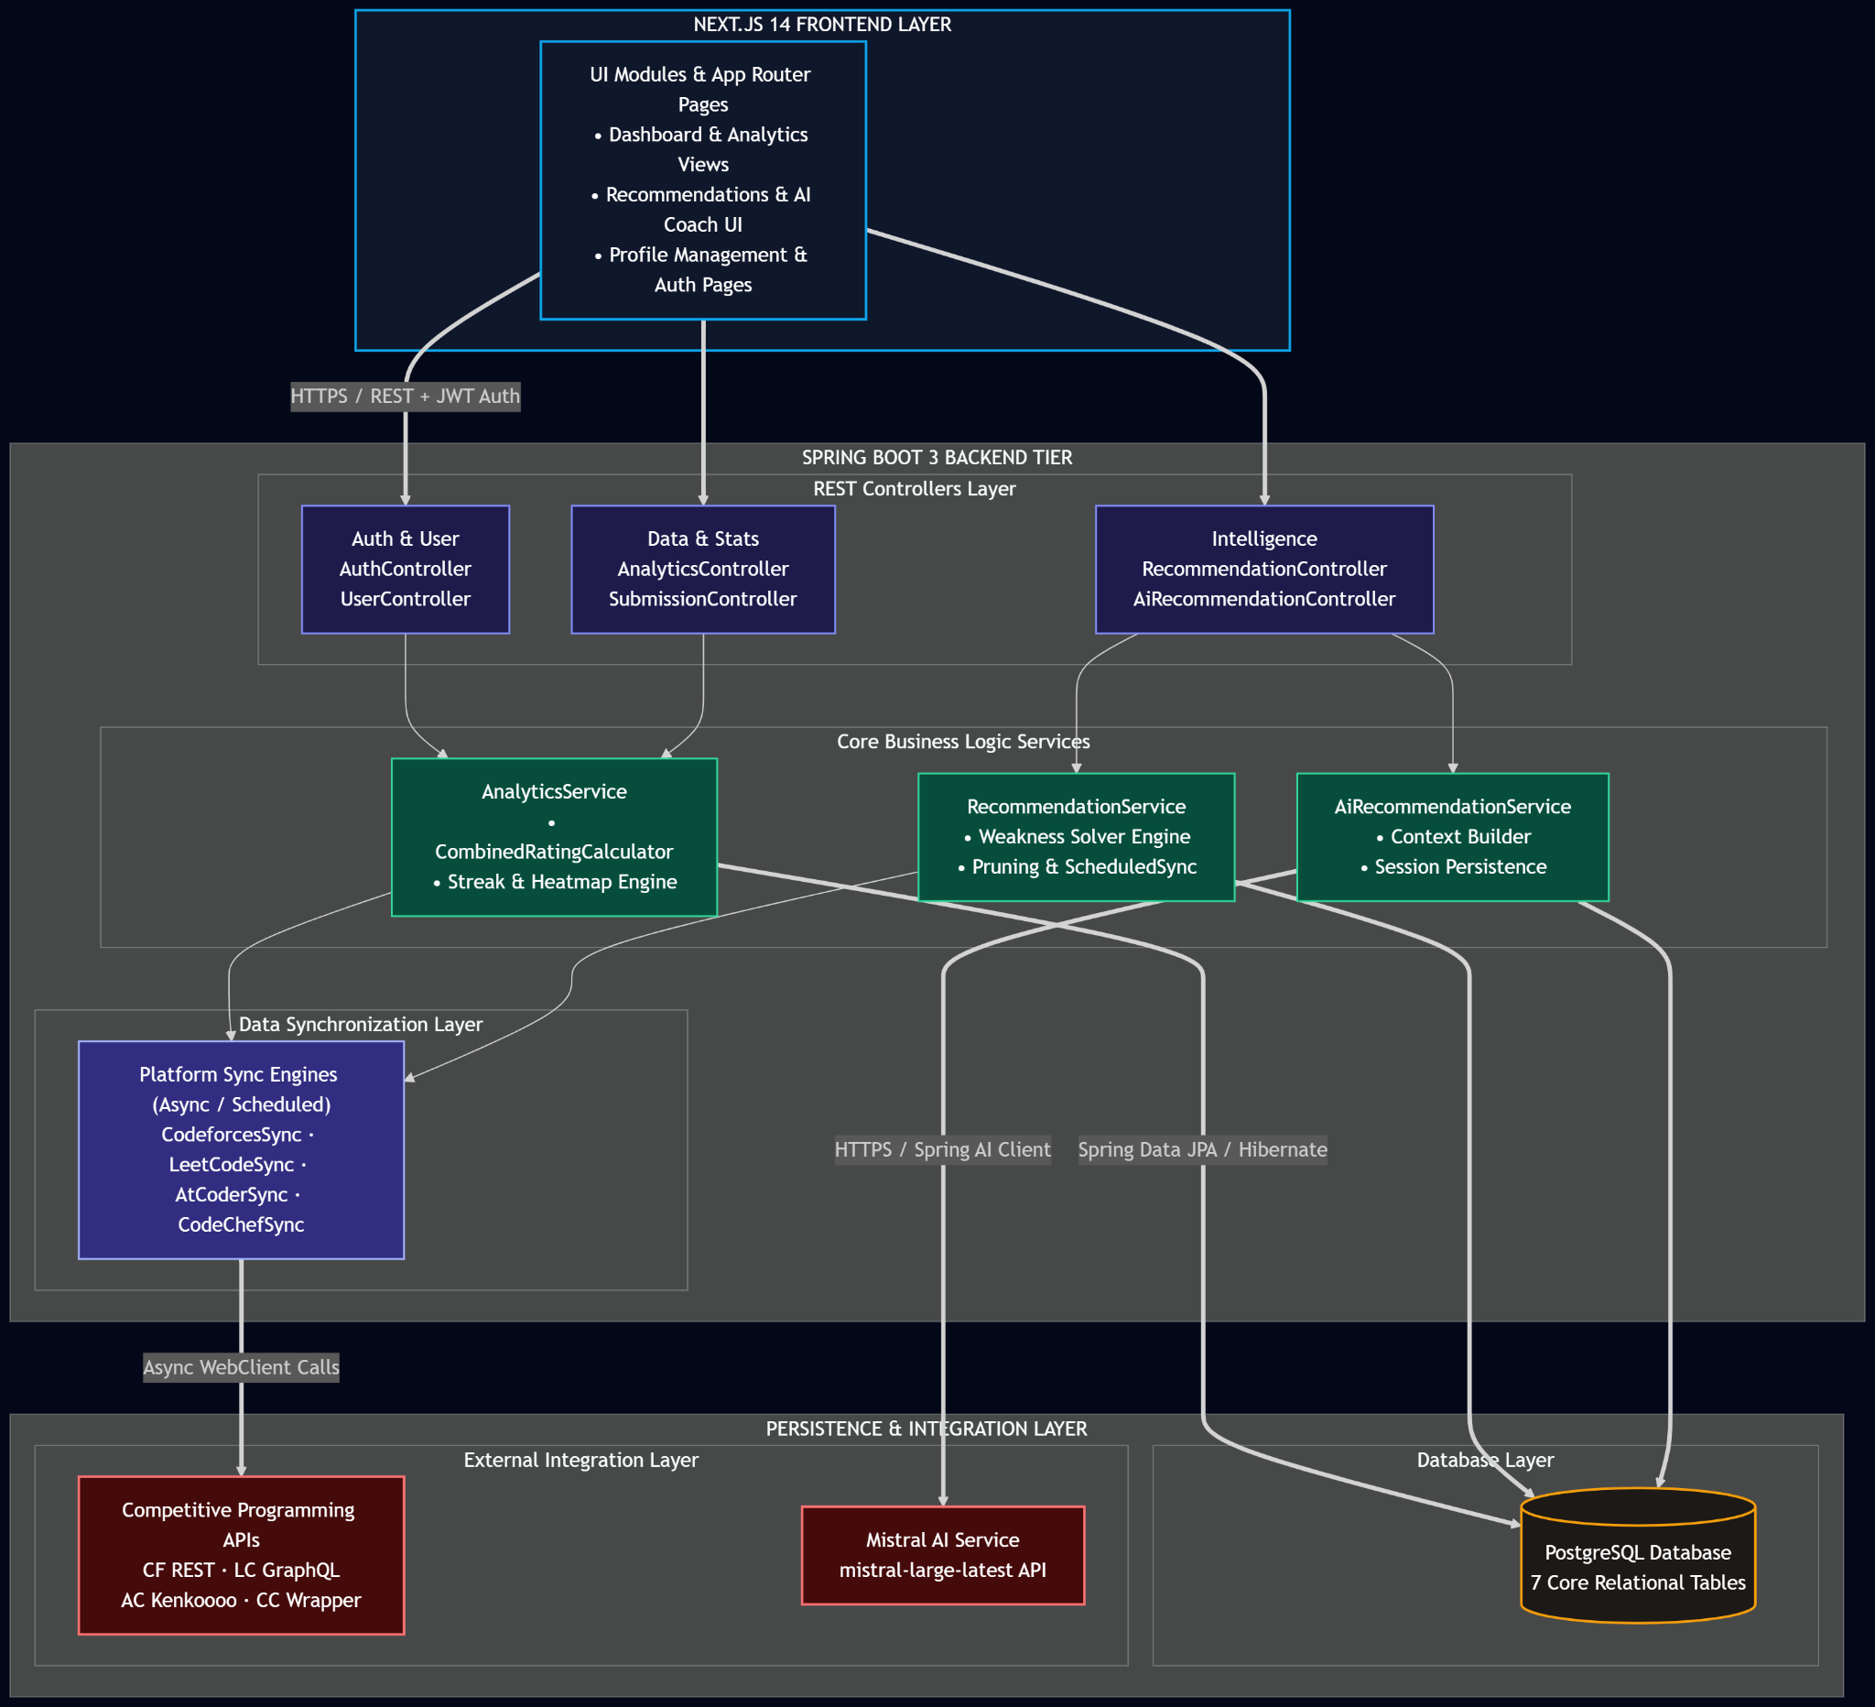

Figure 13 : Component Diagram

5.2 Key Design Decisions

5.2.1 Direct HTTP vs Spring AI SDK for Mistral
Spring AI milestone versions (M4–M6) construct an internal ObjectMapper instance that cannot be overridden via any Spring bean customiser. When the Mistral API added a "prompt_tokens_details" field to its response object, every call through the SDK threw UnrecognizedPropertyException. The solution adopted in CodePulse is to bypass the SDK entirely and call the Mistral REST endpoint directly via RestTemplate, deserialising the response into a JsonNode tree. Since JsonNode accepts any JSON without a target class, future API schema additions are silently ignored without requiring code changes.

5.2.2 CodePulse Rating Algorithm
A single Elo-like number is computed from all connected platforms:
- CF Rating: actual rating from /user.rating or estimated from average difficulty of solved problems.
- LC Rating: 1200 + (easy × 2) + (medium × 9) + (hard × 22) + acceptance-rate bonus.
- AC Rating: average difficulty of solved AtCoder problems × 1.05.
- CC Rating: 1000 + (easy × 3) + (medium × 10) + (hard × 20) + (expert × 35).
- Weight per platform = √(submission count on that platform) — diminishing returns for lopsided activity.
- Final = weighted average, clipped to [800, 3800].

5.2.3 Submission Pruning
To prevent unbounded database growth, each user is capped at 300 submissions (configurable). After every sync, SubmissionPruningService checks the count and deletes the oldest entries in a single bulk DELETE query. Analytics always reflect the most recent 300 submissions.

5.2.4 Hidden Insights Engine
Rather than showing only raw numbers, the frontend's InsightsEngine analyses the analytics response and automatically generates 6–10 contextual findings, categorised as Critical, Warning, Success, Tip, or Pattern. Examples include detecting that a user's failure rate on Dynamic Programming exceeds 60% (Critical), noticing that 75% of solves are Beginner/Easy level (Warning — comfort zone alert), or recognising a 14-day consecutive streak (Success). These are computed client-side from the API response with no additional backend calls.

6. AI Engineering Design

6.1 AI Pipeline
The AI recommendation pipeline consists of five stages:
- Stage 1 — Context Assembly: The backend constructs a rich Markdown-formatted context string including the user's CodePulse Rating, per-platform stats, top 8 weak topics with failure rates, top 5 strong topics, difficulty distribution, last 15 accepted problem titles, and last 5 WA/TLE struggle topics.
- Stage 2 — Prompt Engineering: The context is prepended to the user's free-text prompt and a strict JSON schema. A system prompt instructs the model to return only valid, complete JSON with no surrounding text.
- Stage 3 — LLM Call: A POST request is made to api.mistral.ai/v1/chat/completions using RestTemplate. The response is parsed as JsonNode, making the pipeline immune to API schema additions.
- Stage 4 — Parsing & Validation: The JSON tree is walked to extract recommendations, coach insight, and focus areas. Malformed responses are caught and logged; the user receives a graceful error message.
- Stage 5 — Persistence: The previous session is deactivated and the new session + items are saved to ai_recommendation_sessions and ai_recommendation_items. The response is returned immediately; persistence is part of the same transaction.
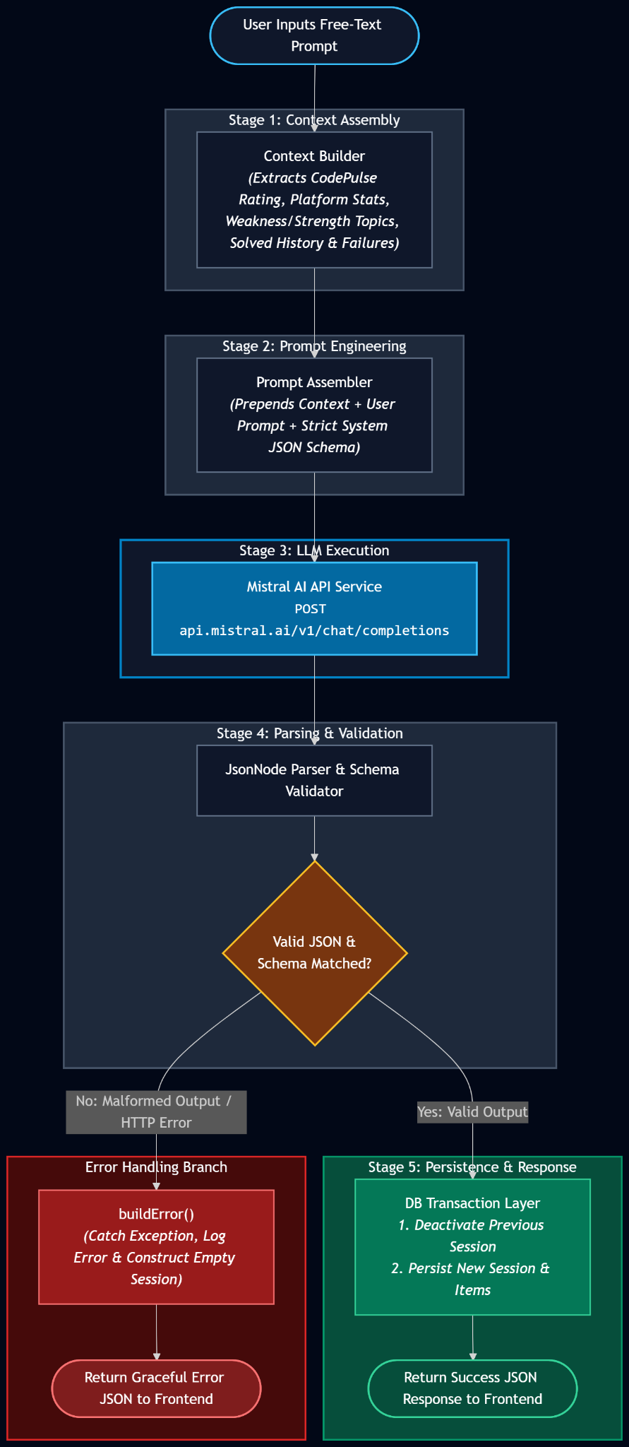
Figure 14 : AI Pipeline Flow Diagram

6.2 Model Selection
Mistral mistral-large-latest was selected for the following reasons:
- Strong knowledge of competitive programming problems across CF, LC, AC, and CC from training data.
- Reliable JSON-only output mode when instructed via system prompt.
- Competitive pricing with a free tier available via console.mistral.ai.
- OpenRouter (openrouter.ai) is provided as a configured fallback, allowing the model to be switched to DeepSeek, Gemini, or any OpenAI-compatible endpoint via a single property change.

6.3 Prompt Design
The system prompt enforces four absolute rules: (1) return only valid complete JSON, (2) never truncate, (3) recommend only real problems with real URLs, and (4) personalise the "reason" field to reference the specific user's weakness or goal. The user message appends a schema template specifying exactly the fields and count expected. This structured prompting approach consistently produces parseable JSON without markdown fences.

7. Preliminary Test Plan

7.1 Testing Objectives
- Validate all 22 functional requirements through unit and integration tests.
- Verify that the CodePulse Rating formula produces results within expected bounds for edge cases (0 platforms connected, one platform only, all 4 connected).
- Confirm that the AI pipeline handles Mistral API errors gracefully without crashing.
- Test submission deduplication and pruning correctness.
- Verify JWT token validation and endpoint protection.

7.2 Features to Be Tested
- Registration and login — correct token returned, password not stored plaintext.
- Profile handle update — new handles reflected on dashboard and dashboard profile fetch.
- Codeforces sync — new submissions saved, existing ones not duplicated.
- LeetCode GraphQL sync — Easy/Medium/Hard labels stored correctly.
- Pruning — after exceeding 300, oldest are removed, count returns to 300.
- Analytics — combined streak calculation correct across 2 platforms.
- Recommendation generation — only unsolved problems recommended.
- AI Coach — prompt submitted, session created, previous session deactivated.
- Mistral error handling — network failure returns graceful error, not stack trace.
- JWT protection — unauthenticated request to /api/analytics/me returns 401.

7.3 Test Cases
TC # | Test Case | Input | Expected Output | Priority
TC-01 | Register with valid data | POST /api/auth/register with unique email/username | 201 + JWT token returned | High
TC-02 | Register duplicate email | Same email twice | 400 "Email already registered" | High
TC-03 | Login with wrong password | Correct email, wrong password | 401 "Invalid credentials" | High
TC-04 | Access analytics without token | GET /api/analytics/me, no Auth header | 401 Unauthorized | High
TC-05 | Save CF handle | PUT /api/users/me with codeforcesHandle | 200, handle visible in GET /me response | High
TC-06 | CF Sync deduplication | Sync called twice, same submissions | Submission count unchanged after 2nd sync | High
TC-07 | Pruning at 300 limit | Insert 310 submissions for user | Submission count = 300, oldest 10 removed | High
TC-08 | Analytics — zero platforms | No handles set, GET /api/analytics/me | 200, all zeros, empty platform breakdown | Medium
TC-09 | CodePulse Rating bounds | 1 user with only 1 easy LC problem solved | Rating in range [800, 1250] | Medium
TC-10 | Curated recs generation | POST /api/recommendations/generate | 200, ≤10 unsolved problems returned | High
TC-11 | Mark recommendation solved | PATCH /api/recommendations/{id}/solved | 200, item no longer in active list | Medium
TC-12 | AI prompt submission | POST /api/ai/recommend with valid prompt | 200, session with ≥1 recommendation | High
TC-13 | AI session persistence | GET /api/ai/sessions/latest after TC-12 | Same session returned without regeneration | High
TC-14 | AI regeneration deactivates old | Submit 2nd prompt for same user | Only new session is active; old is inactive | High
TC-15 | Mistral API error handling | Invalid API key configured | 200 with empty recs + error insight message | High
TC-16 | Streak across 2 platforms | 3 CF subs on day 1, 2 LC subs on day 2 | currentStreak = 2 | Medium
TC-17 | Topic weakness ranking | 10 DP attempts, 8 fail; 5 graph, 2 fail | DP weakness > graph weakness | Medium
TC-18 | Admin list users | GET /api/admin/users with ADMIN token | 200, list of all users | Low
TC-19 | Admin endpoint with USER role | GET /api/admin/users with USER token | 403 Forbidden | High
TC-20 | Recent submissions order | GET /api/submissions/recent?limit=5 | 5 most recent, newest first | Medium

8. Timeline

8.1 Development Phases
Phase | Activities | Duration | Status
Phase 1 | Requirements, SRS, database schema design, entity modelling | Weeks 1–2 | Complete
Phase 2 | Auth module, JWT security, User entity, profile API | Weeks 3–4 | Complete
Phase 3 | Codeforces + LeetCode sync services, Problem/Topic/Submission entities | Weeks 5–6 | Complete
Phase 4 | AtCoder + CodeChef sync, combined analytics service, CodePulse Rating algorithm | Weeks 7–8 | Complete
Phase 5 | Recommendation engine, pruning service, scheduled sync | Week 9 | Complete
Phase 6 | AI Coach integration (Mistral direct HTTP), session persistence, context builder | Weeks 10–11 | Complete
Phase 7 | Next.js frontend: Dashboard, Analytics, Recommendations, AI Coach, Profile | Weeks 12–14 | Complete
Phase 8 | Integration testing, bug fixes, hidden insights engine, report writing | Weeks 15–16 | In Progress

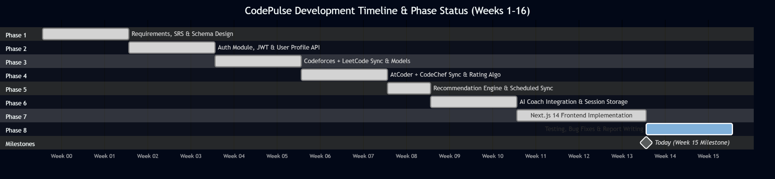
8.2 Gantt Chart

Figure 15 : Gantt Chart (Weeks 1–16)

9. Appendix

9.A API Endpoint Reference
Method | Endpoint | Description | Auth
POST | /api/auth/register | Create account | Public
POST | /api/auth/login | Authenticate, receive JWT | Public
GET | /api/users/me | Get own profile + handles | JWT
PUT | /api/users/me | Update profile / handles | JWT
GET | /api/analytics/me | Full combined analytics | JWT
POST | /api/analytics/sync | Trigger multi-platform sync | JWT
GET | /api/submissions/recent | Recent submissions (all platforms) | JWT
GET | /api/recommendations | Active curated recommendations | JWT
POST | /api/recommendations/generate | Generate new recommendations | JWT
PATCH | /api/recommendations/{id}/solved | Mark solved | JWT
PATCH | /api/recommendations/{id}/dismiss | Dismiss recommendation | JWT
POST | /api/ai/recommend | AI Coach: generate from prompt | JWT
GET | /api/ai/sessions/latest | Load stored AI session | JWT
PATCH | /api/ai/items/{id}/solved | Mark AI item solved | JWT
PATCH | /api/ai/items/{id}/dismiss | Dismiss AI item | JWT
GET | /api/admin/users | List all users (admin only) | JWT + ADMIN

9.B Project Source Code Link
https://github.com/Badhon1401/SPL-3

