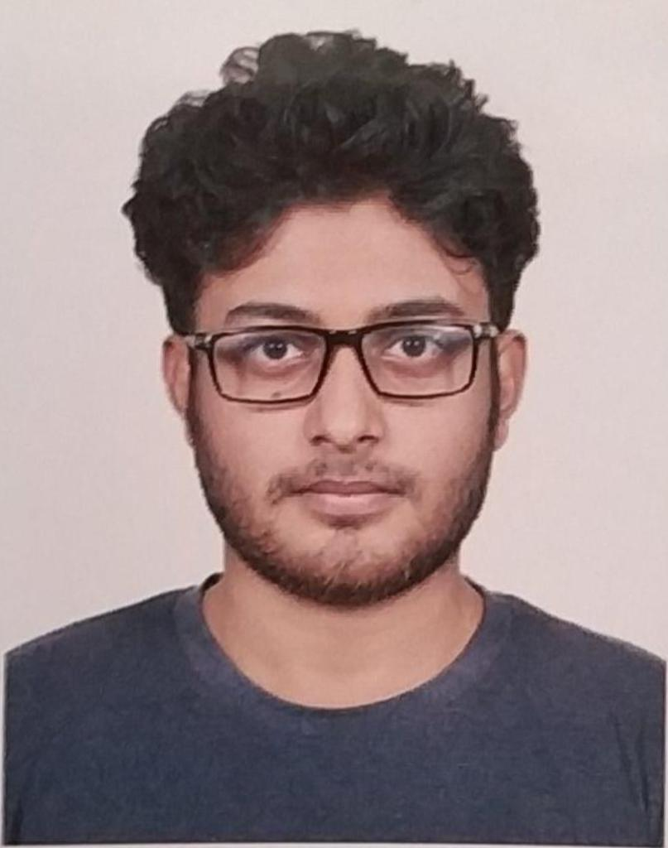

**Mehedi Hasan**

Front-End Developer

CONTACT 69/3, Free School Street, Kathalbagan, Dhaka-1205

INFORMATION **Phone No.** : +8801624350761

**Website** : www.lifeoflikhon.com

**Email** : contact@lifeoflikhon.com

**Facebook** : fb.com/lifeoflikhon

**GitHub** : gihub.com/lifeoflikhon

RESEARCH Data security and privacy, Cloud computing, Internet of Things (IoT), Big

INTERESTS data, Mobile malware, Secure database, Location privacy & security

TOPICS OF Mobile application, Web application, Database, Privacy and security,

INTERESTS Information Technology (IT), Astronomy, Nano-technology, Wireless

Network and devices, Information and Communication Technology for

Development (ICT4D)

PROGRAMMING JavaScript (ES6+)

LANGUAGES

FRAMEWORKS **CSS:** Bootstrap4

LIBRARIES **JavaScript:** p5.js

PROFESSIONAL **Presentation:**

SKILLS [1] Poster Presentation, BUET CSE FEST 2019

- **Topic:** Smart Card: A Pathway Towards Digital Bangladesh

- **Supervised by:** Samrat Kumar Dey, Lecturer, Dept. of CSE,

Dhaka International University.

**Problem Solved (Online Judge - OJ):**

[1] urionlinejudge.com.br

- ID : 309484

- Solved : 18

[2] uva.onlinejudge.org

- ID : 1019930

- Solved : 06

**Others:**

Search Engine Optimization (SEO)

TOOLS **OS** : macOSX (prefer), Windows XP+, Ubuntu, Linux Mint

**Editor/IDE** : Atom (prefer), VS Code

**Version Control**: Git (GitHub as platform)

**Others** : MS Office (Word, Excel, PowerPoint), Adobe XD

EDUCATION **Dhaka International University**, Dhaka, Bangladesh

B.Sc. in Computer Science & Engineering, December 2020

* CGPA: 3.52 (out of 4.00)

**Govt. Mahtab Uddin College**, Jhenaidah, Bangladesh

Higher Secondary, April 2016

* GPA: 4.00 (out of 5.00)

**Hat Barobazar Secondary School**, Jhenaidah, Bangladesh

Secondary, February 2014

* GPA: 4.81 (out of 5.00)

COURSES **Online:**

**Search Engine Optimazation (SEO)**

BASIS Institute of Technology and Management (BITM)

* Trainer: Md. Faruk Khan
* Source: Official YouTube Channel

HONORS AND **Others**

AWARDS [1] District Scouts Award, 2011

WORKSHOPS **Others**

[1] Workshop on Project Management & it’s Major Aspects(October 2018) | Institutional Quality Assurance Cell (IQAC)

[2] Entrepreneurship Awareness Camp for Youth (July 2018) | Institutional Quality Assurance Cell (IQAC)

VOLUNTEER AND **CS Related**

EXTRA- CURRICULAR [1] General Member, DIU Computer Programming Club (2017 - )

ACTIVITIES [2] Member, GDG Bangla – DIU Chapter (2018 - )

**Science Related**

[3] Web Content Writer, Bigganjatra (2015 - )

[4] Non-Academic Volunteer, Bangladesh Mathematical Olympiad (2017 - )

**Others**

[5] Cultural Secretary, Bangladesh Human Rights Commission, DIU Branch (2018 - )

[6] Scout, Bangladesh Scouts (2008 - 2014)

[7] Member, DIU Debating Club (2017 - 2018)

[8] Member, Usher Alo Foundation (2014 - 2015)

LANGUAGES Bengali, English

PERSONAL **Full Name** : Mehedi Hasan Likhon

INFORMATIONS **Nickname** : Likhon

**Father** : Rofiqul Islam

**Mother** : Shiuli Sultana

**Height** : 5 Feet 5 Inch (165.1 cm)

**Weight** : 58 KG (128 lbs.) [updated Nov, 2018]

**Marital** **Status** : Unmarried

**Blood Group** : O (+ve)

**Date Of Birth** : October 7, 1998 (20 years)

**NID** : 8254074498

**Nationality** : Bangladeshi

REFERENCES Available upon request.