**Polarization**

Interference and diffraction are the Phenomena which confirmed the wave nature of light, but it could not establish whether light waves are longitudinal or transverse. The transverse nature of light has been established by polarization Phenomenon. Light is nothing but electromagnetic wave. The light emitting atoms are oscillating independently and emits individual wave trains. As a result oscillations of electric and magnetic fields in light waves are at random. Hence light from sun or electric lamp is unpolarized light. In e.m.waves, direction of electric field is taken as to indicate direction of polarization. In unpolarized light, electric vector has vibration in all possible directions.

**Plane Polarized light:**

If the vibrations of electric vector in a light are confined to a single plane then that light is called Plane Polarized Light or Linearly polarized light.

Vertically polarized light Horizontally polarized light

**Partially Plane Polarized Light:**

If the linearly polarized light contains small additional component of unpolarized light, it is known as Partially Plane Polarized Light.

**. . . . . . . .**

**Circularly Polarized Light:**

If electric vector in a light describes a circle during one time period, it is known as circularly polarized light. If the electric vector in a light rotates in clockwise direction with respect to direction of propagation, then that light is known as R.C.P light. If the electric vector in a light rotates in anti clockwise direction with respect to direction of propagation then that light is known as L.C.P light.

**Elliptically Polarized light:**

If electric vector in a light describes an ellipse during one time period, it is known as elliptically polarized light.

**Brewster’s Law:**

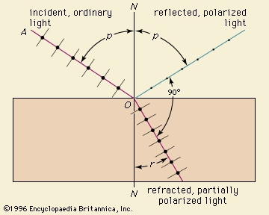

When unpolarized light is reflected at the surface of some transparent medium such as glass, water…. Etc, the reflected light becomes partially polarized. The degree of polarization changes with angle of incidence. At a particular angle of incidence known as angle of polarization, reflected light becomes completely polarized.

In 1811, Brewster found that refractive index of material of the medium ( $μ$) is equal to the tangent of the angle of polarization (ip) i.e., $μ$ = Tan ip

This is known as Brewster’s law.

**Double Refraction**

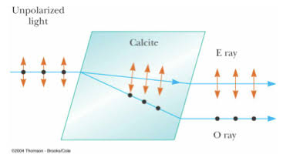

When un-polarized light passes through certain an isotropic crystals such as calcite or Quartz, it split up into two polarized lights. One is ordinary ray and another one is extraordinary ray. This phenomenon is known as double refraction. Ordinary ray travels with same velocity in all direction. Extraordinary ray travels with different velocity in different directions. Both rays travel with same velocity along optic axis. Both O-ray and E-ray are plane polarized with their planes of polarization mutually perpendicular to each other.

**Nicol’s Prism**

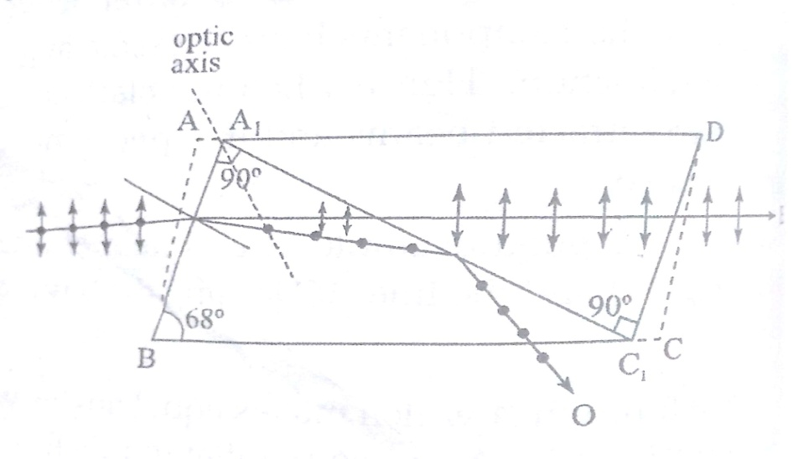

In 1828, William Nicol invented Nicol prism to produce plane polarized light. He modified Calcite crystal in such a way to eliminate one of two refracted rays by total internal reflection.

A Calcite crystal whose length is three times its breadth is taken. The two ends AB and CD of the crystal are cut so that angle ABC reduces from 710 to 680. Then the crystal is cut into two halves along the plane A1C1 which passes through blunt corners and perpendicular to both the principle section and end faces. A1C1 makes an angle 900 with C1D & BA1. The two cut faces are well polished and cemented together using a thin layer of Canada balsm (a clear transperant material) whose refractive index is 1.55 for = 5893 A0 . when unpolarized light enters into Calcite crystal, it split up into ordinary and extraordinary rays. Since refractive index of ordinary ray is (1.658) is greater than that of Canada balsm layer and due to proper shaping of crystal, angle of incidence of O-ray at the Canada balsm layer becomes greater than critical angle. Hence O-ray undergoes total internal reflection and leaves the crystal through its side .Hence only e-ray emerges of the other face of the prism.

Nicol Prism are good polarizer & analyzer and can be used to produce & analyze plane polarized light.

**Wave plate**

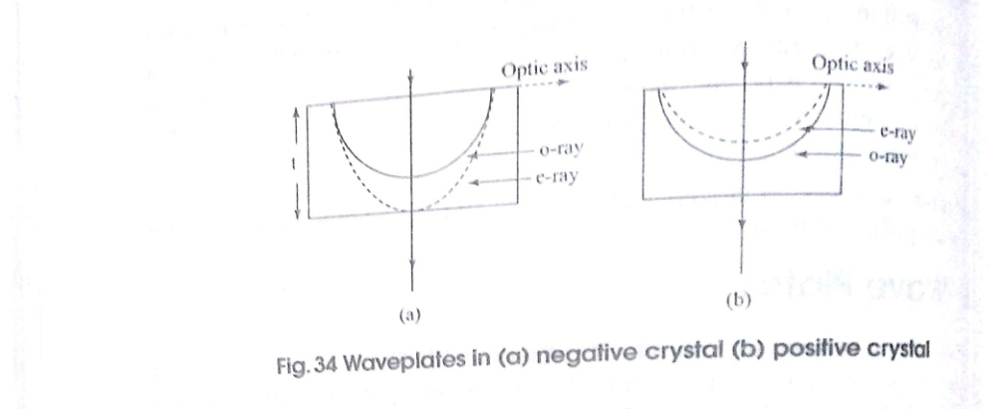

In some crystals such as quartz, velocity if extraordinary ray is less than that of O-ray. Hence ellipsoidal wave front of e-ray lies within the spherical wave front. Such crystals are called +ve uniaxial crystals. In some other crystals such as Calcite ve > v0. Hence ellipsoidal wave front of e-ray lies away from that of v-ray. Such crystals are called negative uniaxial crystals. Wave plates introduce specific path difference between O-ray & e-ray.

Consider a Calcite crystal in the form of a plate with its optic axis along the surface. When an unpolarized light of wavelength $λ$ falls normally on crystal surface, O-wave & e-wave travel with increase in path difference along their propagation direction. If t is thickness of the plate then

Optical path of O-ray = µ0t

Optical path of e-ray = µet

Optical path difference = (µ0 ~ µe) t

**Quarter wave plate:** If the thickness of the plate is such that path difference of the plate is equal to $\frac{λ}{4}$, it is called as Quarter wave plate.

(µ0 ~ µe) t =

t =

(µ0 ~ µe) 4

**Half wave plate:** If thickness of the plate is such that path difference is equal to $λ$/ 2, it is called half wave plate.

(µ0 ~ µe) t =

t =

2(µ0 ~ µe)