**Rapport Mini Projet**

**“Team Ice”**

This is the rapport for my mini project app called “Team Ice” for sharing questions between team members and answering them

You can watch the 2mn youtube video that I made to guide you threw the app

youtube link :

<https://www.youtube.com/watch?v=a3tBGy5qEEo>

youtube sign in video guid :  
  
 <https://www.youtube.com/shorts/Z9C09XfRVIs>

Technologies :

react : for frontend logic and coding

symfony : for backend logic and coding the api

bootstrap : for styling the web app

bootstrap icons : for styling the web app with icons  
 vscode : the ide used to write code

xampp : for interacting with databases using phpmyadmin

json-server : for building a fake api to test the react frontend app

fig-jam : for brain storming



To run this project :

1. download the project from github

2. open xampp or any other similar software :  
 3. start apache & mysql

4. import “db_database.sql”  
 5. cd into “backend-symfony-6” and run those commands :

“composer install”

“symfony server:start”

6. cd into “frontend-react” and run those commands :

“npm install”

“npm start”

7. open browser and open the link generated by npm start

8. there is three users saved for the app

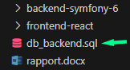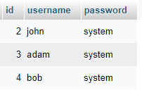

Screenshots for how the app works :

. you can log in with different users and log out

. you can create new users

(with input control for wrong password and existing user)

. you can crud on comments and curd on posts

