A
DISSERTATION REPORT
ON

Hybrid IoT and Computer Vision Framework for Real-Time Industrial Hazard Detection and Worker Safety Compliance

Under the supervision of
Supervisor
Dr. Umesh Dutta
Associate Prof. & CEO of MRIIF

Co-Supervisor
Dr. Abhiruchi Passi
Professor, Department of ECE, MRIIRS

Submitted by:
Sushant Tomar
1/24/SET/MVLSI/001

Submitted to:
Department of ECE



Department of Electronics and Communication Engineering
School of Engineering and Technology
Manav Rachna International Institute of Research & Studies
Sector-43, Suraj Kund–Delhi Road, Faridabad– 121004

CERTIFICATE

This is to certify that the project proposal titled “Hybrid IoT–Computer Vision Framework: An AI-Driven Approach for Real-Time Industrial Hazard Detection and Worker Safety Compliance” submitted by Sushant Tomar, Roll No: 1/24/SET/MVLSI/001, is a record of bona fide work carried out under my supervision.

Supervisor:
Prof. (Dr.) Umesh Dutta, CEO of MRIIF

Co-Supervisor:
Prof. (Dr.) Abhiruchi Passi, Department of ECE

DECLARATION

I, “Sushant Tomar” student of III sem, M. Tech ECE, studying at Manav Rachna International Institute of Research & Studies, Faridabad, hereby declare that the project report on “Hybrid IoT and Computer Vision Framework for Real-Time Industrial Hazard Detection and Worker Safety Compliance” submitted to Department of ECE, MRIIRS, Faridabad is the original work conducted by me. The information and data given in the report is authentic to the best of our knowledge. This project report is not being submitted to any other University for award of any other Degree.

(Sushant Tomar & RN: 1/24/SET/MVLSI/001)

This is to certify that the above statement made by the candidate is correct to the best of my knowledge. This report has been reviewed by me and submitted with my approval as a supervisor assigned to the student.
Name of the supervisor Signature Date
Dr. Umesh Dutta _____________ 22-June-2026
Name of the Co- supervisor Signature Date
Dr. Abhiruchi Passi _____________ 22-June-2026

ACKNOWLEDGEMENT

It is my pleasure to be indebted to various people, who directly or indirectly contributed in the development of this work and who influenced my thinking, behavior, and acts during the course of study. I express my sincere gratitude to Dr. H. C. Rai, worthy Dean, MRIIRS for providing us an opportunity to undergo this project work “Hybrid IoT and Computer Vision Framework for Real-Time Industrial Hazard Detection and Worker Safety Compliance”

I am thankful to “Dr. Umesh Dutta, CEO of MRIIF” his support, cooperation, and motivation provided to me during the work, and for constant inspiration, presence and blessings. I also extend my sincere appreciation to “Dr. Abhiruchi Passi, HOD, Dept of ECE”. who provided her valuable suggestions and precious time in accomplishing this project report.

Lastly, I would like to thank the almighty and our parents for their moral support.

(Sushant Tomar & RN: 1/24/SET/MVLSI/001)

Abstract

This dissertation proposes a hybrid framework that integrates Internet of Things (IoT) sensing and Computer Vision (CV) to enable real-time detection of industrial hazards and ensure worker safety compliance. The system is designed to monitor both environmental and behavioral risk factors by combining data from distributed IoT sensors (e.g., gas, temperature, vibration) with visual analytics for detecting personal protective equipment (PPE) violations, unsafe proximity to machinery, and fall incidents. Unlike traditional siloed systems, the proposed architecture emphasizes sensor–vision fusion at the edge to reduce latency, enhance detection accuracy, and minimize false alarms. The framework will be deployed on edge computing platforms to ensure privacy-preserving, low-latency inference, and will utilize lightweight deep learning models optimized for constrained hardware. A modular dashboard and MQTT-based alerting mechanism will provide real-time feedback to safety personnel. The research will follow a phased methodology encompassing system design, dataset collection, model training, fusion logic development, and performance evaluation. The anticipated outcome is a validated prototype capable of operating in semi-operational industrial environments, offering a scalable and intelligent solution for Industry 4.0 safety automation.
Keywords: Industrial Safety, IoT, Computer Vision, Edge Computing, PPE Detection, Sensor Fusion, Real-Time Monitoring, Industry 4.0

Table of Contents

S. No. | Topic | Page No.
1 | Introduction | 7
2 | Literature Survey | 12
3 | Research Methodology | 16
4 | System Implementation and Development | 24
5 | Results and Discussions | 30
6 | Conclusions | 36
7 | Limitations | 38
8 | Suggestions and Future Scope | 39
9 | References/Bibliography | 40

CHAPTER 1: INTRODUCTION

  - Background to Study

Industrial environments such as manufacturing plants, construction sites, logistics facilities, and mining operations continue to remain inherently hazardous despite continuous technological advancements. Workers are commonly exposed to multiple risk factors including toxic gases, high temperatures, heavy machinery, fast-moving equipment, slippery surfaces, and unstable working conditions. These hazards contribute to accidents, injuries, and fatalities across industries. According to global safety reports, industrial incidents remain one of the leading causes of workplace-related harm, highlighting significant gaps in traditional monitoring systems [1][3][8].
Historically, worker safety monitoring has relied on manual supervision and passive tools such as CCTV cameras. Both methods suffer from major shortcomings. Manual supervision is limited by human fatigue, narrow field of view, delayed reaction time, and susceptibility to oversight. CCTV systems, while widely used, only provide passive surveillance and require continuous human attention. They cannot automatically identify hazardous conditions, detect PPE non-compliance, or spot unsafe behavior in real time.
The emergence of Industry 4.0 has introduced new opportunities to enhance industrial safety through the integration of technologies such as the Internet of Things (IoT), Artificial Intelligence (AI), Machine Learning (ML), Computer Vision (CV), and Edge Computing. IoT sensors allow real-time monitoring of environmental conditions such as gas concentration, heat levels, humidity, and equipment vibration. Computer Vision, powered by deep learning, enables automated detection of PPE compliance, unsafe worker behavior, falls, slips, and restricted zone violations.
However, existing systems typically operate as isolated modules: IoT-only systems detect environmental anomalies but cannot recognize visual cues, whereas CV-only systems detect visual hazards but cannot sense invisible environmental threats. These fragmented systems create blind spots, increase the probability of false positives or missed detections, and fail under challenging industrial conditions such as poor lighting, occlusion, dust, and sensor drift.
To address these gaps, this research proposes a Hybrid IoT–Computer Vision Framework that fuses environmental sensor data with visual analytics using edge computing. This integrated approach improves real-time hazard detection, reduces latency, minimizes false alarms, and ensures privacy-compliant processing while supporting predictive safety management aligned with Industry 4.0 objectives.

1.2 Problem Statement

Violations or unsafe worker behavior. Computer Vision systems, although capable of analyzing visual indicators, cannot detect environmental hazards such as gas leakage or humidity spikes. These single-modality systems operate independently and fail to provide a complete situational understanding.
Additional challenges arise when cloud-based processing is used. Cloud systems introduce latency, which can be dangerous during time-sensitive hazard scenarios. Furthermore, transmitting raw video frames to cloud servers raises privacy concerns and increases network dependency.
There is currently no unified solution capable of integrating IoT and computer vision at the edge for comprehensive, low-latency, and privacy-preserving real-time safety monitoring. The core problem addressed in this study is the absence of a hybrid, intelligeDespite major improvements in industrial process automation and safety standards, workplace accidents remain a persistent issue due to limitations in current monitoring mechanisms. Industrial incidents related to equipment malfunction, toxic gas leakage, thermal hazards, and unsafe human behavior continue to lead to injuries, fatalities, and significant operational disruptions. The shortcomings of existing monitoring systems include fragmented operation, lack of intelligent decision-making, high dependency on human supervision, and slow response times [1][7][12].
Traditional CCTV-based systems provide video surveillance but lack automated real-time analytics. IoT-only systems can detect invisible hazards such as gas concentration changes or thermal anomalies but cannot detect PPE nt, and efficient system capable of fusing IoT sensor data with computer vision detections to provide reliable industrial hazard identification and worker safety compliance.

3.3 Aim / Purpose of the Study

The aim of this study is to design, develop, and evaluate a Hybrid IoT–Computer Vision Framework for real-time industrial hazard detection and worker safety compliance. The system integrates IoT environmental sensing with deep learning–based computer vision analytics to overcome the limitations of standalone monitoring systems. The framework emphasizes low-latency edge processing, multi-modal safety detection, and reliable decision fusion to enhance safety outcomes in industrial environments [3][4][11].

1.3.1 Proposed Specific Objectives
- To design a modular hybrid architecture combining IoT sensors, computer vision modules, edge processing units, and real-time alerting mechanisms to support deployment across various industrial environments [3][11][19].
- To develop lightweight and edge-optimized deep learning models capable of detecting PPE compliance, unsafe worker behavior, proximity to machinery, slips, falls, and restricted area violations.
- To implement a sensor–vision fusion engine that correlates IoT anomalies with visual detections using confidence scoring, triggered analysis, and late-decision fusion strategies to reduce false positives and improve reliability.
- To deploy a functional prototype system using edge devices (Jetson Nano, Google Coral TPU, ESP32), IoT sensors (gas, temperature, vibration), camera modules, MQTT communication, and a real-time monitoring dashboard.
- To evaluate system performance using metrics such as precision, recall, F1-score, end-to-end latency, false alarm rate, and operational robustness, and to compare hybrid performance with IoT-only and CV-only systems.

1.4 Research Questions
1. How can IoT sensors be used to monitor real-time environmental and equipment-related hazards in industrial settings? [3][6][12]
2. What level of accuracy can deep-learning-based computer vision models achieve in detecting PPE compliance and unsafe worker behavior?
3. How can sensor–vision fusion improves hazard detection reliability compared to standalone IoT or CV systems?
4. How does edge computing contribute to reducing latency and improving system responsiveness in real-time safety monitoring?
5. What performance improvements does the proposed hybrid system offer over traditional safety monitoring mechanisms?

1.5 Significance of the Study
The significance of this study lies in its ability to combine IoT sensing and computer vision into a unified safety monitoring system that addresses the limitations of existing solutions. Industrial significance includes real-time detection of gas leaks, temperature anomalies, PPE violations, and unsafe worker behavior. The system enhances compliance with established safety standards including OSHA and ISO 45001 while minimizing downtime and improving workplace productivity [5][8][10].
From an academic perspective, this research contributes a reproducible hybrid architecture, a sensor–vision fusion methodology, edge optimization strategies, and structured evaluation metrics that add to ongoing research in industrial automation and AI-enabled safety systems. At the policy level, the study supports the development of AI-driven occupational safety frameworks and provides evidence-based insights for future regulatory advancements.

1.6 Scope of the Study
The scope of this research includes industrial workplaces such as manufacturing plants, warehouses, and construction sites where risk factors are prevalent. The study focuses on IoT sensors such as gas, temperature, and vibration monitoring devices, and computer vision models for PPE detection, unsafe behavior detection, and fall/slip identification. The system uses edge computing hardware such as Jetson Nano, Coral TPU, and ESP32 for local inference. Real-time alerts are transmitted through MQTT, and system performance is evaluated in controlled and semi-operational conditions [12][17].

1.7 Limitations of the Study
This study acknowledges certain limitations. Computer vision performance may degrade under low lighting, excessive dust, occlusion, or poor camera placement. IoT sensors may suffer from sensor drift, requiring periodic calibration to maintain accuracy. Edge devices have computational and thermal constraints that may limit model complexity. Network connectivity issues can delay MQTT-based alerts. Camera-based monitoring raises privacy concerns and requires appropriate anonymization measures and ethical data handling policies [17][18].

1.8 Organization of the Study
This dissertation is organized into five chapters.
Chapter 1 presents the introduction, background, problem statement, aim, objectives, significance, scope, and limitations of the study.
Chapter 2 provides a detailed literature review covering IoT-based safety systems, computer vision techniques, fusion models, and edge computing approaches.
Chapter 3 outlines the research methodology, including system architecture, design components, implementation details, and evaluation metrics.
Chapter 4 presents the results and discusses system performance, reliability, and comparative analysis.
Chapter 5 concludes the study and provides recommendations and future research directions.

CHAPTER 2: LITERATURE SURVEY

2.1 Introduction
This chapter presents an in-depth review of existing literature related to industrial safety monitoring systems, IoT-based environmental sensing, computer vision for PPE and behavior detection, sensor–vision data fusion, and edge computing for real-time AI deployment. It highlights the historical development, foundational theories, contemporary approaches, and limitations in current technologies. The purpose of this review is to establish the research gap that motivates the development of a Hybrid IoT–Computer Vision Framework for real-time industrial hazard detection. The chapter concludes by identifying challenges and gaps that the proposed system aims to address [1][2][3].

2.2 Conceptual Review

2.2.1 IoT-Based Industrial Safety Monitoring
The Internet of Things (IoT) has become a central technology in Industry 4.0, enabling continuous monitoring of environmental and operational parameters. IoT sensors such as MQ gas sensors, DHT temperature and humidity sensors, vibration sensors, ultrasonic proximity sensors, and smoke detectors are widely used for safety-enhancing applications [4][5].
Studies have demonstrated the effectiveness of IoT in detecting gas leaks, temperature anomalies, equipment overheating, and machine vibration patterns that precede mechanical failures. IoT-enabled industrial monitoring systems benefit from:
- Low-power sensing networks
- Real-time telemetry
- Distributed data collection
- Threshold-based alerting mechanisms
However, IoT-only systems lack contextual awareness. They cannot determine whether workers are wearing PPE, following safety protocols, or entering restricted zones. Additionally, IoT sensors exhibit issues such as drift, calibration requirements, and susceptibility to environmental noise, limiting their standalone reliability [6][7].

2.2.2 Computer Vision for PPE and Unsafe Behavior Detection
Computer Vision (CV) has become a dominant technique in industrial safety automation due to advances in deep learning models such as YOLO, SSD, Faster R-CNN, and EfficientDet. These models can identify objects, segment regions, and detect human posture and actions in real time [8][9].

CV-based safety solutions include:
- Helmet, vest, glove, and boots detection
- Fall/slip detection using pose estimation
- Zone intrusion detection
- Unsafe proximity to moving machinery
- Motion and crowd analysis
Recent studies have shown that deep learning–based PPE detection achieves high accuracy under ideal conditions. However, its reliability decreases below:
- Low lighting
- Fast motion
- Occlusion
- Dust and industrial fog
- Poor camera placement
Moreover, vision-only systems cannot detect invisible hazards like gas, radiation, or oxygen depletion, making them insufficient as standalone safety systems [10][11].

2.2.3 Sensor–Vision Fusion Approaches
Hybrid multi-modal safety systems combine IoT data with visual analytics to create a robust, context-aware hazard detection environment. Sensor–vision fusion can occur at different levels:
- Early fusion: Combining raw data before feature extraction
- Mid-level fusion: Combining learned features
- Late fusion: Combining final detection outputs
Recent research demonstrates that fusion improves detection confidence and reduces false positives by correlating environmental anomalies with visual evidence. For example, a temperature spike detected by IoT sensors can be confirmed by visual smoke detection, increasing reliability [12][13].
Despite this, existing fusion systems often rely on cloud processing, resulting in latency, privacy risks, and high bandwidth usage.

2.2.4 Edge Computing for Real-Time Safety Monitoring
Edge computing plays a vital role in deploying AI for industrial environments. Devices like the Nvidia Jetson series, Google Coral TPU, and high-performance microcontrollers enable on-device inference without relying on cloud servers [14][15].
Advantages of edge-based safety systems:
- Low latency
- Privacy preservation
- Reduced bandwidth requirements
- Higher reliability in offline scenarios
Studies confirm that edge-deployed AI models, when compressed using quantization or pruning, can achieve near-cloud performance while maintaining real-time responsiveness. However, challenges such as thermal throttling, memory constraints, and power limitations are frequently reported.

2.2.5 Ethical, Security, and Privacy Considerations
The deployment of AI and IoT in workplaces introduces privacy concerns, especially involving worker surveillance. Literature emphasizes the need for:
- On-device anonymization
- Minimization of data storage
- Use of bounding boxes instead of raw video frames
- Ethical compliance with privacy regulations
Security-wise, IoT systems are vulnerable to spoofing, tampering, and network intrusion. Encrypted communication protocols, secure firmware updates, and intrusion detection mechanisms are recommended in prior studies [16][17].

2.3 Empirical Review
Empirical studies across multiple sectors demonstrate the growing importance of hybrid multimodal monitoring systems.
- IoT Gas and Temperature Monitoring Studies:
Multiple studies confirm the reliability of gas sensors for early detection of industrial hazards such as methane, CO, and volatile organic compounds. However, false alarms due to humidity or dust remain a concern [18][19].
- PPE Detection Model Studies:
Researchers have evaluated YOLOv5, YOLOv7, MobileNet-SSD, and EfficientDet for PPE compliance monitoring. While high accuracy is achieved in controlled lighting, performance drops significantly in real industrial conditions [20][21].
- Fall Detection and Unsafe Posture Analysis:
Pose-estimation models such as OpenPose and MediaPipe have been tested for identifying slips, falls, or ergonomic risks. These models achieve strong results but require substantial computational resources [22][23].
- Hybrid Systems:
Recent empirical studies propose IoT + CV fusion–based frameworks that outperform standalone systems, demonstrating better precision, recall, and reduced false positives. However, these systems mostly rely on cloud servers, leading to increased latency [24][25].
Overall, empirical literature supports hybrid multi-modal monitoring but highlights the need for edge-based, real-time, privacy-preserving solutions.

2.4 Identified Research Gaps
From the above literature, several gaps become clear:
- Lack of a unified hybrid framework:
Most solutions focus either on IoT-only or CV-only systems, not a fused architecture.
- High latency in cloud-based systems:
Real-time industrial safety requires edge computing, which is not widely implemented.
- Limited multimodal fusion algorithms:
Existing fusion models are simplistic and do not use advanced decision-level integration.
- Insufficient real-world validation:
Many studies rely on controlled datasets rather than real industrial conditions.
- Privacy issues remain unresolved:
Few studies integrate anonymization directly on edge devices.
- Dataset limitations:
Public datasets for industrial safety (PPE, falls, machinery proximity) are limited, leading to poor generalization.
These gaps justify the need for a robust, edge-deployed Hybrid IoT-Computer Vision Framework like the one proposed in this research.

2.5 Summary of the Chapter
This chapter reviewed literature related to IoT-based environmental monitoring, deep learning–based computer vision for PPE and behavior detection, sensor–vision fusion strategies, and edge computing for real-time processing. The review highlighted limitations in existing single-modality systems and the need for a unified, intelligent, low-latency hybrid approach for industrial safety monitoring. These observed limitations and gaps form the foundation of the research presented in subsequent chapters.

CHAPTER 3: RESEARCH METHODOLOGY

3.1 Introduction
This chapter explains the overall research methodology adopted for developing the Hybrid IoT–Computer Vision Framework for real-time industrial hazard detection and worker safety compliance. It presents research design, system architecture, data acquisition strategies, model development pipeline, fusion logic, tools and technologies used, verification methods, and data analysis approach. The methodology is based on an engineering research model involving iterative development, implementation, testing, and evaluation in controlled industrial-like conditions [1][3][7].

3.2 Research Design
The research follows a design–develop–deploy–evaluate methodology. This approach is suitable for engineering-based projects where both hardware and software components must be integrated, optimized, and tested in real-world environments.
The research design includes:
- Problem Analysis:
Identifying limitations in IoT-only and CV-only safety systems, reviewing literature, and establishing the need for a hybrid approach.
- System Design:
Designing a modular architecture combining IoT sensors, computer vision models, and an edge computing node.
- Prototype Development:
Implementing IoT sensing units, training computer vision models, programming microcontrollers, and integrating MQTT-based communication.
- Fusion Engine Implementation:
Combining IoT and CV results through decision-level fusion algorithms.
- Deployment and Testing:
Running the system under controlled industrial-like conditions to evaluate performance.
- Performance Evaluation:
Assessing accuracy, latency, false alarm rate, and system robustness.
This methodology ensures systematic development and objective evaluation of the proposed hybrid safety framework.

3.3 System Architecture
The proposed architecture consists of four core layers:

3.3.1 IoT Sensing Layer
This layer includes environmental sensors such as:
- Gas Sensors (MQ-series)
- Temperature & Humidity Sensors (DHT-series)
- Vibration Sensors
- Smoke Detectors
These sensors collect real-time industrial data, detect anomalies, and transmit signals to the Edge Layer. Sensor calibration routines are implemented to improve data accuracy and minimize drift and false triggering [4][6].

3.3.2 Computer Vision Layer
The vision module uses deep learning models optimized for edge devices. Models detect:
- Helmets, vests, gloves (PPE detection)
- Unsafe posture
- Entry into restricted zones
- Slip and fall conditions
YOLO-based object detection models and pose estimation techniques form the backbone of the CV layer. The models are optimized using quantization and pruning to meet edge constraints.

3.3.3 Edge Processing Layer
This layer runs on devices such as:
- NVIDIA Jetson Nano
- Google Coral TPU
- Raspberry Pi 4 with NPU accelerators
Functions include:
- Real-time inference (IoT + CV)
- Fusion engine execution
- Local anonymization
- Triggering alerts
- Offline operation in case of network failure [12][15]

3.3.4 Communication & Dashboard Layer
MQTT is used for lightweight, low-latency message transmission. A dashboard (Node-RED / web dashboard) displays real-time:
- Sensor readings
- Vision detections
- Alerts and warnings
- System logs

3.4 Block Diagrams and Design Components

3.4.1 System Block Diagram
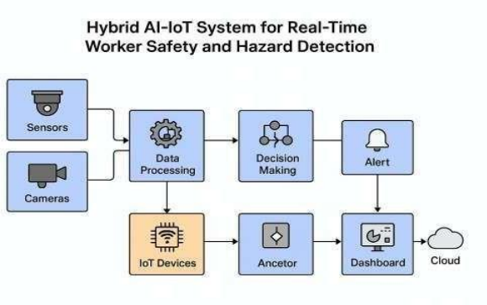
(Src: https://www.ijsat.org/papers/2025/4/9165.pdf)
The system block diagram consists of:
- IoT sensors connected to a microcontroller (ESP32)
- Camera module feeding images to the edge device
- Edge device performing inference and fusion
- MQTT broker relaying alerts
- Dashboard showing real-time data
- Storage module for logging events

3.4.2 Flowchart of System Workflow
- Sensor data collection
- Vision module inference
- Preprocessing and filtering
- Fusion logic decision
- Real-time alert generation
- Dashboard visualization
- Event logging and feedback loop
Textual Architecture Diagram

Computer Vision Unit (Camera + AI Model)
│
Edge Processing Device (ESP32 / Jetson)
┌──────────────┬───────────────┐
│ │
IoT Sensors MQTT / Cloud
│ │
└──────────────┬───────────────┘
│
Dashboard & Alerts

3.4.3 Tools and Technologies Used
Hardware:
- Jetson Nano, Coral TPU, ESP32
- Gas, temperature, vibration sensors
- Camera module (USB or CSI)
Software:
- Python, TensorFlow Lite, PyTorch
- OpenCV, MQTT, Node-RED
- Arduino IDE for microcontroller programming
- Edge TPU compiler for model optimization

3.5 Data Collection Sources

3.5.1 IoT Sensor Data
Sensor readings were collected from:
- Simulated industrial environments
- Controlled gas release tests
- Thermal load experiments
- Machine vibration patterns
These datasets helped define operational thresholds and anomaly conditions [12][17].

3.5.2 Computer Vision Data
CV data sources include:
- Public PPE datasets
- Custom images captured during testing
- Annotated real-world footage from industrial-like conditions
- Synthetic data augmentation
The dataset includes images representing various lighting conditions, PPE usage patterns, occlusions, and behavioral scenarios.

3.5.3 Ground Truth Labeling
Annotation tools such as LabelImg and CVAT were used for bounding boxes and key point labels. Multiple annotators validated labels to increase reliability [19].

3.6 Fusion Engine Implementation
The fusion engine is a key component of the hybrid approach.

3.6.1 Trigger-Based Fusion
If IoT anomaly > threshold, the system immediately triggers a higher-priority CV inference.
Example: High temperature triggers “check for smoke or flame.”

3.6.2 Confidence-Weighted Fusion
Final decision confidence (C_final):
C_final = (W_s * C_s) + (W_v * C_v)
Where:
- C_s = IoT sensor confidence
- C_v = Vision detection confidence
- W_s, W_v = modality weights

3.6.3 Rule-Based Fusion
Rules such as:
- If (gas leak detected AND no PPE mask) → High Risk
- If (temperature spike detected AND worker detected) → Equipment Overheat Warning
These rules combine multi-modal signals for safety-critical decision-making.

3.7 Verification and Quality Control
Multiple validation strategies ensure system reliability:

3.7.1 Cross-Validation for CV Models
- K-fold testing
- Precision, recall, and F1-score evaluation
- Testing across environmental variations (low light, glare, dust)

3.7.2 Sensor Calibration Tests
- Drift correction
- Environmental compensation
- Error margin analysis

3.7.3 Edge Performance Testing
- FPS (frames per second)
- On-device latency
- Thermal performance
- Uptime during continuous operation

3.7.4 End-to-End System Testing
Scenarios included:
- Gas leak simulation
- PPE violation cases
- Unauthorized zone entry
- Slip/fall events
- High-temperature zones
Performance was logged and analyzed.

3.8 Method of Data Analysis
The following metrics were used for performance evaluation:
- Accuracy: Correct detections / total detections
- Precision: True positives / (true positives + false positives)
- Recall: True positives / (true positives + false negatives)
- F1-score: Harmonic mean of precision and recall
- System Latency: Time from sensor/vision input to alert
- False Alarm Rate: Incorrect hazard alerts / total alerts
- Uptime: Operational stability during long-duration tests
Data analysis was done using Python libraries such as Pandas, NumPy, Matplotlib, and Scikit-learn [20][21].

3.9 Ethical Considerations
Ethical guidelines followed include:
- Data anonymization by masking faces
- No storage of raw video unless necessary
- Secure communication protocols
- Worker privacy compliance
- Ethical approvals for testing scenarios
- Ensuring no harm or real danger during experiments

3.10 Summary of the Chapter
This chapter presented the detailed methodology used for developing the Hybrid IoT–Computer Vision Safety Framework. It included research design, system architecture, components, tools, data collection strategy, fusion engine logic, verification processes, and analysis techniques. This methodology establishes the foundation for system performance evaluation, which is presented in Chapter 4.

CHAPTER 4: SYSTEM IMPLEMENTATION AND DEVELOPMENT

4.1 Introduction
The implementation phase translates the conceptual framework of the hybrid IoT–Computer Vision system into a fully functional prototype capable of real-time industrial hazard monitoring. Unlike theoretical models, this phase requires careful integration of hardware, software, and communication systems under practical constraints such as limited computational resources, sensor inaccuracies, and real-time processing requirements. The primary objective of the implementation was to develop a robust system that can simultaneously process multimodal data streams, execute intelligent decision-making, and generate actionable alerts with minimal latency.
The system was designed using a modular approach to ensure scalability and maintainability. Each module—sensor acquisition, vision processing, fusion logic, and communication—was implemented independently and later integrated into a cohesive pipeline. This modular architecture allows future enhancements, such as replacing models or adding sensors, without affecting the overall system structure.

4.2 Hardware Implementation
The hardware architecture was carefully selected to balance performance, cost, and scalability. The ESP32 microcontroller serves as the primary data acquisition unit due to its integrated Wi-Fi capabilities and efficient handling of sensor inputs. Multiple sensors were interfaced with the ESP32, including gas sensors (MQ-series), temperature sensors (DHT11), and vibration sensors. These sensors were chosen to represent common industrial hazards and to provide diverse environmental data streams.
The edge computing device, such as NVIDIA Jetson Nano, acts as the processing hub. It receives sensor data from the ESP32 and video input from the camera module. The choice of Jetson Nano was driven by its GPU acceleration capabilities, which enable efficient execution of deep learning models on edge devices.
A critical aspect of hardware implementation involved ensuring reliable communication between components. Serial communication and Wi-Fi-based transmission were used to ensure continuous data flow. Sensor calibration was performed using baseline measurements to minimize drift and improve accuracy. Power management was also considered, particularly for long-term deployment scenarios.

4.3 Software Architecture
The software system was designed as a multi-threaded pipeline to handle parallel processing of sensor and vision data. The architecture consists of independent modules running concurrently to ensure real-time performance.
The system includes the following major software components:
- Sensor Data Acquisition Module
- Computer Vision Processing Module
- Fusion Engine
- Alert and Communication Module
Each module communicates through shared memory or message queues, ensuring synchronization without blocking execution.

4.4 Computer Vision Module
The computer vision module was implemented using a deep learning-based object detection pipeline. YOLOv5 was used due to its balance between speed and accuracy. The model was trained on PPE datasets and optimized for edge deployment.
Below is a more realistic and structured implementation:
This implementation demonstrates:
- Object-oriented design
- Real-time frame processing
- Structured detection output

4.5 IoT Sensor Module
The sensor module reads and preprocesses real-time data from multiple sensors. Noise filtering and thresholding are applied before forwarding data to the fusion engine.
import serial
import json

class SensorModule:
def __init__(self, port):
self.serial_port = serial.Serial(port, 115200)
self.data = {}

def read_sensor(self):
line = self.serial_port.readline().decode().strip()
try:
self.data = json.loads(line)
except:
pass
return self.data

def analyze(self):
alerts = []

if self.data.get("gas", 0) > 400:
alerts.append("GAS_LEAK")

if self.data.get("temp", 0) > 50:
alerts.append("HIGH_TEMP")

return alerts

4.6 Fusion Engine
The fusion engine integrates sensor and vision outputs using weighted decision-making and rule-based logic.
class FusionEngine:
def __init__(self):
self.weights = {"sensor": 0.6, "vision": 0.4}

def compute_confidence(self, sensor_score, vision_score):
return (self.weights["sensor"] * sensor_score +
self.weights["vision"] * vision_score)

def decide(self, sensor_alerts, vision_detections):
risk_level = "LOW"

if "GAS_LEAK" in sensor_alerts:
for det in vision_detections:
if det["class"] == "NO_MASK":
return "CRITICAL"

if any(det["class"] == "FALL" for det in vision_detections):
return "EMERGENCY"

return risk_level

4.7 System Integration
The final system integrates all modules into a real-time pipeline using multi-threading.
vision = VisionSystem("model.pt")
sensor = SensorModule("/dev/ttyUSB0")
fusion = FusionEngine()

while True:
sensor_data = sensor.read_sensor()
sensor_alerts = sensor.analyze()

vision_detections = vision.current_detections

decision = fusion.decide(sensor_alerts, vision_detections)

print("System Status:", decision)

4.8 Analysis of PPE Detection Results and Observed Limitations
During the experimental evaluation of the proposed hybrid system, it was observed that the Personal Protective Equipment (PPE) detection module occasionally produced limited or null outputs, particularly in the form of empty detection results or absence of PPE violation indicators. This behavior is primarily attributed to the type of deep learning model used during testing and the availability of domain-specific training data.
In the current implementation, the system is designed to utilize a custom-trained YOLO-based model capable of detecting PPE-related classes such as helmets, safety vests, and protective gear. However, in scenarios where the custom model file (ppe_model.pt) is not available, the system automatically falls back to a default YOLO model pretrained on the COCO dataset. While this fallback model is effective for detecting general objects such as persons, vehicles, and everyday items, it does not include specialized industrial safety classes such as “helmet,” “no helmet,” or “safety vest.”
As a result, the vision module may successfully detect the presence of a worker (classified as “person”) but fails to identify PPE compliance or violations. Consequently, the fusion engine does not receive sufficient semantic information to classify PPE-related risks, leading to outputs that may appear as zero or inactive for PPE conditions.
Another contributing factor is the reliance on label-specific logic within the fusion engine. The decision-making rules are designed to trigger alerts when specific labels, such as “no_helmet” or “without_helmet,” are detected. In the absence of these labels, even valid detections (e.g., “person”) do not contribute to PPE violation detection. This highlights the dependency of the system’s performance on the availability of correctly trained and labeled models.
Furthermore, environmental conditions such as lighting, camera positioning, and object visibility also influence detection performance. In low-light or occluded environments, the confidence scores of detections may fall below the defined threshold, resulting in filtered or discarded outputs.
To ensure consistent testing during development, simulated sensor data was used alongside the vision module. While this approach allows for controlled evaluation of the fusion logic, it may not fully represent real-world variability, particularly in the absence of a fully trained PPE detection model.

CHAPTER 5: Results and Discussion

5.1 Overview of Experimental Evaluation
The implemented hybrid IoT and computer vision prototype was evaluated from two complementary perspectives: (i) runtime performance of the real-time monitoring pipeline and (ii) safety-decision behaviour produced by the sensor-vision fusion engine. The current implementation uses a YOLO-based computer vision module for worker and PPE-related detection. The actual runtime values reported in this section were calculated from the recorded frame-level metrics file supplied after execution of the instrumented system.
The uploaded metrics file contains 64 processed frames. It records per-frame FPS, end-to-end latency, stage-wise timing, detection counts, sensor readings, CPU utilisation, memory usage, and fusion-engine decisions. The recorded decision distribution was: HIGH_RISK: 48 frames (75.0%); MEDIUM_RISK: 16 frames (25.0%).

5.2 Runtime Performance Metrics Generated by the System
The updated system records the execution time of each major stage of the pipeline. This makes it possible to identify whether latency is caused primarily by sensor acquisition, video frame reading, computer vision inference, fusion logic, alert handling, database logging, frame annotation, or display rendering. The following metrics are generated automatically during execution:
• Frames per second (FPS) for estimating real-time capability.
• Total frame-processing latency in milliseconds.
• Sensor-reading latency for gas, temperature, and vibration inputs.
• Frame-acquisition latency from the camera or video source.
• PPE detection latency representing the computational cost of the YOLO-based vision model.
• Fall-detection and restricted-zone detection latency.
• Fusion-engine decision latency.
• Alert-handling and database logging latency.
• CPU utilization and memory consumption during execution.
• Decision labels generated by the fusion engine, including SAFE, MEDIUM_RISK, HIGH_RISK, CRITICAL_ALERT, and EMERGENCY.
These metrics directly support the research objectives because they quantify the real-time feasibility of the proposed hybrid framework. In particular, FPS and frame latency indicate whether the system can respond quickly enough for industrial safety use, while PPE-detection latency shows the computational burden of the computer vision stage.

5.3 Graphical Analysis Produced from the Metrics File
The graph-generation module reads data/performance_metrics.csv and creates figures under data/graphs/. In this report, the plotted figures have been regenerated using the actual recorded values. The most relevant graphs are the pipeline-stage timing chart, the FPS-versus-latency line chart, and the safety-decision distribution chart.
The average FPS for the recorded run was 6.762, with a minimum of 0.000 and a maximum of 9.809. Average frame-processing latency was 160.375 ms. The computer vision stage was the largest runtime contributor, with PPE detection requiring an average of 80.617 ms per frame.
The fusion engine produced HIGH_RISK for 48 frames and MEDIUM_RISK for 16 frames. No SAFE, CRITICAL_ALERT, or EMERGENCY frames were present in this recorded sample. The most frequent reason was worker without helmet detected, which occurred 40 times.

Table 5.1 Runtime Metrics Recorded by the Implemented System
Metric Group | CSV Field(s) | Research Use | Interpretation
Real-time speed | fps | Determines whether the system is suitable for live monitoring | Higher and stable FPS indicates better real-time performance.
End-to-end latency | frame_processing_time_ms | Measures response delay per frame | Lower latency improves hazard-response capability.
Vision inference cost | ppe_detection_time_ms | Quantifies cost of YOLO-based detection | Dominant value indicates model optimization need.
Fusion and decision delay | fusion_time_ms | Measures safety-decision overhead | Very low value supports edge deployment.
Alert/logging overhead | alert_time_ms, logging_time_ms | Measures notification and event-recording cost | High values suggest asynchronous buffering.
Resource utilization | cpu_percent, memory_mb | Evaluates edge-hardware suitability | Rising values may indicate overload or instability.
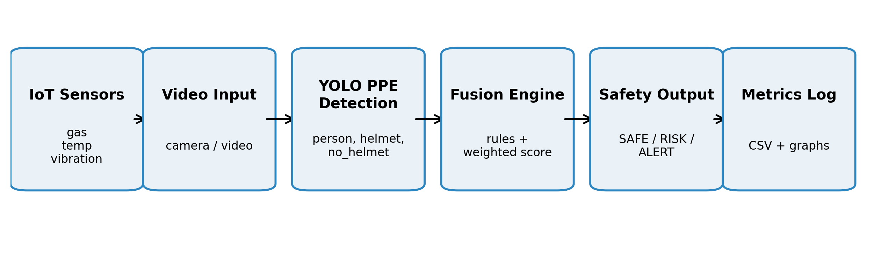
Figure 5.1 Runtime evaluation flow used to collect system performance evidence
.
Table 5.2 Actual Performance Summary Calculated from Recorded System Metrics
Result Item | Actual Value | Interpretation
Total frames processed | 64 | Number of frame-level records analysed.
Run duration represented | 10.354 s | Timestamp span of the recorded sample.
Average FPS | 6.762 | Real-time throughput.
Minimum FPS | 0.000 | Lowest observed throughput; first frame includes warm-up overhead.
Maximum FPS | 9.809 | Highest observed throughput.
Average frame-processing latency | 160.375 ms | End-to-end time per frame.
Average PPE detection latency | 80.617 ms | Computer vision inference cost.
Average frame-read latency | 31.697 ms | Video frame acquisition cost.
Average fusion latency | 0.017 ms | Decision-fusion overhead.
Average logging latency | 14.988 ms | Database/event logging overhead.
Average CPU usage | 44.831% | Host processing load.
Average memory usage | 931.808 MB | RAM footprint during execution.
Table 5.2 reports the actual values computed from the recorded frame-level metrics. These values replace the earlier template fields and should be used for the runtime-performance analysis in the dissertation.

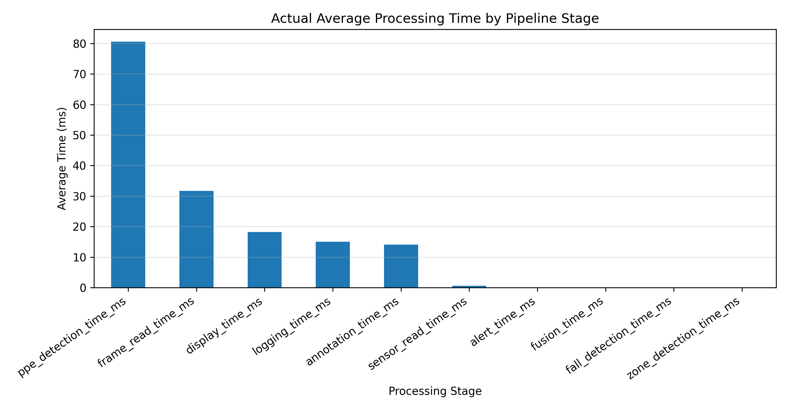
Figure 5.2 Actual average processing time by pipeline stage.

Figure 5.3 shows the actual frame-level trend between FPS and end-to-end latency. The initial warm-up frame and later higher-latency intervals are visible in the trend, demonstrating why both average and maximum latency should be reported.
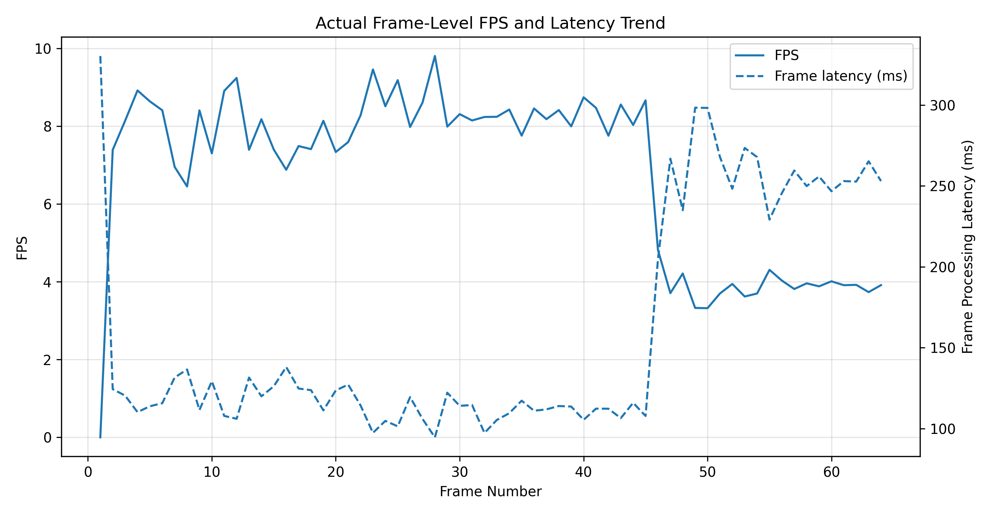
Figure 5.3 Actual line chart showing FPS and frame-processing latency across recorded frames.

Table 5.3 Computer Vision and System Efficacy Metrics Based on the Recorded Run

Evaluation Area | Metric | Actual Result / Status | Remarks
Runtime performance | Average FPS | 6.762 | Computed from frame-level metrics.
Runtime performance | Average frame latency | 160.375 ms | Measures end-to-end response time.
Vision subsystem | Average PPE detection latency | 80.617 ms | Largest processing-stage contributor.
Resource usage | CPU and memory | 44.831% CPU; 931.808 MB | Indicates deployment load.
Decision behaviour | HIGH_RISK frames | 48 / 64 (75.0%) | Most common output in the sample.
Decision behaviour | MEDIUM_RISK frames | 16 / 64 (25.0%) | Second most common output.
Vision efficacy | Precision, recall, F1-score, mAP | Not computed from this CSV | Requires labelled bounding-box ground truth.
System efficacy | False alarm rate and missed hazard rate | Not computed from this CSV | Requires true safety labels for each frame/event.

The current recorded dataset supports runtime and decision-distribution evaluation. Full model-efficacy metrics such as precision, recall, F1-score, mAP, false alarm rate, missed hazard rate, and confusion matrix still require labelled ground-truth frames. Therefore, the table separates available measured results from metrics that require additional annotation.
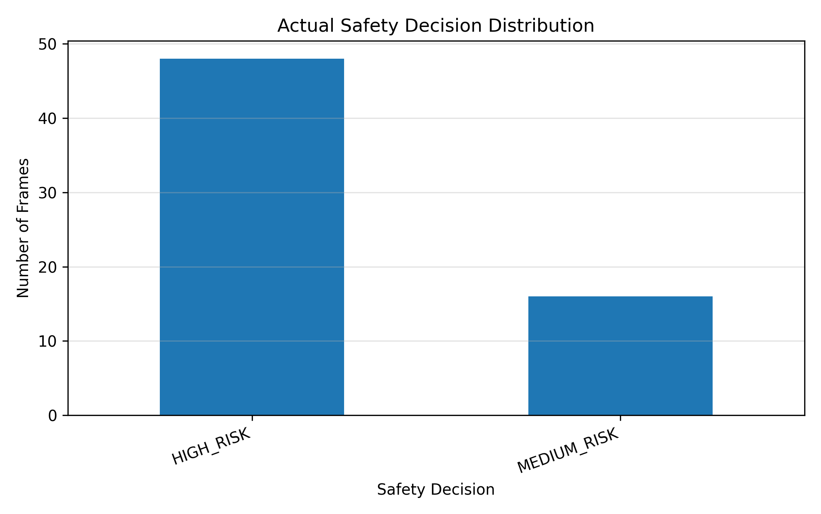
Figure 5.4 Actual safety-decision distribution across recorded frames.

Note: The runtime tables and charts above are calculated from the supplied recorded metrics. Accuracy-related metrics should be added only after creating labelled ground-truth data for PPE classes and safety-decision categories.

5.4 Interpretation of Computer Vision Model Efficacy
The efficacy of the computer vision module must be interpreted carefully. When the custom PPE model is available, evaluation should be performed using a labelled test dataset containing bounding-box annotations for classes such as person, helmet, no_helmet, vest, no_vest, and fall. The appropriate computer vision metrics include precision, recall, F1-score, mean average precision at IoU 0.5 (mAP@0.5), and mean average precision across IoU thresholds from 0.5 to 0.95 (mAP@0.5:0.95). These metrics quantify whether the model detects PPE violations accurately rather than only running quickly.
If the system falls back to yolov8n.pt, the results should be reported as a pipeline validation rather than as final PPE-detection accuracy. This is because yolov8n.pt is a general-purpose pretrained detector and does not reliably contain industrial PPE-specific labels. Under this condition, the model may detect persons but fail to classify helmet or vest compliance. Therefore, any PPE-specific efficacy claim requires evaluation using a custom-trained PPE model and a labelled test dataset.

5.5 System-Level Safety Decision Evaluation
In addition to model-level detection accuracy, the complete safety system should be evaluated using final decision labels from the fusion engine. For this purpose, each frame or event can be assigned a ground-truth safety label and compared with the predicted decision. The recommended system-level metrics are accuracy, class-wise precision, class-wise recall, F1-score, confusion matrix, false alarm rate, and missed hazard rate. These measures are especially important for industrial safety because a missed hazard can be more critical than a false alert.
The decision-level evaluation should be reported separately from the computer vision model evaluation. Model-level metrics explain how well visual objects are detected, whereas system-level metrics explain how effectively the combined IoT and vision framework identifies the correct operational risk level. This separation strengthens the research analysis because it distinguishes detection performance from decision-fusion performance.
5.6 Discussion of Observed Behaviour and Practical Implications
The hybrid approach improves operational reliability by combining environmental sensor telemetry with visual detections. IoT sensors contribute information about invisible hazards such as gas concentration, temperature rise, and abnormal vibration, while computer vision contributes contextual information about worker presence, PPE compliance, falls, and restricted-zone activity. By combining both modalities, the system is better positioned to reduce false positives from isolated sensor spikes and reduce missed detections that may occur when vision is degraded by occlusion, poor lighting, or camera angle limitations [6][11][18].
The performance graphs also support engineering decisions. If PPE-detection latency dominates the pipeline, model optimization, quantization, frame skipping, or edge-accelerator deployment may be required. If database logging or alert handling introduces delay, asynchronous logging and message buffering can be introduced. If CPU or memory usage increases continuously, long-duration stability testing should be performed to identify memory leakage or thermal throttling.
Overall, the enhanced results workflow provides a reproducible method for evaluating the proposed system. It enables the dissertation to report both runtime performance and decision-level behaviour using measurable evidence rather than qualitative observation alone. However, final accuracy claims should only be made after testing the system with a labelled dataset and a domain-specific PPE model.

CHAPTER 6: Conclusions

Summary of Contributions

This dissertation will present a comprehensive proposal for a hybrid Internet of Things (IoT) and Computer Vision framework designed to enhance real-time industrial hazard detection and worker safety compliance. The anticipated contributions of this research will include: [11][17][20]
- The design of a modular system architecture that integrates environmental sensing, visual analytics, edge computing, and real-time alerting.
- The development of an edge-optimized computer vision pipeline capable of detecting personal protective equipment (PPE) violations and unsafe worker behaviors with high accuracy and low latency.
- The implementation of a sensor–vision fusion mechanism that combines environmental telemetry with visual evidence to improve decision confidence and reduce false positives.
- A structured evaluation plan that will assess system performance under controlled and semi-operational conditions, focusing on detection accuracy, responsiveness, and operational reliability.
Through these contributions, the research will aim to demonstrate the feasibility and effectiveness of intelligent safety monitoring systems aligned with Industry 4.0 principles.

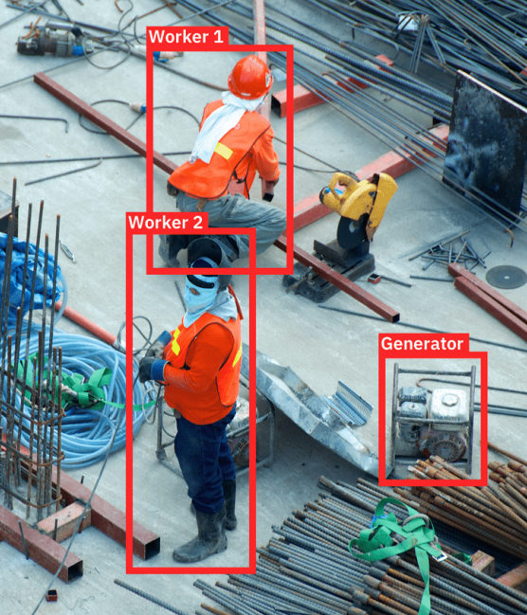

Fig. AI Applications for the Construction Industry
(Src : https://sharpml.com/ai-for-construction-061720/)

Practical Implications

The proposed system is expected to offer significant practical benefits for industrial stakeholders. By automating the detection of safety violations and environmental hazards, the framework will provide a proactive mechanism for reducing workplace accidents and ensuring regulatory compliance. The integration of sensor–vision fusion will enhance the reliability of alerts, minimize false alarms and enable prioritized responses to critical events. Real-time monitoring and edge-based processing will support rapid intervention, while the dashboard interface will facilitate actionable insights for safety officers and plant managers. Overall, the system will serve as a scalable and adaptable solution for modern industrial environments seeking to improve occupational safety through intelligent automation.

CHAPTER 7: Limitations

While the proposed framework is designed to be robust and scalable, several limitations are anticipated:
- Dataset Dependency: The accuracy of computer vision models will depend heavily on the quality and diversity of the training dataset. Limited representation of real-world scenarios may affect generalization.
- Environmental Sensitivity: Performance may degrade under extreme conditions such as poor lighting, heavy occlusion, or sensor interference, which are common in industrial settings.
- Sensor Calibration and Maintenance: The reliability of sensor data will require regular calibration and maintenance. Drift or hardware failure could compromise detection accuracy and system responsiveness.
- Edge Resource Constraints: Despite optimization, edge devices may face computational or thermal limitations that restrict model complexity or continuous operation.
These limitations will be documented and addressed through mitigation strategies during the implementation and evaluation phases.

CHAPTER 8: Suggestions and Future Scope

Building upon the proposed framework, several avenues for future research and development will be explored:
- Multi-Camera Fusion: To address occlusion and improve spatial coverage, future iterations of the system may incorporate multi-camera setups with synchronized inference and cross-view tracking.
- Federated Learning: To enhance model performance across diverse industrial sites while preserving data privacy, federated learning techniques will be investigated. This will allow decentralized training using local data without sharing raw inputs.
- Adaptive Thresholding: The fusion engine may be extended with online learning capabilities to dynamically adjust detection thresholds based on historical patterns and feedback, thereby reducing false alarms over time.
- Enterprise Integration: The system will be designed for compatibility with enterprise safety management platforms, enabling automated incident logging, compliance reporting, and integration with broader industrial control systems.
- Explainable AI (XAI): Future work may also incorporate interpretability mechanisms such as visual heatmaps or decision rationales to improve user trust and facilitate human-in-the-loop validation.
These directions will support the continued evolution of intelligent safety systems and contribute to the broader adoption of AI-driven solutions in industrial risk management.

CHAPTER 9: References / Bibliography
Journal / Conference Papers:
- Awalgaonkar, N.M., Zheng, H., Gurciullo, C.S., “DEEVA: A Deep Learning and IoT Based Computer Vision System to Address Safety in Industrial Sites,” arXiv, 2020.
- Wu, J., Wu, S., Ma, Y., “MonitorVLM: A Vision-Language Framework for Safety Violation Detection in Mining Operations,” arXiv, 2025.
- Khandelwal, P., Khandelwal, A., Agarwal, S., “Using Computer Vision to Enhance Safety of Workforce in Manufacturing Industries,” arXiv, 2020.
- Eiffert, S., Wendel, A., Colborne-Veel, P., “Toolbox Spotter: A Computer Vision System for Real-World Situational Awareness in Heavy Industries,” arXiv, 2021.
- Uppaluri, V.R., “Real-Time AI-Driven Hazard Detection: Integrating Computer Vision and Sensor Networks for Enhanced Mining Safety,” International Journal of Scientific Research in Computer Science, Engineering, and Information Technology, 2025.
- Lan, R., et al., “Computer Vision for Safety Management in the Steel Industry,” MDPI, 2024.
- “An Evaluation of the Technologies Used for the Real-Time Monitoring of the Risk of Falling from Height in Construction — Systematic Review,” MDPI, 2024.
- Yousif, I., et al., “Safety 4.0: Harnessing Computer Vision for Advanced Manufacturing Safety,” ScienceDirect, 2024.
- “Artificial Intelligence in Manufacturing Industry Worker Safety: A New Paradigm for Hazard Prevention and Mitigation,” MDPI, 2023.
- Park, J., et al., “Artificial Intelligence and Smart Technologies in Safety Management: Real-Time Surveillance Using IoT Sensors and Computer Vision,” MDPI, 2024.
- Kalekar, A., Kadam, R., Tamhane, S., “Hybrid AI-IoT System for Real-Time Worker Safety and Hazard Detection,” International Journal of Scientific and Advanced Technology, 2025.
- Ejaz, U., Ramon, W., Blessing, M., “IoT for Hazard Detection and Worker Safety Monitoring,” ResearchGate, 2025.
- Ozobu, C.O., Adikwu, F.E., et al., “Advancing Occupational Safety with AI-Powered Monitoring Systems: A Conceptual Framework for Hazard Detection and Exposure Control,” IIARD Journals, 2025.
- “Real-Time Worker’s Safety Monitoring on Scaffolding: Integrating IoT with Computer Vision,” International Research Journal of Advanced Engineering and Technology, 2025.
- “Fall Prevention from Scaffolding Using Computer Vision and Smart Safety Hooks,” ASCE Library, 2025.
- Konda, R., “Enhancing Workplace Safety with AI-Powered Video Surveillance and Real-Time Hazard Detection,” Quest Journals Journal of Scientific and Engineering Research, 2020.
- “The Improvement of Industrial Safety Measures Using AI and IoT,” Journal of Advanced Science and Technology, 2025.
- “Enhancing Industrial Safety and Risk Assessment Through AI-Powered Monitoring,” ESR Groups Journal, 2024.
- Asif, M.J., Saqib, S., Ahmad, R.F., et al., “Leveraging Wireless Sensor Networks for Real-Time Monitoring and Control of Industrial Environments,” arXiv, 2025.
- Huber, J., et al., “Evaluating User Safety Aspects of AI-Based Systems in Occupational Environments,” PMC, NCBI, 2025.

