CHAIN MEASUREMENTS – 4 LINKS
Measurements organized by link, with geometric reference and example photos
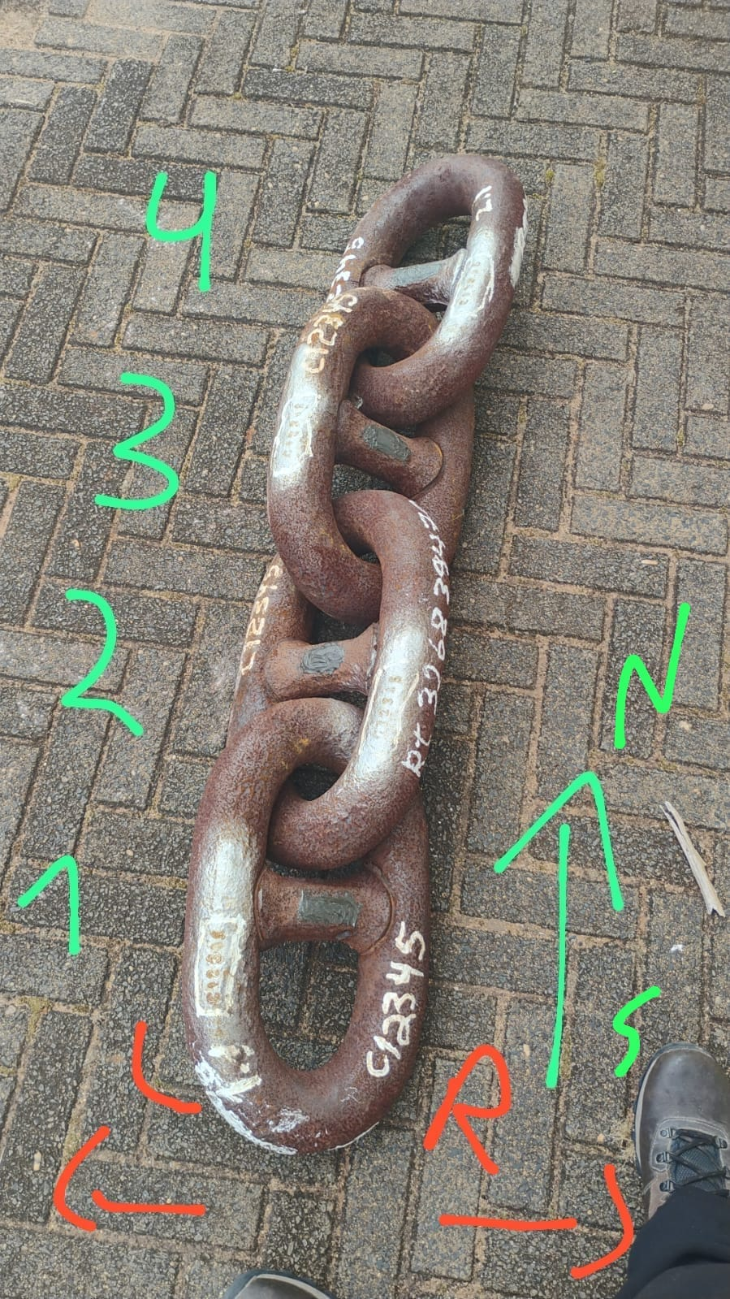 | 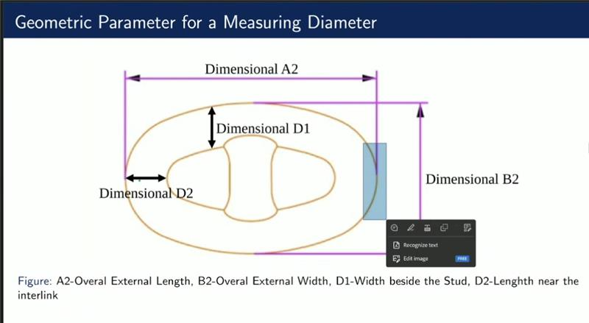
Reference: links are numbered from bottom to top (1 to 4). N/S and L/R follow the markings shown in the photo.
Measurement interpretation
D1 R: diameter / thickness beside the stud on the right side.
D1 L: diameter / thickness beside the stud on the left side.
D2 N: diameter / thickness near the interlink region on the North side.
D2 S: diameter / thickness near the interlink region on the South side.
A2: overall external link length.
B2: overall external link width.
The values below were transcribed exactly as provided. A2 and B2 contain two readings each; the other positions contain four readings each.
LINK 1 (value in cm)
Parameter / position | Reading 1 | Reading 2 | Reading 3 | Reading 4
D1 R | 7.410 | 7.404 | 7.420 | 7.398
D1 L | 7.510 | 7.590 | 7.481 | 7.476
D2 S | 7.380 | 7.372 | 7.324 | 7.414
D2 N | 7.18 | 7.50 | 7.41 | 7.57
A2 | 45.2 | 45.5 | — | —
B2 | 27.2 | 26.9 | — | —

LINK 2
Parameter / position | Reading 1 | Reading 2 | Reading 3 | Reading 4
D1 R | 7.332 | 7.324 | 7.402 | 7.412
D1 L | 7.330 | 7.502 | 7.550 | 7.512
D2 S | 7.110 | 7.072 | 7.150 | 7.102
D2 N | 7.071 | 7.068 | 7.046 | 7.052
A2 | 45.3 | 45.7 | — | —
B2 | 26.6 | 27.1 | — | —

LINK 3
Parameter / position | Reading 1 | Reading 2 | Reading 3 | Reading 4
D1 L – group 1 | 7.420 | 7.572 | 7.516 | 7.508
D1 R | 7.352 | 7.404 | 7.472 | 7.450
D1 L – group 2 | 7.410 | 7.384 | 7.440 | 7.482
D2 S | 7.350 | 7.334 | 7.310 | 7.400
D2 N | 7.134 | 7.142 | 7.200 | 7.148
A2 | 44.7 | 44.9 | — | —
B2 | 26.5 | 26.4 | — | —
Note: in the original notes for Link 3, the label “D1 L” appears twice. Both groups were preserved separately and highlighted in yellow, without changing the original data.

LINK 4
Parameter / position | Reading 1 | Reading 2 | Reading 3 | Reading 4
D1 R | 7.500 | 7.522 | 7.472 | 7.484
D1 L | 7.542 | 7.502 | 7.524 | 7.538
D2 S | 7.388 | 7.418 | 7.420 | 7.422
D2 N | 7.242 | 7.208 | 7.233 | 7.400
A2 | 45.8 | 45.6 | — | —
B2 | 26.7 | 26.9 | — | —

Example photos of how the measurements were taken
The photos below are included only as visual examples to show approximately how the caliper was positioned during the measurement process.
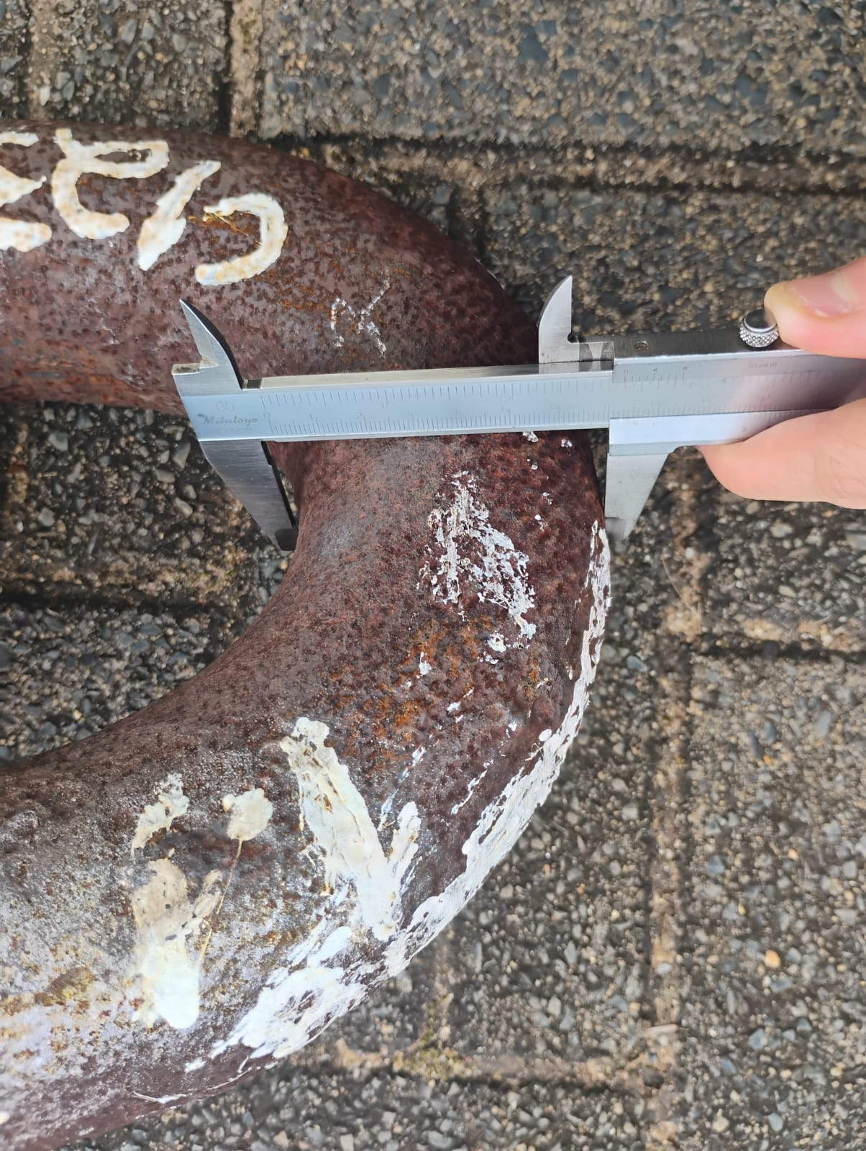  Example 1 – caliper positioned across the outer section of the link. | 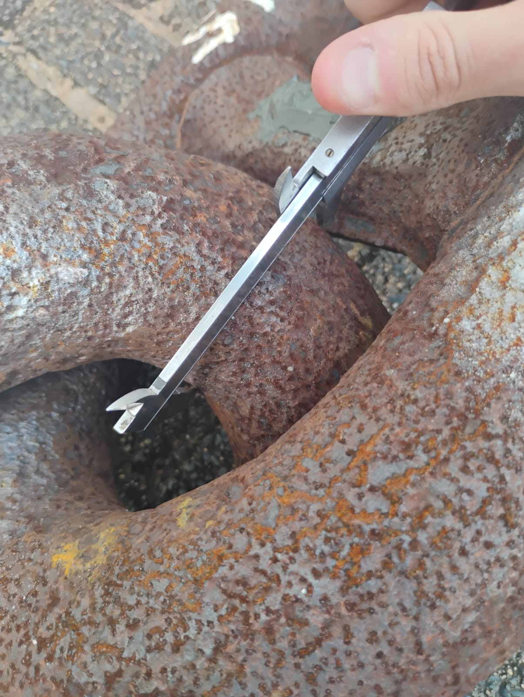  Example 2 – caliper positioned near the interlink area.
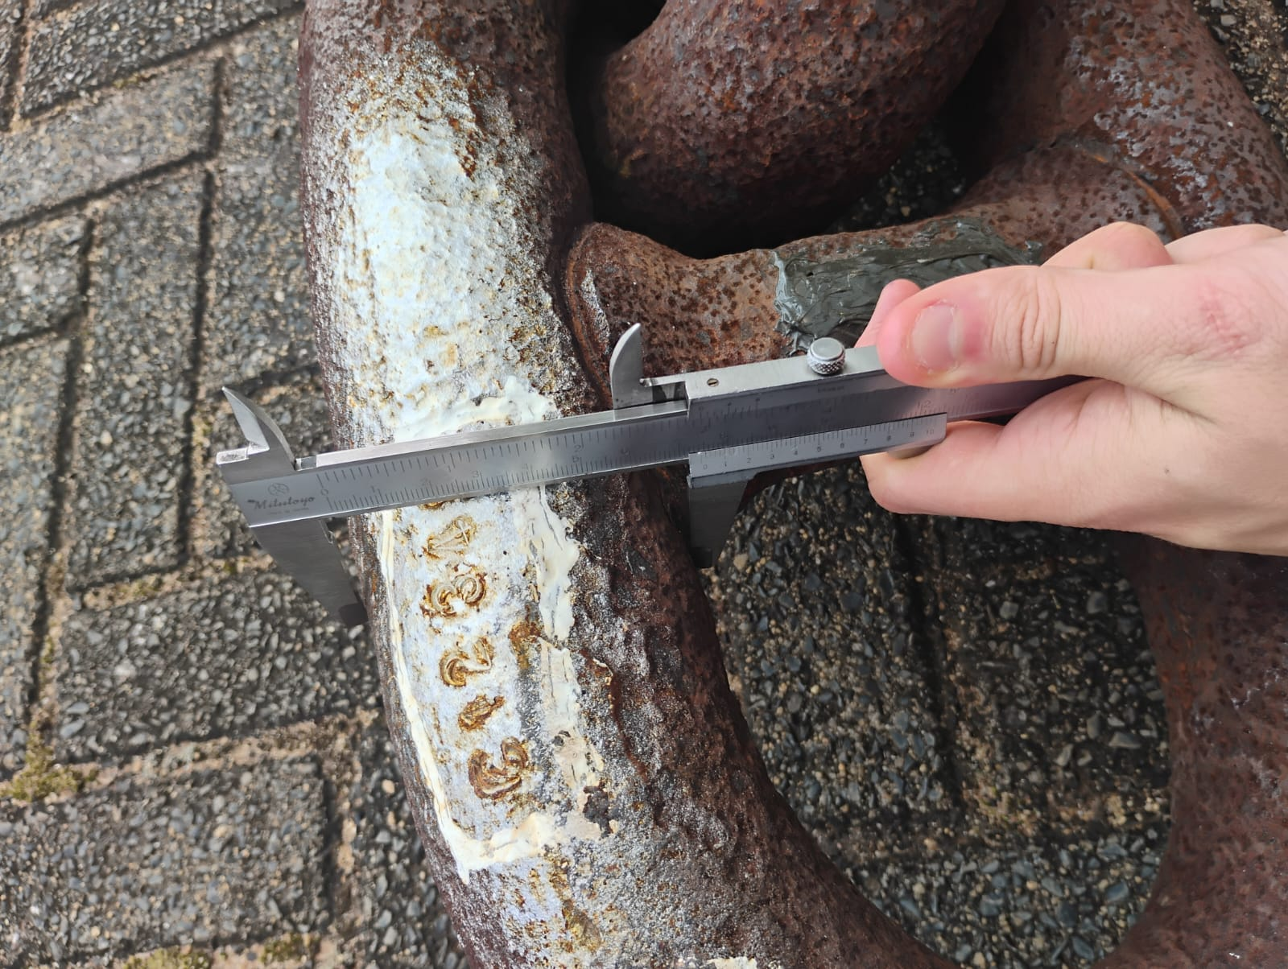  Example 3 – caliper positioned across another outer section. | 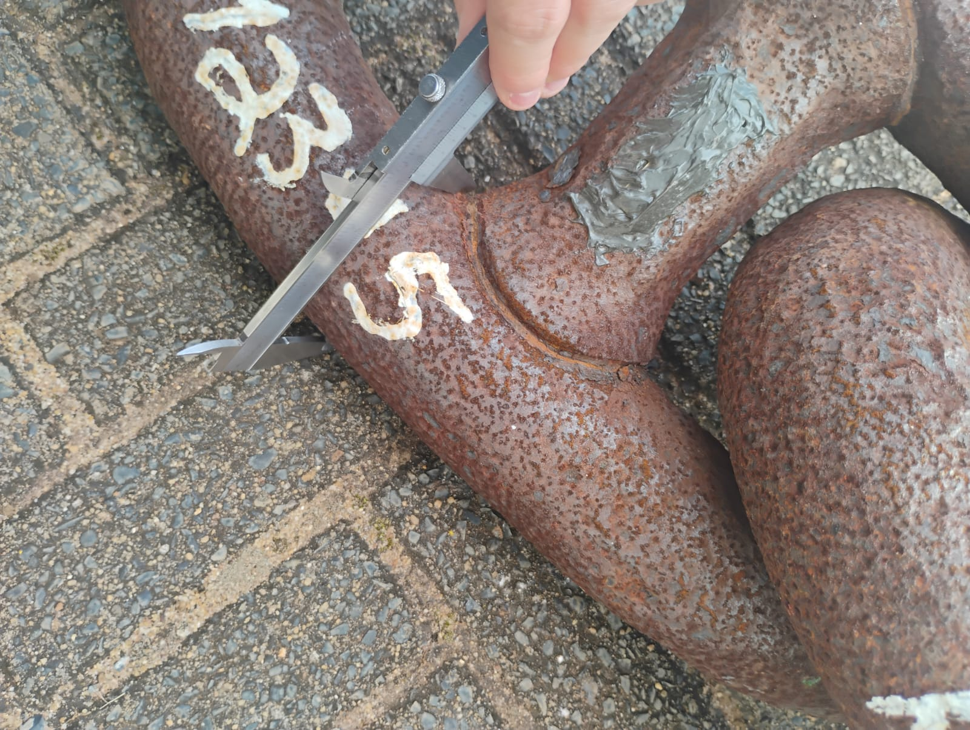  Example 4 – caliper positioned near the transition / stud-side area.

Data Collection Plan
Link 1:
Dis = Distance between camera and chain (measuring using ruler)
F = focal length of the camera
A = angle of the camera or camera position
Link 1 | Dis | F | A | A2 | B2 | D1 | D2

Fill up Dis, F, A for link 1
Work for this link only. Take multiple picture for this link only. Take the picture on the lab, outside of the lab. Take picture from different angle.
