## Analysis

### Menu.cs

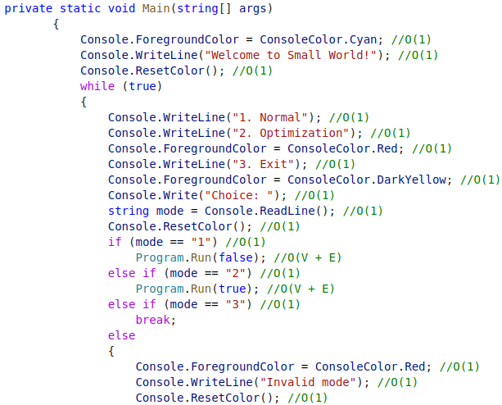

### Program.cs

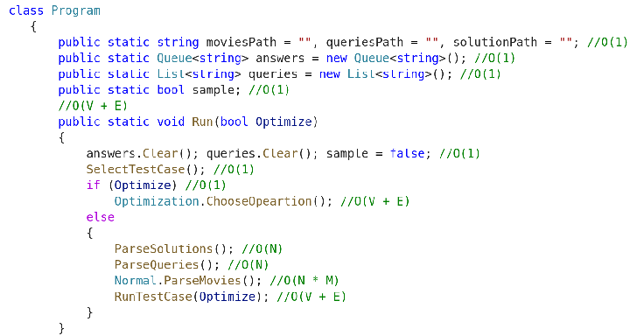

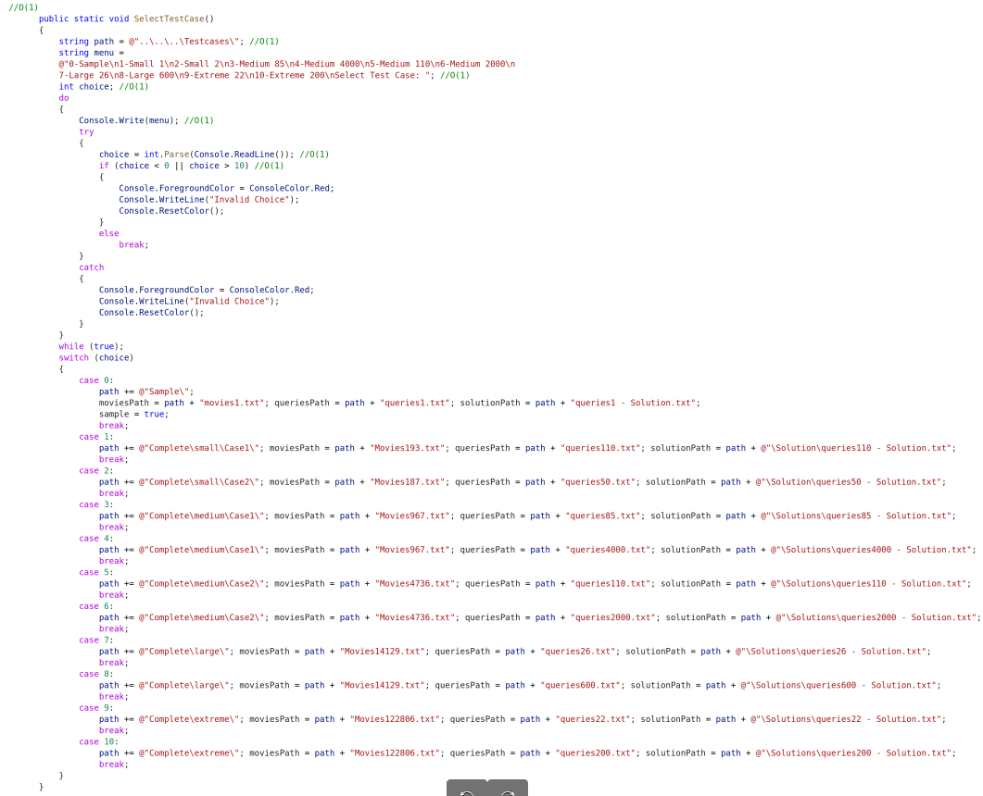

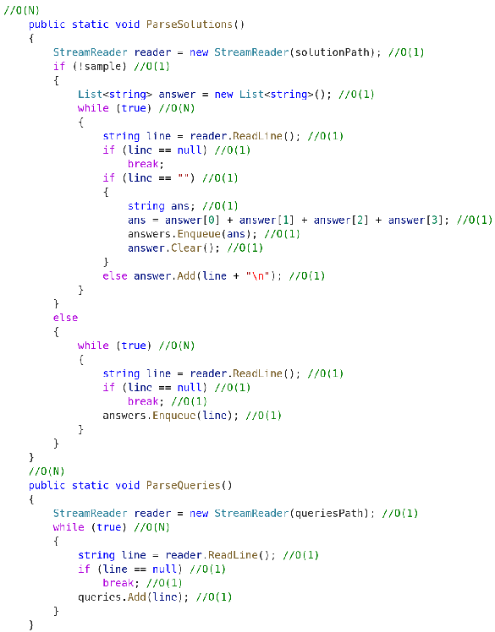

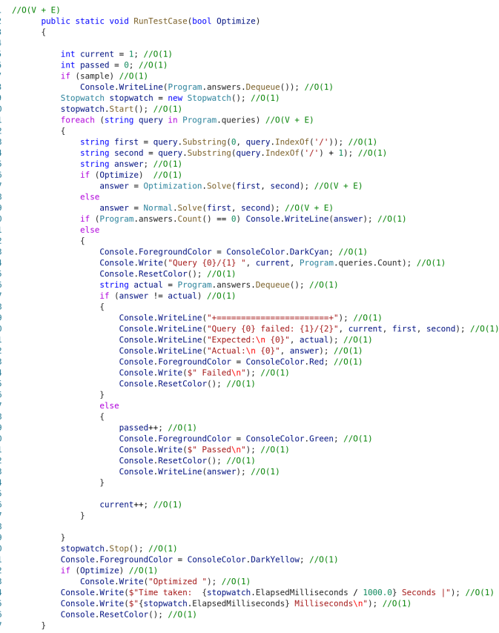

### Normal.cs

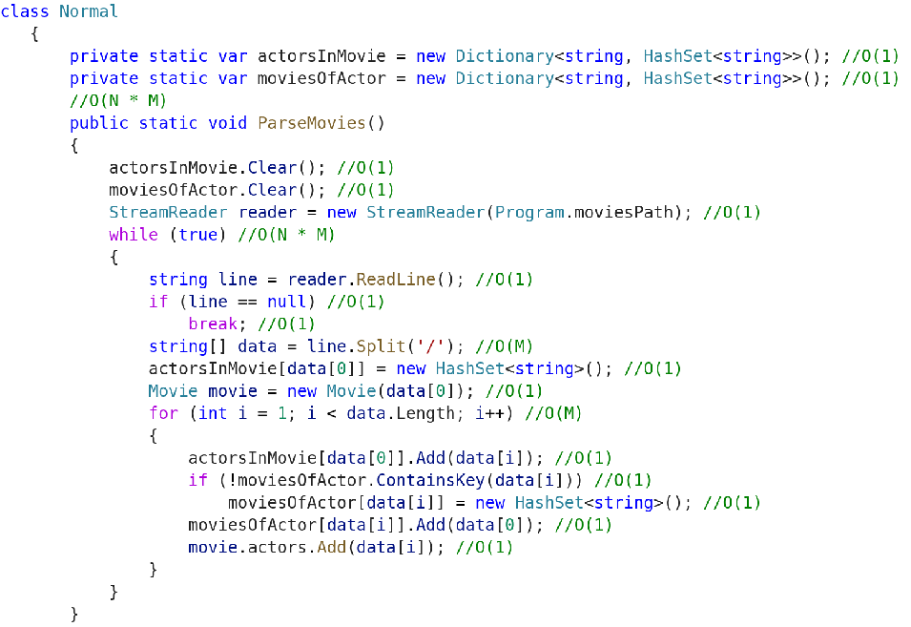

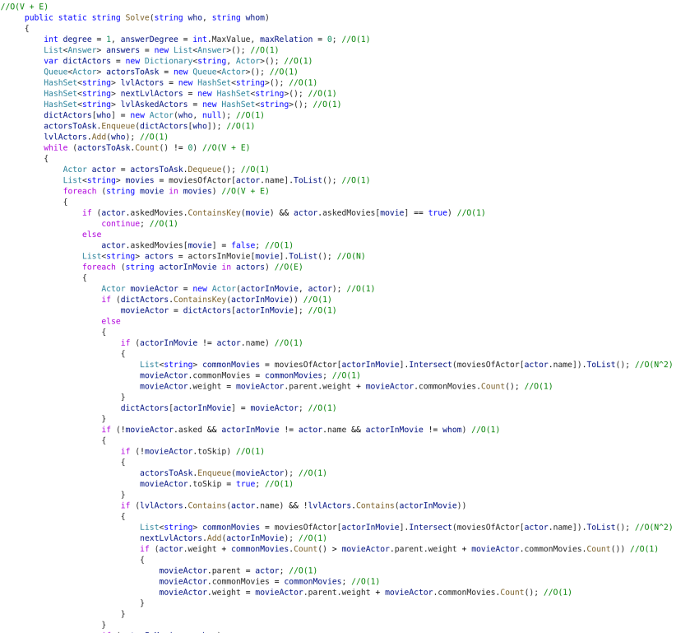

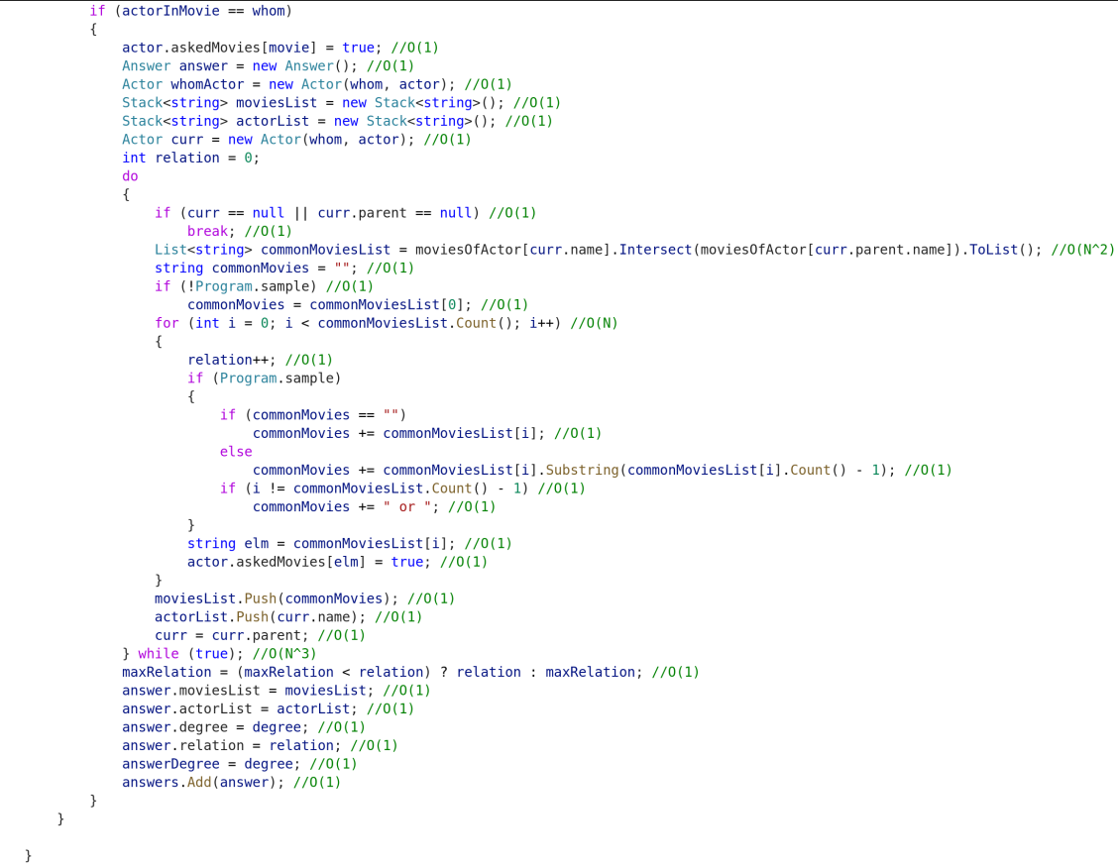

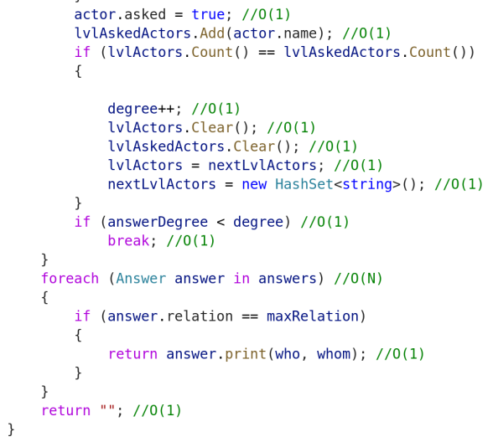

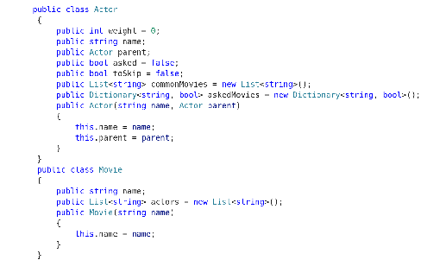

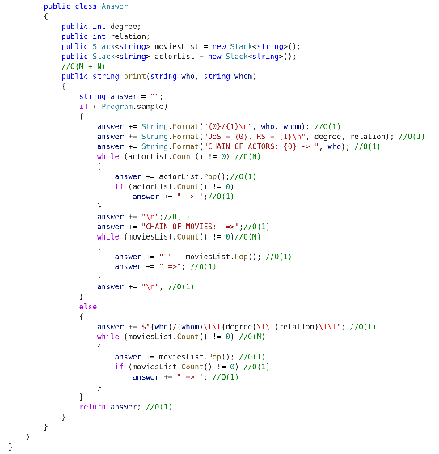

### Optimization.cs

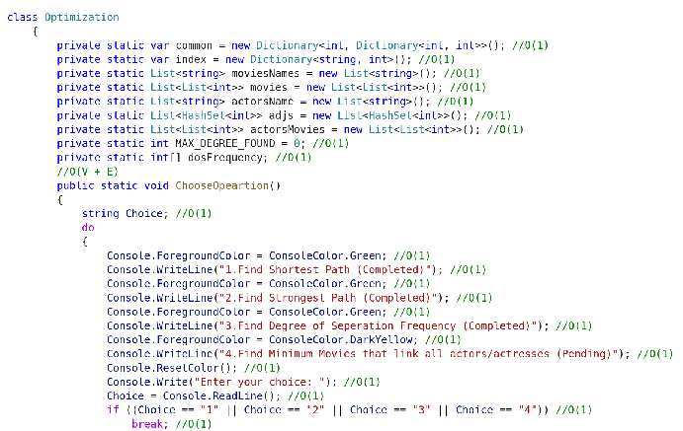

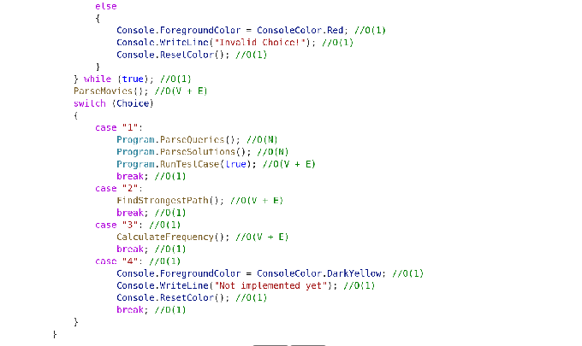

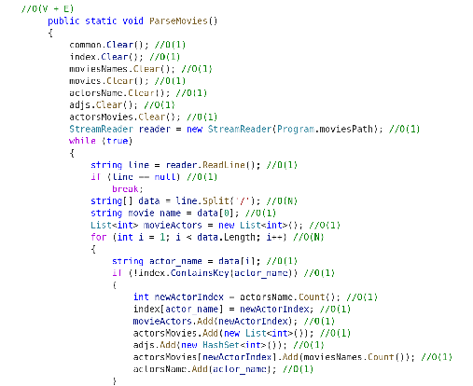

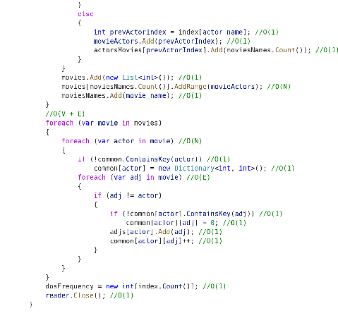

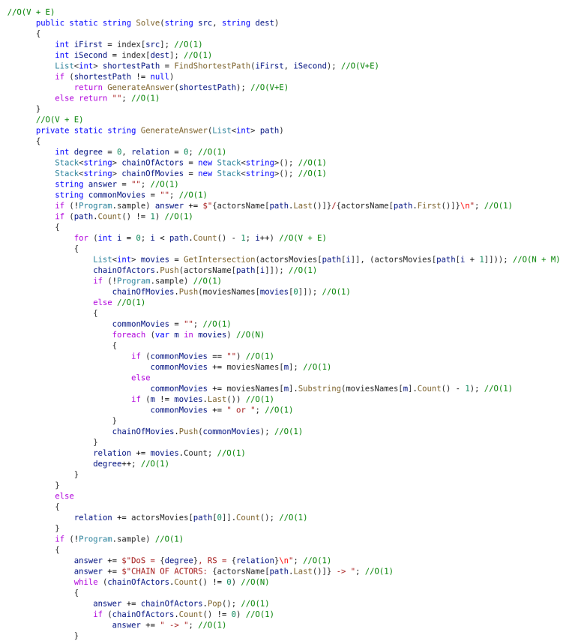

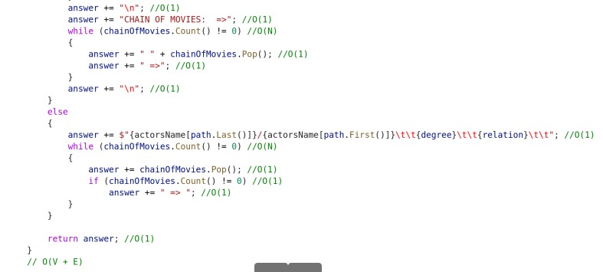

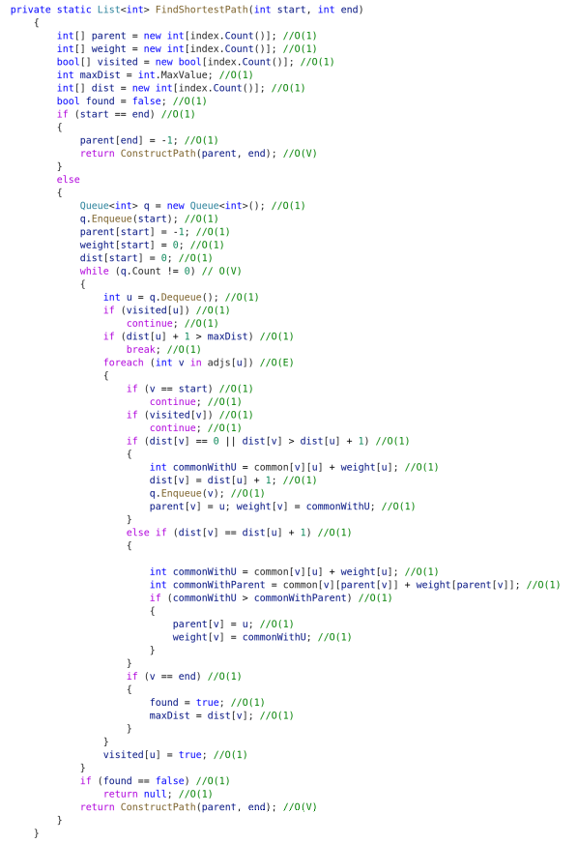

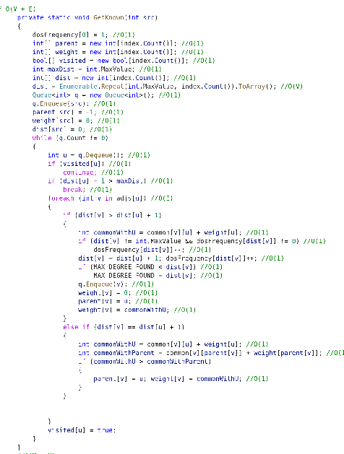

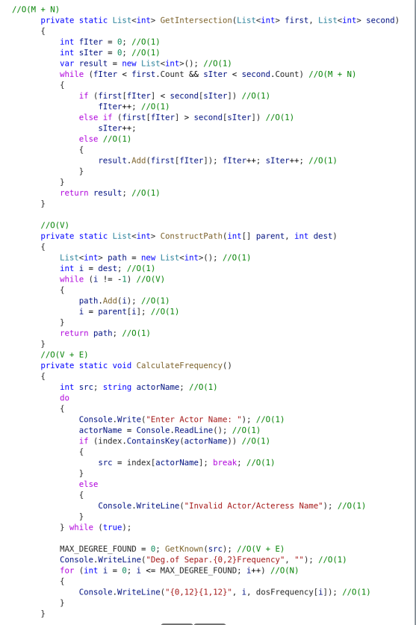

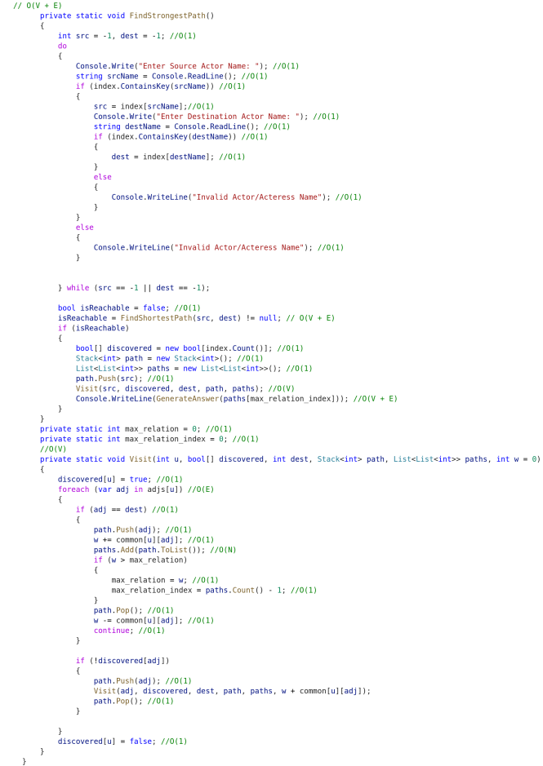

## Execution Time

| **Type** | **Test case** | **Movies** | **Actors** | **Queries** | **Normal (s)** | **Optimization (s)** | **Diff (s)** | **Improvement** |
| --- | --- | --- | --- | --- | --- | --- | --- | --- |
| Small | 1 | 193 | 2513 | 110 | 1.482 | 0.3 | 1.182 | 494% |
| Small | 2 | 187 | 8264 | 50 | 5.729 | 0.6 | 5.129 | 955% |
| Medium | 3 | 967 | 13848 | 85 | 16.241 | 1.5 | 14.741 | 1083% |
| Medium | 4 | 967 | 13848 | 4000 | 262.766 | 26 | 236.766 | 1011% |
| Medium | 5 | 4735 | 43923 | 110 | 46.423 | 5 | 41.423 | 928% |
| Medium | 6 | 4735 | 43923 | 2000 | 175.366 | 22 | 153.366 | 797% |
| Large | 7 | 14129 | 170518 | 26 | 231.683 | 26 | 205.683 | 891% |
| Large | 8 | 14129 | 170518 | 600 | 24.732 | 4 | 20.732 | 618% |
| Extreme | 9 | 122806 | 418451 | 22 | 1651.905 | 85 | 1566.905 | 1943% |
| Extreme | 10 | 122806 | 418451 | 200 | 101.333 | 8 | 93.333 | 1267% |