Phase 3 Submission

Group 12

SQL Queries:

See attached SQL file, or code at https://github.com/angemichaella/CSI4142_project/tree/main/OLAP%20Queries

Part 1

a)

i. Total number of positive cases in the data mart; drill down to August 2020, and drill down to August 22nd, 2020.

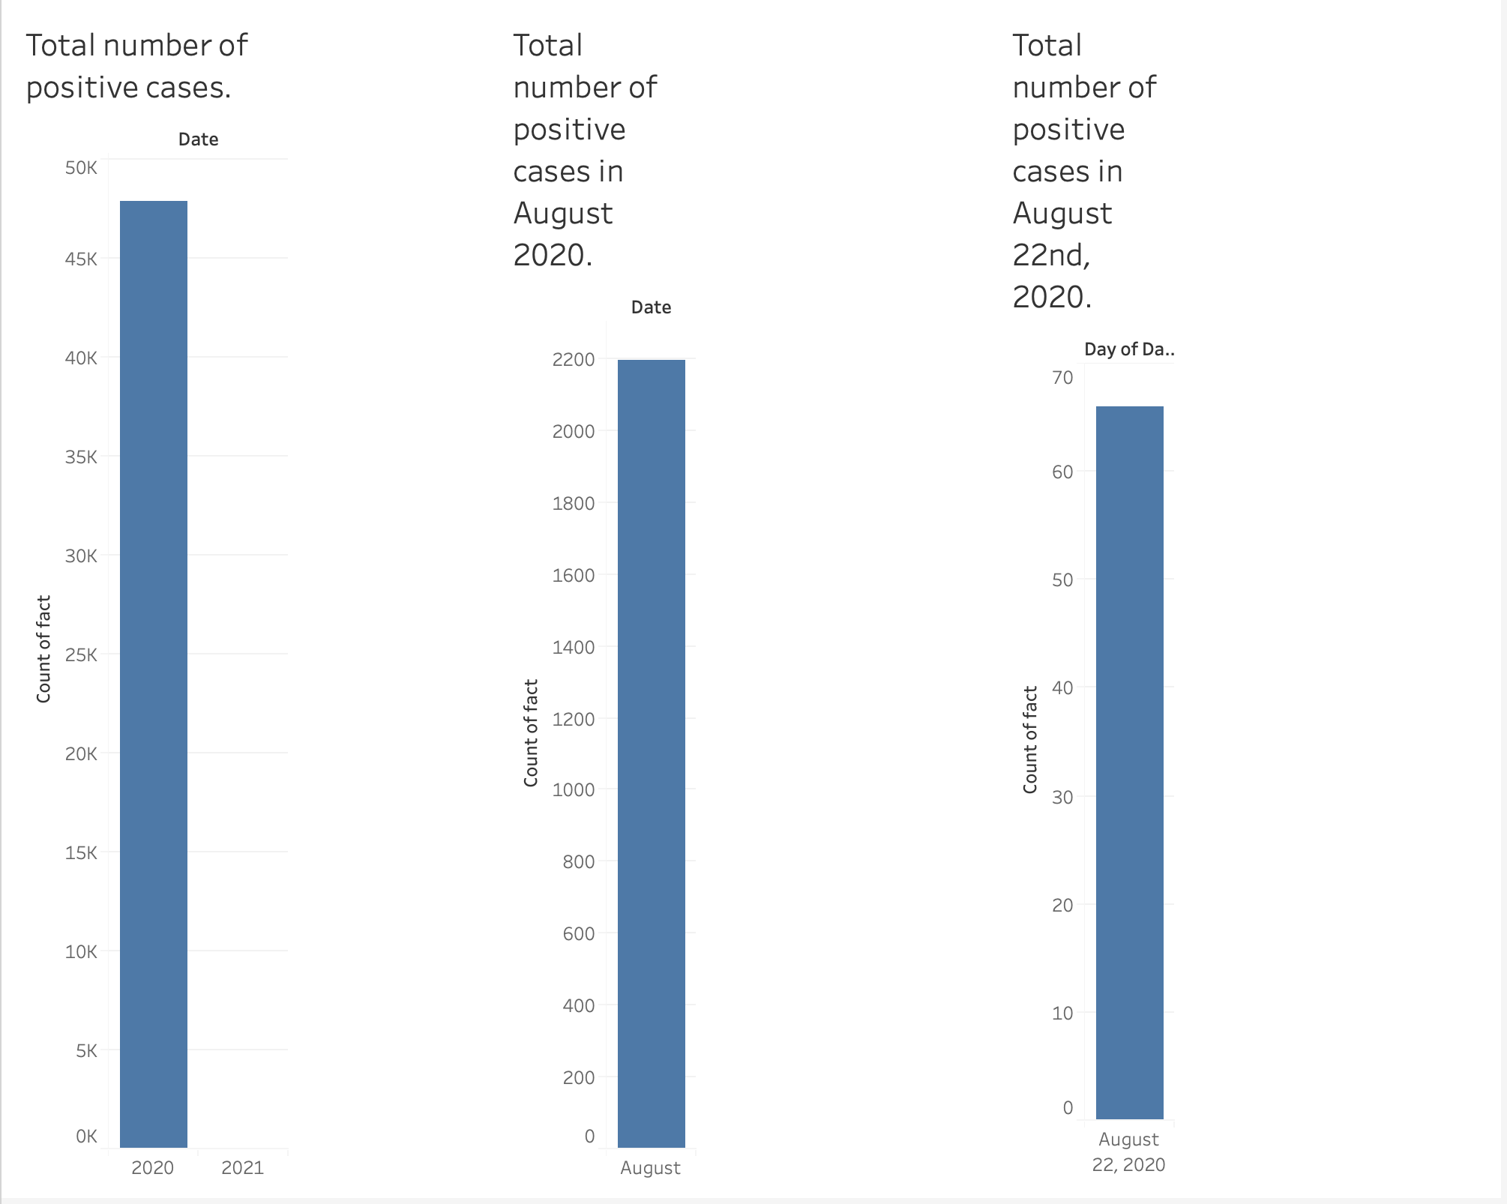

Ii. Total number of resolved cases in the data mart; drill down to August 2020, and drill down to August 22nd, 2020.

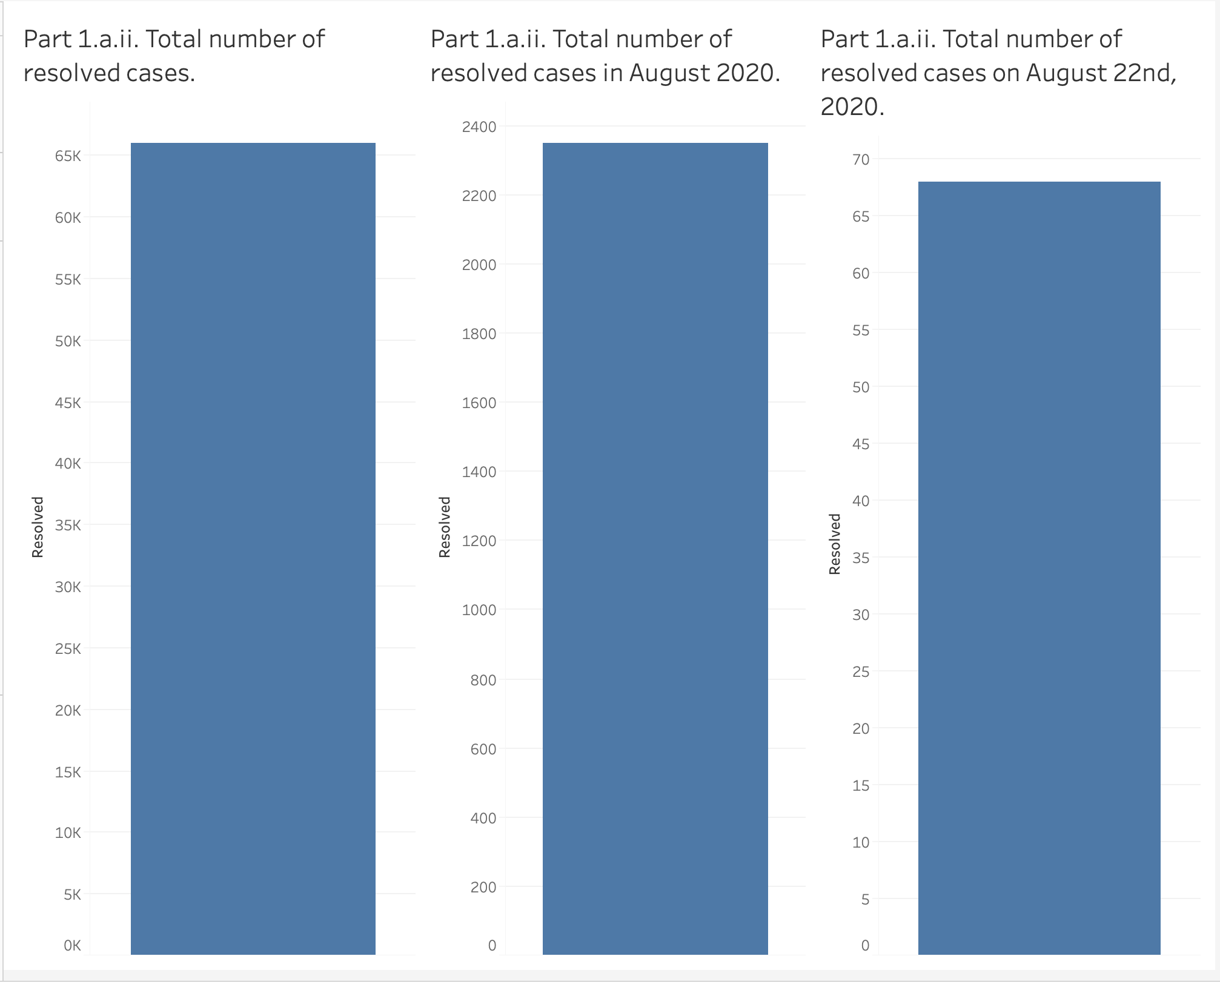

b)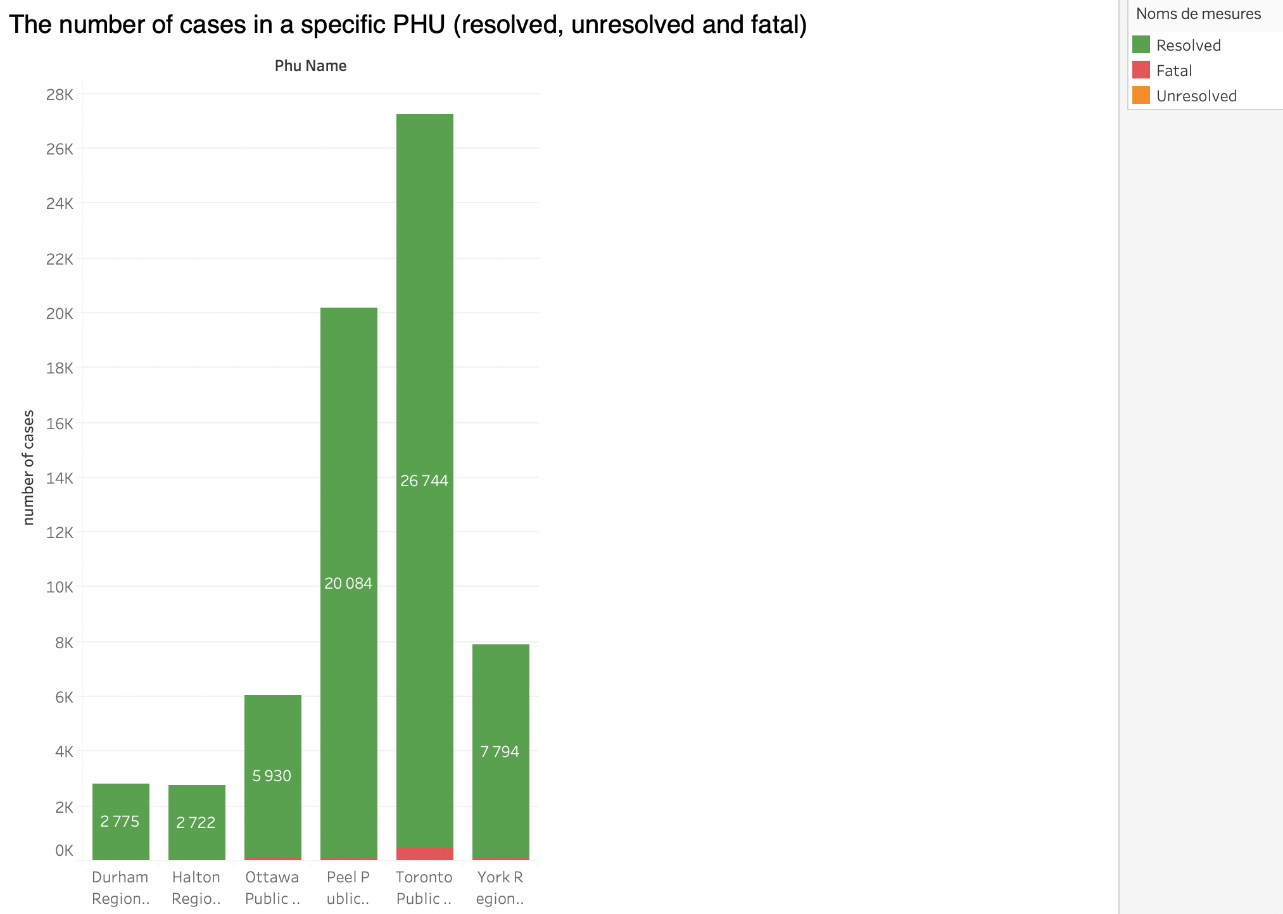

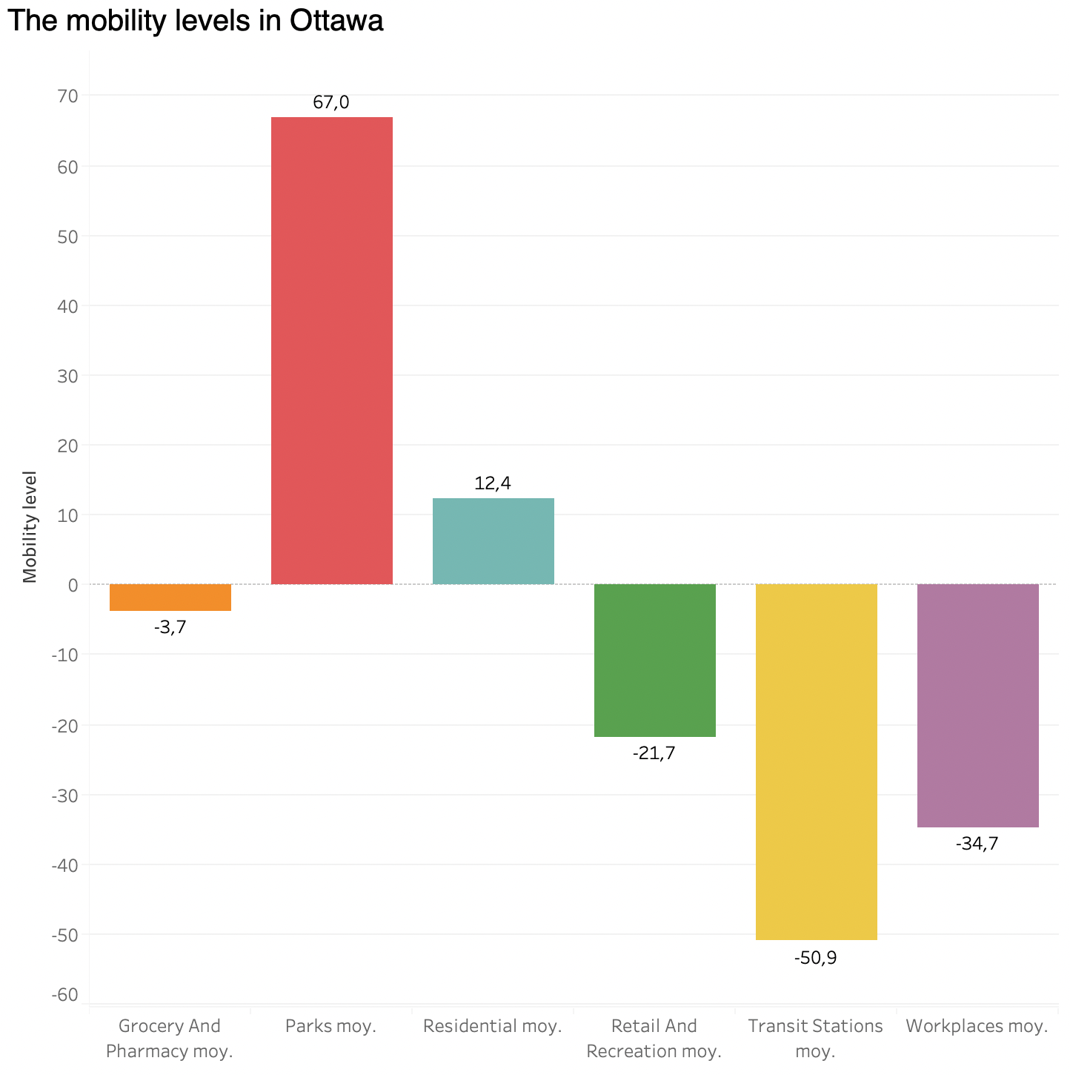

c)

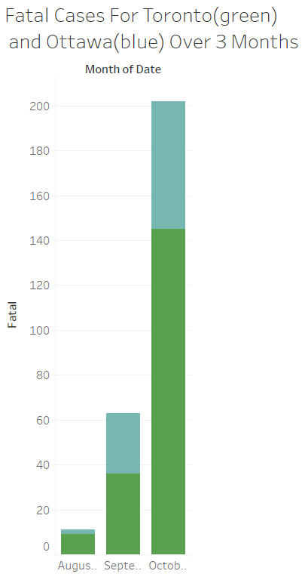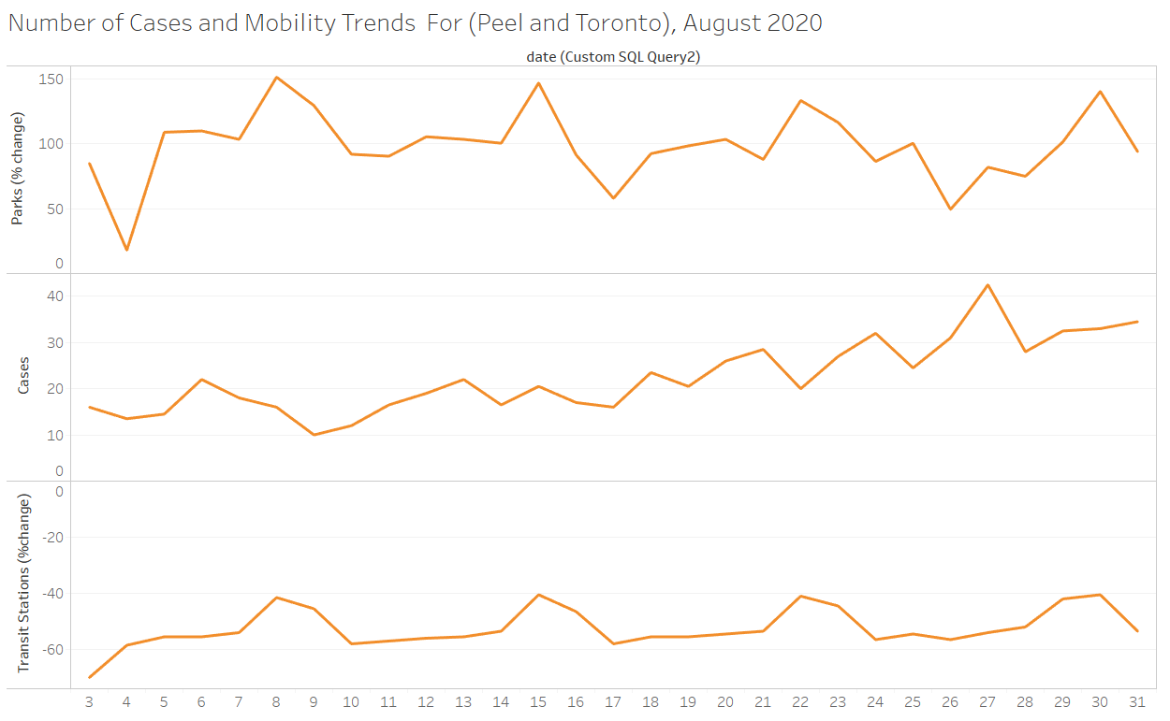

d)

i. 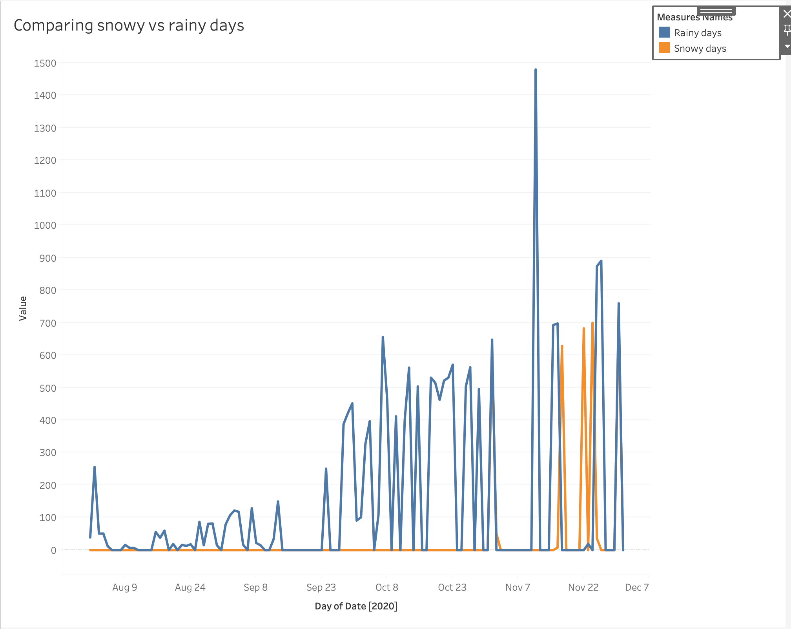

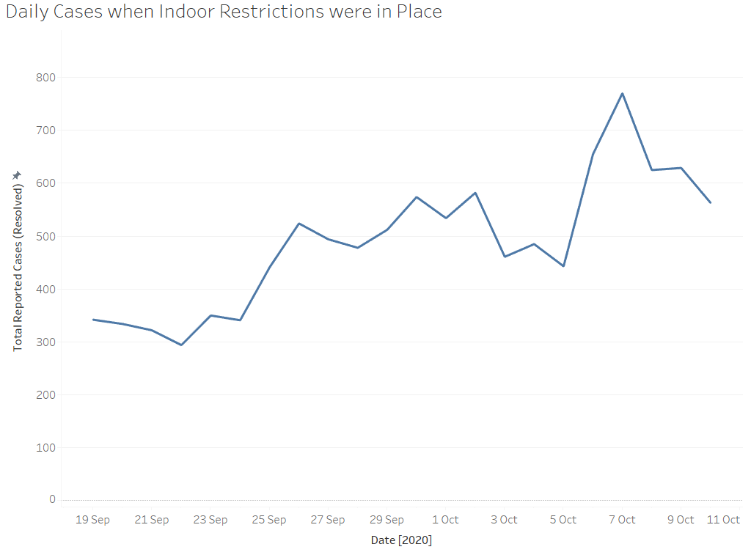

The number of cases in different period of the year

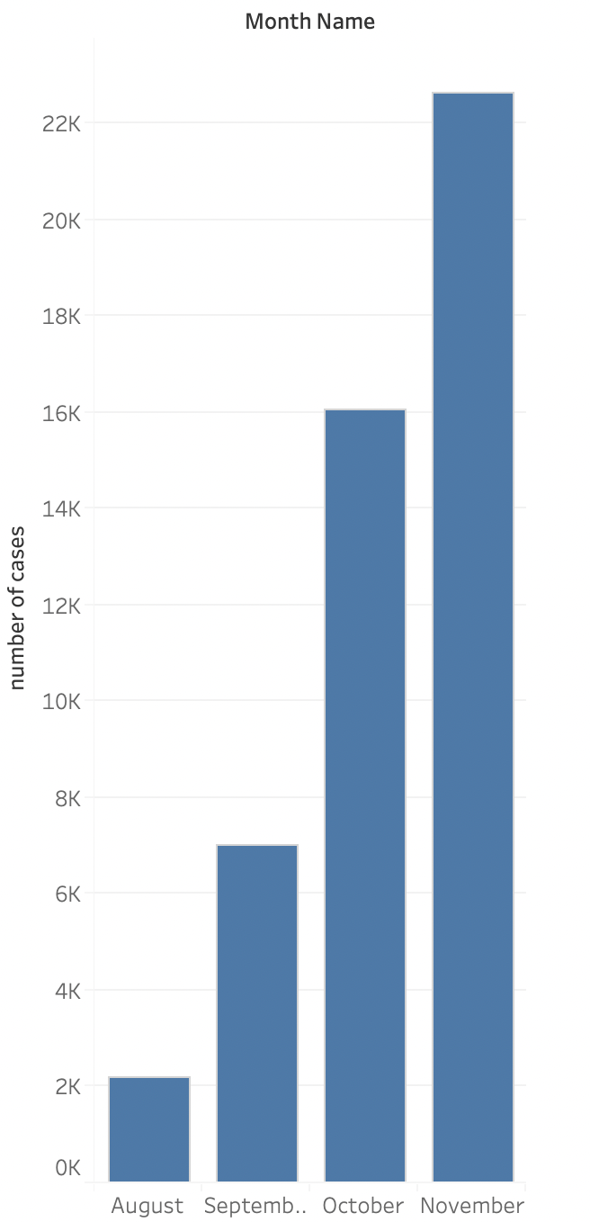

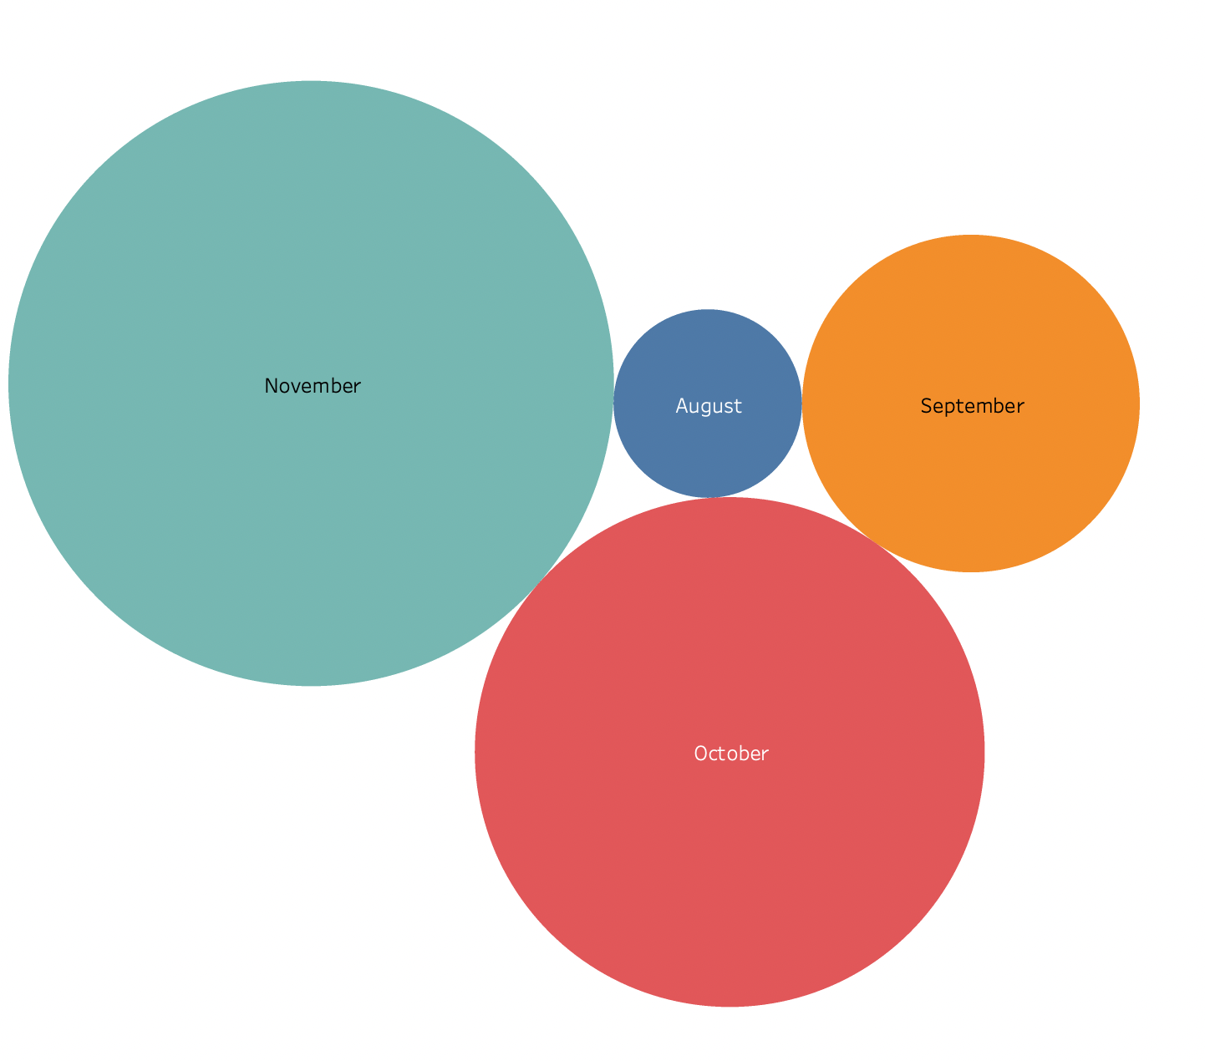

Part 2

a)

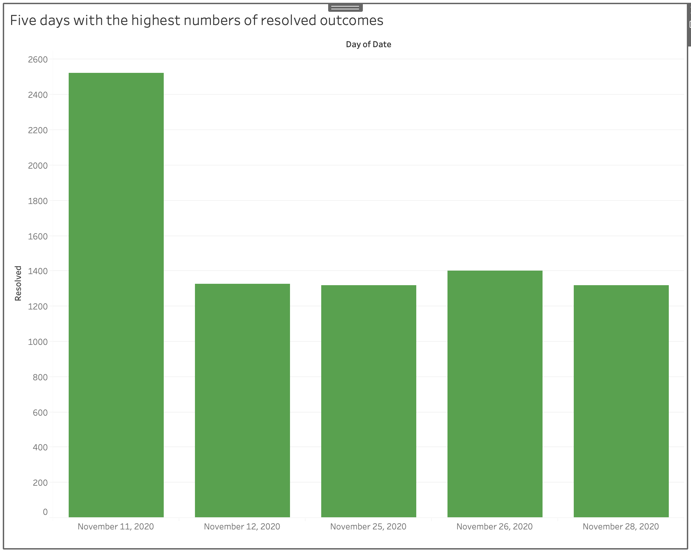

b) The ranking of the PHUs in terms of the number of cases per month

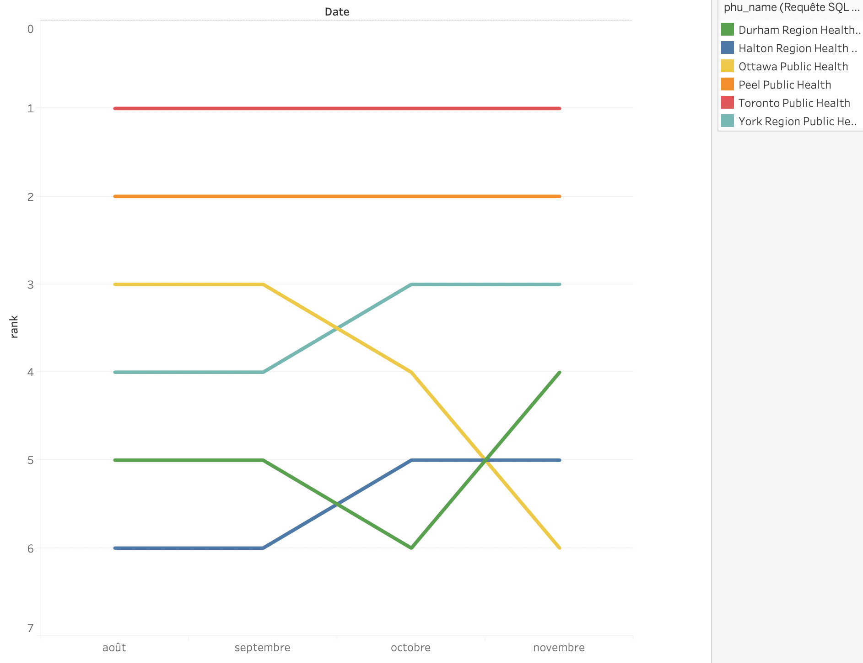

c)

