



**IDS - The Perfect Fit for Dental IT!**

***Prepared by***

**Badr Ahmed El-Badry Ahmed Mohamed Abd El-Aziz**

**Rehaam Mahmoud Ahmed Rania Adel Salah**

**Esraa Abd El-Mohsen Mostafa Al Zahra Ali Hamed**

**Aya Mostafa Hassanien Abdullah**

**Faculty of Commerce,**

**Business Information Systems Program (BIS),**

**Assiut University**

**2024-2025**

**Academic Supervisors**

**Dr. Ramadan AbdAllah Mashraf Dr. Majid Ahmed Askar**

Faculty of CommerceFaculty of Computers and Information

Submitted June 2025 in Partial Fulfillment of the Requirement for the B.Sc. Degree

# **Acknowledgment**

First and foremost, we would like to express our sincere gratitude to our supervisors, Dr. Ramadan Moshref and Dr. Maged Asker, for their continuous guidance, encouragement, and expertise throughout this project. Their unwavering support played a vital role in shaping both the project and our personal growth.

We are deeply thankful to the faculty members of the Faculty of Computing and Information and the Faculty of Commerce for their valuable feedback and academic support during this journey.

We also extend our appreciation to Dr. Mohamed Nahed, the manager of Assiut Dental Hospital, for granting us the opportunity to conduct our research within the hospital environment. We are especially grateful to Dr. Kyrollos, Mr. Mohamed Suleiman, and Mrs. Nada for their time, patience, and assistance in helping us understand the hospital’s processes and documentation, which were essential to the success of our system.

We would like to thank our families and friends for their constant encouragement and emotional support that kept us motivated throughout this challenging yet rewarding experience.

Lastly, we acknowledge the hard work, dedication, and teamwork demonstrated by all group members. This project was a true team effort, and we are proud of what we have accomplished together.

To everyone who supported us directly or indirectly, thank you. Your belief in us made all the difference.

# **Abstract**

This document presents the development of the Integrated Dental System (IDS), a comprehensive management solution designed to streamline patient flow, enhance data organization, and improve inter-clinic coordination within a governmental dental hospital. The system centralizes patient registration, medical history, appointment scheduling, and diagnostic workflows, ensuring seamless communication between specialized departments such as Oral Medicine, Surgery, Orthodontics, Prosthodontics, and more.

By digitizing and integrating critical processes, IDS reduces administrative burdens, minimizes errors, and supports timely, data-driven decision-making. The system is built with a user-friendly interface to accommodate multiple user roles, including receptionists, doctors, and administrators, each with customized access and functionality. This project highlights the system’s architecture, key features, workflow design, and its potential impact on improving efficiency and patient experience in dental healthcare settings.

Table of Contents

**Acknowledgment** i

**Abstract** ii

List of figures vi

List of Tables vii

**Chapter 1 (Software proposal)** 1

**Introduction** 2

**1.1 Problem Statement** 2

**1.2 Objectives** 3

**1.3 System Overview** 4

**1.4 Methodology and technical approach** 5

1.4.1 Flowchart of the system shown in figure 1.1 5

1.4.2 Dataset: 6

**1.5 Evaluation and Maintenance Plan** 8

**Chapter 2 (Software Analysis)** 10

**2.1 Introduction** 11

**2.2 Problem Analysis and Motivation** 11

**2.2.2 Scope of the Project** 12

**2.2.3 Target User Groups** 13

**2.3 System Requirements** 15

**2.3.1 Project Sponsor** 15

**2.3.2 Business Model Canvas** 15

**2.3.3 Business Need:** 17

**2.3.4 Business Request:** 17

**2.3.5 Business Value:** 18

**2.3.5.1 Measurability / Measuring Success** 18

**2.3.5.2 Benefits / Implications** 19

**2.3.6 Specific Problems or Limitations** 20

**2.3.6.1 Infrastructure and Device Availability Constraints** 21

**2.4 Feasibility Study** 22

**2.4.1 Operational Feasibility** 23

**2.4.2 Technical Feasibility** 24

**2.4.3 Economic/Financial Feasibility** 28

**2.5 Executive Summary** 32

**2.6 Market Analysis for IDS** 34

**2.7 Marketing Strategy for (IDS):** 38

**2.8 Market Characteristics** 44

**2.9 SWOT Analysis** 45

**2.10 The Interviews** 49

**2.11 Defining Requirements** 52

**2.11.1 Functional Requirements** 52

**2.11.2 Non-functional Requirements** 53

**2.12 Use Case Diagrams and Descriptions** 54

**2.13 Management Plan** 57

**2.13.1 Current State of the Project** 57

**2.13.2 Project Phases** 58

**2.13.3 Project Timeline (Managed via Jira)** 60

**2.13.4 Division of Responsibilities** 63

**2.13.5 Management Risks** 65

**Chapter 3 (Software requirements specifications)** 67

**3.1 Introduction:** 68

**3.1.1 Intended Audience and Reading Suggestions** 68

**3.1.2 Product Scope** 69

**3.2 Overall Description** 69

**3.2.1 Product Perspective** 69

**3.2.2 Product Functions** 69

**3.2.3 User Classes and Characteristics** 70

**3.2.4 Operating Environment** 70

**3.2.5 Design and Implementation Constraints** 70

**3.2.6 User Documentation** 71

**3.2.7 Assumptions and Dependencies** 71

**3.3 External Interface Requirements** 71

**3.3.1 Hardware Interfaces** 71

**3.3.2 Software Interfaces** 72

**3.3.3 Communication Interfaces** 73

**3.4 Functional Requirements** 73

**3.4.1 User Management** 73

**3.4.2 Patient Management** 73

**3.4.3 Ticket Management** 73

**3.4.4 Clinic & Referral Management** 74

**3.4.5 Reporting & Analytics** 74

**3.5 Other Non-Functional Requirements** 74

**3.5.1 Performance Requirements** 74

**3.5.2 Safety Requirements** 75

**3.5.3 Security Requirements** 75

**4.5.4 Software Quality Attributes** 75

**3.5.5 Business Rules** 76

**Chapter 4 (Software design)** 77

**4.1 Introduction** 78

**4.1.1 Project Background / Purpose** 78

**4.1.2 Hosting Platform & Technology Stack** 79

**4.2 System Architecture** 80

**4.3 Data Design** 83

**4.3.1 Data Description** 83

**4.4 Component Design** 83

**4.4.1 User Authentication Module** 83

**4.4.2 Data Storage Module** 84

**4.4.3 User Interface Module** 86

**4.4.4 Data Processing Module** 88

**4.4.5 Data Flow Diagram** 88

**4.5 User Interface Design** 90

**Chapter 5 (Results & future Scope)** 105

**Conclusion** 106

**Future Works** 107

**Appendices** 108

**Appendix A: System Design Considerations** 108

**Appendix B: Data Dictionary** 111

**References** 116

### List of figures

Figure 1.1 : Flowchart of IDS System 6

Figure 2.1 : IDS SWOT analysis 45

Figure 2.2 Hospital ticket 52

Figure 2.3 : Projct phases 60

Figure 2.4 Jira screenshot 61

Figure 2.5 Jira screenshot 61

Figure 2.6 Jira screenshot 61

Figure 2.7 Jira screenshot 62

Figure 2.8 Jira screenshot 62

Figure 2.9 Jira screenshot 62

Figure 2.10 Jira screenshot 63

Figure 2.11 Jira screenshot 63

Figure 4.1 IDS ERD 85

Figure 4.2 IDS for patient 88

Figure 4.2 IDS for reception 89

Figure 4.3 system UI 95

Figure 4.4 system UI 96

Figure 4.5 system UI 96

Figure 4.6 system UI 97

Figure 4.7 system UI 97

Figure 4.8 system UI 98

Figure 4.9 system UI 98

Figure 4.10 system UI 99

Figure 4.11 system UI 99

Figure 4.12 system UI 100

Figure 4.13 system UI 100

Figure 4.14 system UI 101

Figure 4.15 system UI 101

Figure 4.16 system UI 102

Figure 4.17 system UI 102

Figure 4.18 system UI 103

Figure 4.19 system UI 103

Figure 4.20 system UI 104

### List of Tables

**Table 1.1 : Patient Dataset** 6

**Table 1.2 : Ticket Dataset** 7

**Table 1.3 : Doctors Dataset** 7

**Table 2.1 : technology stack** 25

**Table 2.2 : hardware Requirements** 25

**Table 2.3 technical Challenges** 26

**Table 2.4 : cost components** 28

**Table 2.4 : payback period** 32

**Table 2.5 : IDS services** 38

**Table 2.6 : IDS Features** 39

**Table 2.7 : Hospital needs** 41

**Table 2.8 : IDS risks** 42

**Table 2.9 : IDS roles** 43

**Table 2.10 : SWOT analysis (strengths)** 46

**Table 2.11 : SWOT analysis (opportunities)** 47

**Table 2.12 : SWOT analysis (weaknesses)** 47

**Table 2.13 : SWOT analysis (threats)** 48

**Table 2.14 : non-functional requirements** 53

**Table 2.15 : IDS use case** 56

**Table 4.1 hosting platforms** 80

# **Chapter 1 (Software proposal)**

## **Introduction**

IDS – Integrated Dental System is a digital management solution designed to enhance internal operations within a dental hospital. The system streamlines administrative tasks such as patient registration, appointment scheduling, and communication between clinics and departments.

By centralizing data and automating key processes, IDS improves efficiency, reduces errors, and facilitates smooth coordination among hospital units — including reception, diagnostics, and treatment centers such as Oral Medicine, Surgery, Orthodontics, and more.

With role-based access for staff members, IDS supports hospital administration in managing daily operations with greater accuracy and organization, making it an essential tool for modern dental healthcare management.

## **1.1 Problem Statement**

The Integrated Dental System (IDS) aims to address the inefficiencies and challenges associated with the current paper-based administrative system in dental hospitals. Despite the existence of structured procedures, the heavy reliance on physical documentation creates numerous obstacles:

1. Manual Data Handling: Patient registration, medical history, and treatment records are stored on paper, leading to time-consuming data retrieval and increased risk of loss or damage.
2. Poor Inter-Clinic Communication: Transferring patient information between reception, diagnostic clinics, and treatment departments is slow and prone to errors due to manual handovers.
3. Appointment Mismanagement: Paper-based scheduling results in frequent conflicts, missed appointments, and inefficient use of clinic resources.
4. Lack of Centralized Information: Patient data is scattered across different departments, making it difficult to access a complete and updated record when needed.
5. Administrative Overload: Excessive paperwork increases the workload for staff, reducing time available for essential tasks and patient care.
6. Inefficient Reporting and Monitoring: Generating performance reports, tracking patient flow, or analyzing treatment trends is difficult without digital tools.
7. Security and Privacy Risks: Physical documents are vulnerable to unauthorized access, misplacement, or damage, compromising patient confidentiality.
8. Limited Historical Record Access: Tracing past treatments or follow-ups becomes challenging without a centralized digital archive.
9. Redundant Data Entry: The same information is often re-entered multiple times across departments, increasing chances of inconsistency and human error.
10. Lack of Role-Based Access Control: Without a digital system, managing user permissions and ensuring secure access to sensitive data is not effectively enforceable.

By transforming these processes into a centralized digital platform, IDS eliminates the dependency on paper, improves accuracy, enhances inter-departmental coordination, and streamlines daily operations — ultimately supporting better management and decision-making within the dental hospital.

## **1.2 Objectives**

The objective of this software project is to develop a comprehensive Integrated Dental System (IDS) that digitizes and streamlines internal hospital operations in a governmental dental hospital. The system will serve as a centralized platform for managing patient records, appointments, inter-clinic communication, and administrative workflows.

The primary goals of this project are:

1. To digitize paper-based processes: Replace manual documentation with a digital system to improve accuracy, reduce administrative workload, and ensure secure storage and retrieval of patient data.
2. To centralize patient information: Maintain a unified database that includes patient registration details, medical history, diagnoses, and treatment records to support efficient healthcare delivery.
3. To streamline appointment scheduling: Provide an organized and automated system for booking, rescheduling, and tracking patient appointments across multiple clinics to reduce waiting times and optimize resource use.
4. To enhance inter-clinic coordination: Facilitate seamless transfer of patients from diagnostic clinics to appropriate treatment departments by enabling real-time data sharing between units such as Oral Medicine, Surgery, Orthodontics, Prosthodontics, and more.
5. To improve hospital administration: Assist administrators in managing staff roles, monitoring clinic performance, generating reports, and making data-driven decisions through an intuitive dashboard.
6. To implement role-based access control: Define user roles (e.g., receptionist, doctor, administrator) with specific permissions to ensure data security, prevent unauthorized access, and maintain workflow efficiency.
7. To support efficient reporting and follow-up: Enable easy tracking of patient visits, treatments, and follow-ups, allowing staff to generate reports and analyze trends for better planning and service improvement.

By targeting hospital staff including receptionists, doctors, and administrators, the Integrated Dental System aims to provide a reliable, efficient, and organized digital solution that enhances internal management and supports high-quality dental healthcare delivery.

## **1.3 System Overview**

The Integrated Dental System (IDS) is a digital platform designed to manage internal hospital operations within a governmental dental hospital. The system covers a wide range of administrative and clinical workflows, including patient registration, medical history tracking, appointment scheduling, and inter-clinic coordination.

The system’s user-friendly interface ensures that hospital staff can efficiently manage daily tasks, access patient records, and coordinate between departments such as Oral Medicine, Surgery, Orthodontics, Prosthodontics, and more.

The architecture of IDS is divided into four main modules, each containing one or more user roles:

1. Administration Module:
   * Includes Manager and Admin roles.
   * Used for monitoring operations, managing users, generating reports, and overseeing hospital performance.
2. Reception Module:
   * Includes the Registration Officer role.
   * Designed for patient registration, updating records, and issuing tickets.
3. Diagnostic Clinic Module:
   * Includes the Diagnostic Nurse and Diagnostic Doctor roles.
   * Enables efficient patient triage, diagnosis, and referral to treatment clinics.
4. Treatment Clinic Module:
   * Includes the Clinic Resident and Intern Doctor roles.
   * Facilitates treatment planning, execution, and follow-up within specialty clinics.

These modules operate within a unified web-based platform, ensuring seamless data sharing while maintaining role-based access control for security and efficiency.

The web application allows receptionists to register patients, schedule appointments, and update personal and medical information. It also enables doctors and clinic staff to access patient files, record diagnoses, and coordinate transfers to other treatment units when necessary.

Each user has a role-based interface — including receptionist, doctor, and administrator — with specific permissions to ensure data accuracy, security, and workflow efficiency.

Patient data is stored securely in an encrypted database, and system access is controlled through login authentication to protect sensitive health information.

One of the key features of IDS is its ability to manage patient flow from registration to diagnosis to treatment, ensuring smooth transitions between departments and reducing administrative overhead.

The system inputs include patient personal data, medical history, appointment details, and treatment notes, all of which are stored digitally to eliminate paper-based documentation and improve accessibility.

By digitizing and integrating hospital operations, IDS provides a reliable, efficient, and organized solution that enhances the quality of dental healthcare management.

## **1.4 Methodology and technical approach**

### 1.4.1 Flowchart of the system shown in figure 1.1

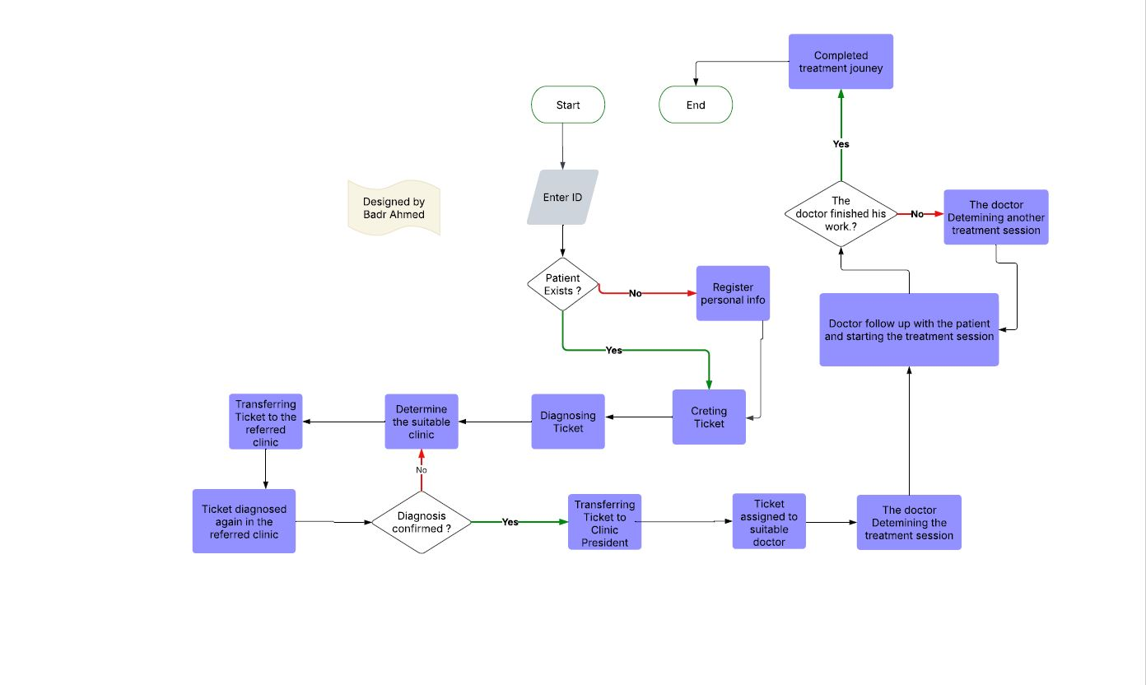

Figure 1.1 : Flowchart of IDS System

### 1.4.2 Dataset:

**Data Description of Patients:**

The patient dataset includes essential personal and medical information required for registration, diagnosis, and treatment planning in a dental hospital setting.

**Table 1.1 : Patient Dataset**

|  |  |
| --- | --- |
| **Field** | **Description** |
| Name | Full name of the patient. |
| Contact Number | Mobile or landline number for communication |
| Address | Patient’s residential address |
| Age | Age at the time of registration |
| Gender | Gender of the patient |
| Profession | Occupation of the patient (used for statistical reporting) |
| Medical History | Records of chronic diseases, allergies, previous surgeries, medications, etc. |

This data is collected through the Reception Module in the IDS system, where reception staff register new patients and update records during follow-up visits.

**Data Description of Tickets:**

Each ticket represents a patient visit and serves as the main unit for tracking appointments, diagnoses, referrals, and treatment progress.

**Table 1.2 : Ticket Dataset**

|  |  |
| --- | --- |
| **Field** | **Description** |
| Ticket ID | Unique identifier for each ticket |
| Patient ID | Reference to the associated patient |
| Appointment Date | Scheduled date and time for the visit |
| Chief Complaint | Patient-reported issue or reason for visit |
| Provisional Diagnosis | Initial diagnosis made by the diagnostic doctor |
| Referral Clinic | Clinic to which the patient is referred |
| Status | Current status of the ticket (Waiting, In Progress, Completed) |
| Next Visit Date | Optional field for scheduling follow-up visits |
| Treatment Notes | Notes added by the treating doctor during the session |
| Level of Completion | Indicates how much of the treatment has been completed |
| Validity | Whether the ticket is still active or archived |

Tickets are created by the receptionist and updated by doctors during diagnosis and treatment stages.

**Data Description of Doctors:**

The doctor dataset contains information about dental professionals working within the hospital, including their role, assigned clinic, and performance metrics.

**Table 1.3 : Doctors Dataset**

|  |  |
| --- | --- |
| **Field** | **Description** |
| Name | Full name of the doctor. |
| National ID | National identification number |
| Contact Number | Mobile number for internal communication |
| Email | Professional email used for login and notifications |
| Password | Encrypted password for secure login |
| Clinic | Assigned clinic (e.g., Oral Surgery, Orthodontics, Prosthodontics) |
| Role | Doctor type (e.g., Intern, Resident, Specialist) |
| Active Patients | Number of current patients under care |
| Successful Cases | Total completed treatments recorded in the system |

Doctors are managed by the System Administrator, who adds or updates their information based on hospital assignments and promotions.

## **1.5 Evaluation and Maintenance Plan**

To ensure the effectiveness, ease of use, and long-term reliability of the Integrated Dental System (IDS), the following evaluation and maintenance plan has been developed:

1. **User Feedback Mechanism:**
   * Implement an internal feedback system within the platform to collect input from hospital staff (receptionists, doctors, and administrators) regarding usability, functionality, and potential errors.
   * Regularly review and categorize feedback to identify common issues and prioritize improvements based on user needs.
2. **Performance Monitoring:**
   * Integrate performance monitoring tools to track system metrics such as response time, error rates, database performance, and user activity across modules.
   * Establish clear performance standards and conduct monthly evaluations to ensure the system meets operational standards and maintains efficiency under pressure.
3. **User Testing:**
   * Conduct structured testing sessions with actual users (hospital staff) to evaluate the system’s usability, workflow efficiency, and accessibility.
   * Use the results from these sessions to improve the interface, enhance navigation, and resolve any issues affecting daily operations.
4. **Continuous Improvement:**
   * Create a scheduled update cycle to implement bug fixes, feature improvements, and security updates based on feedback and performance data.
   * Monitor system usage patterns and evolving hospital requirements to continuously align the system with real-world needs.
5. **Stakeholder Reviews:**
   * Schedule regular meetings with key stakeholders, including hospital management, supervisors, and department heads, to assess how well the system supports administrative goals, clinical workflows, and data management.
   * Use stakeholder insights to guide future development, ensuring that IDS evolves in line with hospital priorities and regulatory standards.

This comprehensive plan ensures that the Integrated Dental System remains efficient, user-friendly, secure, and compatible with hospital operations throughout its lifecycle.

# **Chapter 2 (Software Analysis)**

## **2.1 Introduction**

The Integrated Dental System (IDS) is a comprehensive digital solution designed to modernize and streamline internal operations within governmental dental hospitals. As healthcare facilities face increasing patient volumes and growing administrative demands, there is a pressing need to replace outdated paper-based systems with efficient, centralized digital platforms.

IDS serves as the backbone of hospital management by connecting critical departments — from patient registration and diagnostics to treatment coordination and administrative oversight. It ensures seamless flow of information between reception staff, diagnostic nurses, doctors, clinic residents, interns, system administrators, and hospital managers, improving both operational efficiency and service delivery.

Imagine a dental hospital where patient records are instantly accessible, appointments are managed without conflict, and inter-clinic communication is smooth and error-free. IDS makes this vision a reality by offering a structured, secure, and role-based system tailored specifically to the needs of a multi-specialty dental environment.

With its intuitive design and robust functionality, IDS simplifies complex workflows, reduces human errors, and supports informed decision-making. Whether managing daily patient flow, generating performance reports, or coordinating between clinics, IDS enhances the overall experience for hospital staff and contributes to better healthcare outcomes.

## **2.2 Problem Analysis and Motivation**

Dental hospitals often rely heavily on manual, paper-based processes for managing patient data, scheduling appointments, and coordinating between clinics. This traditional approach leads to inefficiencies such as:

* Delays in retrieving patient records.
* Missed or double-booked appointments.
* Poor communication between departments.
* Difficulty in tracking patient progress across multiple clinics.
* Time-consuming administrative tasks that reduce time available for patient care.

These challenges hinder the quality of service and create unnecessary burdens on hospital staff. The motivation behind developing IDS stems from the urgent need to digitize these processes and implement a unified system that improves workflow efficiency, accuracy, and transparency.

IDS addresses these issues by:

* Replacing paper-based systems with a centralized digital database, ensuring fast and accurate access to patient records.
* Enabling real-time appointment scheduling, reducing conflicts and improving clinic utilization.
* Facilitating inter-clinic communication, allowing seamless transfer of patients between diagnostic and treatment units.
* Providing administrative tools for monitoring performance, generating reports, and making data-driven decisions.

Additionally, the system supports role-based access control, ensuring that only authorized personnel can perform specific actions, thus enhancing security and accountability.

By introducing IDS into the hospital environment, we aim to significantly improve internal operations, enhance coordination between departments, and ultimately support higher standards of dental healthcare.

### **2.2.2 Scope of the Project**

The Integrated Dental System (IDS) is designed to digitize and streamline internal administrative and clinical workflows in dental hospitals. The system connects various departments — including reception, diagnostics, treatment clinics, and hospital administration — into a unified digital platform that enhances efficiency, accuracy, and inter-clinic coordination.

The scope of the project includes the following key activities:

**Research**:

The system was developed based on extensive research into the current paper-based processes used in dental hospitals, identifying pain points and opportunities for digital transformation.

**Digitization & Organization:**

IDS replaces manual data entry and physical records with a centralized digital database for managing patient registration, medical history, appointments, and clinic referrals.

**Inter-Clinic Coordination:**

The system facilitates seamless communication between diagnostic clinics and treatment units, ensuring smooth patient flow from one stage to another.

**User-Friendly Interface:**

IDS offers an intuitive and easy-to-use interface for all user roles — reception staff, doctors, and administrators — to ensure efficient adoption and operation across departments.

**Security & Compliance:**

Patient data is stored securely and accessed only by authorized personnel using role-based permissions. The system ensures compliance with data protection standards.

**Monitoring and Reporting:**

Administrators can monitor daily operations, generate reports, and analyze performance metrics to support informed decision-making and continuous improvement.

**Development & Maintenance:**

The system is developed using modern web technologies and is designed to be scalable, maintainable, and adaptable to future enhancements or integration with larger healthcare systems.

In summary, the scope of IDS is to provide a comprehensive digital solution for managing patient data, scheduling appointments, coordinating between clinics, and supporting hospital management — ultimately improving workflow efficiency and service delivery in dental healthcare.

### **2.2.3 Target User Groups**

The Integrated Dental System (IDS) targets a broader set of internal users within a governmental dental hospital, aiming to streamline workflows, reduce manual processes, and enhance inter-departmental coordination.

The system serves the following key user groups:

**1. Hospital Manager**

The highest-level user with full access to all system data.

Uses IDS to monitor overall hospital performance, generate strategic reports, and ensure smooth daily operations.

Has authority to approve changes in staff roles, permissions, and clinic structures.

**2. System Administrator**

Responsible for managing user accounts, including registration, role assignment, and updating doctor information.

Handles transfers between clinics and promotions (e.g., Intern to Resident).

Ensures system stability, security, and proper access control.

**3. Registration Officer (Reception Staff)**

Manages patient registration, updates personal and medical records, and issues appointment tickets.

Plays a critical role in the initial entry of data into the system.

Helps avoid scheduling conflicts and ensures accurate documentation.

**4. Diagnostic Nurse**

Oversees the flow of patients entering the diagnostic clinic.

Updates ticket statuses and calls patients for examination.

Acts as a digital coordinator between reception and diagnostic doctors.

**5. Diagnostic Doctor**

Reviews patient history and conducts initial diagnosis.

Determines the appropriate treatment clinic and refers the case accordingly through the system.

Ensures patients are directed to the right specialty for care.

**6. Clinic Resident (Specialist / Head of Clinic)**

Supervises the treatment process within their specialty clinic (e.g., Surgery, Orthodontics).

Assigns cases to junior doctors and reviews treatment progress.

Ensures quality control and efficient use of clinic resources.

**7. Clinic Doctor**

Assigned patients by the Clinic Resident.

Conducts treatments under supervision.

Records treatment details and follows up on patient progress.

**8. External Clinics(future):**

By addressing the needs of these eight key roles, IDS ensures:

Better coordination between departments.

Secure, role-based access to sensitive information.

Efficient task delegation and workflow management.

Improved decision-making through centralized data and reporting.

Although the system does not interact directly with patients, it significantly enhances the efficiency, accuracy, and organization of services provided to them by optimizing internal hospital operations.

## **2.3 System Requirements**

The *"System Requirements"* section outlines the critical components necessary for the successful development, deployment, and operation of the Integrated Dental System (IDS). This section provides a detailed description of the project’s sponsor, business need, business request, and expected value, ensuring all stakeholders have a clear understanding of what is required to meet the project’s objectives.

These requirements form the foundation for the design and development phases, guiding the project toward delivering a high-quality, efficient, and user-friendly solution tailored to the needs of a governmental dental hospital environment.

### **2.3.1 Project Sponsor**

The Integrated Dental System (IDS) is sponsored by Assiut University, which will provide the necessary financial support and resources for the project’s development and implementation. The university plays a crucial role in ensuring the availability of technical infrastructure, mentorship, and academic guidance throughout the project lifecycle. This sponsorship aligns with the university's mission to foster innovation, enhance digital transformation in healthcare, and contribute to real-world problem-solving through student-led projects.

### **2.3.2 Business Model Canvas**

**Key Partners:**

* Assiut University.
* Governmental Dental Hospital administration.
* Medical IT consultants.
* Software development tools and platforms providers (e.g., Visual Studio, MySQL Workbench).
* Cybersecurity and data protection experts.
* Training and support providers.

**Key Activities:**

* Development and testing of the Integrated Dental System.
* Integration with hospital workflows and existing systems.
* Training of hospital staff on system usage.
* Ongoing maintenance, updates, and user support.
* Monitoring system performance and gathering feedback for improvements.

**Key Resources:**

* Student development team (IDS developers & UI/UX designer).
* Academic supervisors and advisors.
* Technical infrastructure (development tools, servers, databases).
* Access to a live hospital environment for testing and validation.
* Financial and institutional support from the university.

**Value Propositions:**

* A centralized digital platform that replaces paper-based processes.
* Improved accuracy and accessibility of patient data.
* Efficient inter-clinic coordination and communication.
* Role-based access control for enhanced security and workflow clarity.
* Real-time reporting and monitoring for hospital administrators.
* Scalable and maintainable system architecture for future enhancements.

**Customer Relationships:**

* Direct collaboration with hospital staff during development and testing phases.
* Continuous feedback loop with users to ensure usability and relevance.
* Post-deployment support and training sessions.
* Regular system updates based on evolving hospital needs.

**Channels:**

* Web-based application interface.
* In-person demonstrations and training sessions.
* Digital documentation and user manuals.
* Internal university presentations and showcases.

**Customer Segments:**

* Reception and registration staff.
* Diagnostic nurses and doctors.
* Clinic residents and specialists.
* Intern doctors (dental doctors).
* System administrators.
* Hospital managers and supervisors.

**Cost Structure:**

* Development and design costs (student time, tools, hosting).
* Training and deployment expenses.
* Maintenance and update costs.
* Academic supervision and mentoring.
* Documentation and presentation materials.

**Revenue Streams:**

While the system is primarily developed as an academic and internal hospital tool, potential revenue streams could include:

* Licensing the system to other governmental dental hospitals.
* Offering customization and integration services for similar institutions.
* Providing training and support packages for new deployments.
* Collaborating with healthcare IT companies for commercialization opportunities.

### **2.3.3 Business Need:**

In most dental hospitals, administrative and clinical operations still rely heavily on paper-based systems, leading to inefficiencies such as:

* Delays in retrieving patient records.
* Appointment scheduling conflicts.
* Poor inter-clinic communication.
* Manual data entry errors.
* Lack of centralized monitoring and reporting.

This outdated approach not only slows down daily operations but also increases the risk of errors and reduces the overall quality of care provided to patients.

The Integrated Dental System (IDS) addresses this gap by offering a centralized digital platform that streamlines internal workflows, improves coordination between departments, and enhances the accuracy and accessibility of patient information.

**Key objectives include:**

* Replacing paper-based processes with a secure digital system.
* Enabling seamless communication between reception, diagnostics, and treatment units.
* Providing real-time access to patient data across roles.
* Supporting hospital administrators with performance tracking and decision-making tools by digitizing these processes, IDS aims to improve operational efficiency, staff productivity, and ultimately, the quality of dental healthcare delivery.

### **2.3.4 Business Request:**

The business request for the Integrated Dental System (IDS) is to develop a role-based digital management system that supports all internal operations within a multi-specialty dental hospital. The system should facilitate:

* Patient registration and medical history management.
* Appointment scheduling and tracking.
* Diagnostic referrals and inter-clinic coordination.
* Role-specific access and permissions for managers, admins, doctors, nurses, and reception staff.
* Monitoring, reporting, and analytics for hospital leadership.

This request arises from the need to modernize existing hospital procedures, reduce administrative burdens, and ensure accurate and timely delivery of services.

We aspire to provide a comprehensive digital solution that ensures smooth hospital operations, secure data handling, and efficient patient flow, ultimately enhancing the experience for both staff and patients.

### **2.3.5 Business Value:**

The Integrated Dental System (IDS) has the potential to deliver significant value across multiple dimensions of hospital operations:

* Improved Operational Efficiency:

By replacing manual processes with a digital system, IDS reduces paperwork, minimizes errors, and accelerates task completion across departments.

* Enhanced Inter-Clinic Coordination:

The system enables seamless communication and referral management between diagnostic and treatment clinics, improving patient flow and service delivery.

* Data Security & Accuracy:

With role-based access control and centralized database management, sensitive patient data is better protected and more consistently updated.

* Better Decision-Making for Management:

Hospital administrators gain access to real-time reports and dashboards, supporting informed decisions about resource allocation, staffing, and performance improvements.

* Scalability for Future Expansion:

The modular architecture allows for easy integration with additional clinics or features in the future, making it adaptable to evolving hospital needs.

* Cost Reduction & Resource Optimization:

Reduced administrative workload and improved clinic utilization lead to better use of time and resources.

Ultimately, IDS contributes to a modernized, organized, and efficient dental hospital environment, helping bridge the gap between traditional practices and contemporary digital healthcare standards.

#### **2.3.5.1 Measurability / Measuring Success**

To assess the success of the Integrated Dental System (IDS) , a set of measurable criteria has been established across multiple dimensions of system performance and user experience. These criteria help evaluate whether the system is meeting its intended goals and delivering value to hospital staff and operations.

**1. Operational Efficiency:**

* Reduction in time required to register patients.
* Decrease in appointment scheduling conflicts.
* Time saved on inter-clinic communication and referrals.
* Reduction in manual paperwork and data entry errors.

**2. Data Accuracy & Accessibility:**

* Percentage of complete and up-to-date patient records.
* Speed of retrieving patient data by authorized users.
* Number of data inconsistencies reported post-deployment.

**3. User Adoption & Satisfaction:**

* Number of active users per role (manager, admin, receptionist, doctor, etc.).
* Staff satisfaction ratings through surveys and feedback forms.
* Frequency of use and engagement with the system over time.

**4. Administrative Oversight:**

* Number of reports generated monthly.
* Accuracy of performance metrics (e.g., clinic workload, patient flow).
* Time saved in administrative tasks such as monitoring and auditing.

**5. System Performance:**

* Uptime and system availability.
* Average response time for key actions (e.g., record access, appointment updates).
* Number of bugs or issues reported and resolved.

In addition to these quantitative indicators, qualitative feedback will be collected from users through interviews, observation, and surveys to gain deeper insights into usability, workflow improvements, and areas needing enhancement.

#### **2.3.5.2 Benefits / Implications**

The Integrated Dental System (IDS) offers a wide range of benefits that positively impact both the internal operations of the dental hospital and the overall quality of care delivered to patients. These benefits are categorized below:

* Streamlined Administrative Workflows:
  + Eliminates reliance on paper-based systems.
  + Centralizes on patient registration and appointment management.
  + Reduces administrative workload and human error.
* Enhanced Inter-Clinic Coordination:
  + Facilitates smooth transfer of patients between diagnostic and treatment clinics.
  + Ensures timely communication and data sharing among departments.
  + Supports better planning and resource allocation.
* Secure and Accurate Patient Data Management:
  + Provides a centralized database for storing and retrieving patient medical history, diagnoses, and treatments.
  + Ensures data security through role-based access control and encryption.
  + Improves accuracy and consistency of medical records.
* Improved Decision-Making for Hospital Leadership:
  + Offers real-time dashboards and reporting tools for administrators.
  + Enables data-driven decisions regarding clinic performance, patient flow, and staffing.
  + Supports long-term planning and policy-making.
* Better Doctor-Patient Interaction:
  + Allows doctors to quickly access comprehensive patient files.
  + Reduces waiting times and improves patient throughput.
  + Enhances continuity of care through accurate follow-up tracking.
* Scalable and Maintainable Architecture:
  + Designed with modularity to support future expansion and integration.
  + Easy to maintain and update based on evolving hospital needs.
  + Adaptable to other healthcare environments beyond dentistry.

Overall, IDS contributes significantly to modernizing hospital operations, improving staff efficiency, and ultimately enhancing the quality and accessibility of dental healthcare services.

### **2.3.6 Specific Problems or Limitations**

While the Integrated Dental System (IDS) presents numerous advantages, it also faces several challenges during development, implementation, and adoption. These can be grouped into internal and external limitations:

**Internal Challenges:**

1. Technical Challenges:

* Ensuring system stability, security, and compatibility with existing infrastructure.
* Integrating all seven user roles with distinct permissions and workflows without compromising usability.
* Maintaining data integrity and synchronization across modules.

2. User Training and Onboarding:

* Educating hospital staff on how to use the system effectively.
* Overcoming resistance to change from those accustomed to paper-based methods.
* Providing ongoing technical support during the transition period.

3. Development Constraints:

* Limited time and resources due to being an academic graduation project.
* Dependence on university support and available technologies.
* Balancing feature richness with simplicity and ease of use.

**External Challenges:**

1. Institutional Resistance:

* Potential reluctance from hospital leadership or staff to adopt new digital processes.
* Cultural preference for traditional methods in some government-run hospitals.

2. Regulatory and Compliance Issues:

* Ensuring compliance with national health data protection laws and standards.
* Handling sensitive patient information securely and ethically.

3. Scalability and Adaptability:

* Making the system adaptable for use in different types of dental hospitals or broader healthcare settings.
* Addressing variations in hospital structures, workflows, and IT capabilities.

4. Integration with Existing Systems:

* Some hospitals may already have partial digital systems in place, requiring compatibility or migration strategies.

Despite these challenges, the IDS project remains highly relevant and impactful. With proper planning, stakeholder engagement, and iterative testing, these limitations can be addressed to ensure a successful and sustainable implementation.

#### **2.3.6.1 Infrastructure and Device Availability Constraints**

The successful implementation of the Integrated Dental System (IDS) depends not only on its software design but also on the availability of appropriate hardware and IT infrastructure within the hospital environment.

Currently, there is uncertainty regarding whether the university or hospital will provide dedicated devices (such as computers or tablets) for each user role across departments — including reception, diagnostic clinics, treatment units, and administrative offices.

This limitation may impact:

* Accessibility: Staff may have to share devices or rely on personal equipment, which can slow down workflows.
* User Experience: Limited device access could reduce staff motivation to use the system consistently.
* Efficiency Gains: Without direct access to the system at their workstations, users may continue relying partially on paper-based backups.
* Security Risks: Shared devices might increase the risk of unauthorized access or misuse if proper logout practices are not followed.

To mitigate this challenge, the system has been designed to be lightweight and compatible with a wide range of devices, including desktops, laptops, and tablets. Additionally, it is recommended that future implementations consider investing in basic IT infrastructure to ensure full digital adoption and maximize the benefits of IDS.

## **2.4 Feasibility Study**

**Project description (problem and solution)**

The IDS system is a specialized and comprehensive Dental Hospital Management System (DHMS) intended to streamline and digitize the clinical operations of the Dental Teaching Hospital affiliated with the Faculty of Dentistry.

This system is designed to address the complexity of managing patient care, clinical workflows, doctor assignments, and student training within a teaching hospital environment.

Problem: The current processes—such as patient registration, case tracking, doctor rotations, and student involvement in clinical practice—are often handled manually, leading to delays, errors, and inefficiencies in care delivery and supervision.

Solution: IDS aims to provide a centralized, user-friendly digital platform that supports the core functions of the hospital, with tailored modules for each type of user:

1. Hospital administrators will be able to manage clinic schedules, assign doctors and students to various departments, and monitor hospital-wide performance.
2. Doctors will be able to view their daily clinic assignments, update case notes, and access patient histories in real-time.
3. Dental students will be integrated into the workflow, allowing them to register their cases, document procedures, receive supervision and evaluations, and build a clinical logbook of their experience.
4. Patients will be efficiently registered, tracked through their treatment plans, and have their clinical records stored securely and accessibly.

Key features of the system will include:

* Multi-role access control (admin, doctor, student)
* Dynamic doctor and student rotation management.
* Case-based patient record tracking with dental charting.
* Real-time dashboards and performance analytics.
* Secure and ethically compliant handling of patient health data, aligned with medical confidentiality standards and institutional data protection policies.
* Patient can access his health record from his mobile, (next phase).
* Patient can book a new examination or follow-up appointment through app (next phase).
* All x-rays and medical tests will be sent as soft copies, (next phase).
* Integrates with other systems in hospital like inventory management, (next phase).
* Integrates with National health records (next phase if applicable).
* Support Barcode/QR scanners for fast doctor access and attendance tracking and (next phase).

### **2.4.1 Operational Feasibility**

1. **Target Users:**

* Reception staff: responsible for registering patients and initiating cases.
* Doctors (Head of department, consultative, specialist, deputy): responsible for patient treatment, supervision, and case documentation.
* Students (clinical and pre-clinical levels): involved in practical training and case entry under supervision.
* Clinic supervisors: oversee clinic operations, manage scheduling, and ensure protocol compliance.
* Hospital administrators: responsible for doctor assignment, performance monitoring, and resource allocation.

1. **Existing Workflow & Challenges**

Currently, most processes in the hospital are manual or fragmented:

* Patient data is registered and stored on paper or in basic Excel files.
* Doctor rotations and student schedules are managed manually, leading to overlap, miscommunication, or loss of information.
* Tracking the clinical progress of each patient is time-consuming and error-prone.
* There is no unified platform to access a patient’s treatment history, assigned doctors/students, or case notes.

These limitations reduce efficiency, delay treatment, and create administrative burdens.

1. **How the Proposed System Improves Operations**

The IDS will automate and centralize these processes by:

* Providing real-time access to all case-related data from any workstation.
* Supporting doctor/student assignment to clinics through an interactive and trackable interface.
* Allowing patients to be registered once, with all follow-up procedures tracked in a single digital file.
* Ensuring that each user has role-based access, seeing only what they need (e.g., students can’t edit evaluations).
* Improving accountability through audit logs and activity tracking.

1. **User Readiness and Acceptance**

Preliminary discussions with hospital staff and administration indicate a high level of interest in adopting a digital system, particularly due to:

* The complexity of managing rotations manually.
* The difficulty of retrieving patient records over time.
* Training needs are considered minimal, as most staff are already familiar with basic computer systems.

**Conclusion**

The system is operationally feasible, with a clear need, defined user base, and strong institutional motivation. It will integrate smoothly into the current workflow, solve long-standing bottlenecks, and support the hospital’s mission to provide structured clinical education and efficient patient care.

### **2.4.2 Technical Feasibility**

1. **System Architecture Overview**

The Dental Hospital Management System (DHMS) will be developed as a web- based, modular application using modern, scalable technologies. It will consist of:

* Frontend: Web interface for users (management, doctors, reception, admins).
* Backend: Server-side logic and database operations.
* Database: Centralized storage for patients, users (doctors, admins and staff), clinic assignments, and history.

This architecture ensures accessibility from any authorized workstation within the hospital network (or optionally, through secure external access).

1. **Recommended Technology Stack**

**Table 2.1 : technology stack**

|  |  |
| --- | --- |
| **Layer** | **Technology** |
| Front | HTML5, CSS3, Bootstrap, JavaScript. |
| Backend | ASP.NET Core (MVC architecture), C# |
| Database | SQL Server |
| ORM  (Object Relational Mapping) | Entity Framework Core |
| Authentication | ASP.NET Identity / Role-based Access |
| Optional Features | SignalR (for real-time clinic updates)  By using this Feature, any updates in any element of data will appear automatically and in the same time to everyone who display it. |

1. **Hardware and Infrastructure Requirements**

**Table 2.2 : hardware Requirements**

|  |  |
| --- | --- |
| Server | Dell PowerEdge T550  Visit this site for more information:  <https://www.serverbasket.net/p/dell-poweredge-t550-tower-server/> |
| Clients Devices | Desktop device for each clinic for administration:   |  |  | | --- | --- | | Element | Proposed Specification. | | Brand | Dell Optilplex 7050 | | Processor | Core i5, G10 | | RAM | 8 GB OR MORE | | ROM | 128-256 SSD OR MORE | | Operating System | Windows 10 OR 11 |   Table for each unit:   |  |  | | --- | --- | | Element | Proposed Specification. | | Brand  (using windows to support ASP.NET in full) | Dell latitude 7220 OR zaofepu (this brands support windows) | | RAM | 4-8 GB | | ROM | 64-128 GB SSD | | Operating System | Windows 10 OR 11 | |
| Network | Secure intranet (Present) OR VPN-based remote access. |

1. **Risks & Technical Challenges**

**Table 2.3 technical Challenges**

|  |  |
| --- | --- |
| **Challenge** | **Mitigation** |
| User adoption of new technology | Provide initial and ongoing training with user-friendly interfaces. |
| Data security and access control | Apply role-based access, strong authentication, and data encryption. |
| Future scalability | Use modular code design, a scalable database structure and Enough servers to accommodate future expansion. |

1. **Development Team Requirements**

The system can be developed and maintained by a small, specialized team with the following roles:

1. **Backend Developers (ASP.NET Core) (2:3)**

**Role:** Responsible for building the core logic of the application, including handling HTTP requests, implementing business rules, managing data access (using Entity Framework), and exposing APIs if needed.

**Tasks:**

* Develop controllers, services, and models.
* Integrate with the database securely.
* Handle authentication, authorization, and user roles.
* Optimize performance and system reliability.

1. **Frontend Developers (2:3)**

**Role:** Focus on the structure and responsiveness of the user interface (UI), integrating Razor views, JavaScript, and frontend libraries to ensure users can interact with the system smoothly.

**Tasks:**

* Implement user interfaces for doctors, students, and staff.
* Connect Razor views to backend models.
* Handle client-side validations and dynamic features (e.g., dental charting).
* Work with UI/UX designer to maintain consistency.

1. **UI/UX Developer (1)**

**Role:** Design intuitive, accessible, and user-friendly interfaces tailored to each role (doctor, student, receptionist). Ensures that the system is easy to use and visually consistent.

**Tasks:**

* Create wireframes, prototypes, and visual design assets.
* Conduct usability testing and collect feedback.
* Define color schemes, icons, layout behavior, and navigation flow.
* Collaborate with frontend developers to apply designs precisely.

1. **Database/DevOps Engineer**

**Role:** Designs and manages the system’s database and deployment infrastructure, ensuring data integrity, security, and continuous availability of the system.

**Tasks:**

* Design normalized database schema (SQL Server).
* Configure and monitor hosting environment.
* Set up backup routines and disaster recovery plans.
* Implement CI/CD pipelines for development and deployment.

1. **System Analyst**

**Role:** Bridges the gap between hospital operations and the technical team. Gathers requirements, documents workflows, and ensures the system aligns with the hospital’s real-world needs.

**Tasks:**

* Conduct interviews with end users (doctors, students, admin staff).
* Translate operational workflows into system requirements.
* Prepare system documentation, use cases, and flowcharts.
* Validate that the final system meets hospital goals and regulations.

**Conclusion**

From a technical standpoint, the system is highly feasible:

* It leverages widely adopted and well-supported technologies.
* It requires only standard hardware and infrastructure available in most institutions.
* It can be developed incrementally, allowing early testing and feedback.

### **2.4.3 Economic/Financial Feasibility**

1. **Purpose**

This section evaluates whether the anticipated financial investment required to develop and operate the Dental Hospital Management System (DHMS) is justified by its long-term operational and strategic benefits.

1. **Cost Components**

The financial investment is divided into initial development/setup costs and recurring operational costs.

* 1. Initial cost:
     + System Development:

The cost of building the software system, including backend, frontend, UI/UX, and testing. Includes:

* Developer salaries or outsourcing fees
* Time spent coding, testing, and reviewing
* Tools used during development

**Note**: All of these elements of development cost, included in rate/hour.

Development period (4–6 months) [Low/Medium],

Cost of system development: 5working days/week, 4 hours/day, 2$/hour costs from 224000 to 336000.

* + - Infrastructure Setup:

The initial cost of purchasing and configuring hardware and server equipment to host the system.

**Table 2.4 : cost components**

|  |  |
| --- | --- |
| **Element** | **Cost** |
| Server | Price: 3000$ / 150000 pound  Source: <https://www.serverbasket.net/p/dell-poweredge-t550-tower-server/> |
| Clients Devices | * **Desktop device for each clinic for administration:**   2 devices for each clinic (one for medical supplies room and one for clinic admin),  Cost/Clinic = 2*9800=19600 pound  Total cost for 9 clinics = 176400 pounds  Source: Noon.com   * **Tablet for each unit:**   Cost/tab from 400$ to 900$  Number of beds = 70  Total Cost range from 28000$ to 63000$,  From 1,400,000 to 3,150,000 (according to tab type). |

* + - Staff Training:

Time and resources used to train doctors, students, and administrative staff on how to use the system.

Includes:

* + Training sessions
  + User guides and manuals
  + Ongoing support during initial rollout

Goal: Ensure users understand the interface and workflows.

Cost of Staff Training: free for the first time.

* + - Data Migration:

The cost of transferring existing patient records, doctor schedules, or treatment logs into the new system.

Includes:

* Manual data entry (if needed)
* Writing scripts to import from Excel or old systems
* Data validation and cleanup

**Note**: Importing existing patient and clinic data by hospital staff (Optional).

**Total development cost equal 3,812,400**

* 1. Recurring Annual Costs:
     + Maintenance:

Cost of hiring or retaining someone to fix bugs, add small features, or monitor system health.

In case of retaining us (IDS company), the maintenance cost will be as follows:

free for first year then 500$/year with 10$ increase Y-O-Y up to 1000$.

* + - System Updates:

Future costs for enhancing or modifying the system.

Includes:

* Adding new features (e.g., reporting tools, mobile access)
* Adapting to new hospital requirements or feedback
* Ensuring security patches are applied

**Note**: this based on hospital management needs and company prices at the time of order.

1. **Expected Savings and Benefits**
   1. **Quantifiable Benefits**

Quantifiable benefits are measurable financial or performance gains that can be clearly expressed in numerical or monetary terms. These benefits directly impact operational costs, time, or efficiency, and can be calculated, tracked, and compared over time.

includes:

1. Reduction in printing and paper costs

Annual paper amount is 50,000 paper (average amount of 2023/2024). Source “hospital”.

Cost/500 paper is range from 250 to 400. Source “amazon”.

Average annual cost = ((250+400)/2) *100 = 32,500 pound.

Up to 90% (29,000) of this cost will be eliminated by second/third year of operating the system (due to patient adapting process).

1. Savings from reduced staff workload

From 3 to 4 people works as receptionists in the hospital.

Minimum wage is 7000 pounds.

Average amount of last 4 job grades (3, 4, 5 and 6) is 7500 pounds.

Annual Cost of reception staff range from 270,000 to 360,000 pound

IDS system needs to just one skilled employee to handle reception work

This will cost just 90,000 annually, which reduce annual costs by 180,000 to 270,000.

1. Fewer errors resulting in financial loss

A study conducted across 20 hospitals between 2018 and 2020 and published in Assiut scientific Nursing Journal (Egypt) -- 2022 reported:

A total of 6,584 medical errors were recorded.

Of those, 3,188 were administrative errors, representing approximately 48.4% of all errors.

* Common Types of Administrative Errors:

Incorrect or duplicate patient record entry.

Sending the patient to the wrong department (e.g., imaging, lab).

Mismanagement of consent forms.

Data entry errors or inaccurate medical records.

* Errors in Medical Billing:

Studies indicate that 7% to 80% of medical bills may contain errors, depending on the institution.

Around 62% of these billing issues stem from administrative causes, such as:

Incorrect codes.

Misgendered insurance or patient data.

* Additional Findings from Global Reports:

Nearly 50% of administrative errors result from manual data entry or incorrect patient information.

In some manual systems, 1 in every 4 patients may have incorrect personal data (e.g., name, ID, or birthdate)

**Summary (Numeric Estimate):**

Average errors per hospital based on this study is 6,584/20 = 329 error.

Administrative errors make up approximately 48–50% of all medical errors annually, which is 159 on average.

In this study we will express the cost of administrative errors as the cost of billing errors.

Billing errors can occur in several places:

1. Radiology billing errors
   * There are many types of radiology at varying prices.
   * Average cost per radiology is 318 pounds. Source “hospital”
2. Admission tickets error
   * Admission ticket cost is 10 pounds. Source “hospital”
3. Clinic procedures billing errors.
   * There are many types of clinic procedures at varying prices (based on clinic specialty).
   * Average cost per clinic procedure is 1200 pound. Source “hospital”

Now we can calculate the average cost of error as follows:

Average of all 3 error places is 510/error

Average expected annual errors cost is 510*329 =167,790 pound.

Most of these errors costs will be eliminated by our computerized system (IDS)

1. Faster patient processing leading to higher throughput

Currently, using the manual system, patients spend approximately 2 to 2.5 hours in registration, payment, diagnosis, and X-rays alone. Add to that the time required for specialist examination. This reduces the ability to accommodate large numbers of patients in a single day. This time could be reduced by 60% using our IDS system.

This will increase the average patients per day up 40% easily, which increase the average revenue per day as follows:

Avg revenue/patient = 350 pound. Source “hospital”

Avg patients' number/day = 120

Avg revenue/day = 120*350 = 42000

By using IDS:

Avg revenue/patient = 350 pound

Expected Avg patients' number = 120*140% = 168 patient

Expected Avg revenue/day = 168*350 = 58,800 (increased by 40%)

Expected avg annual revenue increase equal 4,300,000 pound (this will change based on Avg revenue/patient and Avg patients' number/day).

Total quantifiable benefits equal 4,676,000

* 1. **Strategic Benefits** 
     + 1. Enhanced control over hospital operations
       2. Improved clinical education environment for students
       3. Higher patient satisfaction due to smoother processes
       4. Better documentation and data access for accreditation or audits

1. **Return on Investment (ROI)**

ROI = (total net benefit – total investment)/ total investment

ROI = (4,676,000 – 3,812,400) / 3,812,400 = 23% (average rate).

This means that IDS will return 23% of investments by the first year.

1. **Payback period**

Estimate the required time (years) to recover the initial investment, through the cash flow generated by the investment.

Next table shows the investment and expected cash inflow during first 3 years.

**Table 2.4 : payback period**

|  |  |  |
| --- | --- | --- |
| **Year** | **Expected annual cash inflow** | **Cumulative cash flow** |
| 0 | -3,812,400 | -3,812,400 |
| 1 | 4,676,000 | 863,600 |
| 2 | 4,000,000 | 4,000,000 |

payback period = 0+(3,812,400/4,676,000) = 0.82 year.

based on our study, IDS will breakeven after 0.82 year.

**Conclusion**

The IDS is financially feasible:

* It requires a modest investment, particularly if developed internally.
* It brings significant and measurable cost savings and operational improvements.
* The value gained from transparency, efficiency, and better clinical education outweighs the financial cost.

## **2.5 Executive Summary**

This feasibility study outlines the viability and practicality of developing and implementing the Integrated Dental System (IDS) — a digital platform designed to modernize internal operations in governmental dental hospitals.

The system aims to replace outdated paper-based workflows with a centralized, secure, and role-based digital solution that improves patient management, inter-clinic communication, and administrative oversight.

This document presents an overview of the project scope, timeline, required resources, and operational model, helping stakeholders assess whether the system can be successfully developed, deployed, and sustained.

**Company Name:**

Integrated Dental System (IDS)

**Legal Structure:**

Academic Research & Development Project (Sponsored by Assiut University).

**Company Status:**

Developmental / Academic Phase

* **Pre-Operation Start Date:** [20/6/2025]
* **Pre-Operation Period:** 4–6 months (development, testing, and documentation)
* **Operation Start Date:** [1/7/2025]

**Company Activity Classification:**

Educational Technology (EdTech) + Healthcare Information Systems.

* **Operations, Products, Services, and Basic Needs:**

The IDS project provides a web-based hospital management system tailored for multi-specialty dental clinics in governmental hospitals. It supports seven key roles and offers features such as:

Patient registration and medical history tracking

Appointment scheduling and follow-up

Diagnostic referrals and inter-clinic coordination

Role-based access control and data security

Performance reporting and analytics for administrators

This system enhances hospital efficiency and ensures accurate, secure, and streamlined operations.

* **Project Workflow:**

Conduct background research and gather hospital requirements.

Design system architecture and define user roles.

Develop the web application using C#, ASP.NET MVC, and MySQL.

Test the system with real-world scenarios and feedback.

Document the software design, requirements, and usage guidelines.

Present the system to hospital and university stakeholders for approval and possible deployment.

* **Location:**

The development phase of the project is hosted and supported by Assiut University, Egypt.

Deployment will take place in a the Assiut governmental dental hospital under supervision and partnership with hospital management.

* **Company Mission:**

To develop an efficient, secure, and scalable digital system that replaces paper-based processes in dental hospitals, improving workflow accuracy, inter-departmental coordination, and service delivery through technology.

* **Company Tasks:**
  + Conduct interviews and observations at the hospital to understand current workflows.
  + Design and develop a modular web-based system for internal hospital operations.
  + Implement role-based access control and secure data handling.
  + Provide training materials and documentation for hospital staff.

Evaluate system performance and suggest future improvements.

* **Company Vision:**

To become a leading academic initiative in healthcare digitization in Egypt by setting a foundation for transforming traditional dental hospital operations into modern, data-driven environments. In the future, IDS can serve as a model for other healthcare facilities and specialties.

* **Project Timeline:**
  1. Finalize system requirements and design.
  2. Conduct testing and collect feedback from supervisors and hospital staff.
  3. Obtain necessary licenses.
  4. Launch the project and start marketing and advertising.
  5. Monitor project operations and progress.
  6. Prepare final documentation and presentation.
  7. Begin the project establishment phase.

## **2.6 Market Analysis for IDS**

1. **Market Overview and Size**

While IDS is not a commercial product, it addresses a growing need in the digital transformation of healthcare, particularly within dental hospitals. Across Egypt and other developing countries, many public hospitals still rely heavily on paper-based systems for patient registration, appointments, and inter-clinic communication.

Accordingly, there is a growing demand for digital hospital systems that:

* Reduce administrative burdens.
* Improve the accuracy and accessibility of medical records.
* Support coordination between departments.
* Enable real-time reporting and performance tracking.

Although large-scale electronic health record (EHR) systems dominate this market, there is a lack of cost-effective, standardized solutions, such as IDS, that can be implemented in small or regional hospitals with limited budgets and IT infrastructure.

1. **Impact of Market Changes**

The global shift toward digital healthcare systems, driven by advancements in technology and increased pressure on public health services, has made digital transformation more urgent than ever.

In Egypt, government initiatives are encouraging public hospitals to adopt electronic systems to improve efficiency and reduce errors. These changes provide a favorable environment for implementing IDS in pilot hospitals and eventually scaling it nationwide.

1. **Market Demand**

There is a growing demand for digital hospital management systems that streamline internal operations and replace outdated paper-based processes. Many dental hospitals struggle with:

* Lost or incomplete patient records.
* Appointment scheduling conflicts.
* Poor inter-clinic communication.
* Manual data entry and reporting.

With the widespread use of computers and increasing digital literacy among hospital staff, there is a strong opportunity to introduce a centralized system like IDS that improves workflow, enhances data accuracy, and supports better decision-making.

1. **Target Market Segments**

* **Primary Users:**
  + Governmental dental hospitals.
  + Multi-specialty clinics within university hospitals.
  + Hospitals seeking to digitize internal operations.
* **Secondary Users:**
  + Academic institutions conducting research in hospital information systems.
  + Healthcare IT departments looking for open-source or low-cost digital tools.
* **Market Penetration Strategy:**
  + Start with one pilot hospital (e.g., Assiut University Hospital).
  + Gather feedback and refine the system.
  + Expand to neighboring hospitals and clinics.
  + Publish results to encourage adoption in other universities and governmental facilities.

Goal for Next 5 Years:

To become a model for digital transformation in dental healthcare in Egypt, with potential integration into larger national e-health platforms.

1. **Marketing Plan**

Our marketing strategy focuses on internal promotion within the hospital and academic presentation to university stakeholders.

* **Channels**:
  + Live demonstrations and workshops for hospital staff.
  + Presentations to faculty members and hospital leadership.
  + Posters, flyers, and digital presentations inside the hospital.
  + Final defense presentation to university examiners.
  + Video demo shared on YouTube or university platforms.
* **Strategies**:
  + Highlight how IDS solves real problems faced by hospital staff.
  + Offer early access to demo versions.
  + Provide personalized training sessions.
  + Share testimonials from supervisors and test users.

1. **Labor Market**

The labor market for software development in Egypt is strong, especially among students and young developers. Our team consists of skilled students from the Faculty of Commerce BIS program, supported by experienced academic supervisors.

This project provides valuable hands-on experience and contributes to the pool of local talent capable of developing healthcare software solutions.

1. **Competition**

There are existing hospital management systems in the market, such as:

* OpenMRS – Open-source platform for managing patient data.
* Bahmni – Used in public hospitals in India and Africa.
* Commercial EHRs like Cerner, etc.

However, these systems are often:

* Too complex or expensive for small hospitals
* Not tailored to the specific needs of dental hospitals
* Require extensive training and technical support

**Competitive Advantage of IDS:**

* Lightweight and easy to use.
* Designed specifically for dental hospital workflows.
* Developed using affordable technologies.
* Fully customizable for different hospital structures.
* Built as an academic project with future scalability.

1. **Customers**

* Current Stakeholders:
  + Faculty of Dentistry – Assiut University.
  + Supervising professors and mentors.
  + Hospital staff and administrators involved in testing.
* Potential Future Clients:
  + Other governmental dental hospitals.
  + Private dental clinics seeking digital tools.
  + Research institutions focused on healthcare informatics.
* Customer Trends:
  + Increased demand for digital tools in healthcare.
  + More emphasis on data security and role-based access.
  + Growing interest in integrating digital systems into education and practice.

1. **Suppliers**

IDS does not require physical suppliers. However, we depend on:

**Key Technology Providers:**

* Microsoft Visual Studio (Development Tools).
* MySQL (Database Management).
* GitHub (Version Control).
* ASP.NET MVC (Web Framework).
* Jira (Project Management & Task Tracking).
* University labs and internet infrastructure.

**Human Resources:**

* Student developers and UI/UX designers.
* Academic supervisors and mentors.
* Hospital staff for testing and feedback.

We do not face supply chain issues since all development tools are either free or university-provided.

1. **Market Entry Timing**

Now is an ideal time to implement and promote IDS due to:

* Increased focus on digital transformation in healthcare.
* Growing awareness of the benefits of electronic record keeping.
* Support from academic institutions for student-led innovation projects.
* A push from the Egyptian Ministry of Health for modernizing public hospitals.

By aligning our project with current trends and university goals, we ensure relevance and increase the chances of successful implementation and future expansion.

1. **Services Provided by IDS**

**Table 2.5 : IDS services**

|  |  |
| --- | --- |
| **Service** | **Description** |
| Patient Registration. | Digitizes patient intake forms and personal details. |
| Medical History Tracking. | Stores and manages patient health records securely**.** |
| Appointment Scheduling. | Automates booking, rescheduling, and reminders. |
| Inter-Clinic Referral Management. | Enables seamless transfer of patients between diagnostic and treatment units. |
| Role-Based Access Control. | Ensures secure access based on user roles (manager, doctor, admin, etc.). |
| Reporting & Analytics Module. | Provides managers with insights into hospital performance. |

These features collectively aim to improve the efficiency and quality of care in dental hospitals through digital transformation.

## **2.7 Marketing Strategy for (IDS):**

**1. Understand our Target Audience**

**Primary Users:**

* Hospital Manager: Needs performance reports, oversight, and control.
* System Administrator: Manages users, roles, and permissions.
* Reception Staff: Registers patients, schedules appointments.
* Diagnostic Nurses & Doctors: Manage patient flow and diagnosis.
* Clinic Residents & Interns: Conduct treatments under supervision.

**Secondary Stakeholders:**

* University supervisors and faculty members.
* Hospital IT department (responsible for hosting/deployment).
* IT support team.

**2. Highlight Unique Selling Points (USPs)**

Emphasize what makes IDS valuable and different from current paper-based systems:

**Table 2.6 : IDS Features**

|  |  |
| --- | --- |
| **Feature** | **Benefit** |
| Centralized Digital Records. | Eliminates lost files and speeds up data retrieval. |
| Role-Based Access Control. | Ensures secure and accurate access to sensitive data. |
| Appointment Scheduling System. | Reduces conflicts and improves clinic utilization. |
| Inter-Clinic Referral Management. | Enhances coordination between departments. |
| Reporting & Analytics Module. | Helps managers make data-driven decisions. |

**3. Craft a Compelling Message**

**Value Proposition:**

IDS transforms outdated paper-based workflows into a modern, efficient, and secure digital system that streamlines hospital operations, improves communication, and enhances patient care.

**Emotional Appeal:**

Imagine a dental hospital where:

* Patient records are always available with one click,
* Appointments run smoothly without conflict,
* Doctors spend less time searching for files and more on treatment,
* Hospital managers have full visibility into daily operations.

**4. Choose Communication Channels**

Since this is not a public app, focus on internal promotion and academic presentation:

**Internal Promotion:**

* **Live Demonstrations** at the hospital.
* **Training Workshops** for each user group.
* **Flyers/posters** in hospital corridors explaining key features.
* **Email Campaigns** to hospital staff introducing the system.

**Academic Presentation:**

* Create a **video demo** showing how the system works.
* Prepare a **presentation deck** with screenshots and UI walkthroughs.
* Include testimonials or quotes from supervisors or hospital contacts.

**5.Offer Incentives for Early Adoption**

We offer more than one type of incentives while financial incentives aren't applicable:

* **Early Access** to a demo version.
* **Personalized Training Sessions.**
* **Certificates of Participation** for staff who test the system.
* **Feedback Recognition** – publicly thank contributors in documentation/presentation.

**6. Build Partnerships**

Collaborate with:

* **University Faculty** – Get professors to advocate for the system.
* **Hospital Administration** – Secure approval and support for testing.
* **IT Department** – Ensure smooth deployment and technical compatibility.
* **Student Developers** – Expand the team if future development continues.

**7. Measure and Adjust**

Collect feedback through:

* **Direct Observation** of how staff interact with the system.
* **Surveys** after training sessions.
* **Usage Analytics** (if deployed online).

Use this feedback to improve:

* Usability.
* Performance.
* Documentation.
* Future versions of the system.

**8. Long-Term Vision for the System**

If adopted beyond the academic phase, IDS could:

* Be scaled to other government hospitals.
* Integrate with national healthcare databases.
* Support tele-dentistry or remote consultations in the future.

**9. Hospital Environment & Trends**

**9.1 Digital Transformation in Healthcare**

There is a growing push globally and locally toward digitizing healthcare systems. Governmental hospitals are increasingly adopting digital tools to improve efficiency, reduce errors, and enhance patient care.

**9.2 Demand for Inter-Clinic Coordination**

Modern dental hospitals require better communication between departments to ensure smooth patient flow from diagnosis to treatment.

**9.3 Regulatory Push for Data Security**

Healthcare institutions are being encouraged to adopt secure digital systems that protect patient data and comply with national health information standards.

**9.4 Seasonality of Patient Flow**

Certain times of the year see higher patient turnout (e.g., summer months), increasing the need for efficient appointment scheduling and resource allocation.

1. **Internal Hospital Needs**

**Table 2.7 : Hospital needs**

|  |  |
| --- | --- |
| **Problem** | **Solution** |
| Paper-based systems lead to lost records and inefficiencies. | IDS replaces paper files with centralized digital records improve accuracy and accessibility. |
| Manual appointment scheduling causes conflicts and delays. | Automated booking system ensures accurate and conflict-free appointments. |
| Poor inter-clinic communication slows down patient care. | Real-time referral system enhances coordination. |
| Lack of performance monitoring tools for managers. | Built-in analytics dashboard helps track clinic performance and staff productivity. |

**11. Digital Transformation Trends in Hospitals**

* **Paperless Systems:** More hospitals are shifting away from physical documentation.
* **Role-Based Access:** Modern systems use RBAC to manage permissions securely.
* **Centralized Databases:** A single source of truth for patient data improves accuracy and accessibility.
* **Mobile/Remote Access:** While not mobile-first, IDS is accessible via any device with internet access.
* **Integration with Larger EHR Systems:** IDS can serve as a model for integration into larger electronic health record (EHR) systems in the future.

1. **Risks & Mitigation Strategies**

**Table 2.8 : IDS risks**

|  |  |
| --- | --- |
| **Risk** | **Strategy** |
| Resistance to change from hospital staff. | Conduct awareness sessions and training workshops to highlight benefits and ease adoption. |
| Technical issues during development. | Implement agile development with regular testing and version control. |
| Lack of dedicated devices for users. | Design the system to be lightweight and compatible with shared or limited hardware. |
| Limited time and resources (academic constraints). | Focus on core features first; plan for future expansion. |
| Security concerns with sensitive data. | Use role-based access control, encrypted database, and HTTPS protocols. |
| Unclear requirements from stakeholders. | Maintain frequent communication with supervisors and hospital contacts throughout development. |

1. **Project Team Structure**

**Table 2.9 : IDS roles**

|  |  |
| --- | --- |
| **Role** | **Responsibilities** |
| Team Leader | Oversees development, coordinates tasks, and communicates with supervisors. |
| Frontend Developers | Build user interfaces for each role. |
| Backend Developers | Handle logic, database connections, and authentication. |
| UI/UX Designer | Designs intuitive screens for different user groups. |
| Database Administrator | Manages MySQL database structure and security. |
| Documentation Lead | Writes technical documents, reports, and presentations. |
| QA Tester | Tests the system for bugs and usability issues. |
| Academic Supervisors | Provide guidance, feedback, and approval throughout the project. |

Total team size: 7 students

**Tools used:**

* GitHub: For version control and collaboration.
* Jira: For task management, sprint planning, bug tracking, and progress monitoring.
* ASP.NET MVC: Backend framework.
* MySQL: Database.
* HTML/CSS/JavaScript: Frontend development.
* Figma: For UI designs.

**14. Financial Considerations**

**Hardware**: Devices for each user (computers/tablets)

**Hosting**: Server fees if hosted online

**Training**: Initial training sessions for hospital staff

**Maintenance**: Ongoing updates and support

However, as a graduation project, all development is done using university-provided tools and student effort only.

The return on investment lies in:

* Reduced administrative workload.
* Faster patient flow.
* Better data security and accessibility.
* Improved clinic utilization and resource planning.

Revenue could potentially come from:

* Licensing the system to other hospitals.
* Offering customization and support packages.

**15. Organizational Summary of the Project**

As part of our academic graduation project, we aim to revolutionize how internal operations are managed in governmental dental hospitals. The Integrated Dental System (**IDS**) connects key roles — reception, diagnostics, treatment units, and administration — through a centralized platform that enhances coordination, reduces administrative burden, and improves service delivery.

This feasibility study evaluates the organizational viability, technical readiness, and operational impact of implementing IDS within a real hospital environment.

## **2.8 Market Characteristics**

Digital Transformation in Healthcare

* There is a clear trend toward digitizing healthcare services.
* Governments are investing in e-health systems to improve service delivery and reduce costs.

Data Security & Privacy

* With increasing concerns about data breaches, systems must comply with legal standards for handling sensitive patient information.

Regulatory Environment

* While IDS doesn't currently require regulatory approval, any future implementation will need to adhere to national health data protection laws.

Seasonality

* Patient inflow varies seasonally, especially during summer months when more people seek dental care. The system helps manage high patient volumes efficiently.

## **2.9 SWOT Analysis**



Figure 2.1 : IDS SWOT analysis

**Table 2.10 : SWOT analysis (strengths)**

|  |  |
| --- | --- |
| **Strengths** | |
| 1. Centralized Data Management | Eliminates paper-based records by providing a centralized digital database for patient information, improving accessibility and reducing data loss or duplication. |
| 1. Role-Based Access Control (RBAC) | Ensures secure access to sensitive data, with permissions assigned based on user roles such as receptionist, doctor, admin, and manager. |
| 1. Inter-Clinic Coordination | Enhances communication between diagnostic and treatment clinics, ensuring smooth patient flow and timely care delivery. |
| 1. Real-Time Reporting & Analytics | Provides hospital administrators with real-time performance metrics, enabling data-driven decision-making and improved resource allocation. |
| 1. Scalability & Modularity | Built using modular architecture, allowing for future expansion into other departments or integration with larger EHR systems. |
| 1. User-Friendly Interface | Designed with usability in mind, making it easy for hospital staff to navigate and interact with the system efficiently. |
| 1. Use of Modern & Secure Technologies | Built using up-to-date tools including C#, ASP.NET MVC, MySQL, and Microsoft Identity, ensuring high security, scalability, and compatibility with future healthcare systems. |
| 1. Efficient Appointment Scheduling | Automates appointment booking, reduces scheduling conflicts, and improves clinic utilization. |

**Table 2.11 : SWOT analysis (opportunities)**

|  |  |
| --- | --- |
| **Opportunities** | |
| 1. Digital Transformation in Healthcare | Growing demand for digitization in government hospitals opens doors for IDS to be adopted across multiple healthcare facilities. |
| 1. Partnerships with University Hospitals | Collaboration with academic institutions can lead to pilot implementations and further development opportunities. |
| 1. Integration with National Health Systems | Potential for integration with national e-health platforms in the future, enhancing its impact and reach. |
| 1. Expansion to Other Medical Fields | The system’s structure allows adaptation for use in other specialized clinics beyond dentistry. |
| 1. Cloud-Based Deployment | Hosting the system on cloud platforms could improve scalability and remote access for hospital staff. |

**Table 2.12 : SWOT analysis (weaknesses)**

|  |  |
| --- | --- |
| **Weaknesses** | |
| 1. Resistance to Change | Hospital staff accustomed to paper-based systems may resist adopting new technology without proper training and motivation. |
| 1. Limited Hardware Availability | Some departments may not have dedicated devices for accessing the system, limiting full adoption. |
| 1. Academic Project Limitations | As a student-led project, long-term maintenance and support are limited unless adopted by the university or hospital. |
| 1. Initial Learning Curve | While user-friendly, some users may require training to become comfortable with the digital interface. |
| 1. Internet Dependency | The system requires stable internet connectivity, which may be an issue in certain locations or during outages. |

**Table 2.13 : SWOT analysis (threats)**

|  |  |
| --- | --- |
| **Threats** | |
| 1. Data Security Risks | Unauthorized access or breaches could compromise sensitive patient data if security measures are not robust. |
| 1. Lack of Institutional Support | If hospital leadership or IT departments do not support the system, adoption may be difficult. |
| 1. Technical Obsolescence | Rapid changes in technology could render parts of the system outdated unless regular updates are performed. |
| 1. Competition from Commercial EHRs | Larger, more established electronic health record systems may already be in use or preferred by hospitals. |
| 1. Regulatory and Compliance Challenges | Future implementation may face legal requirements related to healthcare data handling and compliance standards. |

**Summary of SWOT Findings**

The Integrated Dental System (IDS) presents a strong opportunity to modernize internal operations in dental hospitals by replacing outdated paper-based workflows with a secure, efficient digital solution.

Its strengths, including centralized data, RBAC, and inter-clinic coordination, make it well-suited for hospital environments.

Opportunities like digital transformation trends and integration potential position IDS for future growth and expansion.

However, weaknesses such as resistance to change and hardware limitations must be addressed through training and infrastructure planning.

Threats, especially around security and institutional support, should be mitigated through robust design and stakeholder engagement.

By leveraging strengths and opportunities while addressing weaknesses and threats, IDS has the potential to become a valuable tool for improving efficiency and quality of care in dental healthcare settings.

## **2.10 The Interviews**

As part of our research and development process for the Integrated Dental System (IDS), we conducted a series of in-person interviews at Assiut University Dental Hospital. We met directly with hospital management, reception staff, nurses, and dental specialists across various clinics to better understand the current workflow, identify pain points in the existing paper-based system, and gather insights that would help shape the design and functionality of our system.

Additionally, we visited the hospital, played the role of a patient, and completed an actual medical history to gain a deeper understanding of the system itself and experience what happens step by step.

These interviews were essential in helping us:

* Understand how different departments communicate and coordinate.
* Map out the patient's journey from registration to treatment.
* Identify key challenges related to data entry, appointment scheduling, inter-clinical referrals, and reporting.
* Learn about the specific needs of each user role within the hospital.

This part outlines the purpose, methodology, participants, and findings of these interviews.

**Purpose of the Interviews**

The main goals of conducting these interviews were:

* To gain a clear understanding of the current administrative and clinical workflows in the hospital.
* To identify the main problems associated with the existing paper-based system.
* To learn how different roles interact with patient data and what features they need most in a digital system.
* To gather feedback on how a centralized digital platform like IDS could improve efficiency and reduce errors.
* To ensure that the system is user-centered and meets the real-world needs of hospital staff.

**Interview Methodology**

We use a semi-structured interview format, allowing flexibility to explore unexpected insights while maintaining focus on core topics such as:

* Daily responsibilities
* Use of current systems (e.g., paper records)
* Communication between departments
* Challenges faced in managing appointments and patient flow
* Opinions on digitizing hospital operations

**Interview Types:**

* In-person meetings with the hospital manager
* Group discussions with reception staff and registration officers
* One**-**on-one interviews with diagnostic nurses, doctors, and clinic residents

Each session lasted between 30–60 minutes, and notes were taken during and after each meeting.

**Interview Participants**

|  |  |
| --- | --- |
| **Role** | Hospital Manager |
| **Number of participants** | 1 |
| **Notes** | Provided strategic overview and support for the project. |

|  |  |
| --- | --- |
| **Role** | Registration and Statistics Officer |
| **Number of participants** | 1 |
| **Notes** |  |

|  |  |
| --- | --- |
| **Role** | Reception Staff |
| **Number of participants** | 3 |
| **Notes** | Shared issues related to manual patient registration and appointment scheduling |

|  |  |
| --- | --- |
| **Role** | Diagnostic Nurses |
| **Number of participants** | 2 |
| **Notes** | Gave insight into patient flow and ticketing system. |

|  |  |
| --- | --- |
| **Role** | Diagnostic Doctors |
| **Number of participants** | 4 |
| **Notes** | Explained challenges in diagnosis and referral processes |

|  |  |
| --- | --- |
| **Role** | Clinic Residents & Interns |
| **Number of participants** | 7 |
| **Notes** | Highlighted difficulties in accessing patient records and coordinating care |

Key Topics Covered

1. Current Workflow: How patients are registered, diagnosed, and referred to treatment clinics.
2. Data Management: How information is stored, retrieved, and shared between departments.
3. Challenges: Issues with lost files, duplicate entries, scheduling conflicts, and lack of centralized monitoring.
4. Digital Readiness: Willingness of employees to adopt a new system and their level of computer literacy.
5. Desired Features: Suggestions for the ideal digital solution (e.g., easy access to records, automated reminders, inter-clinical communication tools).

Findings

The interviews provided valuable insight into the operational structure of the hospital and helped us identify key areas where IDS can make an impact, including:

* The urgent need for centralized digital records.
* A strong desire for appointment scheduling automation.
* The importance of inter-clinic coordination tools.
* Interest in real-time performance tracking from hospital management.
* Concerns about training and adoption among older or less experienced technology employees.

And some figures from papered work:

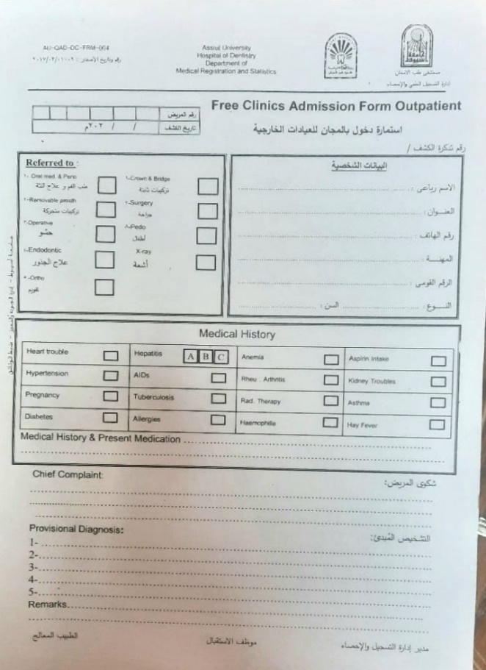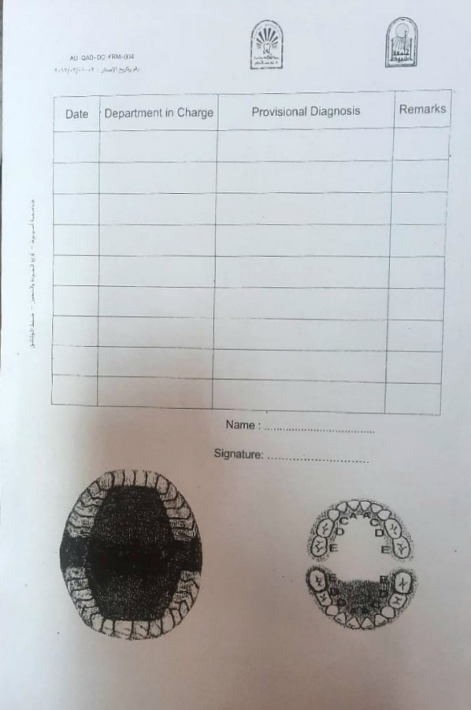

Figure 2.2 Hospital ticket

These findings significantly influenced the design and feature set of the Integrated Dental System, ensuring that it addresses real problems faced by hospital staff daily.

## **2.11 Defining Requirements**

### **2.11.1 Functional Requirements**

Functional requirements define the specific functions and processes that the Integrated Dental System (IDS) must perform to support the hospital's internal workflow.

These features were designed based on realistic needs identified during interviews with Assiut University Dental Hospital staff.

Key functions include:

1. Patient registration and management
   * Adding, updating, and retrieving patient information, including personal data and medical history.
   * Issue unique patient IDs and manage ticket system entries.
2. Role-Based Access Control (RBAC)
   * Define user roles and permissions:
     + Receptionist: Register patients, assign clinics
     + Diagnostic Nurse/Doctor: View patient records, diagnose, refer to treatment units
     + Intern Doctor / Resident: Receive referred cases, record treatments
     + Admin: Manage users, assign roles, edit clinic structure
     + Manager: Monitor performance, generate reports
3. Inter-Clinic Referral System
   * Enable diagnostic doctors to refer patients to appropriate treatment clinics.
   * Track referral status and ensure smooth transitions between departments.
4. Medical History & Patient Record Access
   * Allow authorized users to view and update patient data securely.
   * Maintain historical records for follow-up and continuity of care.
5. Reporting & Analytics
   * Generate reports on:
     + Daily patient flow
     + Clinic workload distribution
     + Appointment trends
   * Provide dashboards for managers to monitor hospital performance.
6. Track User Activity
   * Record all actions taken by users in the system for audit and accountability purposes.

### **2.11.2 Non-functional Requirements**

Non-functional requirements describe how the system will operate under specific conditions, focusing on usability, security, performance, and reliability.

**Table 2.14 : non-functional requirements**

|  |  |
| --- | --- |
| **Requirement** | **Description** |
| Usability | The system interface should be intuitive and easy to use for all staff members, regardless of technical background. |
| Security | Patient data must be protected using strong encryption and role-based access control. Authentication via Microsoft Identity ensures secure login and user verification. |
| Reliability | The system must operate consistently without frequent crashes or errors, even under heavy usage. |
| Performance | The system should respond quickly to user actions such as data entry, search, and report generation. |
| Scalability | The architecture should allow for future expansion, including integration with other hospital systems or additional clinics. |
| Availability | The system must be available around the clock, with minimal downtime for updates or maintenance. |
| Compatibility | The system must be compatible with various devices (desktops/laptops) and browsers used by hospital staff. |
| Maintainability | Code should be modular and well-documented to allow for easy updates and troubleshooting. |

## **2.12 Use Case Diagrams and Descriptions**

Use case diagrams provide a visual representation of how different actors interact with the system. In the Integrated Dental System (IDS), we identify seven main user roles, each with specific interactions and responsibilities.

Use Case Diagram Description

The following details the main use cases associated with each actor in the system.

**1. Hospital Manager**

**Main Responsibilities:**

* Oversee hospital operations.
* Monitor performance and efficiency.
* Approve changes in staff or clinic structure.

**Use Cases:**

* View performance reports.
* Monitor inter-clinic coordination.
* Review user activity logs.
* Edit or approve system-wide settings.

**2. System Administrator**

**Main Responsibilities:**

* Manage user accounts and roles.
* Handle doctor transfers and promotions.
* Ensure system stability and data integrity.

**Use Cases:**

* Create, update, or delete user accounts.
* Assign doctors to clinics.
* Promote Intern Doctors to Residents.
* Reset passwords and manage permissions.

**3. Registration Officer (Reception Staff)**

**Main Responsibilities:**

* Register new patients.
* Issue tickets and schedule appointments.
* Update basic contact information if needed.

**Use Cases:**

* Register New Patient: Enter personal and initial medical information.
* Issue New Ticket: Create a new visit record for both new and returning patients.
* Search Patient Records: Locate patients by name, or ID.
* View Limited Patient Data: Can only see basic personal information of existing patients (no access to medical history or diagnosis).
* Schedule Appointments: Assign time slots and manage daily visits.
* Update Contact Info: Modify phone numbers or addresses if changed.

Important Restriction:

Reception staff cannot view or edit any diagnostic or treatment-related data — only limited personal info and current ticket details are visible.

**4. Diagnostic Nurse**

**Main Responsibilities:**

* Manage patient flow in the diagnostic clinic.
* Call patients based on ticket numbers.

**Use Cases:**

* View incoming patient list.
* Mark patients as "In Progress" or "Completed".
* Notify diagnostic doctors of new arrivals.

**5. Diagnostic Doctor**

**Main Responsibilities:**

* Conduct diagnosis.
* Refer patients to treatment clinics.

**Use Cases:**

* Access patient medical history.
* Record diagnosis notes.
* Select the appropriate treatment clinic.
* Forward patient file to selected clinic.

**6. Clinic Resident (Head of Clinic)**

**Main Responsibilities:**

* Supervise clinic operations.
* Assign cases to junior doctors.

**Use Cases:**

* Access all assigned cases in the clinic.
* Reassign patients among interns.
* Review completed treatments.
* Communicate with other clinics for referrals.

**7. Intern Doctor**

**Main Responsibilities:**

* Treat assigned patients under supervision.
* Record treatment.

**Use Cases:**

* Access assigned patient files.
* Record treatment notes.
* Update treatment status.
* Request further diagnostics if needed.

**Common Use Cases Across Roles**

The following use cases apply to multiple roles within the system:

**Table 2.15 : IDS use case**

|  |  |
| --- | --- |
| **Use Case** | **Description** |
| Login / Logout | Secure authentication for all users using Microsoft Identity. |
| Search Patient Records | Quick search functionality to locate patient files by Name or ID. |
| View Limited Patient Data | Reception staff can view only personal information (name, age, gender, contact). |
| Update Fields | Authorized users can edit relevant parts of patient data (e.g., reception can only update non-sensitive fields like phone number or address). |
| Generate New Tickets | All patients receive a new ticket upon arrival; new patients are registered, returning ones get a new visit record. |
| View Reports | Manager can access performance and workflow reports. |
| Access Control | Each role has limited access based on permissions (e.g., reception cannot view diagnosis or treatment notes). |
| Audit Logs | Track user actions for accountability and system monitoring. |

## **2.13 Management Plan**

**Introduction**

The Integrated Dental System (IDS) management plan identifies the key components needed to successfully manage the project from inception to completion. This plan includes defining project phases, allocating resources, scheduling development tasks, and implementing risk management strategies.

By taking a systematic approach, this plan ensures that all aspects of the project — including requirements gathering, design, implementation, testing, and documentation — are executed efficiently and effectively, resulting in timely and high-quality system delivery.

This plan also outlines how the team organized and managed the development process, ensuring alignment with university guidelines, stakeholder expectations, and real-world hospital workflows.

### **2.13.1 Current State of the Project**

As of the time of writing, the project has progressed through several critical stages:

* **Project Initiation**: Problem statement, objectives, and feasibility study completed.
* **Requirements Gathering**: Conducted interviews with hospital staff at Assiut University Dental Hospital.
* **System Design**: Defined user roles, modules, and system architecture.
* **UI/UX Design**: Developed mockups and interface layouts for each role.
* **Implementation Phase**: backend and frontend development.
* **Testing & Documentation**: Scheduled after implementation is complete.

This structured progression ensures that the final system aligns with the academic requirements and actual needs of hospital staff.

### **2.13.2 Project Phases**

The Integrated Dental System (IDS) management plan consists of eight clearly defined phases, each with specific tasks and objectives. These phases guide the development process from concept to final delivery and ensure the system meets functional, technical, and usability standards.

**Phase 1: Project Initiation**

**Objective:** Define the scope, purpose, and feasibility of the system.

* Identify the problem with current paper-based systems in dental hospitals.
* Define project goals and deliverables.
* Conduct a feasibility study covering technical, operational, and economic aspects.
* Identify stakeholders and initial requirements.

**Phase 2: Planning**

**Objective:** Gather detailed requirements and define the system’s foundation.

* Conduct in-person interviews with hospital staff across departments.
* Document functional requirements (patient registration, appointment scheduling, inter-clinic referrals).
* Document non-functional requirements (security, performance, usability).
* Define user roles and access levels.
* Create system use cases and workflow diagrams.

**Phase 3: System Design**

**Objective:** Develop a clear system diagram before starting programming/coding.

* Create high-level system architecture and module breakdown.
* Design database schema using MySQL.
* Develop UI/UX wireframes for each user role.
* Define APIs, authentication flows, and data structures.

**Phase 4: Implementation**

**Objective:** Build the system based on design specifications.

* Develop frontend interfaces for all user roles (Receptionist, Diagnostic Nurse, Doctor, Intern, Admin, Manager).
* Implement backend logic including patient registration, ticketing, referral system, and reporting.
* Integrate Microsoft Identity for secure login and role-based access control.
* Use Jira to track tasks, assign responsibilities, and monitor progress.
* Regular code reviews and version control using GitHub.

**Phase 5: Testing**

**Objective:** Ensure the system works as intended and is free of major bugs.

* Develop comprehensive test plans based on functional requirements.
* Perform unit testing for individual features.
* Conduct integration testing to verify communication between modules.
* Test role-based access control and data security.
* Collect feedback from supervisors and test users.
* Fix reported issues and refine UI/UX and performance.

**Phase 6: Deployment**

**Objective:** Deliver a stable version of the system ready for demonstration and evaluation.

* Prepare system for deployment in a demo or test environment.
* Ensure all features work correctly and securely.
* Generate final documentation, including user manuals and technical reports.
* Present the system to supervisors and hospital contacts for review.

**Phase 7: Maintenance (post-discussion)**

**Objective:** To support any future improvements or enhancements.

* Providing support during the university discussion and evaluation phase.
* Gather final feedback from supervisors and hospital staff.
* Suggest potential future improvements, such as:
  + Deploying a cloud-based system.
  + Integration with mobile applications
  + Integration with national health records.

**Phase 8: Closing**

**Objective:** Officially conclude the project and evaluate outcomes.

* Submit final documentation and source code to university.
* Conduct a project review meeting with team members and supervisors.
* Reflect on lessons learned and challenges faced during development.
* Evaluate success against original objectives and deliverables.
* Explore opportunities for future development or expansion of IDS.

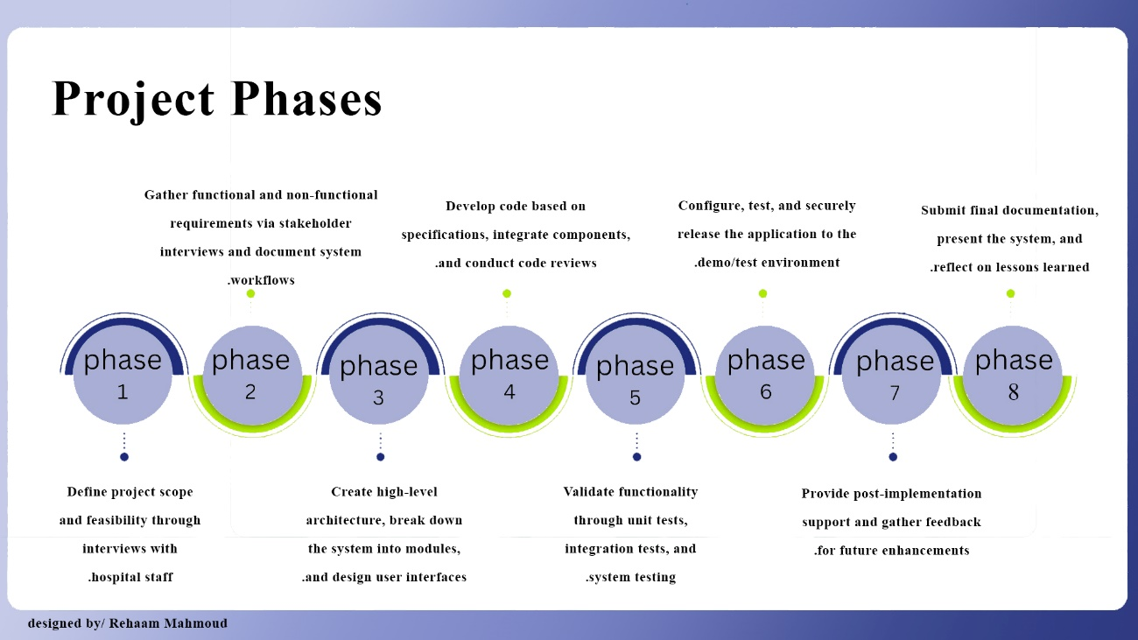

Figure 2.3 : Projct phases

### **2.13.3 Project Timeline (Managed via Jira)**

To ensure efficiency and task tracking, our team used Jira as the main tool for managing the Integrated Dental System (IDS) project. Jira enabled us to:

Break down tasks into sprints

Assign responsibilities to team members

Track progress in real time

Monitor deadlines and deliverables

Below are simplified Jira-style timeline snapshots, showing how we managed each phase of the project.

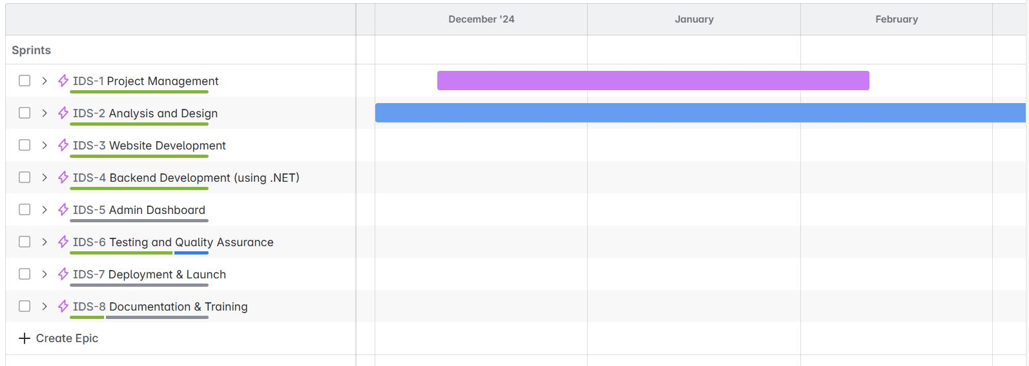

Figure 2.4 Jira screenshot

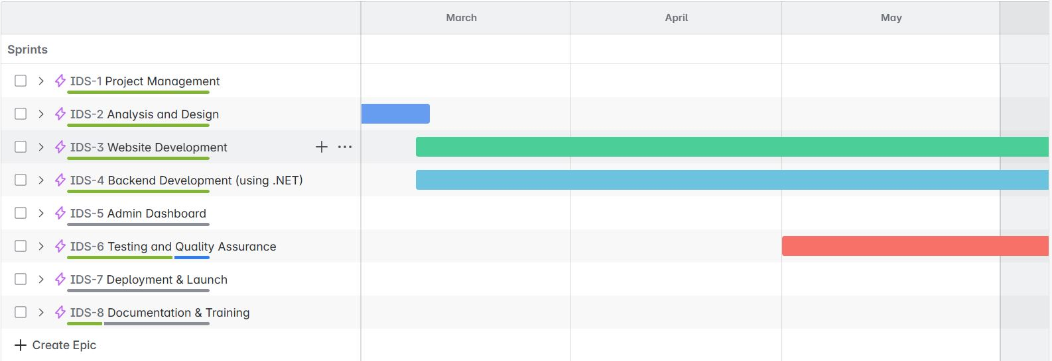

Figure 2.5 Jira screenshot

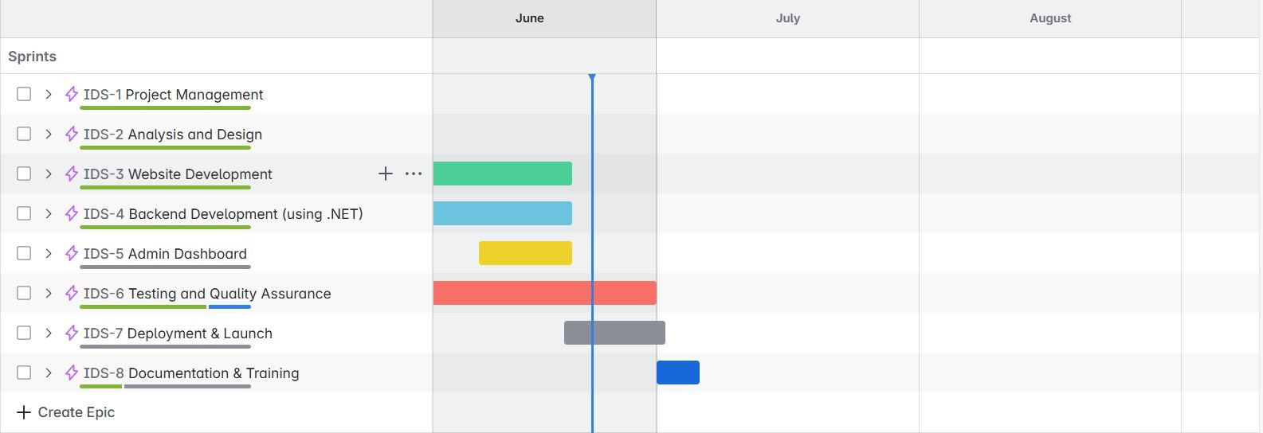

Figure 2.6 Jira screenshot

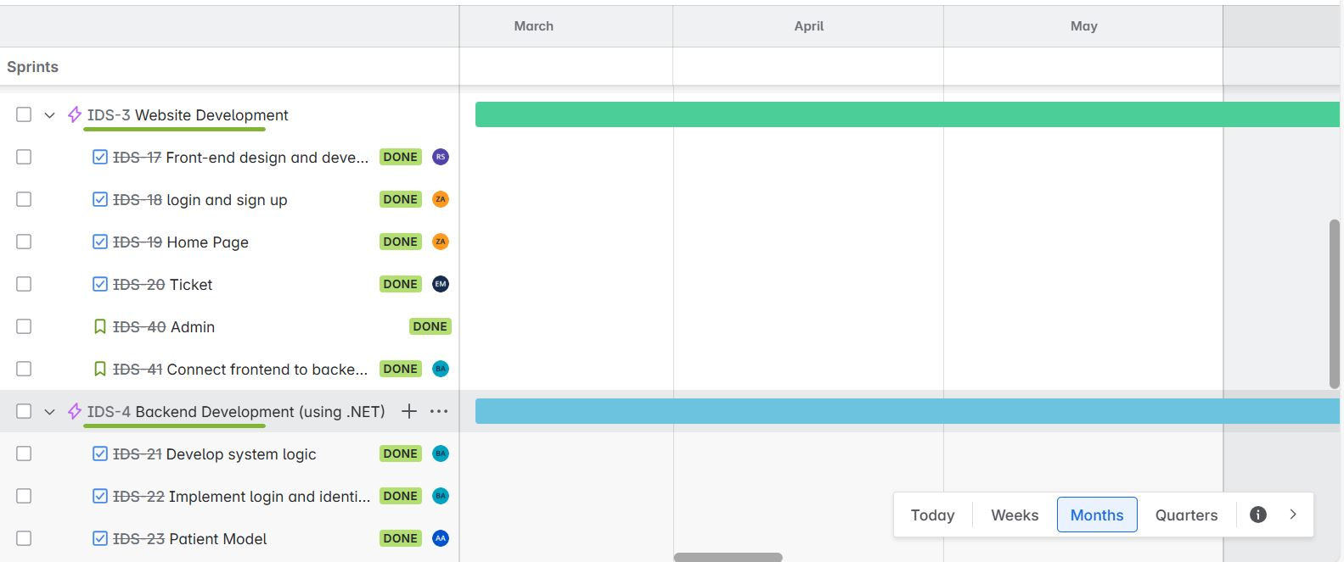

Figure 2.7 Jira screenshot

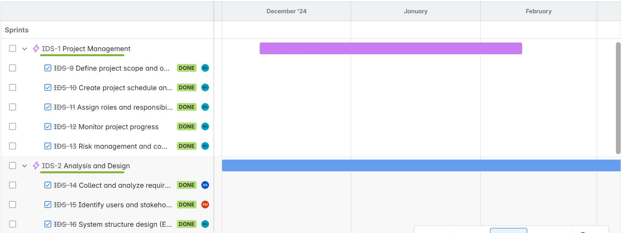

Figure 2.8 Jira screenshot

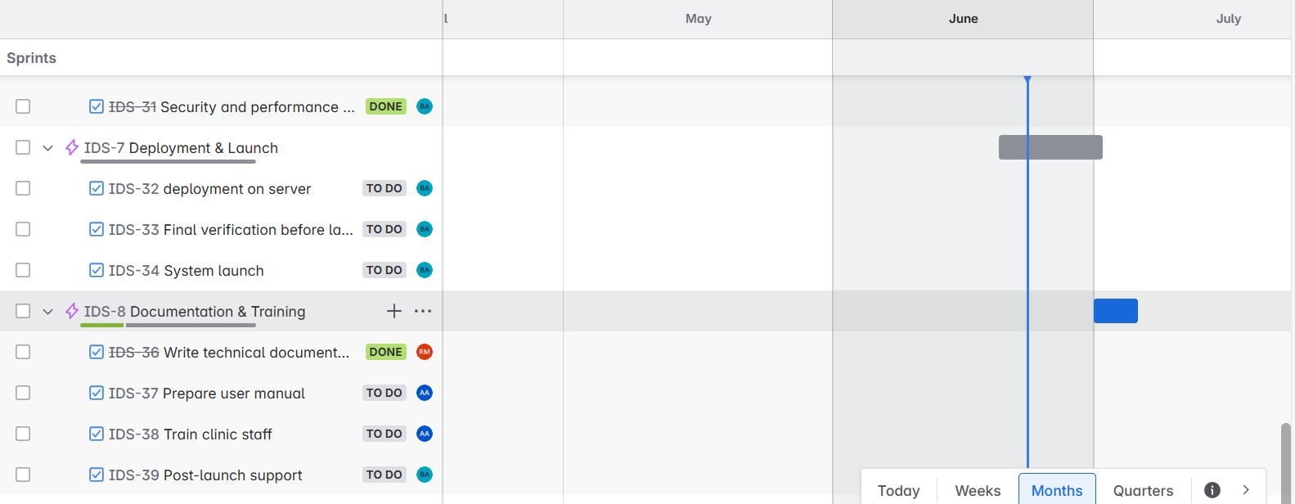

Figure 2.9 Jira screenshot

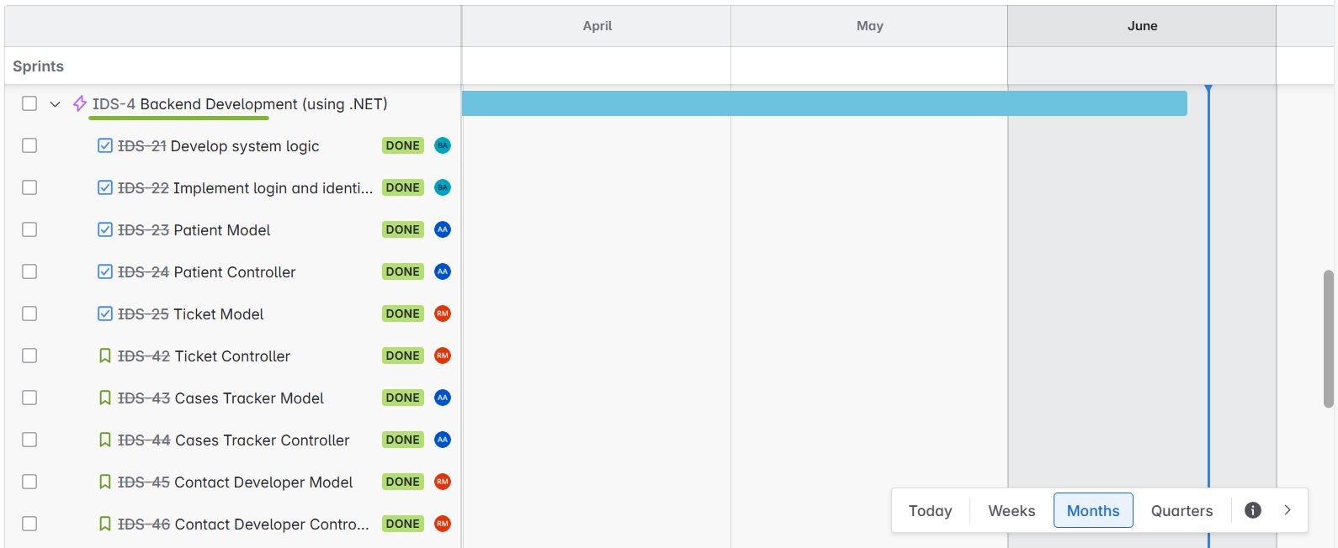

Figure 2.10 Jira screenshot

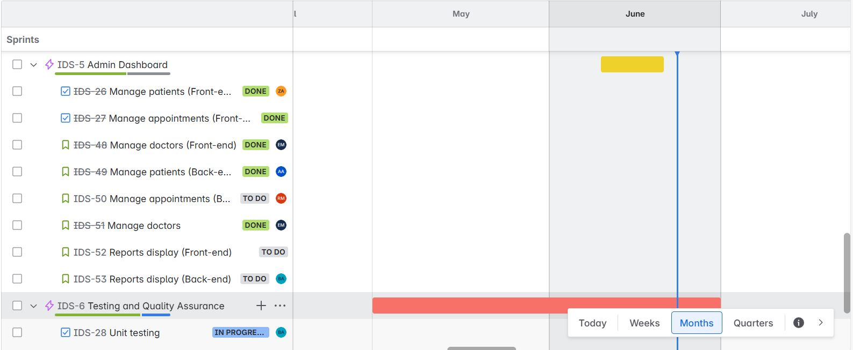

Figure 2.11 Jira screenshot

### **2.13.4 Division of Responsibilities**

Division of responsibilities among team members is a crucial part of Integrated Dental System (IDS) to ensure that every team member knows his responsibilities and every phase is go well and at time

1. **Project Management**
   1. Define project scope and objectives. [Badr]
   2. Create project schedule. [Badr]
   3. Assign roles and responsibilities. [Badr]
   4. Monitor project progress. [Badr]
   5. Risk management and communication. [Badr]
2. **Analysis and Design**

2.1 Collect and analyze requirements [all team]

2.2 Identify users and stakeholders [all team]

2.3 System structure design (ERD, DFD, Use Cases) [Badr, Rehaam]

1. **Website Development** 
   1. Front-end design and development [Rania]
   2. login and sign up [Al-zahra]
   3. Home Page [Al-zahra]
   4. Ticket [Esraa]
   5. Admin [Aya]
   6. Connect frontend to backend [Badr]
2. **Backend Development (.NET)** 
   1. Develop system logic [Badr]
   2. Implement login and identity [Badr]
   3. Patient Model [Rehaam]
   4. Patient Controller [Ahmed]
   5. Ticket Model [Rehaam]
   6. Ticket Controller [Badr]
   7. Cases Tracker Model [Ahmed]
   8. Cases Tracker Controller [Ahmed]
   9. Validations [Badr]
3. **Admin Dashboard**
   1. Manage patients (Front - end) [Al-zahra]
   2. Manage appointments (Front -end) [Aya]
   3. Manage doctors (Front - end) [Esraa]
   4. Manage patients (Back - end) [Ahmed]
   5. Manage appointments (Back -end) [Rehaam]
   6. Manage doctors (Back - end) [Badr]
   7. Reports display (Front - end) [Aya]
   8. Reports display (Back - end) [Badr]
4. **Testing and Quality Assurance** 
   1. Unit testing [Badr]
   2. Integration testing [Ahmed]
   3. Usability testing [Rehaam]
   4. Security and performance testing [Badr]
5. **Deployment and Launch**

7.1 deployment on server [Badr]

7.2 Final verification before launch [Badr]

7.3System launch [Badr]

1. **Documentation and Training** 
   1. Write technical documentation [Rehaam]
   2. Prepare user manual [Ahmed]
   3. Train clinic staff [Ahmed]
   4. Post -launch support [Badr]

### **2.13.5 Management Risks**

Although the Integrated Dental System (IDS) is an academic graduation project, it involves numerous operational and technical risks that could impact its success, usability, or future implementation in real-world settings. Identifying and addressing these risks ensures a smoother development process and better alignment with hospital needs.

**1. Data Accuracy and Patient Information Integrity**

Incorrect or incomplete data entry — especially during patient registration or medical history updates — can lead to errors in diagnosis or treatment planning.

**Solution:**

Implement validation rules and mandatory fields for critical information.

Provide training to reception staff on correct data entry procedures.

**2. User Adoption and Resistance to Change**

Hospital staff may resist switching from paper-based systems to a digital platform due to unfamiliarity or preference for traditional methods.

**Solution:**

Design an intuitive and user-friendly interface.

Conduct practical training sessions and awareness workshops for all user roles.

**3. Security and Data Privacy**

Handling sensitive patient information requires strong security measures. Any breach or unauthorized access could compromise confidentiality and trust.

**Solution:**

Use Microsoft Identity for secure authentication.

Apply role-based access control (RBAC) and database encryption to protect sensitive data.

**4. Hardware and Infrastructure Limitations**

The effectiveness of the system depends on the availability of Hardware (computers/tablets) and internet access in the hospital — which is currently uncertain.

**Solution:**

Design the system to be lightweight and browser-based to work on low-end devices initially.

Advocate for basic IT infrastructure.

**5. Technical Issues and System Downtime**

Bugs, crashes, or server downtime can disrupt daily operations and reduce staff confidence in the system.

**Solution:**

Perform regular testing and bug fixing throughout development.

Ensure code stability and maintain backups for emergency recovery.

**6. Incomplete or Unclear Requirements**

Gathering accurate requirements from hospital staff is essential. Misunderstandings or incomplete feedback can lead to missing features or poor usability.

**Solution:**

Conduct multiple rounds of interviews and observations at Assiut University Dental Hospital.

Maintain close communication with supervisors and stakeholders.

**7. Time Constraints (Academic Timeline)**

As a graduation project, development must align with university deadlines, limiting time for extensive testing or feature expansion.

**Solution:**

Use Jira for task tracking and milestone setting.

Focus on core features first and plan for future enhancements post-graduation.

**8. Limited Long-Term Maintenance Plan**

Since this is an academic project, long-term support and maintenance after submission are not guaranteed unless adopted by the university or hospital.

**Solution:**

Document the system thoroughly to allow future students or developers to continue working on it.

# **Chapter 3 (Software requirements specifications)**

## **3.1 Introduction:**

The Software requirements specifications (SRS) document of the Dental Hospital Management System outlines both the functional and non-functional requirements of the application. This document serves as a formal agreement between the development team and the hospital administration to ensure that the final product meets the expectations of users, staff, and stakeholders.

It provides a clear understanding of the system’s features, constraints, and goals, and will act as the foundation for the system's design, development, testing, and deployment.

By defining user interactions, system workflows, and technical specifications, this SRS ensures that IDS is built to support efficient, secure, and role-based digital operations.

### **3.1.1 Intended Audience and Reading Suggestions**

The intended audience of this system includes:

* Reception Staff: Responsible for patient registration, appointment scheduling, and ticketing.
* Dentists and Assistants: Who need access to patients' records and treatment history.
* Clinic Residents and Intern Doctors: Conduct treatments under supervision and update patient files accordingly.
* Administrators and IT Managers: Responsible for managing system settings and user roles.
* Hospital Managers: Monitor performance metrics, generate reports, and oversee hospital operations.

Reading Suggestions:

* For Reception staff: materials on digital workflow optimization in healthcare, electronic registration systems, and articles on improving patient intake efficiency.
* For Dentists: research on electronic medical records (EMR) and dental case tracking.
* For IT/Admins: best practices for hospital data privacy and system maintenance.
* For Supervisors & Hospital manager: Documentation on digital transformation in healthcare and hospital administration

By identifying each user group and recommending appropriate resources, the system ensures a better user experience and higher efficiency.

### **3.1.2 Product Scope**

The scope of the Dental Hospital Management System is to digitize and streamline the patient journey from arrival to discharge. This includes:

* Digital ticket generation at reception
* Patient registration and data management
* Dentist assignment and treatment tracking
* Real-time internal communication between departments
* Secure storage and access to medical records
* Feedback and reporting system
* Admin dashboard for system oversight and control

The system reduces paperwork, improves service speed, and ensures better tracking of patient cases.

## **3.2 Overall Description**

The web-based system is designed to support all operational stages of a dental hospital visit. It enables receptionists to manage patient check-ins, dentists to access and update medical records, and administrators to oversee the entire workflow digitally. It also facilitates patient feedback and helps maintain a complete digital archive of treatment history.

### **3.2.1 Product Perspective**

The system is a standalone web-based platform but can be integrated with existing hospital software if needed. It provides modules such as:

* Reception Module (ticketing and patient check-in)
* Medical Module (dentist-patient interaction and treatment history)
* Admin Module (user management, reports, data control)

Each user accesses the interface tailored to their role.

### **3.2.2 Product Functions**

The system offers the following core functions:

* Digital ticket issuance for new patients.
* Patient profile creation and medical history tracking.
* Dentist dashboard for reviewing and updating cases.
* Role-based login (Admin, Dentist, Receptionist).
* Internal notifications (e.g., patient ready, case updated).
* Report generation and data export

### **3.2.3 User Classes and Characteristics**

The system targets three primary user types:

* Receptionists: Handle new patient entries and ticketing
* Dentists: Access and update patient data, record diagnoses and treatments
* Administrators: Manage users, monitor system usage, and generate reports

All users are trained on the system, and each class has a customized interface and access level.

### **3.2.4 Operating Environment**

The Dental Hospital Management System is a web-based application accessible via standard web browsers. It is optimized for desktop computers used in hospital reception and dental clinics.

**Hardware:**

* Desktop computers used by hospital staff
* Optional printer support for issuing physical tickets (if needed)
* Minimum recommended specs:
  + RAM: 4GB+
  + Storage: 50 GB free space

**Software:**

* Operating Systems: Windows 10+, optional macOS/Linux compatibility
* Web Browsers: Google Chrome, Firefox, Edge (latest versions)

**Backend & Development Stack:**

* Frontend: HTML, CSS, JavaScript, bootstrap
* Backend: C#, ASP.NET MVC, LINQ
* Database: MySQL
* Hosting: local hospital servers or test deployment via university infrastructure.

### **3.2.5 Design and Implementation Constraints**

To ensure system stability and data integrity, the following constraints apply:

* Multi-user access with role-based authentication (RBAC).
* Sensitive patient data must be encrypted and follow data privacy policies.
* The system should not allow simultaneous login for the same account.
* All actions (e.g., treatment updates, ticket status) must be logged.
* Only authorized personnel can modify or delete medical records.
* System performance must support daily hospital workflows without downtime.

### **3.2.6 User Documentation**

The Integrated Dental System will include a comprehensive user manual and on-screen guidance to help hospital staff and administrators navigate and use the system effectively.

This documentation will guide users step-by-step through essential operations such as patient registration, digital ticket issuance, accessing medical records, and generating reports.

It will also include troubleshooting steps and frequently asked questions to ensure smooth adoption of the system.

### **3.2.7 Assumptions and Dependencies**

Availability of desktop or laptop computers in all hospital departments, along with stable internet connectivity for real-time data access.

Hospital staff willingness to transition from paper-based operations to a digital system.

Presence of basic computer literacy among users (receptionists, dentists, admin).

Cooperation from hospital administration to integrate the system into daily workflows.

These assumptions are essential for the successful implementation and optimal usage of the system.

## **3.3 External Interface Requirements**

The external interface requirements are crucial to ensure that the Dental Hospital Management System integrates well with existing infrastructure and provides a smooth user experience.

These interfaces include hardware, software, and communication components that allow efficient interaction with the system.

### **3.3.1 Hardware Interfaces**

The system is primarily intended for desktop computers or laptops used by hospital staff. Recommended hardware specifications include:

Display: Minimum 15" screen for better visibility of records

RAM: Minimum 4 GB

CPU: Dual-core or higher

Storage: 64 GB of free space for local data caching

Input Devices: Keyboard and mouse for easy navigation

Printer support: For generating physical reports or tickets (if needed).

### **3.3.2 Software Interfaces**

The Dental Hospital Management System will be compatible with commonly used operating systems such as Windows 10+, and major web browsers (Google Chrome, Firefox).

Database:

The system utilizes a cloud-based database such as Firebase or MySQL for secure and scalable data storage. It supports real-time synchronization of patient records and appointments across departments.

**Frameworks and Tools:**

Frontend: HTML, CSS, JavaScript

Backend: C#, ASP.NET MVC, LINQ

Database: MySQL

Operating Systems Supported:

Windows 10 and above

macOS (optional support)

Web browsers: Chrome, Firefox, Edge (latest versions)

User Interfaces (UI):

* Receptionist Interface:
  + Patient registration form
  + Ticket generation
  + Appointment scheduling
  + Search and filter patient records
* Dentist Interface:
  + Access patient treatment history
  + Record diagnosis and procedures
  + View appointments
  + Add medical notes
* Admin Interface:
  + Add/edit/delete user accounts
  + Monitor hospital-wide activity
  + Access logs and reports
  + Configure system settings
* Patient View (Optional future module):
  + View appointment date and feedback
  + Submit review or complaint

### **3.3.3 Communication Interfaces**

To ensure smooth operation and secure data exchange, the system will include:

* Inter-System Communication:

Can be extended to integrate with other hospitals

* Data Storage:

Data will be stored securely in Firebase or a similar platform, with encrypted access to protect patient information.

* User Registration and Login (Authentication):

Role-based user registration with secure login using email and password/ Microsoft Identity.

* Security Interfaces:

Encrypted password storage (e.g., using encryption or Firebase Authentication).

Secure sessions with timeout and token validation.

HTTPS enforced for all communication.

* Data Protection Compliance:

The system will adhere to data protection regulations to safeguard sensitive medical records and personal data.

## **3.4 Functional Requirements**

### **3.4.1 User Management**

* Add/edit/delete users
* Assign roles and permissions
* Reset passwords and manage access rights

### **3.4.2 Patient Management**

* Register new patients
* Update existing patient records
* View full patient history and tooth status

### **3.4.3 Ticket Management**

* Generate new tickets for all visits
* Track ticket status (Waiting, In Progress, Completed)
* Refer tickets to appropriate clinics
* Update treatment notes and completion level

### **3.4.4 Clinic & Referral Management**

* List available clinics
* Allow diagnostic doctors to refer patients
* Ensure smooth patient flow between departments

### **3.4.5 Reporting & Analytics**

* Generate daily/weekly/monthly reports
* Track clinic workload, ticket trends, and doctor performance
* Export data for further analysis

## **3.5 Other Non-Functional Requirements**

### **3.5.1 Performance Requirements**

* Speed and Efficiency

The Dental Hospital Management System must respond to user actions (e.g., navigating between pages, loading patient data) in less than 3 seconds to ensure smooth operation during busy hours.

Search and filtering of patient records, appointments, and doctors should be fast and accurate.

* Compatibility

The system should be compatible with modern web browsers (Chrome, Firefox, Edge) and operate smoothly on different operating systems (Windows 10+, Linux-based systems).

* Stability and Reliability

The system should remain stable under regular use without crashing.

Regular automated backups must be implemented to ensure recovery in case of system failure.

Reliability should be maintained at or above 97%, ensuring continuous service availability.

* Scalability

The system must be scalable to support a growing number of patients, staff, and data over time without performance degradation.

Resource Consumption

Optimize system resource usage to ensure the hospital computers aren’t overloaded.

Network bandwidth and data load should be minimized where possible to accommodate hospitals with limited internet speed.

* Availability

The system must maintain 24/7 availability to allow access by staff in various shifts, with minimal downtime.

* User Satisfaction

Deliver a responsive, clear, and helpful experience to all users (receptionists, doctors, admins), with immediate feedback and error handling to prevent frustration.

### **3.5.2 Safety Requirements**

The Dental Hospital Management System must comply with hospital data protection regulations to ensure patient confidentiality and information safety.

* Access Permissions

Access to patient records and system settings must be role-based (e.g., admin, dentist, receptionist) to limit unauthorized access.

* Defense Against Attacks

The system should implement firewalls and real-time intrusion detection to prevent data breaches and cyberattacks.

* Emergency Support

A disaster recovery plan must be in place to restore system functionality in case of failure.

Technical support should be available during hospital working hours or 24/7 in critical departments.

### **3.5.3 Security Requirements**

The system must implement strong encryption (e.g., HTTPS, secure login tokens) to protect data during transmission and storage.

Periodic security updates must be performed to fix vulnerabilities and maintain a high level of protection.

### **4.5.4 Software Quality Attributes**

The interface should be user-friendly, intuitive, and accessible to non-technical users such as hospital reception staff.

The system must be modular and maintainable, allowing for future updates or feature additions.

Extensive testing must be conducted to ensure system reliability and bug-free operation.

Role-based access ensures that each user can only access the functions relevant to their responsibilities.

### **3.5.5 Business Rules**

The system must follow regulations and standards related to medical data confidentiality and digital record management.

It must support hospital goals, such as efficient patient tracking, reporting, and performance improvement.

The system should be designed with integration capability, allowing for future connection with other hospital systems (e.g., billing, pharmacy, or lab systems).

# **Chapter 4 (Software design)**

## 

## **4.1 Introduction**

The Integrated Dental System (IDS) software design phase represents a fundamental step in transforming functional and non-functional requirements into a structured and scalable digital solution. This phase establishes the system architecture, defines core modules, and outlines the interfaces and interactions that support seamless hospital operations.

Duo to the nature of an IDS as an internal management system for dental hospitals, the software design must align with real-world workflows while ensuring security, usability, and maintainability.

The design also takes into account the specific roles within the hospital — including reception staff, diagnostic nurses, doctors, clinic residents, interns, administrators, and managers — ensuring each has access to only what is necessary for their responsibilities.

Once the detailed design is complete, it should clearly reflect how all system requirements are addressed, laying the groundwork for smooth implementation and future expansion.

### **4.1.1 Project Background / Purpose**

The Integrated Dental System (IDS) aims to digitize and streamline administrative and clinical operations within governmental dental hospitals. The current reliance on paper-based systems leads to inefficiencies such as data duplication, lost records, scheduling conflicts, and poor inter-clinic communication.

IDS provides a centralized platform for managing patient registration, appointment scheduling, diagnosis, treatment tracking, and reporting. It supports multiple user roles with role-based access control to ensure secure and accurate handling of sensitive medical information.

**The primary goal of IDS is to:**

* Replace manual processes with digital workflows.
* Improve coordination between reception, diagnostics, and treatment clinics.
* Enhance hospital administration through performance monitoring and analytics.
* Support better decision-making by providing real-time access to hospital data.

By providing a standardized and secure system, IDS aims to improve efficiency, reduce human error, and provide hospital staff with tools that enhance daily operations — ultimately contributing to improved patient care and organizational performance.

In addition to supporting current hospital needs, the system is designed with future scalability in mind, allowing for integration with larger healthcare platforms or expansion into other medical departments.

### **4.1.2 Hosting Platform & Technology Stack**

Although the Integrated Dental System (IDS) is currently being developed as an academic graduation project, its design allows for deployment in a hospital environment using either local or cloud infrastructure.

**Development Technologies Used:**

**Frontend:**

* HTML, CSS, JavaScript – For structuring and styling interfaces
* Responsive Layouts – Ensures compatibility across different screen sizes and devices used by hospital staff

**Backend:**

* C# – Primary programming language for server-side logic
* ASP.NET MVC – Web framework used to manage routing, controllers, and views
* LINQ – For efficient querying and manipulation of database records

**Database:**

* MySQL – A secure and scalable relational database used to store and manage patient records, tickets, user accounts, and clinic data

**Authentication & Security:**

* Microsoft Identity – Provides secure login, role-based access control, and user management features.
* HTTPS – Ensures encrypted communication between client and server.
* Database Encryption – Protects sensitive patient and staff data from unauthorized access,

**Version Control & Task Management:**

* GitHub – For collaborative development, versioning, and code management.
* Jira – To organize tasks, track progress, and manage sprints throughout the development lifecycle.

**Deployment Options**

Although this project is not deployed online yet, here are potential hosting options for future use:

* Local Hospital Server (Current Use Case)
* Suitable for pilot testing within the university or hospital network
* No internet dependency required
* Easy to deploy using university labs or hospital IT resources
* Cloud Hosting Platforms (Future Expansion)

If adopted beyond the academic stage, IDS can be hosted on various platforms to enable remote access and wider usage:

**Table 4.1 hosting platforms**

|  |  |
| --- | --- |
| **Platform** | **Features** |
| Microsoft Azure | Scalable hosting services, integrated with ASP.NET MVC and Microsoft Identity |
| AWS (Amazon Web Services) | Offers flexible cloud solutions for web applications and databases |
| Firebase (optional) | Can be used for authentication and lightweight cloud storage (not currently implemented) |

**Note**: While Firebase was considered during planning, the current system uses native ASP.NET Identity and MySQL for greater customization and academic clarity.

**Chatbot Integration (Optional Future Feature)**

A chatbot could be added to assist hospital staff with frequently asked questions about the system. Tools like Dialog flow or Microsoft Bot Framework may be explored in future versions for automated helpdesk functionality.

## **4.2 System Architecture**

The Integrated Dental System (IDS) is designed using a modular web-based architecture, divided into seven distinct user roles grouped into four core modules. This structure ensures clear separation of duties, data integrity, and enhanced security through Role-Based Access Control (RBAC).

Each module is tailored to specific workflows and access permissions, ensuring that users interact only with the features relevant to their role.

1. **Administration Module**
   1. Manager Role

The Hospital Manager has full oversight over the entire system.

Can monitor operations, generate reports, manage staff accounts, and adjust hospital settings.

Has the authority to edit or approve changes across all departments.

* 1. Admin Role

The System Administrator manages user accounts, including registration, activation, deactivation, and role assignment.

Handles doctor transfers between clinics and promotions (e.g., from Intern to Resident).

Ensures smooth system operation and data integrity.

These two roles form the Administration Module, which provides centralized control over the system and supports strategic decision-making.

1. **Reception & Registration Module**
   1. Registration Officer (Reception)

Responsible for registering new patients, entering personal and medical information.

Issues patient tickets and schedules initial appointments.

Updates patient records and handles administrative inquiries.

This module serves as the entry point for all patients and ensures accurate and secure data input into the central database.

1. **Diagnostic Clinic Module**
   1. Diagnostic Nurse

Manages incoming patient flow in the diagnostic clinic.

Calls patients based on ticket numbers and updates status in the system.

Acts as an intermediary between reception and diagnostic doctors.

* 1. Diagnostic Doctor

Reviews patient history and assigned ticket.

Conducts diagnosis and determines the appropriate treatment clinic.

Refers patients to the correct treatment unit within the system.

This module focuses on patient triage and diagnosis, streamlining the transition from general intake to specialized care.

1. **Treatment Clinic Module**
   1. Clinic Resident (Head of Clinic / Specialist)

Oversees the daily operations of the treatment clinic.

Assigns cases to doctors (Interns).

Reviews treatments and approves follow-ups or referrals when needed.

* 1. Clinic Doctor

Assigned patients by the Clinic Resident.

Conducts treatments under supervision.

Records progress and updates patient files accordingly.

This module supports specialized treatment delivery, with hierarchical management of case assignments and quality assurance.

Unified Platform & Security

All modules operate within a centralized web-based platform, built with role-based access control (RBAC) to ensure:

Each user sees only what they are authorized to see.

Sensitive data (e.g., patient records, staff details) is protected.

Actions like editing or deleting data are restricted to higher-level roles.

**Technical Architecture Overview:**

All three modules operate on a centralized web platform, connected to a secure backend database. The system uses the following technologies:

**Frontend:**

* HTML, CSS & bootstrap for structure and styling,
* Java (if applicable for UI logic; otherwise, consider JavaScript or frontend frameworks like Bootstrap).
* Designed by a dedicated UI/UX designer to ensure an intuitive and accessible interface across roles.

**Backend:**

* C# for server-side logic.
* ASP.NET MVC framework for handling business logic and routing.
* LINQ for efficient querying and manipulation of database records.

**Database:**

* MySQL for storing and managing structured data such as:
* Patient Records
* Appointments
* User Accounts
* Clinic Operations
* Reports

**Security:**

* Microsoft Identity for authentication and role-based access control (RBAC)
* HTTPS and encryption to protect data during transmission and storage

## **4.3 Data Design**

### **4.3.1 Data Description**

The Integrated Dental System (IDS) relies on a well-structured relational database to manage internal hospital operations. The system includes key entities such as:

* **Patient:** Stores personal and demographic details for registration and treatment tracking.
* **Ticket:** Records each patient visit, including appointment date, chief complaint, provisional diagnosis, referral clinic, and treatment status.
* **Doctor:** Manages staff profiles, clinic assignments, and workload tracking.
* **Medical & Dental History:** Tracks health background and dental conditions (tooth conditions).
* **Clinic & Diagnosis:** Supports inter-clinic coordination, reporting, and treatment planning.

Each entity has specific attributes and relationships to ensure accurate data processing, secure access, and efficient workflow support.

These entities are connected through foreign keys to maintain data integrity and support real-time updates between modules like reception, diagnostics, and treatment units.

## **4.4 Component Design**

The Integrated Dental System (IDS) component design describes the communication interfaces and functionalities of each major module within the system. Each component plays a crucial role in digitizing hospital operations, ensuring secure access, and maintaining data integrity across departments.

This chapter describes how different parts of the system interact with one another and support the overall workflow from patient registration to treatment completion and administrative reporting.

### **4.4.1 User Authentication Module**

The User Authentication Module is responsible for verifying the identity of users before granting access to the Integrated Dental System (IDS). As this system handles sensitive medical data, strong authentication is essential to ensure that only authorized personnel can view or modify information.

**Key Features:**

* Role-Based Login: Supports multiple user roles including Hospital Manager, System Administrator, Reception Staff, Diagnostic Nurse, Doctor, Intern Doctor, and Clinic Resident.
* Secure Login Process: Users authenticate using their email and password, which are verified against the database.
* Session Management: After successful login, the system generates a session token to manage user activity and prevent unauthorized access.
* Password Reset: Users can reset forgotten passwords via email confirmation.
* Access Control: Microsoft Identity ensures role-based access control (RBAC), restricting users to features relevant to their responsibilities.

**Security Measures:**

* Passwords are hashed using ASP.NET Identity 's built-in security protocols.
* All communication is protected using HTTPS.
* Data access is limited based on user roles to maintain confidentiality and compliance with healthcare standards.

In conclusion, the User Authentication Module serves as the first line of defense in securing patient and staff data, ensuring that only verified and authorized individuals can interact with the system.

### **4.4.2 Data Storage Module**

The Data Storage Module manages the storage, retrieval, and manipulation of all critical information related to patients, appointments, treatments, and staff roles within the Integrated Dental System (IDS).

This module is built using a relational database model that ensures data consistency, supports complex queries, and enforces strong relationships between entities. The design allows for secure and efficient handling of sensitive medical records while enabling performance reporting and analytics for hospital management.

All database entities, their attributes, and relationships are visually represented in the Entity-Relationship Diagram (ERD) provided in this section. This diagram illustrates how data flows across modules and supports the system’s functionality.

**Note**: For clarity and maintainability, the ERD includes entities such as Patient, Ticket, Doctor, Clinic, Medical History, Tooth Status (Asnans), Diagnoses, Referrals, User Roles, and more — all linked through foreign key constraints.

This modular approach ensures scalability and adaptability for future integration with larger hospital systems.

|  |
| --- |
|  |

Figure 4.1 IDS ERD

### **4.4.3 User Interface Module**

The User Interface (UI) Module of the Integrated Dental System (IDS) plays a vital role in ensuring smooth interaction between hospital staff and the system. Designed with usability in mind, the UI provides intuitive navigation and role-specific dashboards to enhance productivity and reduce training time.

Each interface is customized according to the user’s role, ensuring that users only access relevant features and data.

**Key UI Components:**

**1.** Login Screen

* Allows users to authenticate using email and password.
* Supports Microsoft Identity for secure login and role-based redirection.

**2.** Role-Based Dashboards

Each user is directed to a dashboard tailored to their responsibilities:

* Reception Staff Dashboard
  + Patient registration form
  + Ticket generation & status tracking
  + Appointment scheduling tools
  + Search patient records
* Diagnostic Nurse Dashboard
  + View waiting list
  + Update ticket status
  + Notify doctors when patients are ready
* Diagnostic Doctor Dashboard
  + Access patient history
  + Record provisional diagnosis
  + Refer patient to treatment clinic
  + Update ticket status
* Intern / Resident Doctor Dashboard
  + View assigned cases
  + Record treatment notes
  + Mark treatment progress
  + Request follow-up diagnostics if needed
* System Administrator Dashboard
  + Manage user accounts
  + Assign roles and permissions
  + Monitor activity logs
  + Edit or deactivate accounts
* Hospital Manager Dashboard
  + Generate reports (daily/weekly/monthly)
  + Monitor clinic performance
  + View patient flow trends
  + Track doctor workload

**3.** Patient Registration Form

* Enables receptionists to:
  + Enter new patient details (name, age, gender, contact info)
  + Select from existing patients for re-visits
  + Issue new tickets without modifying past medical records

**4.** Medical History Viewer

* Available to doctors and diagnostic nurses
* Displays patient's full medical history and tooth status (Asnans)

**5.** Ticket Management Panel

* Used by doctors and clinic residents
* Displays current and past tickets
* Allows updating treatment notes and completion level

**6.** Settings & Account Management

* Users can:
  + View or update basic profile information
  + Change passwords securely
  + Log out or switch accounts

**7.** Notifications Center

* Shows updates such as:
  + New appointments
  + Ticket status changes
  + Referral assignments
* Ensures timely communication between departments

**8.** Reports & Analytics Interface

* Available to hospital managers
* Includes:
  + Daily patient flow report
  + Clinic workload distribution
  + Doctor performance metrics

### **4.4.4 Data Processing Module**

The Data Processing Module handles how data flows through the system, ensuring accurate capture, storage, and retrieval of information used in daily hospital operations.

This module ensures:

* Fast and secure handling of patient data
* Real-time updates to support inter-clinic coordination
* Accurate reporting and analytics for hospital management

### **4.4.5 Data Flow Diagram**

A Data Flow Diagram (DFD) has been created to visually represent how data moves between users, processes, and database entities within the Integrated Dental System.

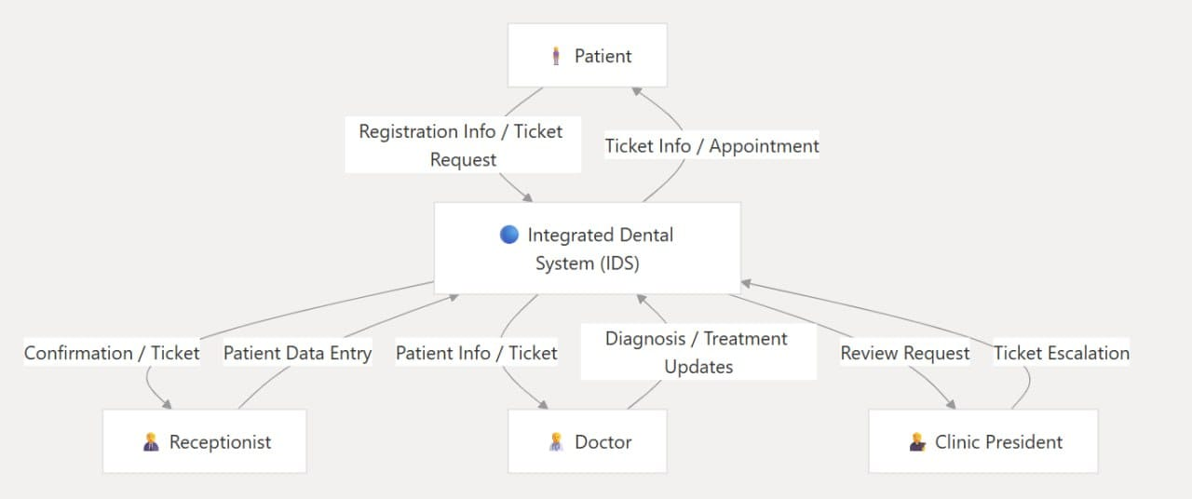

Figure 4.2 IDS for patient

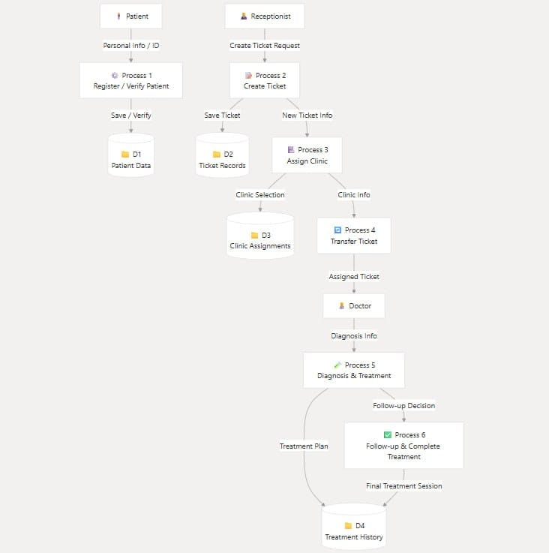

Figure 4.2 IDS for reception

## **4.5 User Interface Design**

This section illustrates the user interface screens of the IDS system, which supports and reflects the patient journey within the hospital. The interface is designed to be intuitive and role-based, ensuring that each user (receptionist, doctor, clinic head) can easily access and perform their tasks. The following screens demonstrate how the system handles patient registration, diagnosis, clinic referral, doctor assignment, and treatment tracking.

Each screen is organized to align with the real-life steps a patient goes through, from arrival at the reception to the completion of their treatment.

**1- Home Page (Reception Dashboard)**

Upon successful login, users are directed to the reception home page, which serves as a central dashboard for the receptionist or registration personnel. The interface is divided into functional cards for quick navigation.

**Key UI Components:**

New Visitor Ticket: For registering a new visitor.

Search Ticket: Allows searching for a ticket using the ticket number.

Existing Visitor Ticket: Enables quick access if the visitor is already registered, using the national ID.

Patient File: Displays patient records based on national ID.

My Account: Opens the personal account settings of the user.

Reports: Access to system reports and statistics.

**2- Creating a Ticket for a New or Existing Patient**

This screen enables the creation of a medical service ticket for patients. Features include:

A search bar to locate existing patients by ID or name.

Input fields to register new patients if not found in the system.

A submission section to generate the ticket and route it to the appropriate department.

**3-Diagnosis Clinic – Home Page**

The doctors in the diagnosis clinic. It allows doctors to either access an existing patient's record or start a new diagnosis.

Patient File Access:

Enter the patient’s national ID to view their profile and previous tickets.

Case Diagnosis:

Enter the current ticket number to start a new diagnosis for the patient in front of you.

**4-Ticket Display & Edit Screen**

This screen is designed for reviewing and editing the full details of a specific patient ticket. It consolidates personal, clinical, and referral data in a structured format. Key interface elements include:

* Personal Information Section:

Displays the patient's full name, address, phone number, occupation, national ID, gender, and age in a right-aligned form layout. Fields are pre-filled and editable.

* Referral Options:

A categorized checkbox list of internal hospital departments (e.g., Surgery, Oral Medicine, Pediatric Dentistry, X-ray) allows doctors to refer the patient to one or more specialties.

* Medical History Section:

A grid of checkboxes covering common medical conditions such as Hepatitis (A, B, C), Heart Disease, Kidney Trouble, Rheumatoid Arthritis, Radiation Therapy, Asthma, Diabetes, and more. This section captures the patient’s medical background.

* Free Text Fields:

Medical History & Present Medication: For detailed notes on ongoing treatments or drug use.

* Chief Complaint:

Allows clinicians to record the patient’s primary reason for visiting.

* Provisional Diagnosis:

A free-form field where the clinician can enter an initial or suspected diagnosis.

Tooth Chart:

A visual diagram of the full set of adult and child teeth.

Doctors can select specific teeth affected (highlighted in blue or gray).

Patient Type Buttons:

Buttons to specify whether the patient is an adult or a child .

Reset Button:

To clear the selections and reset the chart.

Edit Button:

To save changes or finalize the diagnosis data.

**5- Patient Profile and Ticket Details**

This page displays the personal information of the patient, including:

* Full name
* National ID number
* Phone number
* Address
* Gender and age

Additionally, it shows a detailed list of all tickets related to this patient. Each **ticket** includes:

* Ticket number
* Date of ticket creation
* Department referred to
* Date of the next visit (if any)
* Action buttons for editing, printing, or deleting the ticket

At the bottom, there is a navigation button to return to the main patient list

This interface helps doctors and staff manage a patient's treatment history and referrals efficiently.

**6- Determining the right doctor for each patient**

After selecting a specific ticket from the list, the user is redirected to this screen, which displays visit details including:

* Ticket number
* Visit date and time
* Patient name
* Phone number

Main Functionality:

* Doctor Assignment: A dropdown menu is used to assign a treating doctor for the case.

Available Actions:

* View Patient File: Opens the patient’s full medical record
* Examine: Initiates the clinical examination process
* View: Displays the current case details or medical history

**7- Doctor's medical case**

This screen displays a list of all patient medical tickets, with key information for each entry, including:

* Ticket number
* Visit date
* Patient name
* Phone number
* Ticket status (New, Follow-up, Completed)

Available Actions for Each Ticket:

* View: Displays the full details of the ticket
* Edit: Allows updating the ticket’s information
* Delete: Permanently deletes the ticket from the system

Additional Feature:

* A search bar at the top allows searching by patient name or ticket number for quick access.

**8- New Account Registration Page**

This screen allows new users to register and create an account within the IDS (Integrated Dental System) platform. The interface is designed to be clean, user-friendly, and intuitive, ensuring a smooth registration process.

The registration form includes the following fields:

* Username
* Full Name (Three-part name)
* Password
* Confirm Password
* National ID Number
* Email Address
* Phone Number
* Address

Additionally, there is a dropdown or input field for selecting the department, such as Reception.

Once all required fields are filled out correctly, the user can click the "Register" button to complete the sign-up process.

The screen features a modern dental clinic background, reinforcing the medical context and enhancing user trust and engagement through a professional and polished design.

**9- Login Page**

The login page is the gateway to the Integrated Dental System (IDS). It features a clean, user-friendly design with a modern dental clinic background that reinforces the system’s context.

Key UI Elements:

* Username Field: For entering the user's ID or username.
* Password Field: A secure input field for the user’s password.
* Login Button: Triggers the login process.
* Branding: The IDS logo is placed at the top center, ensuring identity consistency.
* Footer: Displays copyright information for the IDS 2025 team.
* Employee Management Screen:

This screen displays a list of all registered employees in the system, along with their essential details:

* Name
* Phone number
* National ID
* Email address
* Role (e.g., Admin, Reception)

Main Functionalities:

* Register New Employee: A button at the top allows the admin to add a new staff member.
* Search Bar: Enables quick searching by employee name.
* Available Actions for Each Employee:
* View Details: Displays full employee information
* Edit: Allows updating employee data
* Delete: Removes the employee from the system permanently

Sidebar Navigation Includes:

* Employee Management
* Doctor Management
* Patient Management
* Appointments
* Roles and Permissions
* Reports and Statistics
* Settings
* Logout

**10- All Patients of the Hospital:**

This interface displays a list of all patients registered in the hospital system. It offers:

A searchable table with columns like Patient Name, ID, Visit Date, etc.

Filters by department, visit date, or attending doctor.

Quick access to each patient’s full profile.

**11- Roles and Permissions Management Screen**

This screen displays a list of all roles defined within the system. Each role determines the level of access and the type of tasks users with that role can perform.

Role Name (e.g., User, Reception, Admin, Diagnosis-Doc, EDoctor, CPresident)

Main Functionalities:

* Register New Role: A button at the top-left allows administrators to create and assign new roles.
* Search Bar: Enables quick look up by role name.

Available Actions for Each Role:

* Edit: Allows modification of role name or associated permissions.
* Delete: Permanently removes the role from the system.

**12- Displaying Account of a System User**

This screen presents user account details within the system. It contains:

User information such as full name, username, email, and role.

Activity tracking data such as last login and recent actions.

Administrative controls to reset password or disable the account.

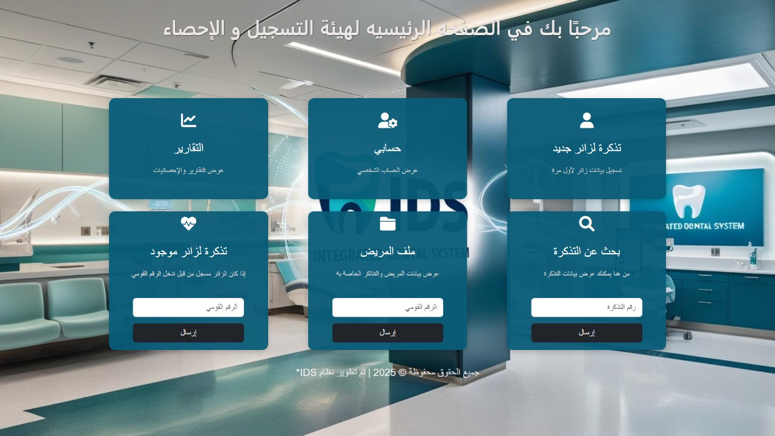

Figure 4.3 system UI

**"The main dashboard provides quick access to key functionalities such as reports, user account management, patient records, and new ticket creation".**

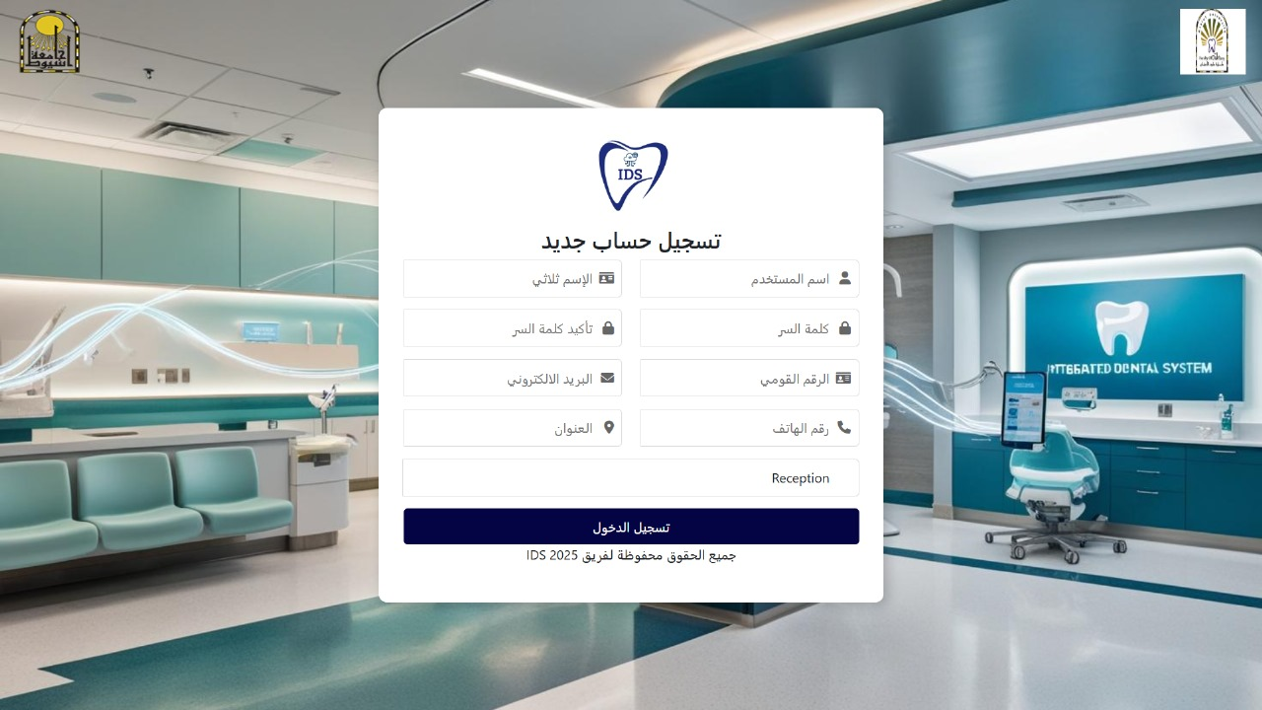

Figure 4.4 system UI

**"The registration form allows users to create a new account by entering personal details and credentials securely."**

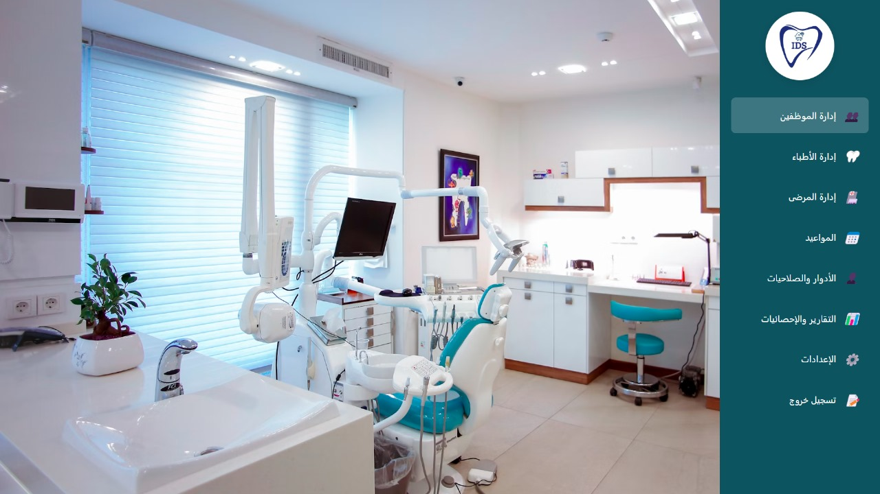

Figure 4.5 system UI

**"The admin dashboard offers comprehensive tools for managing staff, patients, appointments, roles, and settings within the hospital system."**

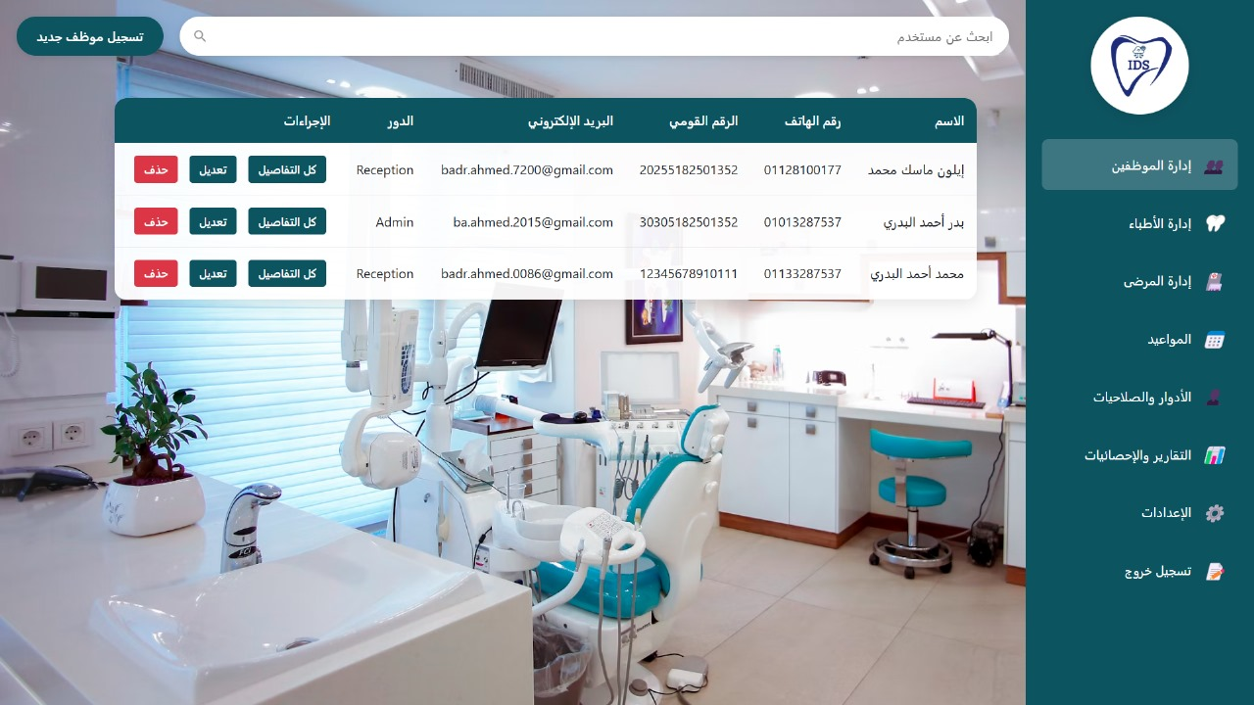

Figure 4.6 system UI

**"The employment management interface allows administrators to view, edit, or delete staff profiles, ensuring accurate and up-to-date information across all hospital departments"**

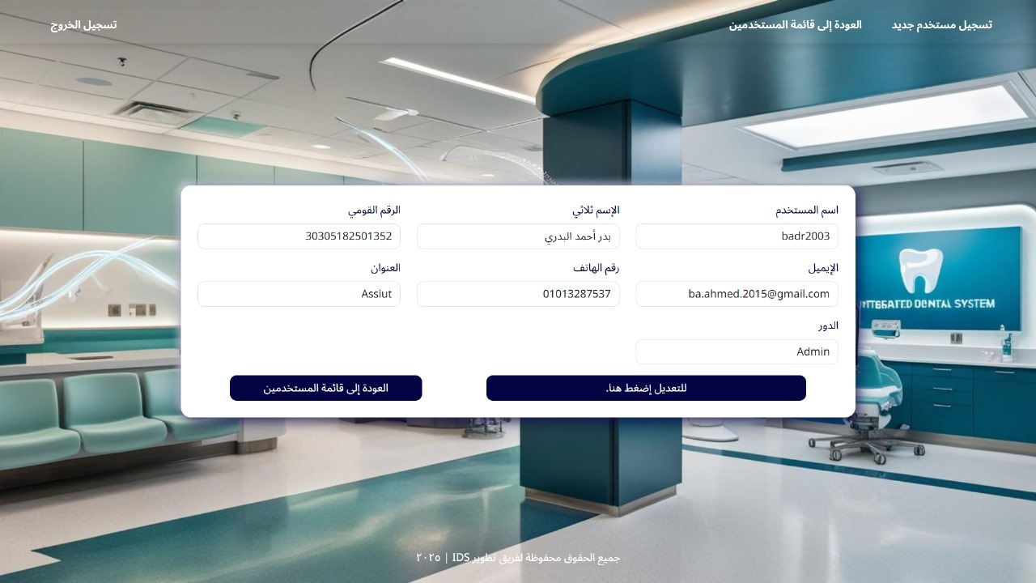

Figure 4.7 system UI

**"The registration form enables new users to create accounts by entering personal details such as name, email, phone number, and role, facilitating secure access to the System."**

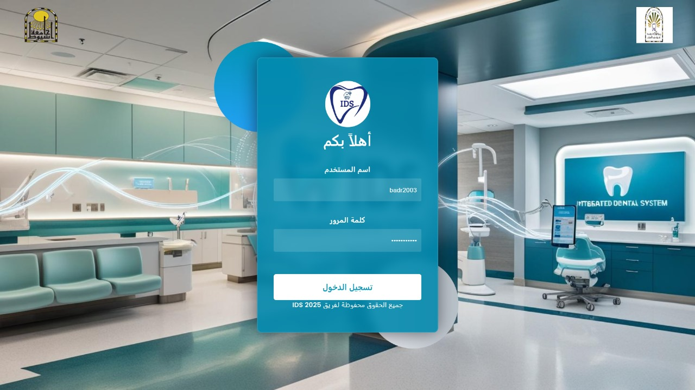

Figure 4.8 system UI

**"The login allows users to securely access the Integrated Dental System using their credentials."**

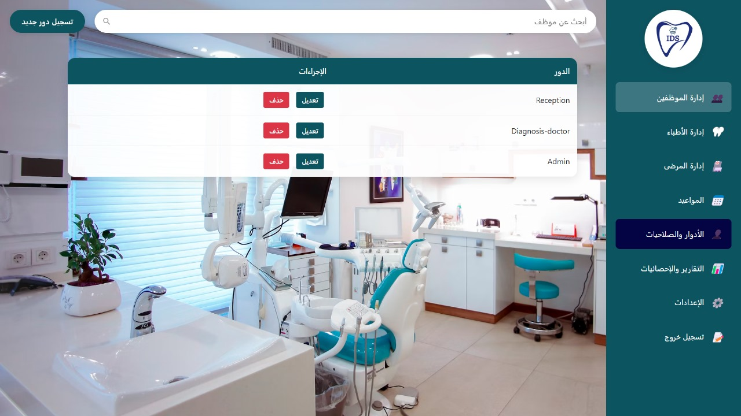

Figure 4.9 system UI

**"The role management interface provides administrators with tools to add, edit, or remove roles within the system, ensuring proper access control and workflow alignment."**

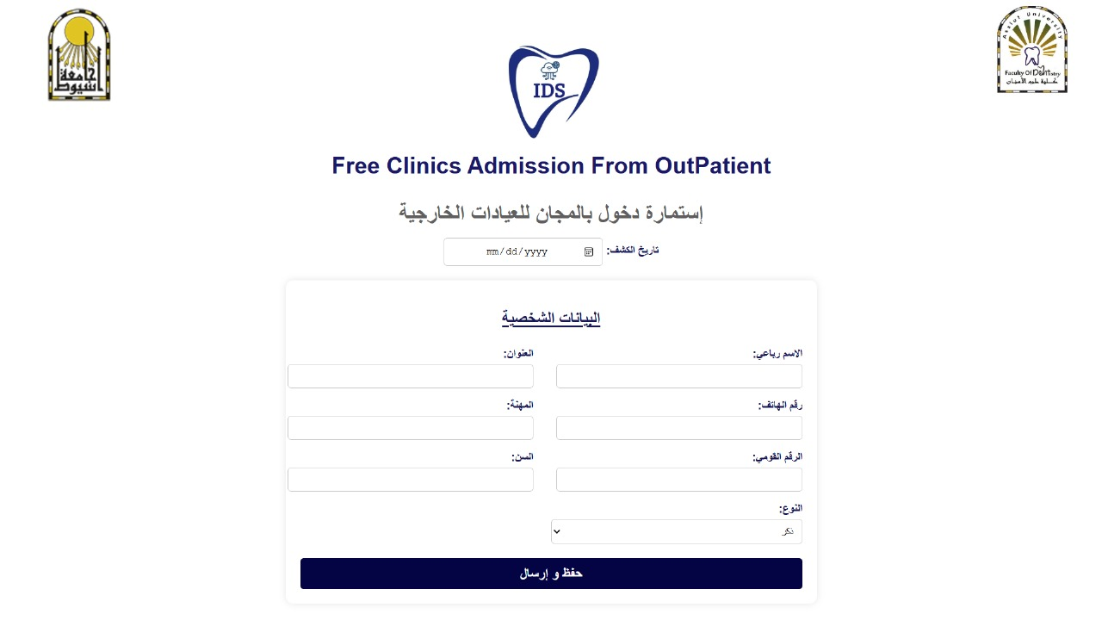

Figure 4.10 system UI

**"The patient registration form collects personal details such as name, address, profession, age, and contact information for new patients."**

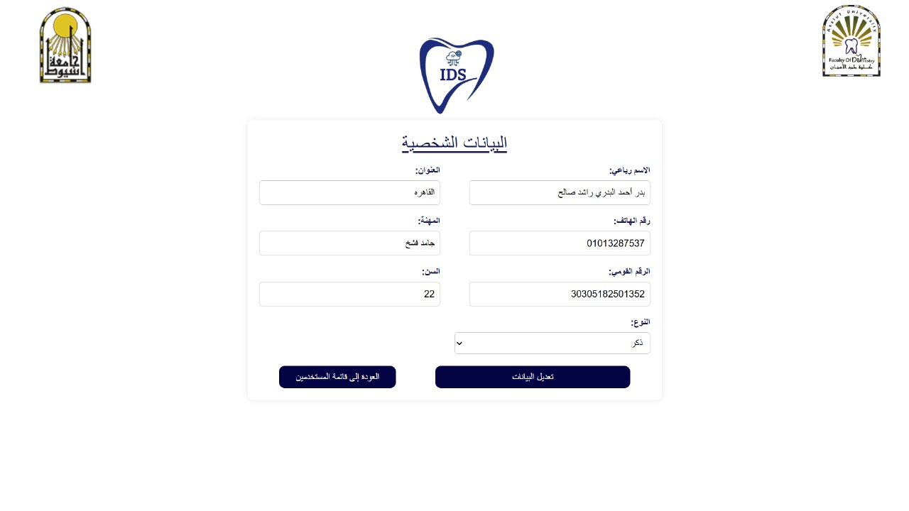

Figure 4.11 system UI

**"The user profile edit enables staff members to update their personal information, including name, address, phone number, and other relevant details."**

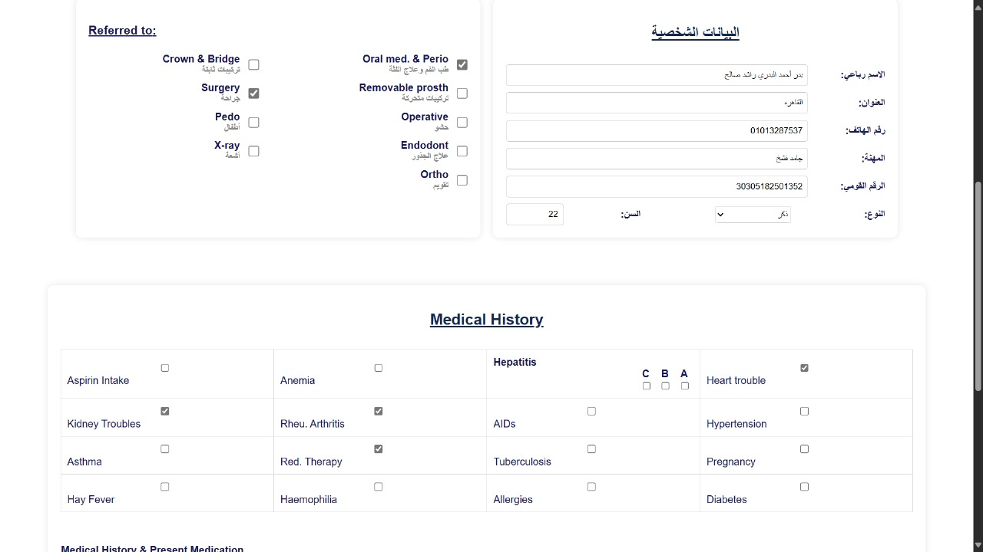

Figure 4.12 system UI

**"The medical history and referral captures patient health conditions, allergies, and clinic referrals to support comprehensive treatment planning."**

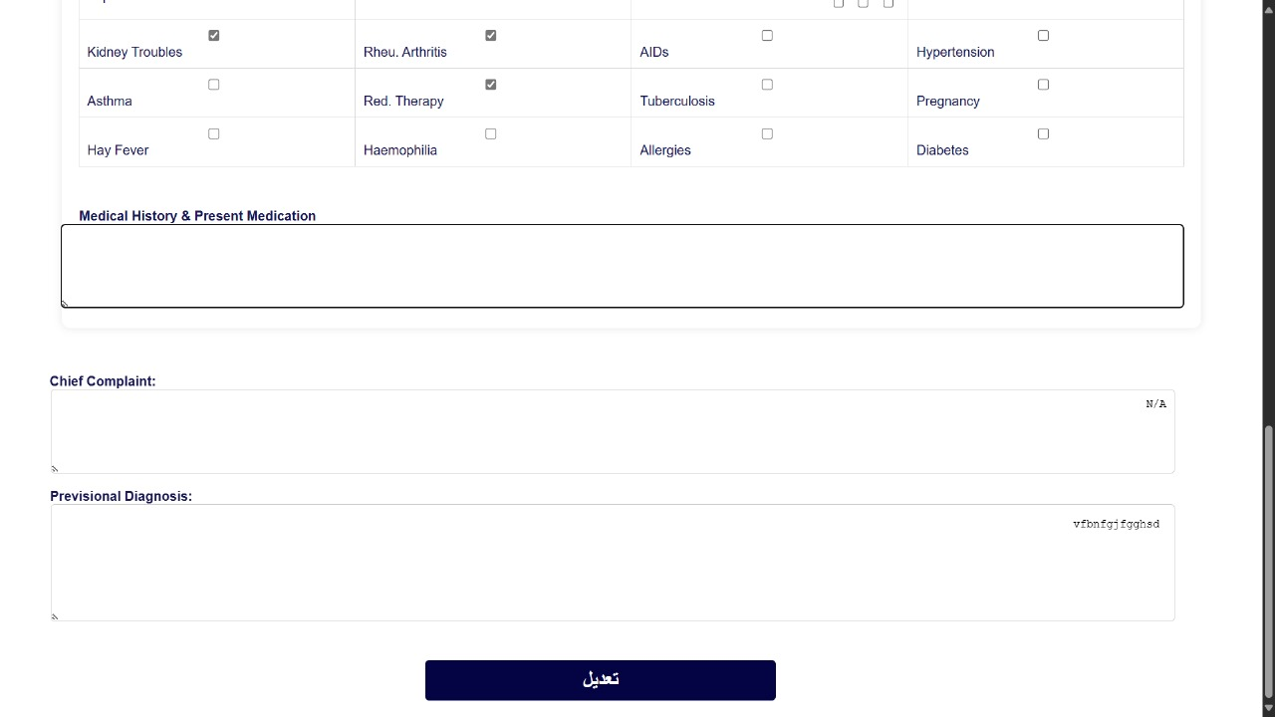

Figure 4.13 system UI

**"The remaining medical history and present medication section allows doctors to record patient health conditions, allergies, and ongoing treatments for comprehensive care planning."**

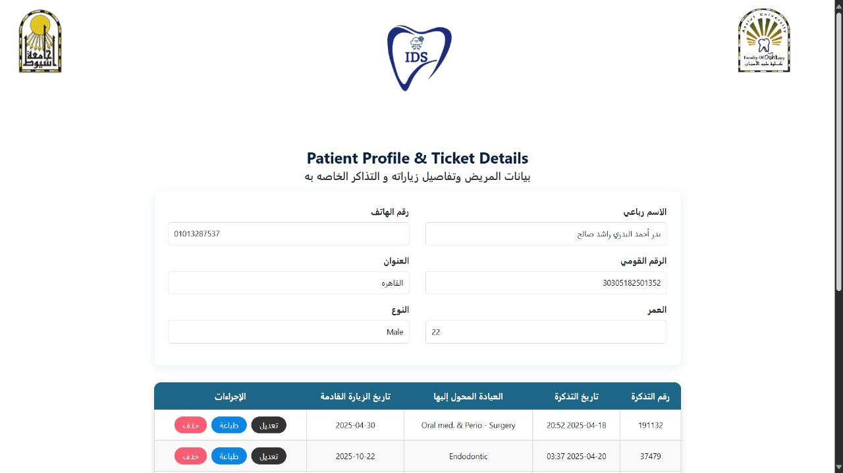

Figure 4.14 system UI

**"The patient profile and ticket details provides a summary of the patient’s personal information, upcoming appointments, clinic assignments, and ticket status."**

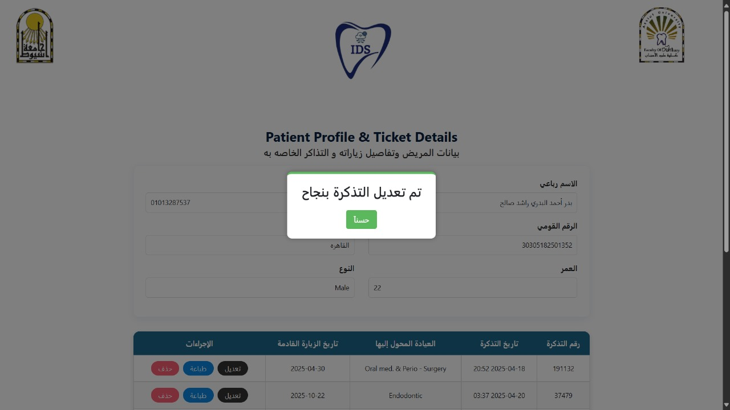

Figure 4.15 system UI

**"A confirmation message indicates that the patient's ticket has been successfully updated, ensuring data accuracy and workflow continuity."**

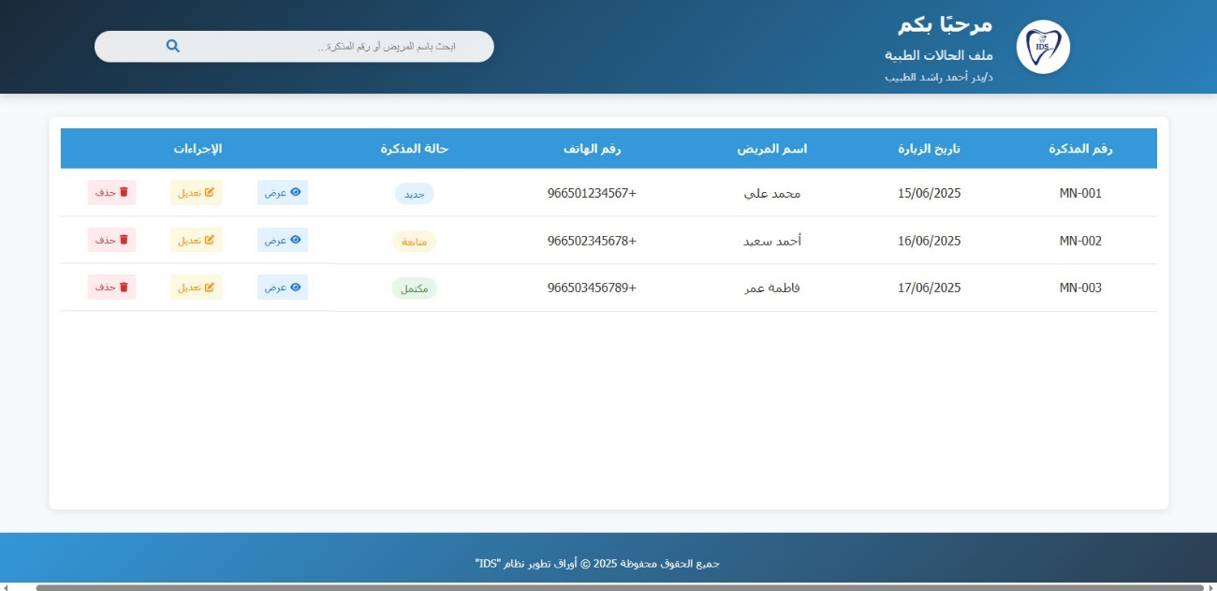

Figure 4.16 system UI

**"The patient search and ticket management interface enables staff to quickly locate patient records by name or ticket number, facilitating efficient appointment scheduling and tracking."**

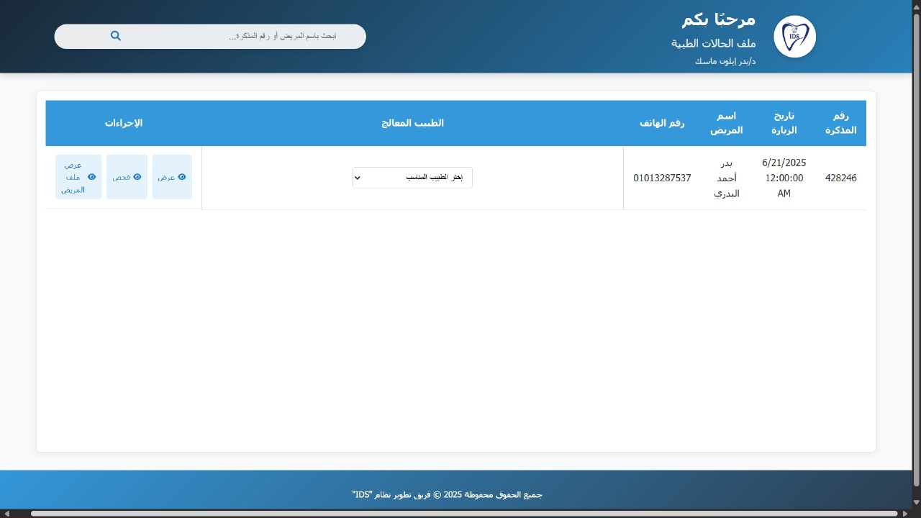

Figure 4.17 system UI

**"The doctor assignment screen allows administrators to select the treating doctor for a patient, ensuring proper referral and coordination between clinics."**

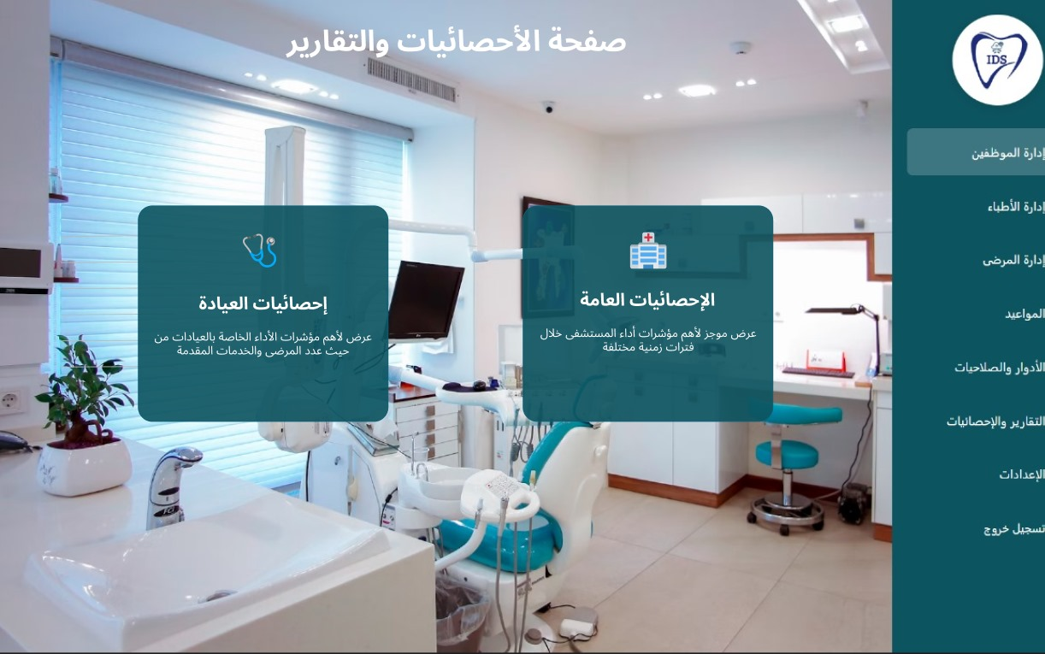

Figure 4.18 system UI

**"The dashboard provides key performance indicators and statistics for clinic operations, including patient counts, service metrics, and overall hospital activity."**

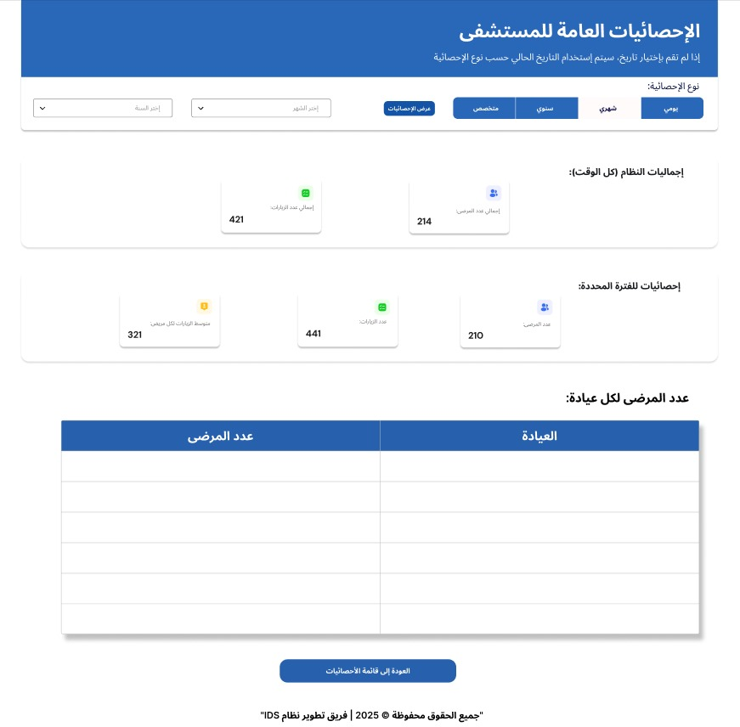

Figure 4.19 system UI

**"The general statistics page allows manager to view aggregated data such as total patients, appointments, and services across different time periods (daily, monthly, yearly)."**

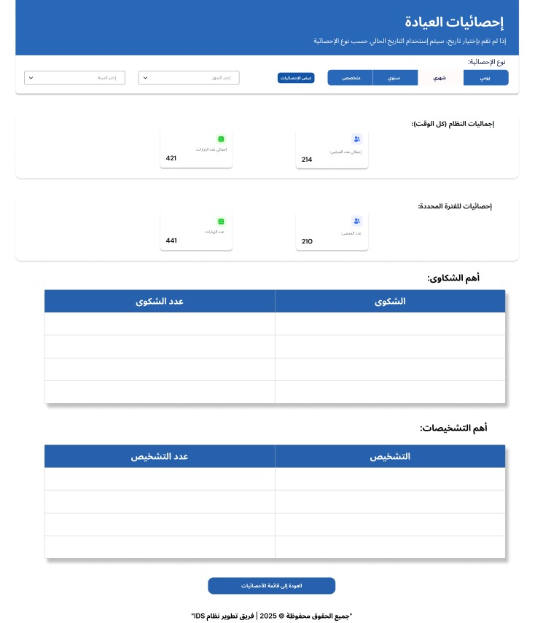

Figure 4.20 system UI

**"The clinic-specific statistics page offers detailed insights into complaints, diagnoses, and performance metrics tailored to clinics."**

# **Chapter 5 (Results & future Scope)**

# 

## **Conclusion**

In the first chapter, the software proposal, the overall concept of the Integrated Dental System (IDS) was introduced, outlining its purpose as a digital solution for streamlining internal operations within governmental dental hospitals. The system aims to replace outdated paper-based workflows with a centralized platform that supports patient registration, appointment scheduling, inter-clinic coordination, and administrative reporting.

The second chapter, software analysis, provided an in-depth understanding of the hospital environment, current challenges, and stakeholder needs. Through field visits and interviews at Assiut University Dental Hospital, we identified key pain points such as lost records, scheduling conflicts, poor communication between departments, and lack of performance monitoring tools. This phase laid the foundation for defining both functional and non-functional requirements, ensuring the system aligns with real-world workflows and user expectations.

The third chapter, software requirements specifications (SRS), provided a comprehensive overview of the system’s functional and non-functional requirements. It served as a formal agreement between the development team and stakeholders, clearly defining what the system must deliver in terms of features, performance, security, and usability. This chapter ensured that all development efforts remain aligned with the goals of digitizing hospital operations and improving internal efficiency.

The final chapter, software design, detailed the architecture, interface layout, and data structure of IDS. The modular design ensures role-based access control across seven distinct user roles, from reception staff to hospital managers. A relational database model was defined to support secure and accurate handling of patient records, tickets, and medical histories. The UI/UX design was developed to be intuitive and accessible, even for users with limited technical experience.

Together, these chapters form a comprehensive and organized documentation of the Integrated Dental System—a project that not only addresses current operational shortcomings in dental hospitals but also lays the foundation for future digital transformation in healthcare environments.

## **Future Works**

While the current version of the Integrated Dental System (IDS) meets the core requirements of a dental hospital management system, there are several enhancements that can be implemented in future development cycles to improve functionality, accessibility, and integration:

1. **Online Doctor Consultation Module**

Add support for remote or online consultations between doctors and patients, especially for follow-up visits or preliminary assessments.

1. **Mobile Application Integration**

Develop a mobile app version of IDS to allow flexible access for doctors and administrators on the go.

1. **Add Multimedia Support for Medical Records**

Allow uploading of X-rays, photos, and voice notes into patient records for better diagnostic and treatment planning.

1. **Integration with National EHR Systems**

Expand the system to integrate with larger Electronic Health Record (EHR) platforms used by national healthcare providers.

1. **Enhanced Reporting & Analytics Tools**

Introduce more advanced analytics and dashboards for hospital managers, including visualizations of clinic workload, patient flow trends, and performance metrics.

1. **Cloud-Based Deployment Option**

Explore hosting the system on cloud platforms like Microsoft Azure or AWS to enable scalability and remote access.

1. **Tele-Dentistry Features**

Implement tools for virtual check-ins, digital prescriptions, and home care guidance based on diagnosis.

1. **Automated Appointment Reminders**

Add SMS or email reminders for appointments to reduce no-shows and improve clinic efficiency.

1. **User Feedback & Performance Review System**

Include a feedback mechanism where staff can rate the system and suggest improvements, helping refine future versions.

1. **Expand Role-Based Notifications**

Improve the notification system to include automated alerts for upcoming appointments, overdue treatments, and referral confirmations.

This graduation project represents a significant step toward modernizing dental hospital operations through technology.

With further development and institutional support, the IDS has the potential to become a model for digital transformation in public healthcare systems across Egypt and beyond.

# **Appendices**

## **Appendix A: System Design Considerations**

Implementing a professional hospital management system like the Integrated Dental System (IDS) requires careful planning, technical expertise, and a deep understanding of healthcare workflows. The following considerations were taken into account during the design and development of the system to ensure its effectiveness, security, and alignment with real-world hospital operations.

* **Project Planning and Management**
  + Requirements Gathering:

Conducted interviews and observations at Assiut University Dental Hospital to understand current workflows, challenges, and user needs.

* + Scope Definition:

Clearly defined the system scope to focus on internal hospital operations — including patient registration, ticketing, inter-clinic referrals, and administrative reporting — to avoid unnecessary complexity.

* + Timeline and Milestones:

Followed a structured timeline across academic semesters, divided into phases such as research, design, implementation, testing, and documentation.

* + Resource Allocation:

Assigned team members to specific roles — Team Leader, Frontend Developers, Backend Developers, UI/UX Designer, QA Tester, Documentation Lead — and used university resources for development tools and hosting.

* **Technical Considerations**
  + Technology Stack:

Built using C#, ASP.NET MVC, LINQ, and MySQL, ensuring compatibility with hospital infrastructure and long-term maintainability.

* + Scalability and Performance:

Designed with modular architecture to support future expansion and integration with larger hospital systems or cloud-based deployment.

* + Security:

Implemented Microsoft Identity for secure login, role-based access control (RBAC) , and data encryption to protect sensitive medical records and staff information.

* + Database Design:

Used relational database modeling to ensure accurate storage of patient data, ticket history, tooth status, and clinic referrals.

* **Development Practices**
  + Agile Methodology:

Adopted an agile approach with regular meetings, sprint planning, and task tracking via Jira to allow flexibility and iterative improvements.

* + Version Control:

Used GitHub for collaborative development, code reviews, and version tracking.

* + Code Quality:

Focused on clean coding standards, modular backend logic, and consistent frontend layout to ensure readability and maintainability.

* + Documentation:

Created comprehensive documentation covering functional requirements, non-functional requirements, use cases, ERD, and user manuals for all roles.

* **User Experience (UX)**
  + Role-Based Interface Design:

Developed distinct interfaces for each role (Reception Staff, Diagnostic Nurse, Doctor, Intern, Clinic Resident, Admin, Manager) to match their daily tasks and responsibilities.

* + Accessibility and Usability:

Ensured simple navigation and responsive design for smooth operation on hospital desktops and laptops.

* + Usability Testing:

Collected feedback from supervisors and hospital staff to refine interface elements and improve workflow efficiency.

* + Onboarding Support:

Included tooltips, instructions, and training materials to help users adapt to the new digital environment.

* **Deployment and Maintenance**
  + Deployment Strategy:

Designed for local deployment in hospital environments; future versions may explore cloud hosting options like Azure or AWS.

* + Monitoring and Logging:

Implemented user activity logs and error tracking to monitor system usage and identify issues quickly.

* + Support and Maintenance Plan:

While this is an academic project, we documented the system thoroughly to allow future students or developers to continue maintenance and improvement efforts.

* + Testing and Debugging:

Conducted unit testing, integration testing, and system testing to ensure functionality and stability before final submission.

* **Communication and Collaboration**
  + Stakeholder Engagement:

Maintained regular communication with university supervisors and hospital staff to align the system with real-world expectations.

* + Team Collaboration:

Used Jira for task assignment and progress tracking, and held weekly meetings to ensure coordination between frontend, backend, and documentation teams.

* + Feedback Integration:

Incorporated suggestions from supervisors and hospital contacts to refine features and enhance usability.

* **Risk Management**
  + Risk Assessment:
* Identified potential risks such as:
* Resistance to change from staff
* Limited device availability
* Incomplete or unclear requirements
* Time constraints due to academic deadlines
  + Mitigation Strategies:
  + Addressed these risks through:
  + Role-specific training and awareness sessions
  + Lightweight browser-based design for shared or limited hardware
  + Frequent validation of requirements with stakeholders
  + Agile sprints and milestone-based development
  + Contingency Planning:

Documented alternative approaches for key modules and prepared fallback strategies in case of unexpected changes or limitations.

## **Appendix B: Data Dictionary**

The Integrated Dental System (IDS) uses a relational database model to store and manage patient records, appointments, medical history, and user roles. The following data dictionary provides a comprehensive list of database entities (tables), their fields, data types, nullability, and default values.

This section helps developers, testers, and future maintainers understand the structure and purpose of each table used in the system. Here are some of the data elements in the IDS system's data dictionary:

**Patients**

|  |  |  |  |
| --- | --- | --- | --- |
| Field | Type | Nullable | Default |
| PatientId | nvarchar(14) | No | Null |
| Name | nvarchar(50) | No | Null |
| Address | nvarchar(255) | No | Null |
| profession | nvarchar(100) | No | Null |
| phoneNumber | nvarchar(11) | No | Null |
| Gender | nvarchar(max) | No | Null |
| Age | int | No | Null |

**Doctors**

|  |  |  |  |
| --- | --- | --- | --- |
| Field | Type | Nullable | Default |
| Id | nvarchar(450) | No | Null |
| ClinicId | int | Yes | Null |
| ActivePatientsUnderResposibility | int | No | Null |
| Successfulcases | int | No | Null |

**Tickets**

|  |  |  |  |
| --- | --- | --- | --- |
| Field | Type | Nullable | Default |
| TicketId | nvarchar(450) | No | Null |
| PatientId | nvarchar(14) | No | Null |
| AppointmentDate | datetime2(7) | No | Null |
| ChiefComlant | nvarchar(1000) | No | Null |
| PrevisionalDiagnosis | nvarchar(1000) | No | Null |
| NextDate | datetime2(7) | Yes | Null |
| Status | nvarchar(max) | No | Null |
| IsValid | bit | No | Null |
| LevelOfCompletness | nvarchar(max) | Yes | Null |
| ClinicId | int | Yes | Null |

**Clinics**

|  |  |  |  |
| --- | --- | --- | --- |
| Field | Type | Nullable | Default |
| ClinicId | int | No | Null |
| Name | nvarchar(255) | No | Null |

**Diagnoses**

|  |  |  |  |
| --- | --- | --- | --- |
| Field | Type | Nullable | Default |
| DiagnosisId | int | No | Null |
| Name | nvarchar(max) | No | Null |

**TicketAccountancies**

|  |  |  |  |
| --- | --- | --- | --- |
| Field | Type | Nullable | Default |
| TicketId | nvarchar(450) | No | Null |
| DoctorId | nvarchar(450) | No | Null |

**TicketDiagnosisDoctors**

|  |  |  |  |
| --- | --- | --- | --- |
| Field | Type | Nullable | Default |
| Id | int | No | Null |
| TicketId | nvarchar(450) | No | Null |
| DiagnosisId | int | No | Null |
| DoctorId | nvarchar(450) | No | Null |

**Asnans**

|  |  |  |  |
| --- | --- | --- | --- |
| Field | Type | Nullable | Default |
| Id | nvarchar(450) | No | Null |
| tooth11 | bit | No | Null |
| tooth12 | bit | No | Null |
| tooth13 | bit | No | Null |
| tooth14 | bit | No | Null |
| tooth15 | bit | No | Null |
| tooth16 | bit | No | Null |
| tooth17 | bit | No | Null |
| tooth18 | bit | No | Null |
| tooth21 | bit | No | Null |
| tooth22 | bit | No | Null |
| tooth23 | bit | No | Null |
| tooth24 | bit | No | Null |
| tooth25 | bit | No | Null |
| tooth26 | bit | No | Null |
| tooth27 | bit | No | Null |
| tooth28 | bit | No | Null |
| tooth31 | bit | No | Null |
| tooth32 | bit | No | Null |
| tooth33 | bit | No | Null |
| tooth34 | bit | No | Null |
| tooth35 | bit | No | Null |
| tooth36 | bit | No | Null |
| tooth37 | bit | No | Null |
| tooth38 | bit | No | Null |
| tooth41 | bit | No | Null |
| tooth42 | bit | No | Null |
| tooth43 | bit | No | Null |
| tooth44 | bit | No | Null |
| tooth45 | bit | No | Null |
| tooth46 | bit | No | Null |
| tooth47 | bit | No | Null |
| tooth48 | bit | No | Null |

**AspNetRoleClaims**

|  |  |  |  |
| --- | --- | --- | --- |
| Field | Type | Nullable | Default |
| Id | int | No | Identity(1,1) |
| RoleId | nvarchar(450) | No | Null |
| ClaimType | nvarchar(max) | Yes | Null |
| ClaimValue | nvarchar(max) | Yes | Null |

**AspNetRoles**

|  |  |  |  |
| --- | --- | --- | --- |
| Field | Type | Nullable | Default |
| Id | nvarchar(450) | No | Null |
| Name | nvarchar(256) | Yes | Null |
| NormalizedName | nvarchar(256) | Yes | Null |
| ConcurrencyStamp | nvarchar(max) | Yes | Null |

**AspNetUserClaims**

|  |  |  |  |
| --- | --- | --- | --- |
| Field | Type | Nullable | Default |
| Id | int | No | Identity(1,1) |
| UserId | nvarchar(450) | No | Null |
| ClaimType | nvarchar(max) | Yes | Null |
| ClaimValue | nvarchar(max) | Yes | Null |

**AspNetUserLogins**

|  |  |  |  |
| --- | --- | --- | --- |
| Field | Type | Nullable | Default |
| LoginProvider | nvarchar(450) | No | Null |
| ProviderKey | nvarchar(450) | No | Null |
| ProviderDisplayName | nvarchar(max) | Yes | Null |
| UserId | nvarchar(450) | No | Null |

**AspNetUserRoles**

|  |  |  |  |
| --- | --- | --- | --- |
| Field | Type | Nullable | Default |
| UserId | nvarchar(450) | No | Null |
| RoleId | nvarchar(450) | No | Null |

**AspNetUsers**

|  |  |  |  |
| --- | --- | --- | --- |
| Field | Type | Nullable | Default |
| Id | nvarchar(450) | No | Null |
| NationalId | nvarchar(max) | No | Null |
| FullName | nvarchar(max) | No | Null |
| Address | nvarchar(max) | Yes | Null |
| Role | nvarchar(max) | Yes | Null |
| UserName | nvarchar(256) | Yes | Null |
| NormalizedUserName | nvarchar(256) | Yes | Null |
| Email | nvarchar(256) | Yes | Null |
| NormalizedEmail | nvarchar(256) | Yes | Null |
| EmailConfirmed | bit | No | Null |
| PasswordHash | nvarchar(max) | Yes | Null |
| SecurityStamp | nvarchar(max) | Yes | Null |
| ConcurrencyStamp | nvarchar(max) | Yes | Null |
| PhoneNumber | nvarchar(max) | Yes | Null |
| PhoneNumberConfirmed | bit | No | Null |
| TwoFactorEnabled | bit | No | Null |
| LockoutEnd | datetimeoffset(7) | Yes | Null |
| LockoutEnabled | bit | No | Null |
| AccessFailedCount | int | No | Null |

**AspNetUserTokens**

|  |  |  |  |
| --- | --- | --- | --- |
| Field | Type | Nullable | Default |
| UserId | nvarchar(450) | No | Null |
| LoginProvider | nvarchar(450) | No | Null |
| Name | nvarchar(450) | No | Null |
| Value | nvarchar(max) | Yes | Null |

**Developers**

|  |  |  |  |
| --- | --- | --- | --- |
| Field | Type | Nullable | Default |
| Id | int | No | Identity(1,1) |
| Name | nvarchar(max) | No | Null |
| Phone | nvarchar(max) | No | Null |
| Role | nvarchar(max) | No | Null |
| Photo | varbinary(max) | No | Null |
| Links | nvarchar(max) | No | Null |

**MedicalHistories**

|  |  |  |  |
| --- | --- | --- | --- |
| Field | Type | Nullable | Default |
| Id | nvarchar(450) | No | Null |
| HeartTrouble | bit | No | Null |
| Hyperttention | bit | No | Null |
| Pregnancy | bit | No | Null |
| Diabetes | bit | No | Null |
| Hepatitis | nvarchar(max) | No | Null |
| AIDs | bit | No | Null |
| Tuberculosis | bit | No | Null |
| Allergies | bit | No | Null |
| Anemia | bit | No | Null |
| Rheumatism | bit | No | Null |
| RadTherapy | bit | No | Null |
| Haemophilia | bit | No | Null |
| AspirinIntake | bit | No | Null |
| KidneyTroubles | bit | No | Null |
| Asthma | bit | No | Null |
| HayFever | bit | No | Null |
| MedicalHistoryText | nvarchar(max) | No | Null |

**ReferredTo**

|  |  |  |  |
| --- | --- | --- | --- |
| Field | Type | Nullable | Default |
| Id | nvarchar(450) | No | Null |
| Oral | bit | No | Null |
| RemovableProsth | bit | No | Null |
| Operative | bit | No | Null |
| Endodontic | bit | No | Null |
| Ortho | bit | No | Null |
| CrownAndBridge | bit | No | Null |
| Surgery | bit | No | Null |
| Pedo | bit | No | Null |
| XRay | bit | No | Null |

# **References**

* ***Online References:***

**Websites:**

* Atlassian. (2024). **Integrated Dental System Timeline in Jira.** Retrieved from <https://www.atlassian.com/software/jira> [Accessed: 1-Abril-2025]
* Bootstrap Team. (2023). **Getting Started with Bootstrap v5.3**. Retrieved from <https://getbootstrap.com/docs/5.3/getting-started/introduction/> [Accessed: 24-June-2025]
* Qwen. (2024). **Qwen AI Models**. Retrieved from <https://qwen.readthedocs.io/> [Accessed: 24-June-2025]
* OpenAI. (2023). **ChatGPT User Guide.** Retrieved from <https://chat.openai.com/> [Accessed: 24-June-2025]
* DeepSeek Team. (2024). **DeepSeek: Into the Unknown.** Retrieved from <https://deepseek.com/> [Accessed: 24-June-2025]
* Lucidchart. (2024). **Lucidchart Diagramming Tool**. Retrieved from <https://www.lucidchart.com/> [Accessed: 24-June-2025]
* YouTube:
  1. For Backend
     + **Stage 1.1: C# & OOP**

1. Elmahdy, [ENG. Mohamed Elmahdy]. (2023). *C# Programming Course* [Video playlist]. YouTube. <https://www.youtube.com/playlist?list=PLsV97AQt78NT0H8J71qe7edwRpAirfqOI> [Accessed: 20-Sept-2024]
2. ITI. *C# Course (2022)* [Video playlist]. YouTube. <https://www.youtube.com/playlist?list=PLesfn4TAj57XLhtaF9ZS_z0dOKQPXKMcE> [Accessed: 20-Sept-2024]
   * + **Stage 1.2: SQL Server**
   1. ITI *SQL Server Database Course* (2024).  [Video playlist]. YouTube. <https://www.youtube.com/playlist?list=PLoRh0POuk1Rw-BZU-DPI6cA_c5W9_2uF_> [Accessed: 1-Dec-2024]
   * **Stage 2.1: .NET & APIs**
   1. ITI. *.NET Core Course (2021)* [Folder]. Mega.nz. <https://mega.nz/folder/ZPFBTaqS#ZoLwhfnHddAMB19s3kx-cQ> [Accessed: 10-Feb-2025]
   2. ITI. *.NET Web APIs* (2022) [Video playlist]. YouTube. <https://www.youtube.com/playlist?list=PLqPejUavRNTWqGYP-f1pHkbLYdbqi_Uhg> [Accessed: 10-Feb-2025]
   * **Stage 2.2: LINQ**
3. Abdelnaby, [Eng Essam Abdelnaby]. (2021). *LINQ Tutorials* [Video playlist]. YouTube. <https://www.youtube.com/playlist?list=PL4n1Qos4Tb6Sj1Y4xJuJoWCuqleeG2yt6> [Accessed: 10-Feb-2025]
   1. For Frontend
      * **HTML**
   2. El zero Web School. (2021). *HTML Course* [Video playlist]. YouTube. <https://youtube.com/playlist?list=PLDoPjvoNmBAw_t_XWUFbBX-c9MafPk9ji&si=nrPR_XkGJnKnMgtL> [Accessed: 20-Sept-2024]
   3. El zero Web School. (2022). *HTML Advanced* [Video playlist]. YouTube. <https://youtube.com/playlist?list=PLDoPjvoNmBAzjsz06gkzlSrlev53MGIKe&si=AFY0Gxd7aClxh8CM> [Accessed: 1-Feb-2025]
      * **CSS**
   4. El zero Web School. (2022). *CSS Course* [Video playlist]. <https://youtube.com/playlist?list=PLDoPjvoNmBAx3kiplQR_oeDqLDBUDYwVv&si=HvWFsDbsbLUuyEYu> [Accessed: 20-Sept-2024]
      * **JavaScript**
   5. Gamal, A. [Abdelrahman Gamal]. (2023). *JavaScript Tutorials* [Video playlist]. YouTube. <https://youtube.com/playlist?list=PLknwEmKsW8OuTqUDaFRBiAViDZ5uI3VcE&si=QKGpEEco2BWxHJFy> [Accessed: 1-Feb-2025]
      * **Bootstrap**
   6. El zero Web School. (2021). *Bootstrap Course* [Video playlist]. YouTube. <https://youtube.com/playlist?list=PLDoPjvoNmBAyvm7f--dc6XqkpfDcen_vQ&si=wLZRQiMNMJ61T8vs> [Accessed: 24-June-2025]
   7. For all
      * **Git & GitHub:** 
        + Ghareeb Elsheikh (2022, August 12). Git & GitHub Tutorial for Beginners [Video]. YouTube. <https://www.youtube.com/watch?v=fDkR0TDR9dI> [Accessed: 17-Sept-2024]