**ESP32 Interfacing with Servo Motor**

**Schematic Diagram:**

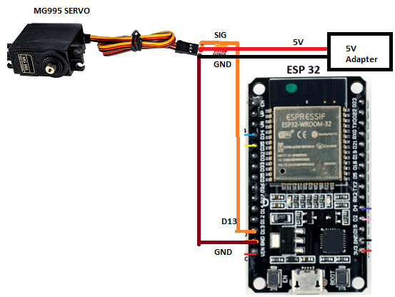

**CODE:**

