Project 2: Extract, Transform, and Load
Members:
Jacob Page, Rahmi Rahmiev, Kazimierz Lubas,Badrija K, Samanthi Jayarathna
Objective of the project:
Extract:
For this project we extracted data from the following data sources
World_Population.CSV
Country_Population.csv
Transform:
Clean and structure the data to suit the project goals. Dropped the “Rank” column from World_Population.CSV file and "Population (2020)" from Country_Population.csv file. And re name the columns to suit the tables created with sql.
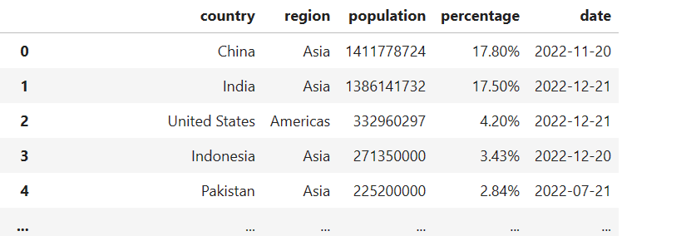
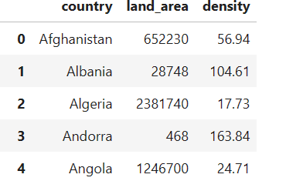
Load:
Created the database connection using python to connect data frames to the sql tables.
Questions & Analysis

​Conclusion

