**Hands-On: Stage 3 - Angular Day 68 – Hands on 1**

<script>

var emp = {firstName:"John",lastName:"Stoke", salary:5000, permanentStaff:false};

console.log(emp);

</script>

**OUTPUT:**

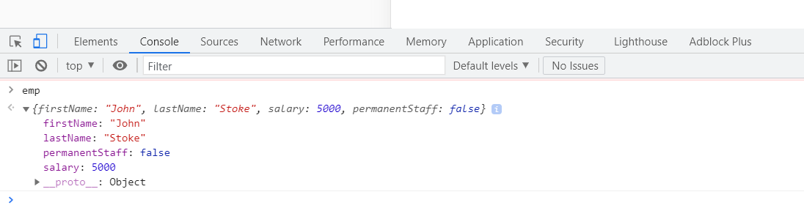

<script>

var emp = JSON.parse('{"firstName":"John", "lastName":"Stoke", "salary":"5000","permanentStaff":"false"}');

console.log("firstName : "+emp.firstName);

console.log("lastName : "+emp.lastName);

console.log("salary : "+emp.salary);

console.log("permanentStaff : "+emp.permanentStaff);

</script>

**OUTPUT:**

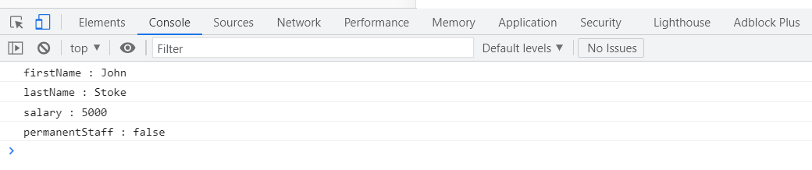

<script>

const data = '{"firstName":"John", "lastName":"Stoke", "salary":"5000", "permanentStaff":"false", "Department":[{"id":"3","name":"payroll"}]}';

var emp = JSON.parse(data);

console.log("firstName : "+emp.firstName);

console.log("lastName : "+emp.lastName);

console.log("salary : "+emp.salary);

console.log("permanentStaff : "+emp.permanentStaff);

console.log("Department id : "+emp.Department[0].id);

console.log("Department name : "+emp.Department[0].name);

</script>

**OUTPUT:**

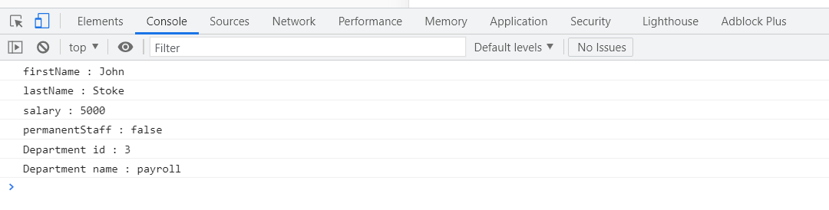

<script>

const data = '{"firstName":"John", "lastName":"Stoke", "salary":"5000", "permanentStaff":"false", "Department":[{"id":"3","name":"payroll"}], "skill":[{"id":"1", "value":"HTML"},{"id":"2", "value":"CSS"},{"id":"2", "value":"Javascript"}]}';

var emp = JSON.parse(data);

console.log("firstName : "+emp.firstName);

console.log("lastName : "+emp.lastName);

console.log("salary : "+emp.salary);

console.log("permanentStaff : "+emp.permanentStaff)

console.log("Department id : "+emp.Department[0].id);

console.log("Department name : "+emp.Department[0].name);

for(var i=0; i<emp.skill.length; i++)

{

console.log("Skill "+(i+1)+" : "+emp.skill[i].id+", "+emp.skill[i].value);

}

</script>

**OUTPUT:**

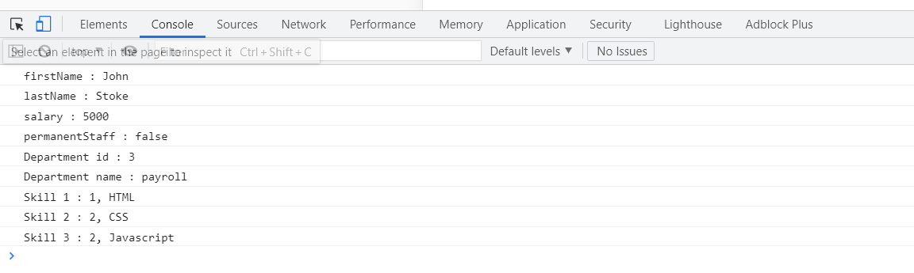

**Employee.ts**

export interface Employee {

id:number;

name:string;

salary:number;

permanent:boolean;

}

**Employee-test.ts**

import { Employee } from './Employee';

var emp:Employee = {

id:3,

name:"John",

salary:5000,

permanent:true,

}

console.log("id : "+emp.id);

console.log("name : "+emp.name);

console.log("salary : "+emp.salary);

console.log("permanent : "+emp.permanent);

**OUTPUT:**

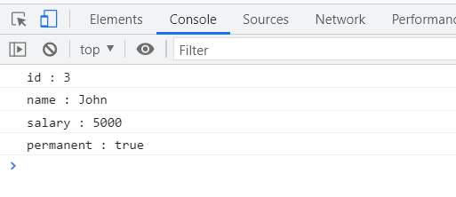

**Department.ts**

export interface Department{

    id:number;

    name:string;

    }

**Employee.ts**

import { Department } from './Department';

export class Employee implements Department{

id:number;

name:string;

salary:number;

permanent:boolean;

constructor(id:number, name:string, salary:number, permanent:boolean){

this.id = id;

this.name = name;

this.salary = salary;

this.permanent = permanent;

}

}

**Employee-test.ts**

import { Department } from './Department';

import { Employee } from './Employee';

var emp1 = new Employee(123, "John", 5000, true);

console.log("id: "+emp1.id);

console.log("name: "+emp1.name);

console.log("salary: "+emp1.salary);

console.log("permanent: "+emp1.permanent);

var dept:Department = {

id:1,

name:"Payroll",

}

console.log("Department id : "+dept.id);

console.log("Department name : "+dept.name);

**OUTPUT:**

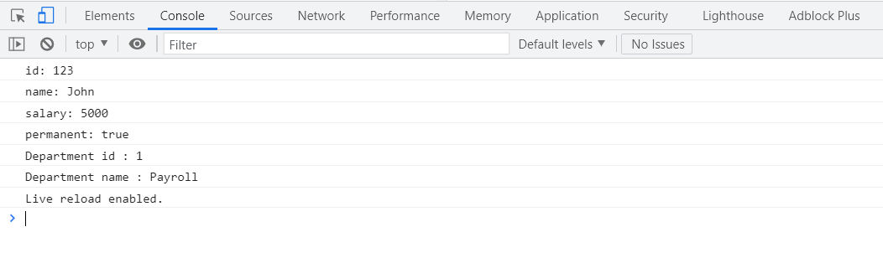

**Department.ts**

export interface Department{

    id:number;

    name:string;

    }

**Skill.ts**

export interface Skill{

    id:number;

    name:string;

    }

**Employee.ts**

import { Employee } from './Employee';

import { Skill } from './Skill';

import { Department } from './Department';

var emp1 = new Employee(123, "John", 10000, true);

console.log("id: "+emp1.id);

console.log("name: "+emp1.name);

console.log("salary: "+emp1.salary);

console.log("permanent: "+emp1.permanent);

var dept:Department = {

    id:1,

    name:"Payroll",

    }

console.log("Department id : "+dept.id);

console.log("Department name : "+dept.name);

var skill1:Skill = {

    id:1,

    name:"HTML",

    }

var skill2:Skill = {

    id:2,

    name:"CSS",

    }

var skill3:Skill = {

    id:3,

    name:"JavaScript",

    }

console.log("Skill[0]:"+skill1.id+", "+skill1.name);

console.log("Skill[1]:"+skill2.id+", "+skill2.name);

console.log("Skill[2]:"+skill3.id+", "+skill3.name);

**Employee-test.ts**

import { Employee } from './Employee';

var emp1 = new Employee(1, "HTML");

var emp2 = new Employee(2, "CSS");

var emp3 = new Employee(3, "Javascript");

console.log("Skill 1: "+emp1.id+", "+emp1.name);

console.log("Skill 2: "+emp2.id+", "+emp2.name);

console.log("Skill 3: "+emp3.id+", "+emp3.name);

**OUTPUT:**

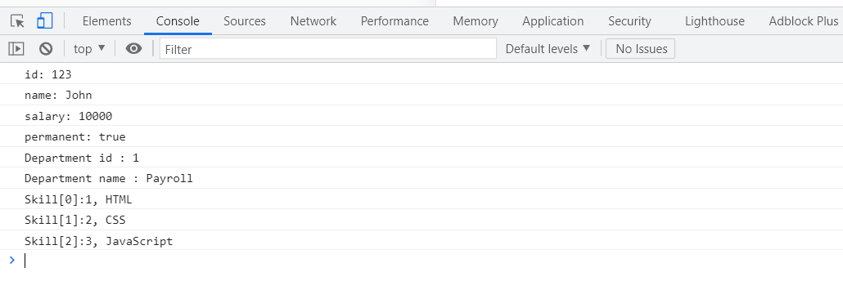

interface User {

name: string;

id: number;

}

class UserAccount {

name: string;

id: number;

constructor(name: string, id: number) {

this.name = name;

this.id = id;

}

}

const user: User = new UserAccount("Murphy", 1);