---------Thury Question-------

Q1)What are the different types of normalizations?

Ans-In database design, several types of normalization are used to reduce data redundancy, improve data integrity, and ensure efficient data retrieval. The different types of normalizations are

First Normal Form (1NF): This normalization ensures that the data in each table's column is atomic, meaning that it cannot be further broken down into smaller pieces. It also eliminates duplicate rows from the table.

Second Normal Form (2NF): This normalization eliminates partial dependencies by ensuring that each non-key column in a table is dependent on the entire primary key rather than on its part of it.

Third Normal Form (3NF): This normalization eliminates transitive dependencies by ensuring that each non-key column in a table is dependent only on the primary key and not on any other non-key columns.

Boyce-Codd Normal Form (BCNF): This normalization is an extension of 3NF and ensures that each determinant in a table is a candidate key.

Fourth Normal Form (4NF): This normalization eliminates multivalued dependencies by ensuring that each non-key column in a table is dependent on the entire primary key and not on any subsets.

Fifth Normal Form (5NF): This normalization is known as the Project-Join Normal Form and ensures that each table in a database has a single theme or topic.

Q2)What is the purpose of an index in SQL, and how does it work?

Ans-An index is use to improve the performance of query for fast data retrieval, It allow to create data structure that store value and allow fast access to data.

Q3)Normalization

Ans-Normalization is the process of minimizing redundancy from a relation or set of relations.

Redundancy in relation may cause insertion, deletion, and update anomalies. So, it helps to minimize the redundancy in relations by splitting tables.

Q4)Denormalization

Ans-Denormalization is a database optimization technique in which we add redundant data to one or more tables. This can help us avoid costly joins in a relational database.

It is an optimization technique that is applied after normalization.

First Normal Form (1NF): This is the most basic level of normalization. In 1NF, each table cell should contain only a single value, and each column should have a unique name. The first normal form helps to eliminate duplicate data and simplify queries.

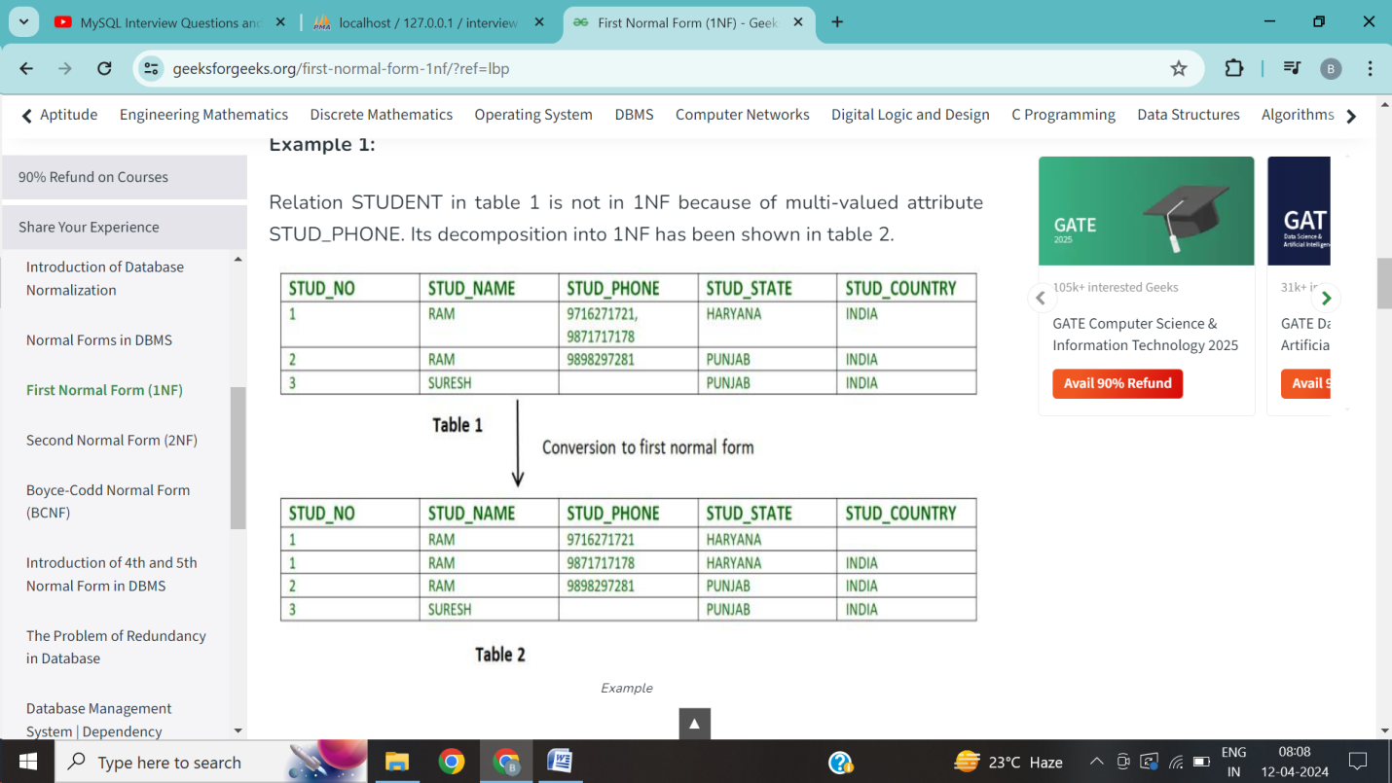

Second Normal Form (2NF): 2NF eliminates redundant data by requiring that each non-key attribute be dependent on the primary key. This means that each column should be directly related to the primary key, and not to other columns.

Third Normal Form (3NF): 3NF builds on 2NF by requiring that all non-key attributes are independent of each other. This means that each column should be directly related to the primary key, and not to any other columns in the same table.

Boyce-Codd Normal Form (BCNF): BCNF is a stricter form of 3NF that ensures that each determinant in a table is a candidate key. In other words, BCNF ensures that each non-key attribute is dependent only on the candidate key.

Fourth Normal Form (4NF): 4NF is a further refinement of BCNF that ensures that a table does not contain any multi-valued dependencies.

Fifth Normal Form (5NF): 5NF is the highest level of normalization and involves decomposing a table into smaller tables to remove data redundancy and improve data integrity.

Q1 Primary key vs Foreign Key



Q2 Primary key vs candidate key



Q3 Super key vs Candidate key





Q5.What is trigger

Ans-A MySQL **trigger** is a stored proceger type which is executed automatically to respond to a specific event such as insertion, updation or deletion occurring in a table.

Q6.Explain Transaction?How to implement it



