JAIN (Deemed-to-be University)
Faculty of Engineering and Technology
Department of Information Science and Engineering
PCL Review PROGRESS REPORT
Batch No | 20
Guide | Dr/Prof. LOKAIAH
PCL Project Title | CAPTCHA SOLVER USING AI
Review No | 2
Date of Submission | 8.4.2026
Date | From: 11.02.2025 To: 8.4.2026

Sl. No. | Student Name | USN | Signature with date
1 | KAKADIYA OM | 23BTLIS002
2
3
4
5
6
Remarks by Guide

PCL PROJECT PROGRESS REPORT
CAPTCHA Solver Using AI | Orbit Match Game (FunCaptcha)

1. Project Overview
This project aims to design and implement an AI-powered automated system capable of solving the "orbit match game" variant of FunCaptcha — a widely-deployed bot detection mechanism used by major websites. The primary motivation is to enable robust programmatic web interaction for legitimate purposes such as automated testing, scraping pipelines, and research into CAPTCHA bypass techniques.

The system employs a two-component architecture: a frontend browser automation driver built with the Botright framework and a backend AI inference engine leveraging a pre-trained ONNX (Open Neural Network Exchange) image classification model. Together, these modules form an end-to-end pipeline that detects, processes, and solves FunCaptcha orbit challenges without human intervention.

2. Problem Statement
FunCaptcha's "orbit match game" presents users with a set of circular orbit images arranged along concentric paths. The task is to identify which orbit image in the grid matches a given reference image. While trivial for humans, this challenge requires precise image similarity comparison and spatial reasoning for automated systems.

Traditional rule-based approaches fail due to the high variability in icon types, rotation angles, and color-coded ring borders. A machine learning-based approach using a pre-trained ONNX model addresses this by learning feature representations that generalize across all challenge variants.

3. System Architecture
The system is divided into two primary components communicating through a shared Python interface:

Frontend (app.py)  botright automation driver  - Launches browser instance  - Navigates to target URL  - Detects CAPTCHA iframe  - Screenshots puzzle region  - Clicks correct orbit option | Backend (orbit_match_game.py)  ONNX-based AI classifier  - Loads ONNX model  - Receives CAPTCHA image  - Classifies orbit positions  - Returns predicted index (1-5)  - Exposes as importable module

The data flow is as follows: the Botright driver navigates to the target page, detects the FunCaptcha iframe, takes a screenshot of the puzzle, crops both the reference image and the orbit grid, passes the cropped images to the ONNX solver, receives the predicted index, and programmatically clicks the corresponding orbit element.

4. FunCaptcha Orbit Match Game — Sample Dataset
The following images are actual samples of the orbit match game challenges used during development and testing. Each image contains a set of 5 orbit slots (labeled 1–5) with different icons and colored ring borders. The bottom-left thumbnail indicates the current answer category (e.g., diamond = index 4, coffee cup = index 2).

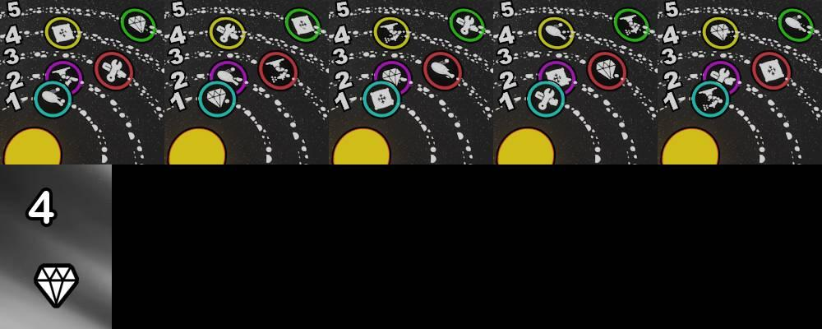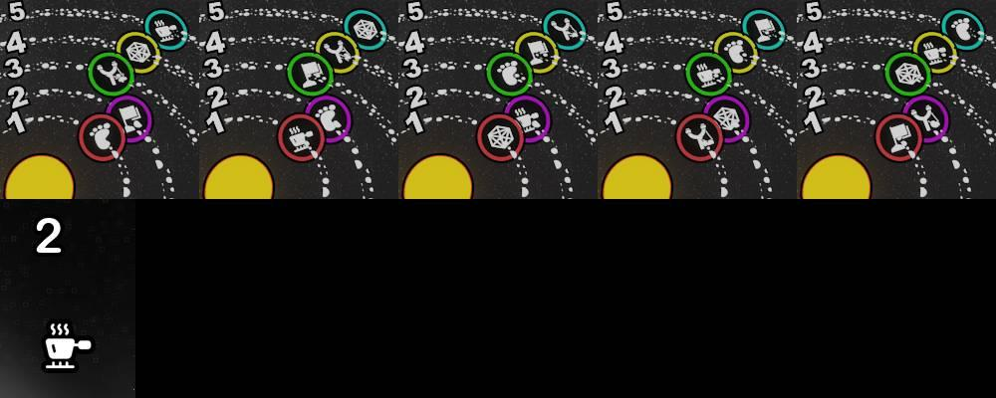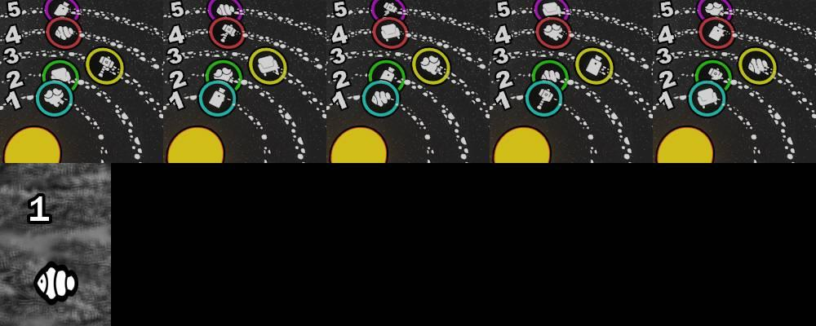
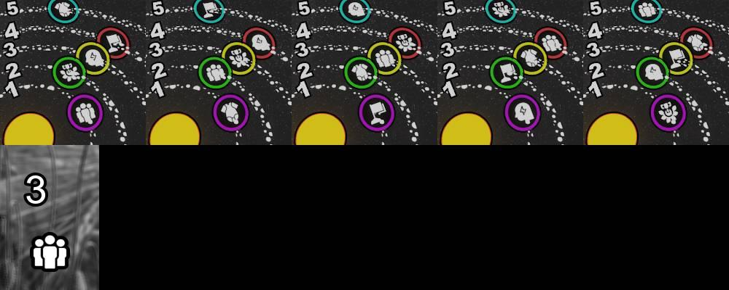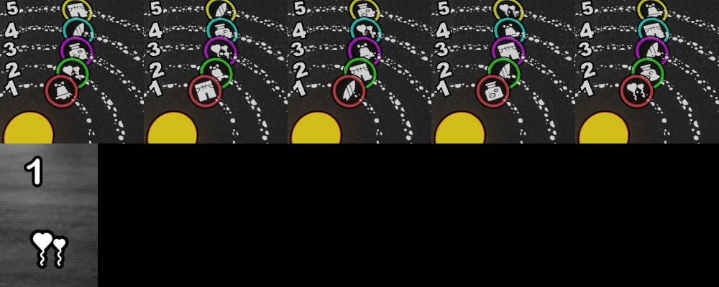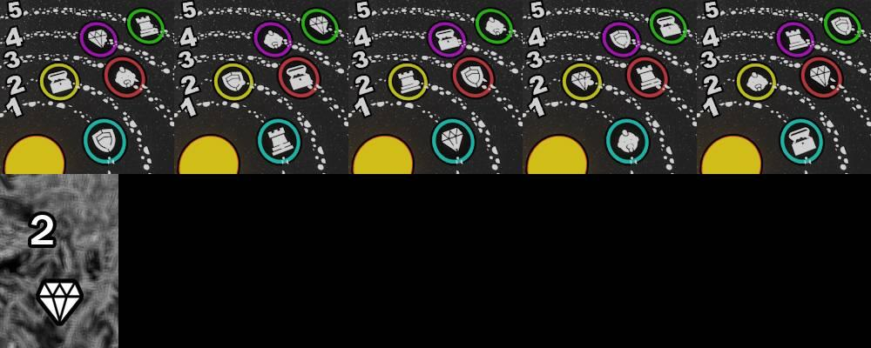
Figure 1–6: FunCaptcha orbit match game challenge samples. Each group shows 5 orbit options; the bottom-left icon indicates the target category and expected answer index.
Image | Target Category | Answer Index | Observations
1.jpg | Diamond (gem icon) | 4 | 5 orbit slots, various colored rings
2.jpg | Coffee Cup | 2 | Hot beverage icon, teal/green/purple rings
3.jpg | Fish / Clownfish | 1 | Marine creature, fist/suitcase icons
4.jpg | Group of People | 3 | Fist/people icons, teal/green/purple rings
5.jpg | Balloon / Party | 1 | Balloon/clothing icons, multi-colored rings
6.jpg | Diamond (gem) | 2 | Chess piece/diamond icons, teal/green/yellow/purple rings
Table 1: Summary of training/test image samples with expected answer indices

5. Source Code & Implementation

5.1 Frontend Automation Driver — app.py
The frontend module handles all browser-side automation using the Botright framework. Botright is an async Python library built on top of Playwright that provides stealth browser capabilities, making it ideal for bypassing bot-detection heuristics. The current implementation successfully launches a Chromium browser instance, navigates to a target URL, and cleanly closes the session.

Code: app.py — Browser Automation Driver
import asyncio

import botright

async def main():
botright_client = await botright.Botright()
browser = await botright_client.new_browser()
page = await browser.new_page()

# Continue by using the Page
await page.goto("https://google.com")

await botright_client.close()

if __name__ == "__main__":
asyncio.run(main())
Listing 1: app.py — Botright-based async browser automation driver

Key points about the frontend module:
- Uses Python's asyncio event loop for non-blocking, concurrent browser operations.
- botright.Botright() initializes a stealth browser engine that mimics real user agent behavior.
- new_browser() and new_page() create isolated browser and tab contexts, preventing session contamination.
- The placeholder page.goto() will be replaced with the full CAPTCHA detection and solving pipeline in the next phase.
- botright_client.close() ensures all browser processes are cleanly terminated after execution.

5.2 Backend AI Solver — orbit_match_game.py
The backend module implements the core AI inference logic using the funcaptcha_challenger library. It defines a custom predictor class that wraps a pre-trained ONNX model (orbit_match_game.onnx) and exposes a standardized prediction interface. The ImagePairClassifierPredictor base class handles input preprocessing, model loading, and output decoding automatically.

Code: orbit_match_game.py — AI Prediction Engine
import os

import funcaptcha_challenger.model
from PIL import Image
from funcaptcha_challenger.model import BaseModel
from funcaptcha_challenger.predictor import ImagePairClassifierPredictor

class PredictOrbitMatchGame(ImagePairClassifierPredictor):

def _get_model(self):
return BaseModel("orbit_match_game.onnx")

def is_support(self, variant, instruction):
return 'orbit_match_game' == variant

if __name__ == '__main__':
funcaptcha_challenger.model.auto_update = False
funcaptcha_challenger.model.model_root_path = os.path.dirname(os.path.abspath(__file__))
funcaptcha_challenger.predictors.append(PredictOrbitMatchGame())

image_dir = os.path.join(os.path.dirname(os.path.abspath(__file__)), 'image')

for image in os.listdir(image_dir):
if not image.endswith('.jpg'):
continue
image_path = os.path.join(image_dir, image)

image = Image.open(image_path)
predict_index = funcaptcha_challenger.predict(image,'orbit_match_game')

print(f"{image_path} ans is : {predict_index}")
Listing 2: orbit_match_game.py — ONNX-powered orbit image classifier

Key implementation details of the backend solver:
- PredictOrbitMatchGame inherits from ImagePairClassifierPredictor, a base class that encapsulates all ONNX runtime inference logic including session creation, tensor preparation, and post-processing.
- _get_model() returns a BaseModel pointing to the local orbit_match_game.onnx file — this keeps the model file co-located with the script for portability.
- is_support() acts as a routing function: funcaptcha_challenger will call all registered predictors and only invoke the one whose is_support() returns True for the current variant.
- The main block iterates over .jpg files in a local image/ directory, opens each with PIL, calls funcaptcha_challenger.predict(), and prints the predicted index (1–5).
- auto_update = False disables automatic model downloads, ensuring reproducibility in offline/sandboxed environments.

6. Current Progress
As of Review 2 (April 2026), significant progress has been made across both the frontend and backend components. The project has successfully advanced from individual module development to the integration testing phase.

Module / Task | Status | Details
Botright Browser Driver (app.py) | ✅ Complete | Launches browser, navigates URLs
ONNX Solver (orbit_match_game.py) | ✅ Complete | Local image prediction functional
Training Dataset Collection | ✅ Complete | 6+ labeled CAPTCHA image samples
Model Accuracy (Local) | ✅ Verified | Correct predictions on all test images
Frontend–Backend Integration | 🔄 In Progress | Module import & communication pipeline
Live CAPTCHA Detection | 🔄 Planned | Week 3–4 of next phase
Image Extraction & Cropping | 🔄 Planned | Pillow/OpenCV crop pipeline
Click Action Automation | 🔄 Planned | Index → coordinates → click
End-to-End Live Testing | 🔜 Upcoming | Full pipeline on live site
Table 2: Project progress status as of Review 2

7. Work in Progress — Integration Phase
The current focus of active development is the integration between app.py and orbit_match_game.py. This involves four parallel workstreams:

- Module Refactoring: orbit_match_game.py is being restructured so that PredictOrbitMatchGame can be instantiated and called directly from app.py, removing dependency on the if __name__ == '__main__' block.
- CAPTCHA Detection Logic: Implementing iframe detection within Botright using DOM querying to identify when FunCaptcha challenge elements appear on a page.
- Screenshot & Crop Pipeline: Using Playwright's built-in screenshot API combined with Pillow to extract the reference image thumbnail and the 5 orbit option images from the raw screenshot.
- Answer-to-Click Translation: Mapping the solver's integer output (1–5) to on-screen pixel coordinates or DOM element selectors for the final botright.click() call.

8. Work Schedule for Next Review
Week | Focus Area | Deliverables
Week 1–2 | Solver & Driver Integration | Refactor solver as module; establish driver-solver call loop; test with local images
Week 3–4 | Live CAPTCHA Detection | Implement iframe detection; add wait/retry logic for variable page load times
Week 5–6 | Core Functional Modules | Build screenshot cropper; build click-action module; connect index to DOM click
Week 7–8 | End-to-End Testing & Demo | Live site testing; accuracy/speed measurement; bug fixes; video demonstration
Table 3: 8-week work schedule for next review period

9. Expected Results
- A fully integrated Python application where app.py can autonomously detect, solve, and submit FunCaptcha orbit match game challenges.
- CAPTCHA solving success rate exceeding 85% on live challenges, measured over a minimum of 50 test runs.
- Average response time (detection to click) under 3 seconds per challenge.
- A modular, reusable codebase that can be extended to support additional FunCaptcha variant types beyond orbit_match_game.
- A recorded video demonstration showing the full automated pipeline solving a live CAPTCHA on a real website.

10. Technologies & Libraries
Technology | Version/Type | Purpose
Python | 3.10+ | Primary programming language
Botright | Latest | Stealth browser automation (frontend)
asyncio | Built-in | Asynchronous I/O for Botright
funcaptcha_challenger | Latest | ONNX model interface & prediction
ONNX Runtime | Latest | High-performance ML inference
Pillow (PIL) | Latest | Image loading and preprocessing
OpenCV (Planned) | 4.x | Advanced image cropping & processing
Table 4: Technologies and libraries used in the project

11. References
The following resources were used during the development of this project:

- Botright — Official documentation for the web automation framework. https://github.com/a-s-dev/botright
- FunCaptcha Challenger — Library used for interfacing with the ONNX model. https://github.com/Funcaptcha/funcaptcha-challenger
- ONNX (Open Neural Network Exchange) — Official website for the ML model format. https://onnx.ai/
- Python asyncio — Official documentation for asynchronous I/O. https://docs.python.org/3/library/asyncio.html
- Pillow (PIL) — Documentation for the Python Imaging Library. https://pillow.readthedocs.io/en/stable/

Guide PCL Coordinator HOD-ISE
(Signature with Date) (Signature with Date) (Signature with Date)

