Test Cases
- Verify successful email sending.
Input: Provide a valid email address.
Output: Prints “OTP Sent Successfully.” and the recipient receives the email.
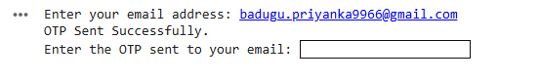
- Handling invalid email address.
Input: Provide an invalid email address.
Output: Prints an appropriate error message.
- Verify correct OTP entry.
Input: Provide the generated OTP.
Output: Grants access and prints “Access granted.”
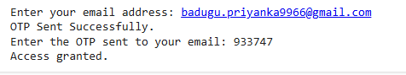
- Verify incorrect OTP entry.
Input: Provide the incorrect OTP.
Output: Prints “Incorrect OTP. You have X attempt(s) left.” and reduces the attempt count.
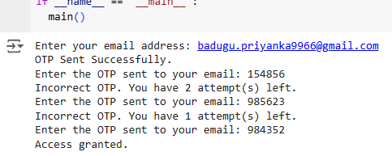
- Verify after exceeding attempts.
Input: Enter incorrect OTP’s 3 times.
Output: Prints “Access denied. Too many incorrect attempts.”
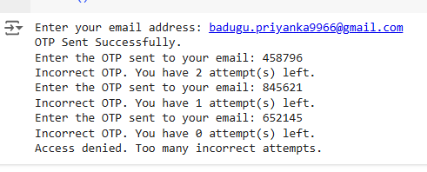
- Handle non-numeric OTP input.
Input: Enter a non-numeric value.
Output: Prints “OTP must be numeric.” and prompts user to enter OTP again.
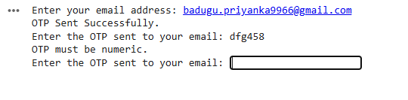
- Handle empty OTP input.
Input: Press enter without entering any value.
Output: Prints “OTP cannot be empty.” and prompts user to enter OTP again.
