Create a workspace and initial application
ng new bbs-home --routing

Open project with Visual studio code
. cd bbs-home
. code .
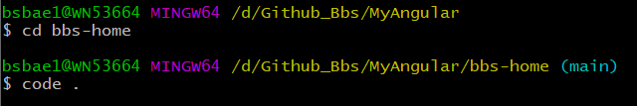

Getting Started with Angular Material
. ng add @angular/material
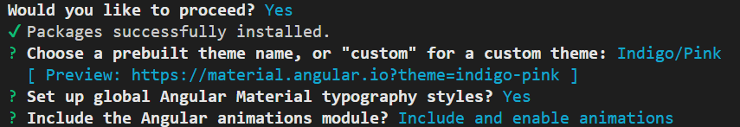

Create home and auth layout
. ng g c layouts/home-layout --skip-tests
. ng g c layouts/auth-layout --skip-tests

Create home and auth module
. ng g m home --routing
. ng g m auth --routing

Create login components
. ng g c auth/login --skip-tests

angular pass data to router outlet component
https://www.youtube.com/watch?v=03FqsZ_XJEc

ng generate service hero

https://www.npmjs.com/package/@auth0/angular-jwt?activeTab=readme
npm install @auth0/angular-jwt
ng g service _service/alert --skip-tests
ng g service services/auth

Main Layout 화면 : Holy-Grail Layout
https://stackblitz.com/edit/angular-mib5gx
https://github.com/angular/flex-layout/wiki/fxFlex-API
. fxFlex 기능: bias, grow, shrink
. FlexLayout으로 responsive web 공부 ?

Dashboard : FlexLayout reponsive
https://indepth.dev/posts/1208/angular-flex-layout-flexbox-and-grid-layout-for-angular-component
https://github.com/angular/flex-layout/wiki/Responsive-API
https://www.angularjswiki.com/flexlayout/fxlayout/
https://www.angularjswiki.com/flexlayout/basics/
https://www.colorxs.com/color/bootstrap-primary

<div
fxLayout="row wrap"
fxLayout.lt-sm="column"
fxLayoutGap="32px"
fxLayoutAlign="flex-start">
<ng-container *ngFor="let _ of [1,2,3,4,5,6]">
<app-card
fxFlex="0 1 calc(33.3% - 32px)"
fxFlex.lt-md="0 1 calc(50% - 32px)"
fxFlex.lt-sm="100%"
></app-card>
</ng-container>
</div>
Each child element has new fxFlex.lt-md and fxFlex.lt-sm directives to configure the card size for each viewport size. As a result, the component displays 2 columns when the small-medium size and a single column when less than the small size. Not only these, but all flexbox directives support the same responsive APIs.
작을 때 한 개의 width 100% , md 일 때 한 개당 50% , 기본은 한 개당 33%
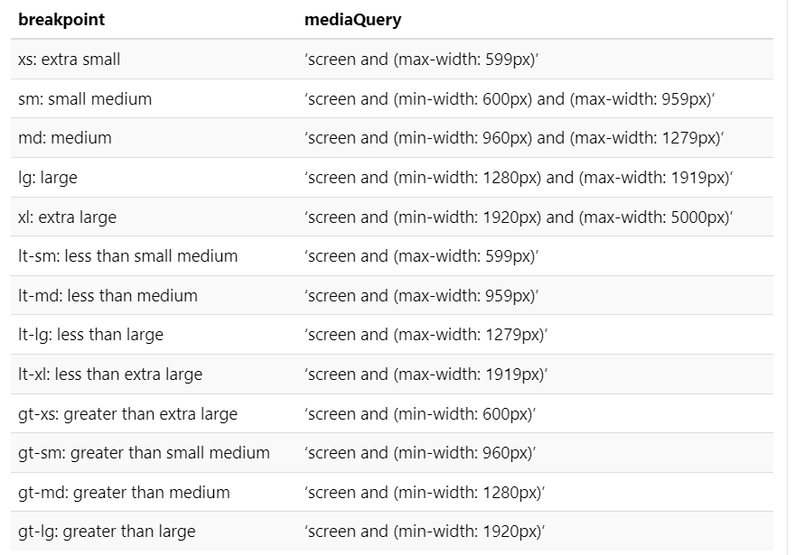

Chart

https://www.freecodecamp.org/news/how-to-integrate-chart-js-in-angular-using-data-from-a-rest-api/

Auth Service
. https://jasonwatmore.com/angular-15-auth-boilerplate-sign-up-with-verification-login-and-forgot-password

Create sign-in 화면
. mat-form-field must contain a MatFormFieldControl
>>https://stackoverflow.com/questions/46705101/mat-form-field-must-contain-a-matformfieldcontrol
>> https://www.positronx.io/create-login-ui-template-with-angular-material-design/
>> https://github.com/angular/flex-layout

>> MatInputModule import: import { MatInputModule } from '@angular/material/input';
>> matInput 스펠링 주의

Component styles
https://angular.io/guide/component-styles

Start by installing the Angular Layout library from npm
. npm i -s @angular/flex-layout @angular/cdk

div 중앙 정렬: angular flex-layout사용
<div fxLayout="column" fxLayoutAlign="flex-start center" fxFlexFill class="main-div" >

.main-div{
padding-top: 100px;
}

Shadow DOM은 무엇일까?
https://wit.nts-corp.com/2019/03/27/5552

