1. Git설치 : <https://git-scm.com/>
2. SourceTree설치 : <https://www.sourcetreeapp.com/>

-. <https://git-scm.com/downloads/guis> ( 비추 )

1. VS Code설치 : <https://code.visualstudio.com/>

3-1. Git Bash를 기본 터미널로 설정

(<https://www.geeksforgeeks.org/how-to-integrate-git-bash-with-visual-studio-code/>)

**Step 1:** Open Terminal in VScode by using the shortcut key **Ctrl+~**. Here you will see that currently, it has PowerShell and we have to add bash to it.

**Step 2:** Then, you have to open settings by **File->Preferences->Settings**or by pressing **Ctrl+, .**You have to click on the **Open Settings(JSON)** icon as shown in the image below:

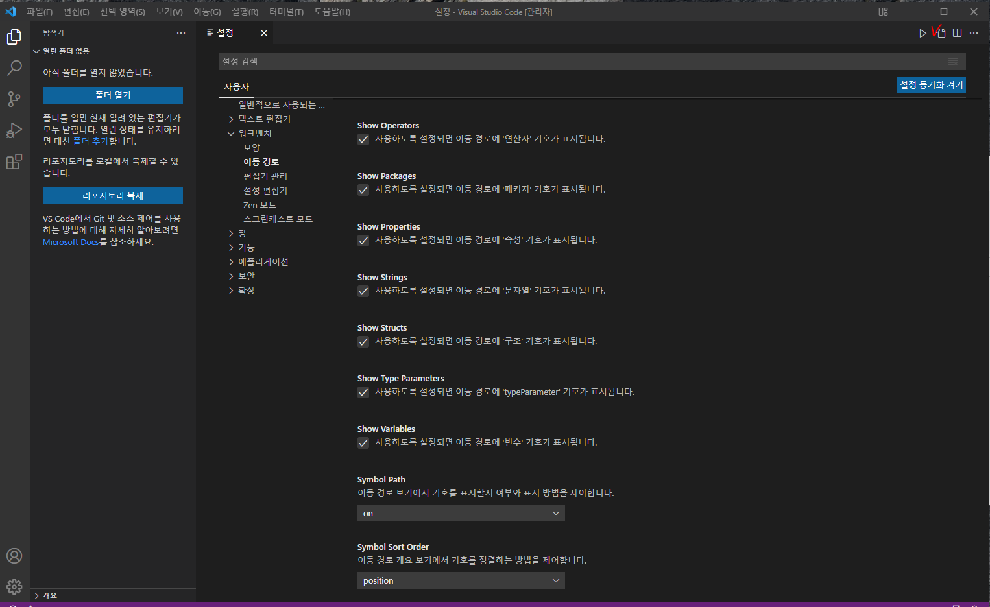

**Step 3:** On clicking, you will see the settings page. You have to add the below propertiesat the last of all settings as shown in the image below:

{

    "workbench.colorTheme": "Visual Studio Dark"

    ,

    "terminal.integrated.profiles.windows":{"GitBash":{"path":"D:\\Program Files\\Git\\bin\\bash.exe"},  },

    "terminal.integrated.defaultProfile.windows": "GitBash",

    }