LANE DETECTION AND STEERING CONTROL ALGORITHM FOR AUTONOMOUS VEHICLES

1. Algorithm Overview
The algorithm presented in this project employs traditional computer vision techniques to detect road lanes from an input video stream and to compute parameters required for autonomous vehicle steering control.
The processing pipeline consists of the following main stages: defining the Region of Interest (ROI), applying a perspective transformation to obtain a Bird’s Eye View, performing color thresholding in the HSV color space, detecting lane lines using the Sliding Window algorithm, and modeling lane geometry using second-order polynomial fitting.
In addition to detecting lane positions, the algorithm is capable of estimating lane curvature, vehicle lateral offset from the lane center, and steering angle. These outputs form a fundamental basis for lane-keeping assistance systems and basic autonomous driving applications.
2. Reasons for Algorithm Selection
Compared to simple image processing approaches such as Canny edge detection or the Hough Transform, the selected algorithm is more robust in tracking curved lanes and maintaining stability when lane markings are not perfectly straight.
Furthermore, modeling lanes with second-order polynomials allows the extraction of important geometric parameters such as curvature, lateral offset, and steering angle, which are essential for vehicle control tasks.
Compared to Deep Learning-based methods, the traditional approach does not require large labeled datasets or complex training procedures and can operate efficiently in real time on limited hardware resources. Additionally, the algorithm offers high transparency, as each processing step is clearly defined and easy to analyze, making it suitable for academic study and research purposes.
3. Detailed Algorithm and Code Explanation
3.1 Video Input and Preprocessing
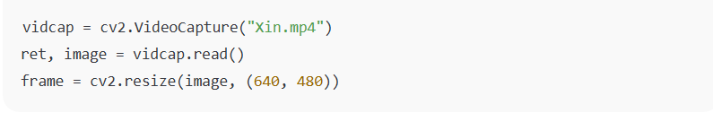
Explanation:
The system uses the OpenCV library to read video input, simulating data captured from a front-facing vehicle camera. Each frame is resized to a resolution of 640×480 pixels to standardize the input, reduce computational cost, and ensure real-time processing performance.
3.2 Region of Interest Selection and Perspective Transformation
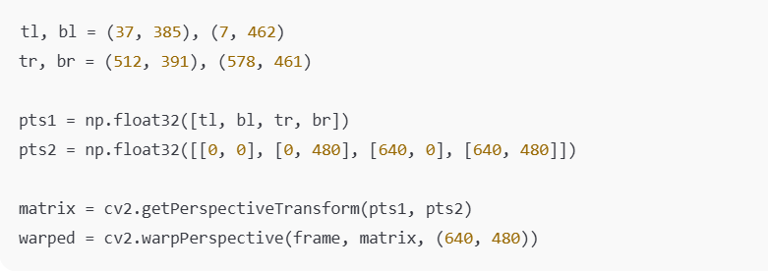
Explanation:
Four ROI points are selected to form a trapezoidal region covering the lane area ahead of the vehicle. A perspective transformation is applied to convert this region into a Bird’s Eye View, where lane lines appear nearly parallel. This transformation simplifies lane detection and geometric modeling.
3.3 Color Thresholding in HSV Space
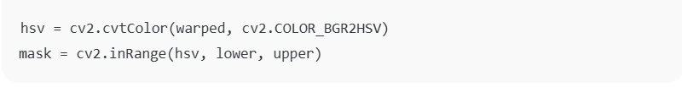
Explanation:
The warped image is converted into the HSV color space. Compared to the RGB color space, HSV is less sensitive to lighting variations. Through color thresholding, pixels corresponding to lane markings are retained in a binary image.
3.4 Histogram Analysis and Sliding Window Algorithm
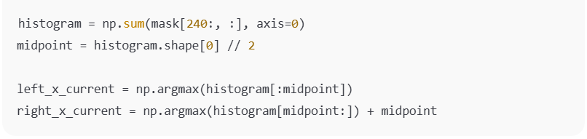
Explanation:
A histogram is computed over the lower half of the binary image to identify the initial positions of the left and right lanes. Based on these positions, the Sliding Window algorithm divides the image into multiple vertical windows and iteratively searches for lane pixels within each window.
The window centers are continuously updated, allowing the algorithm to accurately follow curved lane lines.
3.5 Lane Modeling and Parameter Computation
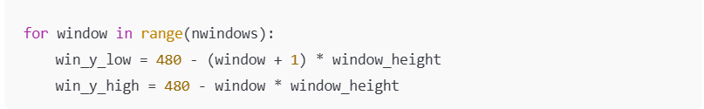
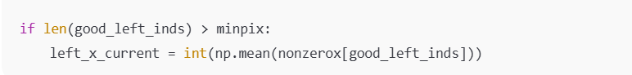
Explanation:
Pixels belonging to the left and right lanes are used to fit second-order polynomial curves. From these models, the system computes lane curvature, the vehicle’s lateral offset from the lane center, and the steering angle based on a look-ahead point strategy.
3.6 Lane Modeling Using Second-Order Polynomial
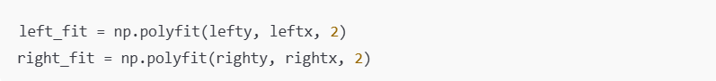
Explanation:
Each lane line is modeled using a second-order polynomial. This polynomial representation effectively captures the natural curvature of road lanes and provides a smooth geometric model of the lane boundaries.
The fitted polynomial curves serve as the foundation for subsequent calculations of lane curvature, vehicle lateral offset, and steering angle.
3.7 Curvature, Lateral Offset, and Steering Angle Calculation
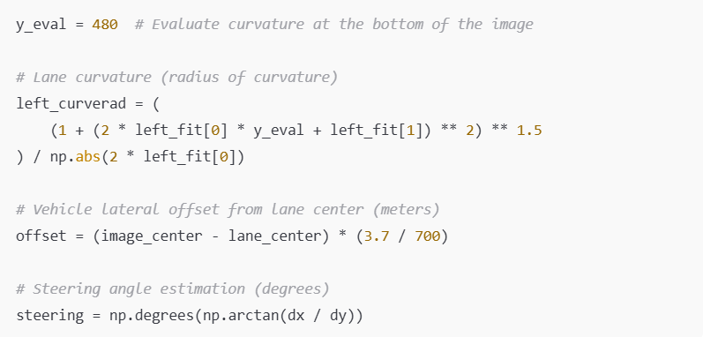
Explanation:
Lane curvature represents the degree of bending of the road and is computed from the polynomial coefficients. A larger curvature radius indicates a straighter road, while a smaller radius corresponds to a sharper curve.
The lateral offset indicates whether the vehicle is deviating to the left or right relative to the lane center. This value is converted from pixel space to meters using an assumed lane width.
The steering angle is calculated based on a look-ahead point located ahead of the vehicle along the lane centerline. This approach simulates a geometric steering control principle commonly used in autonomous vehicle systems.
3.8 Result Visualization and Rendering
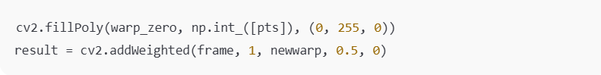
Explanation:
The detected lane area is filled with a colored polygon and projected back onto the original camera frame using inverse perspective transformation. This visualization highlights the detected lane region and enhances interpretability, enabling qualitative evaluation of the lane detection and steering estimation results.

4. Future Development Plan
In future work, the system can be extended in the following directions:
- Integrating Deep Learning models (e.g., CNNs) for lane segmentation under complex lighting and weather conditions.
- Applying Kalman filtering or other state estimation techniques to improve temporal stability across consecutive frames.
- Fusing data from additional sensors such as IMU and GPS to enhance localization accuracy and vehicle control performance.

