Final Assessment – Penetration Testing Engagement in a Controlled Lab

Student ID: 2416509 | Date: June 7, 2026
Target: Ubuntu Server 24.04 LTS | Attacker: Kali Linux
Lab Network: 192.168.56.101 (Kali), 192.168.56.103 (Ubuntu)

1. Executive Summary
This report documents a controlled penetration test of an Ubuntu Server 24.04 LTS target within an isolated VirtualBox host-only laboratory. The engagement followed NIST SP 800-115 and OWASP testing guidance, progressing through reconnaissance, enumeration, exploitation, log analysis, remediation, and re-testing.
Two security weaknesses were confirmed. Weak SSH authentication permitted remote login using credentials discovered by Hydra (testuser:password123). Apache HTTP configuration exposed version information, missing security headers, and enumerable web paths including /server-status.
Mitigations were applied and verified. SSH credentials were hardened, Fail2Ban blocked repeated authentication failures, and Apache was configured with ServerTokens Prod, ServerSignature Off, TraceEnable Off, and custom HTTP security headers. Re-testing confirmed Hydra no longer recovered valid SSH credentials and Apache responses no longer disclosed the full version string.
ID | Finding | Severity | CVSS v3.1 | Status
F-01 | Weak SSH authentication | Critical | 9.8 | Mitigated
F-02 | Apache information disclosure | Medium | 5.3 | Mitigated
The highest residual risk relates to credential governance and the absence of multi-factor authentication.

3. Lab Topology, Scope and Rules of Engagement
The environment comprises a Kali Linux attacker at 192.168.56.101 and an Ubuntu Server 24.04 LTS target at 192.168.56.103 on a VirtualBox host-only network (192.168.56.0/24). This architecture ensures all testing remains contained within the laboratory and cannot reach external systems.
The target exposes only SSH on port 22 and Apache HTTP on port 80. This minimal configuration represents a simple administrative server and supports focused evaluation of authentication and web server security controls.
Rules of engagement permitted active reconnaissance, service enumeration, credential testing, and controlled exploitation within the lab. No destructive changes were made beyond those required for remediation verification. Figure 0 presents the lab topology. Figure 1 documents the Ubuntu target IP (192.168.56.103 on enp0s3), and Figure 2 documents the Kali attacker IP (192.168.56.101 on eth0 via ip a).
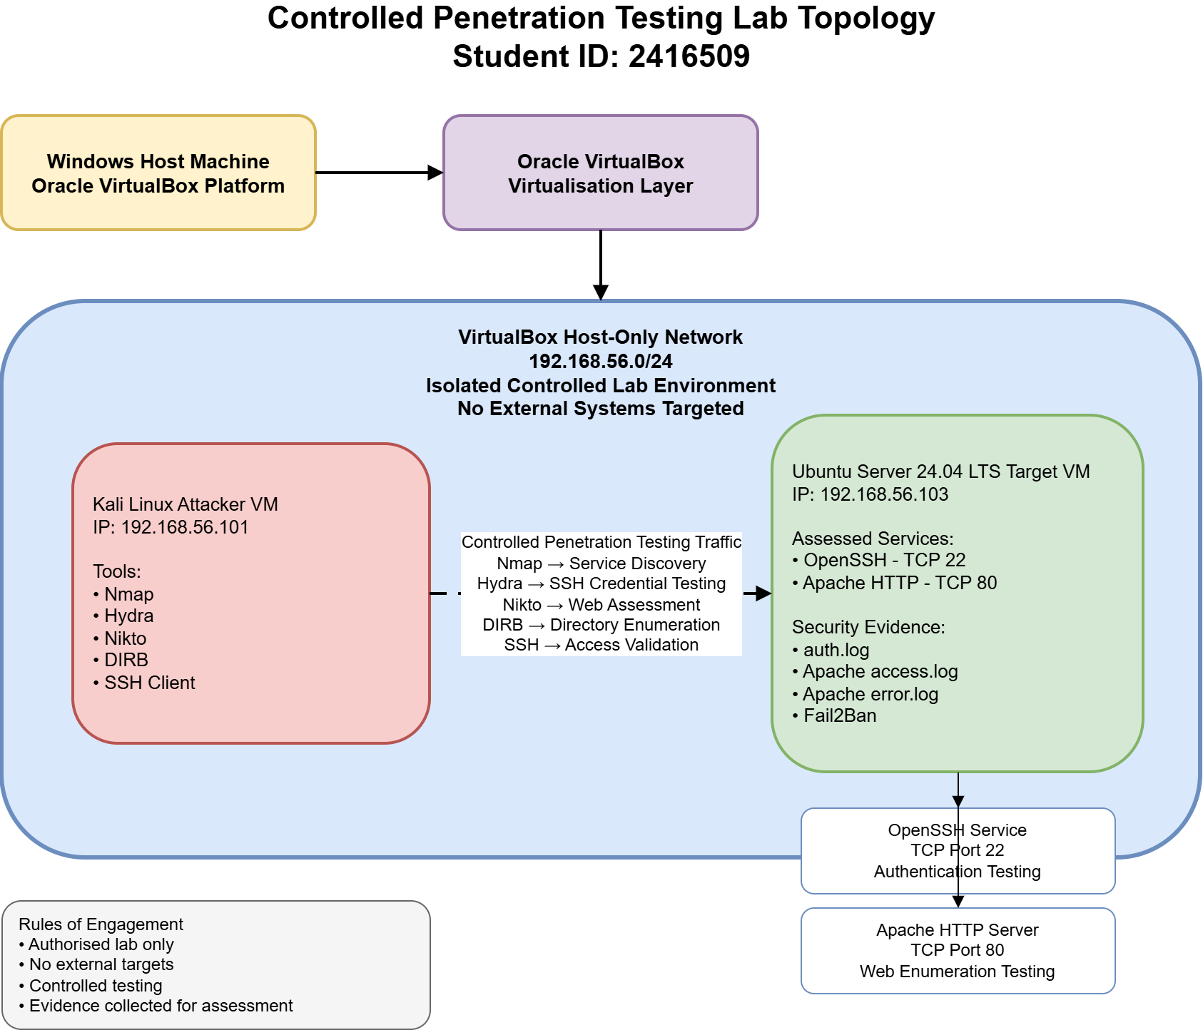
Figure 0: Controlled penetration testing lab topology showing the Kali attacker VM, Ubuntu target VM, VirtualBox host-only network, assessed services, and rules of engagement.
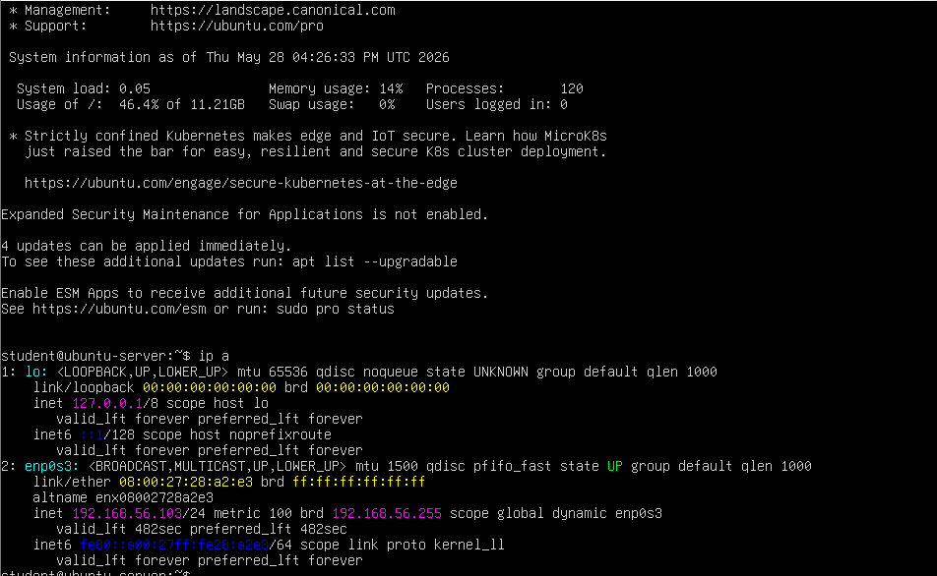
Figure 1: Ubuntu target IP configuration showing 192.168.56.103 on the host-only lab network.
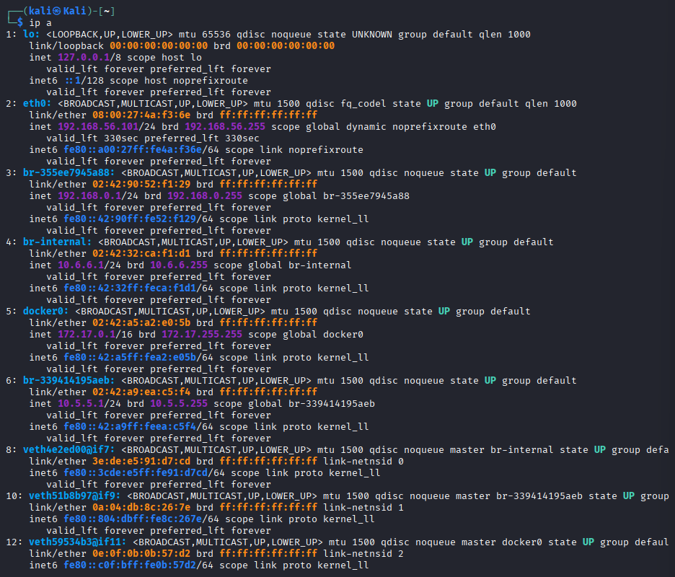
Figure 2: Kali attacker IP configuration showing 192.168.56.101 on the host-only lab network.

4. Server Build and Service Configuration
The target was provisioned with OpenSSH 9.2p1 and Apache/2.4.66. Service status, network connectivity, Nmap discovery, and browser access to the default Apache page were verified to confirm the baseline build (Figures 3–7). The configuration reflects a typical academic lab server: current packages with default service settings that require additional hardening for production use.
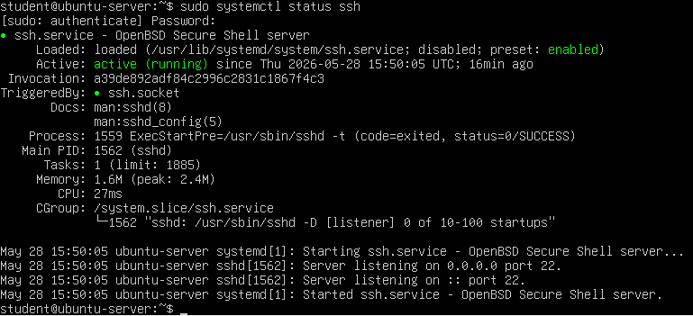
Figure 3: SSH service status confirming OpenSSH is active on the Ubuntu target.
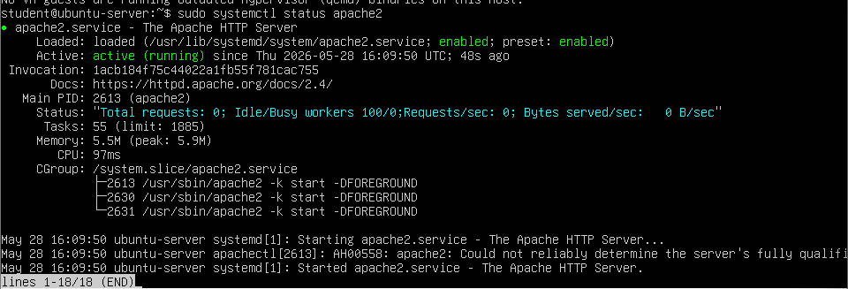
Figure 4: Apache service status confirming Apache HTTP Server is active on the Ubuntu target.
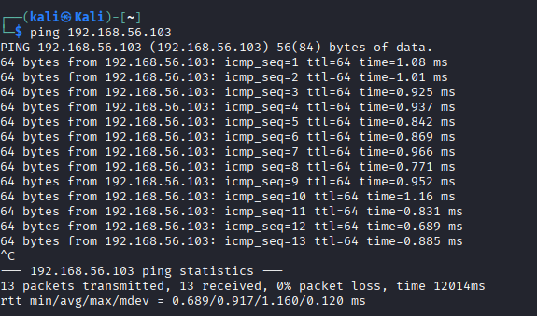
Figure 5: Ping connectivity test confirming network reachability between the Kali attacker and Ubuntu target.
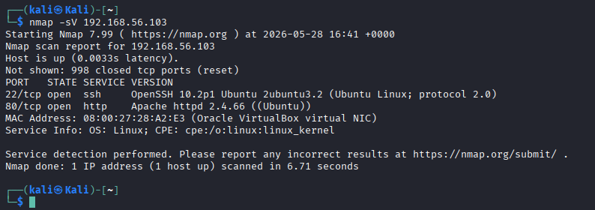
Figure 6: Nmap service discovery identifying OpenSSH on TCP port 22 and Apache HTTP on TCP port 80.
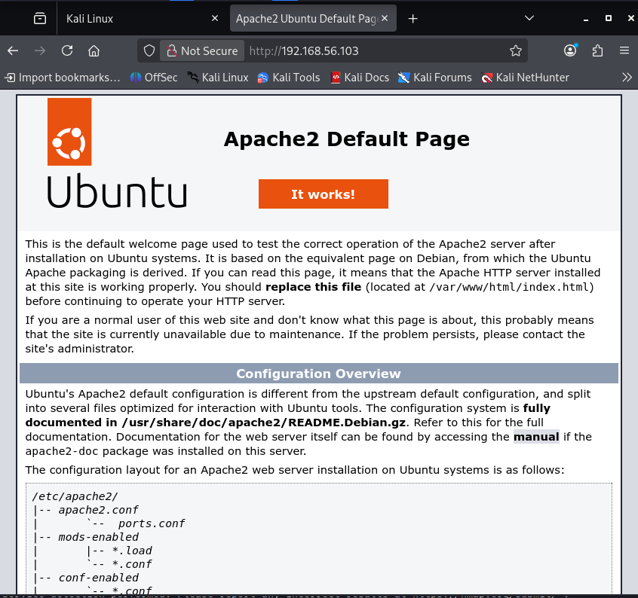
Figure 7: Browser access confirming Apache default web page availability.

5. Methodology
The engagement followed an established ethical testing sequence consistent with NIST SP 800-115 and the OWASP Testing Guide. Phases included reconnaissance, service enumeration, credential-based authentication testing, web application enumeration, log analysis, mitigation implementation, and re-testing.
Initial reconnaissance used ICMP and Nmap to confirm reachability and enumerate services. Web assessment combined curl header inspection, Nikto vulnerability scanning, and Dirb directory enumeration against the Apache document root. SSH testing used Hydra with a controlled six-entry password list against the testuser account. Log evidence was collected using journalctl for SSH and direct review of Apache access and error logs, enabling correlation between attacker tools and recorded events on the target host.

6. Finding 1 – Weak SSH Authentication Controls
Severity: Critical | CVSS v3.1: 9.8

Threat Scenario
A remote threat actor on the local network may exploit weak SSH credentials to gain unauthorised shell access, enabling data exposure, configuration changes, or further privilege escalation.

Methodology and Evidence
Following Nmap confirmation of OpenSSH on port 22, Hydra was executed against the testuser account. The attack identified testuser:password123. Successful SSH login and journalctl logs confirmed exploitation from 192.168.56.101 (Figures 8–11). Figure 11 uses journalctl output showing failed authentication attempts followed by a successful login, providing stronger forensic evidence than grep-based log review alone.
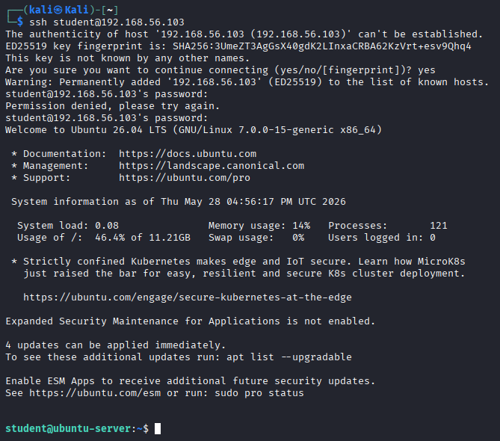
Figure 8: Successful SSH login validating remote access to the Ubuntu target.
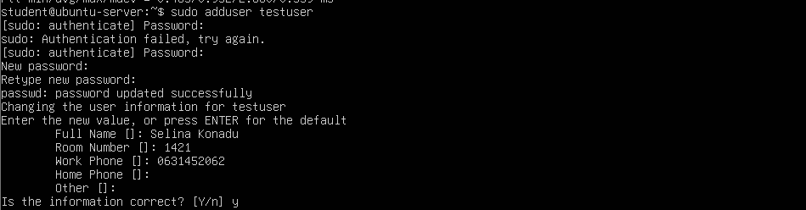
Figure 9: Creation of the testuser account used for controlled credential testing.
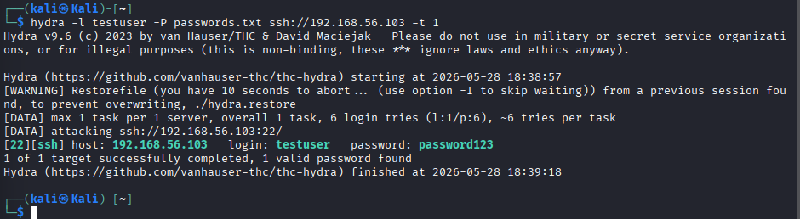
Figure 10: Hydra credential attack identifying the weak SSH credential testuser:password123.
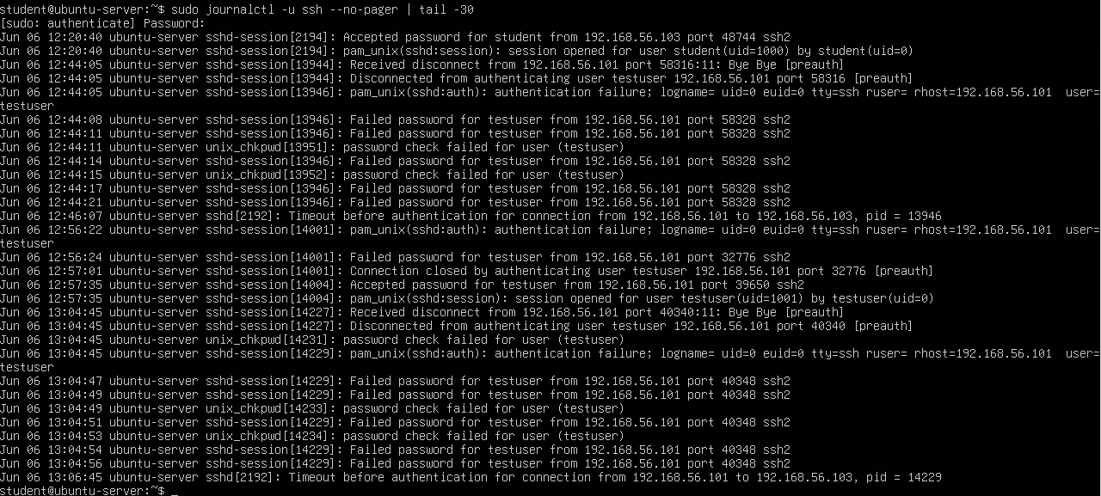
Figure 11: SSH journal logs showing failed authentication attempts, successful authentication, and source IP evidence from the Kali attacker.

Impact
Successful exploitation resulted in unauthorised interactive access to the target system with potential for full compromise.

Mitigation and Re-Test
The weak credential was replaced with a strong password. Fail2Ban was installed and configured to monitor SSH authentication failures. Figures 24–30 document open port verification, Fail2Ban status, password hardening verification, successful login with the new password, and a Hydra re-test that found zero valid credentials.
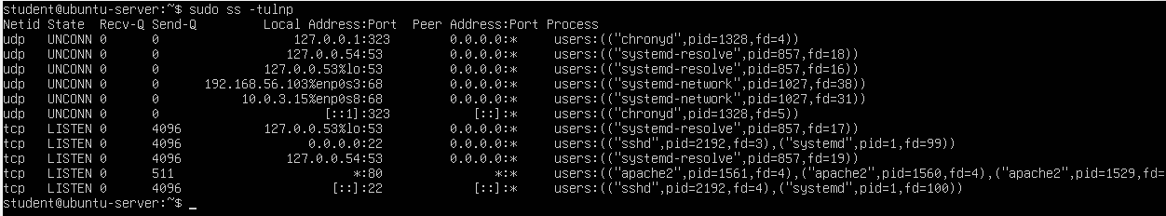
Figure 24: Open ports verification showing SSH and Apache services listening on the Ubuntu target.
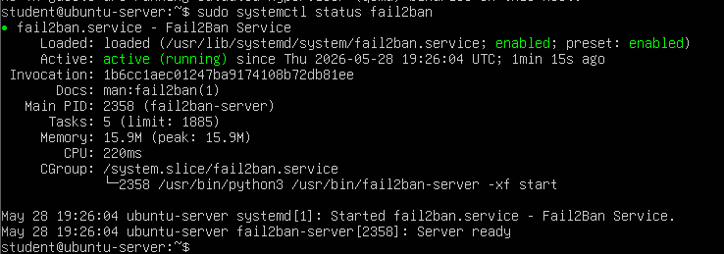
Figure 25: Fail2Ban service status confirming the defensive control is active.
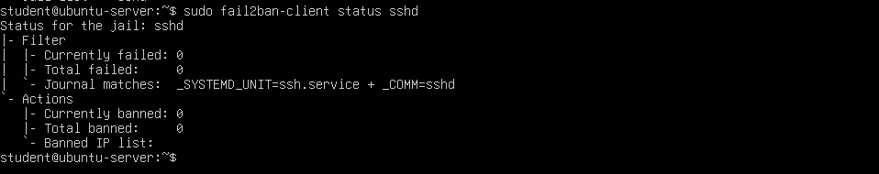
Figure 26: Fail2Ban global status showing active jail monitoring.
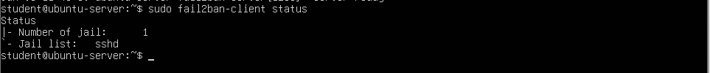
Figure 27: Fail2Ban SSH jail status confirming SSH monitoring.
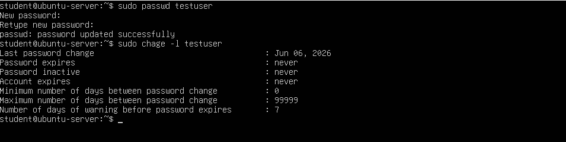
Figure 28: Password hardening verification for the testuser account.
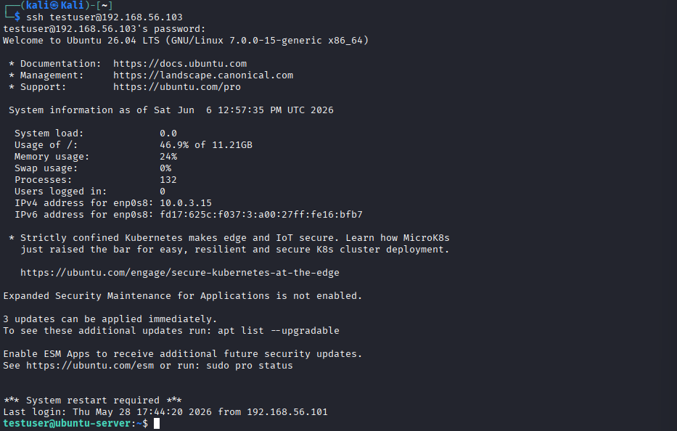
Figure 29: Successful SSH login using the strengthened password after remediation.
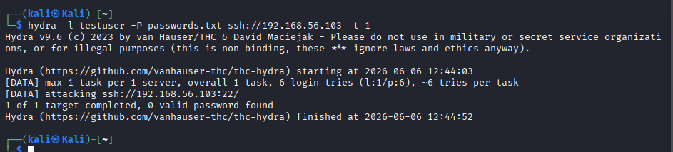
Figure 30: Hydra retest after remediation showing no valid password found.

Critical Evaluation and Residual Risk
While OpenSSH was current, weak password policy and absent brute-force protection created critical risk. Fail2Ban and strong passwords reduced exposure. Residual risk remains without multi-factor authentication and continuous credential auditing.

7. Finding 2 – Apache Enumeration and Information Disclosure
Severity: Medium | CVSS v3.1: 5.3

Threat Scenario
An attacker may exploit HTTP enumeration and information disclosure to identify software versions and misconfigurations, supporting targeted exploitation.

Methodology and Evidence
Before hardening, curl -I http://192.168.56.103 returned Server: Apache/2.4.66 (Ubuntu) with no security headers (Figure 12). Nikto confirmed version disclosure and missing headers; Dirb identified /index.html and /server-status (Figures 13–14). Apache access and error logs recorded enumeration and blocked sensitive path requests from 192.168.56.101 (Figures 15–16).
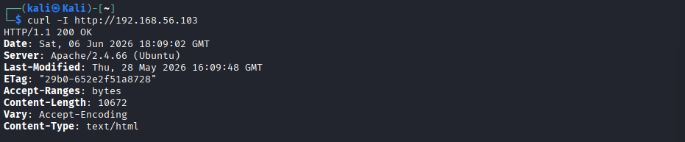
Figure 12: HTTP response headers before hardening showing Apache version disclosure.
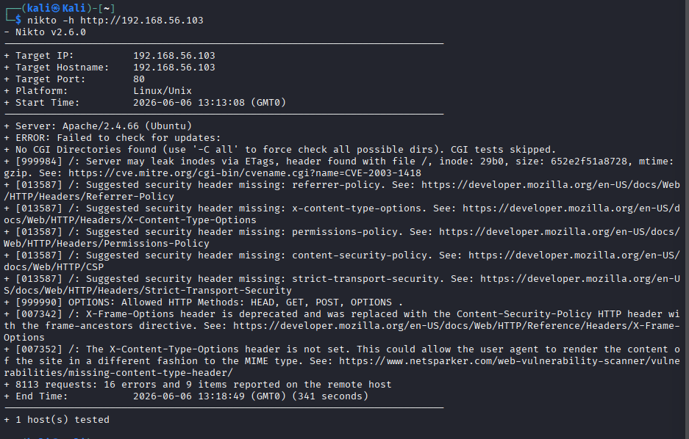
Figure 13: Nikto web server assessment identifying Apache information disclosure and missing HTTP security headers.
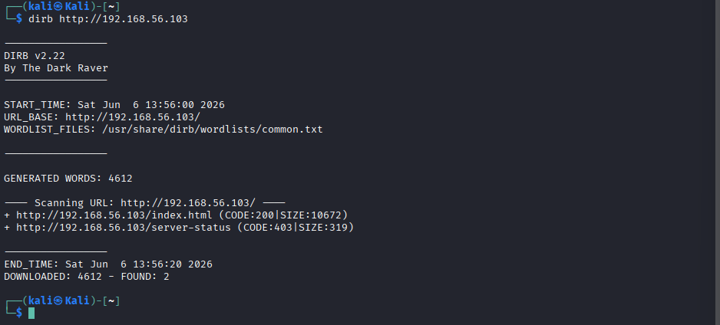
Figure 14: DIRB directory enumeration identifying accessible resources including index.html and server-status.
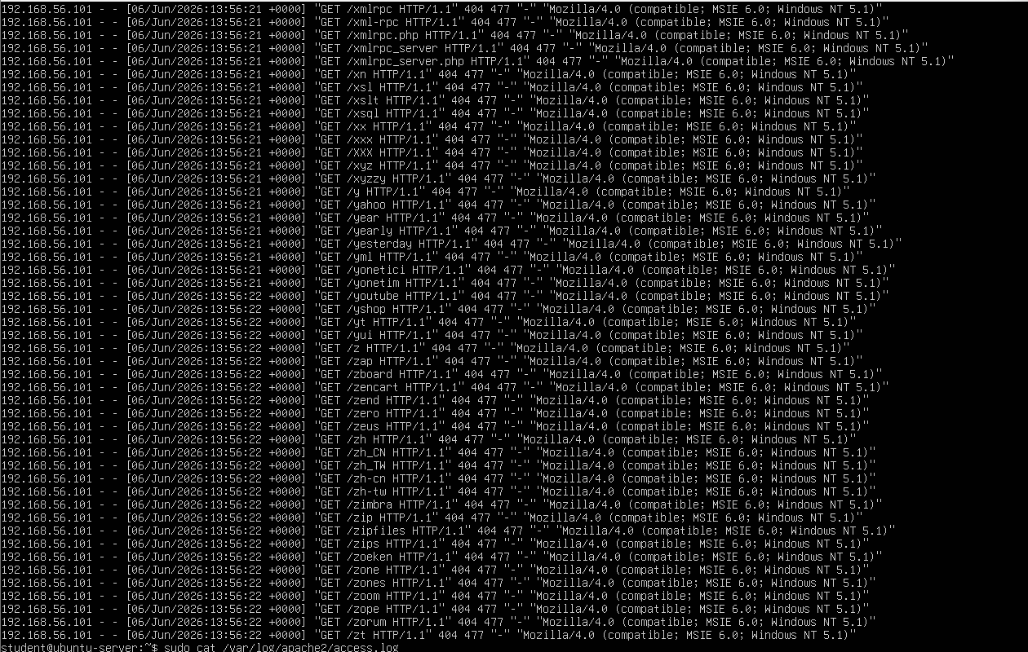Figure 15: Apache access logs showing enumeration activity from the Kali attacker IP address.
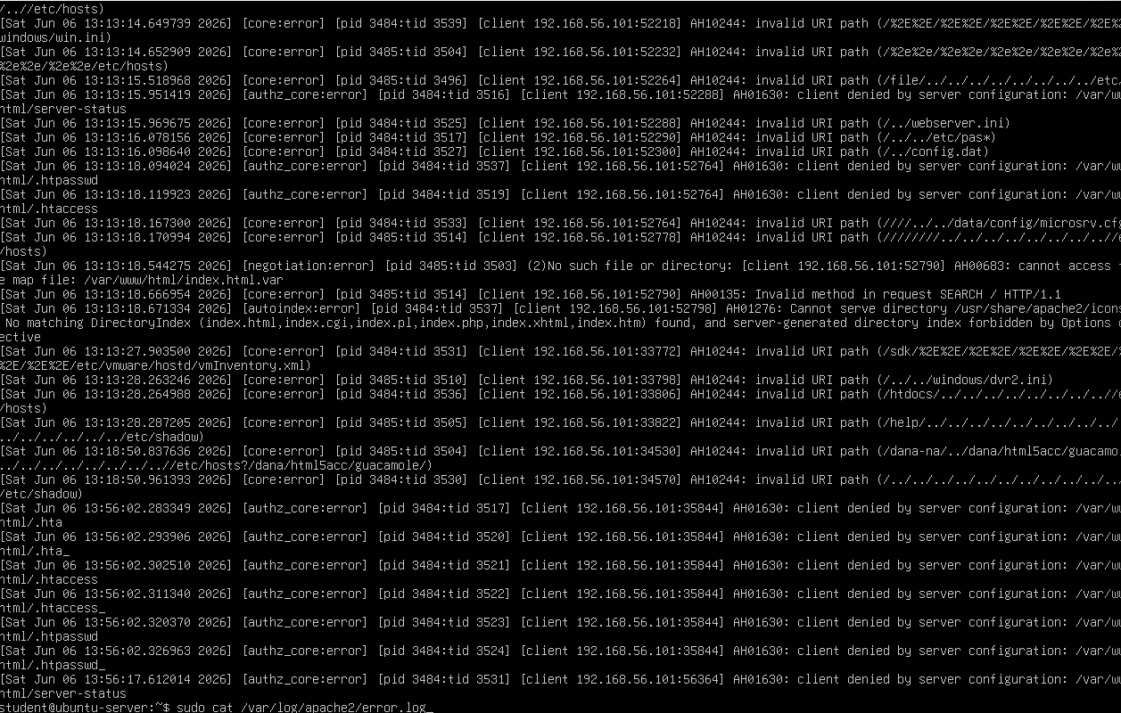
Figure 16: Apache error logs showing invalid URI paths, blocked requests, and attempted access to sensitive paths.

Impact
Information disclosure increases the likelihood of successful follow-on attacks by revealing version and configuration details.

Mitigation and Re-Test
Apache hardening was successfully implemented and validated. Configuration changes included ServerTokens Prod, ServerSignature Off, and TraceEnable Off, with custom security headers enabled via the headers module (Figures 17–21).
Before/After comparison:
Control | Before | After
Server header | Apache/2.4.66 (Ubuntu) | Apache
X-Content-Type-Options | Missing | nosniff
Referrer-Policy | Missing | strict-origin-when-cross-origin
X-Frame-Options | Missing | SAMEORIGIN
Content-Security-Policy | Missing | default-src 'self';
Permissions-Policy | Missing | geolocation=(), microphone=(), camera=()
Post-hardening curl verification and Nikto reassessment confirmed reduced server disclosure and improved header posture (Figures 22–23).
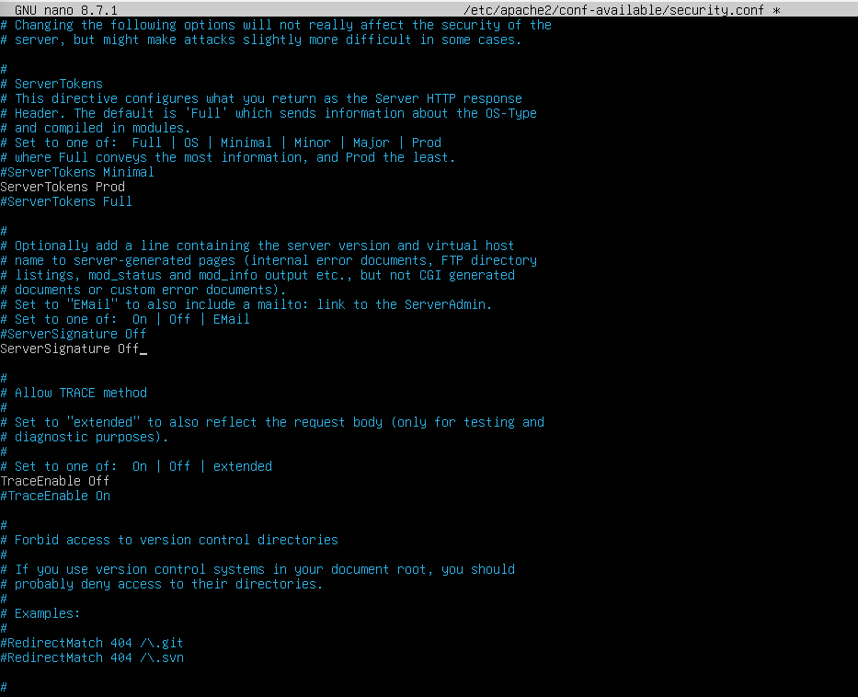
Figure 17: Apache security configuration updated with ServerTokens Prod, ServerSignature Off, and TraceEnable Off.
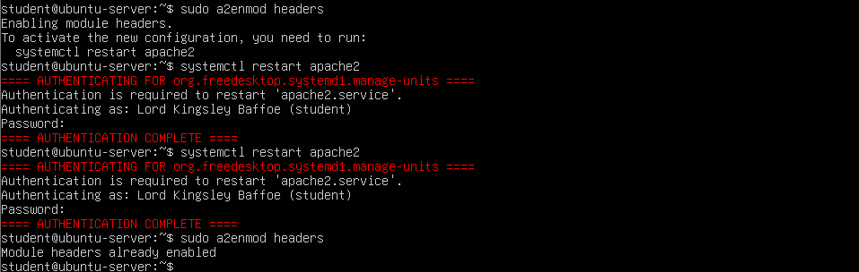
Figure 18: Apache headers module enabled to support HTTP security header configuration.
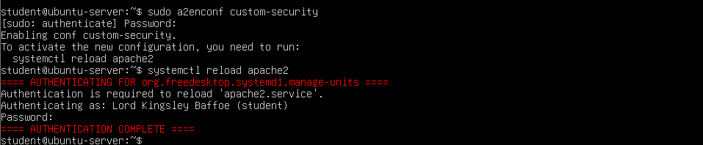
Figure 19: Custom Apache security headers configuration enabled.
Figure 20: Apache configuration test confirming Syntax OK after hardening changes.
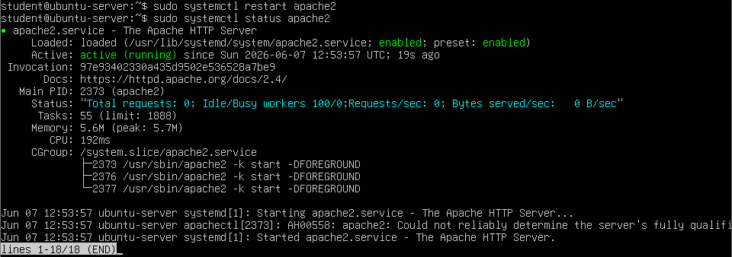Figure 21: Apache restarted successfully after security hardening changes.
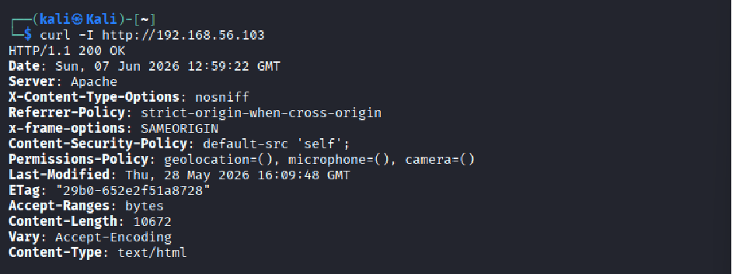Figure 22: Curl verification showing reduced server disclosure and newly applied HTTP security headers.
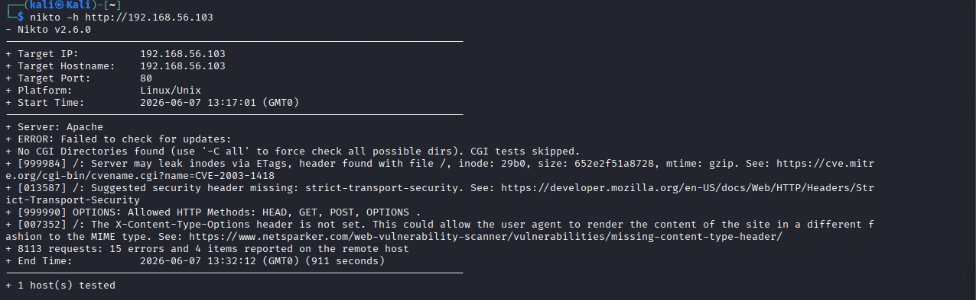
Figure 23: Nikto reassessment after Apache hardening showing reduced findings and reduced server information disclosure.

Critical Evaluation and Residual Risk
Default Apache settings materially assisted reconnaissance. Hardening reduced disclosure without disrupting legitimate HTTP access. Continued log monitoring and periodic scanning are recommended to detect new misconfigurations.

8. Logging, Detection and Impact Analysis
SSH journal logs and Apache access and error logs adequately recorded attacker activity from 192.168.56.101, including failed and successful authentication and web enumeration. The journalctl output in Figure 11 demonstrates that authentication events are attributable to source IP and username, supporting incident investigation. Apache logs similarly captured high-volume Dirb requests and blocked attempts to access sensitive paths.
However, the environment lacked centralised log aggregation, automated alerting, and intrusion detection beyond Fail2Ban. In a production context, integration with a SIEM platform would improve detection timeliness. Weak SSH authentication posed the highest impact due to direct shell access; Apache disclosure posed moderate reconnaissance risk that could amplify other vulnerabilities.

9. Reflection on Ethical and Legal Practice
All testing remained within the authorised isolated VirtualBox host-only lab. No external or production systems were targeted, and no actions were taken outside the defined scope. The assessment demonstrates that penetration testing must be scope-bound, transparent, documented, and accompanied by timely remediation guidance. Professional conduct requires explicit authorisation and proportionate testing techniques that avoid unnecessary harm to systems under assessment.

10. Conclusion
Two lab weaknesses were identified, remediated, and re-tested with sequential evidence from Fig00 to Fig30. Hydra demonstrated that weak SSH credentials are trivially exploitable on a local network, while Nikto and curl showed that default Apache configurations leak actionable intelligence to attackers.
Mitigations including strong password enforcement, Fail2Ban, and Apache hardening were effective and validated through re-testing. The engagement confirms that secure baseline configurations and proactive log review are essential even in small lab environments, and that remediation must be verified rather than assumed.

11. References
Apache Software Foundation (2025) Apache HTTP Server Documentation. Available at: https://httpd.apache.org/docs/2.4/ (Accessed: 7 June 2026).
NIST (2008) NIST SP 800-115: Technical Guide to Information Security Testing and Assessment. Gaithersburg, MD: NIST.
OWASP Foundation (2023) OWASP Testing Guide. Available at: https://owasp.org/www-project-test/ (Accessed: 7 June 2026).
Fail2Ban (2025) Fail2Ban Manual. Available at: https://www.fail2ban.org/wiki/index.php/Main_Page (Accessed: 7 June 2026).
Ruden, J. (2025) Hydra: A Network Logon Cracker. Available at: https://github.com/vanhauser-thc/thc-hydra (Accessed: 7 June 2026).
Sekar, R. (2024) Nikto Web Server Scanner. Available at: https://cirt.net/Nikto2 (Accessed: 7 June 2026).

