**2 – р гэрийн даалгавар/**Гүйцэтгэсэн оюутан: Э.Багабанди 19B1NUM0700**/**

1. GroceColl буюу дэлгүүрийн сагс сэдвийг C4 моделийн 3 түвшинт зургийг зурж явуулах.

@startuml C4_CroceColl

title CroceColl Context

!include https://raw.githubusercontent.com/plantuml-stdlib/C4-PlantUML/master/C4_Context.puml

Person(personAlias, "customer", "person who uses CroceColl")

System(systemAlias, "CroceColl")

Rel(personAlias, systemAlias, "uses", "https")

@enduml

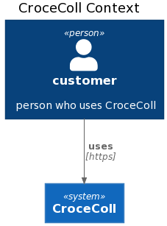**C1: Context diagram**

**C2: Container diagram**

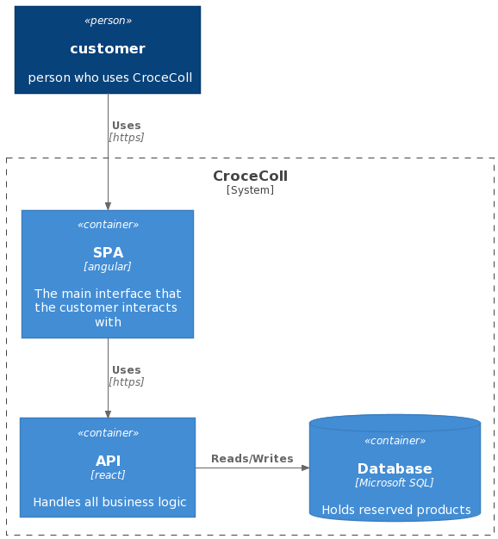

@startuml C4_CroceColl

!include https://raw.githubusercontent.com/plantuml-stdlib/C4-PlantUML/master/C4_Container.puml

Person(personAlias, "customer", "person who uses CroceColl", $sprite="personAlias")

System_Boundary(CroceColl, "CroceColl"){

Container(spa, "SPA", "angular", "The main interface that the customer interacts with", $sprite="angular")

Container(api, "API", "react", "Handles all business logic", $sprite="react")

ContainerDb(db, "Database", "Microsoft SQL", "Holds reserved products", $sprite="msql_server")

Rel(personAlias, spa, "Uses", "https")

Rel(spa, api, "Uses", "https")

Rel_R(api, db, "Reads/Writes")

}

@enduml

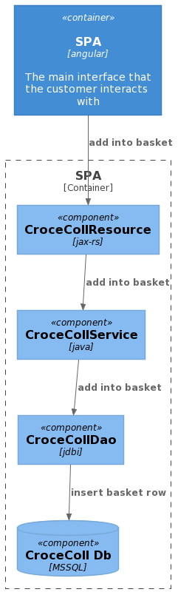**C3: Component diagram /01/**

@startuml C4_CroceColl

!include https://raw.githubusercontent.com/plantuml-stdlib/C4-PlantUML/master/C4_Component.puml

Container(spa, "SPA", "angular", "The main interface that the customer interacts with", $sprite="angular")

Container_Boundary(SPA, "SPA"){

Component(croceCollResource, "CroceCollResource", "jax-rs")

Rel(spa, croceCollResource, "add into basket")

Component(croceCollService, "CroceCollService", "java")

Rel(croceCollResource, croceCollService, "add into basket")

Component(croceCollDao, "CroceCollDao", "jdbi")

Rel(croceCollService, croceCollDao, "add into basket"

ComponentDb(croceCollDb, "CroceColl Db", "MSSQL")

Rel(croceCollDao, croceCollDb, "insert basket row")

}

@enduml

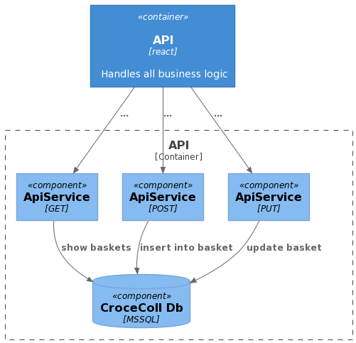**C3: Component diagram /02/**

@startuml C4_CroceColl

!include https://raw.githubusercontent.com/plantuml-stdlib/C4-PlantUML/master/C4_Component.puml

Container(api, "API", "react", "Handles all business logic", $sprite="react")

Container_Boundary(API, "API"){

Component(get, "ApiService", "GET")

Rel(api, get, "...")

Component(post, "ApiService", "POST")

Rel(api, post, "...")

Component(put, "ApiService", "PUT")

Rel(api, put, "...")

ComponentDb(croceCollDb, "CroceColl Db", "MSSQL")

Rel(get, croceCollDb, "show baskets")

Rel(put, croceCollDb, "update basket")

Rel(post, croceCollDb, "insert into basket")

}

@enduml