(Synthetic Two-Seal Title Page Fixture)
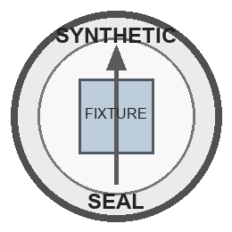

SYNTHETIC DOCUMENT HEADER
Generic County Name
Centered
Title Box
The People of the Synthetic State
To Any Authorized Reviewer

