Create User

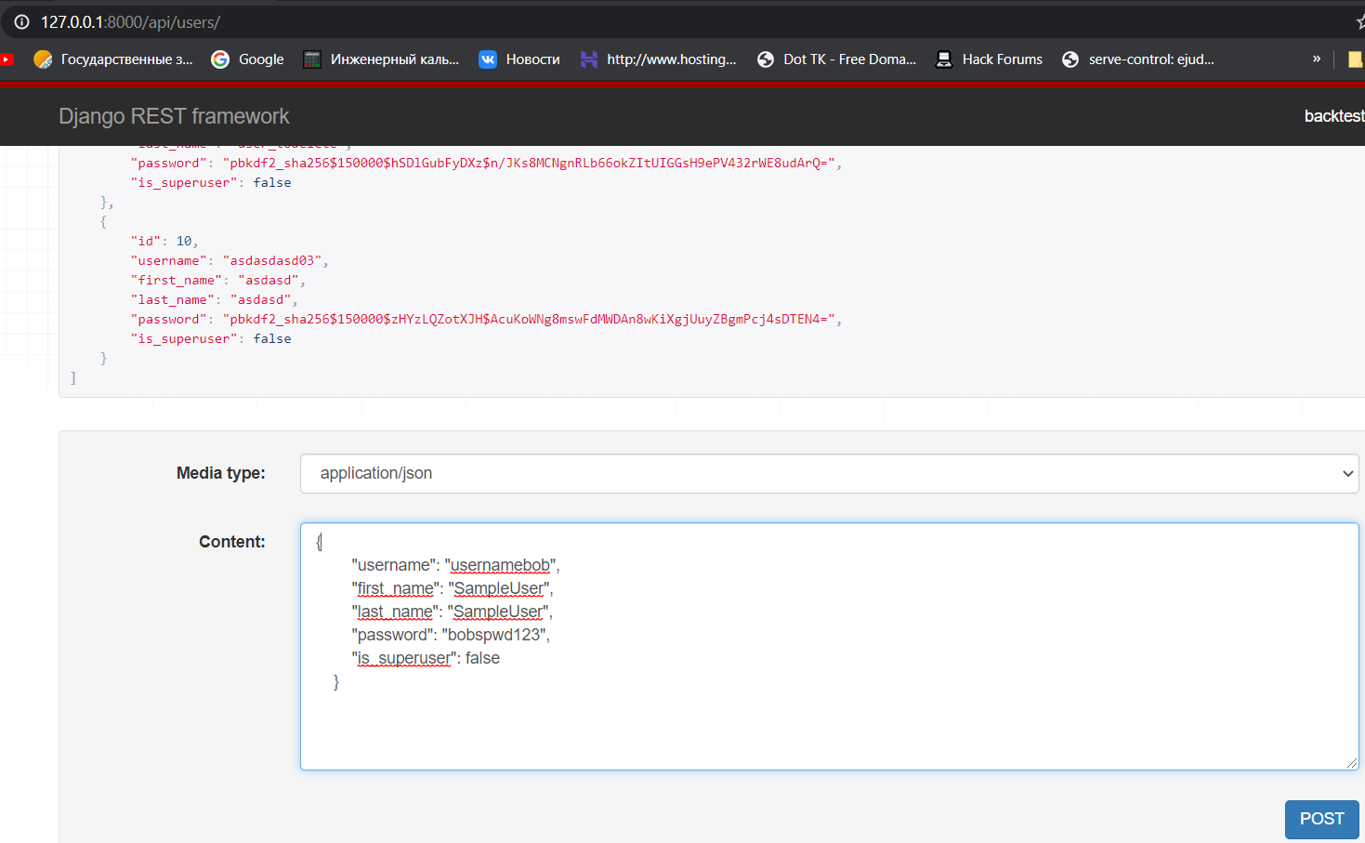

Response

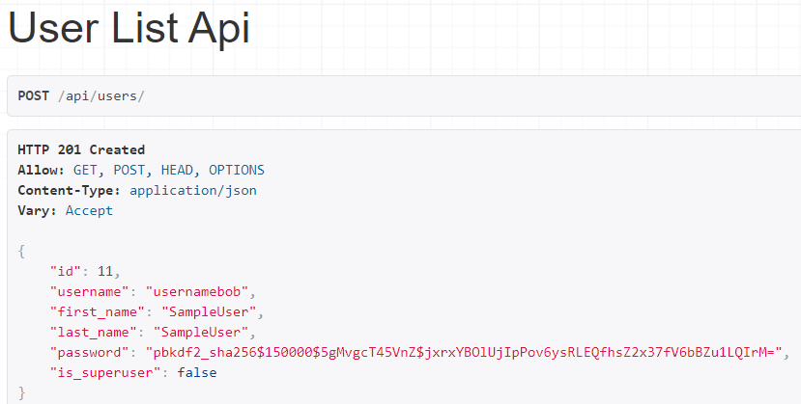

Access to personal records with login and password

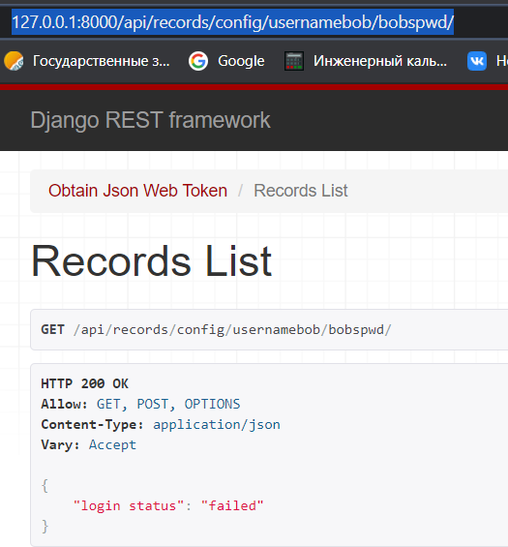

Failed, wrong password

Adding record from admin to some user

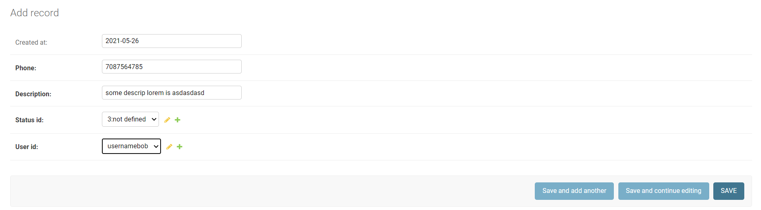

<http://127.0.0.1:8000/admin/api/record/add/>

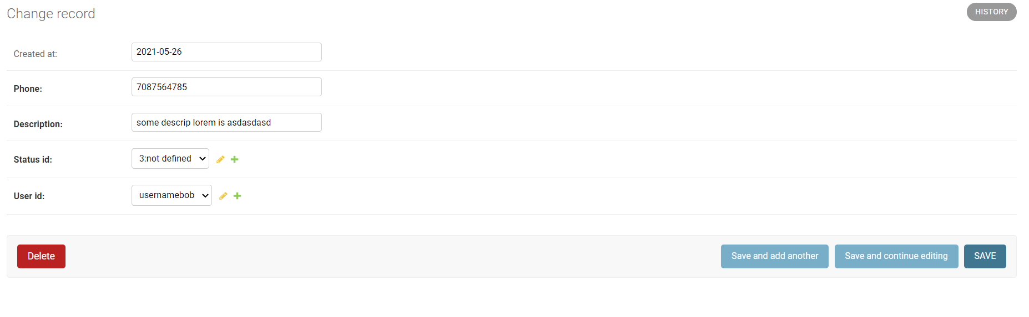

Client side adding:

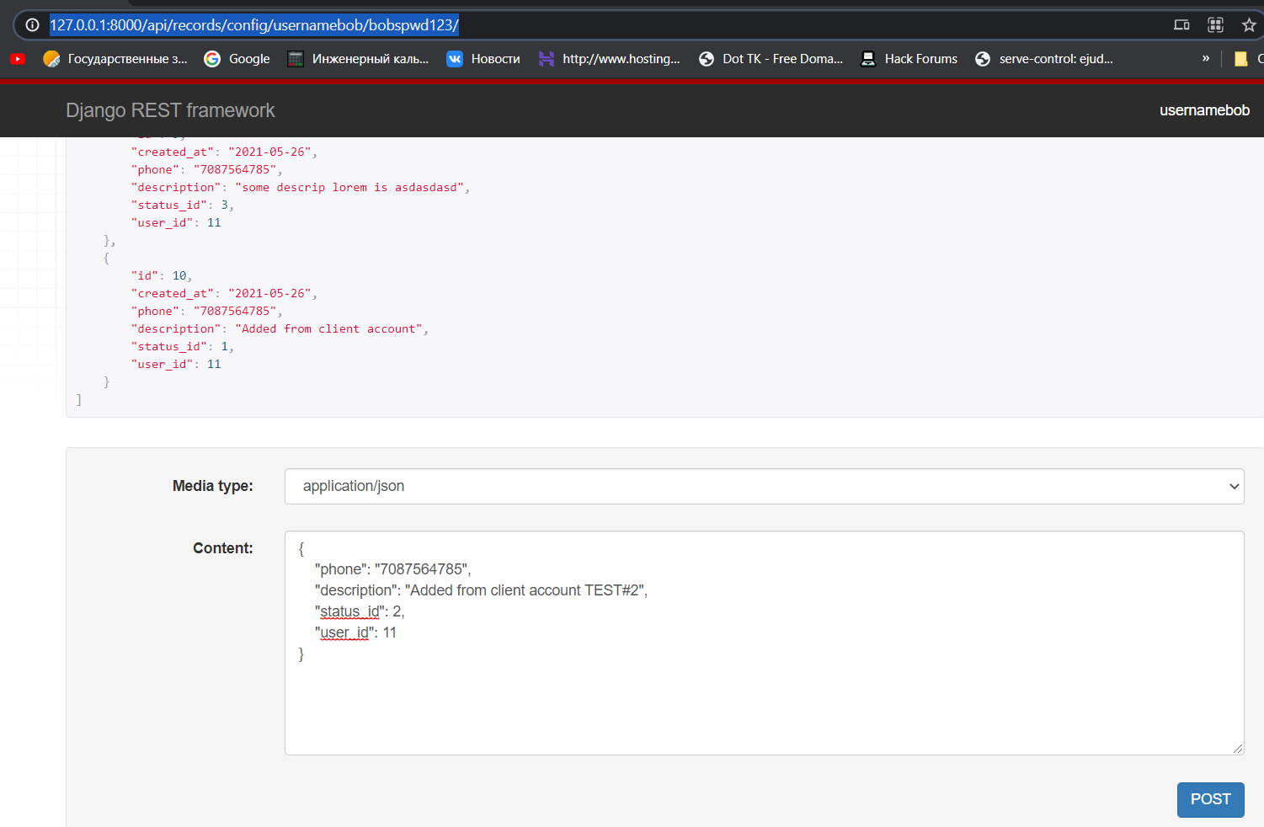

Records of logged client

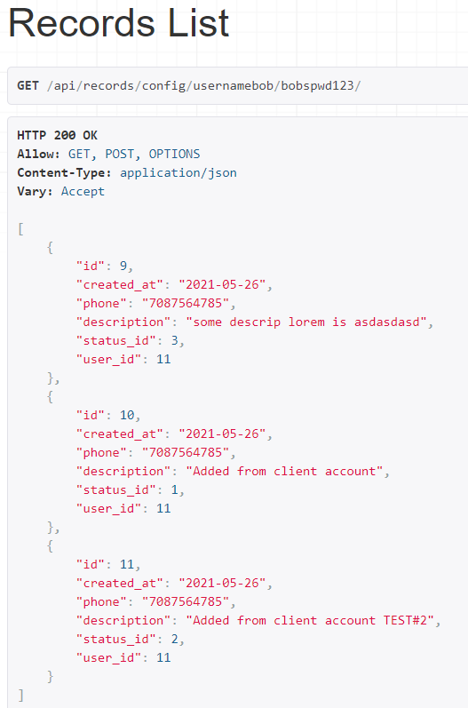

GET record by id from user records

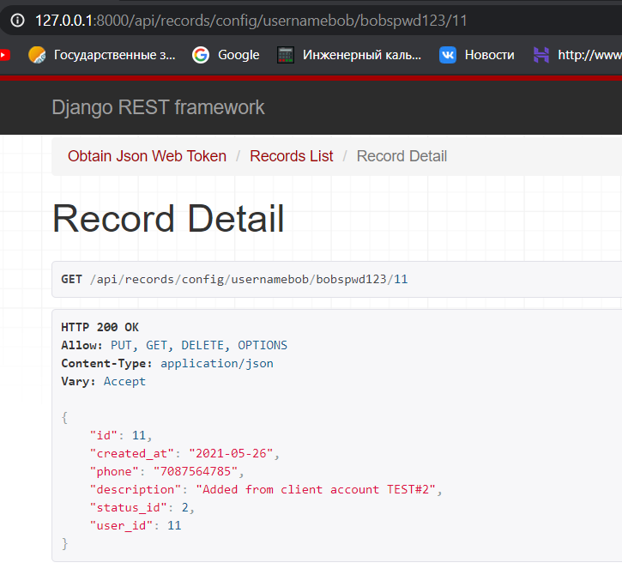

Cant access other users records by id

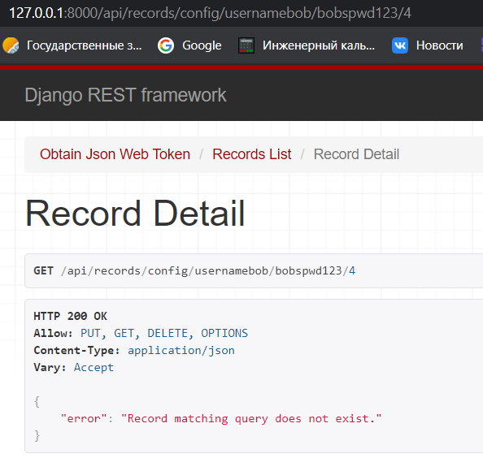

Changing record

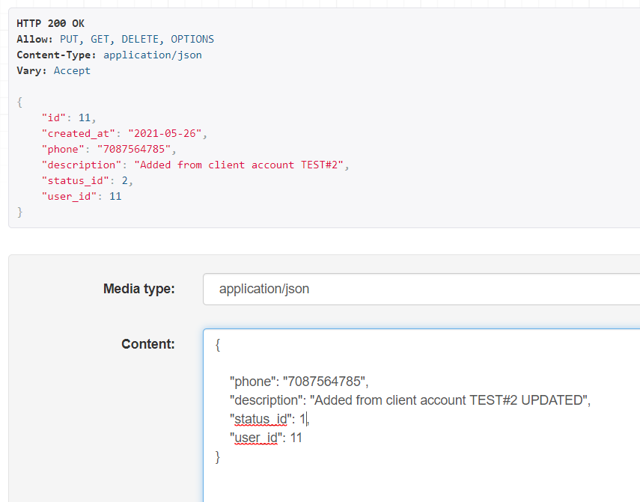

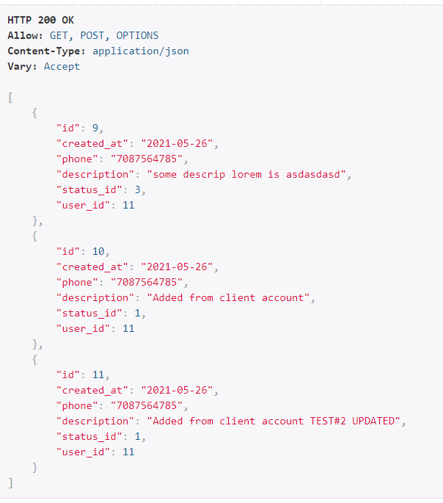

EXPORTING Records of logged user

<http://127.0.0.1:8000/api/records/export/usernamebob/bobspwd123/>

user.id + user.name .csv



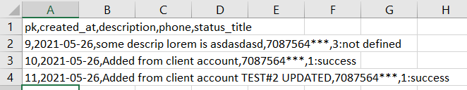

ANOTHER ACCOUNT RECORDS

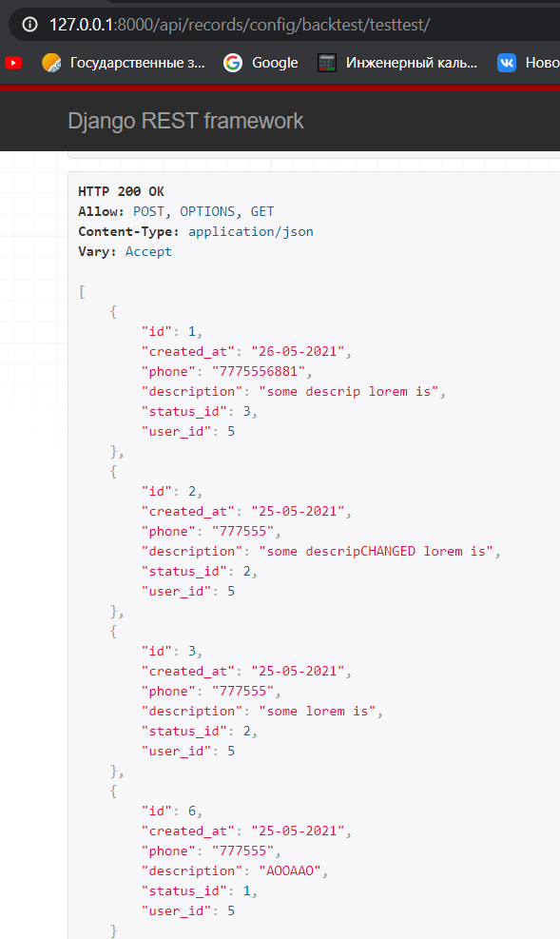

<http://127.0.0.1:8000/api/records/export/backtest/testtest/>

Export



