Entry point, UI and service layer
Main builds every object and connects them, then starts either the command-line interface (CliApp) or the Swing window (GuiApp). Both talk only to LogController, which hands the work to LogViewerService (analysis) and ReportService (reports). AnalysisResult is the record returned from an analysis.

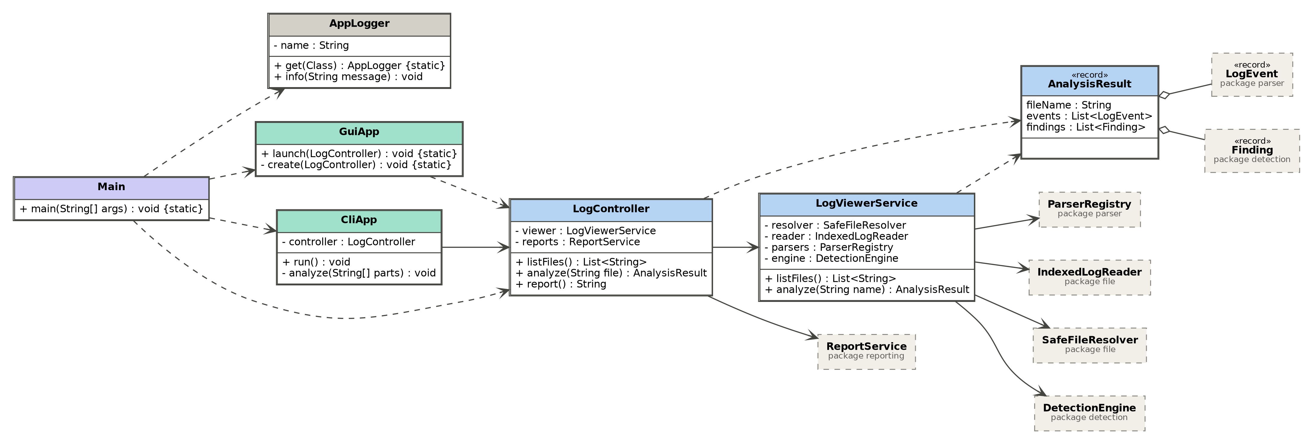 File access and line index
SafeFileResolver turns a user-supplied file name into a real path inside the logs folder and blocks path traversal. IndexedLogReader reads the file into numbered IndexedLine records and caches them through the IndexRepository interface, implemented in memory by MemoryIndexRepository.

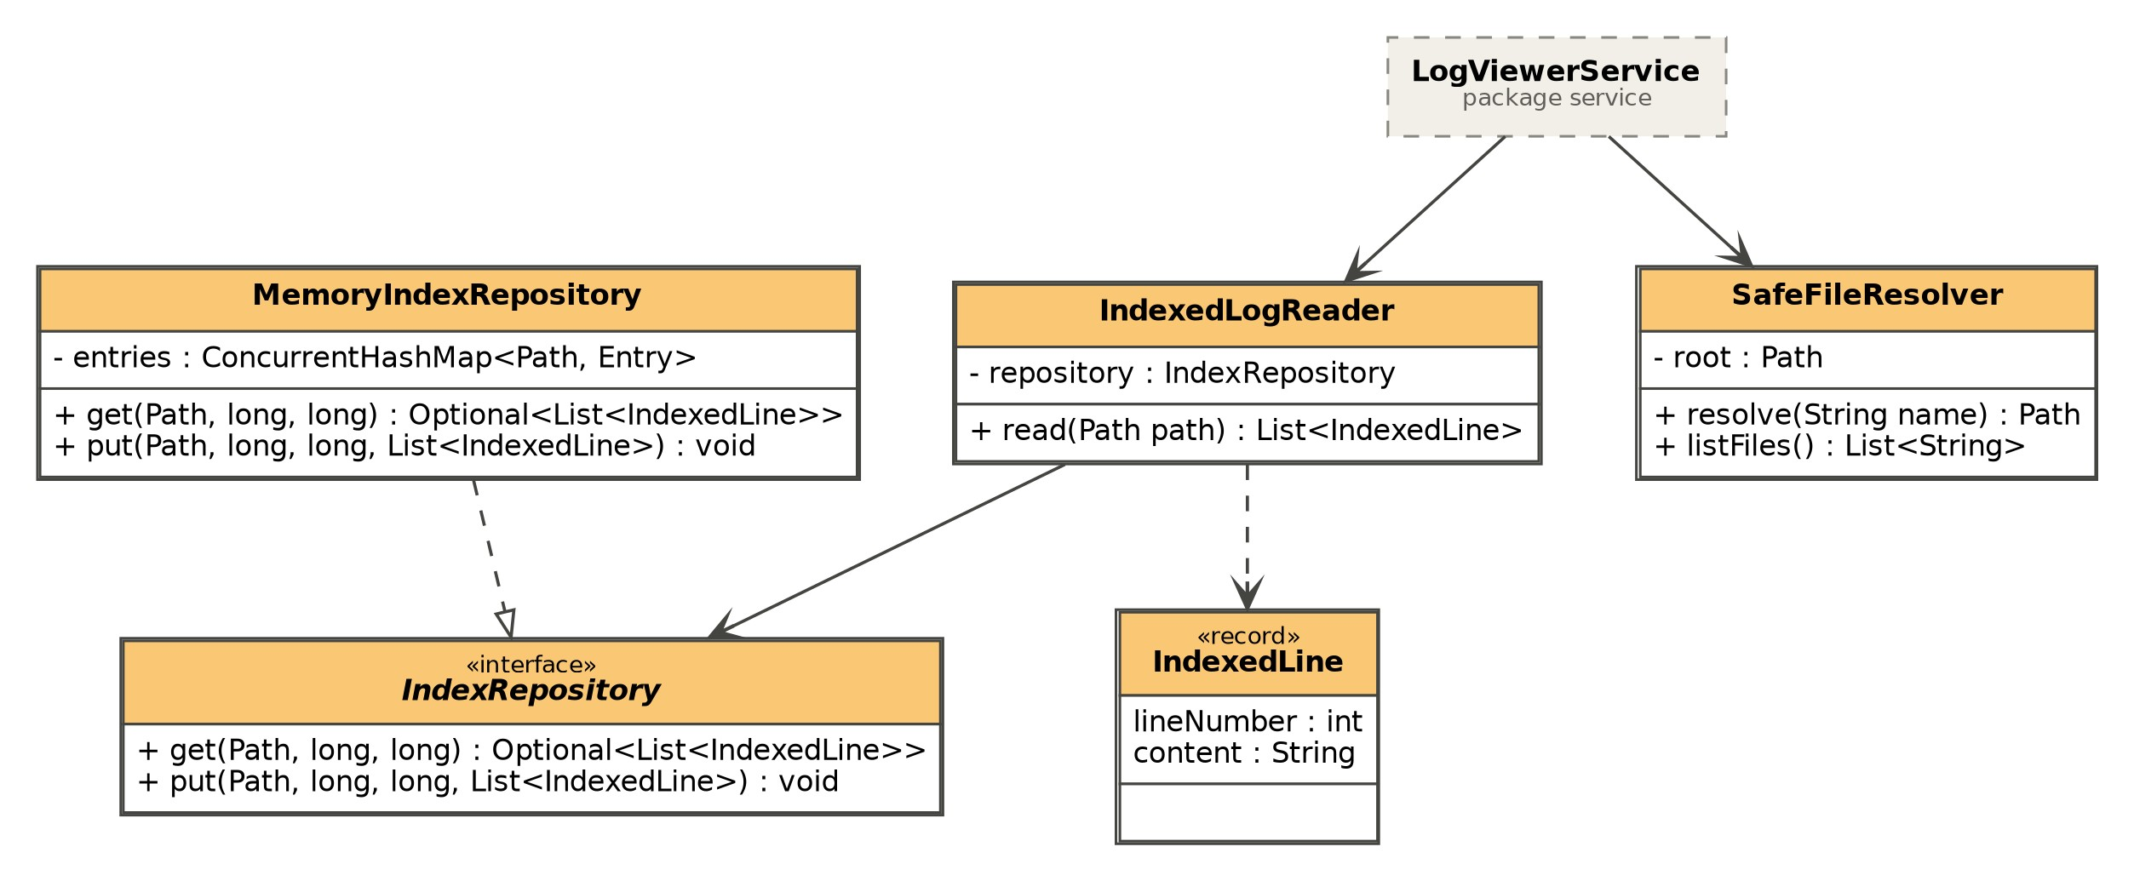 Parsing log lines
ParserRegistry holds the registered LogParser implementations and tries them in order for every line. The first parser that can read the line produces a LogEvent. PlainTextParser accepts any line and is used as the fallback. A package-private helper, ParserSupport, handles timestamp and level normalisation for all parsers and is not shown.

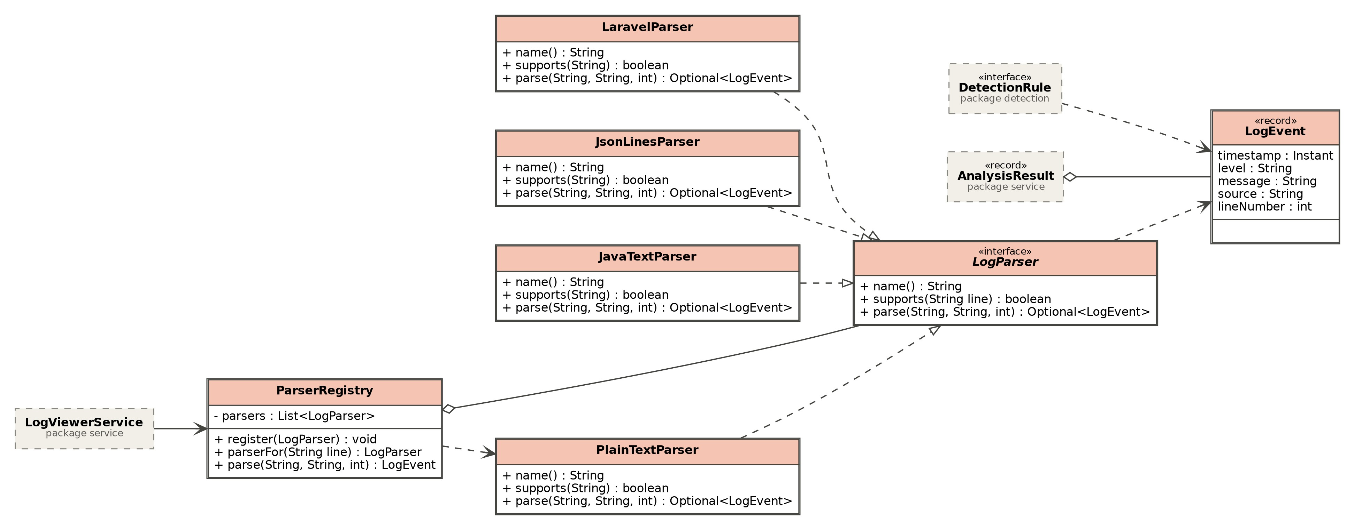 Detection
DetectionEngine runs every registered DetectionRule against the parsed LogEvents, saves each Finding to the repository and returns them.
RepeatedLoginFailureRule is the one rule currently implemented. For each source IP it checks failed logins against a sliding time window and raises a finding whose severity rises with the number of failures: LOW for the first failed login, MEDIUM for a second within five minutes, and HIGH once the threshold of five failures within five minutes is reached.


