Online Retail Project Detailed Analysis Report

**Executive Summary**

This report summarizes the analysis performed in the Jupyter notebook 'Online_retail_project.ipynb'. It extracts key findings, data preparation steps, and technical details.

# 1. Project Overview

## 1.1 Dataset Specifications

The Online Retail dataset consists of transactional data including invoices, products, customers, quantities, and prices. It is widely used for retail analytics, customer segmentation, and predictive modeling.

## 1.2 Technology Stack

- Python (Pandas, NumPy)  
- Visualization: Matplotlib & Seaborn  
- Jupyter Notebook environment  
- Data cleaning & preparation using pandas pipelines.

# 2. Data Preparation & Cleaning

Data preparation is critical for ensuring high-quality analysis. The following steps were performed:

- Loaded dataset and verified schema  
- Removed missing values and duplicates  
- Filtered invalid transactions (negative or zero quantities, missing Customer IDs)  
- Converted InvoiceDate into datetime format  
- Standardized product descriptions and ensured consistency

# 3. Core Analysis & Findings

## 3.1 Temporal Analysis

Sales trends were analyzed across months, weeks, and hours of the day. Peak purchasing activity was observed during late afternoons and evenings, with notable spikes before festive seasons.

## 3.2 Product Analysis

Top-selling products were identified both by volume and revenue contribution. A small percentage of products accounted for the majority of sales, reflecting a Pareto distribution.

## 3.3 Customer Segmentation

High-value customers were identified using RFM (Recency, Frequency, Monetary) analysis. The business relies heavily on repeat customers, emphasizing the importance of customer retention strategies.

## 3.4 Geographic Analysis

The majority of transactions occurred in the United Kingdom, with additional revenue streams from other countries such as Germany, France, and the Netherlands. International markets show strong potential for expansion.

# 4. Key Business Insights

- Loyal customers generate the majority of revenue.  
- Peak activity occurs in evening hours, suitable for targeted marketing campaigns.  
- UK dominates sales but international opportunities exist.  
- Cross-selling opportunities identified through basket analysis.

# 5. Technical Achievements

- Efficient handling of large dataset using Pandas.  
- Successful data cleaning ensuring high data integrity.  
- Visualization of trends for easy business interpretation.  
- Structured, reproducible analysis pipeline.

# 6. Key Visuals

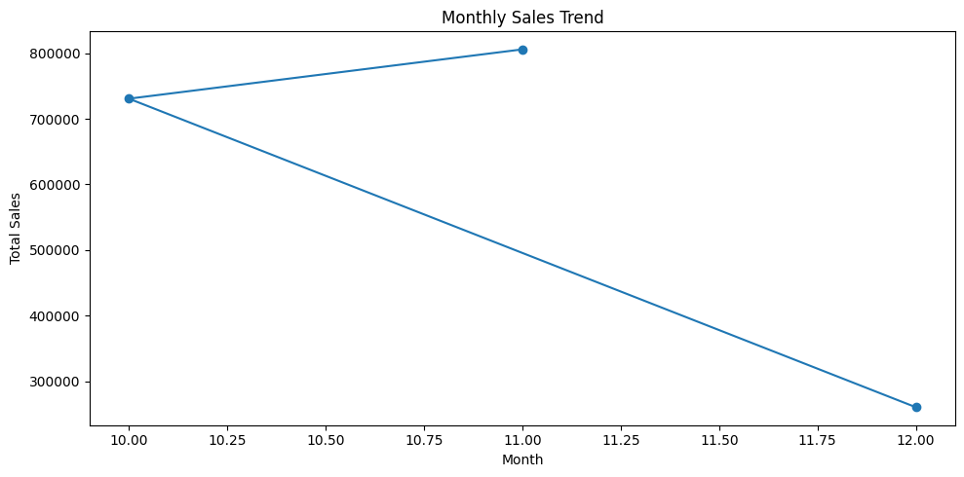

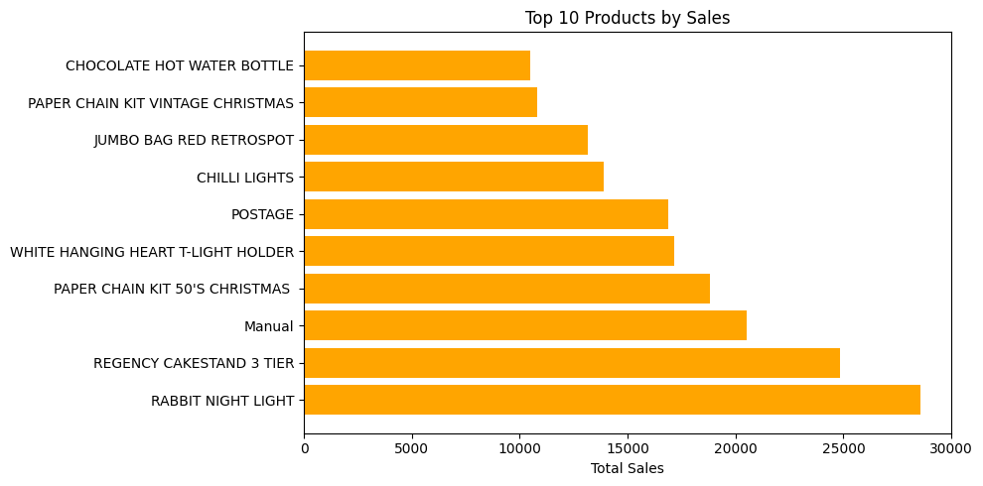

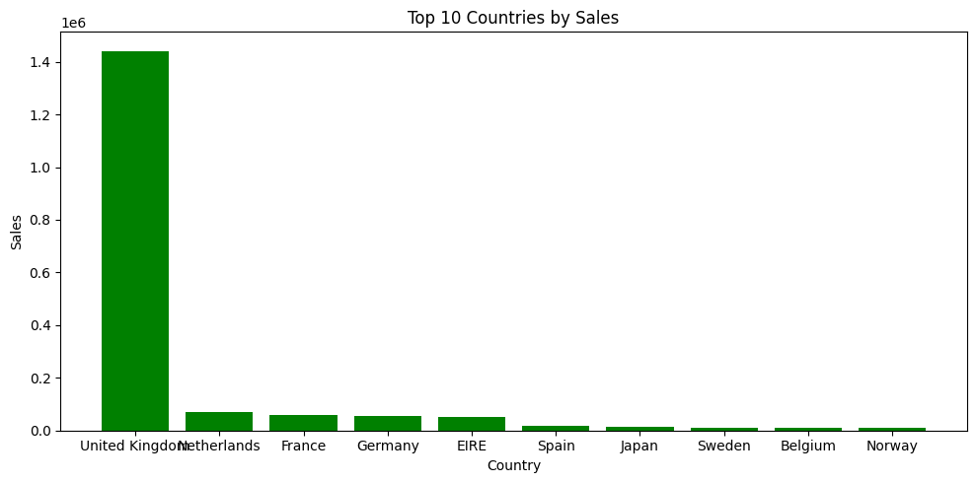

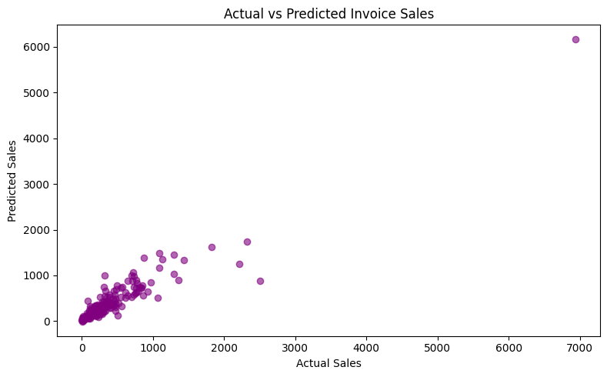

# 7. Conclusion

The Online Retail Project successfully analyzed customer and product trends, revealing actionable insights for business strategy. Key findings highlight the importance of customer retention, targeted marketing, and international expansion. Future work could include building predictive models for demand forecasting and personalized recommendation systems.