Project Report

|  |  |
| --- | --- |
| Product Name | Advanced Certificate in Web Development |
| Qualification Name (NICF) | ITSF - Advanced Certificate in Information Technology (Application Development) |
| Product Name | Front End Web Development |
| Module Name (NICF) | ITSF - Front End Web Development |

|  |  |  |  |
| --- | --- | --- | --- |
| Student name | | Assessor name | |
| I Putu Bagus Nanda Widnyana | |  | |
| Date issued | Completion date | | Submitted on |
| May, 09 2022 | May, 10 2022 | | May, 10 2022 |
|  | |  | |
| Project title | Development of website for a Training Organization | | |

|  |
| --- |
| Learner declaration |
| I certify that the work submitted for this assignment is my own and research sources are fully acknowledged.  Student signature: Date: |

Content

1. Project background
2. Project Objectives
3. Requirement Specifications
4. Task 1
5. Task 2
6. Task 3
7. Task 4
8. Task 5
9. Task 6
10. Task 7

Project Background

Summative Assessment of students in the Module ‘Front End Web Development’ of the ITSF Course ‘ITSF - Advanced Certificate in Information Technology (Application Development).

Scenario: I have been approached by ‘ABC Learning Center’ as a website developer to develop a website for their institute. ‘ABC Learning Center’ is an IT Training institute that conducts courses like ‘Programming in Java’, ‘Programming in .Net’, ‘Microsoft Office’, ‘HTML’ etc. They want to design a website which can be used for providing information about them courses to students and for capturing leads generated by digital marketing.

The website that I have developed needs to be tested by you and final sign-off should be taken from ‘ABC Learning Center’ (Assessor) before hosting it on their web server. I will also provide supporting technical and user documentation for this website

Project Objective

In this assignment, i have to plan, design, develop and implement a website for a training organization. This assignment gives an opportunity to demonstrate my capabilities in the following areas:

* Plan a Website & Develop branding, wireframes, information architecture & storyboard.
* Develop a website using HTML, CSS & JavaScript.
* Develop jQuery Menus & Tabs
* Designing a form using HTML, developing JavaScript to validate the form and submit the form using Ajax.
* Execute the test cases and validate the website meets the design requirements.

B Learning Center’s business goals:

* Increase the number of monthly qualified leads by 19%.
* Increase the website conversion rate by 3%.
* Improve new course awareness by 8%.

ABC Learning Center’s website goals:

* Easy to access and navigate to obtain latest information
* Accessible 24/7
* Website uptime of at least 99.8%
* Able to gather new leads with simple form

Tools & platform used

* Text editor

Visual Studio Code

* library

jQuery and jQuery UI

* Browser

Firefox

* Web server

Apache Tomcat

JDK (require for running tomcat

* Other

Draw.io

Word

Power point

Unsplash

Color palet

Requirement Specification

1. Common Content
   1. Header
   2. Footer
   3. Navigation
2. Home Page
3. About Us Page / Profile Page
4. Course Listing Page (Listing 2 Courses at least)
5. Course Details Page (Develop 2 pages, 1 for each course)
6. Course Schedule Page (Develop 2 pages, 1 for each course
7. Contact Us Page (Develop 1 Html page)
8. Lead Registration Page (Develop 1 form)
9. Registration Thank You Page (Develop 1 HTML page)
10. Sitemap Page (Develop 1 HTML page)
11. Privacy Policy Page (Develop 1 HTML page)
12. Admin
13. Task 1

Task Statement: Requirement specification document for website & administration

Solution:

* 1. Scope
* Display the content relevant to the course
* Lead Generation Form
* Administration
  1. Out of Scope
* User administration – user registration
* Backup site
* Responsive page for administration
  1. Functional Requirements

1. Common Content
   1. Header
   2. Footer
   3. Navigation
2. Home Page
3. About Us Page / Profile Page
4. Course Listing Page
   1. List course min 2 course
5. Course Details Page
   1. Html course detail
   2. CSS course detail
6. Course Schedule Page
   1. Course schedule html
   2. Course schedule CSS
7. Contact Us Page
8. Lead Registration Page
9. Registration Thank You Page
10. Sitemap Page
11. Privacy Policy Page
12. Lead Administration Page
13. Admin

* 1. Non-functional requirements
* Branding
* ABC Learning Center logo
* ABC Learning Center domain name as abc.com
* ABC Learning Center corporate color scheme
* Following browsers but not limited to are to be supported/
* Google Chrome
* Microsoft Edge
* Mozilla Firefox
* Safari
* Opera
  + - Website pages must load within 3 seconds
    - Website must be available 24/7 with 99% uptime.
    - All data store must be secured.
  1. Technical Requirements
     1. Software
* JDK1.8
* Tomcat 9
* VS Code
* HTML, CSS, JavaScript, jQuery
  + 1. Hardware
* Client – Windows 10
* Server – Window 10

1. Task 2

Task Statement: User Interface & Information flow.

Solution: Project presentation

1. Task 3

Task Statement: Developed HTML pages with screen capture.

Solution: Project presentation

1. Task 4

Task Statement: UI component development using jQuery with screen capture

Solution: project presentation

1. Task 5

Task Statement: Summary of effectiveness of lead generation foam based on 2 matric

Solution:

Time to Conversion

Tracking the time to conversion means measuring how long it takes for a visitor to become a verified lead. Knowing this information can give you useful insight into the length of your buyer’s journey and sales cycle. Examples could include tracking how long it takes for a visitor to verify their email address, download an app, or purchase an item that’s been in their online shopping cart.

Return on Investment

Many marketers would probably hail ROI as the most crucial metric of a marketing campaign. ROI is the value that answers the question, “Was this worth my investment?” Simply put, it measures the amount of return on an investment, relative to its cost. Measuring ROI is what helps justify your marketing budget and spend.

Source: marsdenmarketing.com

1. Task 6

Task Statement: Modify User Interface base on effectiveness

Solution: project presentation

1. Task 7

Task Statement: User guide for lead generation form and its administration

Solution:

##### Lead generation form

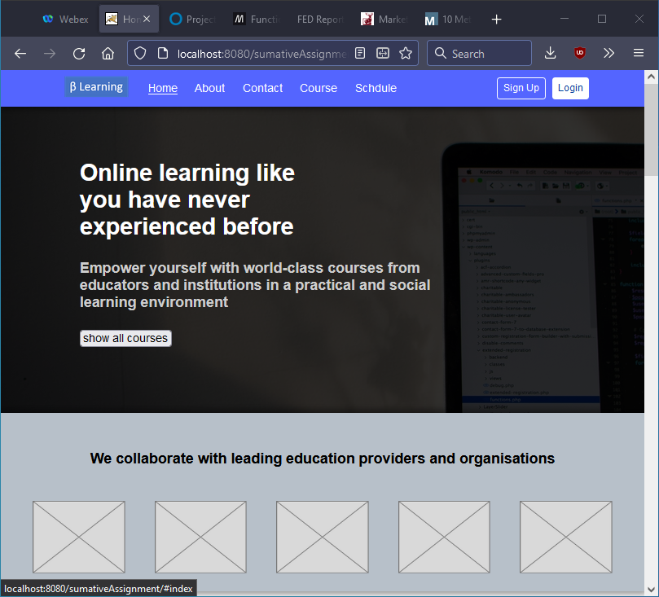

1.Click on signup or login

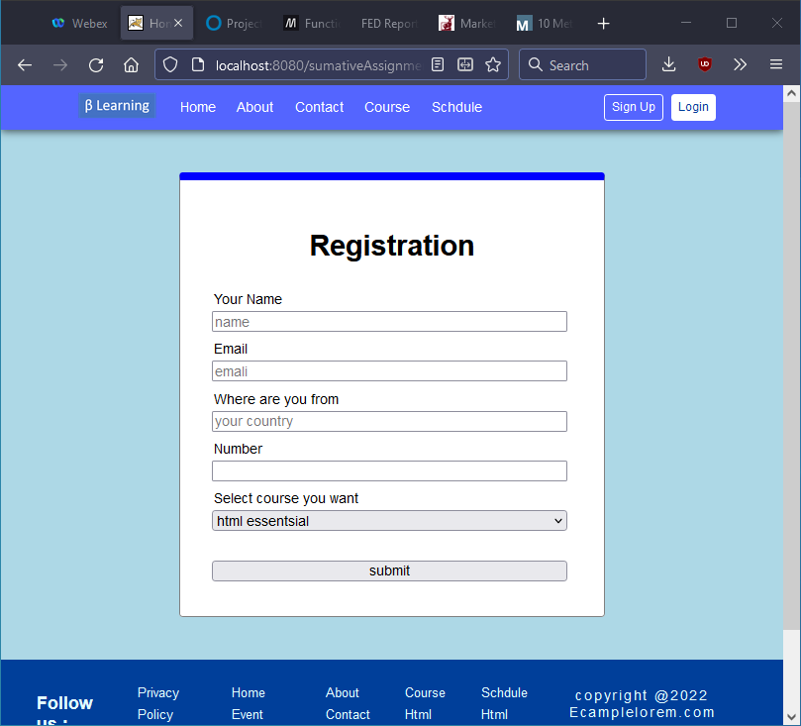

2.Fill the require form input

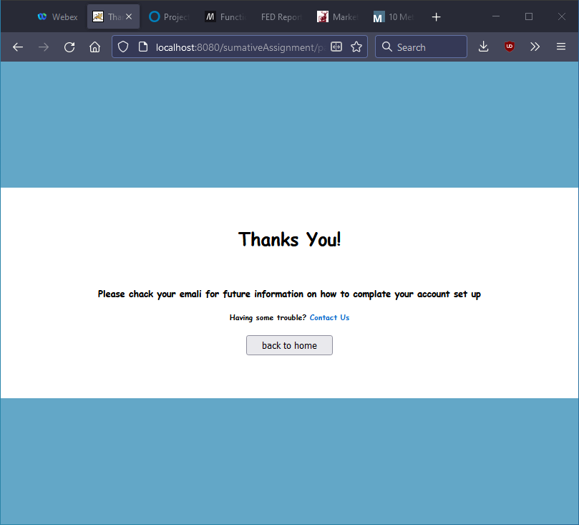

3.you will redirect to thanks page after finish fill the form, then click back to home to continue

##### Lead Administration



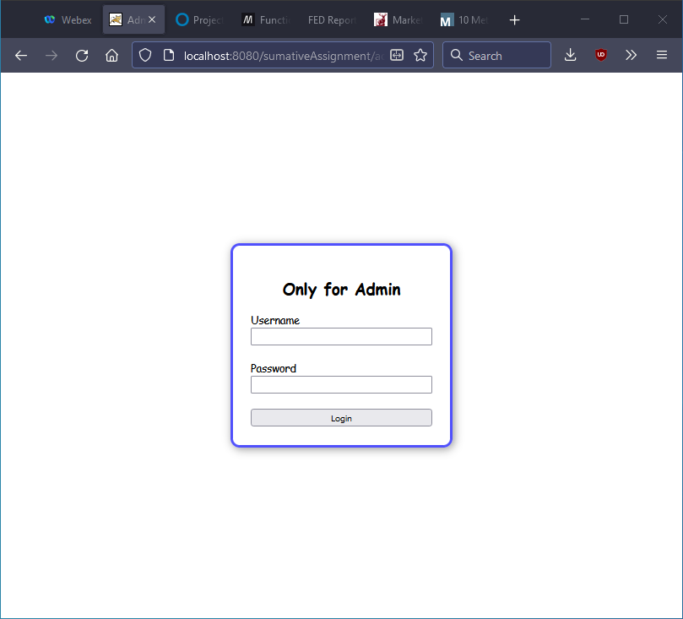

2.after that click enter and you will redirect to this login page, in this project the username is “bagus” and passwd is “nanda” (without quote)

1.type “admin” after the root document( quote not incude), for example in this project the root is sumativeAssignemnt

3. after that you will able to see this table,

**Important: the data that show it dependent to your local storage**

**Note: the edit button is not work and you can delete the user data by click delete button**

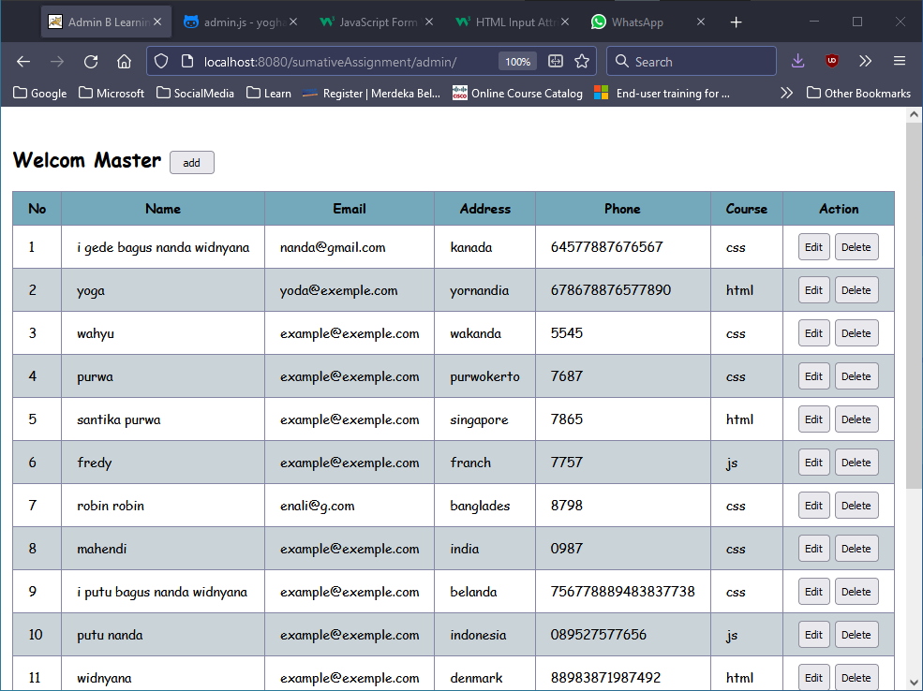

1.To add some data, you need to click on add button than the pop up will come

And here is delete button

Here is edit button

Here is add button

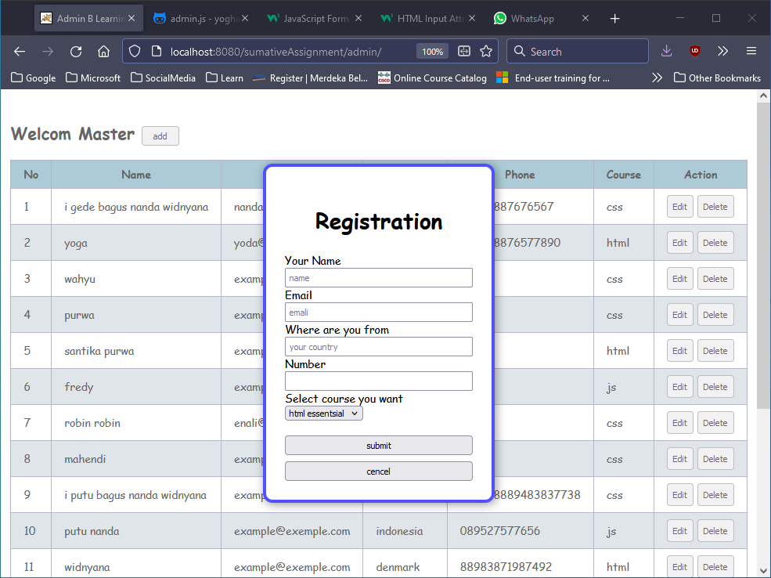

Just fill the form and click submit to save it

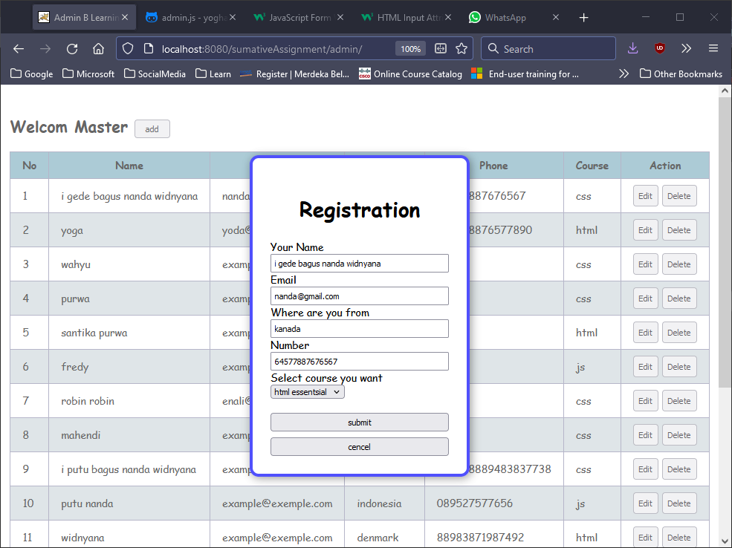

Click submit to update it

2.To edit some data, you need to click edit button on the row you want to edit than the pop up will come

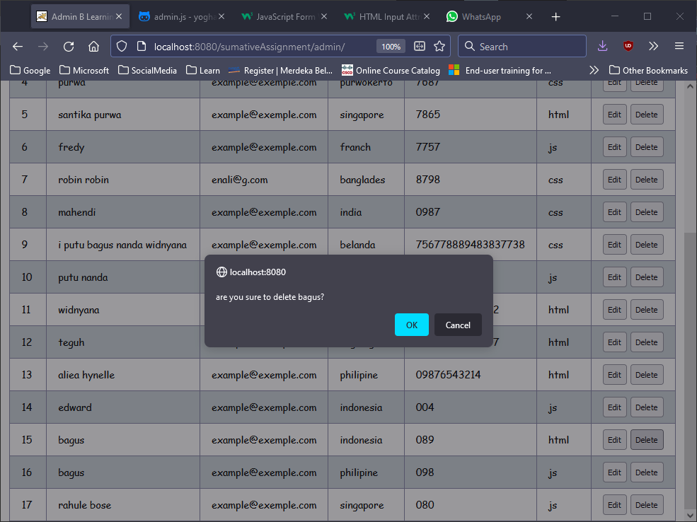

Click ok to remove it

3.To remove some data, you need to click delete button on the row you want to remove than the pop up will come with name of the data (the yellow border)