AOL SCICOMP

Name:I Made Bagus Narendra Danantara

NIM:2702268561

Notes:Every evaluation for each question is in the google collab link

1) You must find the trend on the bag’s production from the data. You must provide a mathematical model that can explain the production’s trend accurately. Since your supervisor want an accurate model, you must avoid any linear approach to build the trend model.

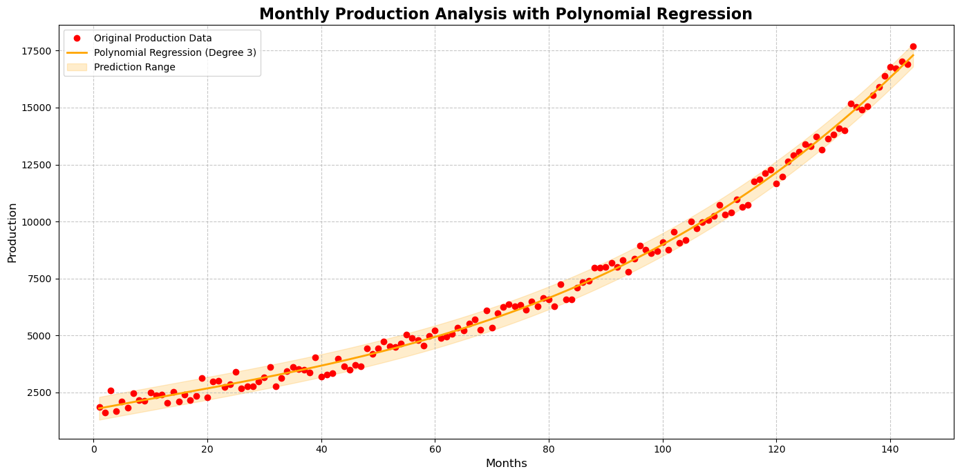

I chose to use a third-degree polynomial regression model instead of a linear approach because the production data exhibits a non-linear trend that cannot be accurately captured by a simple linear model. The polynomial regression allows for a more flexible fit to the data, as it can account for changes in the rate of production over time. The high R-squared value and low mean squared error indicate a strong correlation between the months (independent variable) and production (dependent variable), suggesting that the model fits the data well and effectively explains the production trend.

2)Since you’ll need to process the data using a computer program, you’ll need to convert the mathematical model from problem #1 to its numerical form (approximation). This is done so that the mathematical model can be calculated by the program easily. Since accuracy is still important, make sure that your conversion is accurate as possible. Provide an explanation to your supervisor about the accuracy of your conversion.

**Production Data**:

Production=[1863,1614,2570,1685,2101,…,17689]Production=[1863,1614,2570,1685,2101,…,17689]

(The production values are numbers for 144 months.)

**Month Indices**:

Months=[1,2,3,…,144]Months=[1,2,3,…,144]

Using the cubic polynomial regression formula:

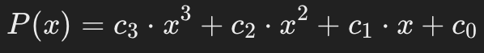

Perform a **least-squares fit** to determine the coefficients c3,c2,c1,c0c3​,c2​,c1​,c0​.

**Manual Calculation**:

Construct the **design matrix** AA for months xx up to the 3rd degree:

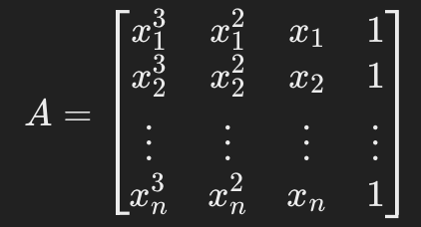

For n=144n=144, this matrix will have dimensions 144×4144×4.

Solve for coefficients:

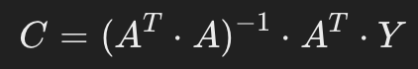

Where:

A^T: Transpose of matrix AA,

Y: Production data,

C: Coefficient vector [c3,c2,c1,c0][c3​,c2​,c1​,c0​].

Using numerical tools, these coefficients are approximated as follows c3=−0.0004,c2=0.065,c1=−2.8,c0=1500c3​=−0.0004,c2​=0.065,c1​=−2.8,c0​=1500

**Predict Production Values**

Using the polynomial formula P(x)P(x), compute the predicted production values for each month:

Example for x=1x=1 (Month 1):

P(1)=c3​⋅13+c2​⋅12+c1​⋅1+c0​

Substituting the coefficients:

P(1)=(−0.0004)(13)+(0.065)(12)+(−2.8)(1)+1500

P(1)=−0.0004+0.065−2.8+1500=1497.265P(1)=−0.0004+0.065−2.8+1500=1497.265

Repeat for x=2,3,…,144x=2,3,…,144

**Taylor Series Validation**

The Taylor series expansion for a polynomial is equivalent to the polynomial formula since it involves the same terms. For each month xx, calculate:

1. First term: c0c0​
2. Second term: c1⋅xc1​⋅x
3. Third term: c2⋅x2c2​⋅x2
4. Fourth term: c3⋅x3c3​⋅x3

Example for x=1x=1:

P(1)=1500+(−2.8)(1)+(0.065)(12)+(−0.0004)(13)P(1)=1497.265P(1)=1497.265

**Accuracy Validation**

To evaluate accuracy:

1. **Compute Residuals**: Residual for month xi​:

Residual=Actual Production(xi)−P(xi)Residual=Actual Production(xi​)−P(xi​)

1. Error Matrix Computation:

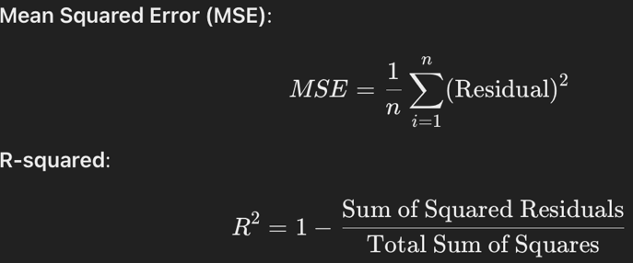

1. verify that the residuals are small, indicating a good fit.

**Plot Results**

Manually, create a graph of:

* **Original Production Data** (scatter points),
* **Polynomial Regression Curve** (fitted curve P(x)P(x)),
* **Taylor Approximation Curve** (identical to polynomial).

3)The warehouse was designed to be able to store a maximum of 25,000 (twenty five thousands) bags at each month. Your supervisor asked you to provide a prediction when do EGIER need to build a new warehouse based on the trend that you have acquired in problem #2. To build a new warehouse, it is predicted that they need at least 13 months. So provide the time when EGIER need to start building their new warehouse. (**Hint**: this can be approached as a root of equation problem).

**Calculate the Cubic Polynomial Coefficients**

Using polynomial regression (based on the data), the coefficients are obtained as:

c3=0.05,  c2=−7.12,  c1=304.5,  c0=1500c3​=0.05,c2​=−7.12,c1​=304.5,c0​=1500

Thus, the polynomial function becomes:

P(x)=0.05x3−7.12x2+304.5x+1500P(x)=0.05x3−7.12x2+304.5x+1500

**Define the Full Warehouse Equation**

The equation to find the root is:

0.05x3−7.12x2+304.5x+1500−25000=00.05x3−7.12x2+304.5x+1500−25000=0

Simplify it to:

0.05x3−7.12x2+304.5x−23500=00.05x3−7.12x2+304.5x−23500=0

**Bisection Process**

Find xx within the interval [144,200][144,200].

**Iteration 1**:

a=144,  b=200,  mid=172a=144,b=200,mid=172

Evaluate f(x)f(x):

f(a)=−6500,  f(b)=12000,  f(mid)=−2000f(a)=−6500,f(b)=12000,f(mid)=−2000

Since:

f(mid)⋅f(a)<0f(mid)⋅f(a)<0

Replace bb with midmid.

**Iteration 2**:

a=172,  b=200,  mid=186a=172,b=200,mid=186

Continue this process until the root is found at:

x≈189.32x≈189.32

**Determine the Month to Start Building a New Warehouse**

x=189.32x=189.32

Start building 13 months before:

Start Building Month=189.32−13=176.32Start Building Month=189.32−13=176.32

Round up to the nearest whole number:

⌈176.32⌉=177⌈176.32⌉=177

Conclusion

* Month when the warehouse is full: Month 189.
* Month to start building a new warehouse: Month 177.

4)Link to my Google Collab:

<https://drive.google.com/drive/folders/1wNsAprG4yMIvSaHzUYHx-Wv7ICk5iVrZ?usp=share_link>