|  |  |
| --- | --- |
|  | [support@magestore.com](mailto:support@magestore.com)  Phone: 084.4.8585.4587 |

**APP ANALYTICS**

**PLUGIN**

**USER GUIDE**

**Table of Contents**

**1. INTRODUCTION**

**2. HOW TO INSTALL**

**3. HOW TO SET UP YOUR GOOGLE ANALYTICS ACCOUNT**

**4. HOW TO CONFIGURE IN MAGENTO BACKEND**

**5. HOW TO GET REPORTS ON APP ANALYTICS**

# 1. INTRODUCTION

Getting an app is such an amazing way to attract more customers and convert more sales. It’s much better if you can know exactly how many customers are using your app, what devices they are using, what pages they view the most, or more importantly, transactions made via mobile app and so on. This significant information now can reach you easily thanks to Google Analytics. However it takes time to install tracking code to your app. How about letting **App Analytics** do this job for you? **App Analytics** plug-in will connect your app with Google Analytics; help you to have a deep insight into your app performance and user experience.

**List of Features:**

* Easy to install and use
* Support Android and iOS
* Connect directly with Google Analytics
* Detailed report on app screen views, users, download, clicks on banners, time on app, user devices, sales conversion…

This document will guide you through the installation and configuration process of App Analytics plug-in and your Google Analytics account.

# 2. HOW TO INSTALL

1. After purchasing plug-in, you will be directed to App management page. Go to **Install Connector** tab; download **App Analytics** connector, which is a zip file.
2. It is required to enable cache in the administration panel of your site. Go to System/Cache Management. Choose all caches and take action “Enable” then submit.
3. Use FTP client (such as Filezilla, WinSCP, cuteFtp) to upload or copy all folders in the zip package to your Magento site root folder. This will not overwrite any existing file; just add new files to the folder structure.
4. After uploading is done, log in to your Magento administration panel to refresh cache. Go to System/Cache Management. Select all caches and take action “Refresh” then submit.
5. Navigate to System/Configuration; if you can see the extension tab, it is installed properly.
6. Now if you get Access denied error when clicking on the extension tab, you need to log out admin panel and log in again.
7. Open the app and test your work.

# 3. HOW TO SET UP YOUR GOOGLE ANALYTICS ACCOUNT

This plug-in is quite different from others since it is only used for administrators (you) only, not for users. Moreover, it works mostly with Google Analytics, thus to make it work, it’s important to set up your Google Analytics account first.

1. **Sign up for an account.**

If you have a Google Analytics account, please visit the [Google Analytics website](http://www.google.com/analytics/) to sign in. Click the *Access Google Analytics* button and follow the on-screen instructions.

If you are new to Google Analytics, you need to click the *Create an account* to sign up for a new account here.

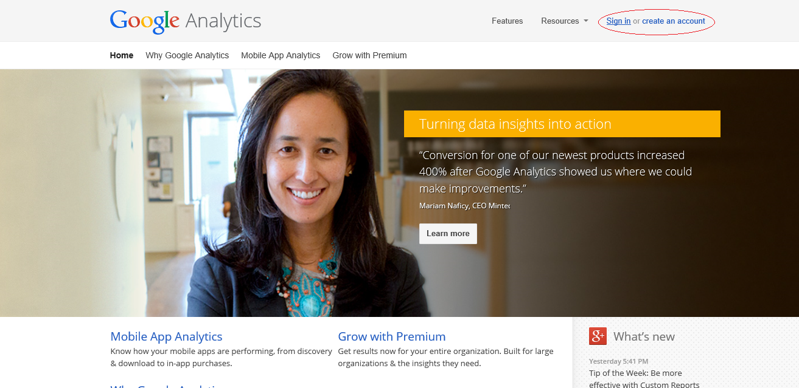

1. **Set up account properties.**

*If you are setting up a new Google Analytics account, start at step 5. If you already have a Google Analytics account and are adding an app property, start at step 1.*

1. Sign in to [your Google Analytics account](https://www.google.com/analytics/web/#home/).
2. Click **Admin** in the top menu bar.

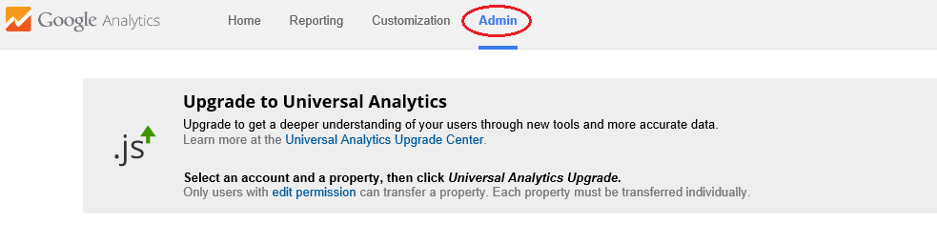

1. From the **Account**column, use the dropdown menu to select the account you want to add the new app property to. If you have a lot of accounts, use the search bar to help you find the right one. You can also [create a new account](https://support.google.com/analytics/answer/1009694). A new property is automatically created through the process of creating a new account.
2. Under the **Property**column, click the dropdown menu and select **Create new property**.
3. Select **App** as the type of property you want to track.

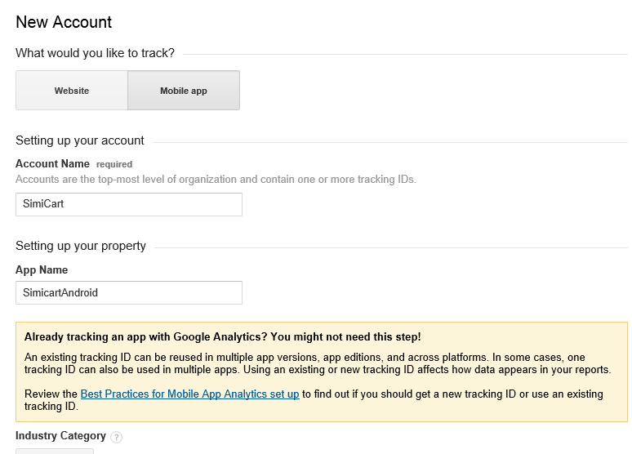

1. Type in a **Name**.  
   *If you have more than one apps, use a very specific and descriptive name. For example: SimiCart iOS app, SimiCart Android App…*
2. Select an **Industry Category**.
3. Select your **Reporting Time Zone**.
4. Enter an **Account Name**.  
   *This option only appears when creating a property on new accounts.*
5. Choose your [data sharing options](https://support.google.com/analytics/answer/1011397).  
   *This option only appears when creating a property on new accounts.*
6. Click **Get Tracking ID**.

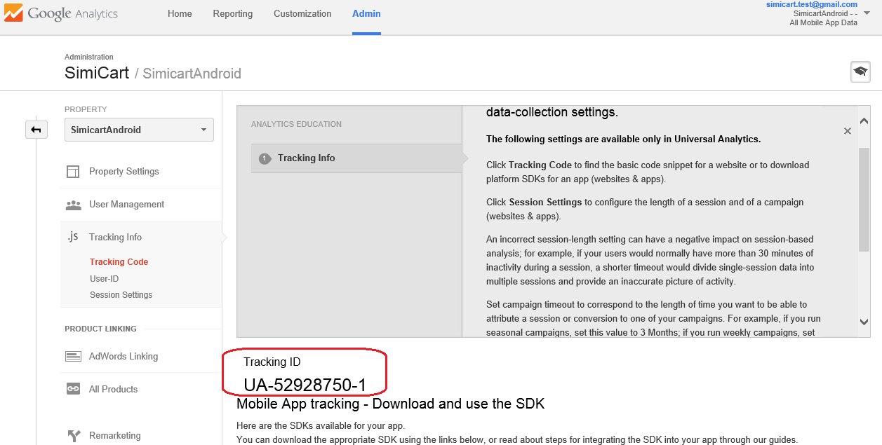

# 4. HOW TO CONFIGURE IN MAGENTO BACKEND

After installing App Analytics, please log in to your Magento Backend, click on SimiCart Connector >> App Analytics Settings. In this section, you need to:

1. Enable the plug-in by selecting **Yes.**

2. Enter the Tracking ID taken from your Google Analytics account (please read the guide in part 3 to get it).

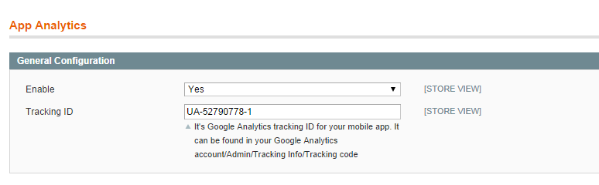

# 5. HOW TO GET REPORTS ON APP ANALYTICS

**A. Screen View Reports:**

To have quick view or deep analytics on screen view of your apps, the time on each screen, the most or least popular page in app, you have to take some steps as follow:

1. Login to your Google Analytics account

2. At Homepage, select Data of one app you want to see the report

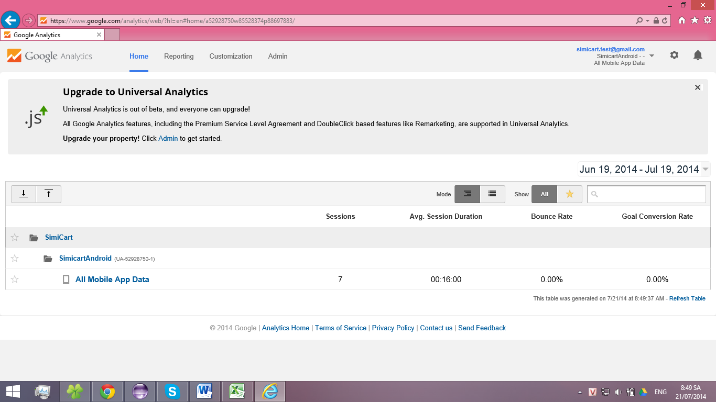

3. Select **Behavior** >> **Screen**, a visualized graph is displayed for you.

4. As you can see, the report shows you overall and some statistics of each screen like time on screen, % exit, unique screen views… If you want to view one screen only, click one screen.

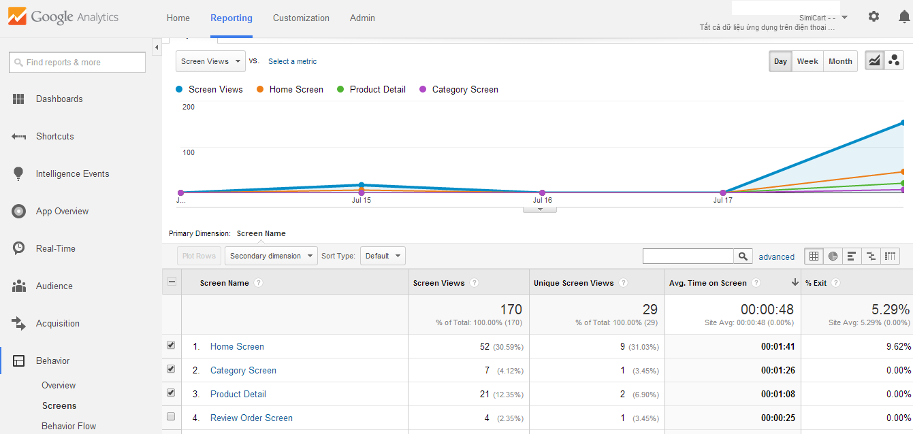

5. There are some types of screen in this report as follow:

|  |  |  |
| --- | --- | --- |
|  | Name | Description |
| 1 | Home Screen | “Home screen” is a main screen of application, show list of spot products: Best seller, most view… and some main information of store store : log in, sign up… |
| 2 | Product Detail | On this screen, the detailed information of each product is shown with important information: price, tax, special points, color, size… |
| 3 | Category | This screen display the whole list of categories |
| 4 | Search Screen | It’s the search result page which shows the list of products found. |
| 5 | Cart Screen | This one shows a list of product you have added to cart |
| 6 | Review Order Screen | This screen is used to review orders with items, detail price, setup billing and shipping addresses, shipping method, payment method, ... before orders are placed |
| 7 | Order History Screen | It [shows a user's order history*o*n "My Account"](http://alisothegeek.com/2011/06/show-a-users-order-history-on-my-account-in-cart66/) |
| 8 | Order History Detail Screen | This page displays a user’s order history in details |

**B. Ecommerce Reports:**

1. Set up Ecommerce tracking:

* Click **Admin** from the menu bar at the top of any screen in Analytics.
* Use the drop down menus to select the *Account*, *Property*, and *View*.
* Click **View Settings**.
* In the*Ecommerce Settings* section, click the toggle so it says **ON**
* Click **Save** at the bottom of the page.

2. View Ecommerce reports:

* Select Ecommerce=>Overview, some important information is shown: Revenue, conversion rate, average order value, number of purchasers, quantity, products list…

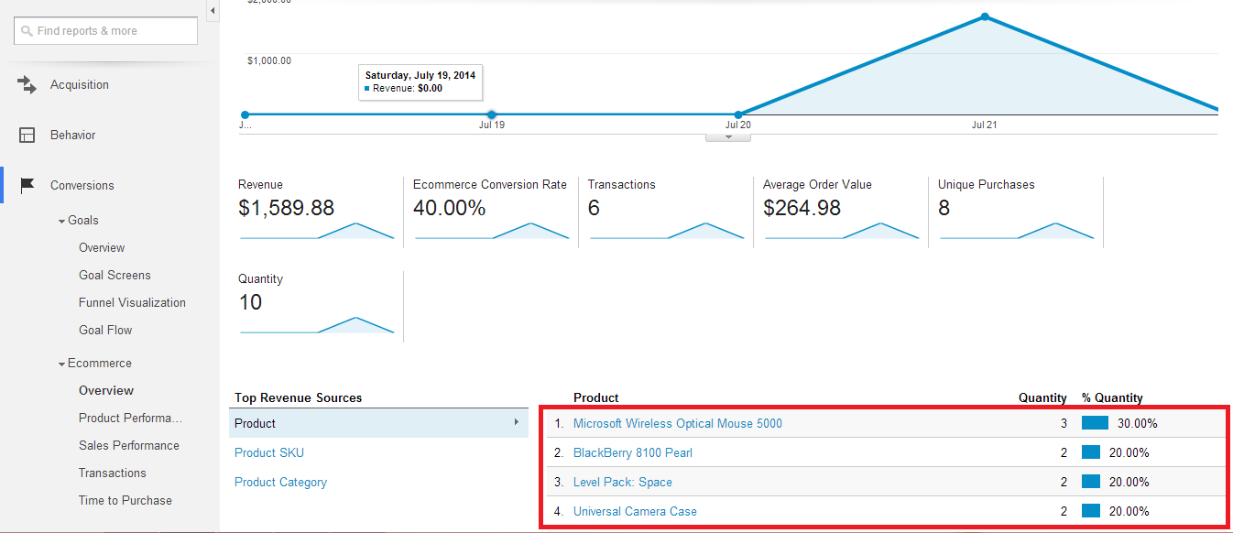

* To view each product report: select **Product Performance:**

In this section, you can see the product list with product name, quantity, number of purchasers, average price and revenue. Here you can find what the best seller is at this time, what has lowest revenue to make necessary adjustments.

Select Transactions to view the order report with Transaction Id, Revenue, Tax, Shipping, Quantity.

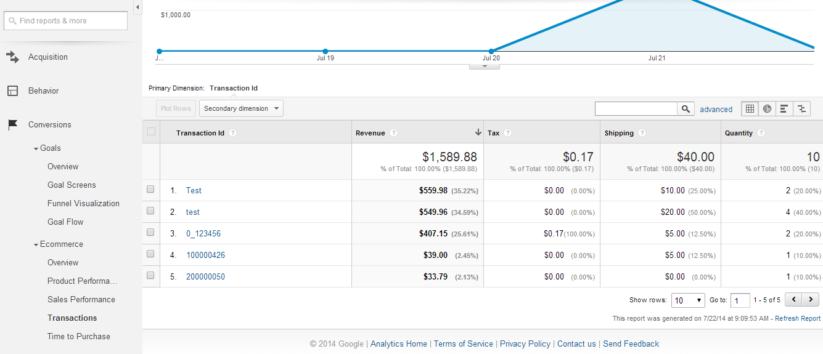

You can also view the sales performance, time to purchase… by clicking on each section of Ecommerce.

**C. View reports on banners:**

Banners are one of app elements and marketing tools, therefore, the effectiveness of banners are conveyed via the click report. To get this report, you need to:

1. Select Behavior > Events > Overview

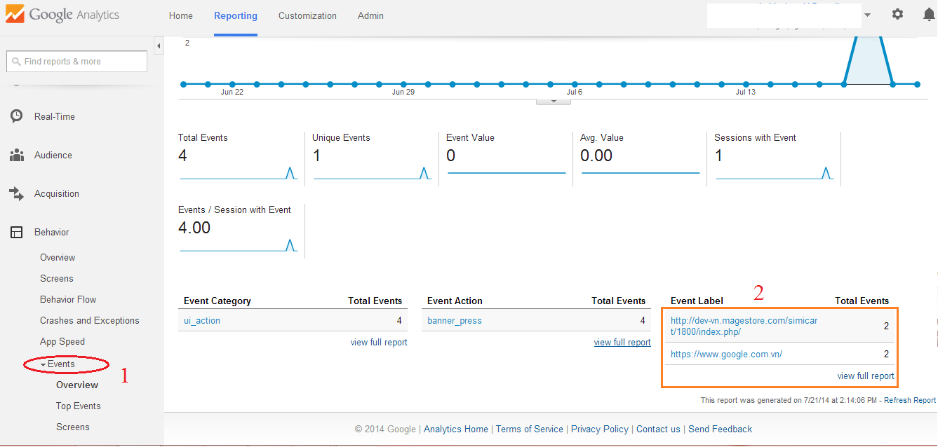

2. In the tablet event label, you can see your banners with the link and the total clicks.

You can also view the total clicks (total events), number of people who clicked (unique events), event value…

**D. App Download Report:**

*1. Generate Tracking URL:*

In order to view the reports on your app download, you have to put some tracking code in the download link of your app.

**a. For Android app:**

Go to URL Builder: <https://developers.google.com/analytics/devguides/collection/android/v3/campaigns#google-play-url-builder>

Fill in the form below:

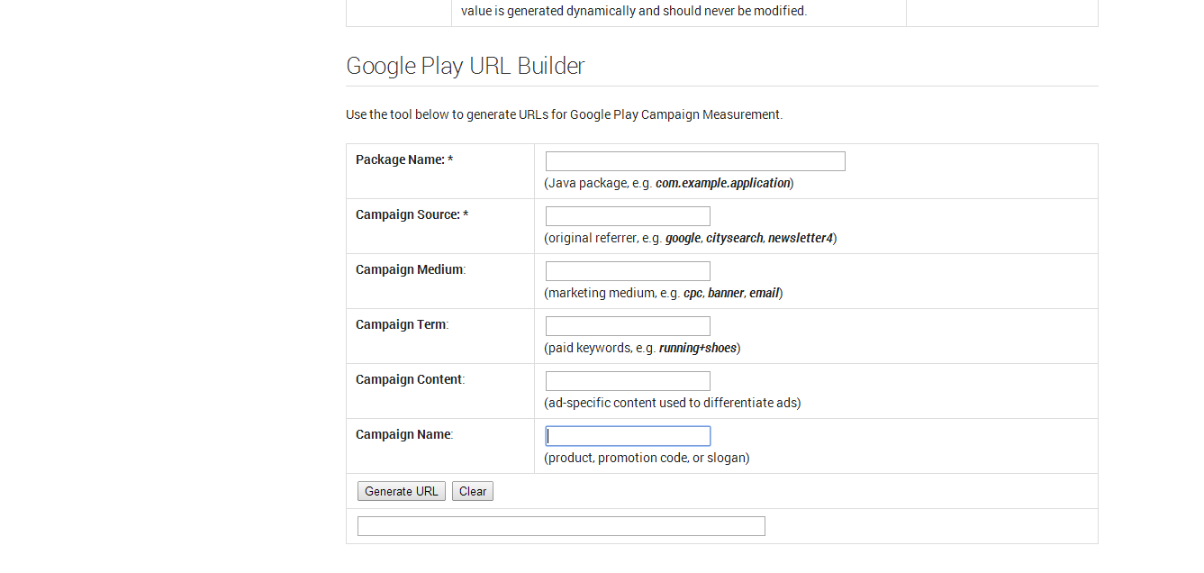

Campaign Source: You should enter the source that you will put this link.

Campaign medium: The materials that you put your link on.

Campaign name: Please make it short and easy to remember.

And then, click on to **submit.**  After that, click **Generate URL** to create this URL and also the QR Code. You can place QR code or URL in your advertisement or anywhere you want to advertise you app. (You can use our feature Promote Your App).

**b. For iOS apps:**

Get link your app from <https://linkmaker.itunes.apple.com/us/>

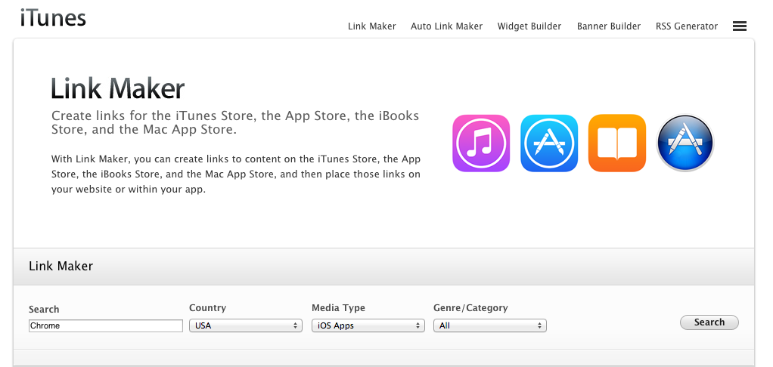

Insert your app name on textbox **Search**.

Insert your country on textbox **Country**

Choose iOS Apps in **Media Types**

Choose All in **Genre/Category**

Click **Search** and you can see result same below:

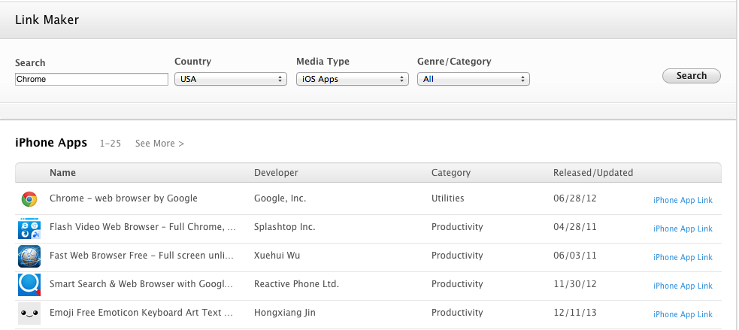

Click iPhone App Link in the above list. A screen appears as follow:

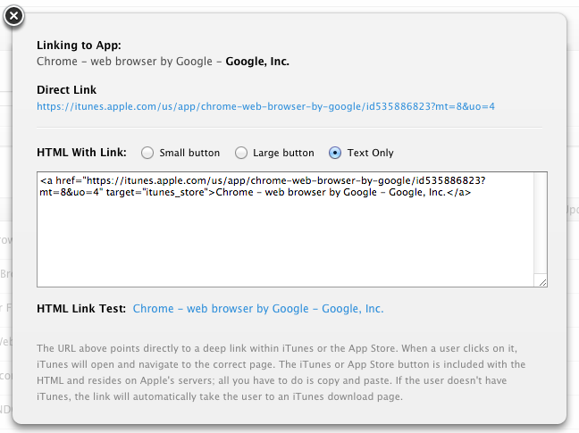

You get the direct link, now you can add tracking code to it.

Please visit:

<https://support.google.com/analytics/answer/1033867?hl=en>

Fill in the form below and click **Submit**:

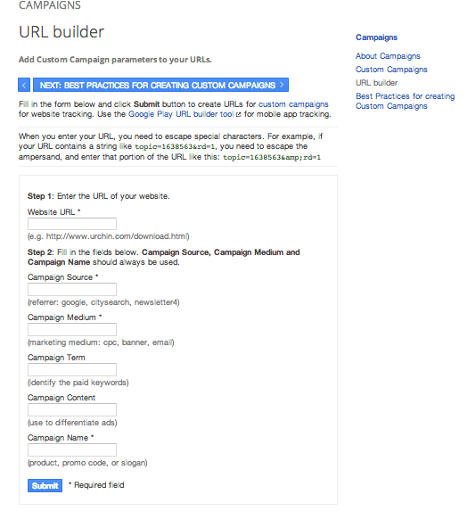

If you set campaign on web, insert the link you did get from step 1 to textbox **Website URL *.**

If you set campaign on app, replace “***http***” in link you did get from step 3 by “***itms-apps***” then insert to textbox **Website URL *.**

You can copy and use the URL in your advertisement or anywhere you want to advertise you app. (You can use our feature Promote Your App).

**2. View reports on app download, usage**

You should go to Google Analytics, click **Acquisition** >> **New User** to view the new download.

If you want to view the source that bring you app downloader, instead of New User, you can go to **Adwords >> Campaigns**

You can see a graph which shows you how effective your app promotion campaign is, which source/medium has the most visits and conversions.

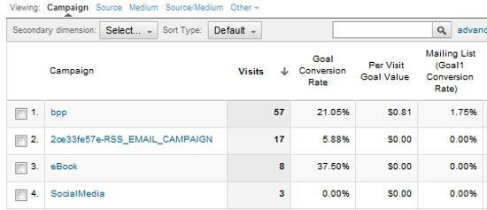

**------------------------------------------------------THE END-------------------------------------------------**