Turatbekov Sultan 2004.01005

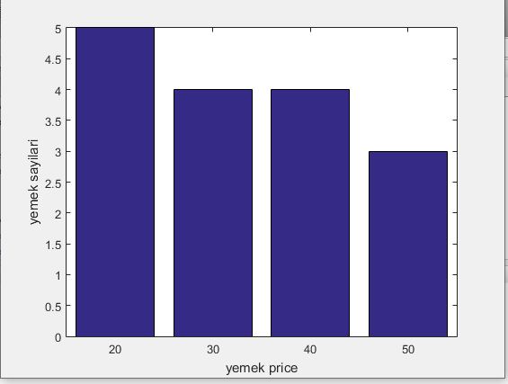clear; clc;

say20=0; say30=0; say40=0; say50=0;

yemektanesi=20; hesap=0;

while hesap<yemektanesi

price=input('Yemek price kac?');

if price==20

say20=say20+1;

end

if price==30

say30=say30+1;

end

if price==40

say40=say40+1;

end

if price==50

say50=say50+1;

end

disp(' yemek price girildi')

hesap=hesap+1;

end

bar([20 30 40 50], [say20 say30 say40 say50])

xlabel('yemek price')

ylabel('yemek sayilari')

1. 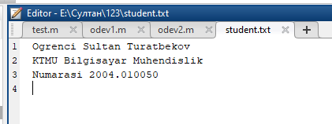

clc; clear;

adi='Sultan';

soyadi='Turatbekov';

numarasi=2004.01005;

fakulte='Bilgisayar';

bolum='Muhendislik';

fid=fopen('student.txt', 'w+');

fprintf(fid, 'Ogrenci %s', adi);

fprintf(fid, ' %s\n', soyadi);

fprintf(fid, 'KTMU %s', fakulte);

fprintf(fid, ' %s\n', bolum);

fprintf(fid, 'Numarasi %f\n', numarasi);

fclose(fid)

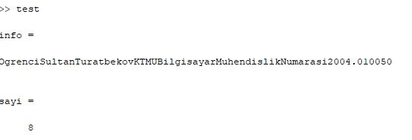

fid=fopen('student.txt','r+');

[info, sayi]=fscanf(fid,' %s\n', inf )

1. 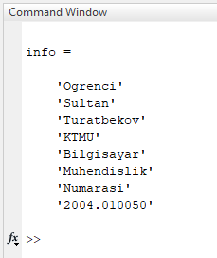

clc; clear;

[info]=textread('student.txt','%s')

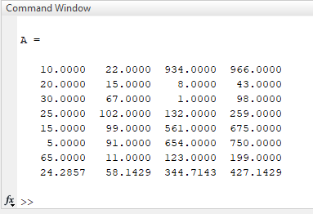A = xlsread('deneme.xlsx', 1, 'C3:F10')

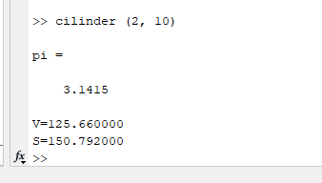function cilinder( r,h )

%V bu kolomu

%S square

pi=3.1415

V=pi\*r\*r\*h;

s1=2\*(pi\*r\*r);

s2=2\*pi\*r\*h;

S=s1+s2;

fprintf('V=%f\n',V)

fprintf('S=%f\n',S)

end