**Bug_ID:** Bug_SD_001

**Bug Title:** The Social Media Links aren’t working**.**

**Steps to reproduce:**

1. Open the browser**.**
2. Navigate to this URL**:** **“**<https://www.saucedemo.com/v1/index.html>**”.**
3. Log in with valid account credentials**.**
4. Click on the Links below on the footer of the page**.**
5. Observe the changes**.**

**Module/Feature:** All Pages**.**

**Test Data For Valid Account Credentials:**

| **Username** | standard_user |
| --- | --- |
| **Password** | secret_sauce |

**Tested Links:**Twitter**,** Facebook**,** Linkedin**.**

**Expected Result:**The Social Media links should work**.**

**Actual Result:**The Social Media links aren’t working**.**

**Severity:** Low**.**

**Priority:** Low**.**

**Environment:** Windows 11 pro **-** OS 64**-**bit**,** Google Chrome **-** latest version**,** Sauce Demo web**.**

**Attachment:“**<https://drive.google.com/file/d/1A-F_svaoI5nFcLcpieGlsiwbLT5T3Mgb/view?usp=sharing>**”.**

**Bug_ID:** Bug_SD_002

**Bug Title:** The Logged out user can access the web pages**.**

**Description:** Logged-out users are redirected to the Products Listing page when using the browser Back button**.**

**Steps to reproduce:**

1. Open the browser.
2. Navigate to this URL**:** **“**<https://www.saucedemo.com/v1/index.html>**”.**
3. Log in with valid account credentials**.**
4. Open the Side menu**.**
5. Click on the Logout button**.**
6. Click on the Backward button on the browser**.**
7. Observe the changes**.**

**Test Data For Valid Account Credentials:**

| **Username** | standard_user |
| --- | --- |
| **Password** | secret_sauce |

**Expected Result:**The Logged out users shouldn’t be able to access restricted pages.

**Actual Result:**The Logged out users are able to access restricted pages**.**

**Severity:** High**.**

**Priority:** High**.**

**Environment:** Windows 11 pro **-** OS 64**-**bit**,** Google Chrome **-** latest version**,** Sauce Demo web**.**

**Attachment: “**<https://drive.google.com/file/d/1nSmjUNr8PRtC6K9M2PovYDvcMZJCtlHO/view?usp=sharing>**”.**

**Bug_ID:** Bug_SD_003

**Bug Title:** Products added to cart are visible to a different logged-in user**.**

**Steps to reproduce:**

1. Open the browser**.**
2. Navigate to this URL**:** **“**<https://www.saucedemo.com/v1/index.html>**”.**
3. Log in with valid account credentials**.**
4. Move to any product**.**
5. Click on the Add To Cart button**.**
6. Open the Side menu**.**
7. Click on the Logout button**.**
8. Log in with another valid account credentials**.**
9. Open the Cart page**.**

**Module/Feature:** Cart Page**.**

**Test Data For Valid Account Credentials:**

| **Username_No.1** | standard_user |
| --- | --- |
| **Password_No.1** | secret_sauce |
| **Username_N0.2** | problem_user |
| **Password_No.2** | secret_sauce |
| **The Added Product to the Cart** | Sauce Labs Backpack |

**Expected Result:** The added products to cart shouldn’t be visible to a different logged-in user**.**

**Actual Result:**The added products to cart are visible to a different logged-in user**.**

**Severity:** Critical**.**

**Priority:** High**.**

**Environment:** Windows 11 pro **-** OS 64**-**bit**,** Google Chrome **-** latest version**,** Sauce Demo web**.**

**Attachment:“**<https://drive.google.com/file/d/1ppNzFo9qcwzl9hITUIbiCM-C0f8n41gO/view?usp=sharing>**”.**

**Bug_ID:** Bug_SD_004

**Bug Title:** Product images are not loading for a specific logged-in user**.**

**Steps to reproduce:**

1. Open the browser**.**
2. Navigate to this URL**:** **“**<https://www.saucedemo.com/v1/index.html>**”.**
3. Log in with valid account credentials**.**
4. Observe the products’ images on the Products Listing page**.**

**Module/Feature:** Product Listing Page**.**

**Test Data For Valid Account Credentials:**

| **Username** | problem_user |
| --- | --- |
| **Password** | secret_sauce |

**Expected Result:** The products’ images should be loaded successfully with any logged-in user**.**

**Actual Result:**The products’ images aren’t loaded successfully with an specific logged-in user**.**

**Severity:** Medium**.**

**Priority:** Medium**.**

**Environment:** Windows 11 pro **-** OS 64**-**bit**,** Google Chrome **-** latest version**,** Sauce Demo web**.**

**Attachment: “**<https://drive.google.com/file/d/1McQaU4mQBoBwyKyJvCHPX9Jda5XXYd54/view?usp=sharing>**”.**

**Bug_ID:** Bug_SD_005

**Bug Title:** Incorrect product details displayed**.**

**Steps to reproduce:**

1. Open the browser**.**
2. Navigate to this URL**:** **“**<https://www.saucedemo.com/v1/index.html>**”.**
3. Log in with valid account credentials**.**
4. Click on any product’s name**.**

**Module/Feature:** Products Listing Page**.**

**Test Data For Valid Account Credentials:**

| **Username** | problem_user |
| --- | --- |
| **Password** | secret_sauce |

**Expected Result:** Products details should be displayed correctly.

**Actual Result:** Products’ details are displaying incorrectly.

**Severity:** Medium**.**

**Priority:** High**.**

**Environment:** Windows 11 pro **-** OS 64**-**bit**,** Google Chrome **-** latest version**,** Sauce Demo web**.**

**Attachment:“**<https://drive.google.com/file/d/1ZZCL9gmJN6toHYXcM_SA2FFl-HeGsaT7/view?usp=sharing>**”.**

**Bug_ID:** Bug_SD_006

**Bug Title:** The "Name (Z to A)" sorting method doesn't

work as expected with a specific user.

**Steps to reproduce:**

1. Open the browser**.**
2. Navigate to this URL**:** **“**<https://www.saucedemo.com/v1/index.html>**”.**
3. Log in with valid account credentials**.**
4. Click on the Sorting drop down list**.**
5. Select the Name (Z to A) sorting method**.**
6. Observe the changes**.**

**Module/Feature:** Products Listing Page**.**

**Test Data For Valid Account Credentials:**

| **Username** | problem_user |
| --- | --- |
| **Password** | secret_sauce |

**Expected Result:** The "Name (Z to A)" sorting method should be working as expected**.**

**Actual Result:** The "Name (Z to A)" sorting method doesn’t work as expected**.**

**Severity:** Low**.**

**Priority:** Medium**.**

**Environment:** Windows 11 pro **-** OS 64**-**bit**,** Google Chrome **-** latest version**,** Sauce Demo web**.**

**Attachment:**

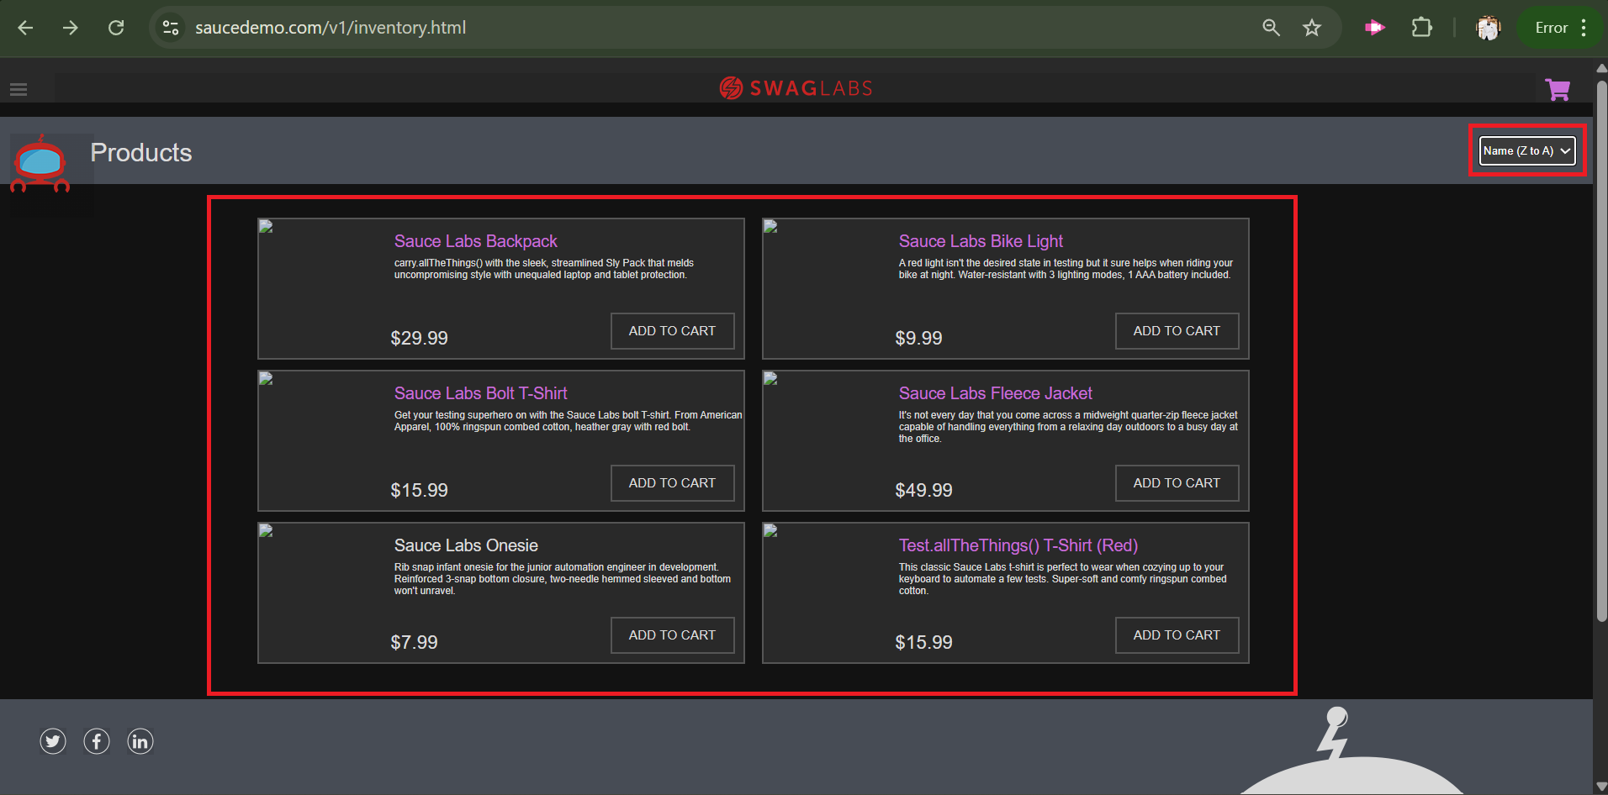

**Bug_ID:** Bug_SD_007

**Bug Title:** The "Price (low to high)" sorting method doesn't

work as expected with a specific user**.**

**Steps to reproduce:**

1. Open the browser**.**
2. Navigate to this URL**:** **“**<https://www.saucedemo.com/v1/index.html>**”.**
3. Log in with valid account credentials**.**
4. Click on the Sorting drop down list**.**
5. Select the Price (low to high) sorting method**.**
6. Observe the changes**.**

**Module/Feature:** Products Listing Page**.**

**Test Data For Valid Account Credentials:**

| **Username** | problem_user |
| --- | --- |
| **Password** | secret_sauce |

**Expected Result:** The "Price (low to high)" sorting method should be working as expected**.**

**Actual Result:** The "Price (low to high)" sorting method doesn’t work as expected**.**

**Severity:** Medium**.**

**Priority:** High**.**

**Environment:** Windows 11 pro **-** OS 64**-**bit**,** Google Chrome **-** latest version**,** Sauce Demo web**.**

**Attachment:**

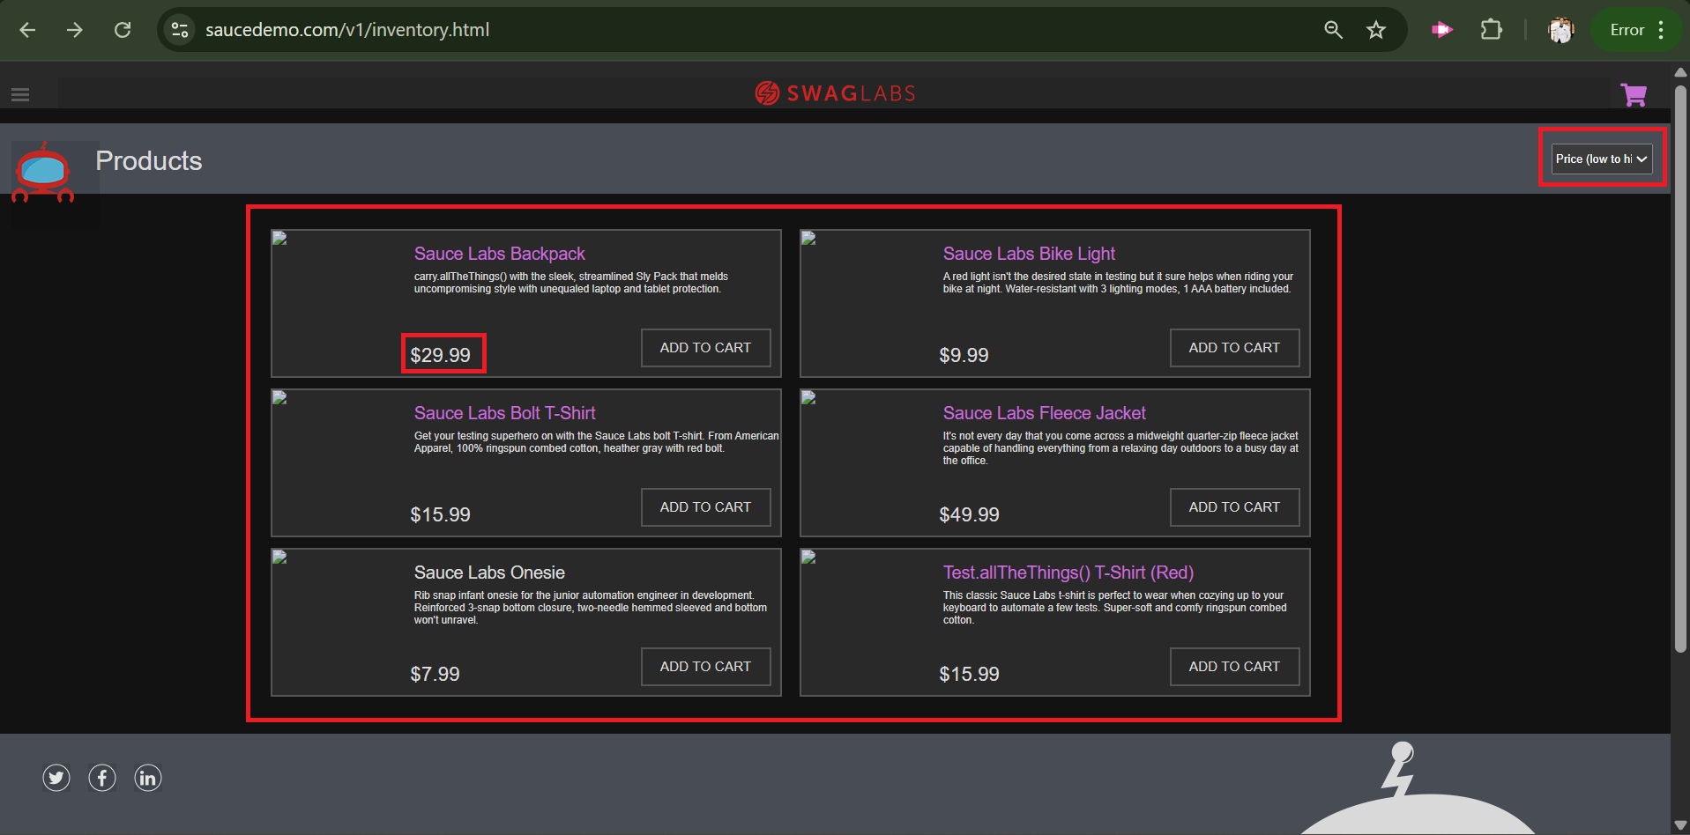

**Bug_ID:** Bug_SD_008

**Bug Title:** The "Price (high to low)" sorting method doesn't

work as expected with a specific user**.**

**Steps to reproduce:**

1. Open the browser**.**
2. Navigate to this URL**:** **“**<https://www.saucedemo.com/v1/index.html>**”.**
3. Log in with valid account credentials**.**
4. Click on the Sorting drop down list**.**
5. Select the Price (high to low) sorting method**.**
6. Observe the changes**.**

**Module/Feature:** Products Listing Page**.**

**Test Data For Valid Account Credentials:**

| **Username** | problem_user |
| --- | --- |
| **Password** | secret_sauce |

**Expected Result:** The "Price (high to low)" sorting method should be working as expected**.**

**Actual Result:** The "Price (high to low)" sorting method doesn’t work as expected**.**

**Severity:** Medium**.**

**Priority:** High**.**

**Environment:** Windows 11 pro **-** OS 64**-**bit**,** Google Chrome **-** latest version**,** Sauce Demo web**.**

**Attachment:**

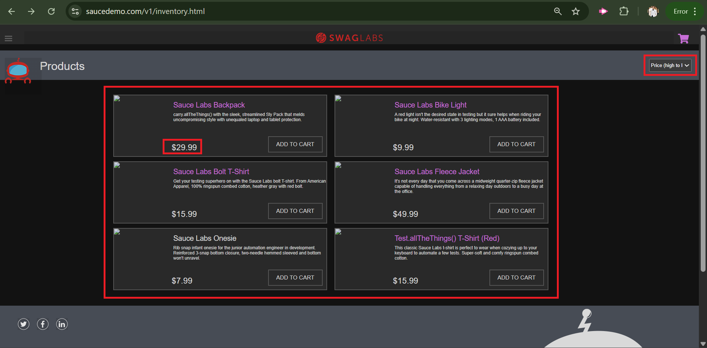

**Bug_ID:** Bug_SD_009

**Bug Title:** The Remove button doesn't work as expected with a specific user**.**

**Description:** After adding a product to the cart, the user can’t remove it**.**

**Steps to reproduce:**

1. Open the browser**.**
2. Navigate to this URL**:** **“**<https://www.saucedemo.com/v1/index.html>**”.**
3. Log in with valid account credentials**.**
4. Move to any product**.**
5. Click on Add To Cart button**.**
6. Click on the Remove button**.**

**Module/Feature:** Products Listing Page**.**

**Test Data For Valid Account Credentials:**

| **Username** | problem_user |
| --- | --- |
| **Password** | secret_sauce |

**Expected Result:** The Remove button should be working as expected**.**

**Actual Result:** The Remove button doesn’t work as expected**.**

**Severity:** High**.**

**Priority:** High**.**

**Environment:** Windows 11 pro **-** OS 64**-**bit**,** Google Chrome **-** latest version**,** Sauce Demo web**.**

**Attachment:“**<https://drive.google.com/file/d/1YtrSy5HIxCVcCGSFmJq_bXdce21opYx5/view?usp=sharing>**”.**

**Bug_ID:** Bug_SD_010

**Bug Title:** The Checkout button is clickable even the Cart is empty with a specific user**.**

**Description:** After emptying the Cart, the user can process and finish a checkout process**.**

**Steps to reproduce:**

1. Open the browser**.**
2. Navigate to this URL**:** **“**<https://www.saucedemo.com/v1/index.html>**”.**
3. Log in with valid account credentials**.**
4. Add any product to the cart**.**
5. Open the Cart pae**.**
6. Click on the remove button**.**
7. Click on the Checkout button**.**
8. Observe the changes**.**

**Module/Feature:** Cart Page**.**

**Test Data For Valid Account Credentials:**

| **Username** | problem_user |
| --- | --- |
| **Password** | secret_sauce |

**Expected Result:** The Checkout button shouldn’t be clickable if the Cart is empty**.**

**Actual Result:** The Checkout button is clickable even the Cart is empty and the user can process a checkout process**.**

**Severity:** High**.**

**Priority:** High**.**

**Environment:** Windows 11 pro **-** OS 64**-**bit**,** Google Chrome **-** latest version**,** Sauce Demo web**.**

**Attachment:“**<https://drive.google.com/file/d/1TEvosIFfvifdr7vrB0btZsZpTdKMfAix/view?usp=sharing>**”.**

**Bug_ID:** Bug_SD_011

**Bug Title:** The First Name field value changes when typing in the Last Name field.

**Description:** By typing the Last Name, the text of the First Name is changed to be as same as the text of the Last Name.

**Steps to reproduce:**

1. Open the browser**.**
2. Navigate to this URL**:** **“**<https://www.saucedemo.com/v1/index.html>**”.**
3. Log in with valid account credentials**.**
4. Add any product to the cart**.**
5. Open the Cart pae**.**
6. Click on the Checkout button**.**
7. Enter a valid First Name in the First Name textfield**.**
8. Enter a valid Last Name in the Last Name textfield**.**
9. Observe the changes**.**

**Module/Feature:** Checkout Step One Page**.**

**Test Data:**

**Test Data For Valid Account Credentials:**

| **Username** | problem_user |
| --- | --- |
| **Password** | secret_sauce |

**Test Data For Checkout Form Fields:**

| **First Name** | **Bahaa** |
| --- | --- |
| **Last Name** | **Elhamouly** |

**Expected Result:** The First Name shouldn’t change by typing the Last Name and each field should be independent**.**

**Actual Result:** The First Name is changed by typing the Last Name and its text be the same as the text of the text of the Last Name**.**

**Severity:** High**.**

**Priority:** High**.**

**Environment:** Windows 11 pro **-** OS 64**-**bit**,** Google Chrome **-** latest version**,** Sauce Demo web**.**

**Attachment:“**<https://drive.google.com/file/d/1NYJHn9rsvp6zxvYOzAQ8Xd9RTQNbPPD_/view?usp=sharing>**”.**

**Bug_ID:** Bug_SD_012

**Bug Title:** The system displays the product’s price and the calculation incorrectly**.**

**Steps to reproduce:**

1. Open the browser**.**
2. Navigate to this URL**:** **“**<https://www.saucedemo.com/v1/index.html>**”.**
3. Log in with valid account credentials**.**
4. Add any product to the cart**.**
5. Open the Cart page**.**
6. Click on the Checkout button**.**
7. Enter valid data in the Checkout form**.**
8. Click on the Continue button**.**
9. Check the Calculation on the Checkout Step Two page**.**

**Module/Feature:** Checkout Step Two Page**.**

**Test Data:**

**Test Data For Valid Account Credentials:**

| **Username** | problem_user |
| --- | --- |
| **Password** | secret_sauce |

**Test Data For the Added To Cart Product:**

| **Product’s Name** | Sauce Labs Backpack |
| --- | --- |
| **Product’s Price** | $29.99 |

**Test Data For Checkout Form Fields:**

| **First Name** | Bahaa |
| --- | --- |
| **Last Name** | Elhamouly |
| **Zip/Postal Code** | 11843 |

**Expected Result:** The Checkout’s calculation should be displayed correctly**.**

**Actual Result:** The Checkout’s calculation displayed incorrectly**.**

**Severity:** Critical**.**

**Priority:** High**.**

**Environment:** Windows 11 pro **-** OS 64**-**bit**,** Google Chrome **-** latest version**,** Sauce Demo web**.**

**Attachment:“**<https://drive.google.com/file/d/1ozn4a3HCf5LIlu4BHEODl5TqhPpHg8r6/view?usp=sharing>**”.**

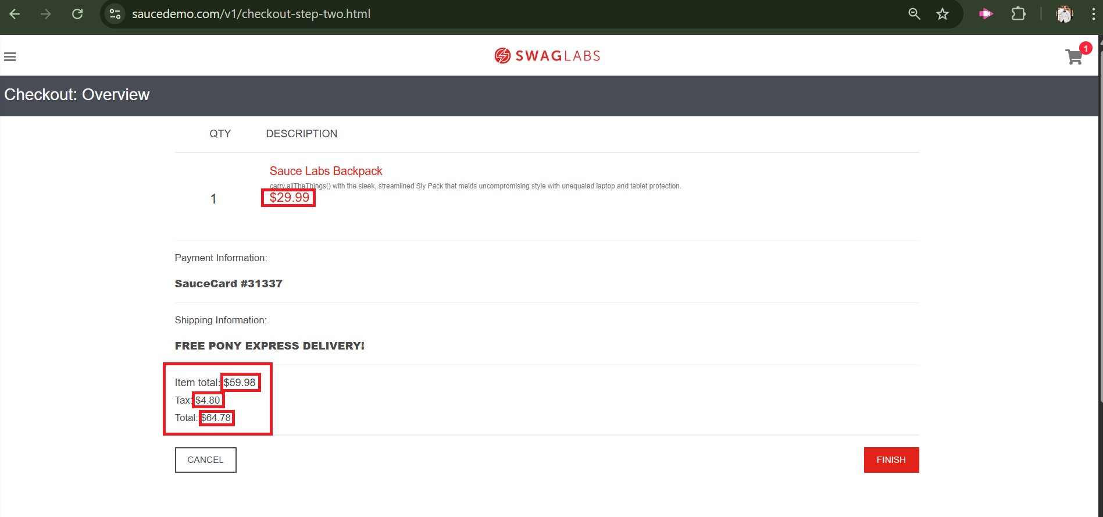

**Bug_ID:** Bug_SD_013

**Bug Title:** The added to cart product still exists in the Cart even the user has done the Checkout process successfully.

Steps to reproduce:

1. Open the browser**.**
2. Navigate to this URL**:** **“**<https://www.saucedemo.com/v1/index.html>**”.**
3. Log in with valid account credentials**.**
4. Add any product to the cart**.**
5. Open the Cart pae**.**
6. Click on the Checkout button**.**
7. Enter valid data in the Checkout form.
8. Click on the Continue button.
9. Click on the Finish button.
10. Open the Cart page.

**Module/Feature:** Cart Page**.**

**Test Data:**

**Test Data For Valid Account Credentials:**

| **Username** | problem_user |
| --- | --- |
| **Password** | secret_sauce |

**Test Data For the Added To Cart Product:**

| **Product’s Name** | **Sauce Labs Backpack** |
| --- | --- |

**Test Data For Checkout Form Fields:**

| **First Name** | **Bahaa** |
| --- | --- |
| **Last Name** | **Elhamouly** |
| **Zip/Postal Code** | **11843** |

**Expected Result:** The Cart should be empty after a successful checkout process for the existing added to cart product**.**

**Actual Result:** The added to cart product still exists in the Cart page after a successful checkout for it**.**

**Severity:** High**.**

**Priority:** High**.**

**Environment:** Windows 11 pro **-** OS 64**-**bit**,** Google Chrome **-** latest version**,** Sauce Demo web**.**

**Attachment:“**<https://drive.google.com/file/d/1LuFYVG5zWRJU2zrrzoNB19nmNmmKs_WQ/view?usp=sharing>**”.**