FixConnect: Worker Profile & Portfolio Implementation
This document outlines the technical specifications, workflows, and method references for the Worker Profile and Portfolio phase of the FixConnect project.

1. Files & System Architecture
The following files were created or modified to implement this phase:
Layer | File Path | Action
Data Access (DAL) | FixConnect.DAL/Models/Worker.cs | Modified: Added PhotoUrl & Verification navigation
Data Access (DAL) | FixConnect.DAL/Models/WorkerVerification.cs | New: Entity for ID Verification docs
Business Logic (BLL) | FixConnect.BLL/Services/WorkerService.cs | New: Profile management logic
Business Logic (BLL) | FixConnect.BLL/Services/PortfolioService.cs | New: Portfolio CRUD logic
Presentation (PL) | FixConnect.PL/Controllers/WorkerController.cs | New: UI logic & File upload handling

2. Method Definitions (Services & Controllers)
Below is a summary of the key methods implemented in this phase:
Component | Method | Description
WorkerService | GetWorkerProfile | Retrieves full worker details with User info and Portfolio items.
WorkerService | SubmitVerification | Uploads ID documents and sets verification status to Pending.
PortfolioService | AddItem | Validates image limit (Max 10) and saves the item.
PortfolioService | DeleteItem | Removes record from DB and deletes physical file from server.
WorkerController | EditProfile (POST) | Processes form data, manages file streams, and updates the database.

3. System Workflow (Step-by-Step)
- Step 1: Data Update - The system fetches the worker's current data from the SQL database using Entity Framework Core.
- Step 2: File Handling - If the worker uploads a new profile picture or ID documents, the system generates a unique GUID filename and saves it to wwwroot/uploads/.
- Step 3: Business Validation - The Services check for constraints (e.g., maximum portfolio items or valid file types).
- Step 4: Persistence - Changes are committed to the database. If verification docs are uploaded, the IsVerified flag remains false until Admin approval.

4. Visual Diagrams (Logical Representation)

Portfolio Upload Flow (Sequence)
Worker UI -> WorkerController: Send Image File
WorkerController -> Disk: Save File to /PortfolioPictures/
WorkerController -> PortfolioService: Call AddItem(Path)
PortfolioService -> Database: Insert Portfolio Record
Database -> Worker UI: Refresh and Show New Item

Verification Lifecycle (Flowchart)
Start -> Upload ID Front & Back -> Status: Pending -> Admin Review -> [Approved / Rejected]
If Approved: IsVerified = True -> Show Verified Badge

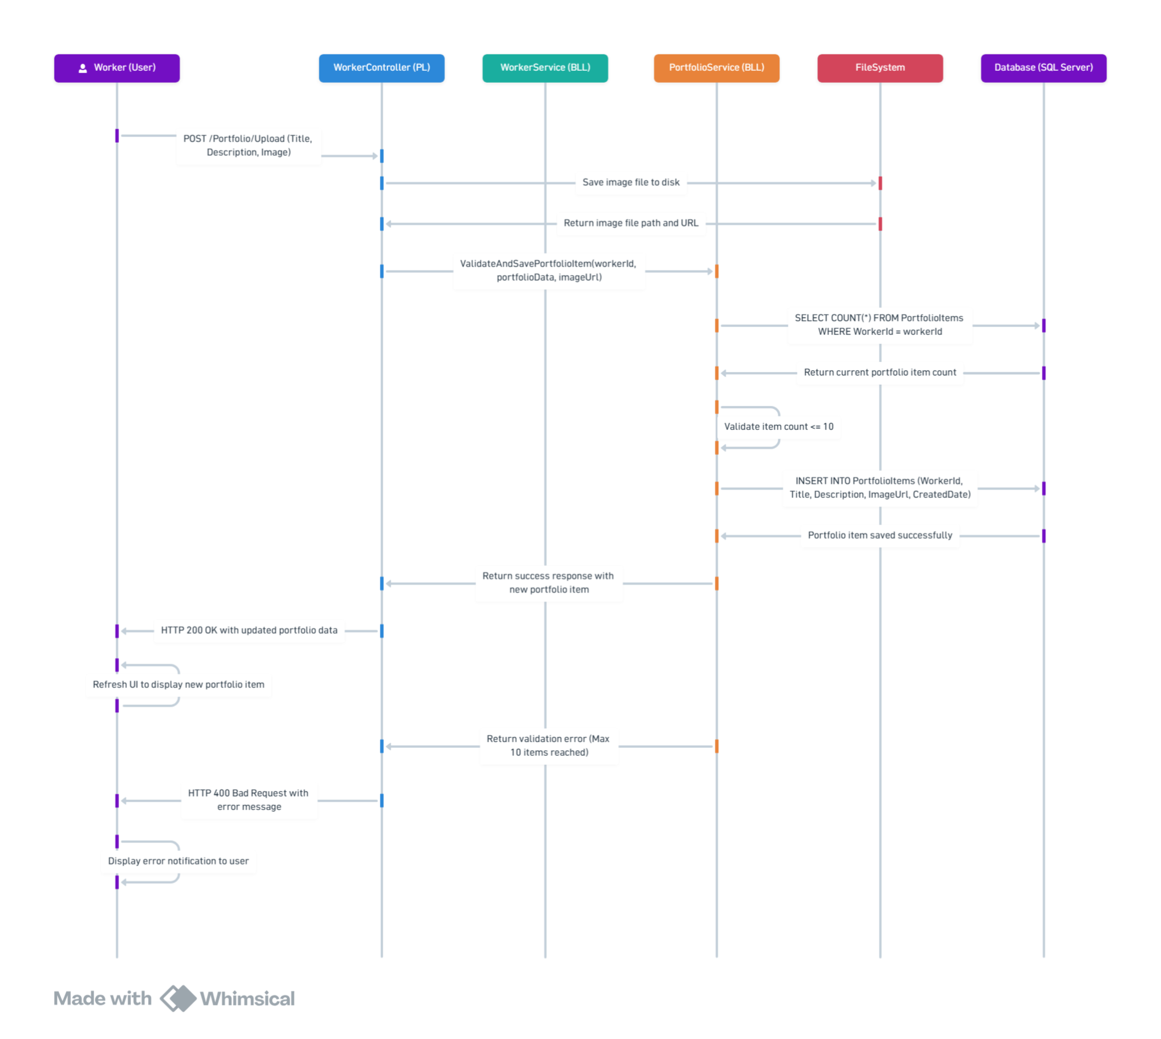
5. Final Checklist
- Migrations applied to include WorkerVerification and PortfolioItems.
- Services registered in Dependency Injection container.
- Physical storage folders created in wwwroot.
- Views implemented with proper enctype="multipart/form-data".

