Data Technician Week 5
Workbook
Azure Data Fundamentals

Name: Alex-Leigh Thomas
Course Date: 10/8/2026
Table of contents
Day 1: Task 1 3
Day 1: Task 2 4
Day 1: Task 3 5
Day 2: Task 1 6
Day 3: Task 1 10
Day 3: Task 2 11
Day 3: Task 3 12
Day 4: Task 1 13
Day 4: Task 2 14
1. Scenario Background 14
2. Data Laws and Regulations 14
3. Azure Service Recommendations 14
4. Data Types and Data Modelling 14
5. Data Storage Formats and Structures in Azure 15
6. Additional Considerations 15
Submission Guidelines: 15
Course Notes 18
Additional Information 19

Day 1: Task 1

Please research and complete the questions below relating to key concepts of cloud.

Be prepared to discuss the below in the group following this task.

What can cloud computing do for us in the real-world? | Cloud computing basically means you can use computers and storage that live on the internet, instead of on your own machine. So instead of buying expensive servers, a business can just rent space and power online and use it whenever they need it..  https://www.cloudflare.com/learning/cloud/what-is-the-cloud/  https://cloud.google.com/customers/spotify
How can it benefit a business? | It saves money because you don’t need to buy your own hardware. You only pay for what you actually use, and you can grow or shrink your usage easily. It also means people can work from anywhere since everything is online, not stuck on one office computer.  https://cloud.google.com/customers/spotify  https://www.sprintzeal.com/blog/spotify-cloud  https://cloud.google.com/security/encryption
What’s the alternative to cloud computing? | The alternative is on-premises — meaning the business buys and looks after its own physical servers in their own building. This costs more upfront and needs IT staff to manage and fix it. https://phoenixnap.com/blog/alternatives-to-cloud-computing  https://www.cloudflare.com/learning/serverless/glossary/what-is-edge-computing/
What cloud providers can we use, what are their features and functions? | There are several cloud platforms competing in the market, with Amazon, Microsoft and Google being the leaders. Each cloud platform features its own functions to support users.  Amazon Web Services (AWS) was first implemented in 2006 and now operates across 39 regions. Innovation and security are two key functions focused on by AWS with enterprises including Booking.com and Epic games utilising the platform.  Microsoft Azure, first implemented in 2010, operates over 60 geographical regions. Azure aims to support scalability in a cost effective way, allowing enterprises to purchase the server space required. They also focus on AI development to improve optimisation and decision making.  Google cloud, established in 2013, now provides more than 200 services, including Machine Learning and Data Analytics.  https://aws.amazon.com/what-is-aws/  https://azure.microsoft.com/en-us/resources/cloud-computing-dictionary/what-is-azure#Benefits-3  https://cloud.google.com/why-google-cloud  https://www.bmc.com/blogs/aws-vs-azure-vs-google-cloud-platforms/

Day 1: Task 2

Please research the below cloud offerings, explain what they are and provide Introduction to Microsoft Azure Data Core data concepts - Training | Microsoft Learn v
Do core concepts - 22min. Provide 40 mins to do this
examples of use cases.

Cloud Offerings | Explain what it is | When / how might you use this service in the real-world?
IaaS (Infrastructure as a service) | Infrastructure as a service (IaaS), is one model of cloud computing. The platform provides services to enterprises. Iaas provides space for scalability and flexibility. However this model requires a developer to configure applications and systems, including the operating system.  https://azure.microsoft.com/en-us/resources/cloud-computing-dictionary/what-is-iaas | Spotify could use infrastructure as service to support scalability and manage complex data. Spotify use more than 300 microservers on Kubernetes clusters on google cloud platform.  https://www.sprintzeal.com/blog/spotify-cloud  https://cloud.google.com/customers/spotify?
PaaS (Platform as a service) | Secondly, Platform as a service (PaaS) is another cloud computing model. This model provides some preinstalled software and applications, including the operating system. Implementing this model enables developers to focus on innovation to improve the enterprise.  https://azure.microsoft.com/en-us/resources/cloud-computing-dictionary/what-is-paas | Enterprises may operate on a cloud using platform as a service (PaaS). If Spotify integrated a PaaS, one benefit is management of SQL databases with the cloud responsible for managing it. Another benefit of using the cloud is the benefit of AI tools to support innovation.  https://cloud.google.com/products#featured-products
SaaS (Software as a service) | The third model of cloud computing is Software as a service (SaaS). This model provides an enterprise with resources they require. This model provides ongoing maintenance to the platform on behalf of the enterprise.  https://azure.microsoft.com/en-gb/resources/cloud-computing-dictionary/what-is-saas | Enterprise may utilise software as a service (Saas) to benefit from preconfigured applications. Utilising this software supports collaboration and innovation across organisations.  https://www.leapit.co.uk/blog/the-best-saas-software-as-a-service-examples-you-should-know-about/

Day 1: Task 3

Please research the below terms and explain what they are, when they would be appropriate and a real-world example of where it could be implemented (i.e. what type of organisation).

Public Cloud | Public cloud is one model used within cloud computing. It relies on a third party provider to install and configure applications and services with resources being pooled together. There are several benefits to implementing a public cloud. Utilising a public cloud can be cost efficient initiating pay as you go plans. This enables enterprises to control costs. Secondly, public clouds provide room for flexibility and scaling, supporting enterprises to manage increase in network activity. Additionally, public clouds are required to maintain security and compliance with standards including GDPR. However because it is public, it creates concerns for security, particularly sensitive and classified data, increasing vulnerability to cyber attacks.  Enterprises use public clouds to conduct analytics or as storage. Spotify may use a public cloud to capture and analyse real time data to improve user experience.  https://www.ibm.com/think/topics/public-cloud  https://www.qa.com/resources/blog/disadvantages-of-cloud-computing/  Public Cloud Examples, Applications & Use Cases | IBM
Private Cloud | Another model used is a private cloud, where an allocated environment is designated to one enterprise. Due to the security of a public cloud, the organisation is required to conduct required maintenance. However, security is one benefit provided by a private cloud because enhanced security measures including perimeter security and biometric authentication.  Enterprises that retain highly confidential data, including governments and financial, utilise private clouds. The purpose is to ensure control and security of data. In relation to Spotify, they may choose to use a private cloud to protect sensitive data, such as customer payment details.  What is a Private Cloud - Definition | Microsoft Azure  Private Cloud Advantages and Disadvantages | IBM  What Is a Private Cloud in Data Management & Security? | Cloudera
Hybrid Cloud | An alternative model is the hybrid cloud that uses both public and private cloud. Combining both cloud models ensures the enterprise retains control over their data, while implementing a cost effective method for scalability.  Enterprises may deploy hybrid cloud to to benefit from innovation and compliance with industry standards, including ICO standards and GDPR. However despite the enterprise utilising the private cloud to secure their data, there is a security concern. This is because services are maintained by third party vendors, which creates a risk for sensitive data. Spotify could use a hybrid cloud with onsite storage and data centers.  https://azure.microsoft.com/en-us/resources/cloud-computing-dictionary/what-is-hybrid-cloud-computing  https://www.ibm.com/think/insights/hybrid-cloud-advantages-disadvantages  https://engineering.atspotify.com/2019/12/views-from-the-cloud-a-history-of-spotifys-journey-to-the-cloud-part-1-2
Community Cloud | Community cloud is an additional model used within cloud computing. This model relies on infrastructure that is shared with other organisations.  Enterprises with multiple offices or trusts, like the NHS, may implement a public cloud to enable users to access shared applications and resources. If Spotify used a community cloud, they may benefit from standardised security standards.  https://www.ionos.co.uk/digitalguide/server/know-how/community-cloud/  https://www.cloudcomputing-news.net/news/how-hybrid-multi-cloud-and-community-clouds-are-coming-together-best-all-worlds/  https://cloud.google.com/customers/spotify

Day 2: Task 1

Describe, with examples, the three major areas that the Computer Misuse Act deals with. Cite your sources.

Area | Description | Example
Unauthorised access to a computer Materials | it is an offence to gain unauthorised access to devices, with the intention of accessing data. | includes logging on to a system using a colleague's credentials.
Unauthorised access with the intent of committing or facilitate commission of further offences | It is an offence to gain unauthorised access to a device and commit further crimes. | One example is a threat actor gaining unauthorised access to an enterprise's organisation with the intention of committing identity threat through unauthorised access.
Unauthorised acts with intent to impair, or with recklessness as to impairing operations of a computer | This section makes it illegal to carry out unauthorised modifications to devices or damage systems.  Including intentional or reckless behaviour. | Includes accessing and deleting data on a colleagues computer.  Alongside conducting a DDoS attack on a website to cause it to crash, making it unavailable for legitimate users.  https://www.cps.gov.uk/prosecution-guidance/computer-misuse-act#_Toc532920178

The Computer Misuse Act 1990 is an act under which an individual can be criminalised for a computer-related offence. Describe three extra powers that the Police and Justice Act 2006 (Computer Misuse) has added. (Cite sources)

Description
The implementation of the Police and Justice Act (2006), alongside the Computer Misuse Act (1990) enhanced consequences for cybercrimes. One additional power introduced, by the 2006 amendment, is enforcing increased penalties. Under the act courts can assign maximum prison sentences to offenders, with time depending on the crime. One example prison sentence is a maximum of two years for gaining unauthorised access to devices or systems.
Computer Misuse Act 1990
https://www.legislation.gov.uk/ukpga/2006/48/contents
With the amendment through the Police and Justice Act (2006) through the Computer Misuse Act (1990), it was made an offence to make, obtain and distribute hacking tools. The purpose is to reduce distribution of unethical tools, such as malware, used to commit cybercrimes.
Computer Misuse Act 1990
https://www.legislation.gov.uk/ukpga/2006/48/contents
It is a crime to conduct unauthorised modifications, including distribution of malware and Denial of service attacks (DoS).
Additionally, another enhanced power enforced within the 2006 Police and Justice amendment was criminalising unauthorised modifications with unethical intentions. With the amendment, criminal actions can be pursued in line with the Computer Misuse Act (1990) and the Police and Justice Act (2006).
Computer Misuse Act | The Crown Prosecution Service
https://www.legislation.gov.uk/ukpga/2006/48/contents

Look at the website below to answer the questions:
https://www.gov.uk/personal-data-my-employer-can-keep-about-me

Write down three items of data which a company can store about an employee.
One type of data an enterprise can store without employee consent is their name. Under the Data Protection Act (2018), organisations can store employee names because of legal obligations. Working in an enterprise, like Spotify, the organisation is responsible for sharing financial information with HMRC.
https://www.gov.uk/personal-data-my-employer-can-keep-about-me
https://ico.org.uk/for-the-public/does-an-organisation-need-my-consent/
Under the Data Protection Act (2018), addresses are another type of data organisations can store. This is because if an individual enters a contract the organisation may require an address for further communication. Spotify will store addresses of premium members for billing purposes.
https://www.gov.uk/personal-data-my-employer-can-keep-about-me
https://ico.org.uk/for-the-public/does-an-organisation-need-my-consent/#legitimate
Additionally, organisations can retain and store employee National Insurance Numbers, under DPA due to having a legitimate purpose. Organisations may use National Insurance numbers when dealing with payroll.
https://www.gov.uk/personal-data-my-employer-can-keep-about-me
https://ico.org.uk/for-the-public/does-an-organisation-need-my-consent/#legitimate

Give three more examples of data that an employer can only store if they first get the employee’s permission.
Biometric data is a sensitive form of data including iris scans and fingerprints. Employers require explicit consent to store biometric data from employees under the Data Protection Act (2018).
https://www.gov.uk/personal-data-my-employer-can-keep-about-me

Employers are required to gain explicit consent from employees to health information. Under UK GDPR, health information is protected because it is sensitive.
https://www.gov.uk/personal-data-my-employer-can-keep-about-me

Religion
Religion is a protected characteristic under the Equality Act (2010). Organisations require explicit consent to store religious information because it is sensitive. However organisations, such as Spotify may request to store employee religion data to monitor diversity and inclusion.
https://www.gov.uk/personal-data-my-employer-can-keep-about-me
https://ico.org.uk/for-organisations/uk-gdpr-guidance-and-resources/lawful-basis/special-category-data/what-is-special-category-data/#scd1
https://www.legislation.gov.uk/ukpga/2010/15/contents

Conduct further research to answer the questions below. (Please do your fact-checking and cite sources.)

Question | Answer
Provide one example of: Copyright infringement | The term copyright infringement is derived from the Copyright, Designs and Patents Act 1988. Under this act, individuals have a right to own their work including text, data or media. Therefore, it is an offence to use a body of work without consent or pass it as their own work which can be punished through financial penalties or law proceedings.  Copyright infringement is common within the music industry, where artists implement copyright to protect their intellectual property. In 2013, a song called ‘Blurred Lines’ was released by two music artists, Pharrell Williams and Robin Thicke. However, the estate for Marvin Gaye initiated legal action against both artists for copyright infringement. The case was successful for the Gaye estate with awards including monetary damages.  https://www.legislation.gov.uk/ukpga/1988/48/contents  https://realbusiness.co.uk/copyright-infringement-examples/
Provide one example of: Plagiarism | Plagiarism is the act of using a body of work, without providing credit to the author. There are several categories of plagiarism, ranging from complete to accidental plagiarism.  Plagiarism is commonly highlighted in academic and political industries. It also applies to areas including code and data. One example is a student writing up a dissertation. Forgetting to include citations is a form of plagiarism, even if it is accidental.  https://www.scribbr.co.uk/category/preventing-plagiarism/  https://www.ox.ac.uk/students/academic/guidance/skills/plagiarism
What are two consequences of copyright infringement and software piracy? | Software piracy is the act of distributing copyrighted software without licensing. Operating in line with the Copyright, Designs and Patents Act (1988), it is an offense to commit copyright infringement and software piracy.  In the UK, copyright infringement and software piracy can result in civil cases, with owners seeking compensation for damages. Serious infringements can lead to criminal action, including financial penalties or imprisonment.  https://www.britannica.com/topic/piracy-copyright-crime  https://www.revenera.com/software-monetization/glossary/software-piracy  https://consultantlm.uk/consultant-article/uk-copyright-infringement-penalties-what-you-need-to-know?
Give three possible consequences for individuals when using pirated software | As pirated software is illegal under the Copyright, Design and Patent Act (), individuals can face financial penalties. It puts an individual's device at risk of cyberattack by creating an entry for malware.  If used within an enterprise, it can impact the organisation's systems, resulting in potential breaches, penalties and reputational damage.  https://www.computer.org/publications/tech-news/trends/why-you-shouldnt-use-pirated-software  https://www.revenera.com/software-monetization/glossary/software-piracy  https://www.metalcam.com/en/blog/risks-pirated-cad-cam-software.html

Listed below are some laws which we have covered today:

1. Computer Misuse Act 1990
2. Police and Justice Act 2006 (Computer Misuse)
3. Copyright, Designs and Patents Act 1988
4. Copyright (Computer Programs) Regulations 1992
5. The Health and Safety (Display Screen Equipment) Regulations 1992
6. Data Protection Act 2018
7. Consumer Rights Act 2015
- Insert a number in the first column of each row to match each of the statements with one of the above Acts.

- One of the statements is incorrect and not illegal. For this statement, write ‘Not illegal’.

Act number | Clause
3 | With some exceptions, it is illegal to use unlicensed software
7 | Any product, digital or otherwise, must be fit for the purpose it is supplied for
1 | Unauthorised modification of computer material is illegal
2 | It is illegal to create or use a hacking tool for penetration testing
6 | Personal data may only be used for specified, explicit purposes
5 | Employers must provide their computer users with adequate health and safety training for any workstation they work at
2 | It is illegal to distribute hacking tools for criminal purposes
3 | It is illegal to distribute an illicit recording
6 | Personal data may not be kept longer than necessary
1 | Gaining unauthorised access to a computer system is illegal
5 | Employers must ensure that employees take regular and adequate breaks from looking at their screens
2 | It is illegal to prevent or hinder access (e.g. by a denial-of-service attack) to any program or data held in any computer
6 | Personal data must be accurate and where necessary kept up to date

Day 3: Task 1 – Lab 1

Please complete the lab - Your tutor will guide you

Completed lab

Day 3: Task 2 – Lab 2

Please complete the lab - Your tutor will guide you

Completed lab

Day 3: Task 3 – Lab 3

Please complete the lab - Your tutor will guide you

Completed lab

Day 3: Task 4 – Lab 4

Please complete the lab – Your Tutor will guide you.

Completed lab

Day 4: Task 1 – Lab 6

Complete Lab – Your tutor will guide you.

Result

Day 4: Task 2

1. Scenario Background
"Paws & Whiskers" is a growing pet shop that aims to improve its business by analysing sales, customer information, and inventory data. Currently, the data is collected manually or stored in spreadsheets. Management is interested in transitioning to Microsoft Azure to streamline data storage, analysis, and reporting, enabling them to make data-driven decisions.

2. Data Laws and Regulations
Identify and explain the data laws and regulations relevant to handling customer data within the proposal. Ensure you cover the following points:
- GDPR Compliance: Highlight the importance of adhering to the General Data Protection Regulation (GDPR), particularly as it relates to storing and processing customer information.
- Data Protection Act (DPA) 2018: Outline how the DPA 2018 may affect the way "Paws & Whiskers" collects and stores data, ensuring compliance with UK laws on data privacy.
- Other Industry Standards: Research any additional data protection standards or regulations that may apply to pet shop data, particularly if they involve sensitive or payment information.

3. Azure Service Recommendations
Recommend Microsoft Azure services that would suit the company’s data analysis needs and explain why these services are suitable. Your recommendations should include:
- Data Storage: Identify suitable storage options, such as Azure Blob Storage or Azure SQL Database, and discuss the benefits of each for storing large datasets, including inventory, sales transactions, and customer details.
- Data Analysis Tools: Recommend tools such as Azure Machine Learning for customer behaviour analysis or Azure Synapse Analytics for analysing sales trends.
- Data Integration and Automation: Explain how services like Azure Data Factory could automate data collection and integration processes, improving efficiency.

4. Data Types and Data Modelling
Define the types of data "Paws & Whiskers" will need to work with and describe your approach to data modelling:
- Data Categories: Identify key data types, such as customer demographics, transaction history, pet inventory, and product categories.
- Data Modelling Approach: Outline how you would structure this data using a relational model or a data warehouse approach, considering factors like tables, entities, relationships, and primary keys.

5. Data Storage Formats and Structures in Azure
Discuss how you would store data within Azure and the formats you would recommend:
- Data Formats: Specify recommended formats (e.g., CSV for raw data imports, JSON for structured data, Parquet for analytics) and explain why these formats are suitable for specific data types.
- Data Security and Encryption: Include recommendations for securing data using Azure’s built-in encryption features and access controls to ensure compliance with data privacy regulations.

6. Additional Considerations
Provide any other considerations that might enhance data handling and efficiency in Azure, such as:
- Backup and Disaster Recovery: Outline a backup plan using Azure Backup or Azure Site Recovery to safeguard against data loss.
- Data Visualisation: Discuss the potential use of Power BI within Azure for creating dashboards that provide management with real-time insights into sales and customer trends.
- Future Scalability: Comment on how Azure services can scale as the business grows, accommodating larger datasets and more complex analyses.

Submission Guidelines:
- Structure: Ensure your report is well-organised, with sections for each task (e.g., Data Laws, Azure Services, Data Types, etc.).
- Formatting: Include headings, bullet points where appropriate, and any visuals or diagrams that support your explanations.
- References: Cite any resources or regulations referenced in the report.
- Length: Aim for 1500-2000 words.
- Undertake your fact-checking and cite your sources

Note:
This is a report, not an essay, so please format this task as a report that you would provide to your Line manager.

Introduction
Paws & Whiskers currently operates as a small business using spreadsheets to store data, which might be beneficial for a small business. Despite being a useful tool, spreadsheets can break or corrupt when handling large quantities of complex data. Alongside being limited in the amount of data a spreadsheet contains, preventing enhanced analysis to support decision-making.

As Paws & Whiskers grows as a business, they will need to manage and store massive amounts of data safely. Microsoft Azure is a flexible cloud computing service that can support business development and innovation, providing more than 200 products in a cost-effective way. Transitioning to Microsoft Azure will support Paws and Whiskers improve division making with streamlined analysis, reporting, and storage.

Data Laws and Regulations
Paws & Whiskers are required to comply with several laws, regulations and standards, operating in the UK, managing how data is collected, used and stored. Regulations are enforced to protect and maintain privacy regarding sensitive data, including customer names, contact details and payment details, ensuring data is handled lawfully, maintaining confidentiality and transparency.

UK General Data Protection Act
The UK General Data Protection (UK GDPR 2018) enforces seven strict principles regarding the collection, use and storage of sensitive data. There is a lot of data Paws & Whiskers processes, including customer information, sales and marketing.

Key Principles Essential to Paws & Whiskers
- Paws & Whiskers must obtain and store data on a lawful and valid basis, including storing customer names if they have store membership and enter a contract.
- Paws & Whiskers must collect essential data only, such as a customer address for a delivery. Data should be anonymised and minimised to reduce data storage, maintain compliance and prevent data leaks.
- Paws & Whiskers are required to maintain transparency and ensure customers understand why their data is being used while promoting accountability by maintaining records including access logs.
- Paws & Whiskers are required to ensure data confidentiality and integrity by ensuring security through implementing encryption and passwords.

Data Protection Act 2018
The Data Protection Act 2018 (DPA 2018) works in line with UK GDPR, establishing legal frameworks regarding the handling of personal data. The implementation of DPA provided authority to the Information Commissioner’s Office (ICO) to conduct investigations and impose penalties. Paws & Whiskers are obliged to protect personal data in line with regulations.

Key Principles Essential to Paws & Whiskers
- Paws & Whiskers are required to maintain accurate records in relation to data processing, for instance, maintaining accurate logs measuring data access.
- Paws & Whiskers must adhere to data retention dates to minimize data storage and maintain best practice.
- Paws & Whiskers must adhere to data security regulations to prevent ICO consequences and promote security.

Payment Card Industry Data Security Standard
The Payment Card Industry Data Security Standard (PCI DSS) was implemented to preserve confidentiality of data relating to card details. Paws & Whiskers are required to comply with PCI DSS if they manage card payments. Maintaining compliance protects sensitive data and reduces the risk of data leaks.

Key Principles Essential to Paws & Whiskers
- Paws & Whiskers are required to use an approved and secure payment terminal to reduce risks of interception.
- Paws & Whiskers must store card details using secure encrypted files in line with ICO standards and maintain role-based access.
- Paws & Whiskers are required to monitor and perform regular updates to payment systems to reduce the risk of security breaches (Teya) resulting from outdated software.

Privacy and Electronic Communications Regulations 2003
The Privacy and Electronic Communications Regulation (PECR, 2003) works in addition to UK GDPR by managing how Paws & Whiskers use marketing communications including emails, texting and website cookies. The ICO can enforce financial fines up to £500,000 for poor compliance.

Key Principles Essential to Paws & Whiskers
- Paws & Whiskers must adhere to and respect customer communication preferences.
- Paws & Whiskers are required to inform website users of cookies and their uses. Cookies can support personalisation, but users have a right to deny cookies.
- Paws & Whiskers must request customer consent before sending marketing schemes.

Azure Service Recommendations
Data Storage
As Paws & Whiskers continues to develop, datasets including sales, inventory, and customer information will increase. Azure operates several cloud-based storage services to support data handling (Microsoft Learn). Two appropriate storage models identified for Paws & Whiskers are Azure Blobs and Azure SQL Database, both providing individual advantages contingent on the stored data.

Azure Data Blobs
Azure Blobs provide a secure cloud model designed to store binary large objects, including both raw and semi-structured data (Microsoft Learn). This is an ideal storage method for processing mixed data types utilised by Paws & Whiskers, specifically CVS files, EPOS data, and promotional videos.

Benefits
- Scalability - Storage up to 190.7 TiB per blob, enabling expansion and increased data processing.
- Cost-effective - Data can be stored in tiers to support data management with reduced long-term costs.
- Flexible - Provides storage for various data types, including inventory spreadsheets and multimedia.
- Accessible - Supports integration across applications and tools using multiple languages, including Python.

How can Paws & Whiskers apply Azure Blobs?
- Upload promotional videos and images for website use.
- Store daily EPOS reports for analysis.
- Store essential CVS files, such as customer names, loyalty members, or employee contact details.

Azure SQL Database
Azure SQL Database is a fully managed cloud model designed to store and manage relational and structured data (Microsoft Learn). This is a suitable model for handling more sensitive data, including transactions, products, and customers.

Benefits
- Automatic Security Patches and Updates - Maintained by Azure to ensure data protection.
- Elastic Pools (Microsoft Learn) - Support databases with resource sharing and improve scalability to support business growth using a cost-effective method.
- Reduced Downtime - Azure provides service level agreements to reduce and minimise disruption.
- Enhanced Insights - SQL queries strengthen analysis and product performance.

How can Paws & Whiskers apply Azure SQL Database?
- Generate regular insights using SQL queries to understand business requirements, for example, whether a promotion is required to influence the purchase of a product.
- Store data in relational tables to support effective data management, such as suppliers, products, and sales.

Data Analysis Tools
Paws & Whiskers can deploy several tools, including Synapse Analytics, Machine Learning, and Power BI, to refine data. These tools are used to develop a deeper understanding of customer behaviour and sales trends and produce clear insights to improve decision making (Azure Microsoft).

Azure Synapse Analytics
Synapse Analytics (Microsoft Learn) is a powerful service designed to provide enhanced analytics utilising a combination of tools, including SQL and Power BI. It is a suitable service to implement for a growing business as it can process large quantities of data.

Benefits
- Refined insights - Identify sales trends and product performance to improve decision-making.
- Interactive - Enables the business to explore data and ask questions such as ‘What pet food sold best in the first quarter?’.
- Works in conjunction with Azure storage tools - Data stored in Blobs and SQL Database can be analysed.
- Visualisation - Enables dashboard creation through Power BI integration.

How can Paws & Whiskers apply Azure Synapse Analytics?
- Analyze sales trends and identify patterns, such as seasonal demand.
- Connect datasets to enhance insights, for example, the average best-selling item to loyalty members.

Data Integration and Automation
To effectively manage and maintain various data types, such as EPOS and inventory data, Azure provides additional tools, including Data Factory, to improve business operations. Automation (Microsoft Learn) is one service Azure provides to support data management and automate repetitive tasks. Additionally, Azure provides data integration (Microsoft Learn) designed to unify data into a consistent method to support users accessing the data.

Azure Data Factory
Data Factory is a cloud service designed to manage data integration across 170 data sources to improve decision-making (Microsoft Learn). Data Factory will enable Paws & Whiskers to retrieve data, such as EPOS and product data, using two integration methods.
- Extract, Transform and Load (ETL) - Method used when data requires cleaning or organisation before processing.
- Extract, Load and Transform (ELT) - Method used when raw data requires transforming before processing.

Benefits
- Automation - Reduces manual work required for spreadsheet creation.
- Analysis - Data is tidied and structured to support visualization creation.
- Integration - Data Factory supports various data types.
- Consistency - Data is cleaned and organised to maintain standardisation.

How can Paws & Whiskers apply Azure Data Factory?
- Analyse consistent data that is cleaned and organized.
- Schedule frequent data refreshes for accurate dashboards.
- Transfer payment EPOS data into storage automatically.

Data Types and Modelling
Paws & Whiskers works with a large quantity of data types including customers, sales and products. Categorizing data types ensures data is processed efficiently and accurately to support analytics and decision-making (Scribd). Utilising structured data maintains standardisation to improve data reliability for data reporting (Microsoft Learn).

Data Categories
Customer Demographics
Paws & Whiskers collects customer data to support and improve communication and customer satisfaction. Several data types are used to store customer information:
- Boolean - Store binary values for conditional values.
Example: Loyalty_Member = Yes/No.
- Date & Time - Capture live data and time-related events, such as loyalty member registration date.
Example: 2025-09-07 11:05.
- Numeric - Store primary keys used for unique identification.
Example: Employee_ID.
- String - Store text-based data.
Example: Customer_Email.

Sale Data
Paws & Whiskers stores transactional data to improve business operations and financial reporting.
- Boolean - Conditional flagging.
Example: Returned_Item = True/False/
- Currency - Numeric values relating to sales and products.
Example: Total_Sales.
- Date & Time - Sale timestamps.
Example: 2025-09-28 15:30
- Numeric - Primary keys.
Example: Customer_ID.

Product Data
Paws & Whiskers store data relating to stock categories and pricing.
- Date & Time - Track product expiration dates and quality.
Example: Best Before 2026-01-05
- Currency - Product prices
Example: Unit_Price
- Numeric - Primary keys.
Example: Product_ID.
- String - Stores descriptive product information.
Example: Dog_Food.

Supplier Data
Paws & Whiskers store data related to suppliers to manage stock effectively.
- Boolean - Highlights supplier status.
Example: Supplier_Status = True/False.
- Numeric - Primary keys.
Example: Supplier_ID.
- String - Stores supplier information.
Example: Supplier_Name.

Modeling
Relational models standardise data utilising structured tables and identified relationships (Data Bricks), to improve business operations and decision making. Online analytical processing (Microsoft Learn) is one suitable model for Paws & Whiskers, utilising real-time data capturing while maintaining data integrity (Data Bricks).

Operational database tasks:
- Processing live sales
- Recording stock levels
- Monitoring loyalty members
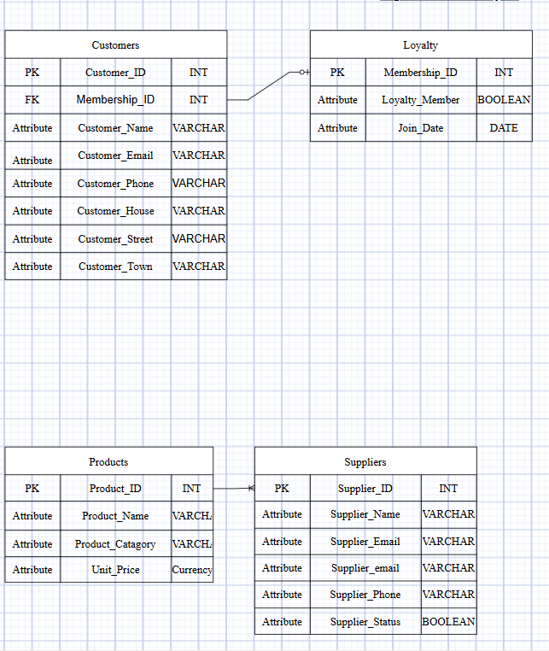
Example: Customer and Loyalty Program Relationship

Membership_ID, identified as the foreign key in the customers table, is used to connect loyalty customers and loyalty membership.

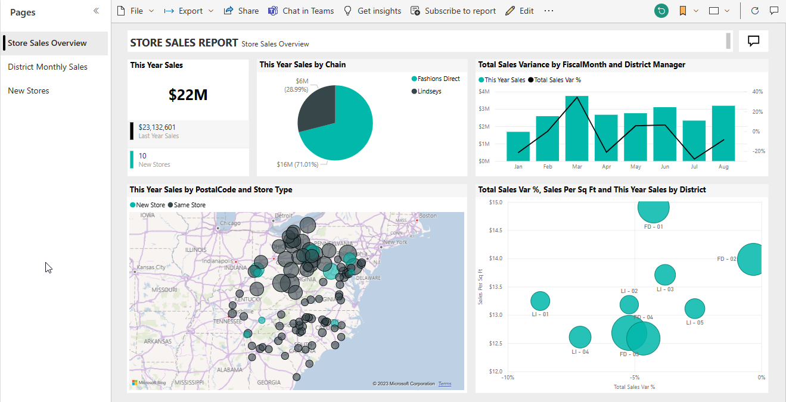
Paws & Whiskers can benefit from structured data to improve by using evidence-based data to make informed decisions (IBM). Analytical processing (Microsoft Learn) enhances data insight using complex calculations.

Example:
Gathering insights from multiple stores across a region to monitor sales and identify trends. This will enable stakeholders to make informed decisions, such as implementing a promotion to drive sales of a new product.(Microsoft Learn)

Data Warehouse
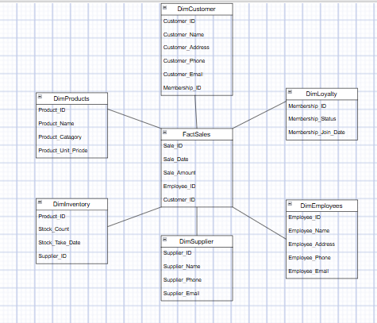

Data warehouses are implemented for managing scalable storage for both semi-structured and structured data (Microsoft Learn). It is a suitable approach for Paws & Whiskers as it supports decision-making through reporting and integration of SQL (Microsoft Azure).


Star Schema
Star schemas support Paws & Whiskers in effectively managing data through one centralized fact table (GeeksforGeeks). It is a multidimensional model used to improve analytics with the ability to process large datasets (Data Bricks).

Data Formats
Azure provides several suitable storage formats, including CVS, JSON, and Parquet, to support Paws & Whiskers with effective data management (DEV). Each format is designed to store and manage different data types.

CVS (Comma Separated Values)
Paws & Whiskers can use CVS files to store raw Epos data such as daily reports (EposNow). They are widely used for storing and transferring clear text files (GeeksforGeeks) and are suitable for Blob storage (Microsoft Learn).

JSON(JavaScript Object Notation)
Paws & Whiskers can use JSON files to support data management and web use (W3Schools). Supports SQL (Microsoft Learn) structured method.

Parquet (Columnar Storage Format)
Paws & Whiskers can use Parquet to support data management and process complex datasets (Data Bricks) using Blobs and Synapse Analytics (Microsoft Learn).

Data Security
In line with the law and industry standards, Azure provides several security tools designed to maintain data security (Microsoft Azure).

Access Controls
Paws & Whiskers can use role-based access control (RBAC) to promote data security. RBAC prevents unauthorized access to sensitive data (Microsoft Learn), with access permissions assigned to specific job roles.

Encryption
Paws & Whiskers can maintain data security by utilizing Azure's encryption in line with industry compliance and laws (Microsoft Azure), including the Data Protection Act 2018(GovUK). Data is encrypted both in transit and at rest (Microsoft Learn), maintaining data integrity to raw CVS files such as Epos data.

DDoS Protection
Paws & Whiskers can improve cybersecurity utilising Azure Distributed Denial of Service protection (DDoS) (Microsoft Learn). They reduce the risk of operational disruption resulting from cyber attacks (Microsoft Azure), maintaining availability for authorised users and agreed SLA (Microsoft Azure).

Additional Considerations
Backup and Disaster Recovery
To maintain Paws & Whiskers data integrity and availability, Azure provides two essential security services, including Azure Backup (Microsoft Azure) and Azure Recovery (Microsoft Azure). Azure backups provide Paws & Whiskers with safeguarding of data, such as Epos reports stored in blobs, in a secure and scalable way. While also protecting Paws & Whiskers from cyber attacks, including ransomware (Microsoft Learn). Additionally, Azure recovery aids Paws & Whiskers with business continuity by maintaining operations in the event of disruption (Microsoft Learn)

Visualisation
Paws & Whiskers can utilise Power BI (Microsoft Learn) within Azure to create insightful dashboard reports that support stakeholders in making informed decisions. Power BI is compatible with other Azure services, including Synapse Analytics and SQL Data Lakes. Visualising data, such as Epos reports and inventory stock, enables patterns and trends to be identified. Dashboards translate data into charts and graphs, highlighting key information, like store performance.

Conclusion
In conclusion, migrating from spreadsheets to Microsoft Azure will enable Paws & Whiskers to streamline large datasets and improve decision-making, while maintaining compliance with industry standards. Storage solutions, including Azure Blob Storage and SQL Database, provide reliable and scalable platforms with the ability to process structured and unstructured data. Advanced analytic tools, Synapse Analytics and Data Factory, enhance business intelligence through refined insights and clear visualisations. In addition, robust security measures, such as encryption and DDoS protection, allow Paws & Whiskers to grow while ensuring protection in relation to customer data. Integrating Azure will ensure Paws & Whiskers makes informed decisions while continuing to develop.

Course Notes

It is recommended to take notes from the course, use the space below to do so, or use the revision guide shared with the class:

Additional Information

We have included a range of additional links to further resources and information that you may find useful, these can be found within your revision guide.

END OF WORKBOOK

Please check through your work thoroughly before submitting and update the table of contents if required.

Please send your completed work booklet to your trainer.

