Data Technician
Week 2 Workbook
Tableau and Power BI

Name:
Course Date:
Table of contents
Day 2: Task 1 3
Day 2: Task 2 6
Day 3: Task 1 8
Day 3: Task 2 (Optional) 9
Day 4: Task 1 10
Day 4: Task 2 12
Day 4: Task 3 (Optional) 13
Course Notes 13
Additional Resources to learn and Practice 14

Day 2: Task 1
Start new Tableau page.
Download GapminderHealth.xlsx dataset.
Using the Health GapminderHealth dataset, conduct an analysis to find trends and key information that could be used by an organisation for future support.

Column Name | Description | Data Type | Example
Continent | Continent where the country is located. | Text | Asia
Country | Name of the country. | Geographic | Afghanistan
Year | Year of observation or measurement. | Numeric | 1990
Life Expectancy | Average number of years a person is expected to live at birth. | Numeric | 48.9
Gender | Gender group for which the metrics are reported. | Text | Women
BMI | Average Body Mass Index of the population. | Numeric | 20.7
Blood Pressure | Average blood pressure measurement of the population. | Numeric | 124
Cholesterol | Average cholesterol level of the population. | Numeric | 4.55
Lung Cancer | Lung cancer incidence | Numeric | 194
Liver Cancer | Liver cancer incidence | Numeric | 107
Stomach Cancer | Stomach cancer incidence | Numeric | 406
Population | Total population of the country for the specified year. | Numeric | 6,067,694
Population Growth | Annual population growth rate expressed as a percentage. | Decimal (%) | 6.75

Scenario:
You are a data analyst working for a global health organization. Your team needs to quickly understand key health trends and disparities across different countries and continents. They are particularly interested in seeing how health metrics vary and how life expectancy has changed over time.
Your Task:
Using the GapminderHealth dataset in Tableau, create a series of visualizations to answer the following questions. Focus on using basic chart types and features.

Instructions & Deliverables:
- Life Expectancy by Continent (Most Recent Year):
  - Create a bar chart showing the average Life Expectancy for each Continent.
  - Filter the data to show only the most recent year available in the dataset.
  - Sort the continents by Life Expectancy in ascending or descending order.
  - Deliverable: A worksheet named "Life Expectancy by Continent".

- Life Expectancy Trend Over Time (Top 5 Countries):
  - Create a line chart to show the trend of Average Life Expectancy over Year.
  - Filter the data to display only the top 5 countries with the highest average Life Expectancy across all years. (Hint: Use a Top N filter on Country based on Average Life Expectancy).
  - Use Country on Colour to differentiate the lines.
  - Deliverable: A worksheet named "Life Expectancy Trend".

- Population Distribution by Gender (Latest Year for a Selected Country):
  - Create a pie chart showing the Population distribution by Gender.
  - Add a Country filter to the worksheet (e.g., set it to 'United States' or a country of your choice initially, but ensure the filter is available for interaction). Change filter type to Single Value (dropdown).
  - Filter the data to show only the most recent year available in the dataset.
  - Add Population to Labels. Right click on sum (Population) under marks card and change Quick table calculation to Percentage of Total.
  - Deliverable: A worksheet named "Population by Gender".

- Health Metric Comparison (Scatter Plot):
  - Create a scatter plot to explore the relationship between Average Life Expectancy and Average BMI.
  - Place Life Expectancy on one axis and BMI on the other.
  - Use Country on Detail to represent individual countries as points.
  - Use Continent on Colour to differentiate points by continent.
  - Add Continent to filters and show filter.
  - Deliverable: A worksheet named "Life Expectancy vs BMI".
- Viz of your Choice
  - Use any other fields or chart types to add another visual.

- Dashboard Creation:
  - Combine all worksheets (Life Expectancy by Continent, Life Expectancy Trend, Population by Gender, Life Expectancy vs BMI, Viz of your Choice) into a single dashboard.
  - Ensure the "Country" filter on the "Population by Gender" worksheet applies to the "Life Expectancy Trend" worksheet as well (if applicable or make it a global filter if you prefer the user to select one country to see all relevant details for it). Self-correction: Given it's basic, let's keep the filters simple. Just place the filter on the dashboard and ensure it's applied to the relevant sheet(s) where it makes sense.
  - Add a Title to your dashboard, e.g., "Global Health Insights".
  - Publish your dashboard to Tableau Public Website
  - Deliverable: A dashboard named "Global Health Dashboard".

Paste your dashboard screens here | 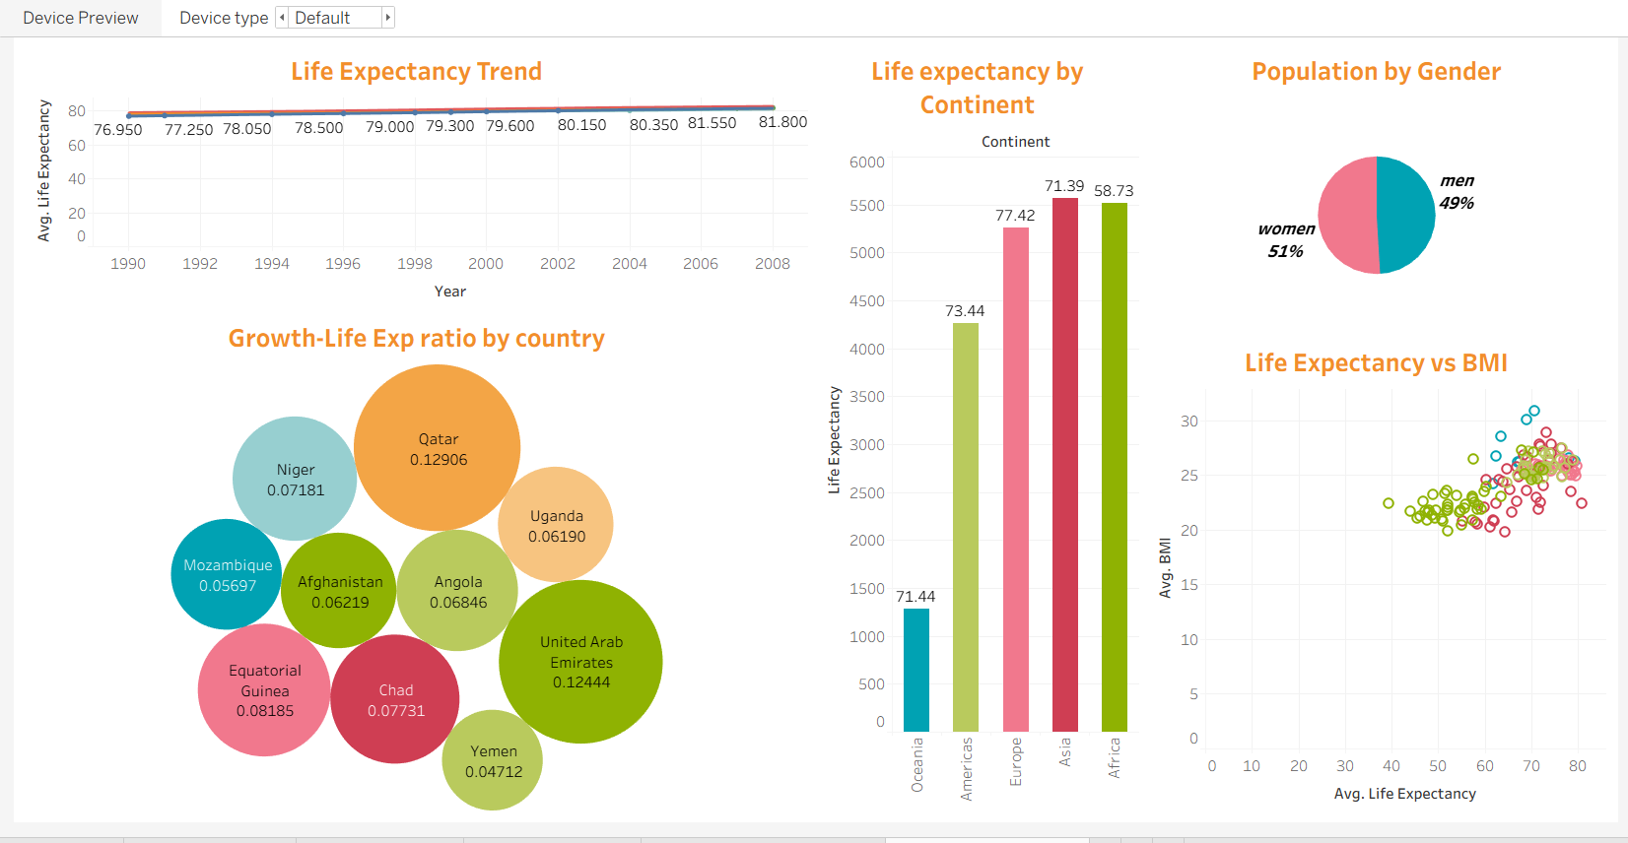
What did you find and any reflections on how the NHS could use this? | A few critical patterns stand out from the dashboard:  Rising life expectancy from 77 to 82 years.  Europe leads in life expectancy, while regions like Africa lag behind.  Higher BMI levels closely correlate with life expectancy, highlighting the impact of modern lifestyle diseases.  NHS should focus on elderly and aging population, men's population (since women generally live longer than men), also they should compare regional performances to ensure money is spent where it yields the highest health improvements.
Link to your dashboard | https://public.tableau.com/views/GapminderHealth_17846432241650/GapminderHealthday2?:language=en-US&:sid=&:redirect=auth&:display_count=n&:origin=viz_share_link

