**Fundamental Theorem of Calculus (FTC) and Its Relationship with Density Functions and Cumulative Distribution Functions (CDFs)**

**1. The Fundamental Theorem of Calculus (FTC)**

The Fundamental Theorem of Calculus (FTC) establishes the essential connection between **differentiation** and **integration**. It is usually divided into two complementary parts:

**FTC Part 1 – Differentiation of an Integral**

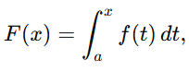If f is continuous on an interval [a,b], and we define

then F is differentiable on (a,b), and its derivative is

**Interpretation:** Differentiation and integration are inverse processes. The derivative of the accumulated area under the curve of f(t)f(t)f(t) is simply the function itself.

### ****FTC Part 2 – Evaluation of a Definite Integral****

If F is any antiderivative of f (i.e., F′(x)=f(x)), then

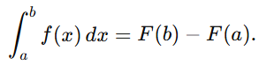

**Interpretation:** A definite integral can be computed by evaluating an antiderivative of the integrand at the endpoints of the interval.

**2. Connection to Probability Theory**

In probability theory, the FTC provides the mathematical foundation for linking **probability density functions (PDFs)** and **cumulative distribution functions (CDFs)** for continuous random variables.

**2.1 Probability Density Function (PDF)**

A **probability density function** f(x) describes how probability is distributed over the real line for a continuous random variable X.

Key properties:

* *f*(x)≥ 0 for all x.
* The total probability is 1:

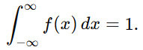

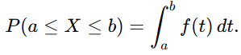**Important Note:** For continuous random variables, f(x) itself is not the probability that X takes the value x. Instead, probabilities are obtained as **areas under the density curve**. For example, the probability that X lies in an interval [a,b] is:

### ****2.2 Cumulative Distribution Function (CDF)****

The **cumulative distribution function** (CDF) of X is defined as:

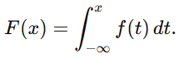Using the PDF, this can be expressed as:

This definition is a direct application of FTC Part 2: the CDF accumulates the probability density up to the point x.

### ****2.3 Connecting PDFs and CDFs via the FTC****

The relationship between PDFs and CDFs follows directly from the two parts of the FTC:

1. **From CDF to PDF (Differentiation):**  
   If F(x) is differentiable, then by FTC Part 1:



The PDF is the derivative of the CDF.

1. 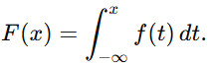**From PDF to CDF (Integration):**  
   Since the CDF is defined as an integral of the PDF, by FTC Part 2:

The CDF is the accumulated area under the PDF curve.

1. **Probability over an interval:**  
   The probability that X falls between two values a and b can be written either as an integral of the PDF or as a difference of CDF values:

