**Shannon Entropy, Diversity Measures, and Primitive Roots**

**Shannon Entropy and Diversity Measures**

**Shannon Entropy**, introduced by Claude Shannon in the context of information theory, measures the level of uncertainty or randomness in a probability distribution. For a discrete distribution

P={*p1,p2,…,pn*},

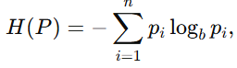the Shannon entropy is defined as:

where the base b of the logarithm determines the units of entropy (e.g., b=2 gives entropy in bits, while b= e gives entropy in nats). This formula expresses the expected amount of information or uncertainty associated with the outcome of a random variable.

Entropy and related measures are fundamental in **cryptography**, **data compression**, and **statistics**, because they quantify how unpredictable or diverse a dataset is.

**Other Diversity Measures**

Several generalizations and alternatives to Shannon entropy are widely used:

* **Rényi Entropy**:  
  A generalization of Shannon entropy, defined as

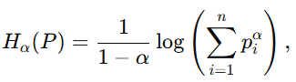

where α>0, α≠1.

As α→1, Rényi entropy converges to Shannon entropy.

* **Tsallis Entropy**:  
  Another generalization, expressed as

which reduces to Shannon entropy when q→1.  
This measure is often applied in physics and complex systems.

* **Simpson’s Index**:  
  Commonly used in ecology, defined as
* 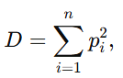

which represents the probability that two randomly chosen individuals belong to the same category. Its complement, 1− D, is also used as a diversity measure.

## ****Primitive Roots****

In number theory, a **primitive root modulo p** (where p is prime) is an integer g with the following property:

For every integer a that is coprime to p (gcd(a,p) = 1), there exists an integer k such that

In other words, g is a generator of the multiplicative group of integers modulo p, denoted (Z/pZ)×.   
This means that every nonzero residue modulo p can be expressed as some power of g.

Primitive roots always exist for prime moduli and play an essential role in **cryptography** (e.g., Diffie–Hellman key exchange, ElGamal encryption), since they allow the construction of secure cyclic groups used in modular arithmetic–based algorithms.

