LASSA FEVER IN NIGERIA: TRENDS IN INCIDENCE, MORTALITY AND PUBLIC HEALTH CHALLENGE.

Introduction
Lassa fever is a viral haemorrhagic illness caused by the Lassa virus and is spread mainly through contact with the multimammate rat, Mastomys natalensis.¹,³ Infection occurs through food or surfaces contaminated with rat urine or faeces, or through bodily fluids of infected individuals.³ Non-rodent hosts such as domestic animals, birds and lizards can also be vectors.³ Index case was in 1969 at a town in Borno state; the disease has since evolved rapidly been a persistent endemic in Nigeria and across West Africa.¹ Today, the disease affects 34 of Nigeria's 36 states.⁵ West Africa records between 100,000 and 300,000 new infections annually, with an estimated 5,000 deaths per year.³ Nigeria bears the greatest share of this burden. As of January 2025, NCDC data revealed that within a single three-week window, over a thousand suspected cases were logged, with 53 confirmed deaths and a case fatality rate of 18.3%.⁵ Lassa fever is an active, recurring crisis that demands sustained attention.

The Core
Nigeria recorded high annual confirmed case counts between 2018 and 2023, rising from 633 confirmed cases in 2018 to 1,270 in 2023, spanning 29 states and 125 local government areas.² Ondo, Edo, and Bauchi states consistently account for the most confirmed cases since 2016.³
High incidence is typically recorded during the dry season, between November and April, where the harsh conditions cause the migration of the multimammate rats into human settlements.³,⁵ This cycle is perpetuated by poor hygiene and lifestyle practices, unsafe food handling and storage, and continued contact with M. natalensis, including bushmeat consumption.³ Other social and ecological factors include rapid urbanisation, leading to overcrowding, poor sanitation, weak waste management, and deforestation, which make rodent infestation more likely.³,⁴
Mortality is worsened when cases are not detected early or managed effectively. Diagnosis is difficult because symptoms are often nonspecific — fever, muscle pain, sore throat, nausea, vomiting, and chest and abdominal pain — which overlap significantly with other common febrile illnesses in Nigeria.¹,² Weak surveillance systems further compound this challenge. Nigeria's Integrated Disease Surveillance and Response (IDSR) framework, but incomplete data capture from remote areas and delayed laboratory confirmation continue to hamper outbreak response.⁵ Traditional surveillance methods mostly do not detect outbreaks before damage has already been done [5].
Treatment options remain limited as there are no specifically licensed antivirals, and commonly used therapies such as ribavirin and convalescent plasma have limited clinical evidence.⁴ High treatment costs reduce access for low-income households.⁴ Underfunded health systems, inadequate facilities including isolation centres, insufficient trained personnel, and gaps in infection prevention and control in hospitals can increase severe outcomes and healthcare-associated transmission.⁴ Weak political commitment, fragmented coordination across government levels, and reliance on emergency donor funding keep the response reactive rather than preventive, allowing outbreaks to grow and increasing avoidable deaths.⁴

Recommendations / Public Health Implications
- Community-Based Education and Behaviour Change: Students, clinicians, and community health professionals have a role in educating the public on the significance of Lassa fever burden in Nigeria through outreach activities and community postings.³,⁴ The public must be aware of different ways they can protect themselves and reduce the burden, such as making their homes rodent-proof, properly storing and drying food, and proper waste disposal, ensuring anything that will attract rodents is not disposed of in a place they can easily access.³
- Research Exploits: With recent AI advances, detecting or predicting early outbreaks has high potential.⁵ More professionals combining health education and technology skills are needed to aid research and ensure quality data is fed into surveillance systems.⁵ Research on vaccine development also requires increased promotion and investment.⁴
- Infection Prevention and Control Protocols: Healthcare workers account for a significant proportion of Lassa fever cases and deaths.⁴ Full barrier nursing, appropriate PPE, and hand hygiene are must practices in any encounter with a suspected case.⁴
- Integrated One Health Approach: This connects human health, animal reservoirs, and environmental management, and includes effective rodent control measures, stopping deforestation, urban planning, and cross-sector policy coordination.³,⁴,⁵

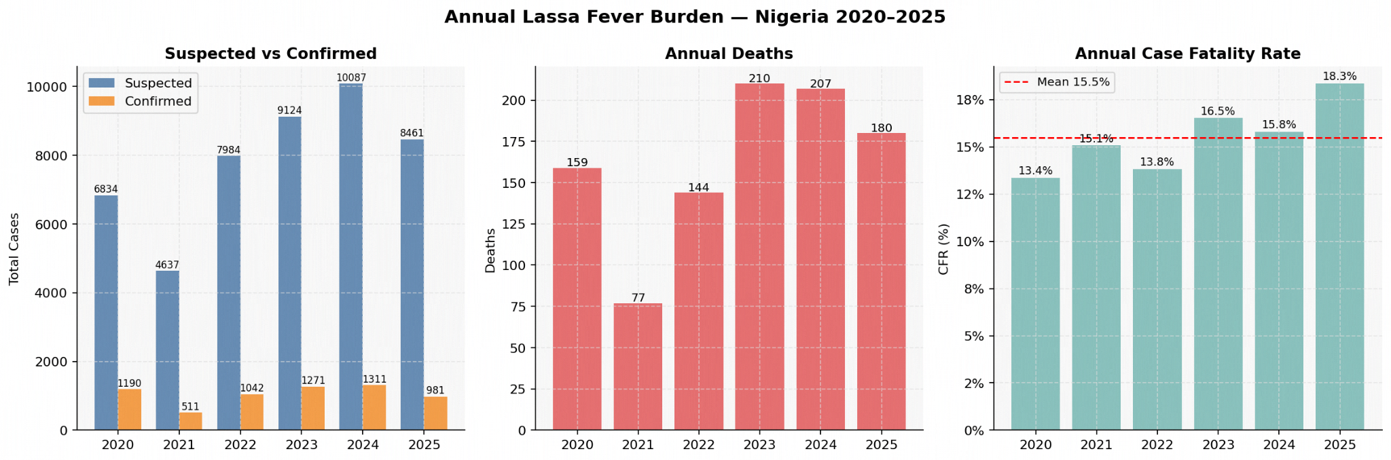
Figure 1: Annual Lassa Fever Burden in Nigeria, 2020–2025 — Suspected vs. Confirmed Cases, Deaths, and Case Fatality Rate (CFR).
The charts illustrate year-on-year trends derived from 307 weeks of epidemiological surveillance data, highlighting the 2021 peak in confirmed cases and deaths, and persistent CFR variability ranging from approximately 10–21% across the period.
Source: Nigeria Centre for Disease Control (NCDC) Weekly Situation Reports, ncdc.gov.ng.

References
- Naeem A, Idris I, Bakre AA, Arthur JF, D'Souza JN. Re-emergence of Lassa fever in Nigeria: a new challenge for public health authorities. Health Sci Rep. 2023;6(10):e1628. doi:10.1002/hsr2.1628
- Al-Mustapha AI, Adesiyan IM, Orum TG, Ogundijo OA, Lawal AN, Nzedibe OE, et al. Lassa fever in Nigeria: epidemiology and risk perception. Sci Rep. 2024;14(1):27669. doi:10.1038/s41598-024-78726-3
- Izah SC, Ovuru KF, Ogwu MC. Lassa fever in Nigeria: social and ecological risk factors exacerbating transmission and sustainable management strategies. Int J Trop Dis. 2022;5:065. doi:10.23937/2643-461X/1710065
- Eneh SC, Obi CG, Ikpongifono UE, Dauda Z, Udoewah SA, Anokwuru CC, et al. The resurgence of Lassa fever in Nigeria: economic impact, challenges, and strategic public health interventions. Front Public Health. 2025;13:1574459. doi:10.3389/fpubh.2025.1574459
- Ogah JI, Kolawole CF, Uthman OA, Kolawole OM. The prospects of machine learning approaches for early detection of Lassa fever outbreaks using integrated surveillance data in Nigeria. Biokemistri. 2026;38(1):21-38.

