Homework – 3 : Computer Networks Lab
الطالب بهاء الدين نوفل – 202311316

The topology required for this homework is as following:
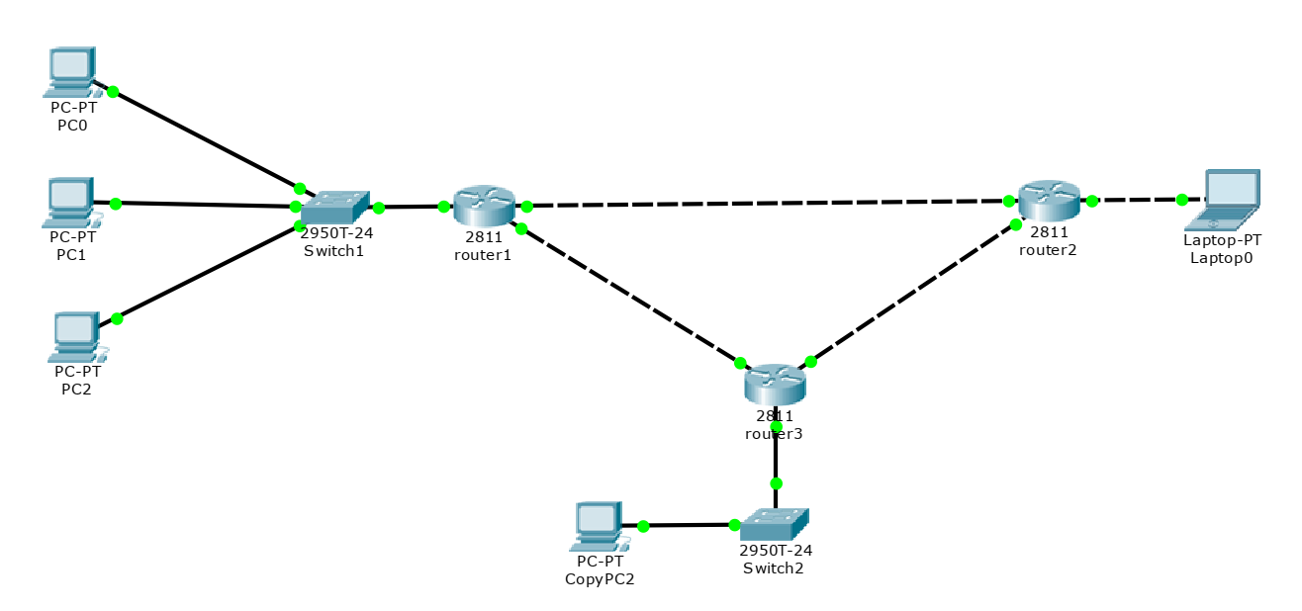
128.18.0.0
192.168.1.2
192.168.1.1
128.17.0.0
192.168.3.1
192.168.2.1
192.168.2.2
192.168.3.2
University
Prof Home

127.19.0.0
My Home

Topology used with each IP for each router interface, and the three inner network pools: 128.17.0.0, 128.18.0.0, 128.19.0.0
where router 2 on the right side is the router for DHCP configuration. All pools are configured on this router.

Showing that the design is correct using ping.
Ping on device PC0 to Laptop0 (from left network to right network):
(laptop0 has the IP address: 128.17.0.2)
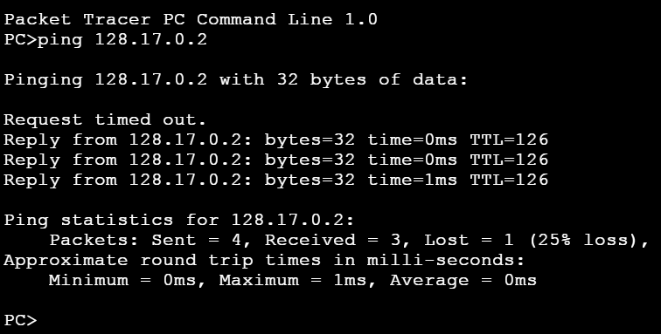

The first request timed out because devices needed some time to see each other. Let’s also try from PC2 to CopyPC2 (I forgot to name this device so it remained “CopyPC2”).
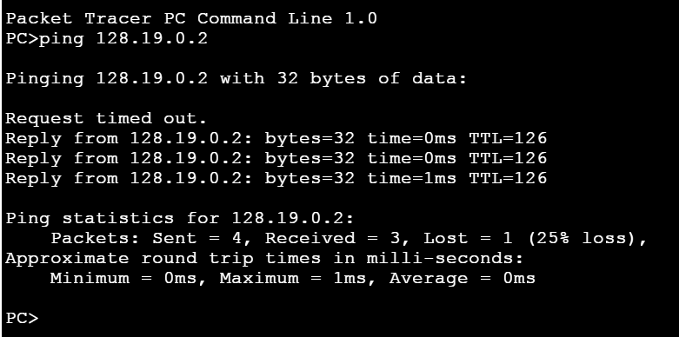

The Router-Router Connection IPs:
Router1: 192.168.1.2, 192.168.3.1
Router2: 192.168.1.1, 192.168.2.1
Router3: 192.168.3.2, 192.168.2.2
The Router-Switch/Device Connection IPs:
Router1: 128.18.0.1
Router2: 128.17.0.1
Router3: 128.19.0.1

Telnet and SSH Configuration:
The difference between SSH and Telnet is that SSH requires the following
commands to work:
username admin password 123
ip domain-name university.edu
crypto key generate rsa
line vty 0 15
login local
transport input all
The name of the domain I used throughout the homework is university.edu.
So from that, SSH requires the following:

1. A Unique Hostname

2. An IP Domain Name

3. RSA Crypto Keys

4. Local User Accounts

5. AAA or Local Authentication on VTY Lines

6. Transport Protocol Enable.

Here are some SSH experiments between the devices:
1. SSH from PC1 (left LAN) to Router 1 (Left):
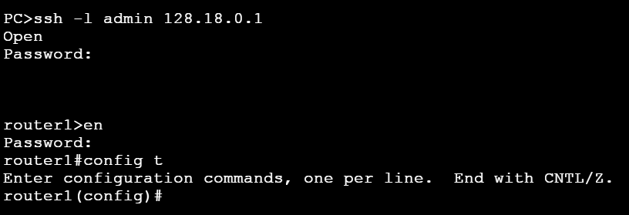
2. SSH from PC1 to Laptop0 on right LAN:
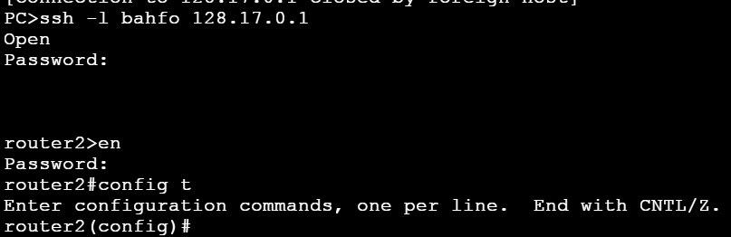
The submission contains also three .txt files. Each for each router, and the packet tracer file of the topology.

End of Solutions

