ABDM V3 — HIP Service API Documentation
Milestone 2 (M2): Link Care Contexts
Service: hip-service (In.ProjectEKA.HipService)
Linking / HFR / SMS / scan-and-share fixes
References: ABDM sandbox V3, User-initiated linking swagger, HIP-initiated linking

1. What M2 covers
Milestone 2 links a hospital visit (care context) to the patient’s ABHA address so that later M3 data transfer can happen. ABDM describes two registration situations, plus discovery that a patient can start from a PHR app at any time.
Scenario | When | HIP action
HIP-initiated linking | Patient shared ABHA address during hospital registration | On each new visit, HIP obtains a link token (if needed) and POSTs carecontext to HIE-CM
SMS notify then user-initiated | Patient did not share ABHA at registration | HIP asks ABDM to SMS a deep link; patient discovers and links from PHR
User-initiated discovery and link | Patient already has ABHA and uses PHR to find this facility | Gateway calls HIP discover / link-init / link-confirm; HIP replies with on-* callbacks
Scan and share | Patient scans facility QR in PHR at the counter | Gateway POSTs profile to HIP /api/v3/hip/patient/share; HIP queues the patient

V3 linking is still asynchronous on this HIP: Gateway (or Bahmni) POSTs, HIP returns 202 immediately, then Hangfire / background work talks to OpenMRS and callbacks HIE-CM. Clinical FHIR is not sent in M2 — only care-context reference numbers, display labels, and hiType.

2. Actors, tokens and HFR ID

2.1 Actors
Actor | Role
PHR app | Patient discovers facilities, confirms OTP, scans QR
ABDM Gateway / HIE-CM | Routes discover/link; issues link tokens; sends SMS; calls HIP callbacks
hip-service | Matches patients, sends OTP, stores links, posts on-discover / on-init / on-confirm / carecontext
OpenMRS / Bahmni | Source of patients, visits, location HFR attributes; triggers new-carecontext and SMS notify
OTP service | Sends hospital OTP for user-initiated link-init (not ABHA OTP)

2.2 Link token vs gateway session token
- Gateway session token: client_credentials accessToken on every HIP-to-ABDM HTTP call (same as M1).
- Link token (X-LINK-TOKEN): patient-scoped JWT for HIP-initiated linking. HIP stores it per ABHA address + HFR ID. JWT must contain claim abhaAddress and must not be expired (UserAuthService.CheckAccessToken).
- X-HIP-ID: HFR / HIP id of the visit location. Required on generate-token, add carecontext, and context notify.
- Composite in-memory key: abhaAddress + "##:##" + hipId in UserAuthMap.HealthIdToAccessToken. The same ABHA can have different tokens for different facilities.

2.3 Visit-wise HFR ID (V3 change)
Care context referenceNumber in this service is patientId:visitUuid. HIP extracts visitUuid, loads the OpenMRS visit location, and reads HFR ID and ABDM facility name from location attributes. Values are cached in HfrIdCache / FacilityNameCache. If the location has no HFR attribute, HIP falls back to BahmniConfiguration default hip id.
careContexts[].referenceNumber = "{openMrsPatientId}:{visitUuid}"
HIP -> OpenMRS visit -> location.attributes -> HFR ID + facility name
Used as X-HIP-ID on generate-token, link/carecontext, context/notify, and SMS hip.id

2.4 Common ABDM headers (HIP to Gateway)
Header | When
Authorization | Always — gateway session token
REQUEST-ID | Always — UUID; for generate-token HIP passes its own requestId so on-generate-token can match
TIMESTAMP | Always — UTC yyyy-MM-dd'T'HH:mm:ss.fff'Z'
X-CM-ID | Always — Gateway.cmSuffix
CORRELATION-ID | When present on inbound call
X-HIP-ID | HIP-initiated generate-token, add carecontext, context notify
X-LINK-TOKEN | HIP-initiated add carecontext and context notify

3. Flow A — User-initiated linking
Patient opens PHR, picks this facility, and asks ABDM to find records. Gateway calls HIP. HIP must return care contexts with no clinical content. After the patient selects visits, Gateway asks HIP to start linking; HIP sends an OTP to the hospital mobile and later verifies it.
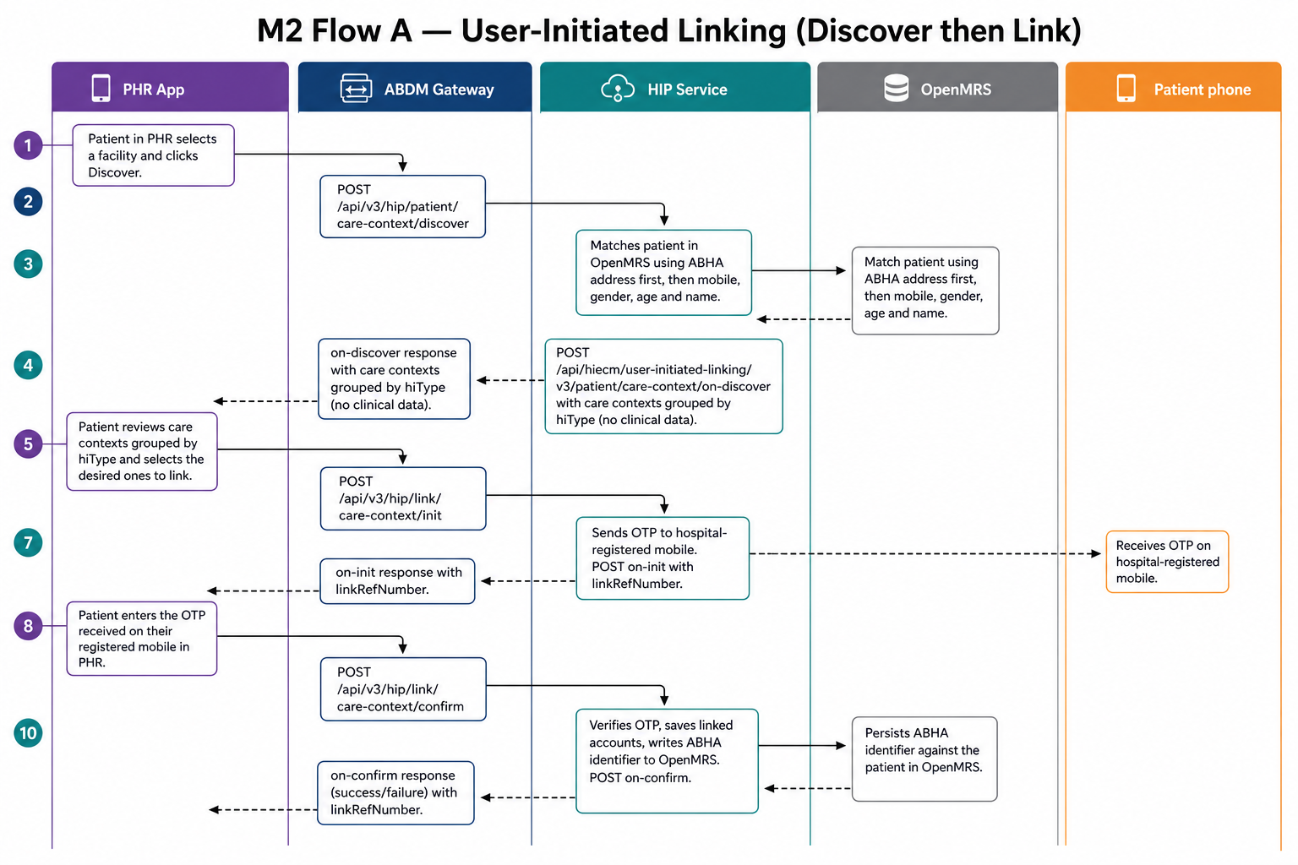
Figure 1. User-initiated discover, then link-init (OTP), then link-confirm.

3.1 Discover care contexts

Discover (Gateway to HIP)
Item | Value
Direction | ABDM Gateway -> HIP callback
HIP path | POST /api/v3/hip/patient/care-context/discover
HIP auth | Gateway scheme (Authorize)
HIP HTTP | 202 Accepted immediately; work on Hangfire
HIP callback | POST {Gateway.url}/api/hiecm/user-initiated-linking/v3/patient/care-context/on-discover
Controller | Discovery.CareContextDiscoveryController
Purpose | Match one patient in OpenMRS and return care contexts grouped by hiType

Inbound headers: CORRELATION-ID, REQUEST-ID, TIMESTAMP. If REQUEST-ID is empty, HIP generates a UUID.
Gateway request body (DiscoveryRequest)
{
"transactionId": "uuid-from-phr",
"patient": {
"id": "first.last@sbx",
"name": "First Last",
"gender": "F",
"yearOfBirth": 1990,
"verifiedIdentifiers": [
{ "type": "MOBILE", "value": "98xxxxxxxx" },
{ "type": "ABHA_NUMBER", "value": "91-xxxx-xxxx-xxxx" }
],
"unverifiedIdentifiers": [
{ "type": "MR", "value": "BAH123" }
]
}
}
Matching order used by HIP (aligned with ABDM discovery algorithm):
- ABHA address / ABHA number on the OpenMRS patient
- Else verified mobile, then gender, year of birth within +/- 5 years, phonetic name
- Else medical record (MR) identifier
- Zero or more than one match becomes an error on on-discover (No Matching Record Found or More than one Record Found)
HIP on-discover body (GatewayDiscoveryRepresentation) — success
{
"transactionId": "uuid-from-phr",
"matchedBy": ["MOBILE"],
"patient": [
{
"referenceNumber": "openMrsPatientUuid",
"display": "First Last",
"hiType": "OPConsultation",
"count": 1,
"careContexts": [
{ "referenceNumber": "openMrsPatientUuid:visitUuid", "display": "OPD 22-Aug-2026" }
]
}
],
"response": { "requestId": "<inbound REQUEST-ID>" }
}
Care contexts are grouped by hiType (OPConsultation, Prescription, DiagnosticReport, DischargeSummary, ImmunizationRecord, WellnessRecord, HealthDocumentRecord, Invoice). HIP also stores PatientInfoMap[abhaAddress] for later identifier write-back. Discovery transaction is saved so link-init can prove these contexts were discovered.

3.2 Link init (send OTP)

Link init (Gateway to HIP)
Item | Value
Direction | ABDM Gateway -> HIP callback
HIP path | POST /api/v3/hip/link/care-context/init
HIP HTTP | 202 Accepted; Hangfire LinkPatient()
HIP callback | POST {Gateway.url}/api/hiecm/user-initiated-linking/v3/link/care-context/on-init
Controller | Link.LinkController.LinkFor
Purpose | Validate discovery, generate linkRefNumber, SMS OTP to hospital mobile

Gateway request body (LinkReferenceRequest)
{
"transactionId": "uuid-from-discover",
"abhaAddress": "first.last@sbx",
"patient": [
{
"referenceNumber": "openMrsPatientUuid",
"hiType": "OPConsultation",
"count": 1,
"careContexts": [
{ "referenceNumber": "openMrsPatientUuid:visitUuid" }
]
}
]
}
HIP checks:
- Discovery request exists for this transactionId + abhaAddress + patient reference.
- Patient and each care context exist in OpenMRS.
- Saves a unique linkReferenceNumber, sends OTP via OTP service using visit facility name.
- Deletes the discovery row after OTP is queued so it cannot be reused.
HIP on-init body (success) — GatewayLinkResponse
{
"transactionId": "uuid-from-discover",
"link": {
"referenceNumber": "linkRef-uuid",
"authenticationType": "MEDIATED",
"meta": {
"communicationMedium": "MOBILE",
"communicationHint": "98xxxxxxxx",
"communicationExpiry": "2026-08-22T07:10:00.000Z"
}
},
"resp": { "requestId": "<inbound REQUEST-ID>" }
}

3.3 Link confirm (verify OTP)

Link confirm (Gateway to HIP)
Item | Value
Direction | ABDM Gateway -> HIP callback
HIP path | POST /api/v3/hip/link/care-context/confirm
HIP HTTP | 202 Accepted; Hangfire LinkPatientCareContextFor()
HIP callback | POST {Gateway.url}/api/hiecm/user-initiated-linking/v3/link/care-context/on-confirm
Controller | Link.LinkController.LinkPatientFor
Purpose | Verify OTP, persist linked accounts, write ABHA identifiers into OpenMRS

Gateway request body (LinkPatientRequest)
{
"confirmation": {
"linkRefNumber": "linkRef-uuid",
"token": "123456"
}
}
HIP on-confirm body (success) — patient list grouped by hiType
{
"patient": [
{
"referenceNumber": "openMrsPatientUuid",
"display": "First Last",
"hiType": "OPConsultation",
"count": 1,
"careContexts": [
{ "referenceNumber": "openMrsPatientUuid:visitUuid", "display": "OPD 22-Aug-2026" }
]
}
],
"resp": { "requestId": "<inbound REQUEST-ID>" }
}
On success HIP also POSTs ABHA number + ABHA address to OpenMRS ws/rest/v1/hip/existingPatients/update/{patientUuid} and dumps NdhmDemographics (healthId, name, gender, YOB, mobile) so later HIP-initiated linking can generate a link token from demographics.

4. Flow B — HIP-initiated linking
Used when the hospital already knows the ABHA address (M1 login/create, or scan-and-share, or a previous link). Bahmni notifies HIP of a new visit. If that care context is not yet linked, HIP gets a link token (cached or via demographic generate-token) and POSTs link/carecontext. If it is already linked, HIP only notifies the new records.
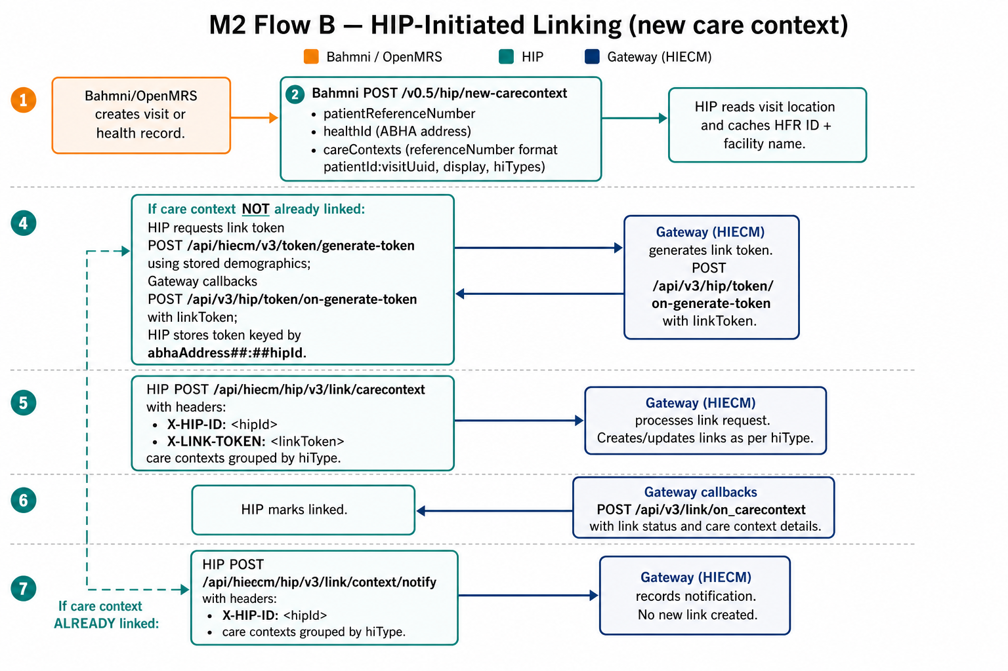
Figure 2. HIP-initiated linking: new-carecontext, generate-token, add carecontext or context notify.

4.1 Bahmni entry: new care context

Pass new care contexts (Bahmni to HIP)
Item | Value
Direction | Bahmni / OpenMRS -> HIP
HIP path | POST /v0.5/hip/new-carecontext
HIP HTTP | 200 OK when processed; 500 on failure
Controller | Link.CareContextController.PassContext
Purpose | For each care context: cache HFR from visit, then add (first link) or notify (already linked)

HIP request body (NewContextRequest)
{
"patientReferenceNumber": "openMrsPatientUuid",
"patientName": "First Last",
"healthId": "first.last@sbx",
"careContexts": [
{
"referenceNumber": "openMrsPatientUuid:visitUuid",
"display": "OPD 22-Aug-2026",
"hiTypes": ["OPConsultation", "Prescription"]
}
]
}
Per care context HIP does:
- On the first context, SetHfrIdForVisitAsync(visitUuid) from OpenMRS location attributes.
- If referenceNumber is already in linked care contexts → CallNotifyContext.
- Else → CallAddContext (generate/reuse link token, then POST carecontext).

4.2 Generate link token (demographic auth)
CallAddContext first tries an in-memory token for abhaAddress##:##hipId. If missing or expired, it loads AuthConfirm from DB for that healthId+hipId. If still missing, it POSTs generate-token using dumped demographics and waits (polls RequestIdToAccessToken) until Gateway callbacks on-generate-token.

Generate token (HIP to Gateway)
Item | Value
Direction | HIP -> Gateway
Gateway path | POST /api/hiecm/v3/token/generate-token
HIP callback | POST /api/v3/hip/token/on-generate-token
Controller (callback) | UserAuth.UserAuthController.OnGenerateLinkToken
Purpose | Obtain X-LINK-TOKEN for this ABHA at this HFR without a new OTP if demographics match

HIP generate-token body (GenerateLinkTokenRequest)
{
"abhaAddress": "first.last@sbx",
"name": "First Last",
"gender": "F",
"yearOfBirth": "1990"
}
Headers include X-HIP-ID = visit HFR id and REQUEST-ID = HIP’s requestId.
Gateway callback body (OnGenerateTokenRequest)
{
"abhaAddress": "first.last@sbx",
"linkToken": "<jwt>",
"response": { "requestId": "<HIP requestId>" },
"error": null
}
HIP validates JWT (abhaAddress claim, exp), upserts AuthConfirm(healthId, hipId, token) in DB, and sets HealthIdToAccessToken[abhaAddress##:##hipId]. Errors on the callback are stored in RequestIdToErrorMessage so the waiting add-context loop can stop.

4.3 Add care context (first link of this visit)

Add carecontext (HIP to Gateway)
Item | Value
Direction | HIP -> Gateway
Gateway path | POST /api/hiecm/hip/v3/link/carecontext
HIP callback | POST /api/v3/link/on_carecontext
Controller (callback) | Link.LinkController.HipLinkOnAddContexts
Purpose | Attach care contexts to ABHA using X-LINK-TOKEN and X-HIP-ID

HIP body (GatewayAddContextsRequestRepresentation)
{
"abhaAddress": "first.last@sbx",
"patient": [
{
"referenceNumber": "openMrsPatientUuid",
"display": "First Last",
"hiType": "OPConsultation",
"count": 1,
"careContexts": [
{ "referenceNumber": "openMrsPatientUuid:visitUuid", "display": "OPD 22-Aug-2026" }
]
}
]
}
HIP generates a unique linkReferenceNumber per add request, saves initiated link + care context names, and groups patient[] by hiType (same shape as user-initiated on-confirm). Missing link token throws and the Bahmni call returns 500.
Callback HipLinkContextConfirmation: on Status success HIP VerifyAndLinkCareContexts(requestId) marks link rows and SaveLinkedAccounts.

4.4 Notify existing care context (new records on an already linked visit)

Context notify (HIP to Gateway)
Item | Value
Direction | HIP -> Gateway
Gateway path | POST /api/hiecm/hip/v3/link/context/notify
HIP callback | POST /api/v3/links/context/on-notify
Controller (callback) | Link.CareContextController.HipLinkOnNotifyContexts
Purpose | Tell PHR apps that an already-linked care context has new hiTypes / records

HIP body (GatewayNotificationContextRepresentation)
{
"notification": {
"patient": { "id": "first.last@sbx" },
"careContext": {
"patientReference": "openMrsPatientUuid",
"careContextReference": "openMrsPatientUuid:visitUuid"
},
"hiTypes": ["OPConsultation", "Prescription"],
"date": "2026-08-22T06:40:00.000Z",
"hip": { "id": "IN2710001820" }
}
}
Requires a valid in-memory link token for that ABHA+HFR. Callback is logged only (acknowledgement status).

5. Flow C — SMS notify (no ABHA at registration)
When Bahmni has only a phone number, HIP cannot HIP-initiate. It asks ABDM to SMS a deep link. The patient opens PHR and runs Flow A (discover + link) against this facility. HIP resolves facility id/name from the latest visit cached for that phone’s ABHA; if the phone is unknown it returns 400.
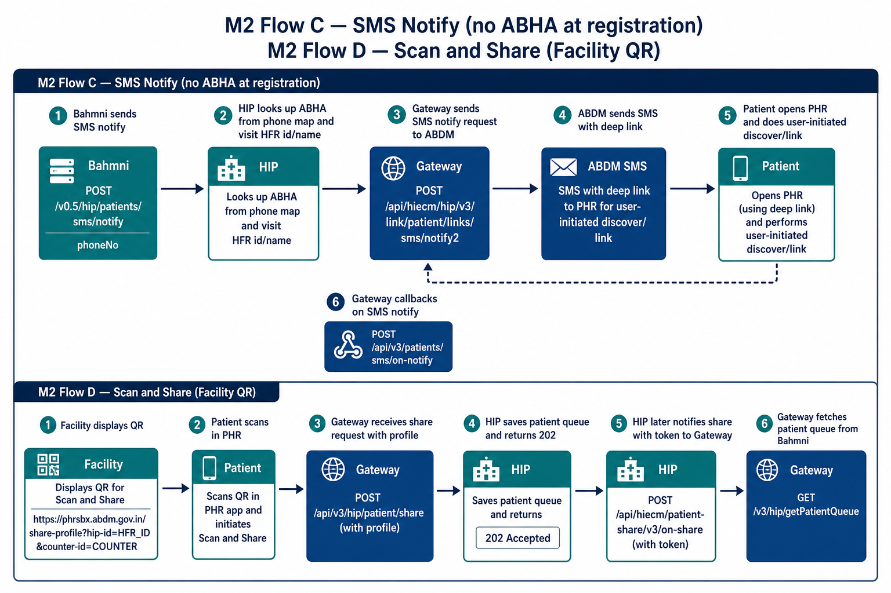
Figure 3. Top: SMS notify. Bottom: scan-and-share facility QR.

SMS notify (Bahmni to HIP to Gateway)
Item | Value
Direction | Bahmni -> HIP -> Gateway
HIP path | POST /v0.5/hip/patients/sms/notify
Gateway path | POST /api/hiecm/hip/v3/link/patient/links/sms/notify2
Gateway callback | POST /api/v3/patients/sms/on-notify
Controller | SmsNotification.SmsNotificationController
Purpose | ABDM sends SMS deep link so the patient can discover/link this HIP

HIP request body (SmsNotifyRequest)
{
"phoneNo": "98xxxxxxxx"
}
HIP to Gateway body
{
"notification": {
"phoneNo": "98xxxxxxxx",
"hip": {
"name": "<URL-encoded facility name>",
"id": "<URL-encoded HFR id>"
}
}
}
Resolution rules in SmsNotificationService:
- phoneNo is required; empty → 400 Phone number is required.
- Phone is normalized (strip +91 / 91) and looked up in PhoneNumberToHealthId.
- Unknown phone → 400 No details found for the given phone number.
- If HealthIdToLatestVisitUuid has a visit, use that visit’s HFR id and facility name; else Bahmni defaults.
CallAddContext seeds PhoneNumberToHealthId from demographics before generate-token so SMS notify does not race. on-notify is log-only (status or error).

6. Flow D — Scan and share (facility QR)
The QR must use ABDM’s PHR domain, not the hospital domain. PHR validates the HIP id, then Gateway posts the patient profile to the registered HIP callback.
Sandbox QR URL
https://phrsbx.abdm.gov.in/share-profile?hip-id={HFR_ID}&counter-id={COUNTER}

Share profile (Gateway to HIP)
Item | Value
Direction | ABDM Gateway -> HIP callback
HIP path | POST /api/v3/hip/patient/share
HIP HTTP | 202 Accepted if valid; 400 if invalid body
HIP callback (after ~500 ms) | POST {Gateway.url}/api/hiecm/patient-share/v3/on-share
Bahmni poll | GET /v3/hip/getPatientQueue (Bahmni auth)
Controller | Patient.PatientController
Purpose | Receive ABHA profile at the counter and queue the patient for registration

Gateway request body (ShareProfileRequest)
{
"intent": "PROFILE_SHARE",
"metadata": {
"hipId": "IN2710001820",
"context": "REGISTRATION-DESK-1",
"hprId": null,
"latitude": "...",
"longitude": "..."
},
"profile": {
"patient": {
"abhaAddress": "first.last@sbx",
"abhaNumber": "91-xxxx-xxxx-xxxx",
"name": "First Last",
"gender": "F",
"yearOfBirth": 1990,
"phoneNumber": "98xxxxxxxx"
}
}
}
HIP on-share acknowledgement (success)
{
"acknowledgement": {
"status": "SUCCESS",
"abhaAddress": "first.last@sbx",
"profile": {
"context": "REGISTRATION-DESK-1",
"token": "<queue-token>",
"expiry": "1800"
}
},
"response": { "requestId": "<inbound request-id>" }
}
token is an integer queue number from SavePatient. Bahmni uses GET /v3/hip/getPatientQueue (Bahmni auth) to pick up shared profiles. metadata.context is the counter-id from the QR. Callback URL must be public HTTPS and registered in ABDM sandbox as https://{hip-host}/api/v3/hip/patient/share.

7. Optional: HIP-side user auth (fetch-modes / init / confirm)
These v0.5 HIP APIs are still used when Bahmni wants a linking token through patient KYC (MOBILE_OTP, AADHAAR_OTP, DEMOGRAPHICS, DIRECT) instead of silent generate-token. They talk to Gateway users/auth/* and store the same HealthIdToAccessToken / AuthConfirm used by Flow B.
HIP API | Gateway API | Callback on HIP | Notes
POST /v0.5/hip/fetch-modes (Bahmni auth) | POST /v0.5/users/auth/fetch-modes | POST /v0.5/users/auth/on-fetch-modes | Returns auth modes + HIP always appends DIRECT. Polls until callback or 504.
POST /v0.5/hip/auth/init (Bahmni auth) | POST /v0.5/users/auth/init | POST /v0.5/users/auth/on-init | Stores transactionId per healthId. purpose often KYC_AND_LINK.
POST /v0.5/hip/auth/confirm (Bahmni auth) | POST /v0.5/users/auth/confirm | POST /v0.5/users/auth/on-confirm | authCode is Base64 OTP, or Demographic object. Returns patient details; saves accessToken.
POST /v0.5/hip/auth/direct (Bahmni auth) | (patient approves in PHR) | POST /v0.5/users/auth/notify then HIP POST /v0.5/users/auth/on-notify | Polls GRANTED/DENIED. GRANTED also saves accessToken.
POST /v0.5/hip/ndhm-demographics | local only | — | Persists NdhmDemographics for later generate-token.

fetch-modes / auth-init request sketch
POST /v0.5/hip/fetch-modes
{ "healthId": "first.last@sbx", "purpose": "KYC_AND_LINK" }
POST /v0.5/hip/auth/init
{ "healthId": "first.last@sbx", "authMode": "MOBILE_OTP", "purpose": "KYC_AND_LINK" }
POST /v0.5/hip/auth/confirm
{ "healthId": "first.last@sbx", "authCode": "<Base64 OTP>" }

8. M2 API catalogue
# | HIP / Gateway path | Direction | Flow
A1 | POST /api/v3/hip/patient/care-context/discover | GW -> HIP | User-initiated
A1b | POST /api/hiecm/user-initiated-linking/v3/patient/care-context/on-discover | HIP -> GW | User-initiated
A2 | POST /api/v3/hip/link/care-context/init | GW -> HIP | User-initiated
A2b | POST /api/hiecm/user-initiated-linking/v3/link/care-context/on-init | HIP -> GW | User-initiated
A3 | POST /api/v3/hip/link/care-context/confirm | GW -> HIP | User-initiated
A3b | POST /api/hiecm/user-initiated-linking/v3/link/care-context/on-confirm | HIP -> GW | User-initiated
B0 | POST /v0.5/hip/new-carecontext | Bahmni -> HIP | HIP-initiated
B1 | POST /api/hiecm/v3/token/generate-token | HIP -> GW | HIP-initiated
B1b | POST /api/v3/hip/token/on-generate-token | GW -> HIP | HIP-initiated
B2 | POST /api/hiecm/hip/v3/link/carecontext | HIP -> GW | HIP-initiated first link
B2b | POST /api/v3/link/on_carecontext | GW -> HIP | HIP-initiated first link
B3 | POST /api/hiecm/hip/v3/link/context/notify | HIP -> GW | HIP-initiated update
B3b | POST /api/v3/links/context/on-notify | GW -> HIP | HIP-initiated update
C1 | POST /v0.5/hip/patients/sms/notify | Bahmni -> HIP | SMS notify
C1b | POST /api/hiecm/hip/v3/link/patient/links/sms/notify2 | HIP -> GW | SMS notify
C1c | POST /api/v3/patients/sms/on-notify | GW -> HIP | SMS notify
D1 | POST /api/v3/hip/patient/share | GW -> HIP | Scan and share
D1b | POST /api/hiecm/patient-share/v3/on-share | HIP -> GW | Scan and share
D2 | GET /v3/hip/getPatientQueue | Bahmni -> HIP | Scan and share

9. Typical call order

9.1 Patient already has ABHA in Bahmni (HIP-initiated)
1. Complete M1 (create or verify ABHA) so NdhmDemographics exist.
2. Create visit in Bahmni. Location must have HFR ID attribute.
3. Bahmni POST /v0.5/hip/new-carecontext with healthId and careContexts[].referenceNumber = patientId:visitUuid.
4. HIP generate-token if needed; Gateway POST on-generate-token.
5. HIP POST link/carecontext with X-HIP-ID and X-LINK-TOKEN.
6. Gateway POST on_carecontext; HIP marks linked.
7. Later records on the same visit → context/notify instead of add.

9.2 Patient has no ABHA (SMS then user-initiated)
1. Register patient with mobile only; create visit.
2. Bahmni POST /v0.5/hip/patients/sms/notify { phoneNo } (only works if HIP already mapped that phone to an ABHA from a prior M1/login; otherwise patient must create/verify ABHA first).
3. Patient receives SMS, opens PHR, discovers this HFR.
4. Gateway discover → HIP on-discover; link-init OTP → on-init; link-confirm OTP → on-confirm.

9.3 Counter QR (scan and share)
1. Display QR https://phrsbx.abdm.gov.in/share-profile?hip-id={HFR}&counter-id={desk}.
2. Patient scans in PHR sandbox app.
3. Gateway POST /api/v3/hip/patient/share; HIP 202 and later on-share with queue token.
4. Registration desk GET /v3/hip/getPatientQueue and continues M1/M2 as needed.

10. Implementation notes from the V3 changes
- User-initiated and HIP-initiated payloads group care contexts by hiType and include count.
- Each add-context request gets its own linkReferenceNumber (not shared across visits).
- X-HIP-ID is visit/location HFR, not a single hospital-wide constant.
- Link tokens are stored per (abhaAddress, hipId) in AuthConfirm (migration AddHipIdToAuthConfirm).
- UserAuthMap dictionaries are ConcurrentDictionary (thread-safe).
- SMS notify uses notify2 and visit-wise hip name/id when HealthIdToLatestVisitUuid is set.
- HIP never puts clinical data on discover/link/notify — only referenceNumber, display, hiType.
- Discover/link callbacks are Gateway-auth. new-carecontext and sms/notify are called by Bahmni without the same Bahmni-auth attribute as M1 (sms/notify has no [Authorize] on the outbound route).
- PATH_SET_HFR_ID (/v0.5/hip/set-hfr-id) is defined but unused; HFR is resolved from OpenMRS visit location.

11. Code map (M2)
Area | Primary types
User-initiated discover | Discovery/PatientController.cs (CareContextDiscoveryController), IPatientDiscovery
User-initiated link | Link/LinkController.cs, Link/LinkPatient.cs, Link/PatientVerification.cs
HIP-initiated | Link/CareContextController.cs, Link/CareContextService.cs
Link token | UserAuth/UserAuthService.cs, UserAuth/UserAuthController.cs, UserAuth/UserAuthMap.cs
SMS notify | SmsNotification/SmsNotificationController.cs, SmsNotificationService.cs
Scan and share | Patient/PatientController.cs, IPatientProfileService
HFR cache | Common/Model/BahmniConfiguration.cs, HfrIdCache.cs, FacilityNameCache.cs
Paths | Common/Constants.cs (PATH_CARE_CONTEXTS_DISCOVER, PATH_LINKS_*, PATH_GENERATE_TOKEN, PATH_ADD_PATIENT_CONTEXTS, PATH_SMS_NOTIFY, PATH_PROFILE_SHARE)

12. What comes next (M3)
M3 is consent and health-information exchange: Gateway POST /api/v3/consent/request/hip/notify, HIP on-notify, then POST /api/v3/hip/health-information/request, HIP on-request, encrypted FHIR push to the HIU dataPushUrl, and health-information/notify with hipId. That section will be written after this M2 recap.

13. External references
- ABDM Sandbox V3: https://sandbox.abdm.gov.in/sandbox/v3/new-documentation
- HIP-initiated linking: https://sandbox.abdm.gov.in/sandbox/v3/new-documentation?doc=HIPInitiatedlinking
- User-initiated linking swagger: sandbox v3 swagger with integration_label abdm_user_initiated_linking_phr
- Facility QR: PHR domain phrsbx.abdm.gov.in/share-profile (see docs/ABDM_Facility_QR_Code_Guide.md)
End of Milestone 2. M3 (consent + data flow) can be added after recap.

