ABDM V3 — HIP Service API Documentation
Milestone 3 (M3): Consent and Health Information Exchange
Service: hip-service (In.ProjectEKA.HipService) acting as HIP / data provider
Companions: M1 docs/changesExpalined.docx , M2 docs/FlowExpalined-M2.docx
Starting commit: 83ddacfe — “abdm V3”, plus data-transfer, hipId, doneAt, date-range, consent fixes
References: ABDM sandbox V3 data-flow and consent paths

1. What M3 covers
Milestone 3 is health-information exchange. After M2 has linked care contexts to an ABHA address, a Health Information User (HIU) — typically a PHR app or another hospital — may request those records. The patient grants a consent artefact. ABDM notifies this HIP. Later ABDM asks this HIP to collect FHIR bundles from OpenMRS, encrypt them with the HIU’s ECDH key, push them to the HIU dataPushUrl, and notify Gateway of success or failure.
Step | What happens | HIP role
Consent notify | Patient grants / revokes consent in PHR for this HIP’s care contexts | Store or update artefact; acknowledge on-notify
Health-information request | HIU asks ABDM for data against a consent id | 202, look up consent, enqueue RabbitMQ, on-request ACKNOWLEDGED or ERRORED
Collect + encrypt + push | Background worker builds FHIR per hiType and care context | ECDH/AES-GCM encrypt; POST to HIU dataPushUrl
Transfer notify | ABDM and HIU need delivery status | POST health-information/notify with hipId and per-context hiStatus

This HIP is only the data provider. It does not initiate consent as an HIU. Legacy v0.5 routes POST /consent/notification and POST /health-information/request are marked [Obsolete]; V3 uses the /api/v3 paths below.

2. Actors and prerequisites
Actor | Role
Patient / PHR | Grants or revokes consent for hiTypes and date range
HIU | Requests data; publishes ECDH public key + nonce; hosts dataPushUrl
ABDM Gateway / HIE-CM | Notifies HIP of consent; forwards HI request; receives on-request and notify
hip-service | Persists consent, collects FHIR, encrypts, pushes, notifies
OpenMRS | FHIR bundles via ws/rest/v1/hip/{hiType}/visit or /program
RabbitMQ | Async queue hip-data-request after HIP has acknowledged the HI request
PostgreSQL | ConsentArtefact, DataFlowRequest, HealthInformation (large-payload links)

Prerequisites from M1/M2:
- Care contexts already linked to the ABHA address (M2). HIP resolves OpenMRS patientUuid from the linked account.
- Care context referenceNumber format patientId:visitUuid so HFR id can be read from the visit location.
- Gateway session token (same M1 pattern) on every HIP-to-Gateway and HIP-to-HIU call.

3. Flow A — Consent artefact notify
When the patient grants consent for this HIP, Gateway POSTs the artefact. HIP stores it and must be able to look it up by consentId when the later health-information request arrives. Revoke / deny / expire update the same row.
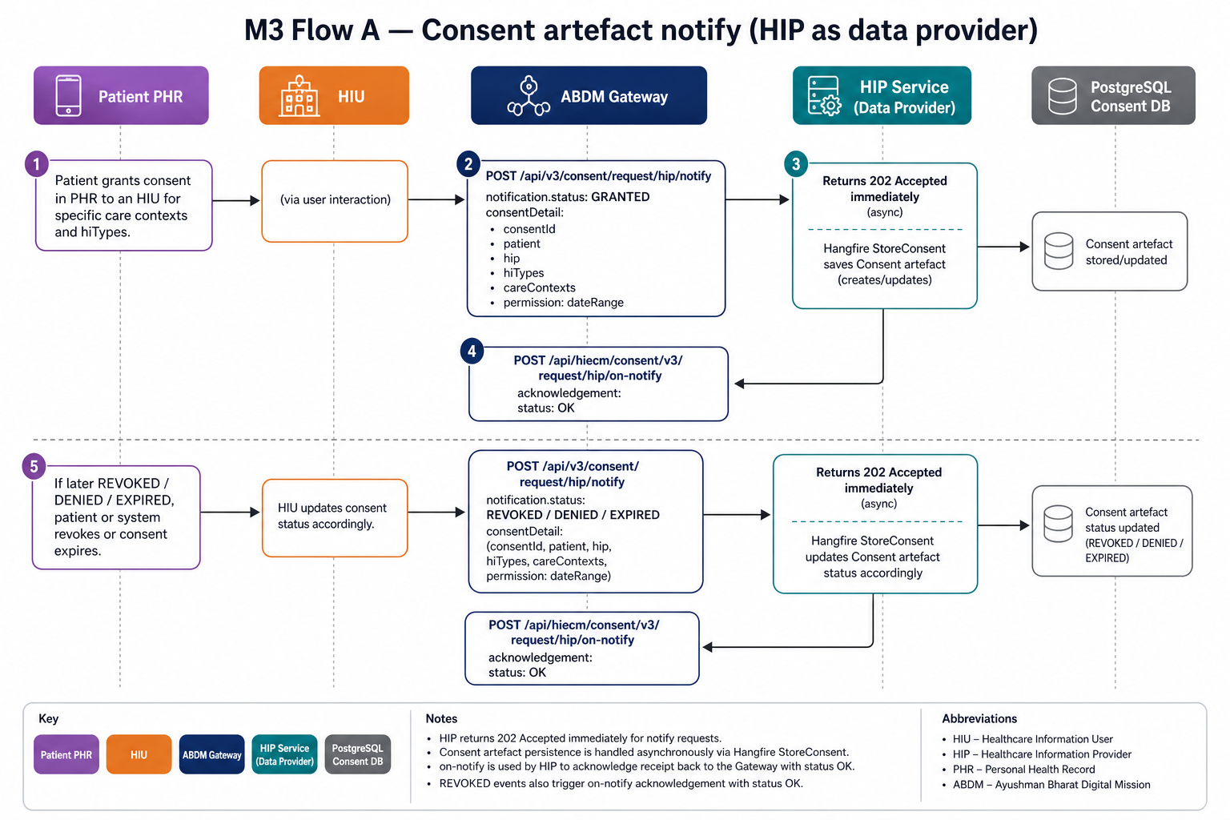
Figure 1. Consent notify: Gateway to HIP, persist artefact, on-notify acknowledgement.

Consent notify (Gateway to HIP)
Item | Value
Direction | ABDM Gateway -> HIP callback
HIP path | POST /api/v3/consent/request/hip/notify
HIP HTTP | 202 Accepted immediately; Hangfire StoreConsent
HIP callback | POST {Gateway.url}/api/hiecm/consent/v3/request/hip/on-notify
Controller | Consent.ConsentNotificationController
Purpose | Persist GRANTED artefact, or update REVOKED / DENIED / EXPIRED status

Inbound headers: CORRELATION-ID, REQUEST-ID (required), TIMESTAMP.
Gateway request body (ConsentArtefactRepresentation)
{
"notification": {
"status": "GRANTED",
"consentId": "consent-uuid",
"signature": "<cms-signature>",
"grantAcknowledgement": true,
"consentDetail": {
"consentId": "consent-uuid",
"createdAt": "2026-08-22T06:00:00.000Z",
"patient": { "id": "first.last@sbx" },
"hip": { "id": "IN2710001820" },
"consentManager": { "id": "sbx" },
"hiTypes": ["OPConsultation", "Prescription"],
"careContexts": [
{ "patientReference": "openMrsPatientUuid", "careContextReference": "openMrsPatientUuid:visitUuid" }
],
"permission": {
"accessMode": "VIEW",
"dateRange": { "from": "2026-01-01T00:00:00.000Z", "to": "2026-08-22T23:59:59.000Z" },
"dataEraseAt": "2026-09-22T00:00:00.000Z"
}
}
}
}
HIP behaviour by status
notification.status | HIP action | on-notify
GRANTED | Insert Consent (artefact id, detail, signature, status, consentId) | Yes — acknowledgement.status OK
REVOKED | Update status; load artefact for cmSuffix | Yes — acknowledgement.status OK
DENIED / EXPIRED / REQUESTED | Update status if row exists | No callback in current code

HIP on-notify body (GatewayConsentRepresentation)
{
"acknowledgement": {
"status": "OK",
"consentId": "consent-uuid"
},
"error": null,
"response": { "requestId": "<inbound REQUEST-ID>" }
}
ConsentStatus enum: REQUESTED, GRANTED, DENIED, REVOKED, EXPIRED. HIP does not verify the CMS signature in this service; it stores the signature with the artefact.

4. Flow B — Health information request and transfer
After consent is GRANTED, the HIU asks ABDM for data. Gateway calls this HIP with the consent id, a date range, the HIU dataPushUrl, and ECDH keyMaterial. HIP acknowledges quickly, then a RabbitMQ worker collects OpenMRS FHIR, encrypts, pushes to the HIU, and notifies Gateway.
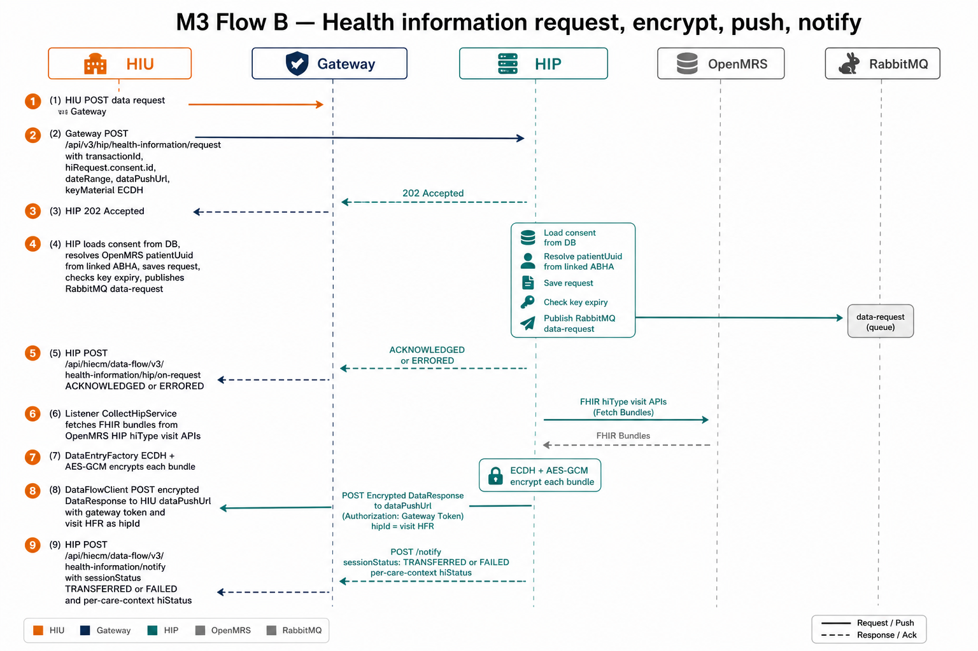
Figure 2. Health-information request, collect FHIR, encrypt, push to HIU, notify Gateway.

4.1 Receive request and on-request

Health-information request (Gateway to HIP)
Item | Value
Direction | ABDM Gateway -> HIP callback
HIP path | POST /api/v3/hip/health-information/request
HIP HTTP | 202 Accepted; Hangfire HealthInformationOf
HIP callback | POST {Gateway.url}/api/hiecm/data-flow/v3/health-information/hip/on-request
Controller | DataFlow.PatientDataFlowController
Purpose | Validate consent, persist request, enqueue collect/encrypt, acknowledge Gateway

Inbound headers: CORRELATION-ID, REQUEST-ID, TIMESTAMP, X-GatewayID (consent manager / gateway id).
Gateway request body (PatientHealthInformationRequest)
{
"transactionId": "txn-uuid",
"hiRequest": {
"consent": { "id": "consent-uuid" },
"dateRange": {
"from": "2026-01-01T00:00:00.000Z",
"to": "2026-08-22T23:59:59.000Z"
},
"dataPushUrl": "https://hiu.example/api/v3/hiu/health-information/push",
"keyMaterial": {
"cryptoAlg": "ECDH",
"curve": "Curve25519",
"nonce": "<base64-32-bytes>",
"dhPublicKey": {
"expiry": "2026-08-23T00:00:00.000Z",
"parameters": "Curve25519/32byte random key",
"keyValue": "<base64-HIU-public-key>"
}
}
}
}
HIP processing before on-request:
- Load consent by hiRequest.consent.id. Missing artefact → error ContextArtefactIdNotFound.
- Resolve OpenMRS patientUuid from linked account of consent.patient.id. If empty, wait 5 seconds and retry (covers race with M2 link-confirm).
- Save HealthInformationRequest keyed by transactionId. Duplicate/DB failure → internal error.
- Reject if keyMaterial.dhPublicKey.expiry is already past (ErrorCode.ExpiredKeyPair).
- Publish DataRequest to RabbitMQ exchange hip-data-request (topic).
HIP on-request body (success)
{
"hiRequest": {
"transactionId": "txn-uuid",
"sessionStatus": "ACKNOWLEDGED"
},
"error": null,
"resp": { "requestId": "<inbound REQUEST-ID>" }
}
On failure sessionStatus is ERRORED and error.code/message are set. cmSuffix on the callback is Gateway.CmSuffix.

4.2 Collect FHIR from OpenMRS
MessagingQueueListener consumes the queue and calls DataFlowMessageHandler. CollectHipService walks each granted care context and each consented hiType, then OpenMrsPatientData GETs Bahmni HIP REST.
hiType | OpenMRS path root | Query
OPConsultation | ws/rest/v1/hip/opConsults/visit | patientId, visitUuid, fromDate, toDate
Prescription | ws/rest/v1/hip/prescriptions/visit | same
DiagnosticReport | ws/rest/v1/hip/diagnosticReports/visit | same
DischargeSummary | ws/rest/v1/hip/dischargeSummary/visit | same
ImmunizationRecord | ws/rest/v1/hip/immunizationRecord/visit | same
HealthDocumentRecord | ws/rest/v1/hip/healthDocumentRecord/visit | same
WellnessRecord | ws/rest/v1/hip/wellnessRecord/visit | same
Invoice | ws/rest/v1/hip/invoice/visit | same

Visit care contexts: visitUuid is the part after “:” in careContextReference. fromDate is expanded by minus one day and toDate by plus one day (V3 date-range fix). Program care contexts matching “(ID Number:n)” use ws/rest/v1/hip/{root}/program/ with programName and programEnrollmentId instead of visitUuid.
Each OpenMRS item’s bundle JSON is parsed as FHIR R4 Bundle and kept as CareBundle(careContextReference, bundleJson). Unknown hiType names are skipped.

4.3 Encrypt (ECDH + AES-GCM)
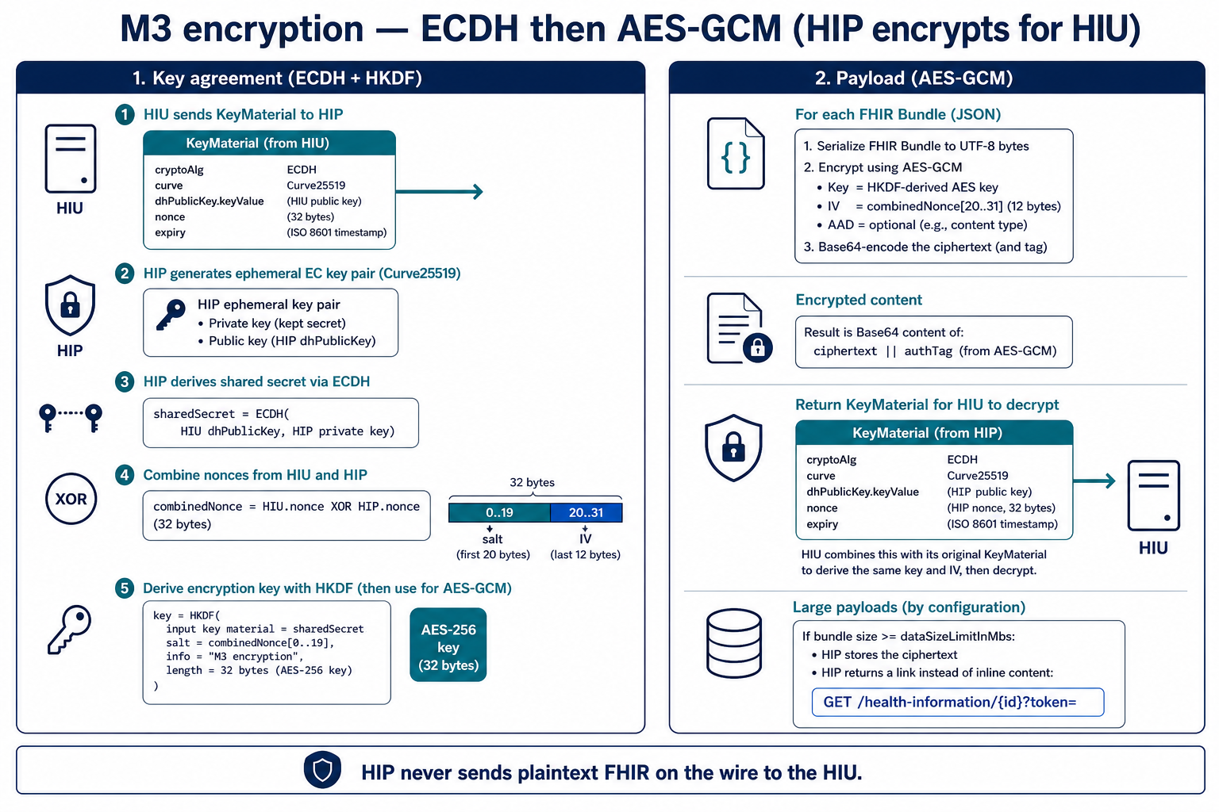
Figure 3. HIP derives a shared AES key with the HIU via ECDH, then AES-GCM encrypts each FHIR Bundle.
DataEntryFactory generates an ephemeral EC key pair on the HIU’s curve (typically Curve25519) and a 32-byte HIP nonce. Encryptor derives a shared secret from the HIU dhPublicKey and HIP private key, XORs HIP nonce with HIU nonce, uses the first 20 bytes as salt and last 12 as IV, derives AES key, and encrypts UTF-8 FHIR JSON with AES-GCM (128-bit tag). Ciphertext is Base64. HIP returns its public key and nonce in the push payload so the HIU can decrypt.
If Unicode byte size of ciphertext >= dataFlow.dataSizeLimitInMbs (default 5 MB):
- HIP stores the encrypted entry in HealthInformation with a random informationId and token.
- Push payload contains a link instead of content: {hip.url}/health-information/{id}?token={token}.
- HIU later GET that URL; HIP returns content if token matches and DataLinkTtlInMinutes (default 10) has not expired.
Checksum on entries is currently the literal string iplit-md5 when a bundle exists.

4.4 Push encrypted data to HIU

Data push (HIP to HIU)
Item | Value
Direction | HIP -> HIU dataPushUrl (not via HIE-CM body routing)
HTTP | POST {hiRequest.dataPushUrl}
Auth | Gateway session token (Authorization Bearer) plus REQUEST-ID, TIMESTAMP, X-CM-ID, CORRELATION-ID
Facility header | CreateHttpRequestWithContentType sets X-HIU-ID to the visit HFR id
Content-Type | application/json (payload); entries.media is application/fhir+json
Class | DataFlow.DataFlowClient.SendDataToHiu

HFR id is taken from the first granted care context’s visitUuid (same M2 location-attribute cache). If missing, HIP loads it from OpenMRS or uses the default Bahmni hip id. Transaction_Id header is the data transactionId.
HIP push body (DataResponse)
{
"pageNumber": 0,
"pageCount": 1,
"transactionId": "txn-uuid",
"entries": [
{
"content": "<base64-AES-GCM-ciphertext>",
"media": "application/fhir+json",
"checksum": "iplit-md5",
"careContextReference": "openMrsPatientUuid:visitUuid"
}
],
"keyMaterial": {
"cryptoAlg": "ECDH",
"curve": "Curve25519",
"nonce": "<HIP-base64-nonce>",
"dhPublicKey": {
"expiry": "<copied from HIU key expiry>",
"parameters": "<copied from HIU>",
"keyValue": "<HIP-ephemeral-public-key-base64>"
}
}
}

4.5 Notify Gateway of transfer status

Health-information notify (HIP to Gateway)
Item | Value
Direction | HIP -> Gateway
Gateway path | POST /api/hiecm/data-flow/v3/health-information/notify
Class | DataFlowNotificationClient.NotifyGateway
Purpose | Tell ABDM whether the session TRANSFERRED or FAILED, per care context

Always sent after the push attempt (success or catch). sessionStatus TRANSFERRED and hiStatus DELIVERED when the HTTP send to dataPushUrl succeeded and gateway authenticate succeeded; otherwise FAILED / ERRORED. notifier.type is HIP; notifier.id is Gateway.ClientId. hipId in statusNotification is the visit HFR id. doneAt is UTC DateTime.Today formatted yyyy-MM-ddTHH:mm:ss.fffZ.
HIP notify body (GatewayDataNotificationRequest wrapper)
{
"notification": {
"transactionId": "txn-uuid",
"consentId": "consent-uuid",
"doneAt": "2026-08-22T00:00:00.000Z",
"notifier": { "type": "HIP", "id": "<clientId>" },
"statusNotification": {
"sessionStatus": "TRANSFERRED",
"hipId": "IN2710001820",
"statusResponses": [
{
"careContextReference": "openMrsPatientUuid:visitUuid",
"hiStatus": "DELIVERED",
"description": "Successfully delivered health information"
}
]
}
}
}

4.6 Optional: HIU fetches a large-payload link

Health information by link (HIU to HIP)
Item | Value
Direction | HIU -> HIP
HIP path | GET /health-information/{informationId}?token={token}
Controller | DataFlow.DataFlowController.HealthInformation
Purpose | Return stored encrypted content when inline push was too large

HTTP | When
200 + HealthInformationResponse.content | token matches and link not older than DataLinkTtlInMinutes
403 InvalidToken / LinkExpired | wrong token or TTL exceeded
404 HealthInformationNotFound / ContextArtefactIdNotFound | unknown id
400 ExpiredKeyPair | legacy mapping on this action result helper

5. M3 API catalogue
# | Path | Direction | Flow
A1 | POST /api/v3/consent/request/hip/notify | GW -> HIP | Consent
A1b | POST /api/hiecm/consent/v3/request/hip/on-notify | HIP -> GW | Consent
B1 | POST /api/v3/hip/health-information/request | GW -> HIP | Data request
B1b | POST /api/hiecm/data-flow/v3/health-information/hip/on-request | HIP -> GW | Data request
B2 | POST {dataPushUrl} | HIP -> HIU | Encrypted FHIR push
B3 | POST /api/hiecm/data-flow/v3/health-information/notify | HIP -> GW | Transfer status
B4 | GET /health-information/{id}?token= | HIU -> HIP | Large payload link
L1 | POST /consent/notification [Obsolete] | legacy | Do not use for V3
L2 | POST /health-information/request [Obsolete] | legacy | Do not use for V3

6. Typical call order
1. M2 has already linked the visit (careContextReference = patientId:visitUuid).
2. Patient in PHR grants consent to an HIU for this HIP, selected hiTypes and date range.
3. Gateway POST /api/v3/consent/request/hip/notify (GRANTED). HIP 202, saves artefact, on-notify OK.
4. HIU requests data through ABDM. Gateway POST /api/v3/hip/health-information/request.
5. HIP 202, on-request ACKNOWLEDGED, publishes RabbitMQ.
6. Worker GETs OpenMRS FHIR per hiType, encrypts, POSTs DataResponse to dataPushUrl.
7. HIP POST health-information/notify with TRANSFERRED / DELIVERED (or FAILED / ERRORED).
8. If a later notify arrives with REVOKED, HIP updates artefact status and on-notify OK. Subsequent HI requests still find the row; they do not currently re-check GRANTED before collect — operationally ABDM should not request after revoke.

7. Implementation notes from the V3 changes
- on-request and notify use /api/hiecm/data-flow/v3/... ; consent on-notify uses /api/hiecm/consent/v3/...
- Data push and transfer notify include visit-wise HFR id (hipId), not only the default Bahmni id.
- Data push uses CreateHttpRequestWithContentType, which sets header X-HIU-ID to that hipId.
- doneAt on notify is UTC DateTime.Today in TIMESTAMP_FORMAT (doneAt fixes).
- Visit FHIR fromDate/toDate are expanded by one day on each side.
- If patientUuid is not yet in linked accounts, HIP waits 5 seconds once (link-confirm race).
- RabbitMQ is required for actual transfer; acknowledging on-request without a running listener will not push data.
- HIP never sends plaintext FHIR to the HIU; only AES-GCM ciphertext (or a short-lived link to ciphertext).
- Obsolete v0.5 consent/notification and health-information/request remain compiled but are not the V3 contract.

8. Code map (M3)
Area | Primary types
Consent notify | Consent/ConsentNotificationController.cs, ConsentRepository, Common.Model.ConsentArtefact
HI request | DataFlow/DataFlowController.cs (PatientDataFlowController), DataFlow/DataFlow.cs
Queue | DataFlow/MessagingQueueListener.cs, DataFlowMessageHandler.cs
Collect FHIR | DataFlow/CollectHipService.cs, OpenMrsPatientData.cs
Encrypt | DataFlow/DataEntryFactory.cs, Encryptor/Encryptor.cs, EncryptorHelper.cs
Push + notify | DataFlow/DataFlowClient.cs, DataFlowNotificationClient.cs
HFR on transfer | Common/Model/BahmniConfiguration.cs (same cache as M2)
Paths | Common/Constants.cs PATH_CONSENTS_HIP, PATH_CONSENT_ON_NOTIFY, PATH_HEALTH_INFORMATION_*

9. Document set
- M1 ABHA create/verify — docs/changesExpalined.docx
- M2 link care contexts — docs/FlowExpalined-M2.docx
- M3 consent + data flow — this file docs/FlowExpalined-M3.docx

10. External references
- ABDM Sandbox V3: https://sandbox.abdm.gov.in/sandbox/v3/new-documentation
- HIP callback: POST /api/v3/consent/request/hip/notify
- HIP callback: POST /api/v3/hip/health-information/request
- HIP to Gateway: /api/hiecm/consent/v3/request/hip/on-notify
- HIP to Gateway: /api/hiecm/data-flow/v3/health-information/hip/on-request
- HIP to Gateway: /api/hiecm/data-flow/v3/health-information/notify
End of Milestone 3. M1, M2 and M3 together are the ABDM V3 HIP path in this service.

