Data-Driven Insights into the Saudi Arabian Used Car Market
shape 8035 rows × 13 columns

Objective:

“Analyzing the Saudi Used Car Market to Identify Sales Growth Opportunities”

Data Summary :
- Manufacture total = 54
- Total prices = 431 M
- Number of Luxury Cars = 1.147 K
- Number of Negotiable Cars = 2.527 K
- top Make is Toyota
- top type is Land Cruiser
- top options is Full options
- top fuel type is Gas
- top gear type is Automatic
- top region is Riyadh
- Oldest Date(Year) For Car =1963
- Newest Date(Year) For Car =2022
- Ferrari , Rolls-Royce and Aston martin is the highest price cars
- automatic cars is more expensive
- Riyadh and Jeddah and Dammam is the regions with the highest total value of sales of used cars
- Luxury Brands in data
'Mercedes', 'BMW', 'Lexus', 'Cadillac', 'INFINITI', 'Audi', 'Porsche',
'Land Rover', 'Jaguar', 'Rolls-Royce', 'Bentley', 'Aston Martin', 'Maserati', 'Ferrari', 'Genesis'

Analysis :
New features created :
- Car Age Column
- Is_luxury column
- average_price_per_options pivot table
- count_type_per_make pivot table (to see the most and least types)
- price_per_make pivot table
- Negotiable cars pivot table

Outliers is flaged for further study not removed

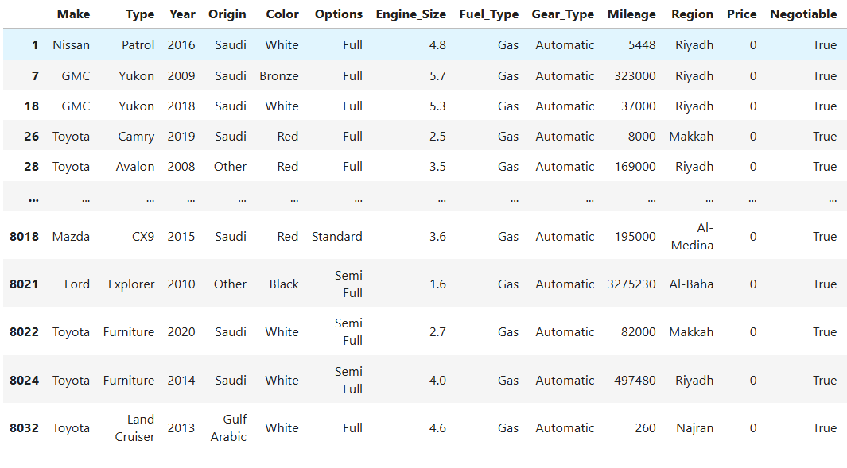

notice here that every time the price is 0 Negotiable is True This suggests that these cars are not yet sold or their prices have not been finalized. It's likely that sellers marked the price as 0 and used the Negotiable flag to indicate the price will be set after negotiation

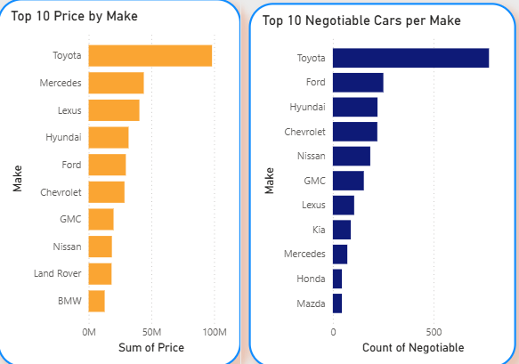

Notice that Toyota give most of sales cause it is the most accruing in data also gives most negotiable cars

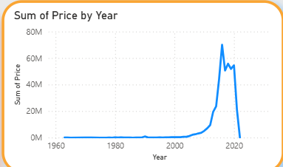
Cars models that after year 2000 tend to give more money than the old cars
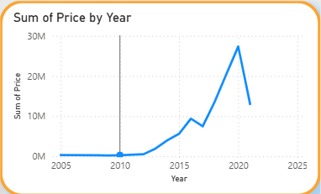
The prices outliers gives 105 M at sales Mercedes gives most of them and a significant increase in cars prices after year 2010

Cars with big mileage tend to be cheaper than others

The old cars before (2000) tend to have more mileage and manual gear type

Recommendations :
- Try focusing on cars that age are after 2000 it tend to sell more than the older ones Specially cars after year 2010 has the highest prices
- Toyota and Mercedes gives sell more so we need to focus on them also as the top 10 I provided
- The most saled cars are automatic , gas , low mileage , low age ,full options so we need to focus on these aspects on cars to have cars sell more
- Riyadh and Jeddah and Dammam is the regions with the highest total value of sales of used cars they need more focus
- Luxury brands give 143 M out of total sales of 431 that’s huge with total of 15 manufacture out 59 luxury cars need more focus
- Negotiable cars are 2527 out of 8035 they 31.45% of total still not sold or got price yet they need more focus and promotions

Recommendations summary :
“Identified key factors driving used car sales in Saudi Arabia — recommending focus on post-2010 automatic cars and luxury brands in Riyadh and Jeddah to increase revenue by targeting high-value segments.”

