**Prepare answers to following questions:**

* Which interface JDK tools use to connect to JVM locally?
  + JVM Tool Interface
* What is difference between profiling and traceability?
  + Profiling is the process of measuring an application or system by running an analysis tool called a profiler. Traceability means the ability to trace something.

**OutOfMemory (OOM) error troubleshooting**

**Get OOM error**

Execute and press any key:

java -jar -Xmx100m heap-1.0.0-SNAPSHOT.jar

**Use jvisualvm to observe OOM**

* Execute:

java -jar -Xmx100m heap-1.0.0-SNAPSHOT.jar

* In jvisualvm connect to our java process
* Go to "Monitor" tab
* Press any key in our application
* Observe how heap grows

**Get heap dump**

**Using -XX:+HeapDumpOnOutOfMemoryError option**

* Execute and press any key:

java -jar -Xmx100m -XX:+HeapDumpOnOutOfMemoryError heap-1.0.0-SNAPSHOT.jar

**[Optional] Using jcmd**

Get pid using jps here and further through this document:

jps -lvm

jcmd <pid> GC.heap_dump <filename>

**[Optional] Using jmap**

jmap -dump:format=b,file=snapshot.hprof <pid>

**Get heap histogram**

**Using jcmd**

jcmd <pid> GC.class_histogram

**Using jmap**

jmap -histo <pid>

**Analyze heap dump**

**Using Java Visual VM**

* Open retrieved heap dump in jvisualvm
* Identify memory leak

**OQL**

Execute OQL in jvisualvm:

select objs from java.lang.Object[] objs where objs.length > 100

select referrers(objs) from java.lang.Object[] objs where objs.length > 100

select referrers(arr) from java.util.ArrayList arr where arr.size > 100

Startup jhat (note: jhat was decommissioned in JDK 9)

jhat <head_dump.hprof>

Execute OQL in jhat

select [objs, objs.length] from [Ljava.lang.Object; objs where objs.length > 100

select referrers(objs) from [Ljava.lang.Object; objs where objs.length > 100

select referrers(arr) from java.util.ArrayList arr where arr.size > 100

Please note small OQL syntax difference in jhat and jvisualvm.

**Deadlock troubleshooting**

**Get deadlock**

* Execute java application that simulates deadlock:

java -jar deadlock-1.0.0-SNAPSHOT.jar

* Get thread dump and locate lines similar to:

Found one Java-level deadlock:

=============================

"Thread 2":

waiting to lock monitor 0x000000001bf40b68 (object 0x000000076b7777c8, a java.lang.Object),

which is held by "Thread 1"

"Thread 1":

waiting to lock monitor 0x000000001bf43608 (object 0x000000076b7777d8, a java.lang.Object),

which is held by "Thread 2"

Java stack information for the threads listed above:

===================================================

"Thread 2":

at com.epam.jmp.mat.deadlock.SimulateDeadLock.method2(SimulateDeadLock.java:44)

- waiting to lock <0x000000076b7777c8> (a java.lang.Object)

- locked <0x000000076b7777d8> (a java.lang.Object)

at com.epam.jmp.mat.deadlock.DeadLockMain$2.run(DeadLockMain.java:18)

"Thread 1":

at com.epam.jmp.mat.deadlock.SimulateDeadLock.method1(SimulateDeadLock.java:24)

- waiting to lock <0x000000076b7777d8> (a java.lang.Object)

- locked <0x000000076b7777c8> (a java.lang.Object)

at com.epam.jmp.mat.deadlock.DeadLockMain$1.run(DeadLockMain.java:11)

Found 1 deadlock.

**Get thread dump**

1} jstack

jstack -l <pid>

2} kill -3

kill -3 <pid>

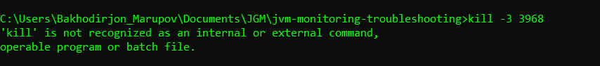

3} jvisualvm

4} Windows (Ctrl + Break)

5} jcmd

jcmd <pid> Thread.print

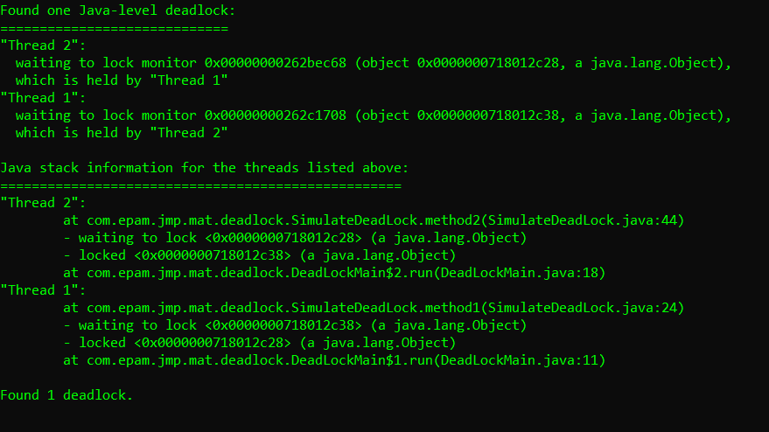

**Remote JVM profiling**

Using [JMX Technology](https://docs.oracle.com/javase/8/docs/technotes/guides/management/agent.html)

For insecure remote connection use parameters:

-Dcom.sun.management.jmxremote

-Dcom.sun.management.jmxremote.port=7890

-Dcom.sun.management.jmxremote.authenticate=false

-Dcom.sun.management.jmxremote.ssl=false

java -jar -Dcom.sun.management.jmxremote -Dcom.sun.management.jmxremote.port=7890 -Dcom.sun.management.jmxremote.authenticate=false -Dcom.sun.management.jmxremote.ssl=false simple-1.0.0-SNAPSHOT.jar

Connect to JVM using jconsole:

jconsole localhost:7890

**Inspect a Flight Recording**

Execute JVM with two special parameters:

-XX:+UnlockCommercialFeatures

-XX:+FlightRecorder

java -jar -Xmx100m -XX:+UnlockCommercialFeatures -XX:+FlightRecorder -XX:StartFlightRecording=dumponexit=true,filename=flight.jfr heap-1.0.0-SNAPSHOT.jar

Enable Flight Recording on JVM without these parameters:

java -jar -Xmx100m -XX:+UnlockCommercialFeatures heap-1.0.0-SNAPSHOT.jar

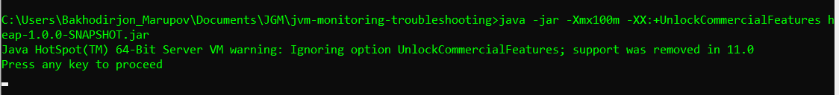

jps -lvm

jcmd <pid> JFR.start name=heap_recording filename=flight.jfr dumponexit=true

Open Java Mission Control and connect to default HotSpot of our JVM:

Jmc

Couldn’t open jmc.exe

**jinfo**

Print system properties and command-line flags that were used to start the JVM.

java -jar simple-1.0.0-SNAPSHOT.jar

jps

jinfo <pid>

**Practical task evaluation rules:**

* OOM errors troubleshooting : 1.5 points
* Deadlock troubleshooting : 1.5 points
* Remote JVM profiling : 1 point
* FlightRecorder : 1 point