Pattern lab1

## Done By: Ahmed Nasser – 8350 Baher Ahmed Hosny – 8165

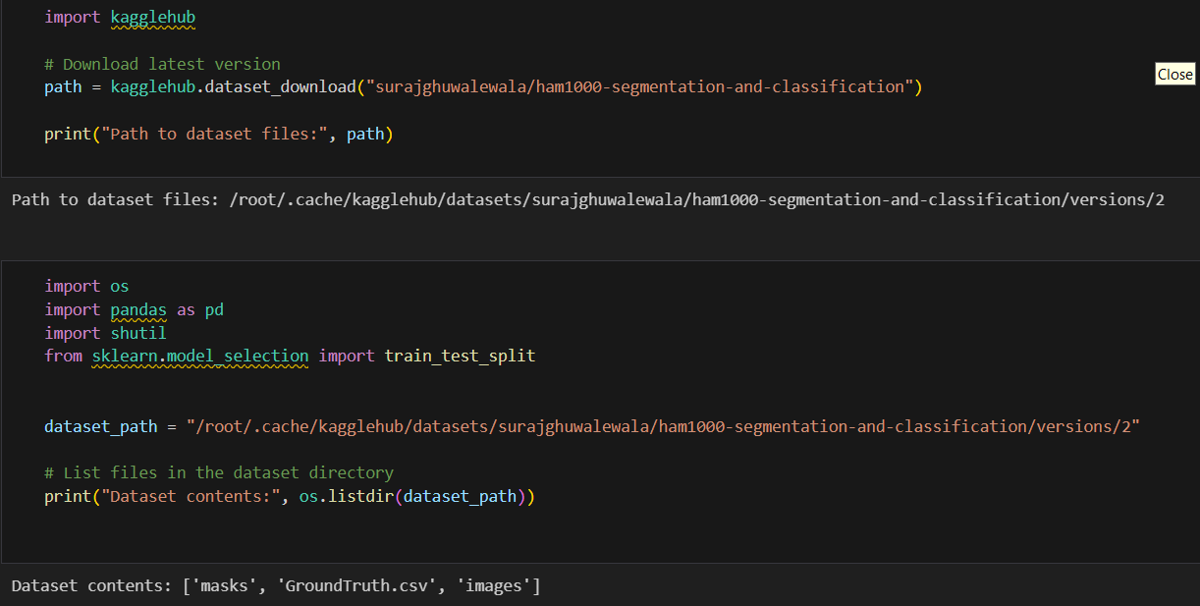**Part1:**

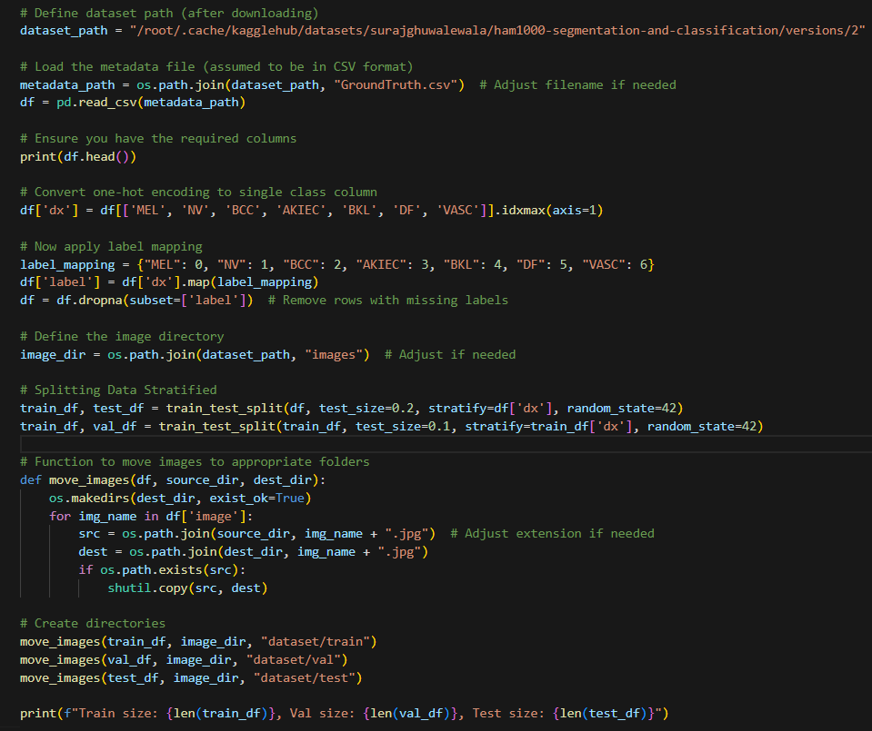

Notes:

* Downloaded dataset using Kaggle
* Add labels to the data
* Split them evenly using stratify
* Move data to train, validation, and test folders.

**Part2:**

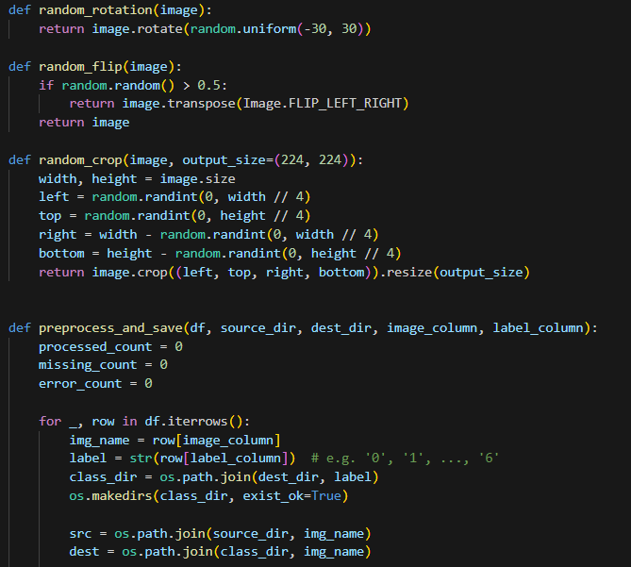

Notes:

* First remove duplicate entries from each folder with each other
* Remove repeated patient ID’s in different folders
* Move each image according to split and verify if its corrupt, if so add to corrupted_images array.

**Part3:**

Notes:

* Use ResNet18 which is a CNN architecture which is implemented using pytorch.
* We check parameters are less than 60 million and display them
* Print a confusion matrix and display recall and F1 score

**Part4:**

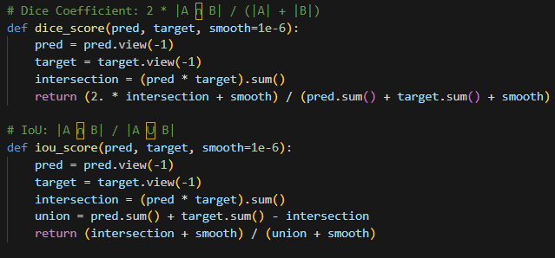

Notes:

* Used a UNET architecture for segmentation
* Read images and masks from folders and applies some transformations for preprocessing and augmentation.
* Training and validation done and calculate effectiveness of model using IoU (Intersection over Union) and Dice coefficient.

**Images:**