**Checkpoint mongo DB :**

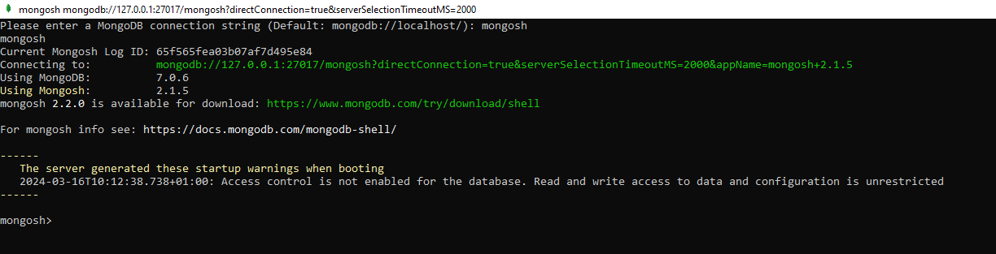

Display all of Databases :

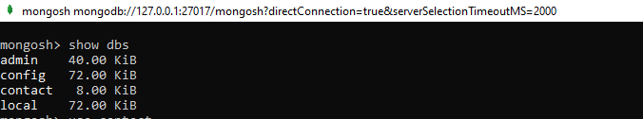

Use the dB (database): contact



Insert juste one Contact:



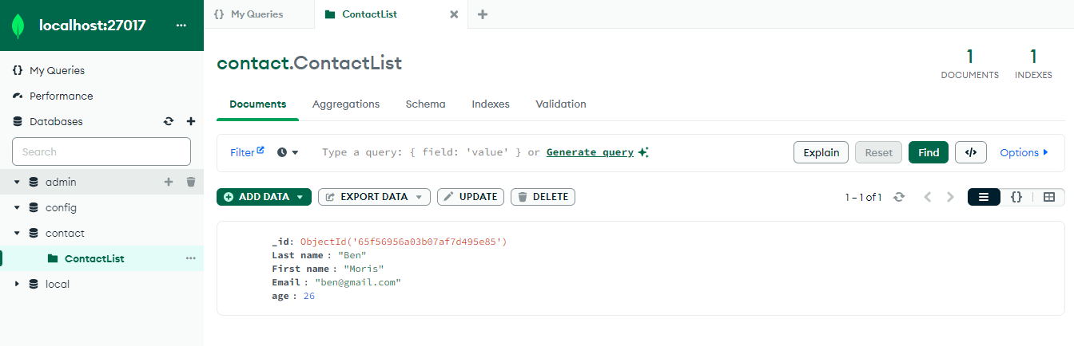

Insert of all ContactList in db contact:

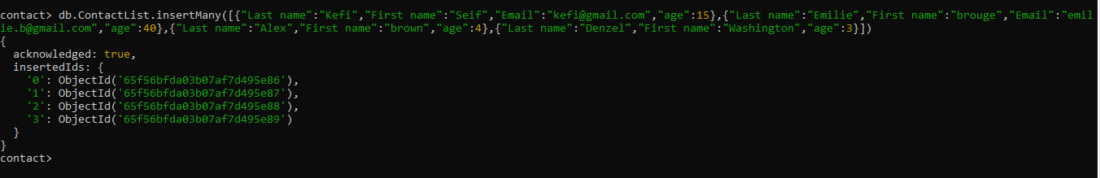

Display of all Contact List:

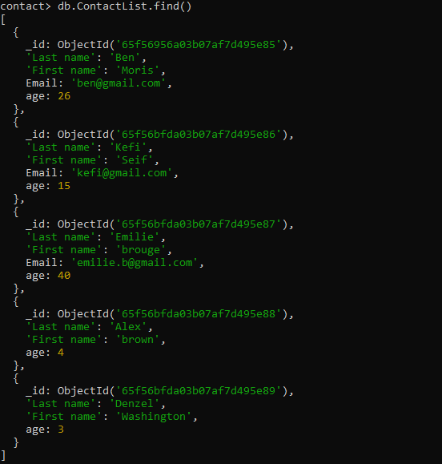

Find Contact by Id :

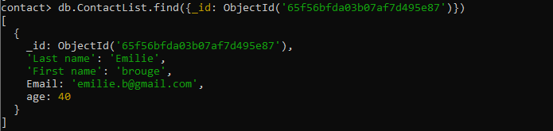

Find Contact by age and First name:

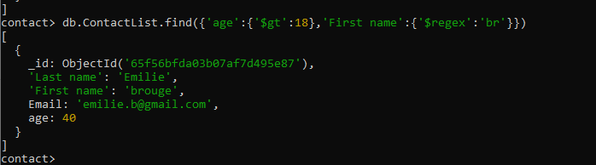

Update Contact :

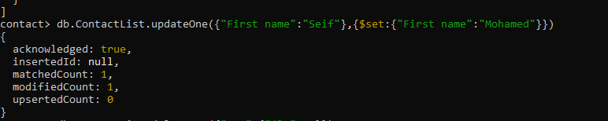

Delete One Contact :



Remove Contact

