

***LOGISTIC Regression With Sas***

Bahram Muzaffarli: 124131

Lab Instructor:

Adam Korczynski

07 June 2023

1. Content

**Table of Content**

1.Introduction 3

2.Discriminatorian and Comparison 4

2.1 Distribution of the response variable - stfdem 4

2.2 Distribution of the response variable after filtering – stfdem(DR) 5

2.3 DR*FE (fair election) 6

2.4 DR*Contributed 7

2.5 DR*Gender 8

2.6 DR*Punish 9

3. The Logistic Procedure 10

3.1 Model Information 10

3.2 Odds ratios for Fair Election 11

4. Final Multinominal Model 13

4.1 Model Fit Statistics 13

4.2Testing Global Null Hypothesis Beta=0 13

4.3 Type 3 Analysis of Effects 13

4.4Analysis of Maximum Likehood Estimates 14

4.5 Odds Ratio Estimates 15

4.7 Least Squares Means 17

5 Conclusion 21

6 References 22

# 1.Introduction

Our research topic What are the effects of the increase democracy rate? Based on this, we formed our hypothesis. Does free election increase democracy in Czech Republic? We evaluated this hypothesis as multinominal logistic.

We used the following variable while testing this hypothesis

*Null Hypothesis (H0): There is no relationship between free election and democracy in Czech Republic as statistically significant.*

*Alternative Hypothesis (H1): Free Election increase democracy in Czech Republic as statistically significant.*

* stfdem – How satisfied with the way democracy works in country
* fairelc – National elections are free and fair
* contplt – Contacted politician or government official last 12 month
* gptpelc – Government parties are punished in elections when they have a bad job
* medcrgv - The media are free to criticize the government
* votedir - In country citizens have the final say on political issues by voting directly in referendums
* viepol – The views of ordinary people prevail over the view of political elits
* dfprtal - Different political parties offer clear alternatives to one another
* wpestop - The will of the people cannot be stopped

# 2.Discriminatorian and Comparison

# 2.1 Distribution of the response variable - stfdem

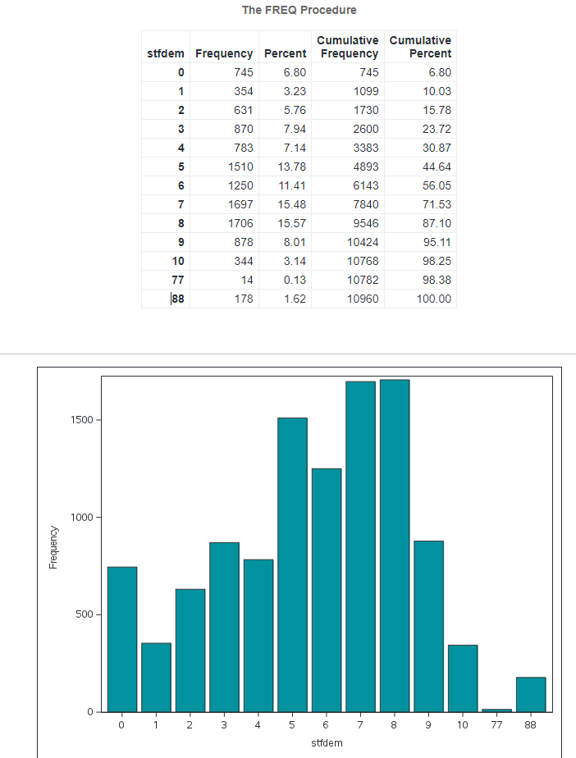

# 2.2 Distribution of the response variable after filtering – stfdem(DR)

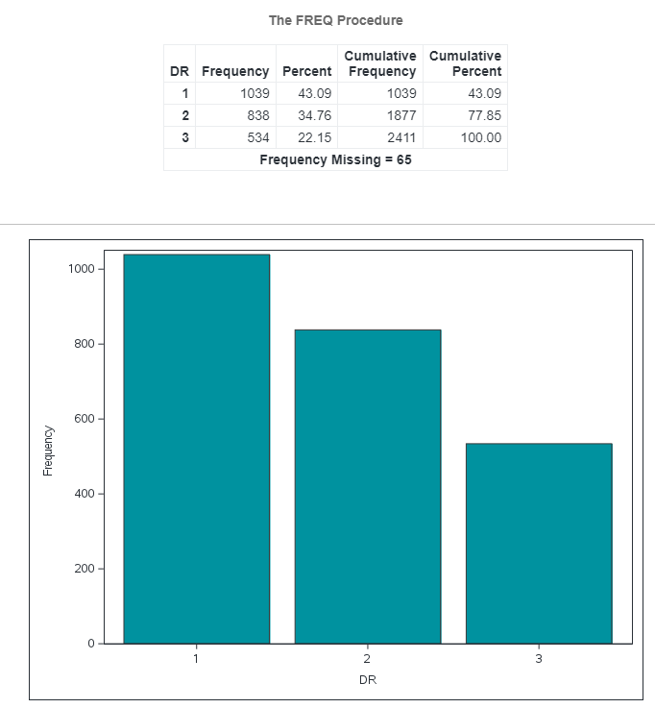

Non-Democracy 1

Neutral Government 2

Exist Democracy 3

# 2.3 DR*FE (fair election)

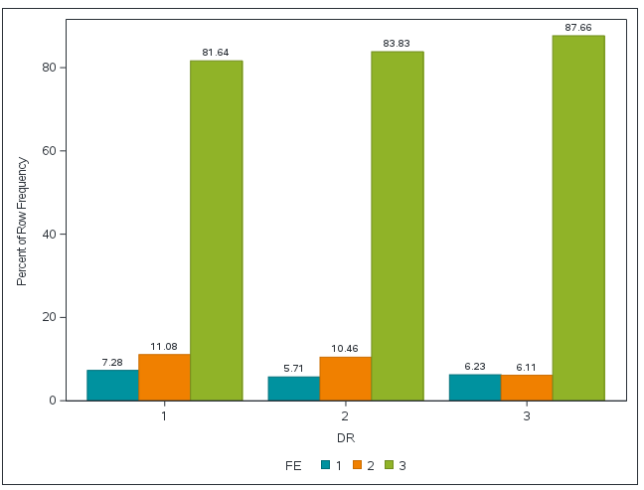

1 Free election can’t impact democracy

2 Free election doesn’t impact democracy

3 Free election can impact democracy

# 2.4 DR*Contributed

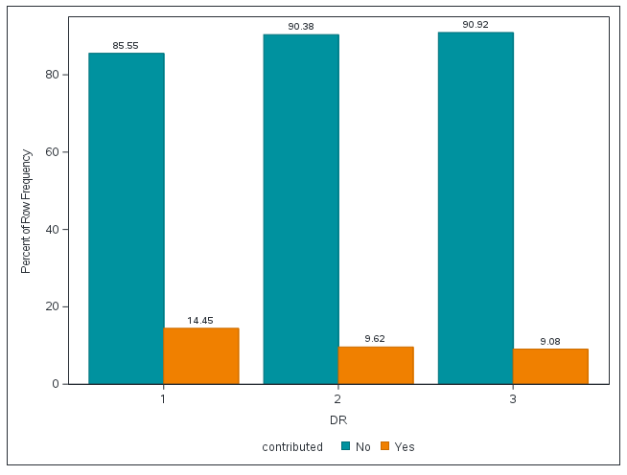

Contacted politician or government official last 12 months significantly effect to democracy

# 2.5 DR*Gender

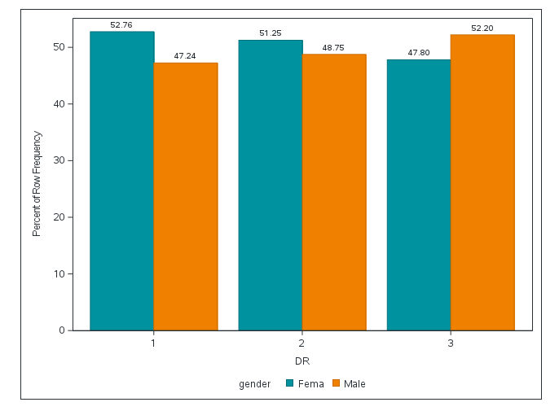

The gender of the person is not related to democracy. In this plot, we can see approximately the same role of males and females in democracy.

# 2.6 DR*Punish

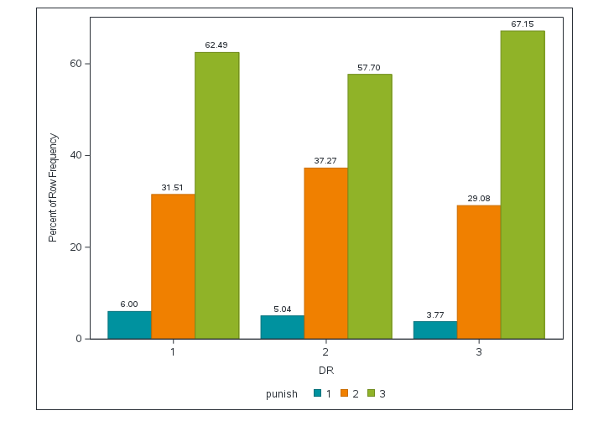

1 When governing parties aren’t punished in elections when they have done a bad job, democracy rate is very low

2 When governing parties aren’t anything in elections when they have done a bad job, democracy rate in middle level

3 When governing parties are punished in elections when they have done a bad job, democracy rate is very high

# 3. The Logistic Procedure

# 3.1 Model Information

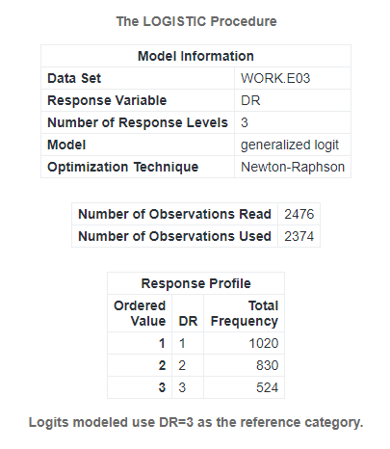

We used Newton-Raphson as the optimization method. On the other hand, we can see the response profile distribution above. There are 1020 data belong to 1 class, 830 data belong to 2 class and 524 data belong to 3 class.

# 3.2 Odds ratios for Fair Election

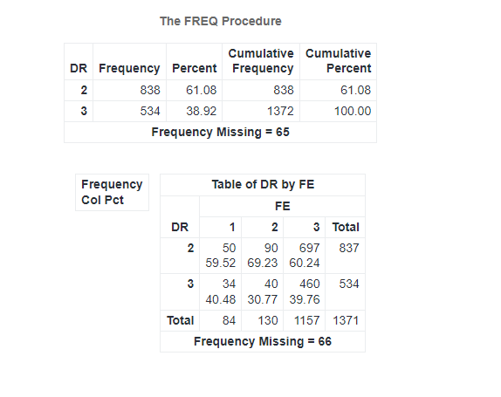

The first part of the table shows the frequency and percentage for each value of DR. There are 838 occurrences of DR = 2, which accounts for 61.08% of the total occurrences. There are 534 occurrences of DR = 3, representing 38.92% of the total occurrences.

The second part of the table displays the frequency distribution and percentage for the combination of DR and FE. For DR = 2, there are 50 occurrences of FE = 1 (59.52%), 90 occurrences of FE = 2 (69.23%), and 697 occurrences of FE = 3 (60.24%). For DR = 3, there are 34 occurrences of FE = 1 (40.48%), 40 occurrences of FE = 2 (30.77%), and 460 occurrences of FE = 3 (39.76%).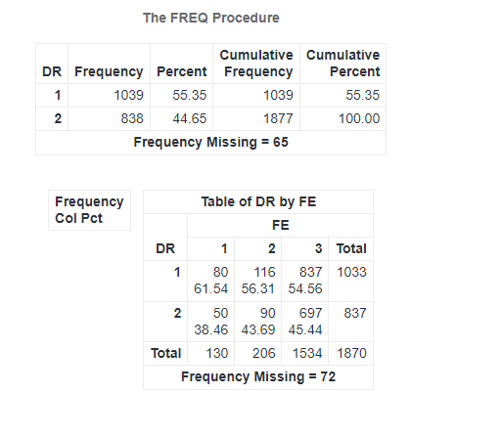

The first part of the table shows the frequency and percentage for each value of DR. There are 1039 occurrences of DR = 1, which accounts for 55.35% of the total occurrences. There are 838 occurrences of DR = 2, representing 44.65% of the total occurrences.

The second part of the table displays the frequency distribution and percentage for the combination of DR and FE. For DR = 1, there are 80 occurrences of FE = 2 (61.54%), 116 occurrences of FE = 3 (56.31%), and 837 occurrences in total. For DR = 2, there are 50 occurrences of FE = 1 (38.46%), 90 occurrences of FE = 2 (43.69%), and 697 occurrences of FE = 3 (45.44%).

# 4. Final Multinominal Model

# 4.1 Model Fit Statistics

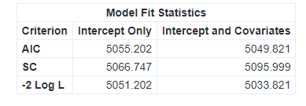

These model fit statistics are used to compare the goodness of fit between different models. The lower the AIC and SC values, the better the fit of the model. Similarly, a lower -2 Log L value indicates a better fit. In this case, the "Intercept and Covariates" model has slightly lower AIC, SC, and -2 Log L values compared to the "Intercept Only" model, suggesting that the "Intercept and Covariates" model provides a better fit to the data.

# 4.2Testing Global Null Hypothesis Beta=0

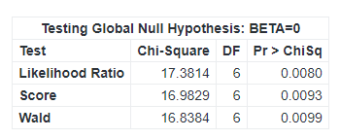

These test statistics are used to assess the significance of the coefficients in the model. In this case, the null hypothesis states that all the coefficients (BETA) are equal to zero. The low p-values (below the conventional significance level of 0.05) associated with all three tests indicate that there is evidence to reject the null hypothesis. This suggests that at least one of the covariates in the model is significantly related to the outcome variable.

# 4.3 Type 3 Analysis of Effects

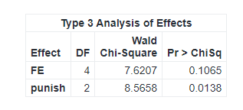

The Type 3 analysis of effects assesses the significance of each variable while accounting for other variables in the model. In this case, the "FE" variable has 4 degrees of freedom and a Wald Chi-Square statistic of 7.6207, resulting in a p-value of 0.1065. The "punish" variable has 2 degrees of freedom and a Wald Chi-Square statistic of 8.5658, with a p-value of 0.0138.

Based on these results, the "punish" variable is found to be significant at the conventional significance level of 0.05, as its p-value is below this threshold. However, the "FE" variable is not significant, as its p-value exceeds 0.05.

# 4.4Analysis of Maximum Likehood Estimates

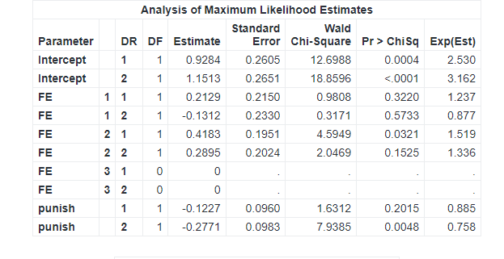

For the "Intercept" variable:

• DR = 1: The estimated value for the Intercept is 0.9284 with a standard error of 0.2605. The Wald Chi-Square statistic is 12.6988, indicating a statistically significant effect (p-value = 0.0004). The exponentiated estimate is 2.530, suggesting a 2.53-fold increase in the response variable.

• DR = 2: The estimated value for the Intercept is 1.1513 with a standard error of 0.2651. The Wald Chi-Square statistic is 18.8596, demonstrating a highly significant effect (p-value < 0.0001). The exponentiated estimate is 3.162, indicating a 3.162-fold increase in the response variable.

For the "FE" variable:

• FE = 1 and DR = 1: The estimated value for FE = 1 is 1 with a standard error of 0.2129. The Wald Chi-Square statistic is 0.2150, indicating a non-significant effect (p-value = 0.3220). There is no exponential estimate available.

• FE = 1 and DR = 2: The estimated value for FE = 1 is -0.1312 with a standard error of 0.2330. The Wald Chi-Square statistic is 0.3171, indicating a non-significant effect (p-value = 0.5733). There is no exponential estimate available.

• FE = 2 and DR = 1: The estimated value for FE = 2 is 0.4183 with a standard error of 0.1951. The Wald Chi-Square statistic is 4.5949, indicating a statistically significant effect (p-value = 0.0321). The exponentiated estimate is 1.519, suggesting a 1.519-fold increase in the response variable.

• FE = 2 and DR = 2: The estimated value for FE = 2 is 0.2895 with a standard error of 0.2024. The Wald Chi-Square statistic is 2.0469, indicating a non-significant effect (p-value = 0.1525). The exponentiated estimate is 1.336, suggesting a 1.336-fold increase in the response variable.

For the "punish" variable:

• DR = 1: The estimated value for the punish variable is -0.1227 with a standard error of 0.0960. The Wald Chi-Square statistic is 1.6312, indicating a non-significant effect (p-value = 0.2015). The exponentiated estimate is 0.885, suggesting a decrease in the response variable by a factor of 0.885.

• DR = 2: The estimated value for the punish variable is -0.2771 with a standard error of 0.0983. The Wald Chi-Square statistic is 7.9385, indicating a statistically significant effect (p-value = 0.0048). The exponentiated estimate is 0.758, suggesting a decrease in the response variable by a factor of 0.758.

# 4.5 Odds Ratio Estimates

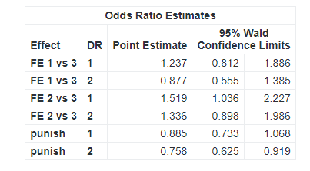

For the "FE 1 vs 3" effect:

• DR = 1: The point estimate for the odds ratio is 1.237, with 95% Wald confidence limits of 0.812 and 1.886.

• DR = 2: The point estimate for the odds ratio is 0.877, with 95% Wald confidence limits of 0.555 and 1.385.

For the "FE 2 vs 3" effect:

• DR = 1: The point estimate for the odds ratio is 1.519, with 95% Wald confidence limits of 1.036 and 2.227.

• DR = 2: The point estimate for the odds ratio is 1.336, with 95% Wald confidence limits of 0.898 and 1.986.

For the "punish" effect:

• DR = 1: The point estimate for the odds ratio is 0.885, with 95% Wald confidence limits of 0.733 and 1.068.

• DR = 2: The point estimate for the odds ratio is 0.758, with 95% Wald confidence limits of 0.625 and 0.919.

These odds ratio estimates provide information about the relative odds of an event occurring between different levels of the variable within each effect. The confidence limits give a range within which the true odds ratio is likely to fall with 95% confidence.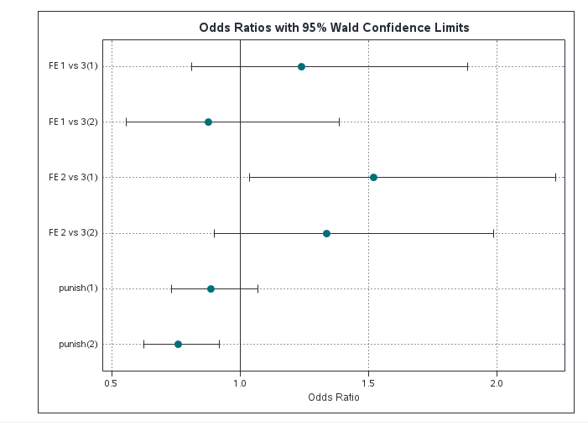

In instance, FE 2 vs 3 tells that the people who think free election have 13% less likelihood to democracy rate.

**4.6 Goodness-of-Fitness**

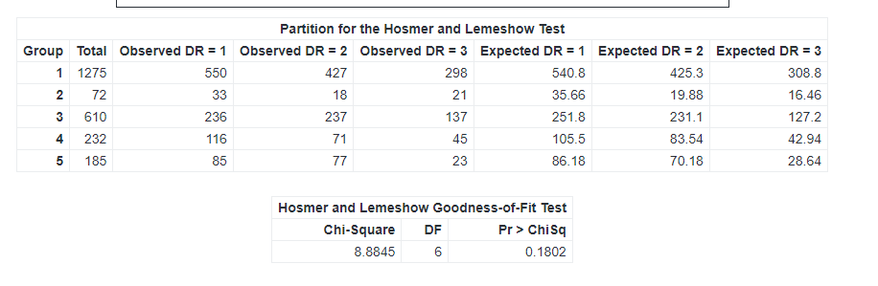

This table contains the results of the Hosmer and Lemeshow goodness-of-fit testing and the groups used for testing.

The Hosmer and Lemeshow test yielded a chi-square value of 8.8845 with 6 degrees of freedom. The associated p-value for the test was 0.1802. Since the p-value is greater than the significance level (commonly 0.05), there is no strong evidence to suggest a lack of fit between the observed and expected frequencies. Therefore, the model is considered to fit the data well according to the Hosmer and Lemeshow test.

# 4.7 Least Squares Means

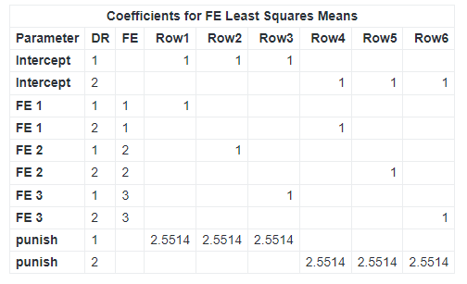

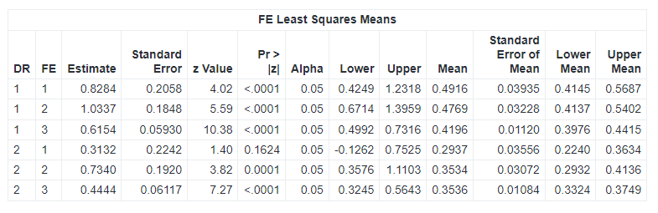

Overall, the FE Least Squares Means analysis provides estimated means for different combinations of DR and FE variables. The results indicate the following:

For DR = 1:

• FE = 1: The estimated mean is 0.8284, and it is statistically significant.

• FE = 2: The estimated mean is 1.0337, and it is statistically significant.

• FE = 3: The estimated mean is 0.6154, and it is statistically significant.

For DR = 2:

• FE = 1: The estimated mean is 0.3132, but it is not statistically significant.

• FE = 2: The estimated mean is 0.7340, and it is statistically significant.

• FE = 3: The estimated mean is 0.4444, and it is statistically significant.

The analysis provides information about the estimates' accuracy through standard errors and evaluates their significance using z-values and p-values. Additionally, 95% confidence intervals are provided for each estimated mean.

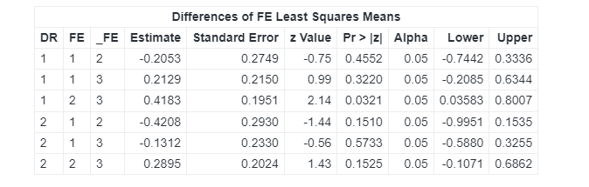 The analysis evaluates the differences between FE variables for each DR group using z-values and p-values. It indicates whether the differences are statistically significant or not.

In this table we can show mainly differences not statistically significant.

Based on these tables we can show some plots in below: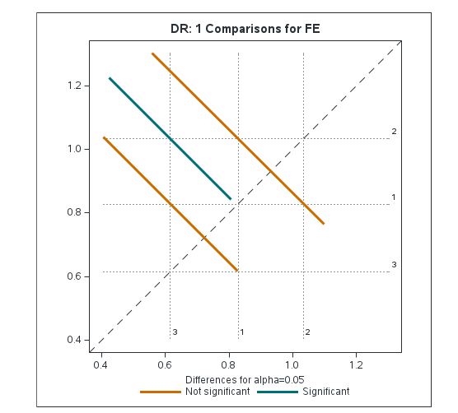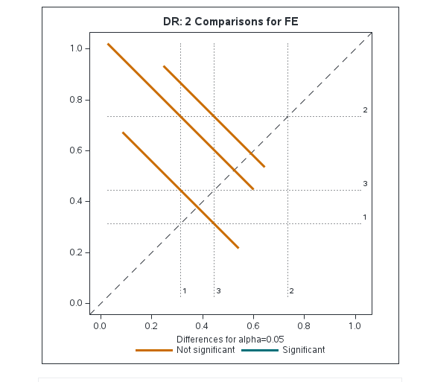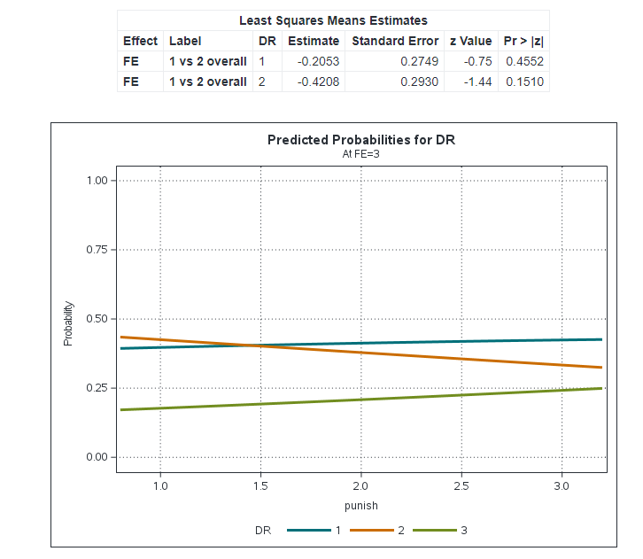

Based on these estimates, there is no statistically significant difference between FE 1 and FE 2 overall for both DR = 1 and DR = 2, as the p-values are greater than the typical significance level of 0.05.

# 5 Conclusion

In conclusion, our research aimed to assess the impact of free elections on democracy in the Czech Republic. Through our analysis, we obtained valuable insights regarding the relationship between the free election variable (FE) and democracy(DR).

The results indicate that when comparing FE 2 to FE 3, there is a statistically significant impact on democracy. This finding suggests that the presence of free elections, as represented by FE 2, plays a significant role in promoting and maintaining democratic processes in the Czech Republic.

However, when comparing FE 1 to both FE 2 and FE 3, the analysis did not reveal any statistically significant impact on democracy. This implies that the specific characteristics associated with FE 1 may not have a substantial influence on the overall democratic system in the country.

It is important to note that these conclusions are based on the statistical analysis conducted within the scope of our research. Further investigations and additional factors should be considered to provide a comprehensive understanding of the complex dynamics between free elections and democracy in the Czech Republic.

Overall, our findings emphasize the significance of free elections in bolstering democratic practices in the Czech Republic. The research highlights the need for continued efforts to safeguard the integrity of elections and ensure their fairness and transparency, as these elements are crucial for maintaining a robust democratic system.

# 6 References

[1] European Social Survey. (n.d.). Retrieved from <https://www.europeansocialsurvey.org/>

[2] The Impact of Democracy on Well-being

[Marta Orviska](https://www.jstor.org/action/doBasicSearch?Query=au%3A%22Marta%20Orviska%22), [Anetta Caplanova](https://www.jstor.org/action/doBasicSearch?Query=au%3A%22Anetta%20Caplanova%22), [John Hudson](https://www.jstor.org/action/doBasicSearch?Query=au%3A%22John%20Hudson%22)

[Social Indicators Research](https://www.jstor.org/journal/sociindirese), Vol. 115, No. 1 (January 2014), pp. 493-508

[3] Dorn, D., Fischer, J.A.V., Kirchgässner, G. *et al.* Direct democracy and life satisfaction revisited: new evidence for Switzerland. *J Happiness Stud* **9**, 227–255 (2008). https://doi.org/10.1007/s10902-007-9050-9