The Penguin
Team A – Allan Estes, Aykut Kir, Brian Lawrence, Charles Cisneros (?), and Shaun Norem
UAT – GAM 460

Story
Don't be fooled, this game is not about a penguin, no, rather it is about the journey of an elite combat space ship, The Penguin. The Penguin was designed to be the fastest ship known to man, while maintaining excellent maneuverability in the ever reaching abyss of space. The Penguin was built by Earth's best and brightest, when a message from an unknown entity found its way to the planet. The message, after being decrypted, said that the planet should be evacuated within the next galactic month, or have all remaining life wiped out. Obviously, this wouldn't do, and so the Penguin came to be. The pressurized vessel could withstand the deep cold of space, but we didn't know what awaited us on the planed Seal-5. An aquatic nightmare.

Characters
The Penguin, piloted by Sergeant Dan Ger – This is the protagonist to the game, the player character. Using this super powered ship, combined with his unmatched wit and combat skills, Dan Ger sets out to eliminate the alien threat, before it's too late.

Rha'Mon – Leader of the alien threat. Commander of a great fleet, with one goal – take over Earth. Rha'Mon predicts that his troops will take care of the Sergeant with ease, but in case they fail, he's ready to rumble.

Level / Environment Design
The game takes place in space, among asteroids, planets, and things unknown. The invading forces are still quite far from Earth, so there will be some interesting things to be seen.
A typical level should include boundaries above at the top and bottom of the screen, whether it be strings of asteroids, a cave system, or something else. Protrusions will occasionally appear from these walls, leading to vertical obstacles that the player must avoid.
While this is happening, the player might encounter other object in space, such as enemies and mysterious droids that will repair,or otherwise enhance The Penguin.
As an idea, a level might look something like this, with improved art:

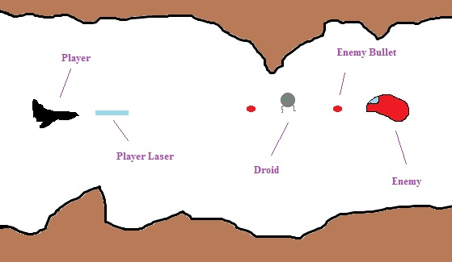

Gameplay
Gameplay will be fairly basic. The level will scroll along, while obstacles and enemies appear periodically. After a while, the boss for the level will appear and put the player to the test. Once a level is complete, the player will move on to the next level.
The player will use the W,A,S,D keys to move their ship and spacebar to fire.
While not all enemies will be destroyed, as the player misses them and they do not return, each enemy or object that the player destroys will award points. These points will create the player's score for the level, and will be added to their total score for the game. At the end of the game, this score will be stored in a high score list, viewable by the player.
If the player fails to avoid terrain, enemies, or enemy fire, they will lose a life. If the player's lives reach 0, they lose the game. *Life and gameover conditions may change by the end of the game's production

Art
Art for this game will be handled by Brian Lawrence. No actual art has been made at this time, so there is none to display here. The art will not look like the example level above.

Sound and Music
The game will have music, which will attempt to give a space-like feel to things, or to hype up the player in combat.
Player shots will not create sound, as this feature grows to be very annoying in games such as this. We'll blame it on space having no air, and thus sounds being incredibly difficult to hear.
Maybe there will be an explosion sound for the boss and player at Game Over. Game logic.

